INDUSTRIAL TECHNOLOGY VALIDATION

Holcim Alpena Thermoelectric Generation Supplemental Technical Annex
  - Supporting source exhibits omitted from the restructured technical report
Companion report: Holcim_Alpena_TEG_Technical_Report.docx
Primary source PDF: itv_m_v_holcim_ats_2025.06.09_0.pdf
Project report title: Thermoelectric Generation at Holcim Alpena

Purpose and Use
This annex preserves detailed evidence from the source PDF that is not reproduced in full in the restructured project report. It is intended as a companion for audit and technical review; the completed report remains the primary reading document for conclusions and interpretation.

Project Summary from the Completed Report
This evaluation tested an Advanced Thermovoltaic Systems (ATS) thermoelectric generation (TEG) pilot at Holcim’s Alpena cement plant. The pilot recovered electricity from heat transferred through a working-fluid loop, with Lake Huron water as the cold sink. At the best tested condition, gross output reached 10.0 kW, net output reached 7.7 kW, and thermal efficiency reached 5.0%. The vendor’s gross-power claim was not reached, while peak net power and peak efficiency met or exceeded stated claims. Annual generation at Alpena and typical cement plants is modeled, not observed.

Source Pages Included
The selected pages reproduce source technical material, including instrumentation/data coverage, operating conditions, equations and model diagnostics, uncertainty and detailed result exhibits, equipment information, figures, and scale-up or market analysis where present. Each page is reproduced directly from the original PDF. Original page headers, captions, tables, and printed page numbers remain visible; “PDF page” labels refer to the file page index.
Included source PDF pages: 20-21, 24-26, 30-35, 37-41, 43-51, 57-71, 75, 77, 82-89, 91-93, 95-97, 100, 102, 105, 107-118, 120-122.
These are facsimile reproductions, not a new analysis. Values, chart scales, and qualifications are as presented in the source. Refer to the completed report for the summarized findings and project-specific interpretation.

Source PDF page 20 | Holcim Alpena Thermoelectric Generation
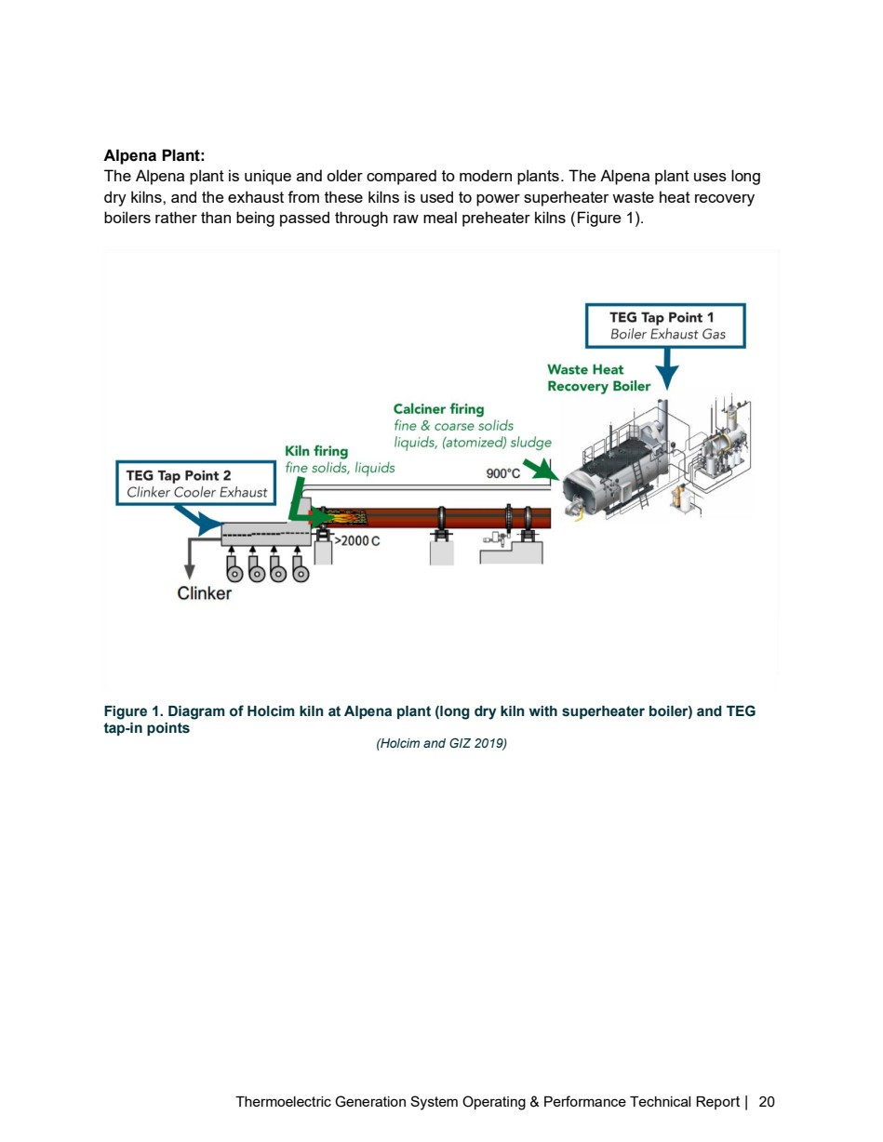

Source PDF page 21 | Holcim Alpena Thermoelectric Generation
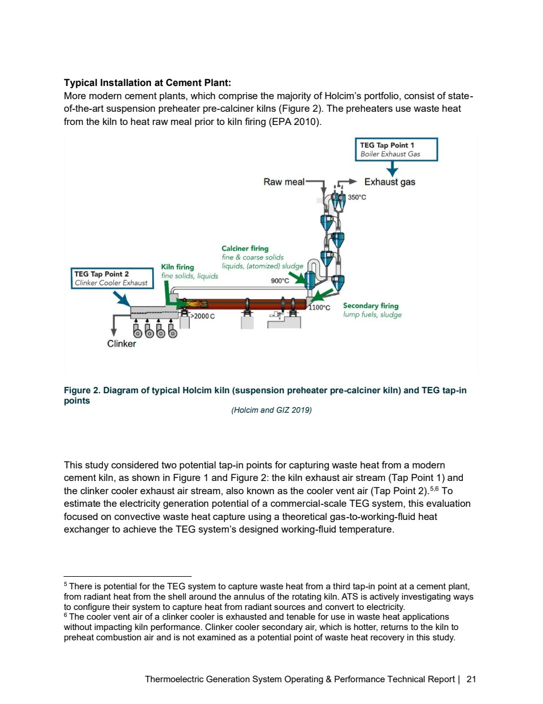

Source PDF page 24 | Holcim Alpena Thermoelectric Generation
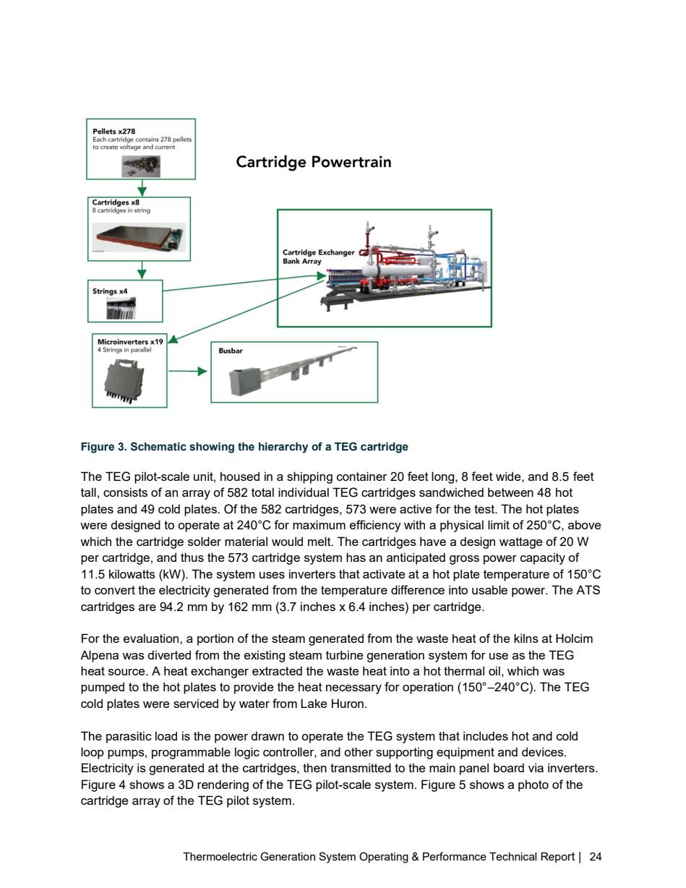

Source PDF page 25 | Holcim Alpena Thermoelectric Generation
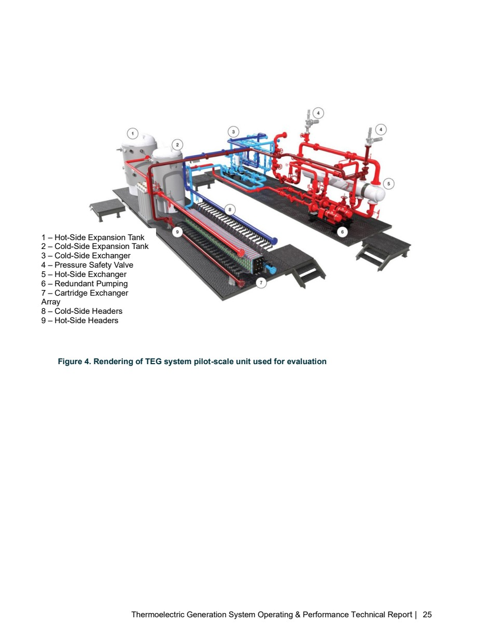

Source PDF page 26 | Holcim Alpena Thermoelectric Generation
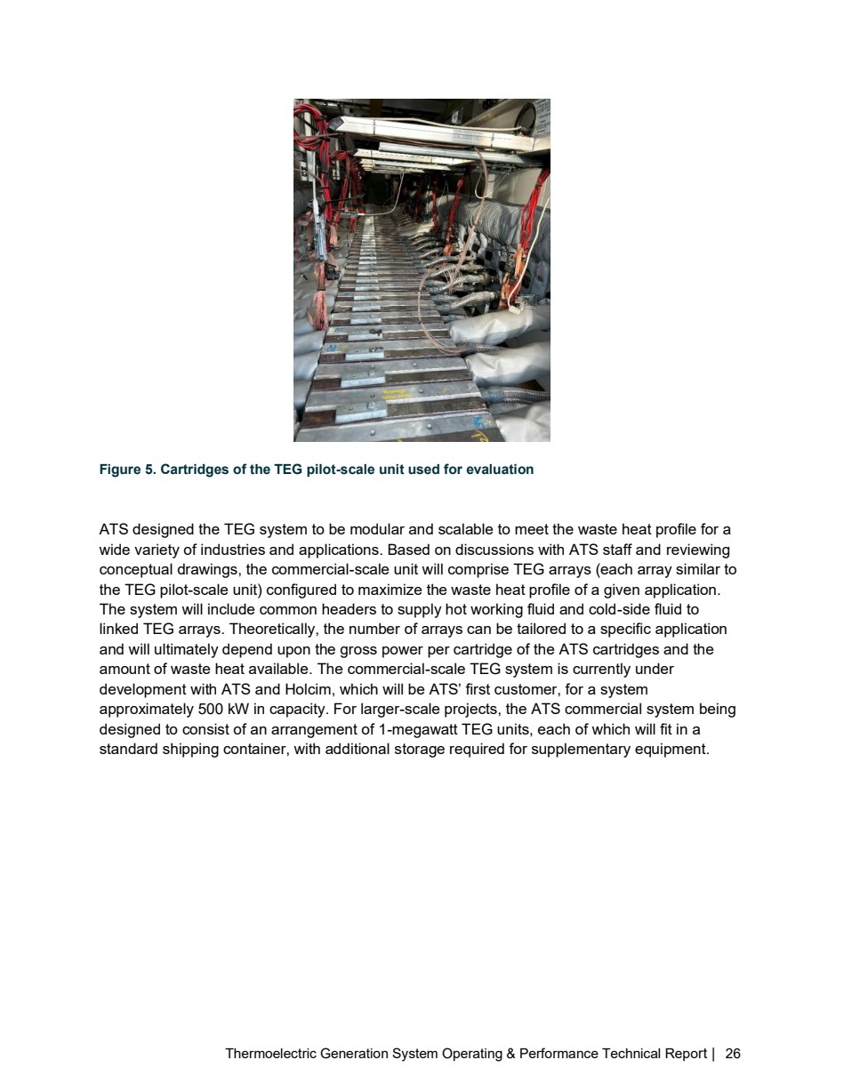

Source PDF page 30 | Holcim Alpena Thermoelectric Generation
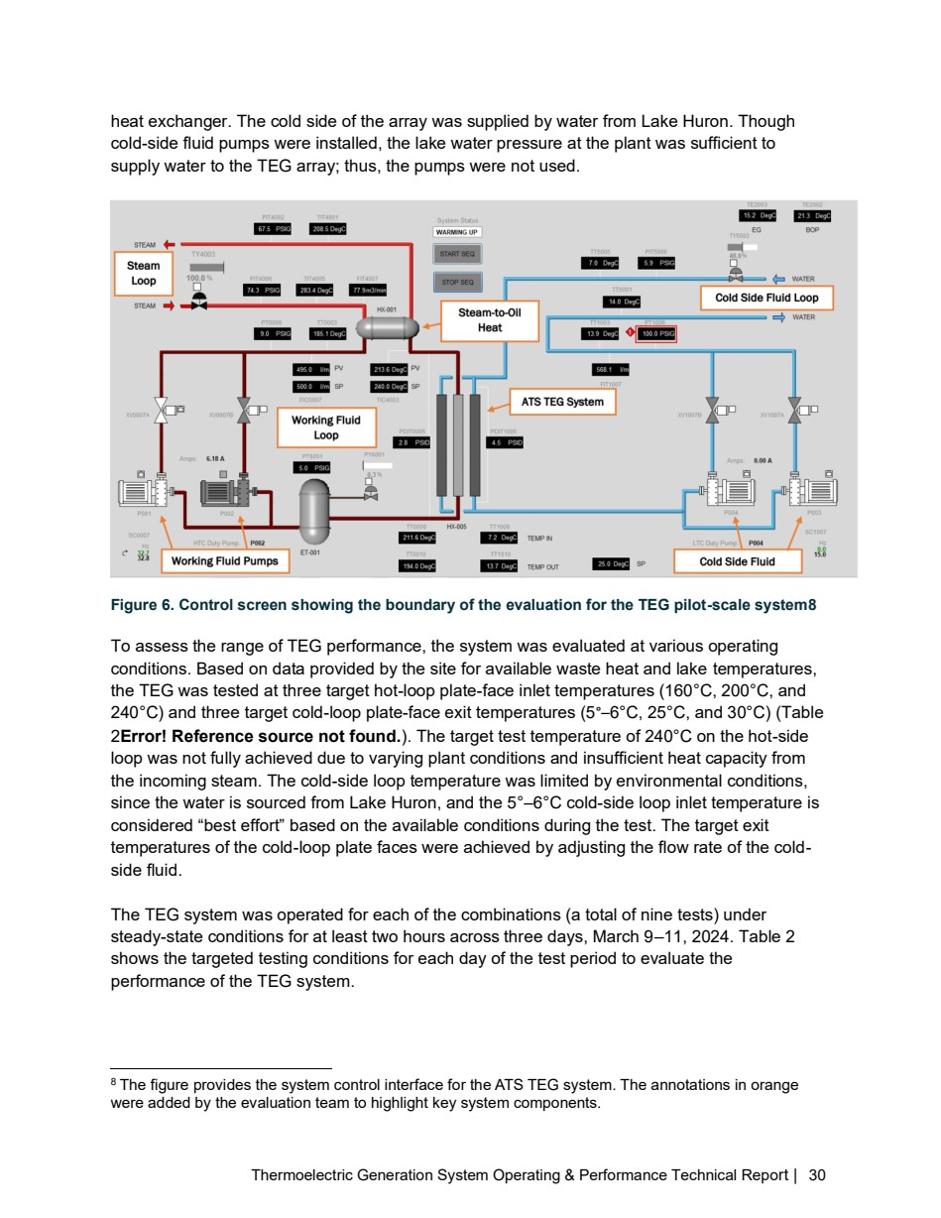

Source PDF page 31 | Holcim Alpena Thermoelectric Generation
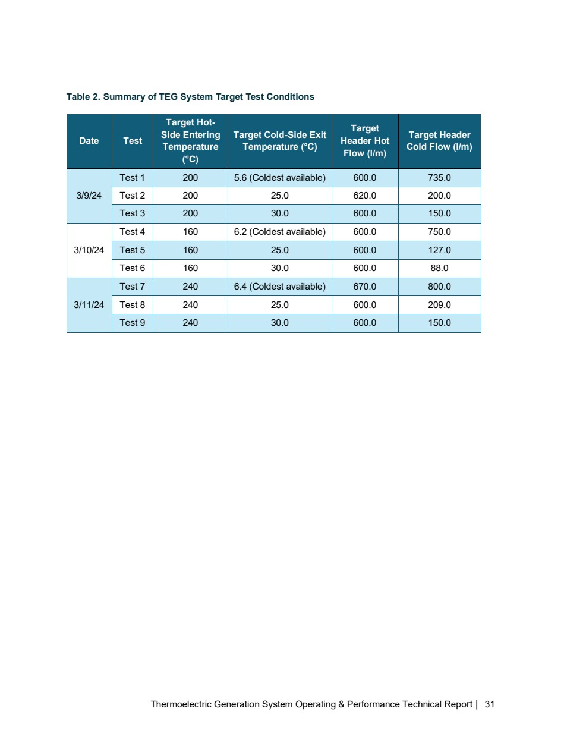

Source PDF page 32 | Holcim Alpena Thermoelectric Generation
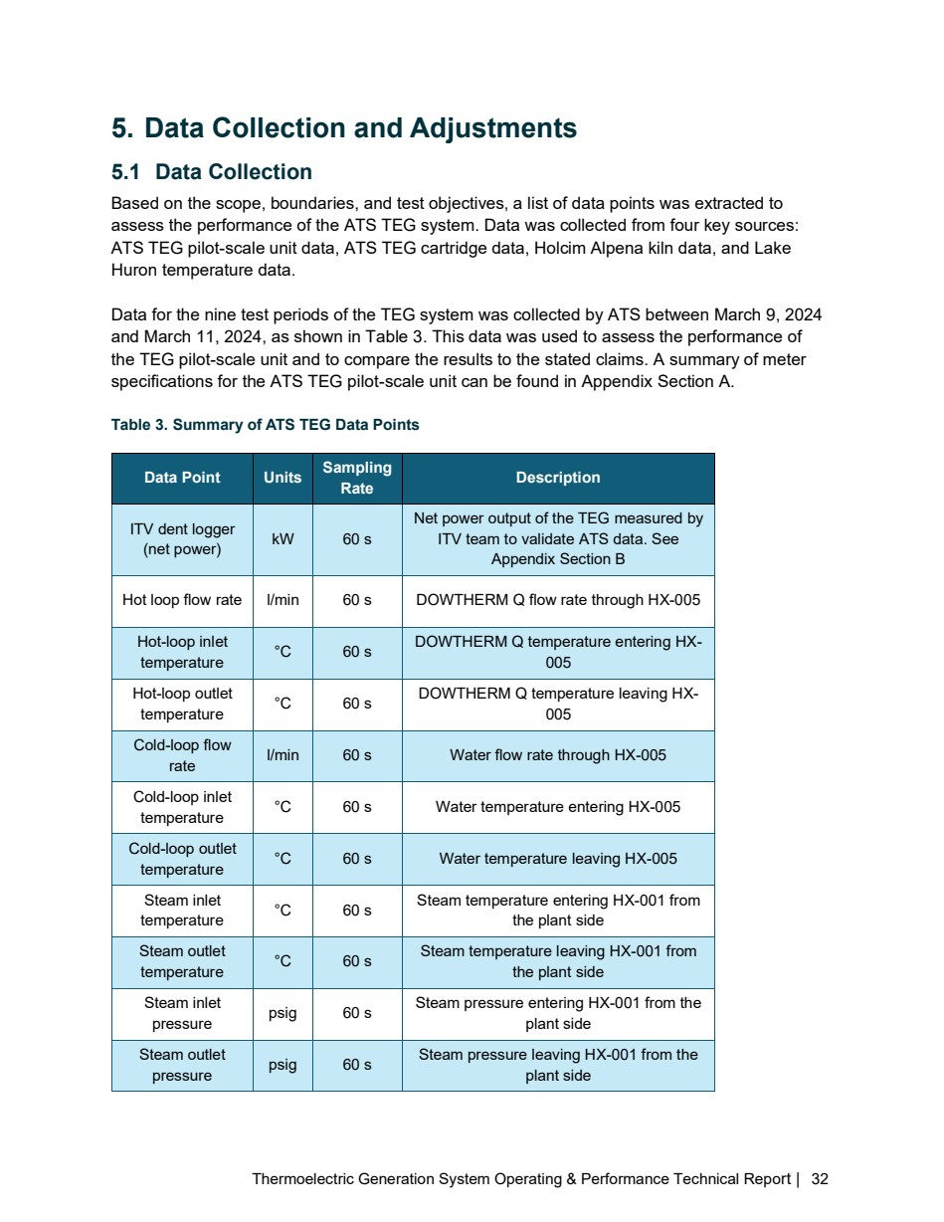

Source PDF page 33 | Holcim Alpena Thermoelectric Generation
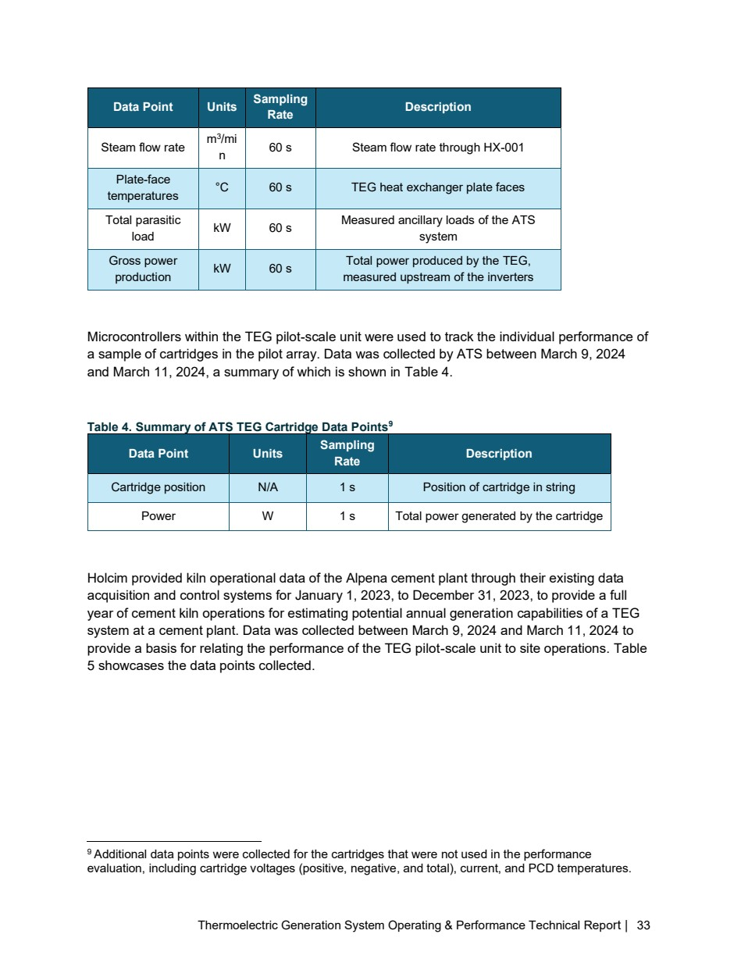

Source PDF page 34 | Holcim Alpena Thermoelectric Generation
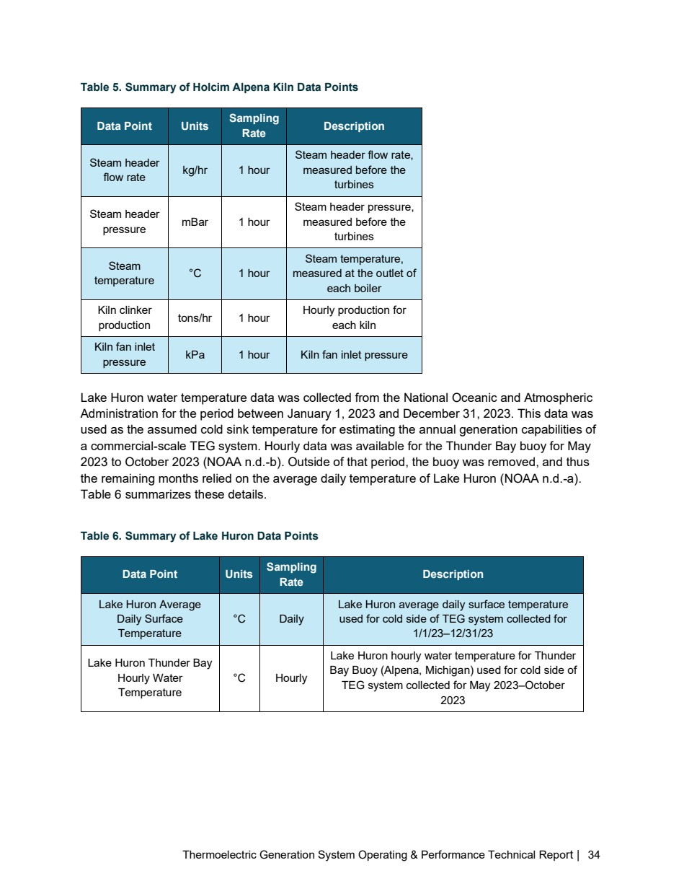

Source PDF page 35 | Holcim Alpena Thermoelectric Generation
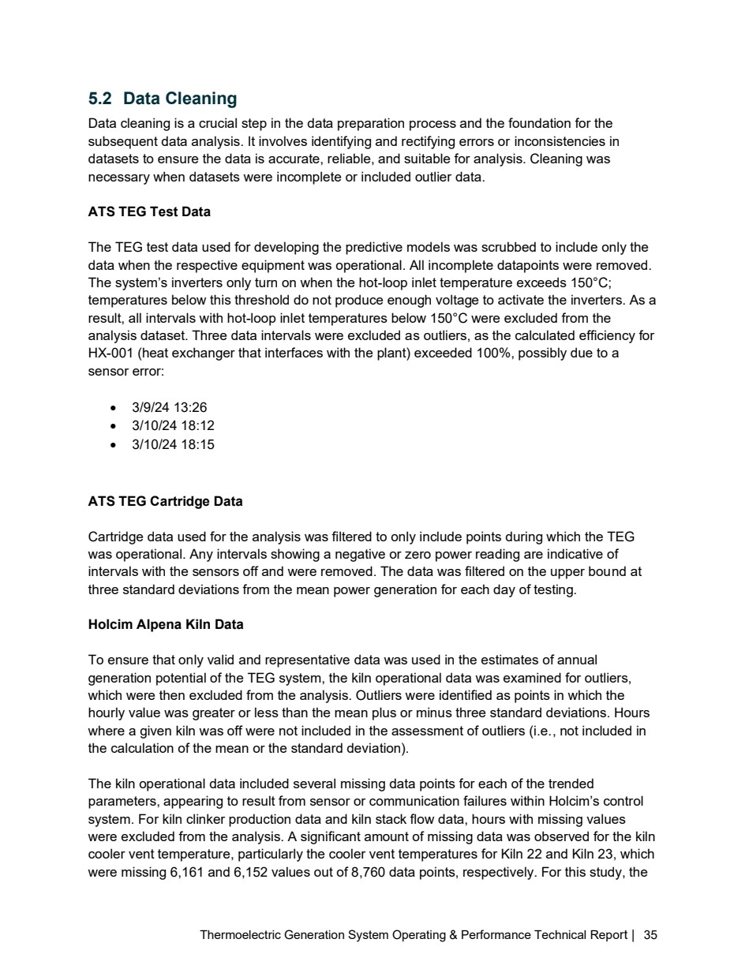

Source PDF page 37 | Holcim Alpena Thermoelectric Generation
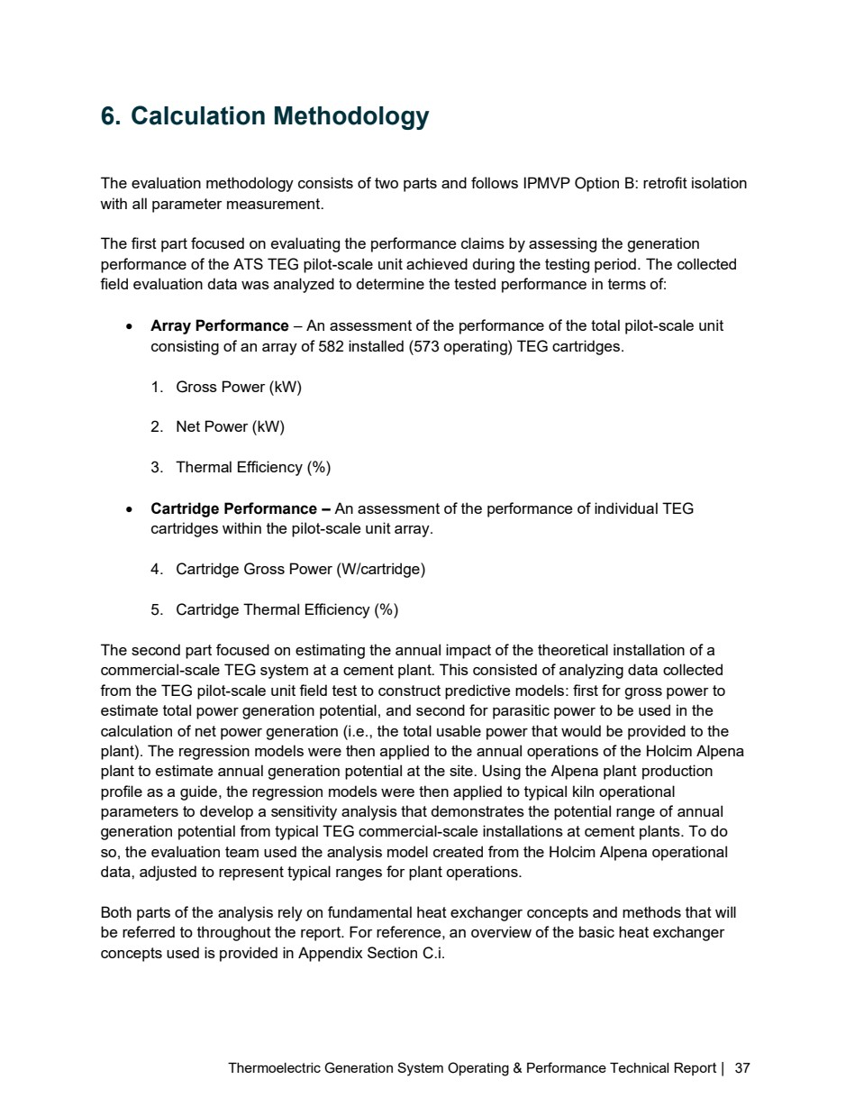

Source PDF page 38 | Holcim Alpena Thermoelectric Generation
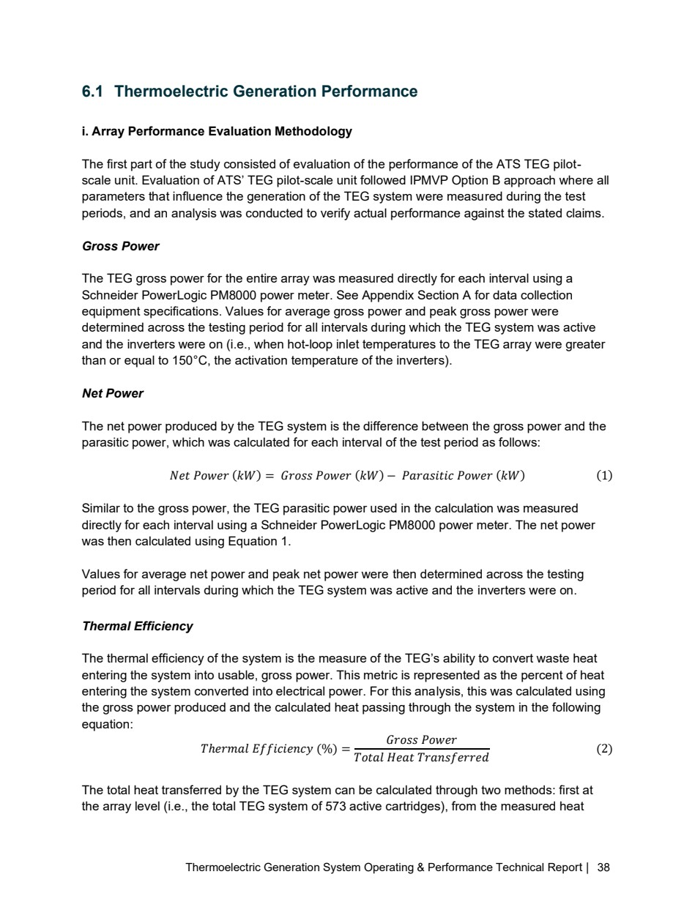

Source PDF page 39 | Holcim Alpena Thermoelectric Generation
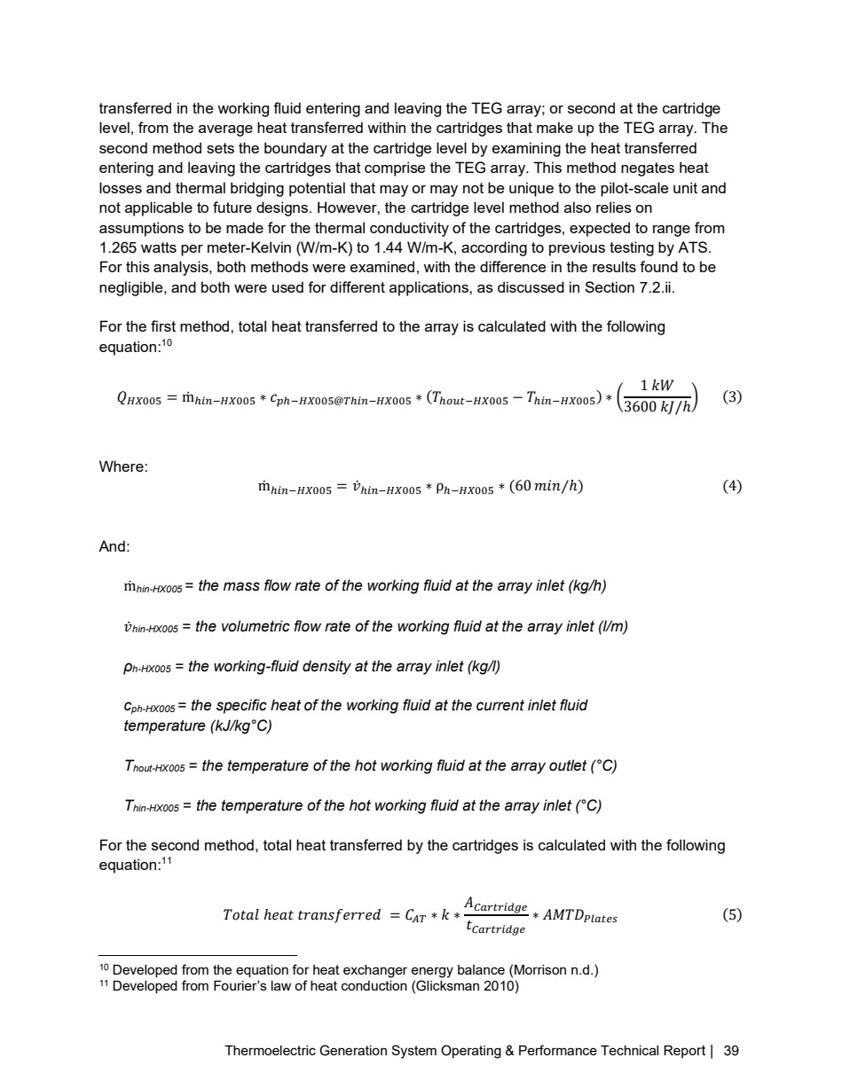

Source PDF page 40 | Holcim Alpena Thermoelectric Generation
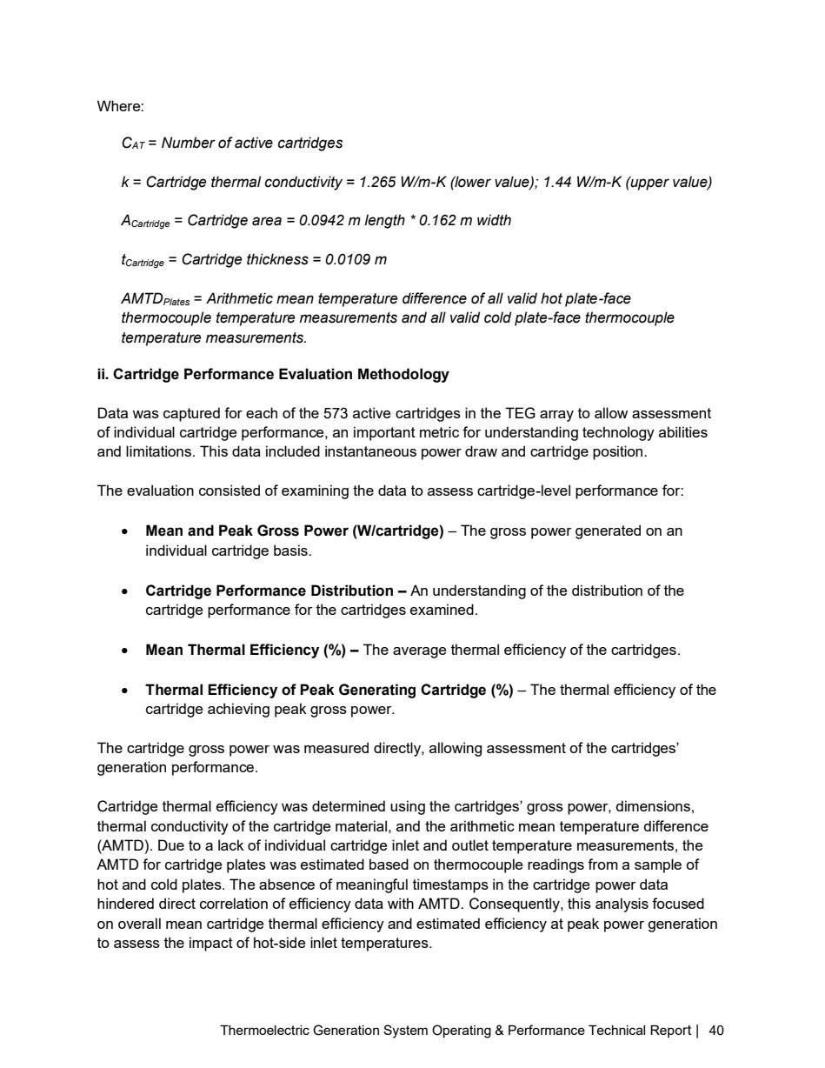

Source PDF page 41 | Holcim Alpena Thermoelectric Generation
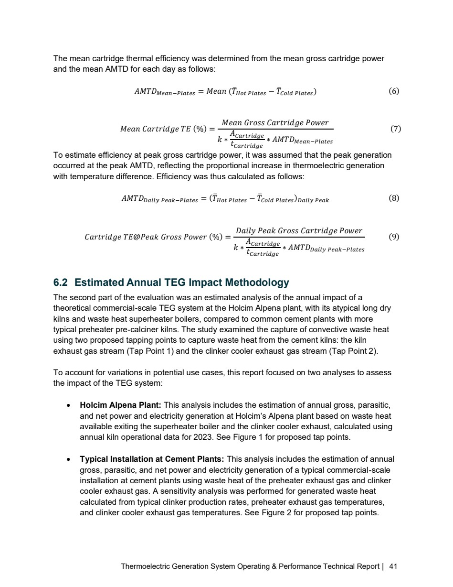

Source PDF page 43 | Holcim Alpena Thermoelectric Generation
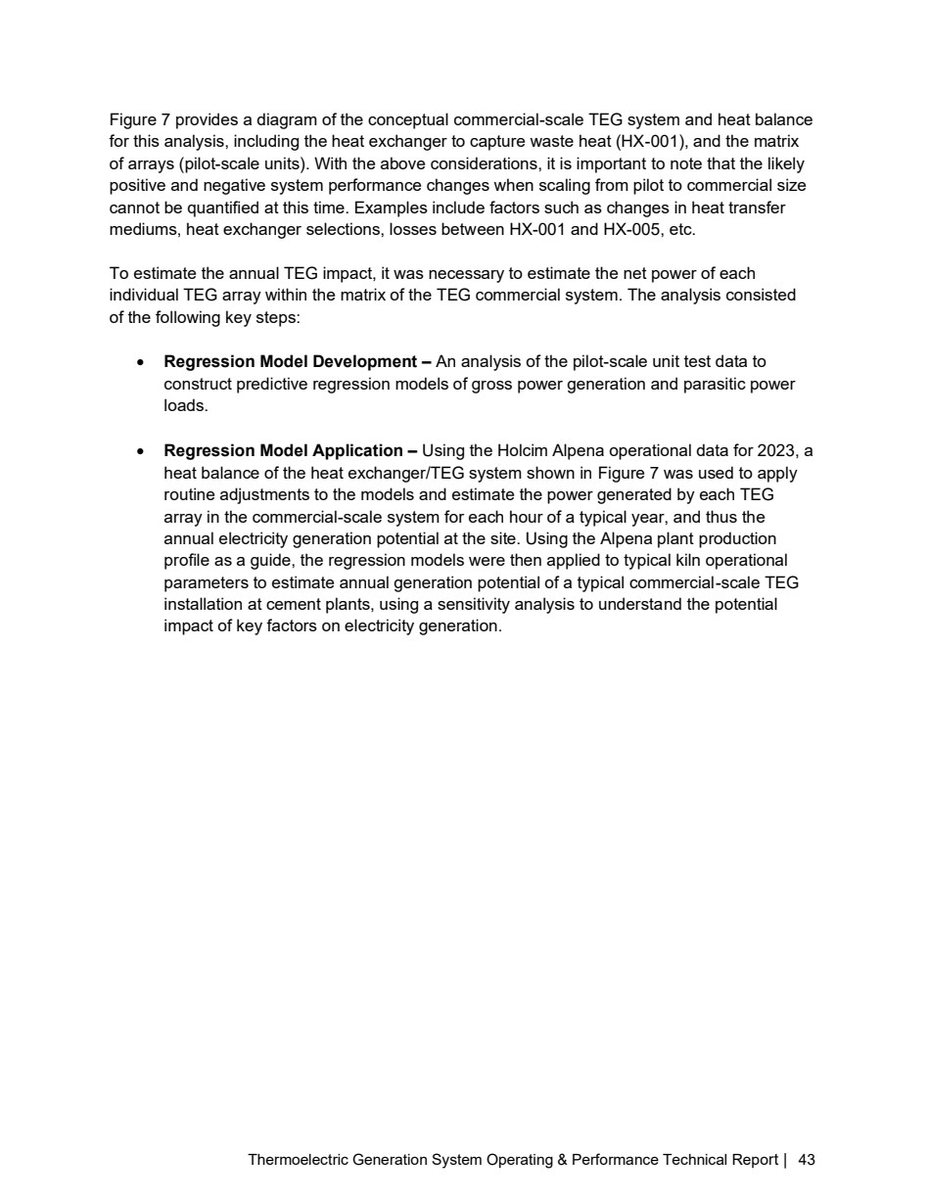

Source PDF page 44 | Holcim Alpena Thermoelectric Generation
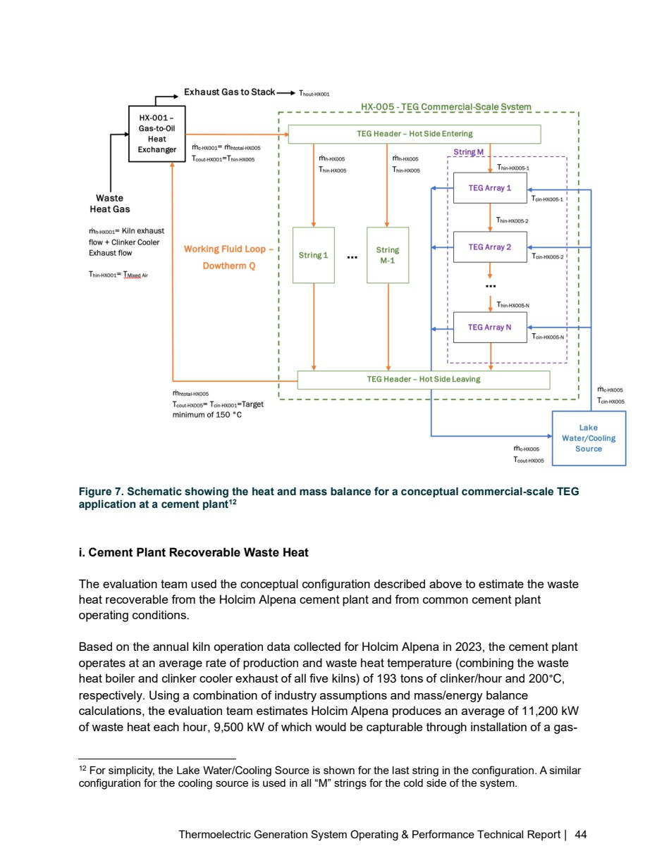

Source PDF page 45 | Holcim Alpena Thermoelectric Generation
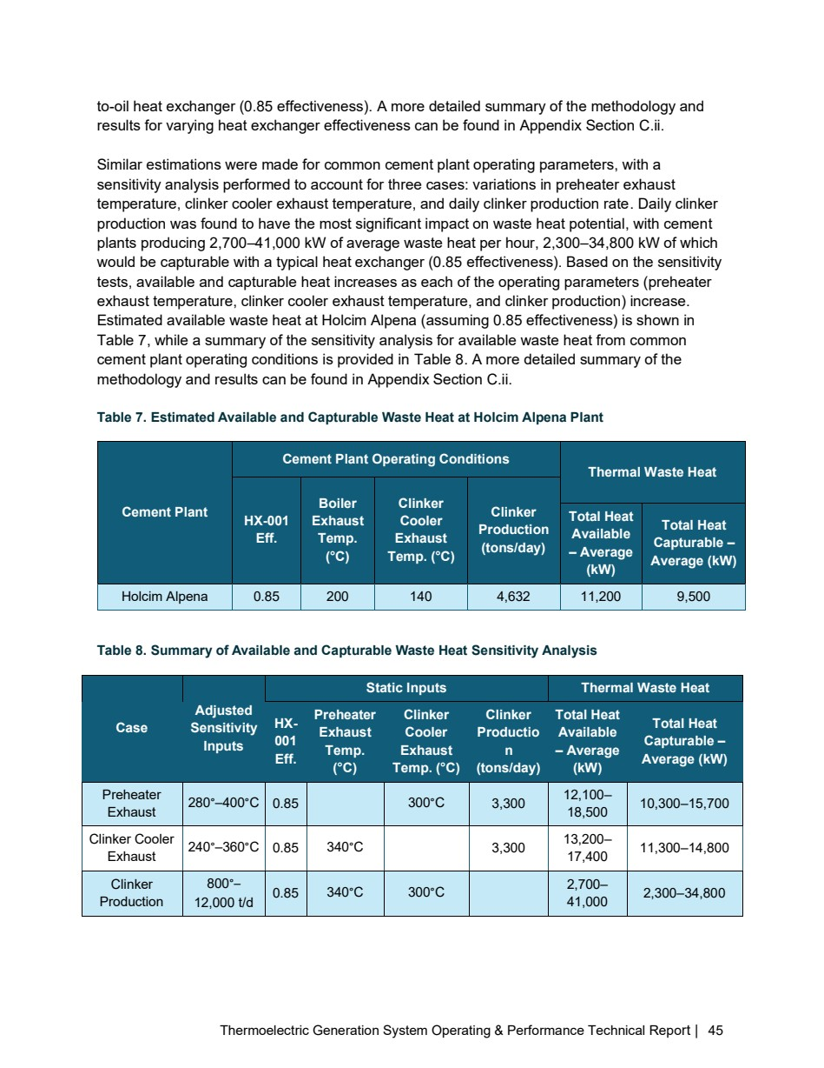

Source PDF page 46 | Holcim Alpena Thermoelectric Generation
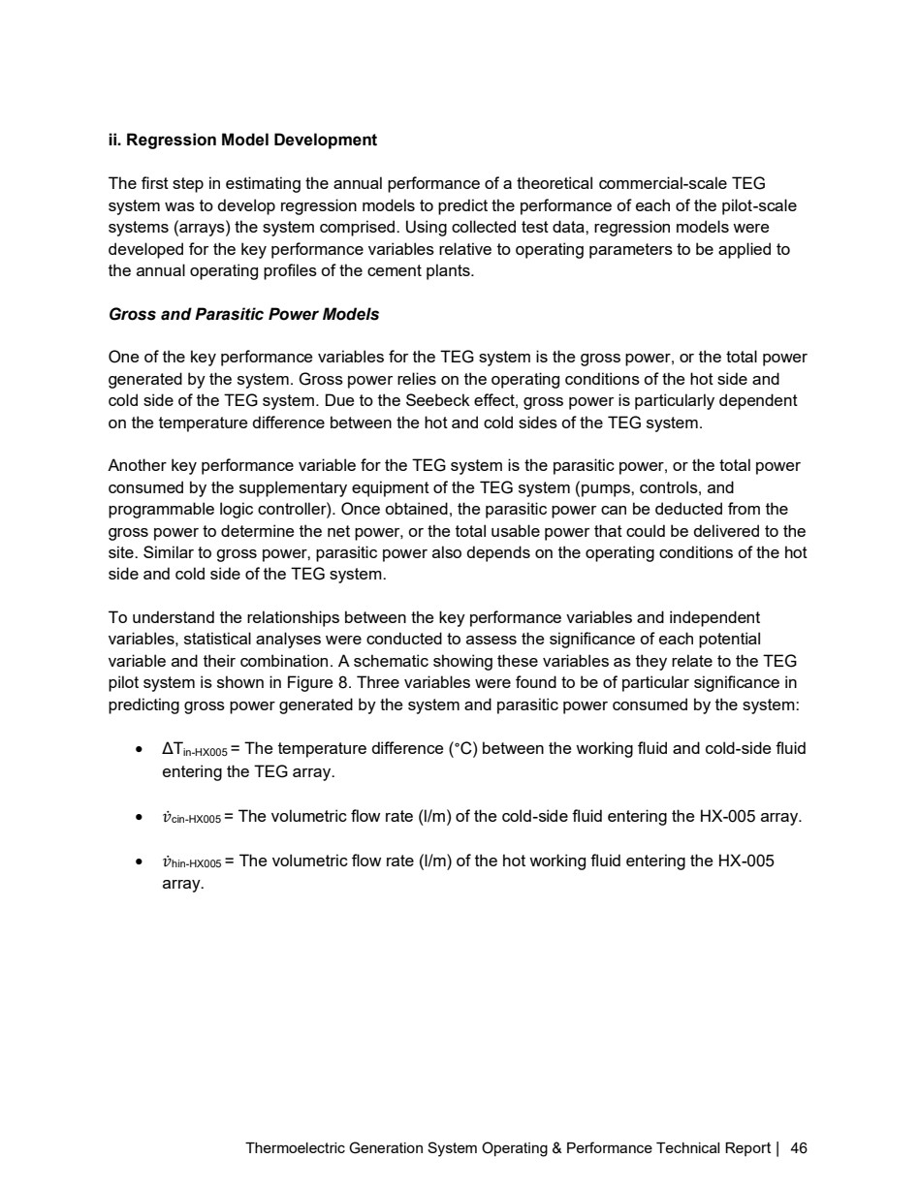

Source PDF page 47 | Holcim Alpena Thermoelectric Generation
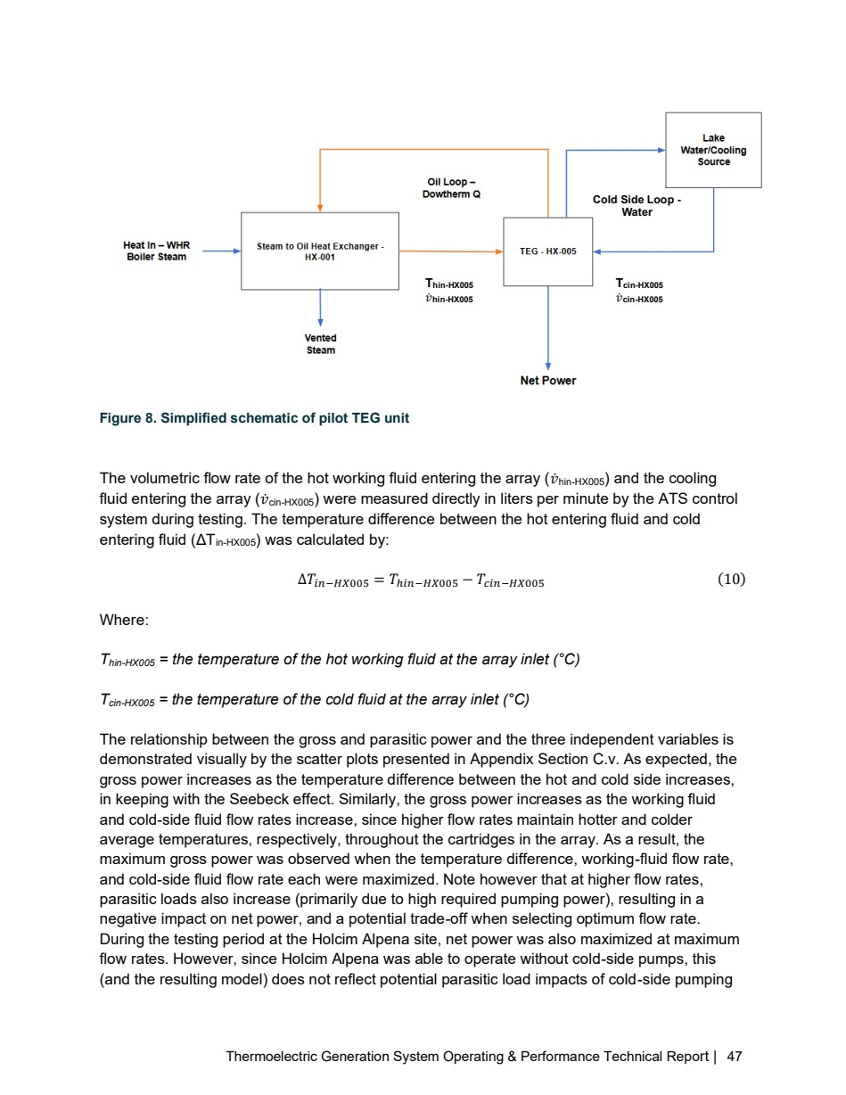

Source PDF page 48 | Holcim Alpena Thermoelectric Generation
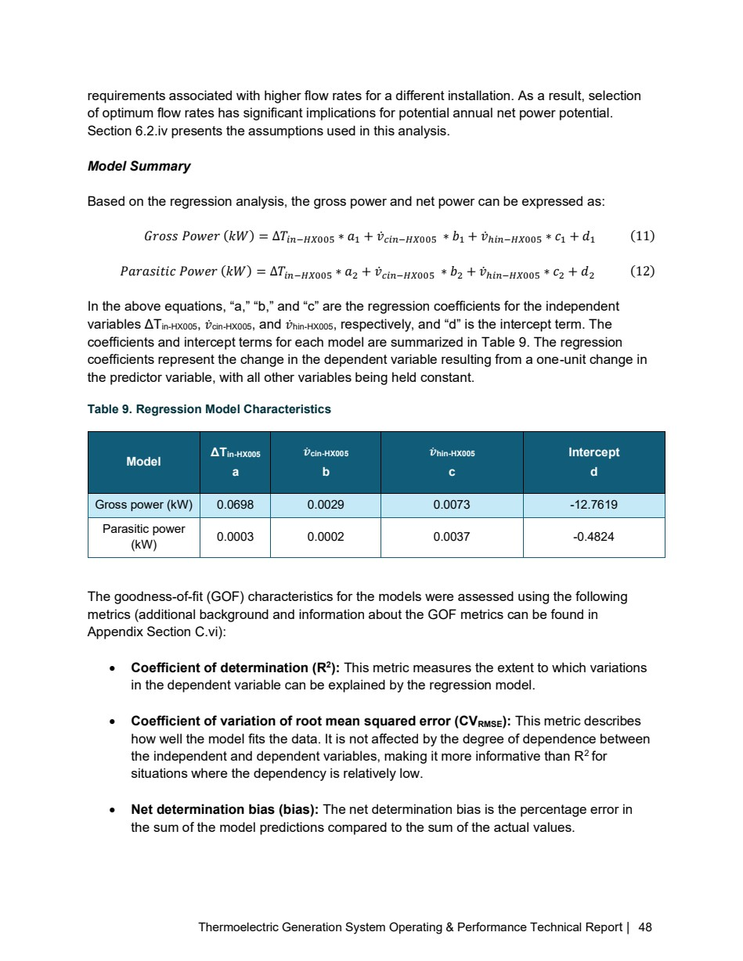

Source PDF page 49 | Holcim Alpena Thermoelectric Generation
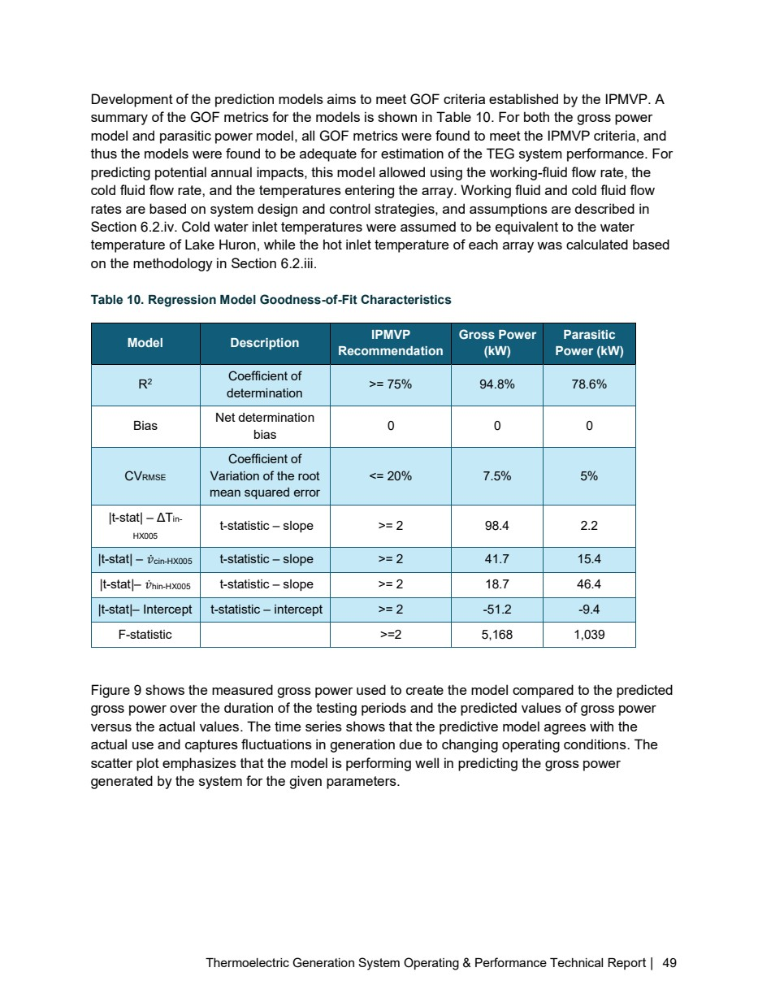

Source PDF page 50 | Holcim Alpena Thermoelectric Generation
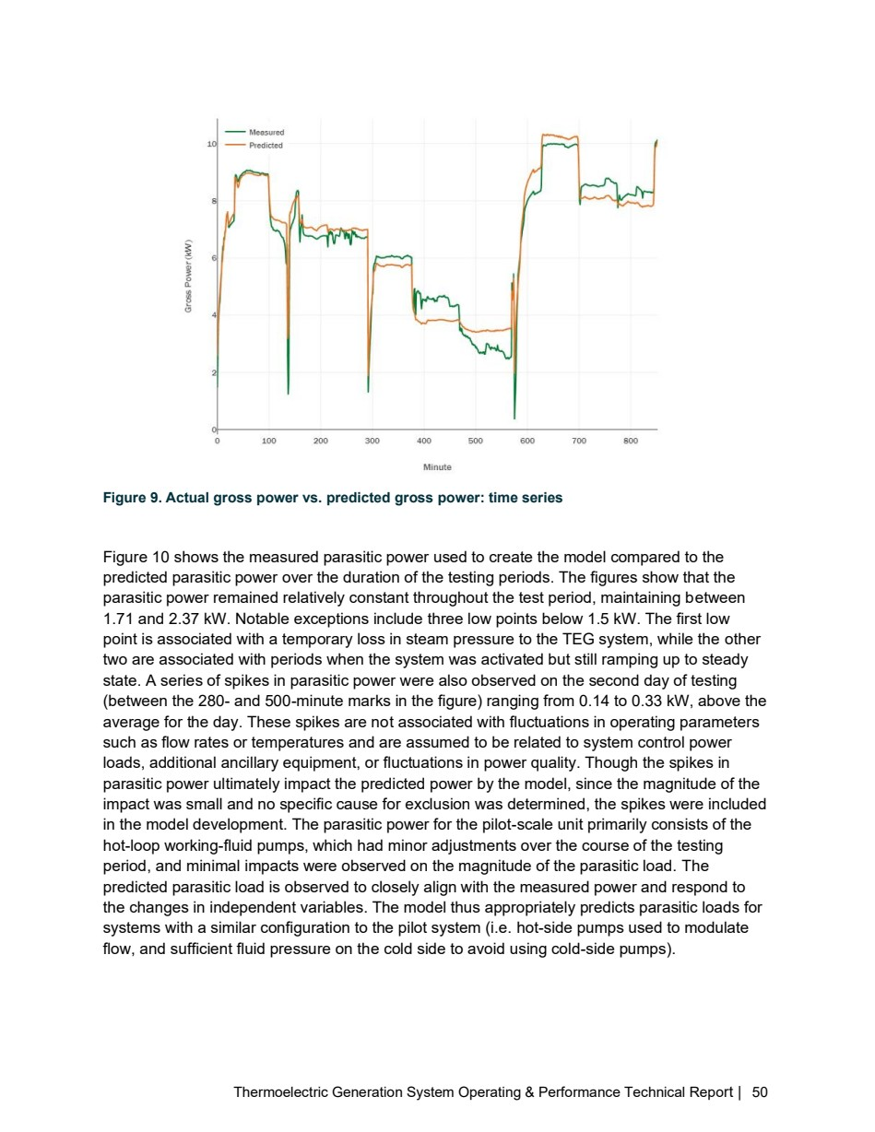

Source PDF page 51 | Holcim Alpena Thermoelectric Generation
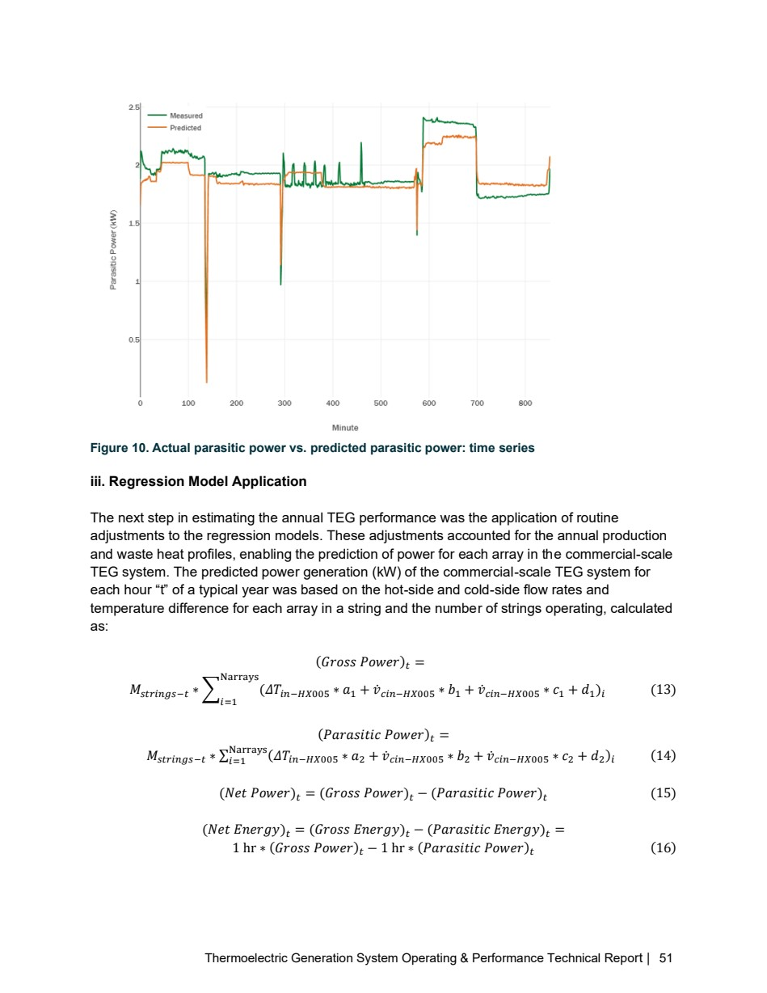

Source PDF page 57 | Holcim Alpena Thermoelectric Generation
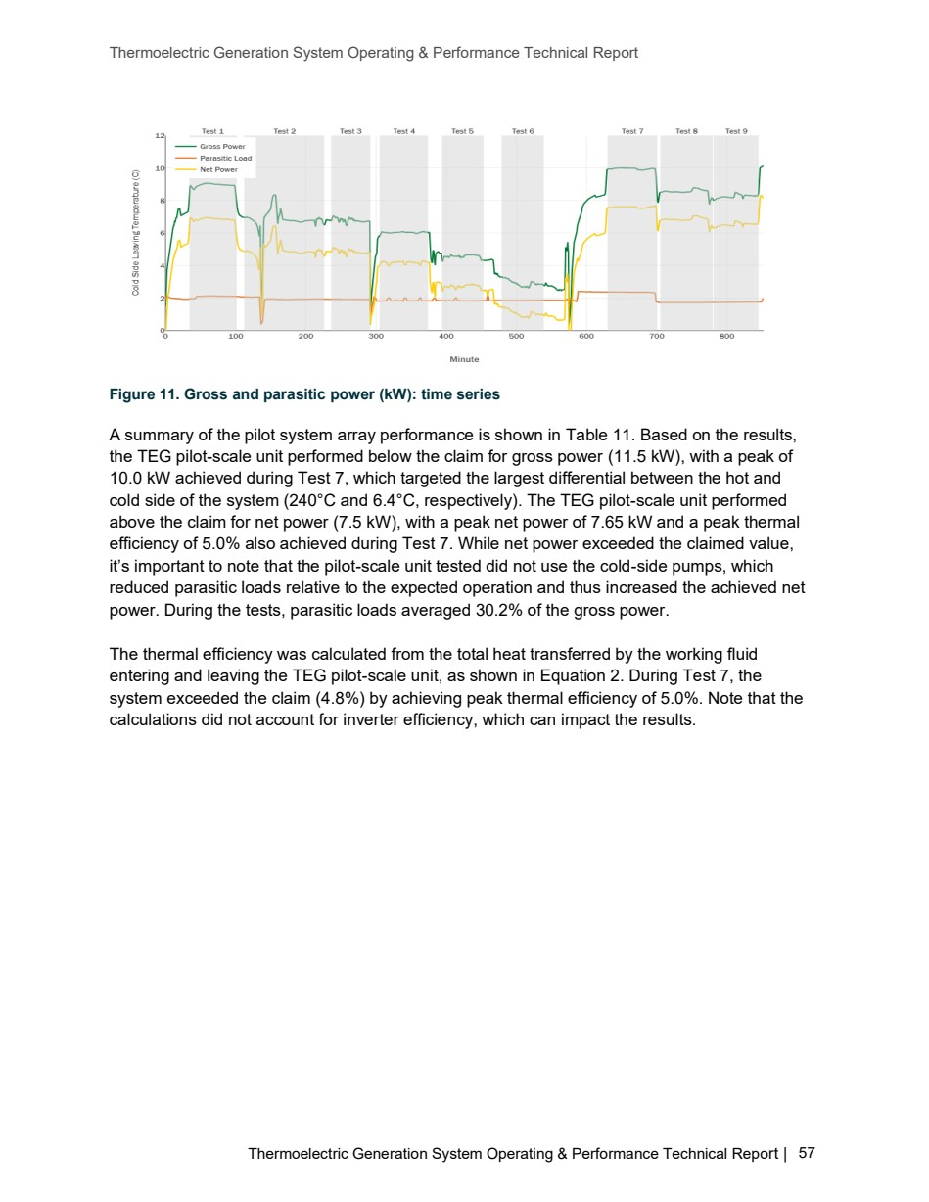

Source PDF page 58 | Holcim Alpena Thermoelectric Generation
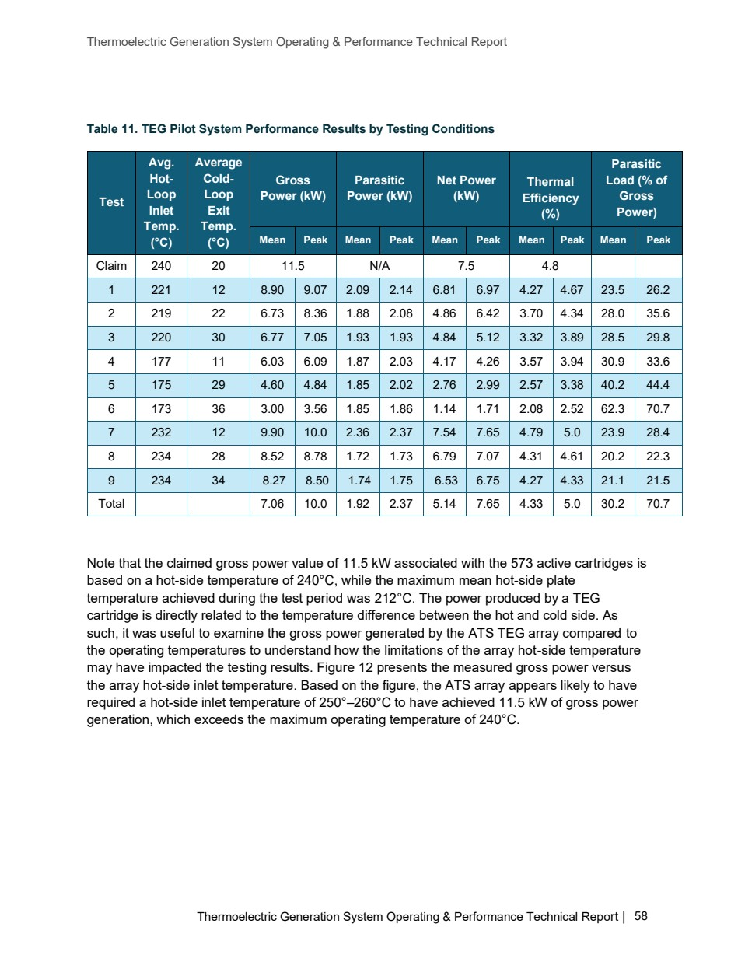

Source PDF page 59 | Holcim Alpena Thermoelectric Generation
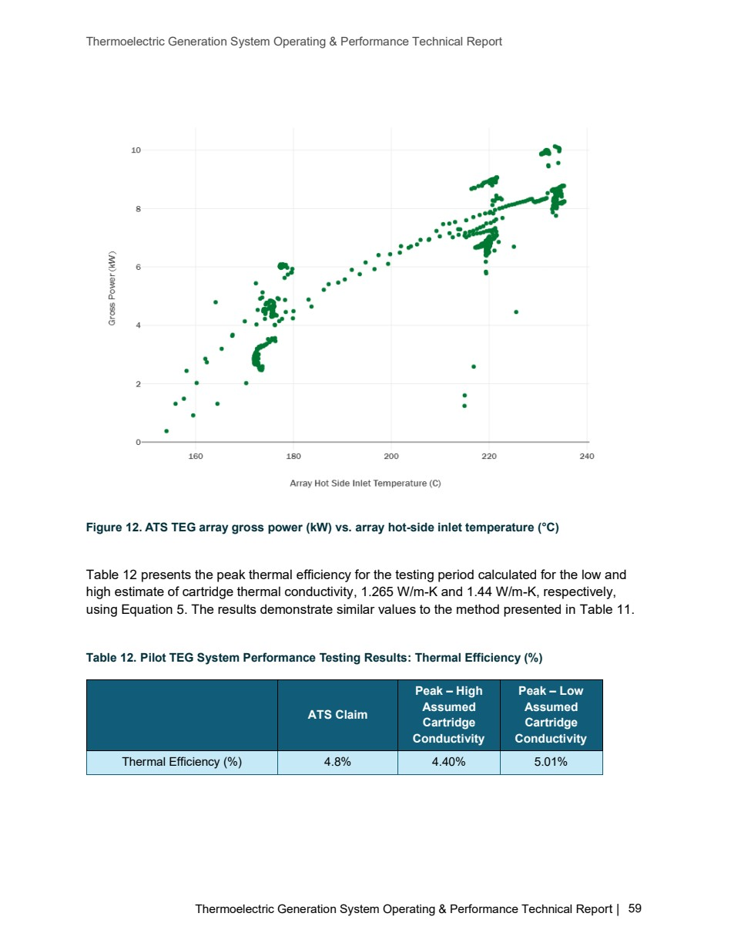

Source PDF page 60 | Holcim Alpena Thermoelectric Generation
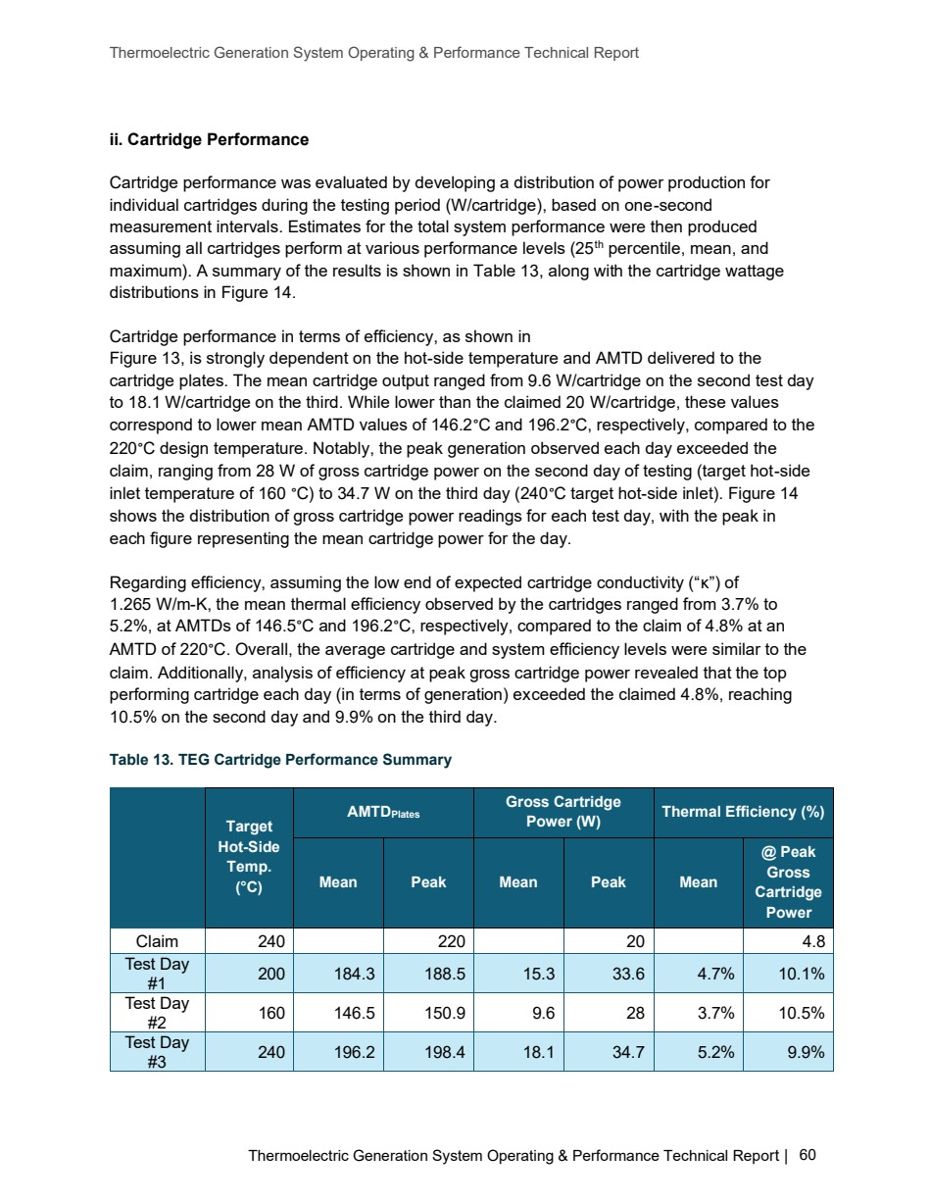

Source PDF page 61 | Holcim Alpena Thermoelectric Generation
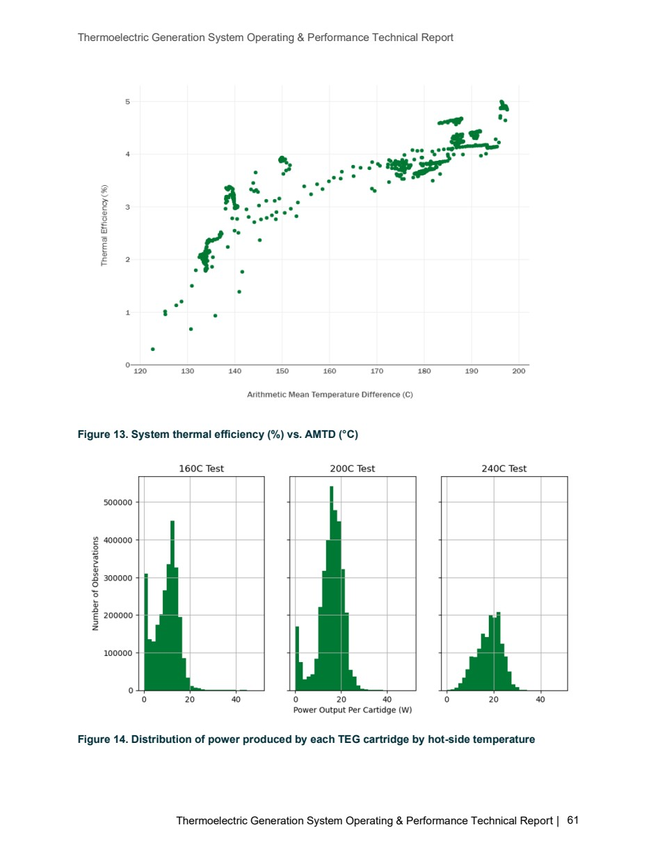

Source PDF page 62 | Holcim Alpena Thermoelectric Generation
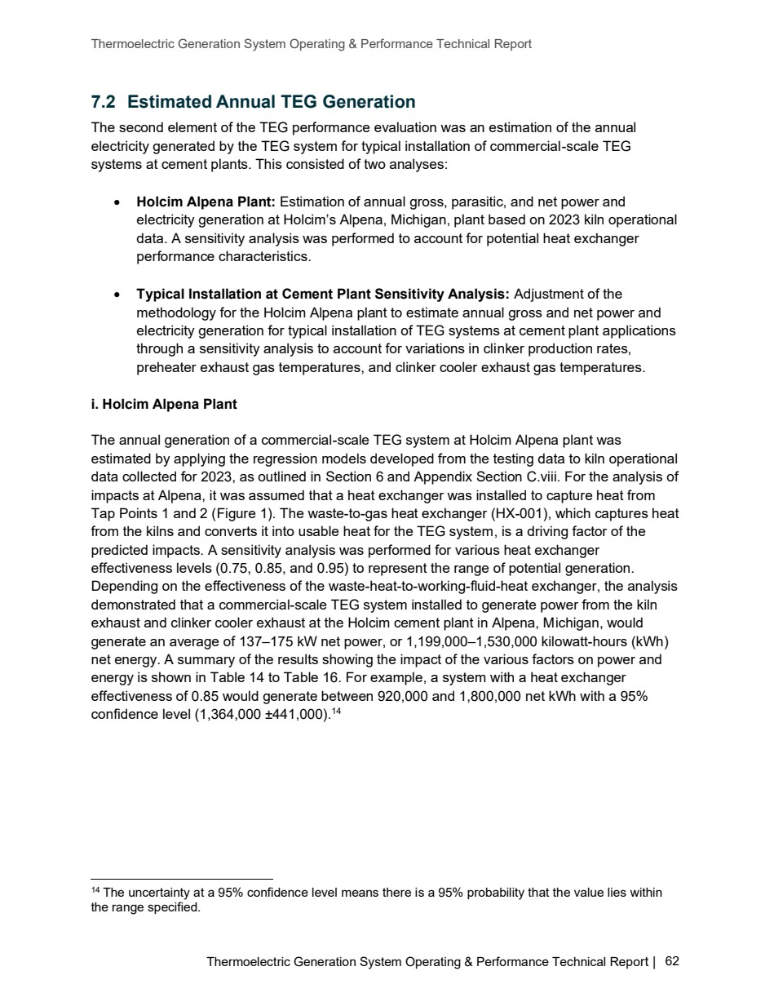

Source PDF page 63 | Holcim Alpena Thermoelectric Generation
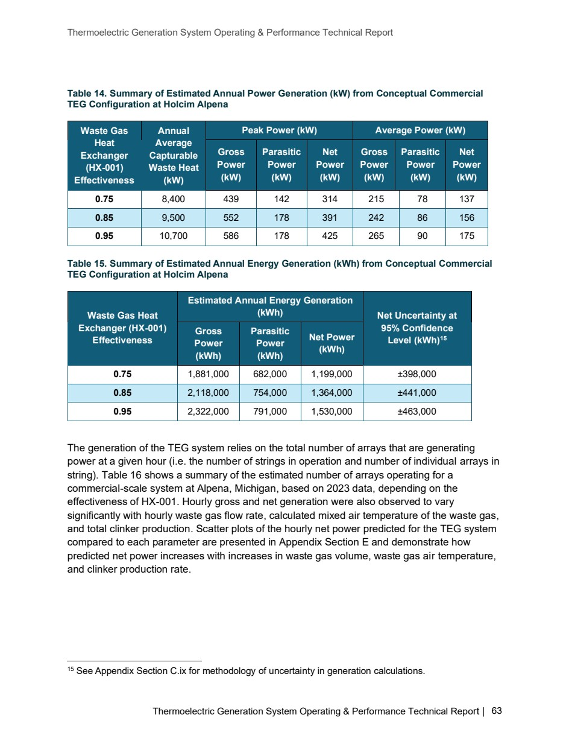

Source PDF page 64 | Holcim Alpena Thermoelectric Generation
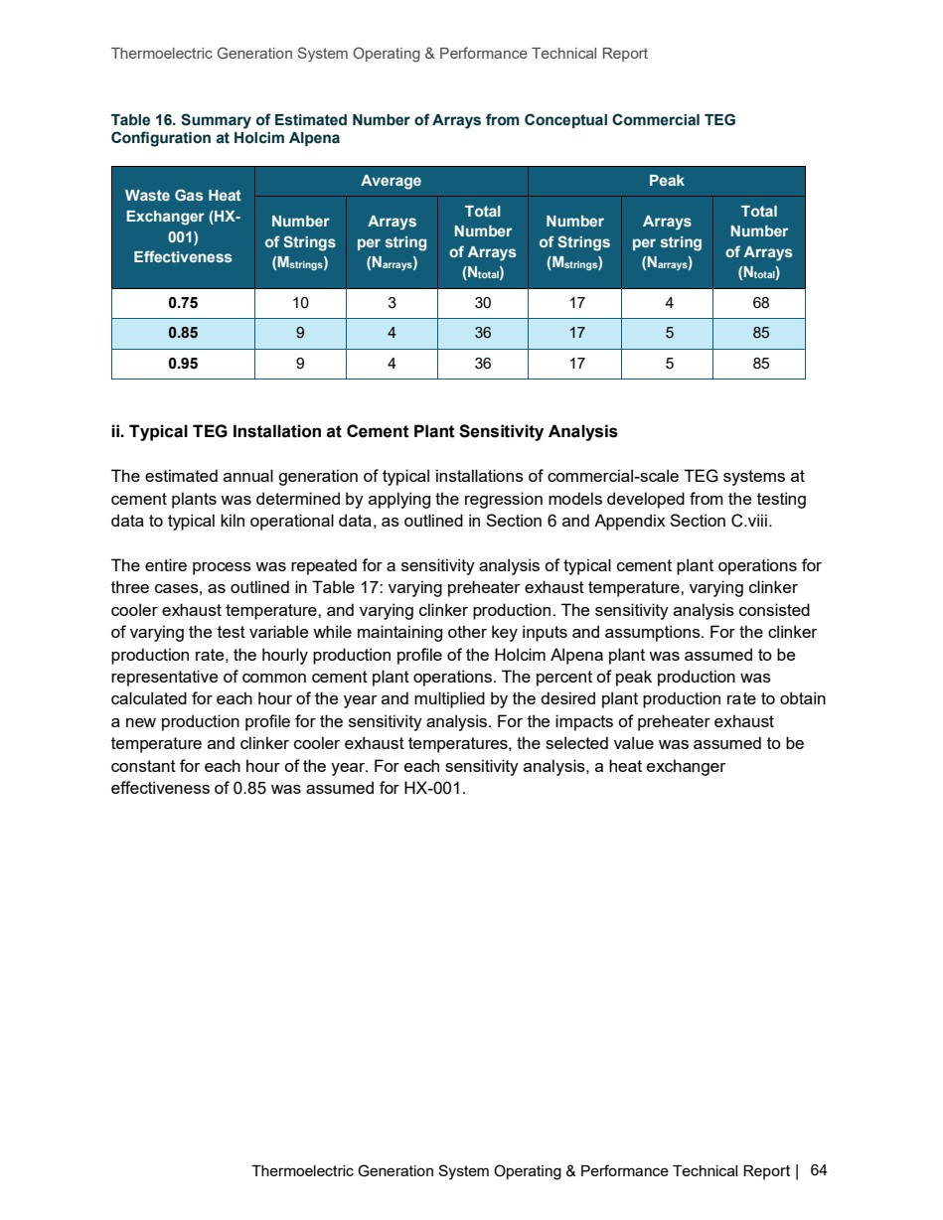

Source PDF page 65 | Holcim Alpena Thermoelectric Generation
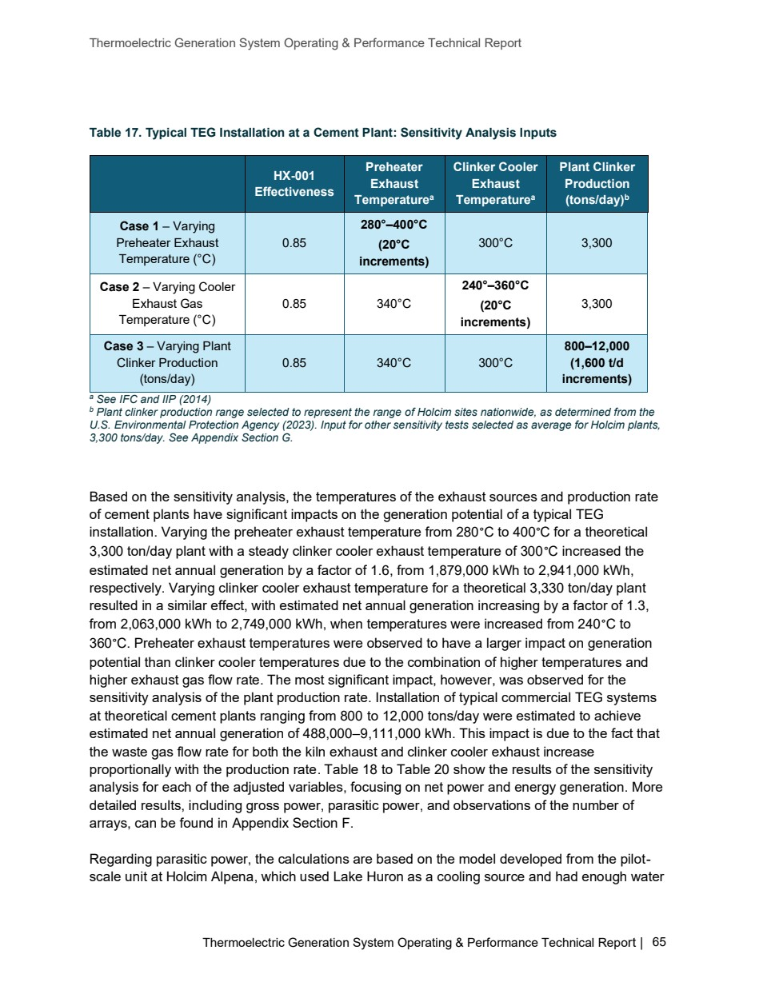

Source PDF page 66 | Holcim Alpena Thermoelectric Generation
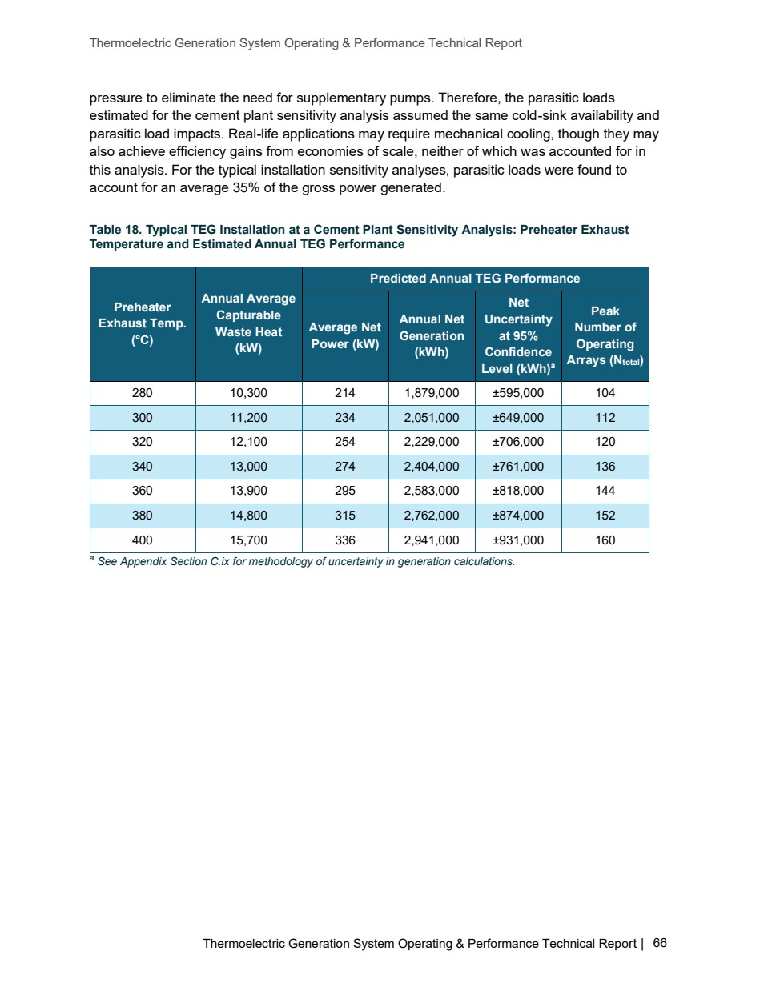

Source PDF page 67 | Holcim Alpena Thermoelectric Generation
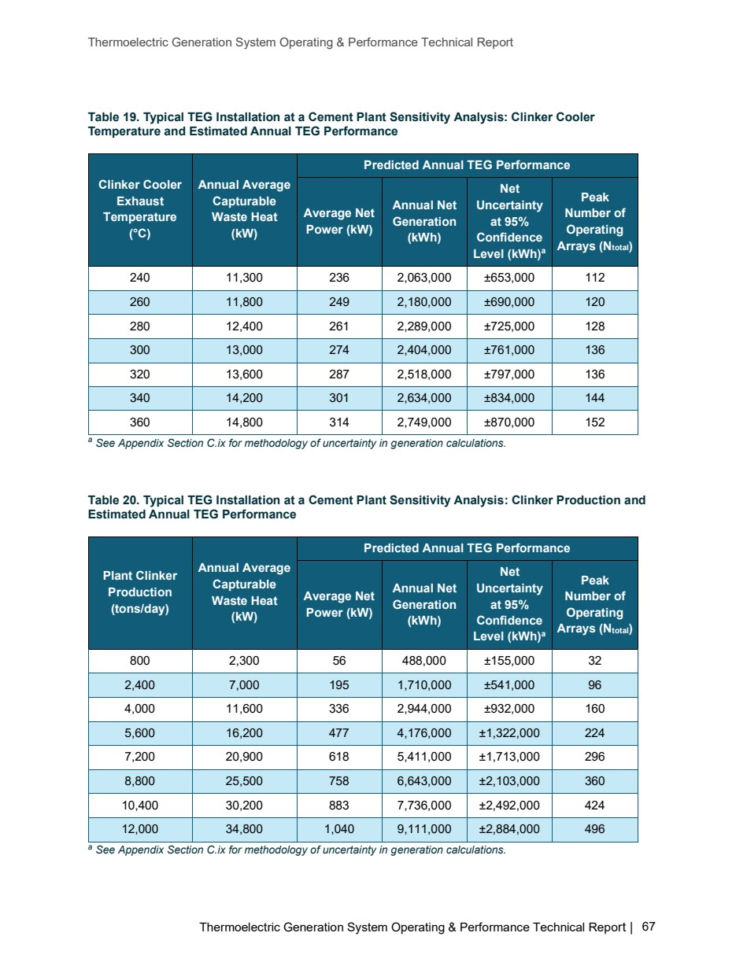

Source PDF page 68 | Holcim Alpena Thermoelectric Generation
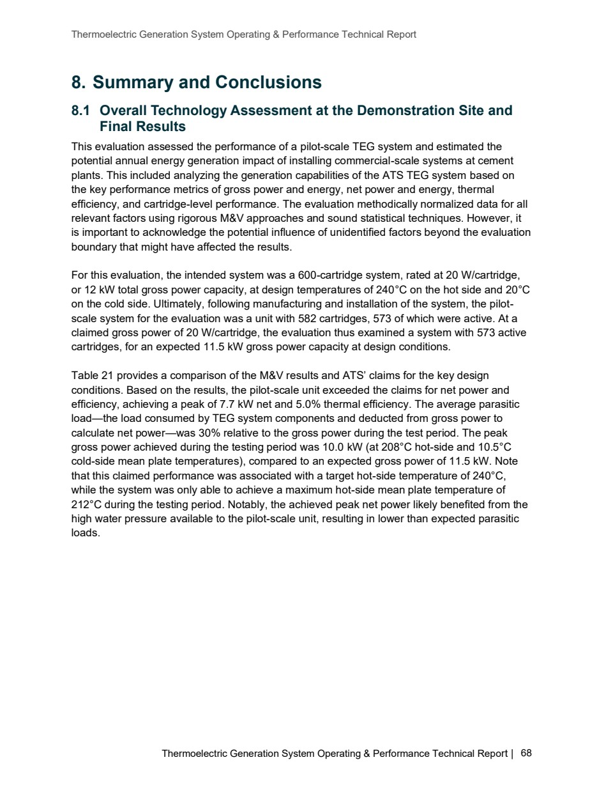

Source PDF page 69 | Holcim Alpena Thermoelectric Generation
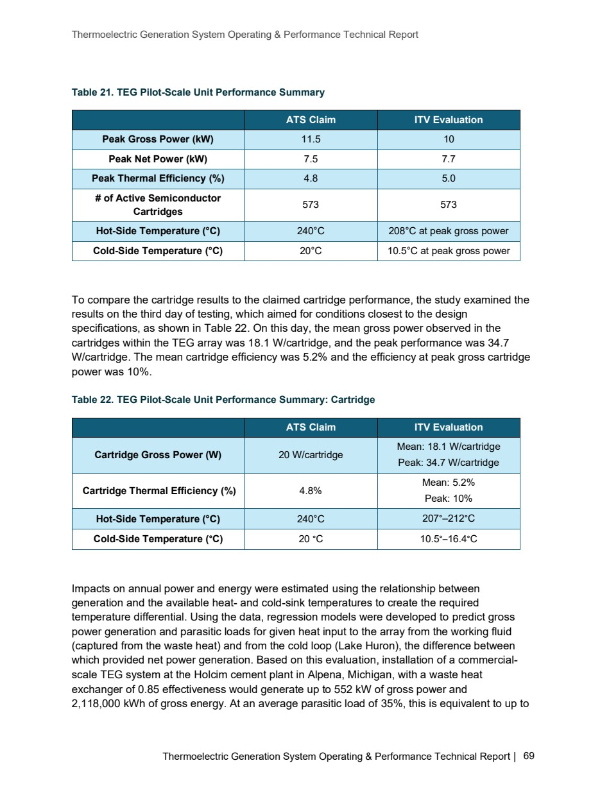

Source PDF page 70 | Holcim Alpena Thermoelectric Generation
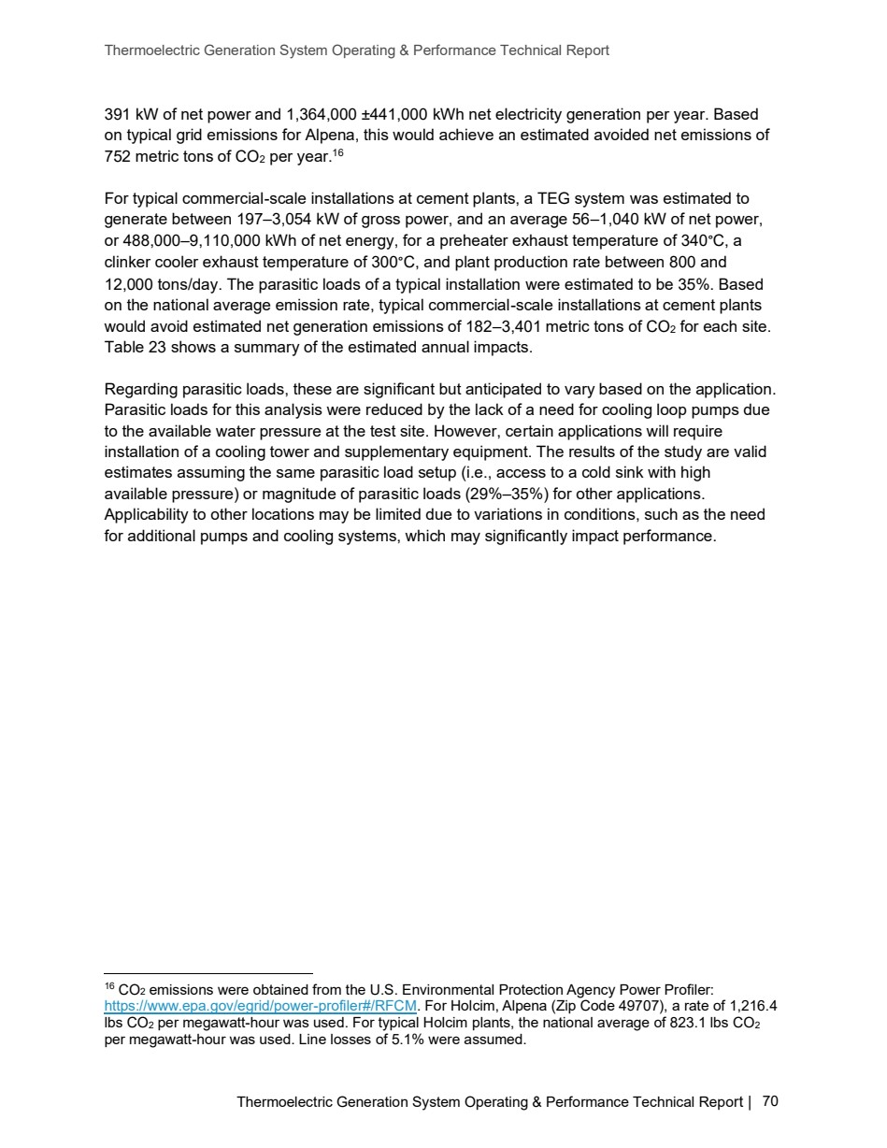

Source PDF page 71 | Holcim Alpena Thermoelectric Generation
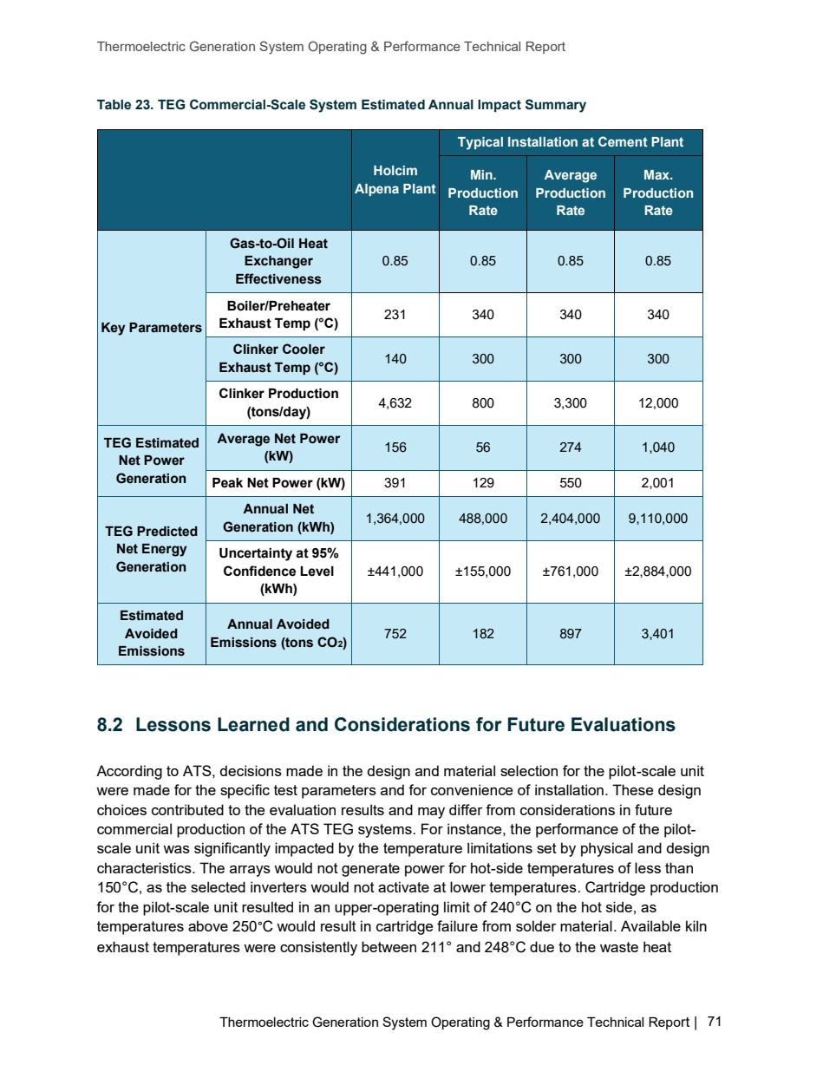

Source PDF page 75 | Holcim Alpena Thermoelectric Generation
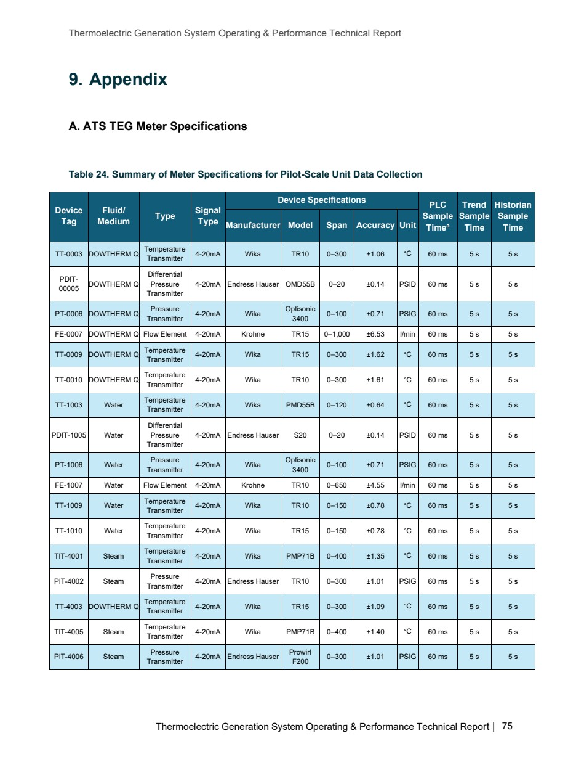

Source PDF page 77 | Holcim Alpena Thermoelectric Generation
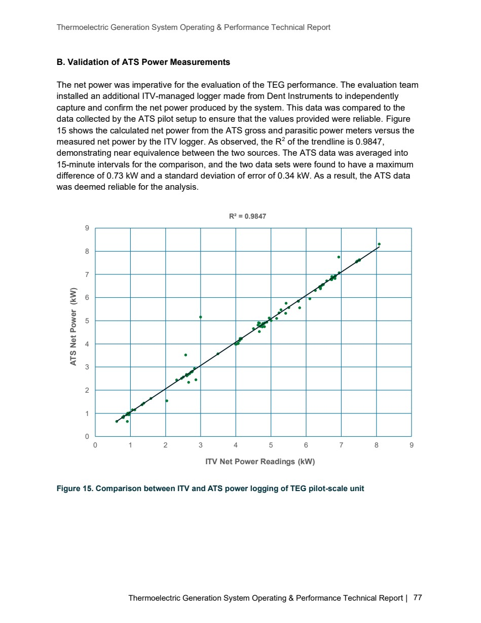

Source PDF page 82 | Holcim Alpena Thermoelectric Generation
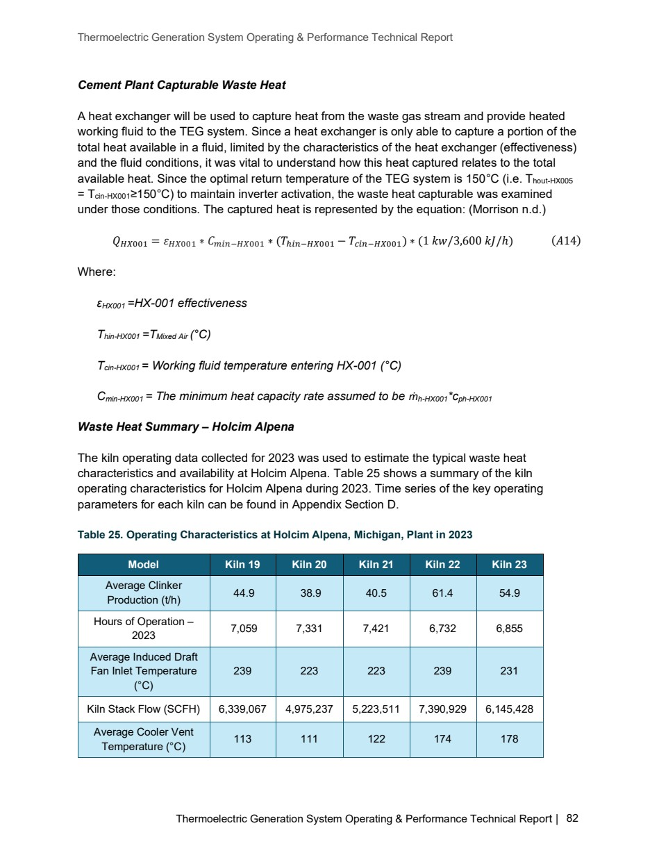

Source PDF page 83 | Holcim Alpena Thermoelectric Generation
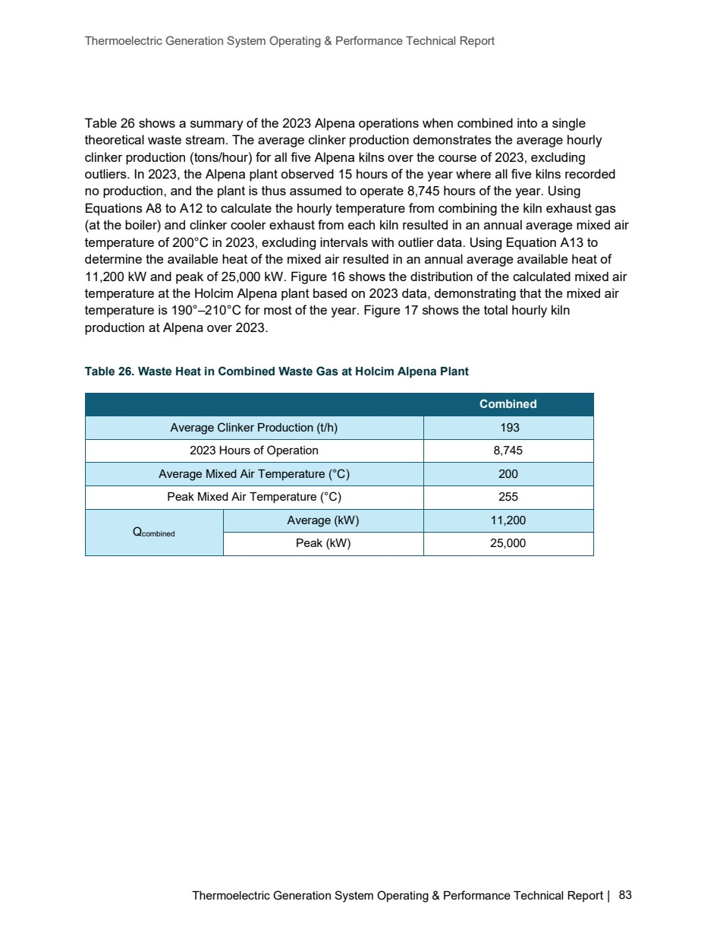

Source PDF page 84 | Holcim Alpena Thermoelectric Generation
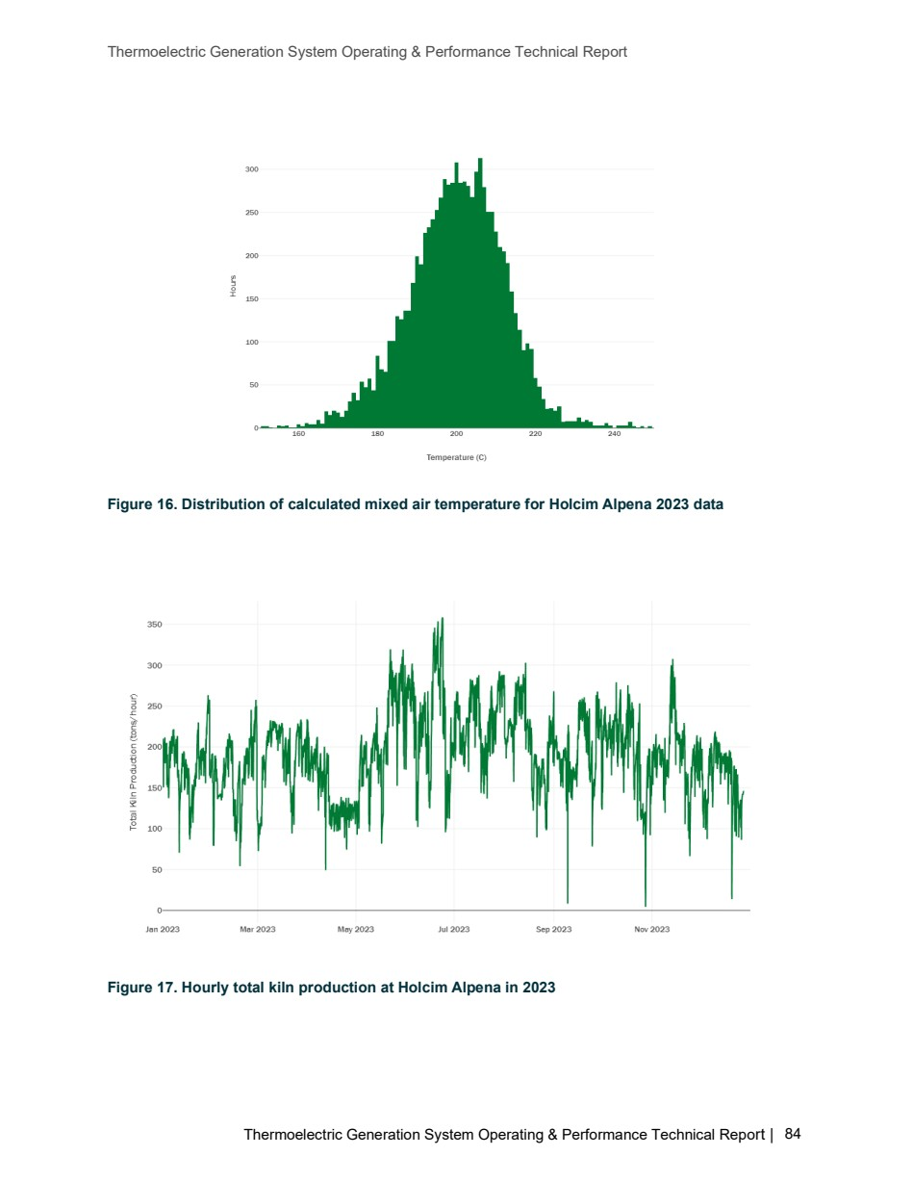

Source PDF page 85 | Holcim Alpena Thermoelectric Generation
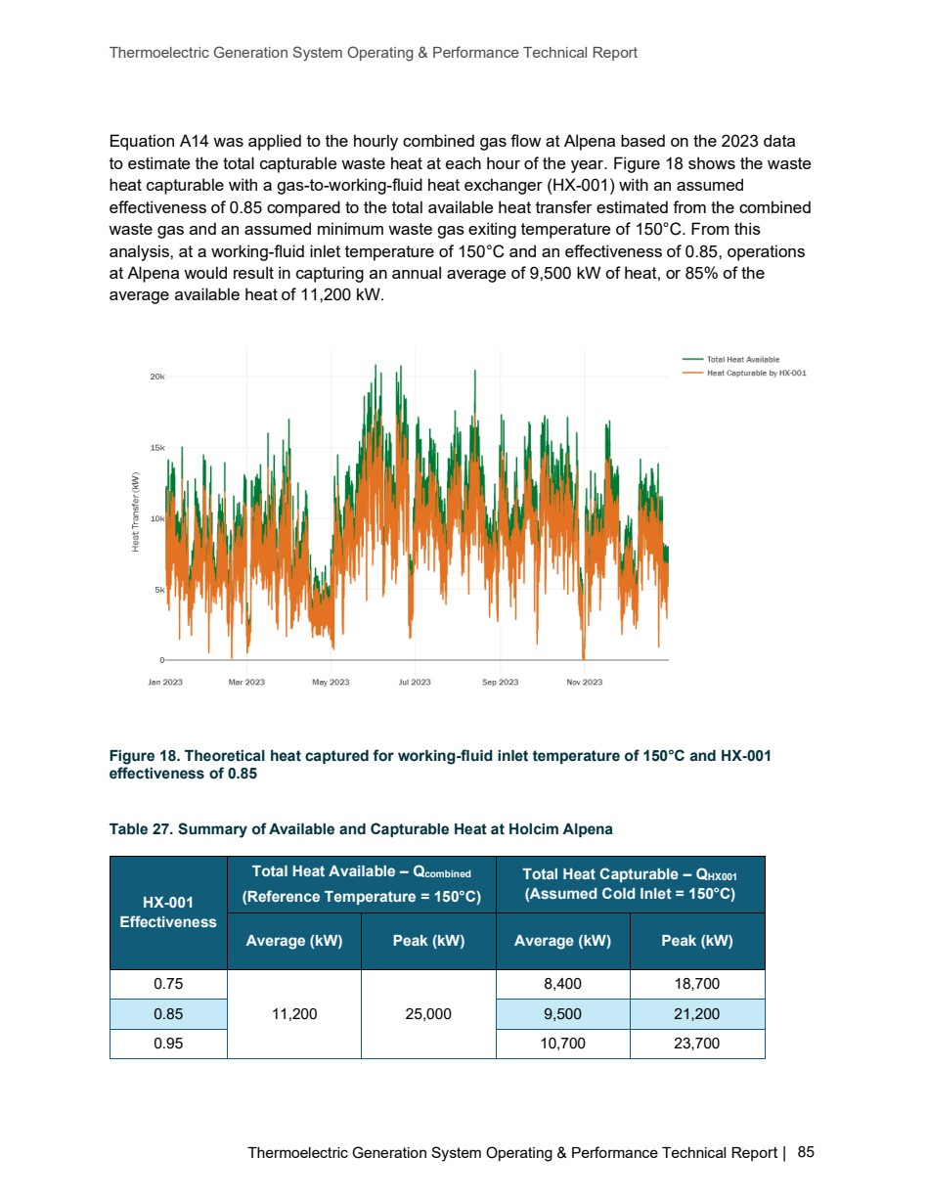

Source PDF page 86 | Holcim Alpena Thermoelectric Generation
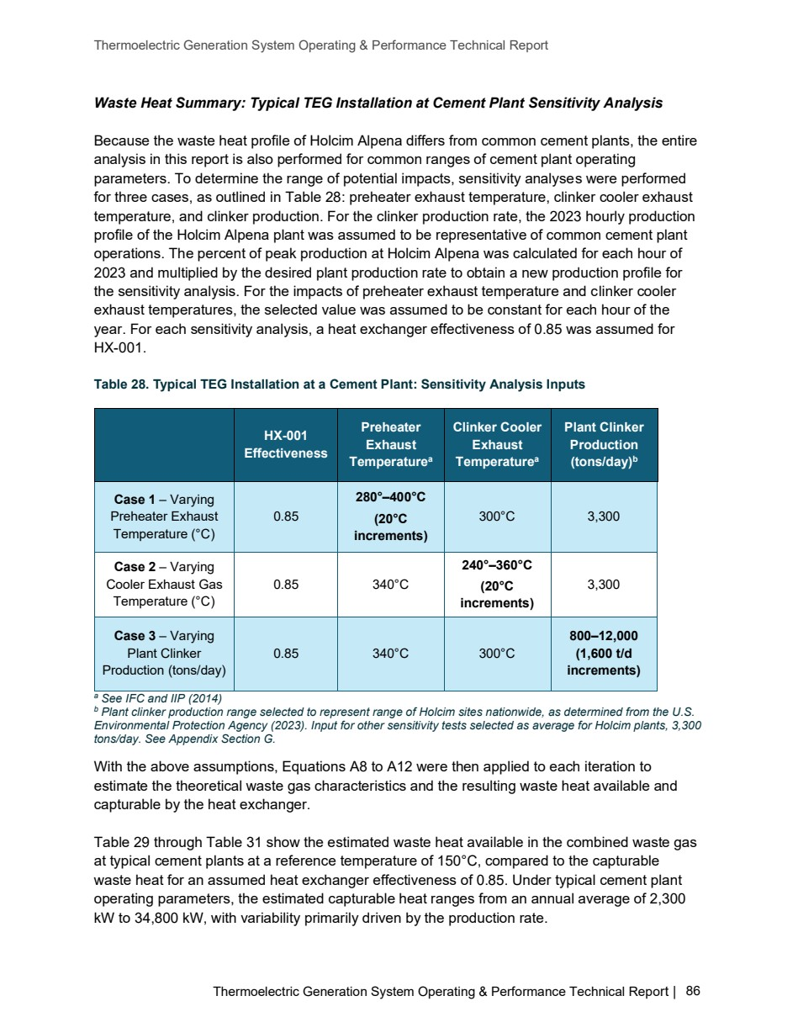

Source PDF page 87 | Holcim Alpena Thermoelectric Generation
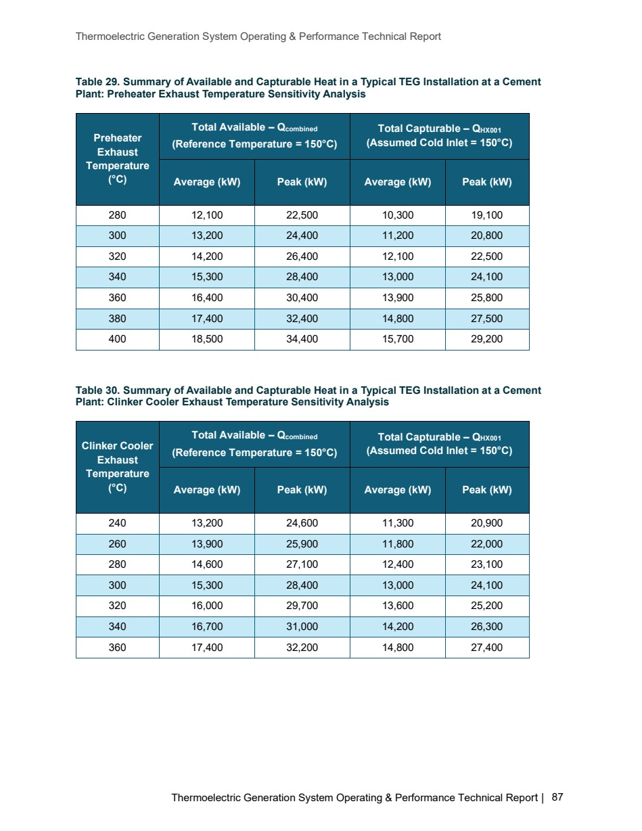

Source PDF page 88 | Holcim Alpena Thermoelectric Generation
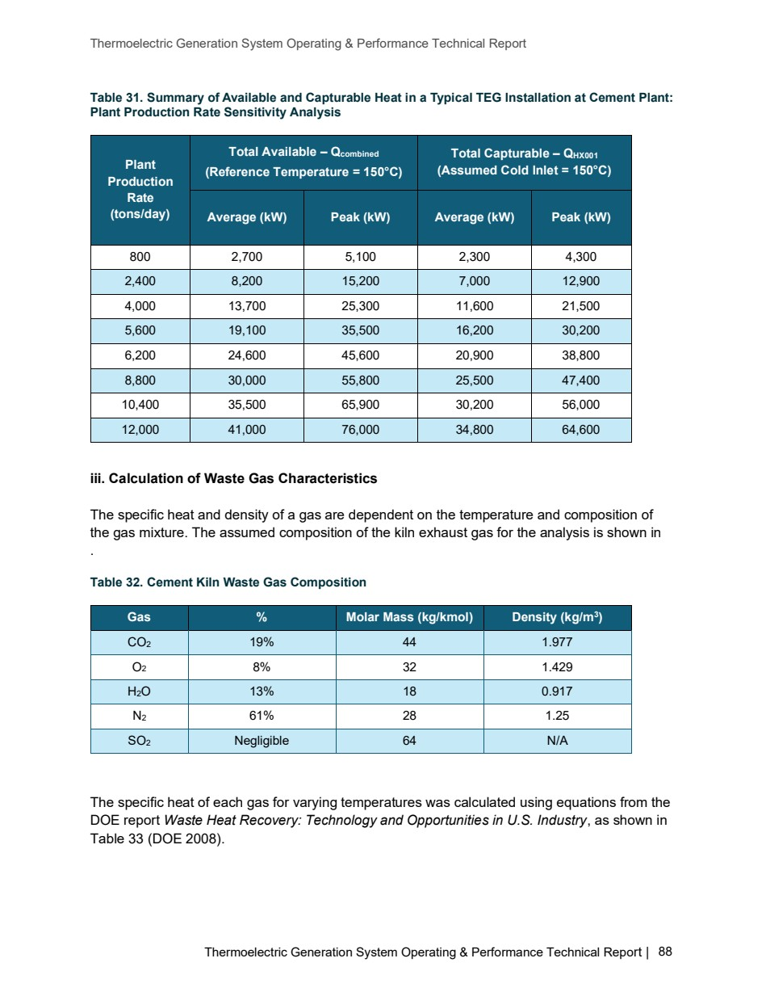

Source PDF page 89 | Holcim Alpena Thermoelectric Generation
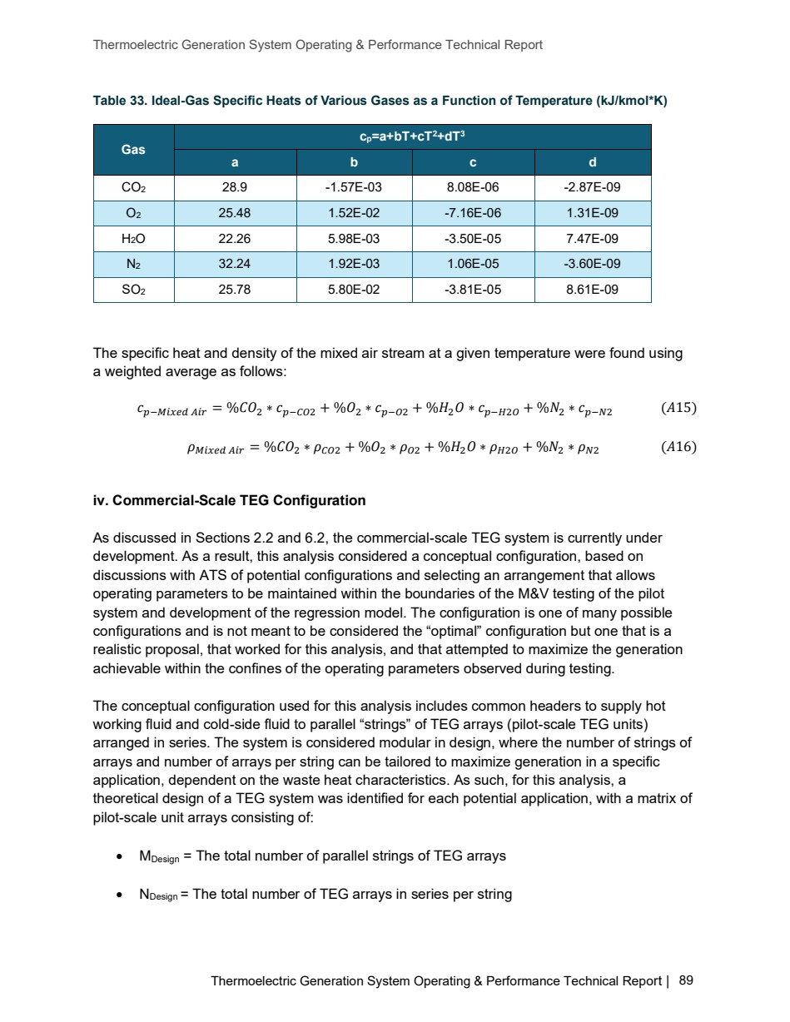

Source PDF page 91 | Holcim Alpena Thermoelectric Generation
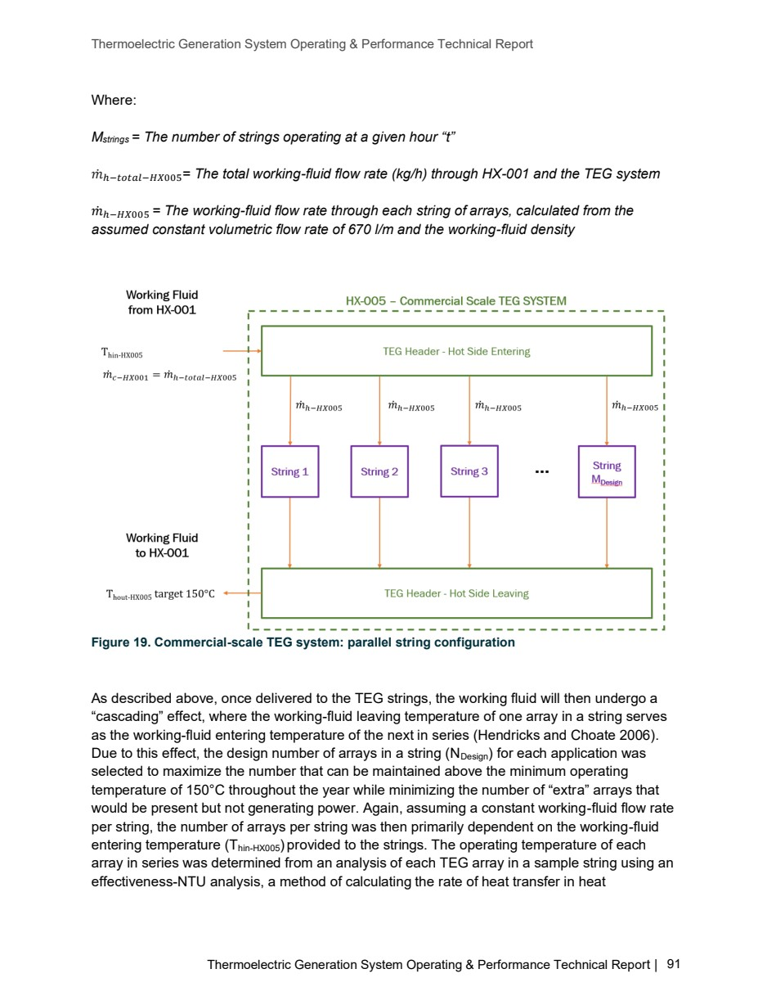

Source PDF page 92 | Holcim Alpena Thermoelectric Generation
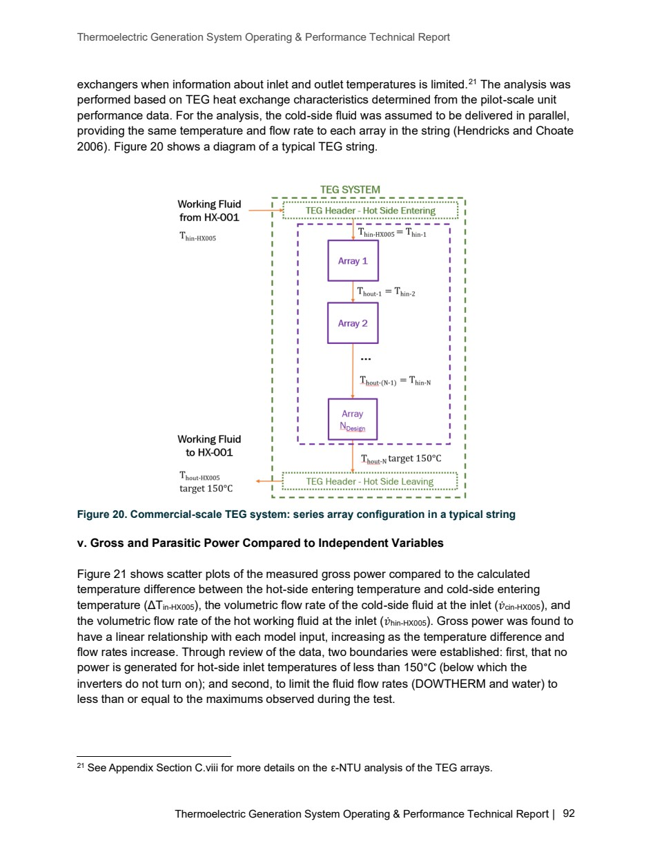

Source PDF page 93 | Holcim Alpena Thermoelectric Generation
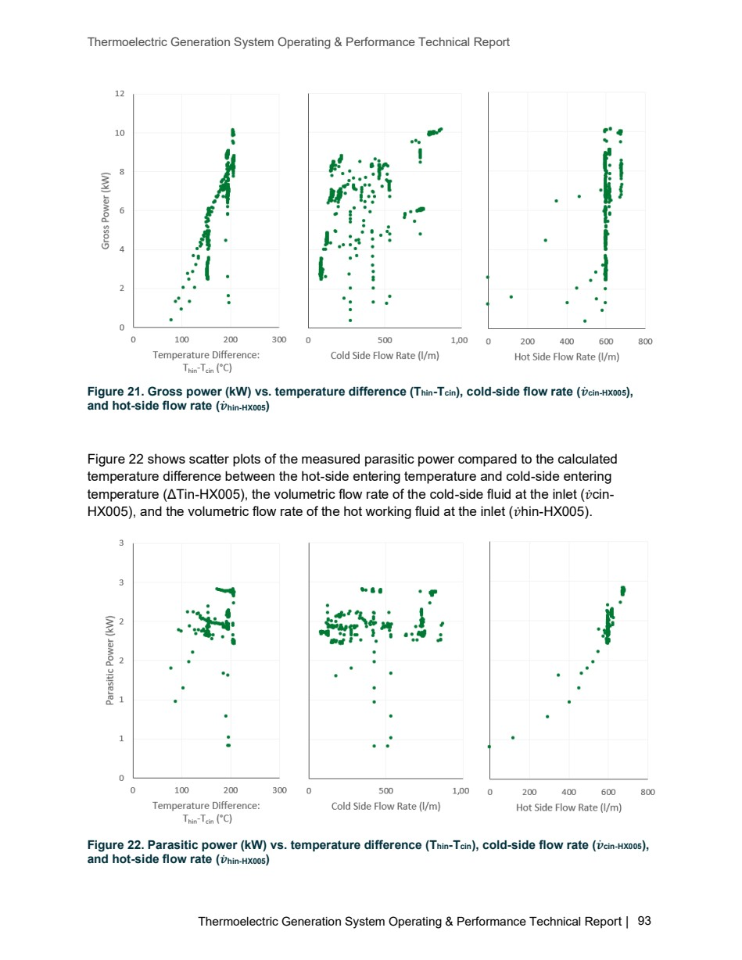

Source PDF page 95 | Holcim Alpena Thermoelectric Generation
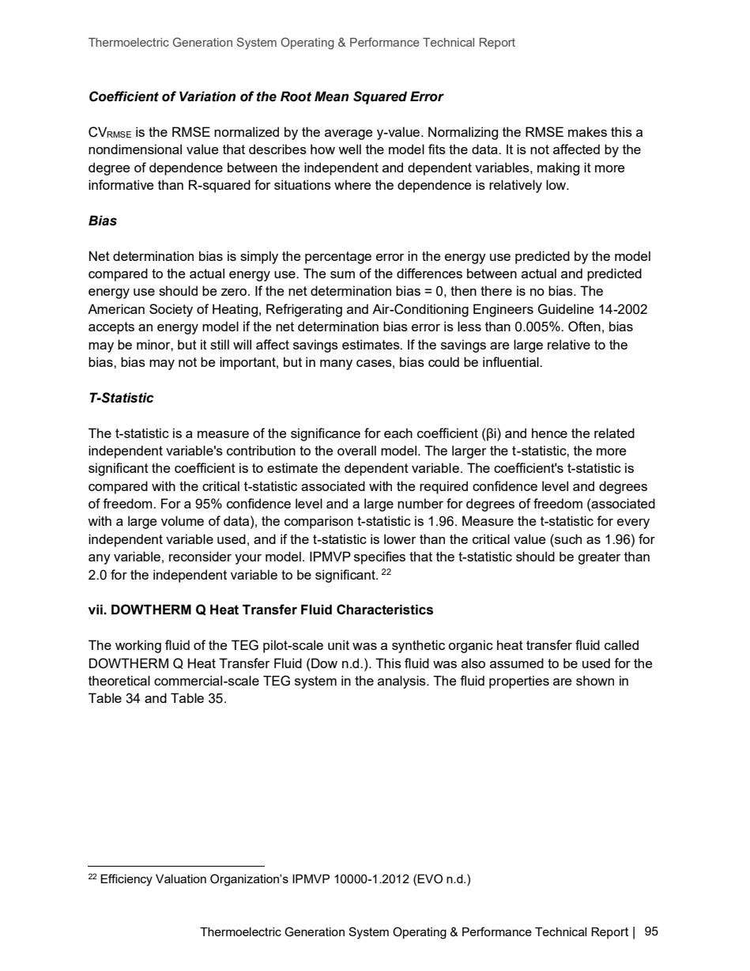

Source PDF page 96 | Holcim Alpena Thermoelectric Generation
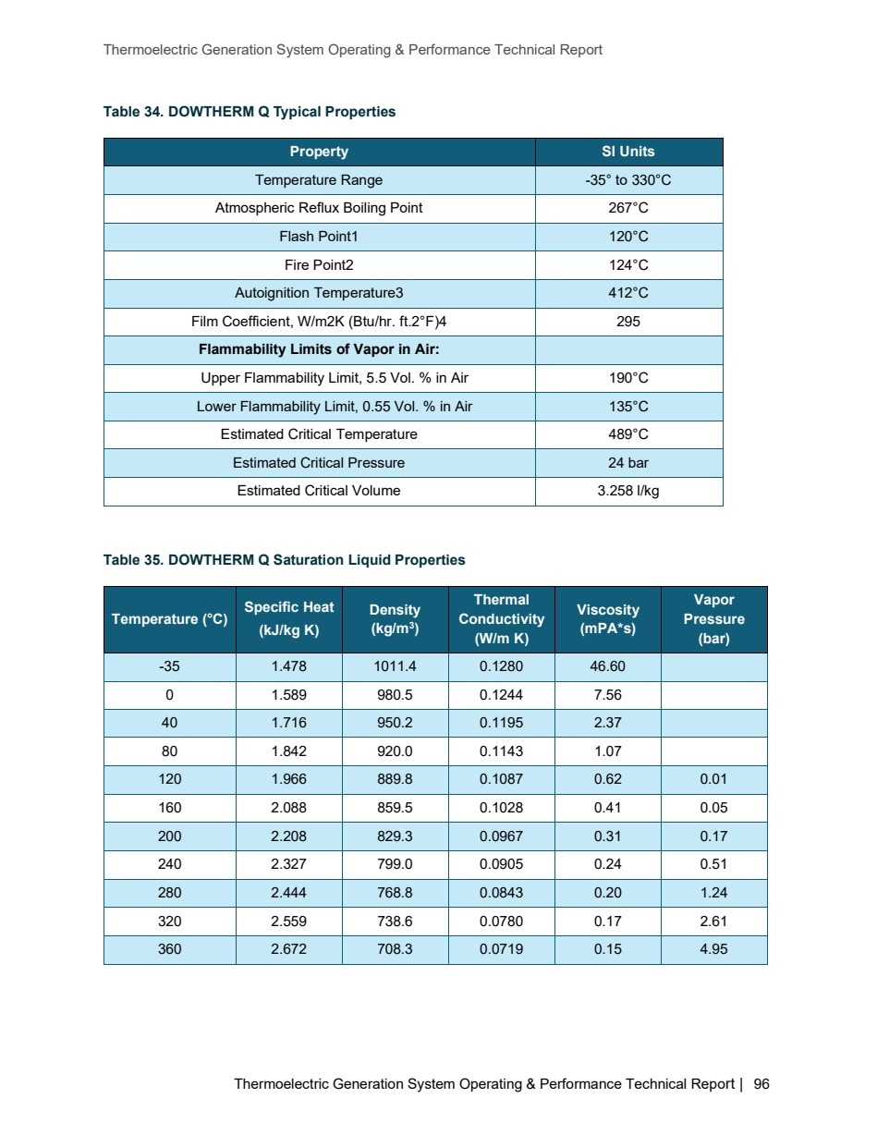

Source PDF page 97 | Holcim Alpena Thermoelectric Generation
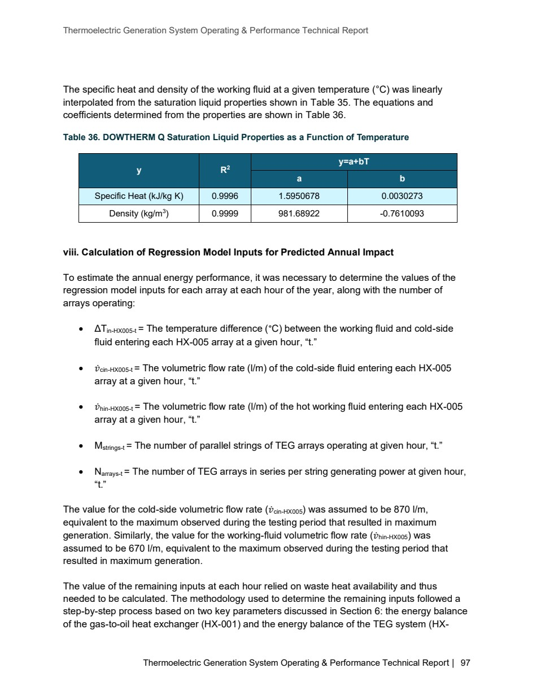

Source PDF page 100 | Holcim Alpena Thermoelectric Generation
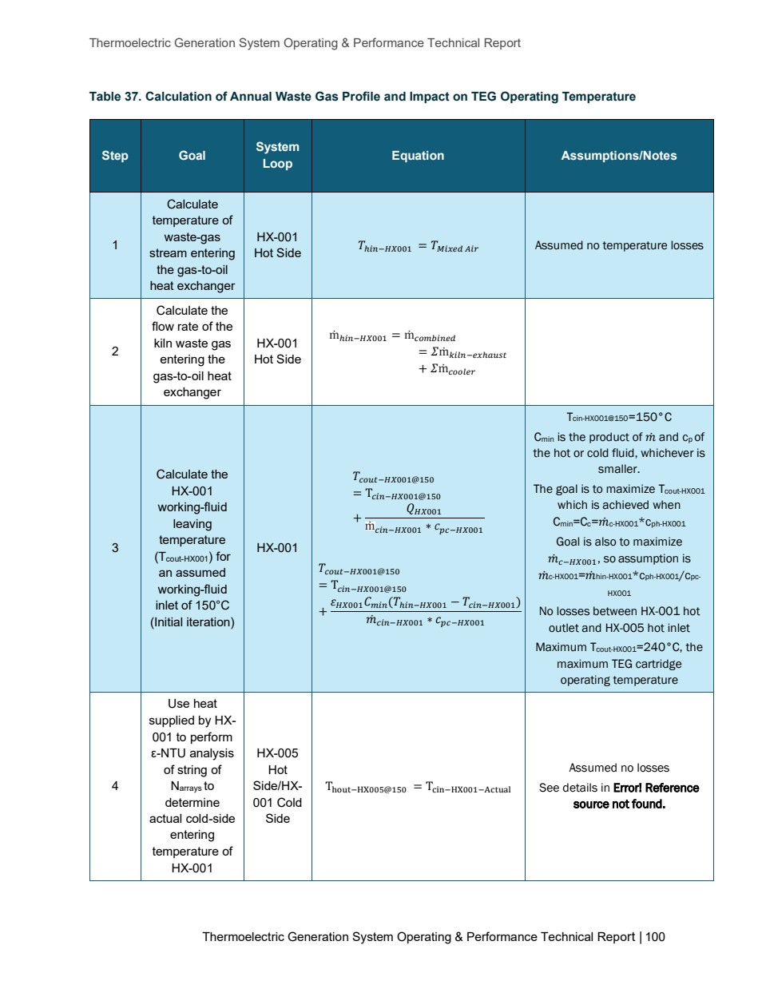

Source PDF page 102 | Holcim Alpena Thermoelectric Generation
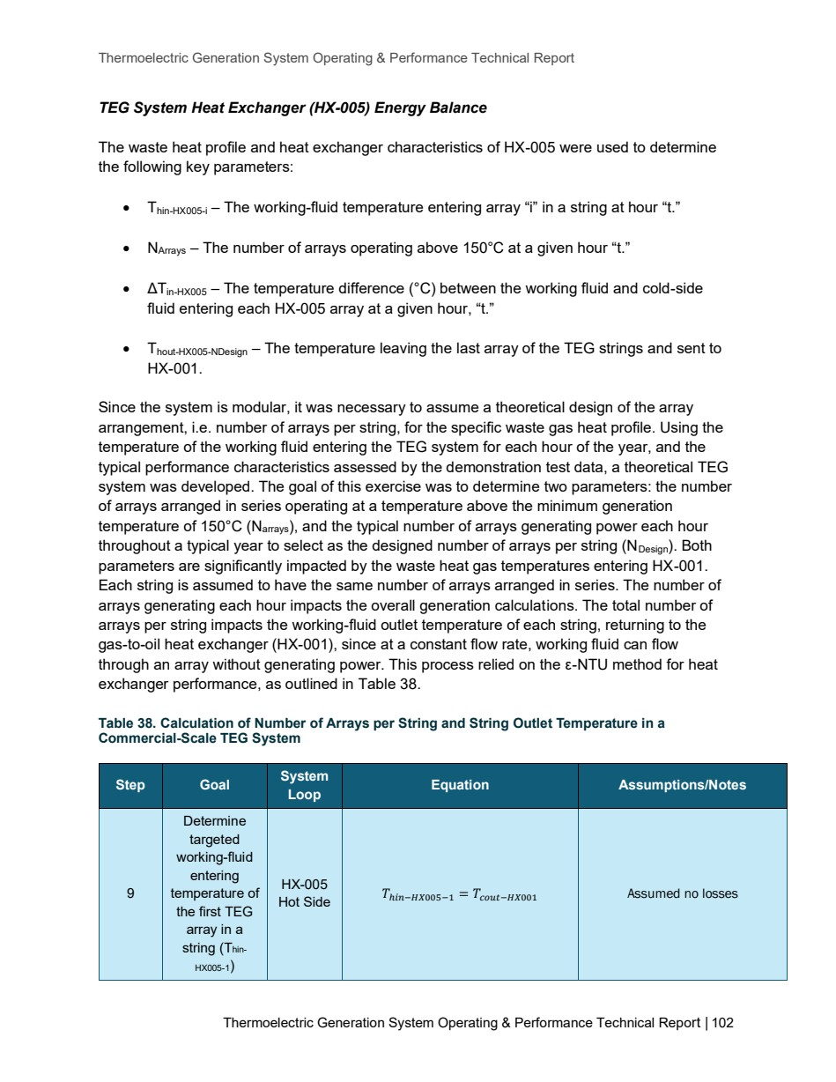

Source PDF page 105 | Holcim Alpena Thermoelectric Generation
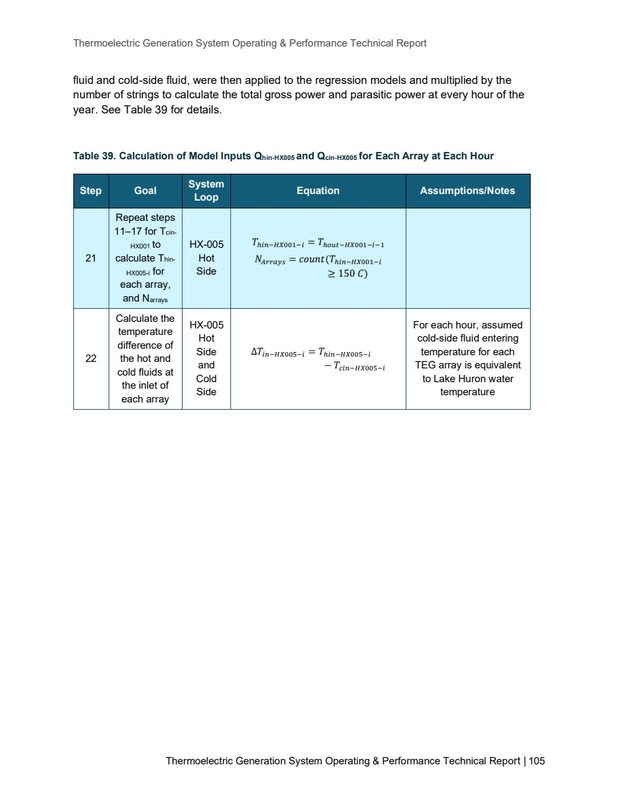

Source PDF page 107 | Holcim Alpena Thermoelectric Generation
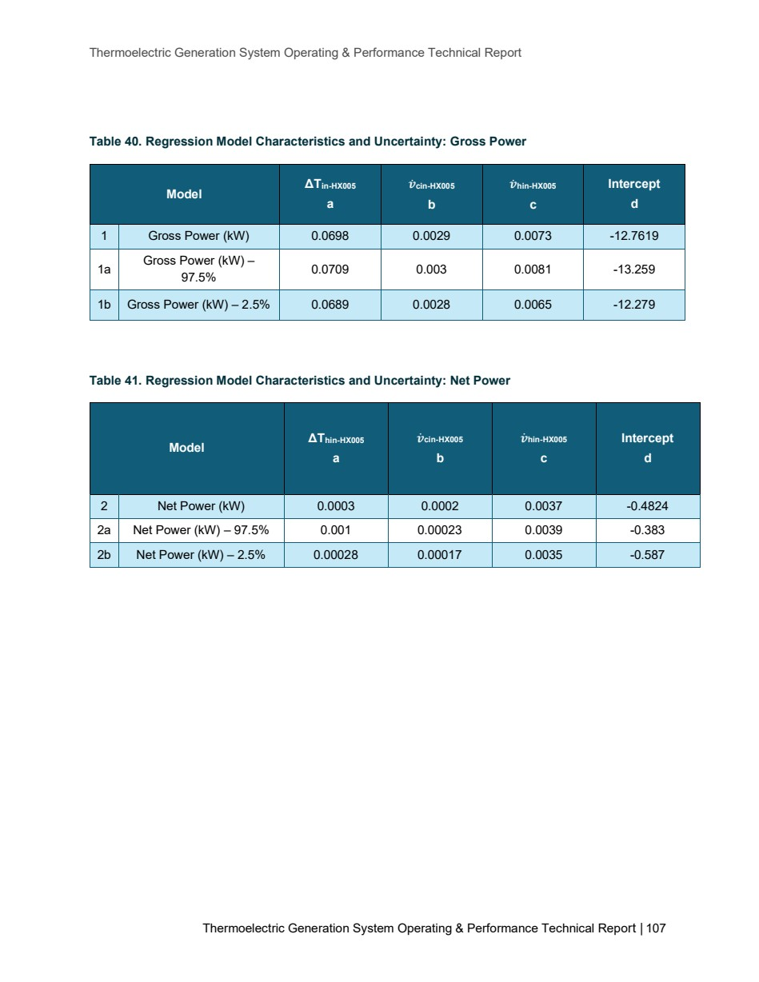

Source PDF page 108 | Holcim Alpena Thermoelectric Generation
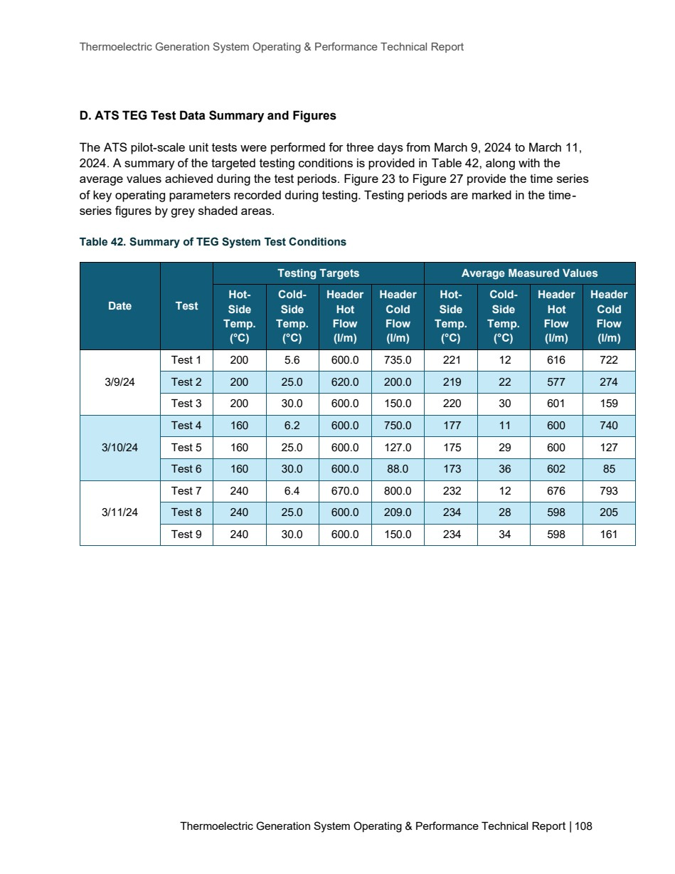

Source PDF page 109 | Holcim Alpena Thermoelectric Generation
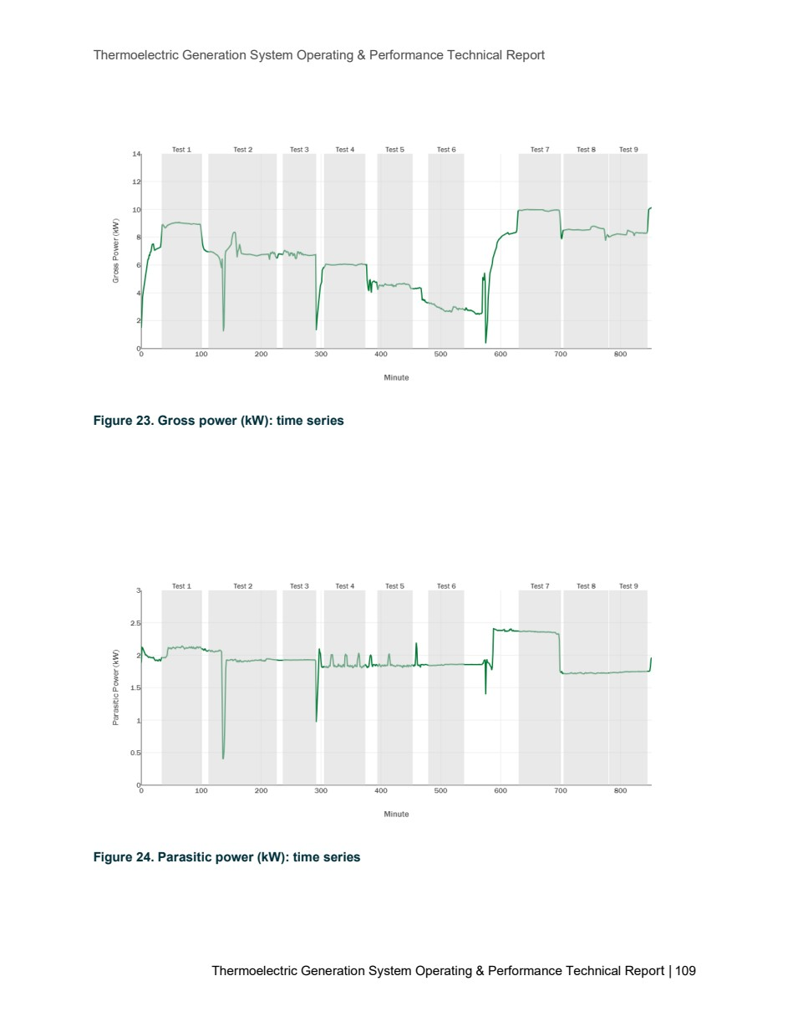

Source PDF page 110 | Holcim Alpena Thermoelectric Generation
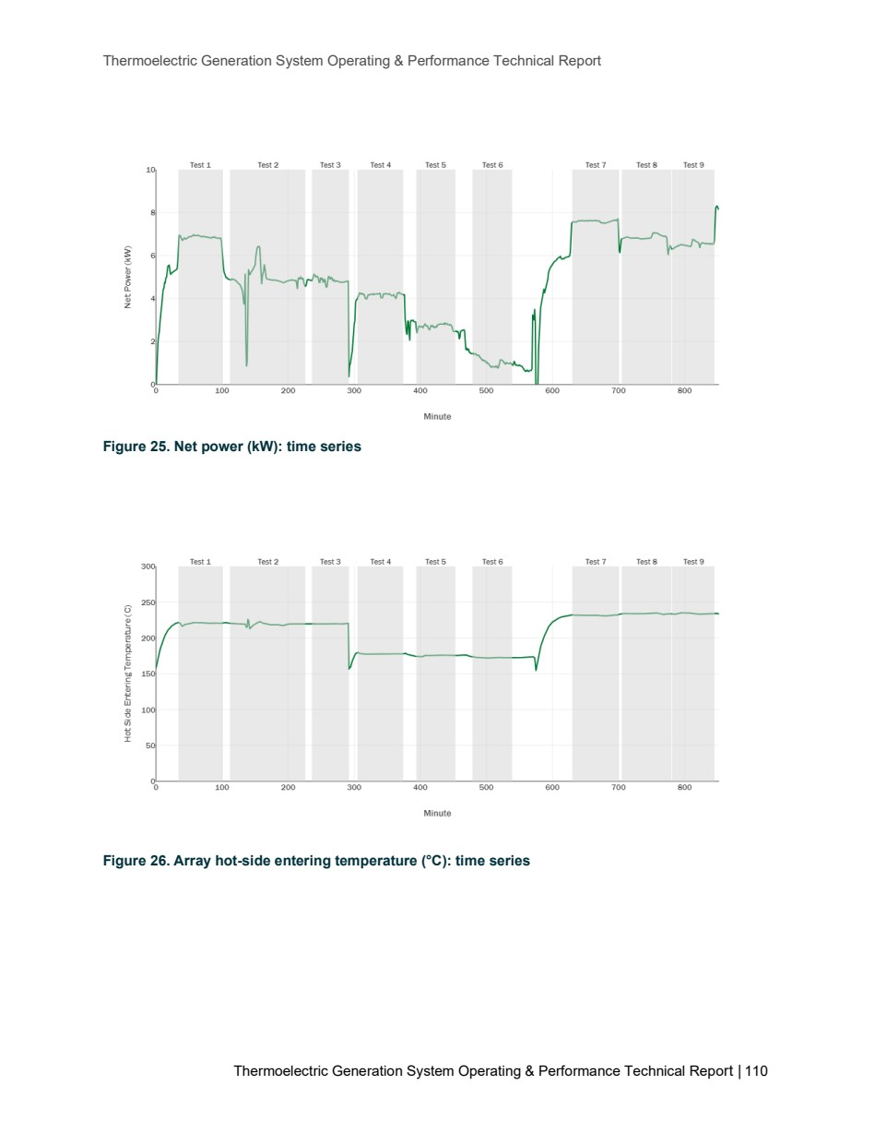

Source PDF page 111 | Holcim Alpena Thermoelectric Generation
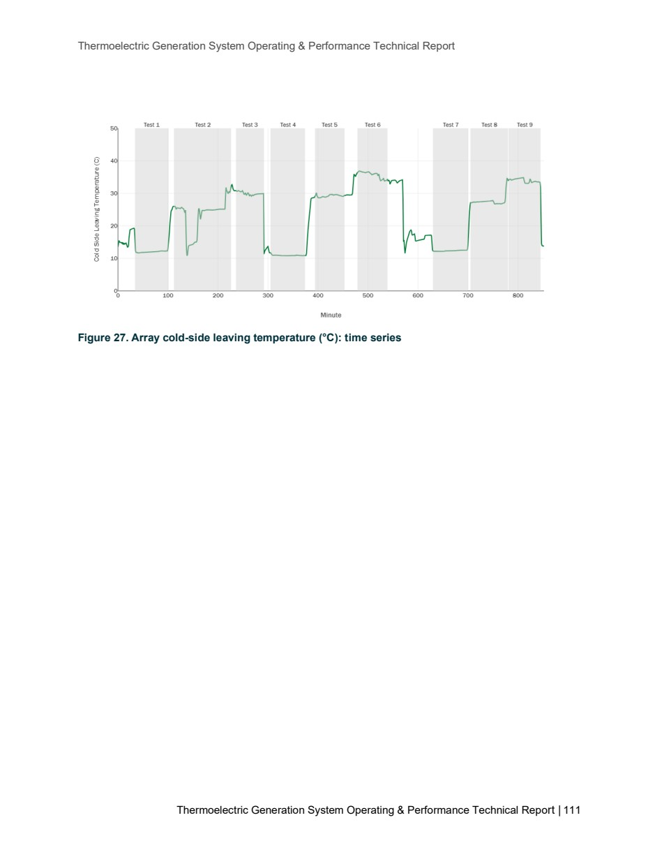

Source PDF page 112 | Holcim Alpena Thermoelectric Generation
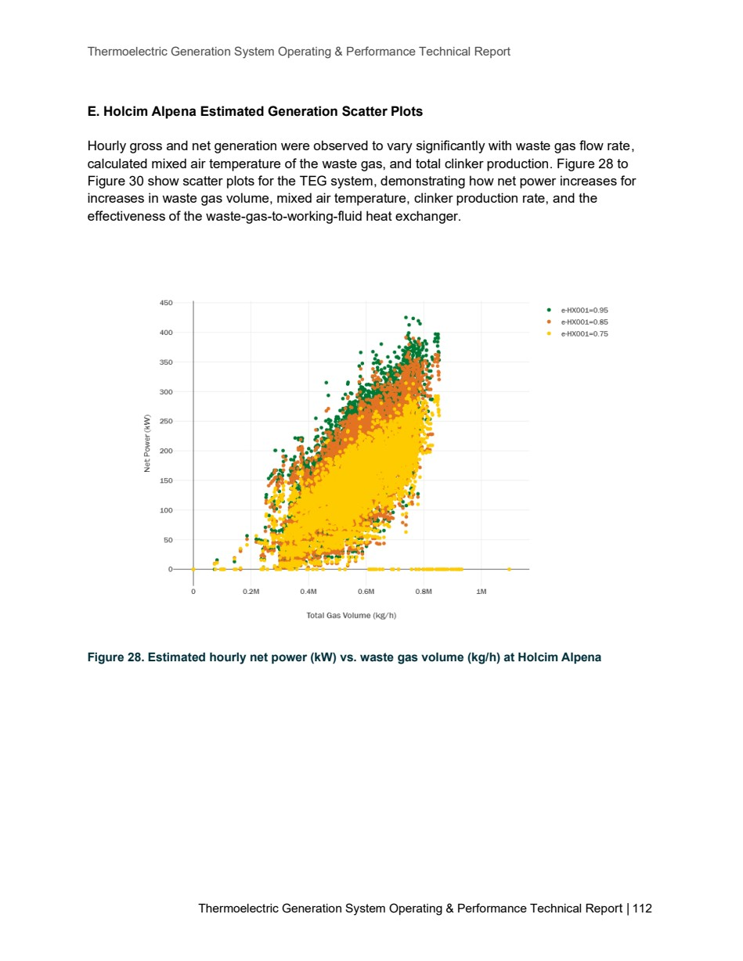

Source PDF page 113 | Holcim Alpena Thermoelectric Generation
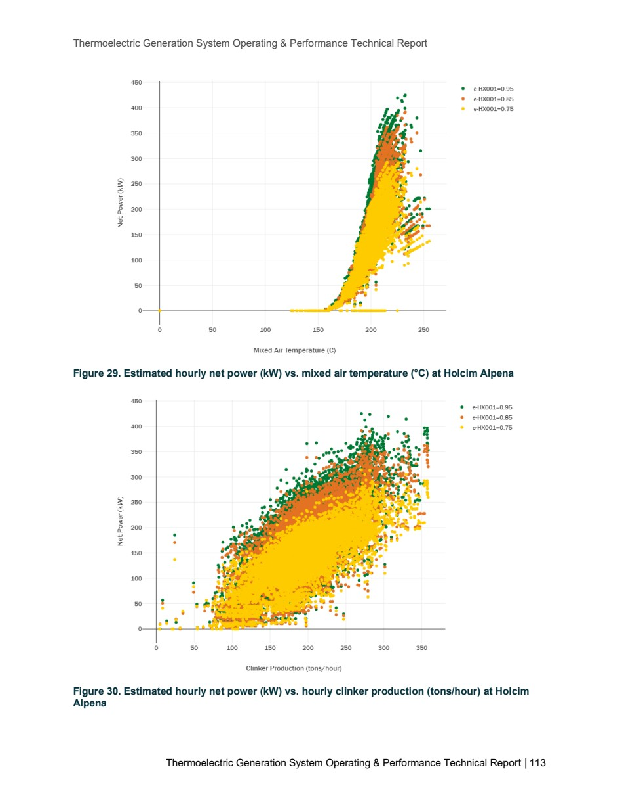

Source PDF page 114 | Holcim Alpena Thermoelectric Generation
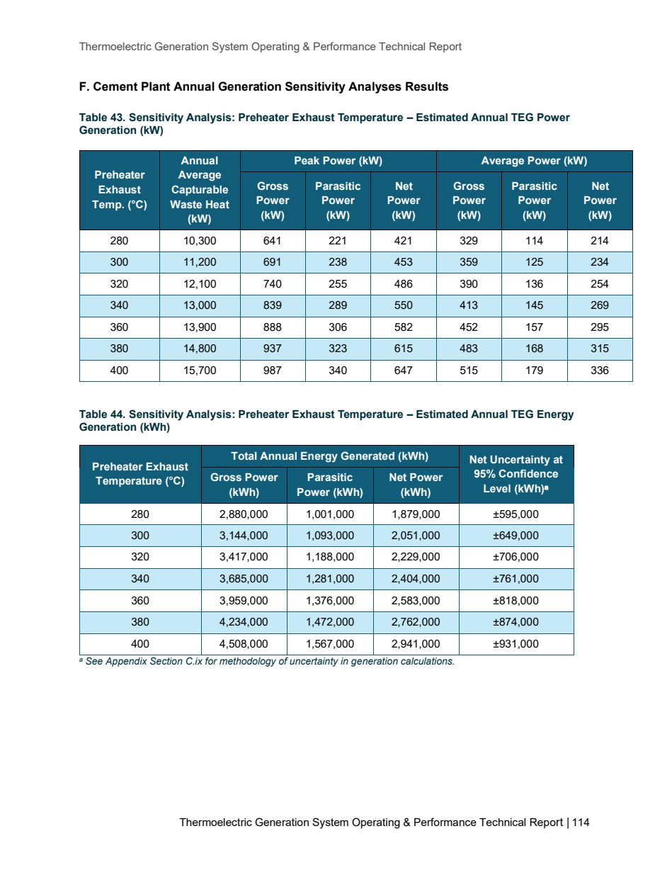

Source PDF page 115 | Holcim Alpena Thermoelectric Generation
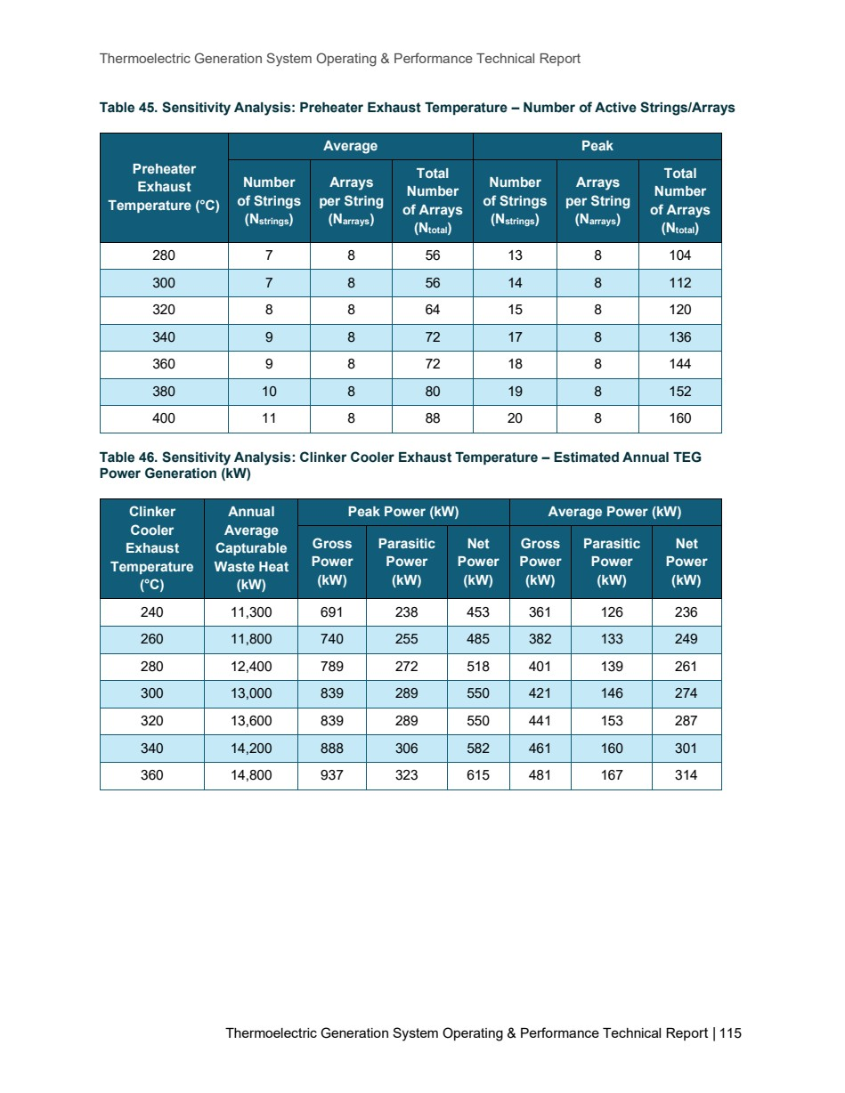

Source PDF page 116 | Holcim Alpena Thermoelectric Generation
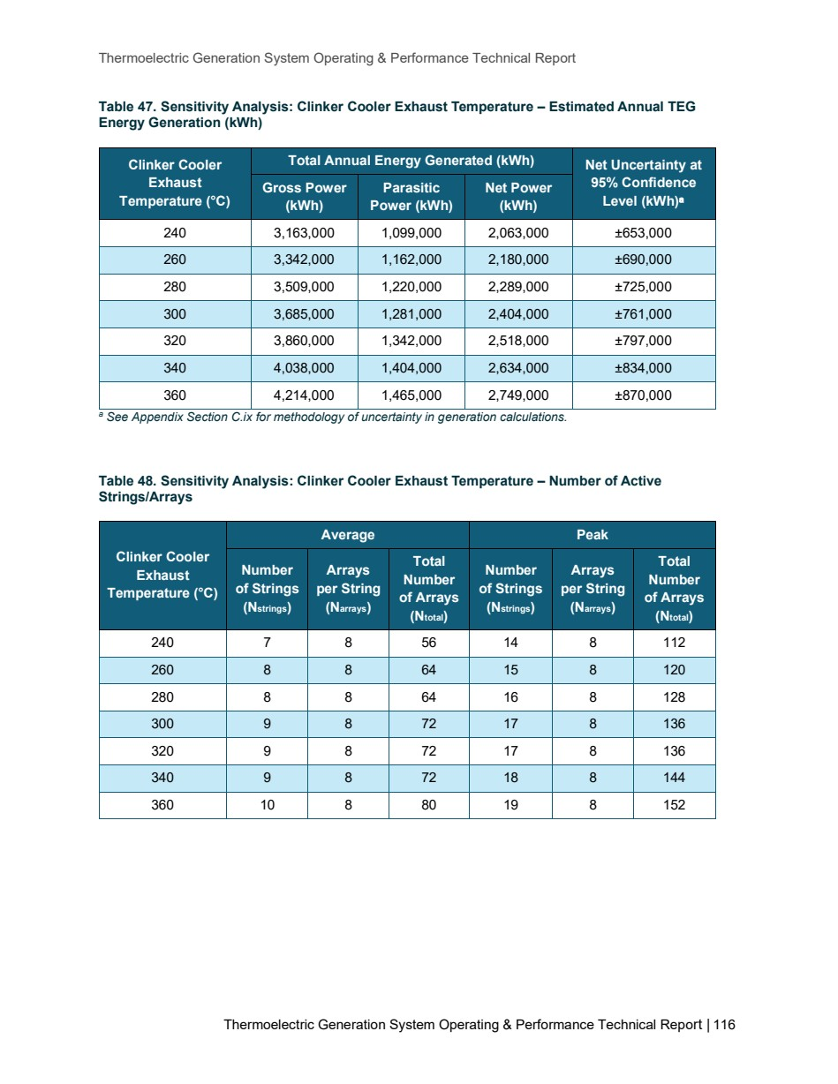

Source PDF page 117 | Holcim Alpena Thermoelectric Generation
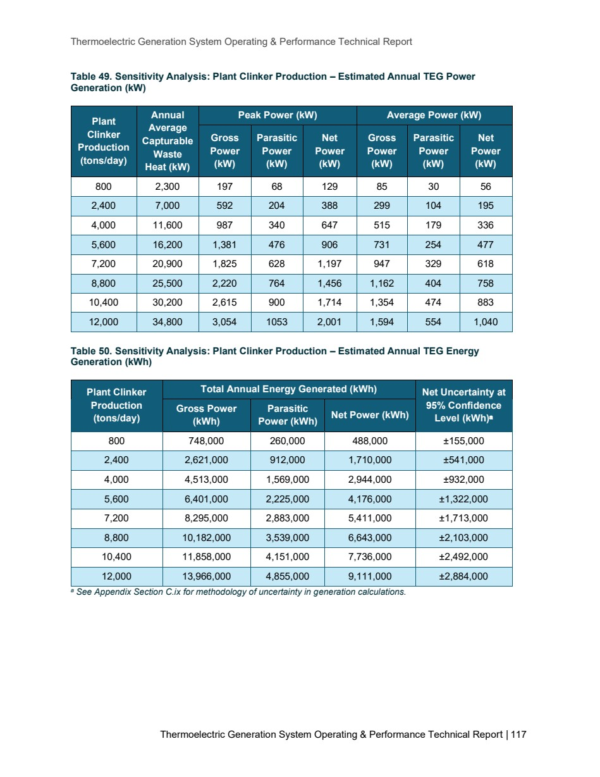

Source PDF page 118 | Holcim Alpena Thermoelectric Generation
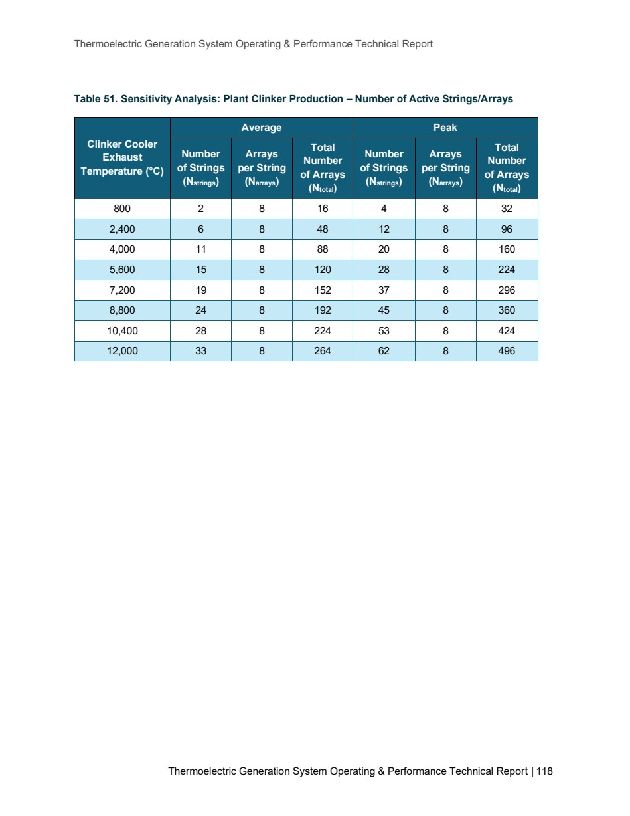

Source PDF page 120 | Holcim Alpena Thermoelectric Generation
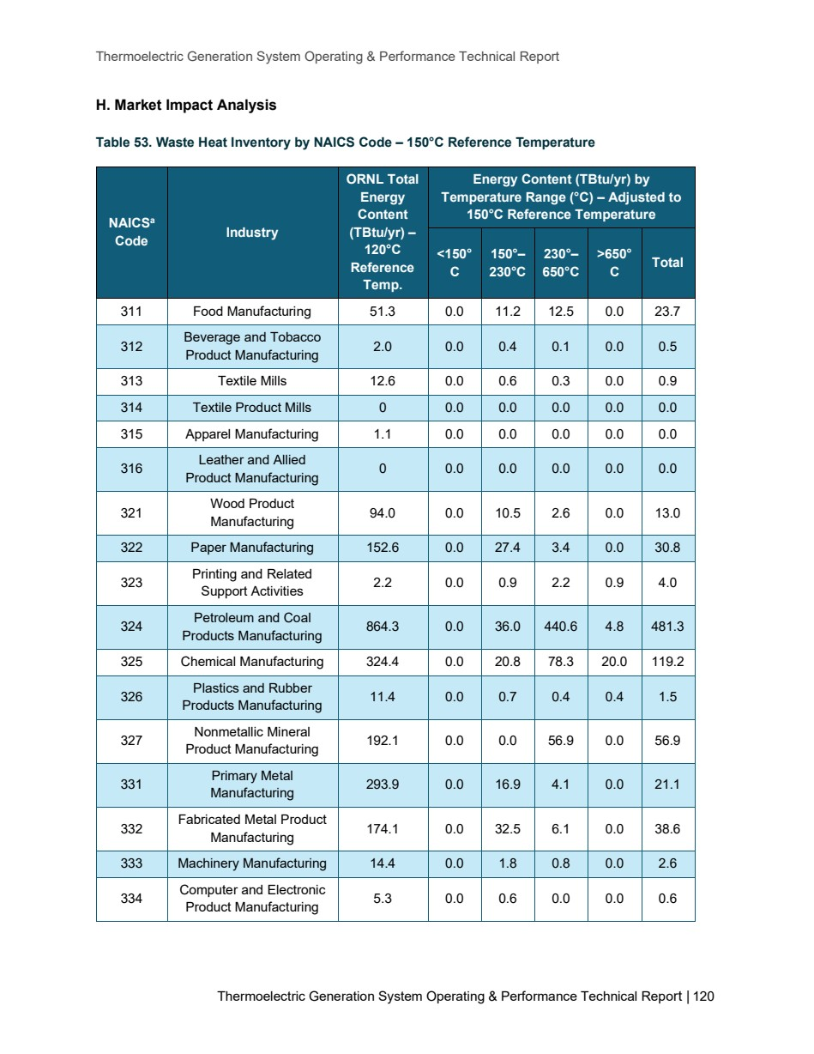

Source PDF page 121 | Holcim Alpena Thermoelectric Generation
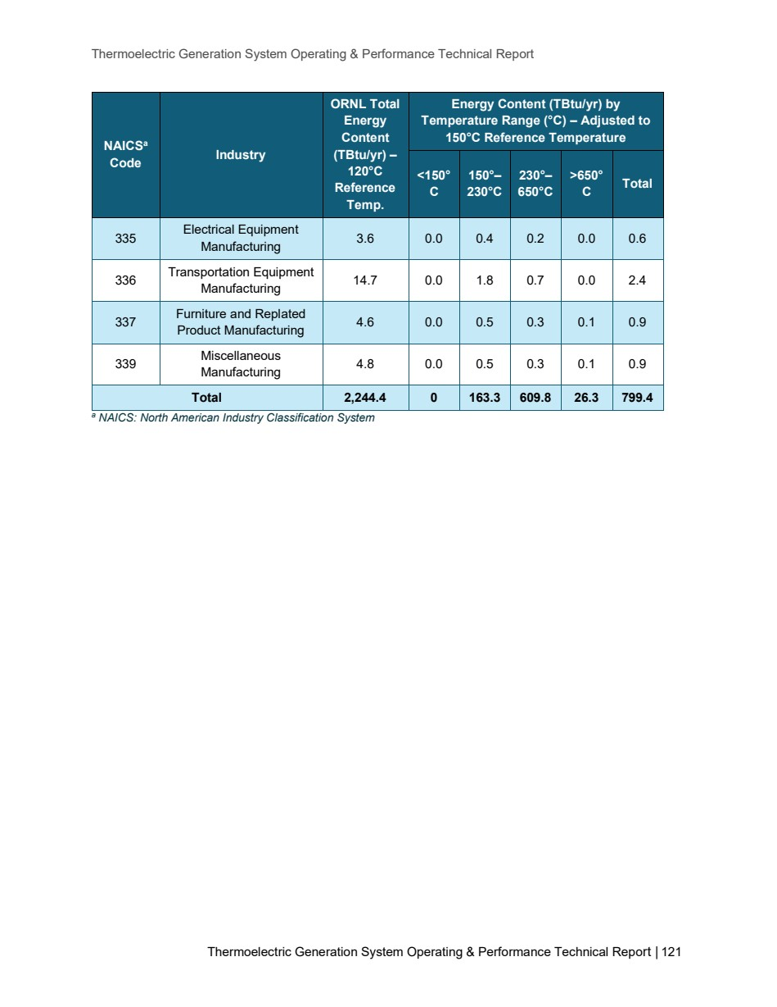

Source PDF page 122 | Holcim Alpena Thermoelectric Generation


