INDUSTRIAL TECHNOLOGY VALIDATION

Nissan ElectroCell Supplemental Technical Annex
  - Supporting source exhibits omitted from the restructured technical report
Companion report: Nissan_ElectroCell_Technical_Report.docx
Primary source PDF: iedo-itv-nissan-electrocell .pdf
Project report title: Electrochemical Water Filtration at Nissan Canton

Purpose and Use
This annex preserves detailed evidence from the source PDF that is not reproduced in full in the restructured project report. It is intended as a companion for audit and technical review; the completed report remains the primary reading document for conclusions and interpretation.

Project Summary from the Completed Report
The Industrial Technology Validation (ITV) evaluation compared an ElectroCell EC-6000 electrochemical treatment system with Nissan Canton’s incumbent cooling-tower filtration arrangement over two successive one-year periods. Filtration electricity fell substantially, while modeled chiller and cooling-tower energy showed no measurable improvement. The analysis estimated lower makeup water and chemical costs, but these outcomes must be read in light of a nonstandard baseline and changes to water and chemical controls.

Source Pages Included
The selected pages reproduce source technical material, including instrumentation/data coverage, operating conditions, equations and model diagnostics, uncertainty and detailed result exhibits, equipment information, figures, and scale-up or market analysis where present. Each page is reproduced directly from the original PDF. Original page headers, captions, tables, and printed page numbers remain visible; “PDF page” labels refer to the file page index.
Included source PDF pages: 17-18, 22-23, 25-28, 30, 32-41, 43-46, 48, 52-57.
These are facsimile reproductions, not a new analysis. Values, chart scales, and qualifications are as presented in the source. Refer to the completed report for the summarized findings and project-specific interpretation.

Source PDF page 17 | Nissan ElectroCell
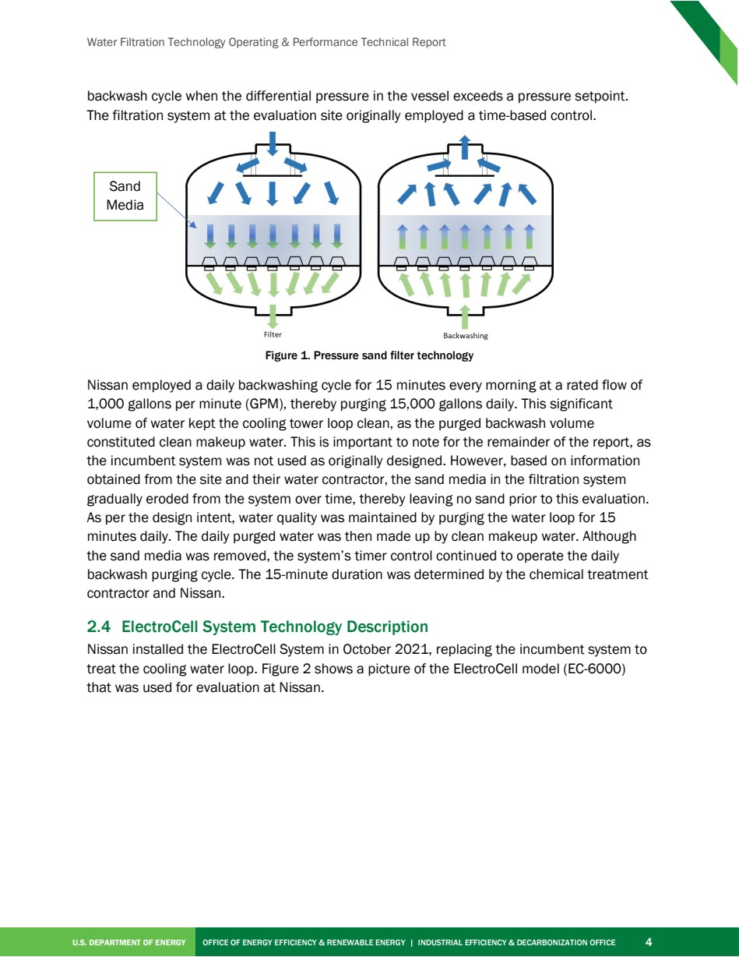

Source PDF page 18 | Nissan ElectroCell
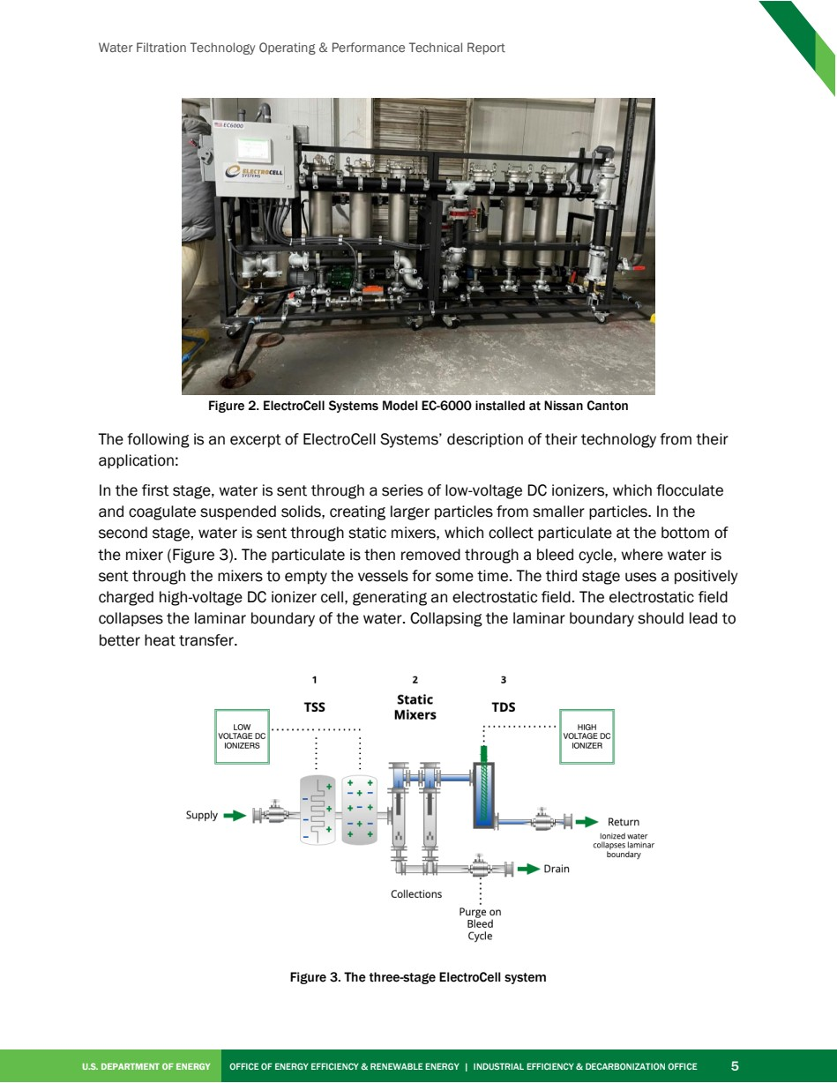

Source PDF page 22 | Nissan ElectroCell
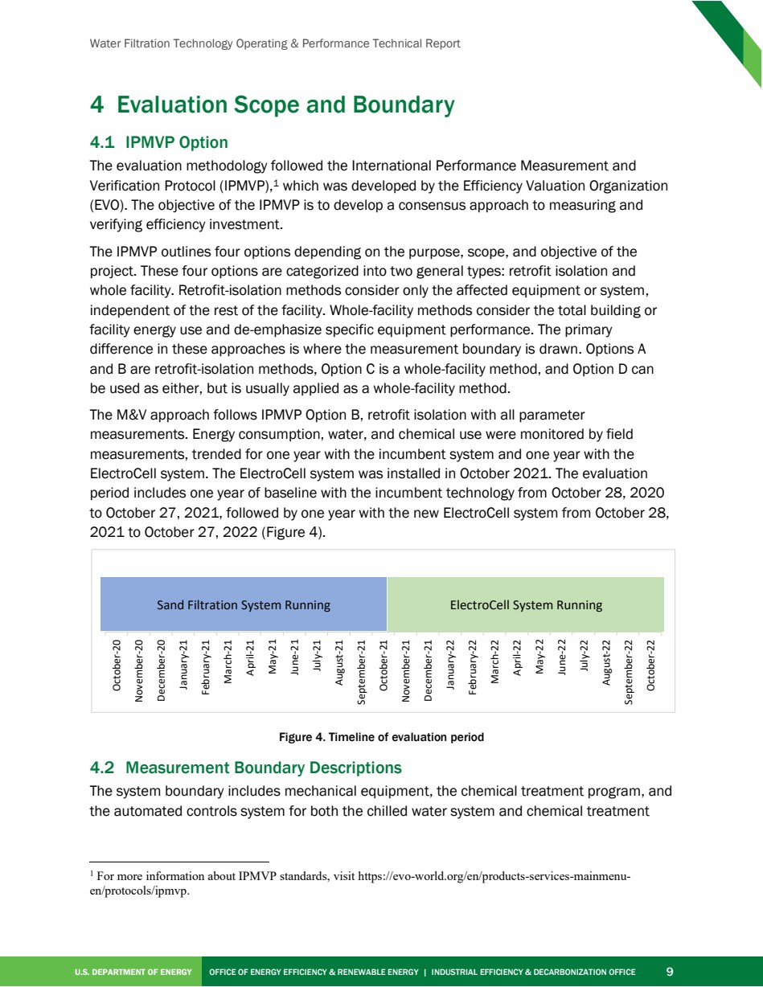

Source PDF page 23 | Nissan ElectroCell
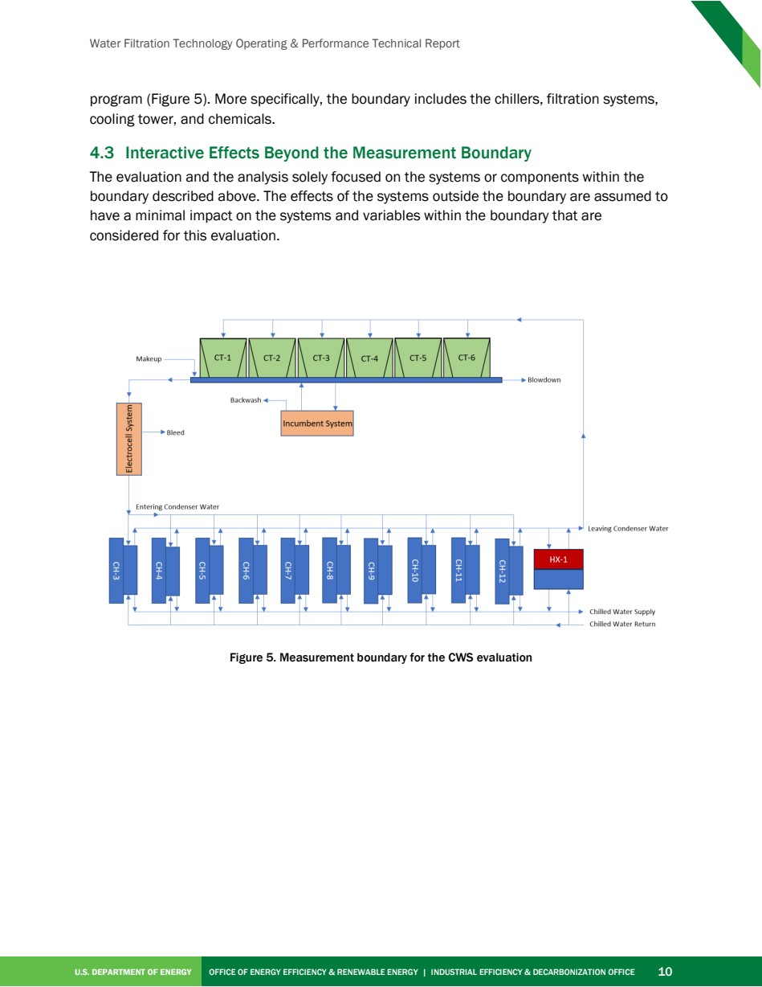

Source PDF page 25 | Nissan ElectroCell
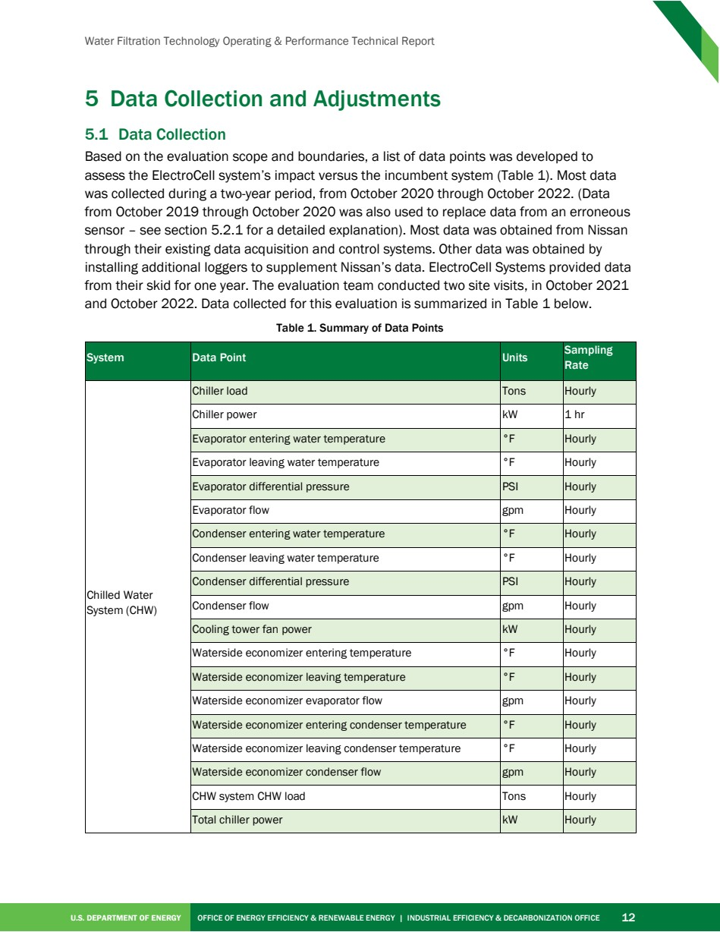

Source PDF page 26 | Nissan ElectroCell
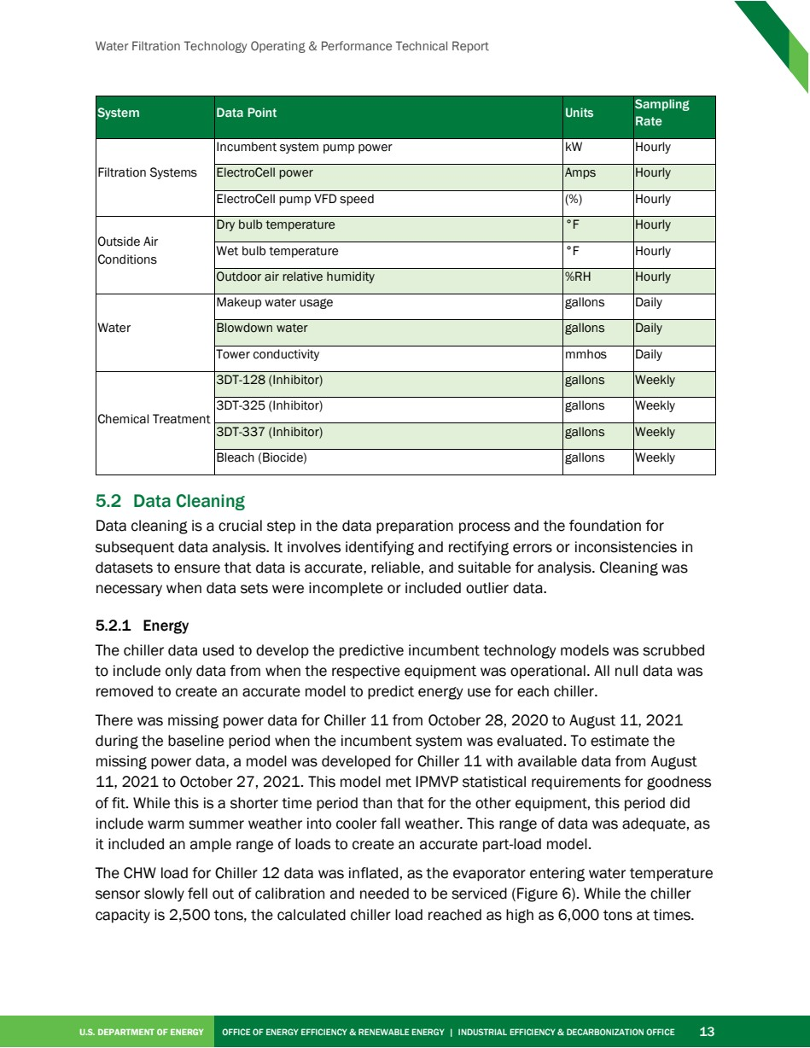

Source PDF page 27 | Nissan ElectroCell
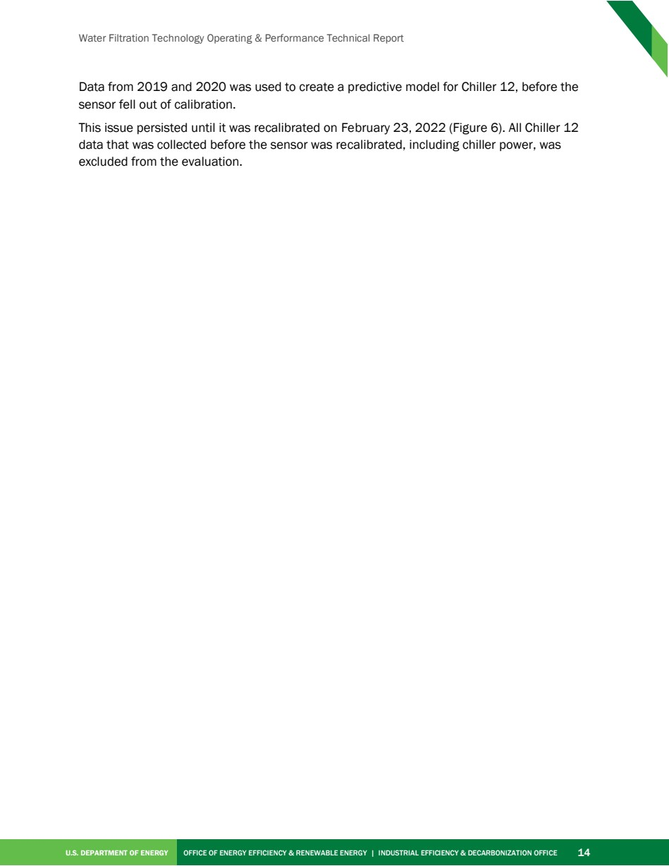

Source PDF page 28 | Nissan ElectroCell
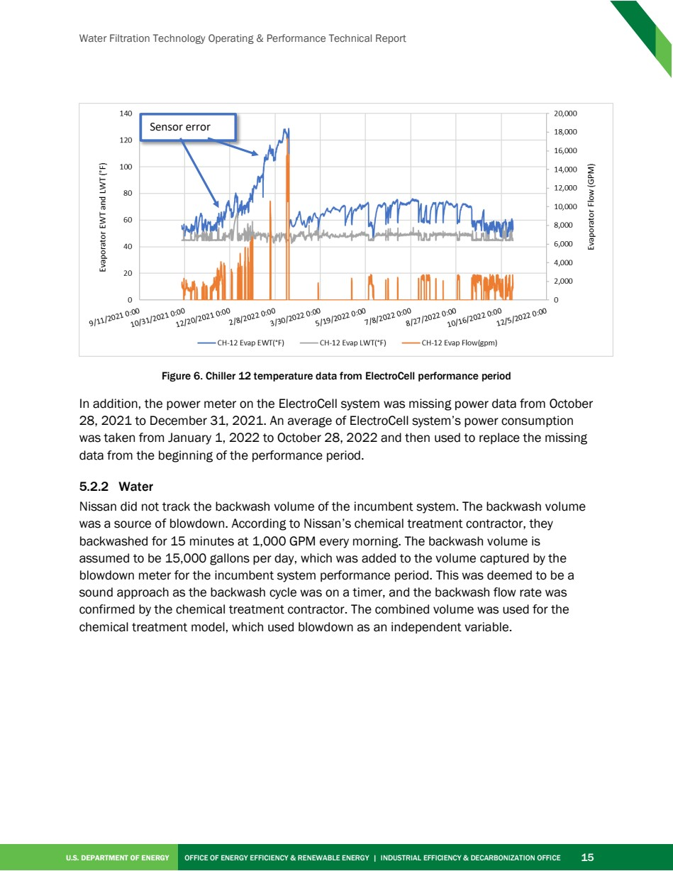

Source PDF page 30 | Nissan ElectroCell
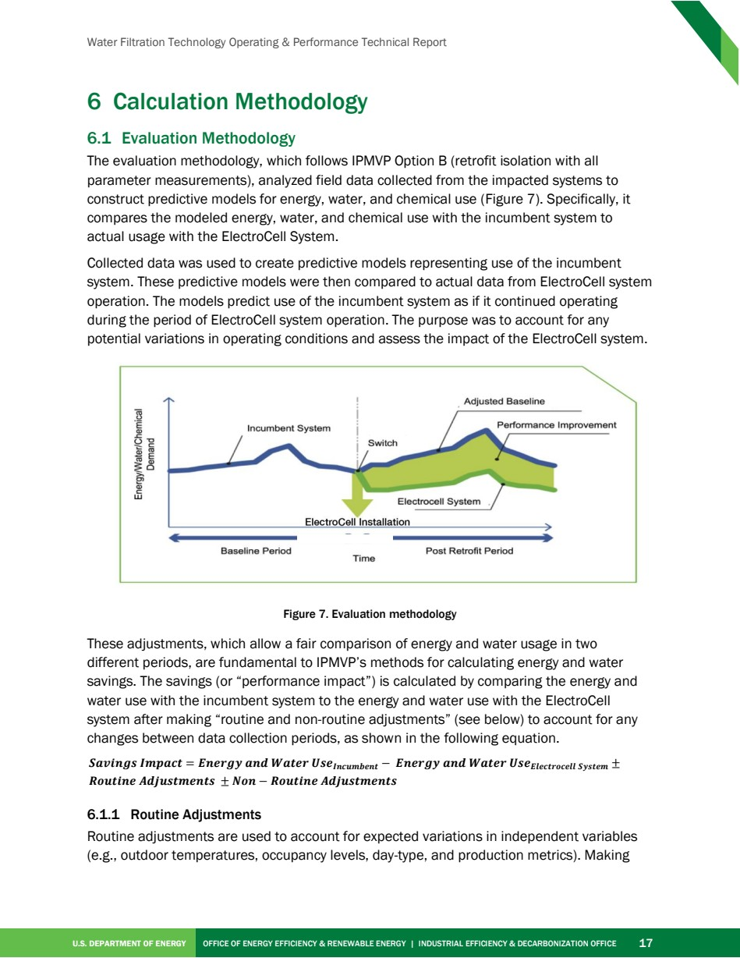

Source PDF page 32 | Nissan ElectroCell
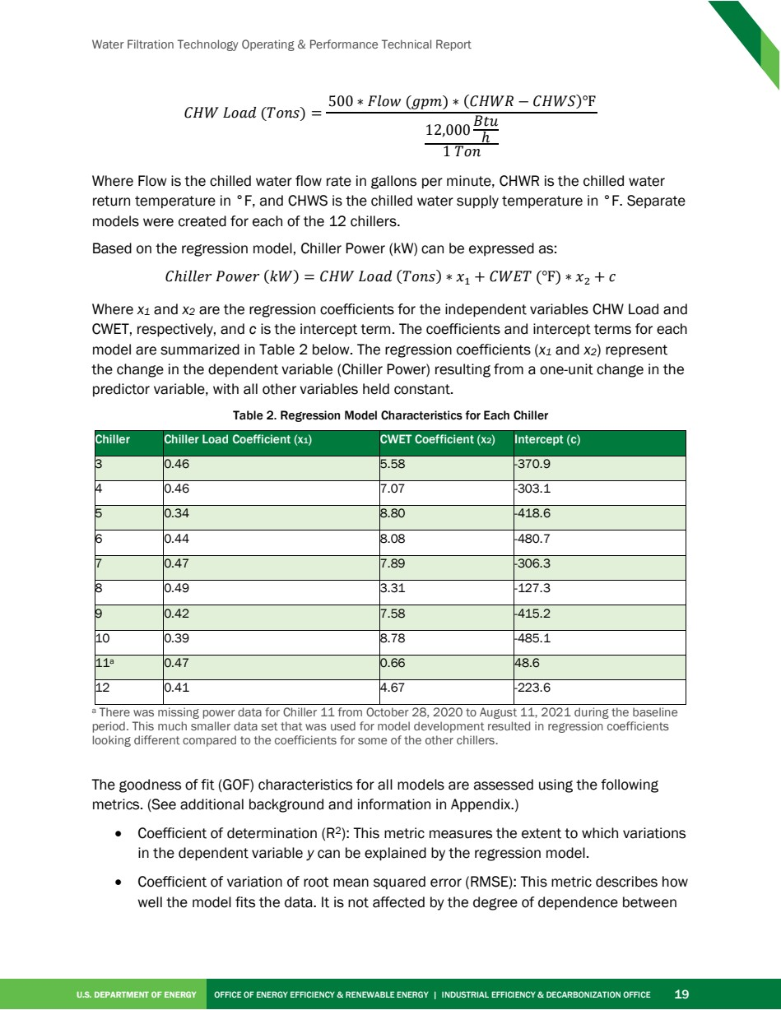

Source PDF page 33 | Nissan ElectroCell
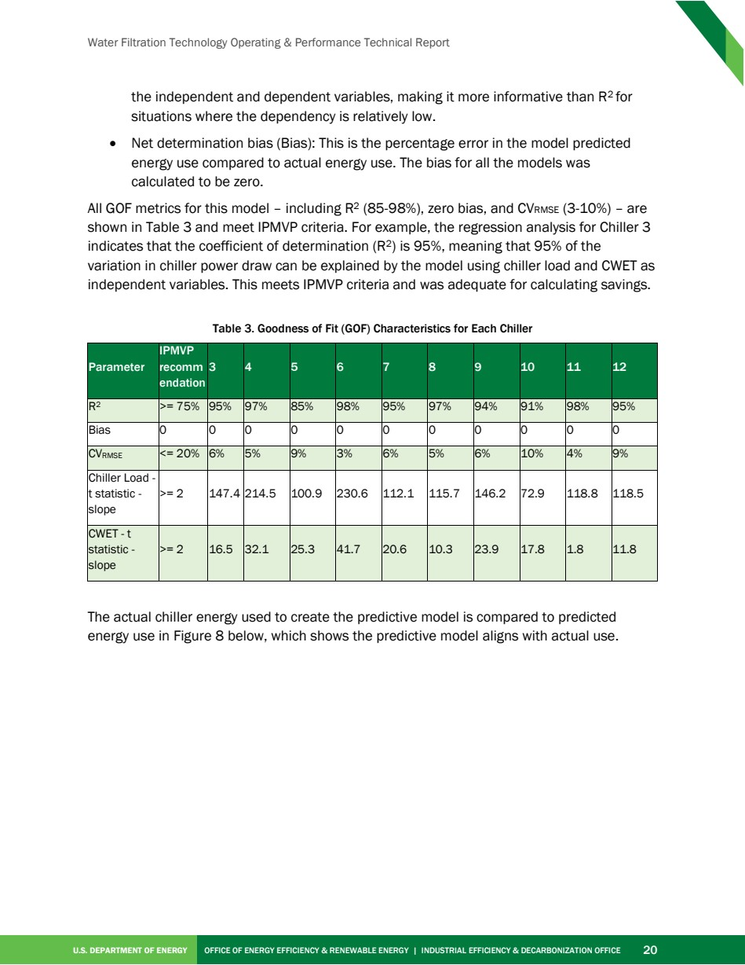

Source PDF page 34 | Nissan ElectroCell
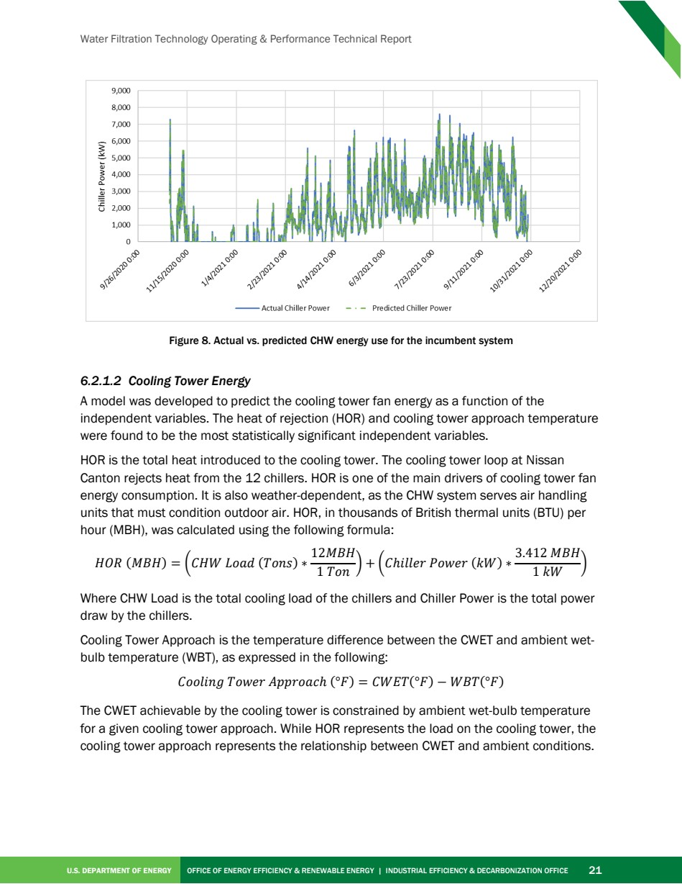

Source PDF page 35 | Nissan ElectroCell
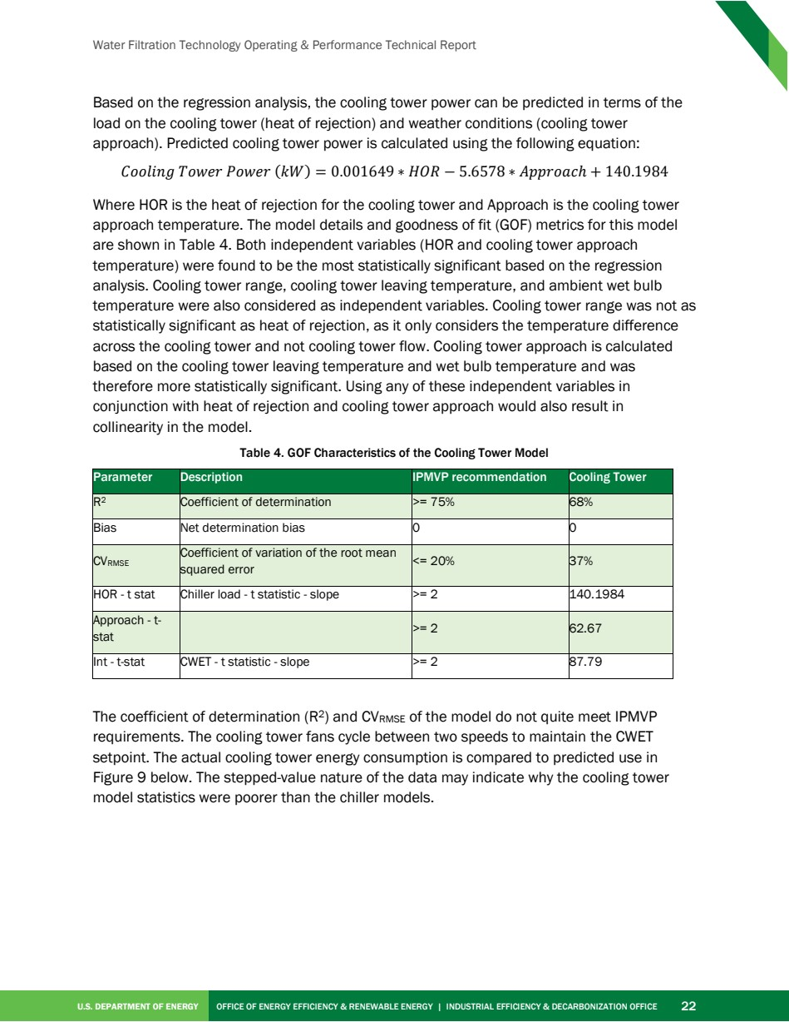

Source PDF page 36 | Nissan ElectroCell
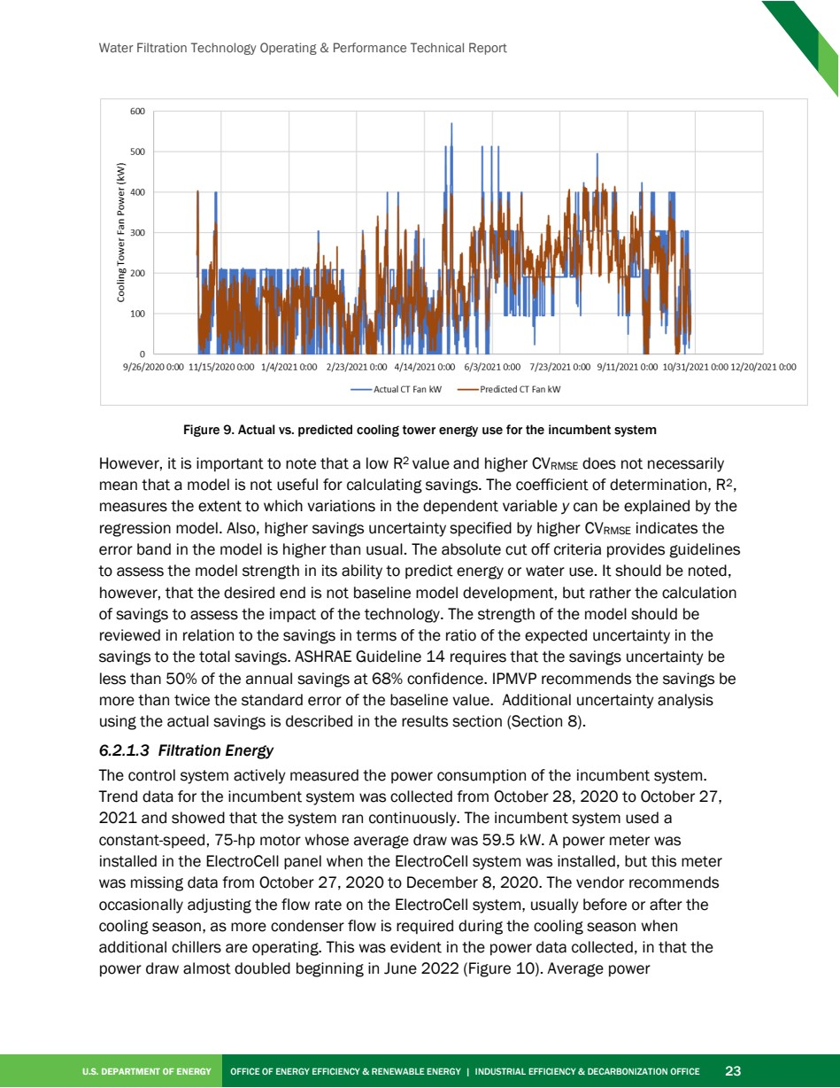

Source PDF page 37 | Nissan ElectroCell
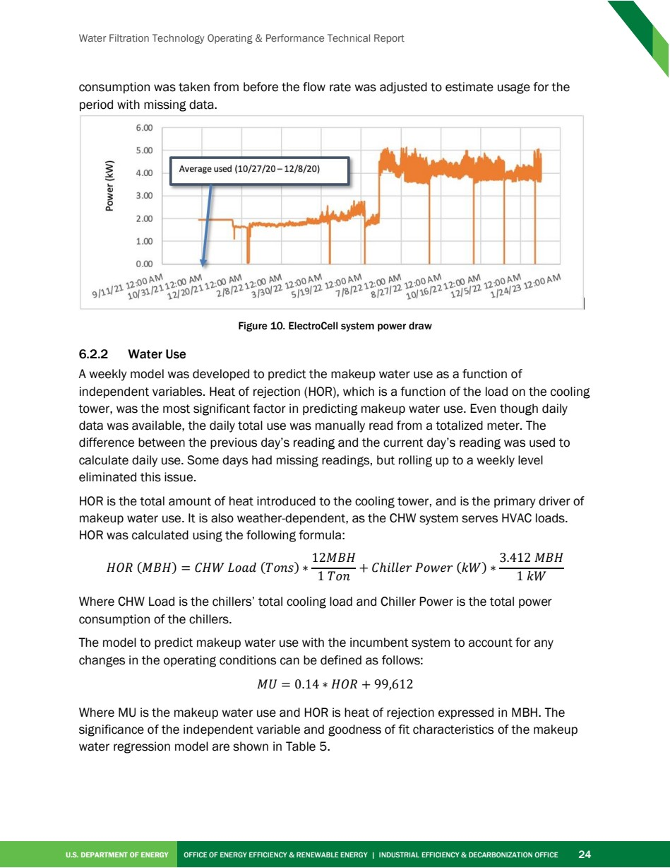

Source PDF page 38 | Nissan ElectroCell
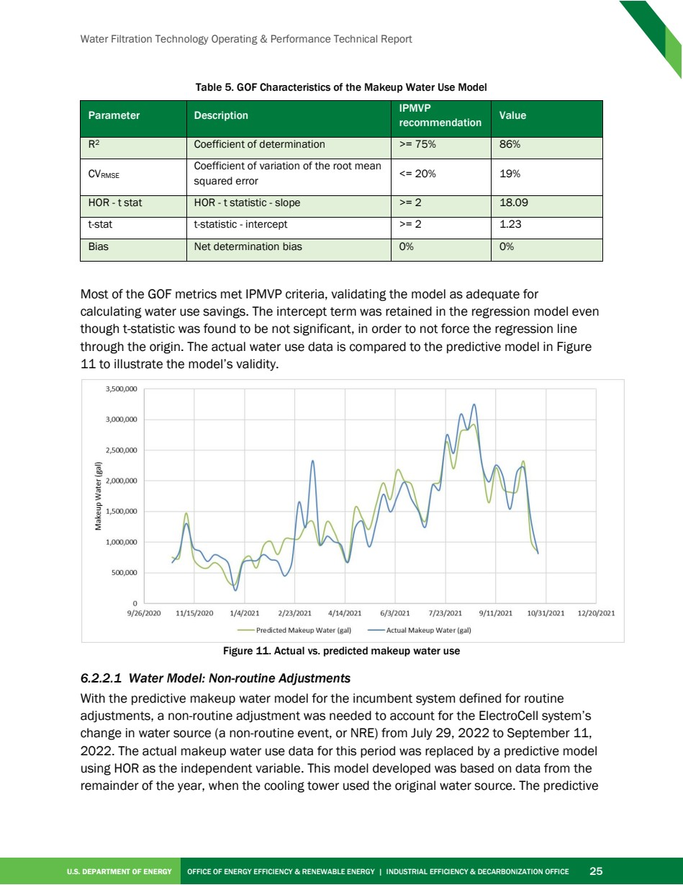

Source PDF page 39 | Nissan ElectroCell
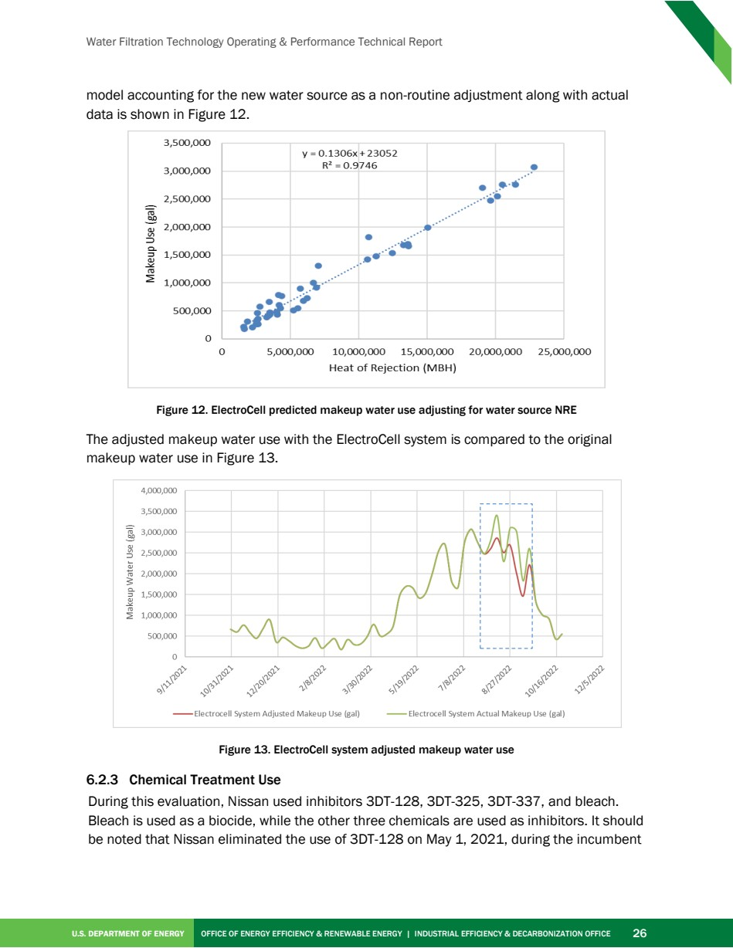

Source PDF page 40 | Nissan ElectroCell
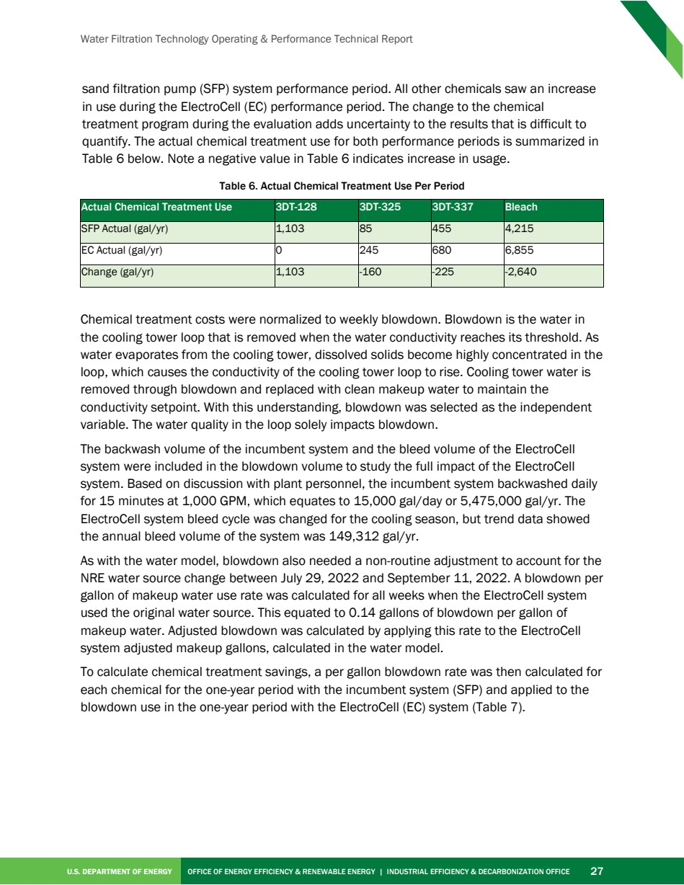

Source PDF page 41 | Nissan ElectroCell
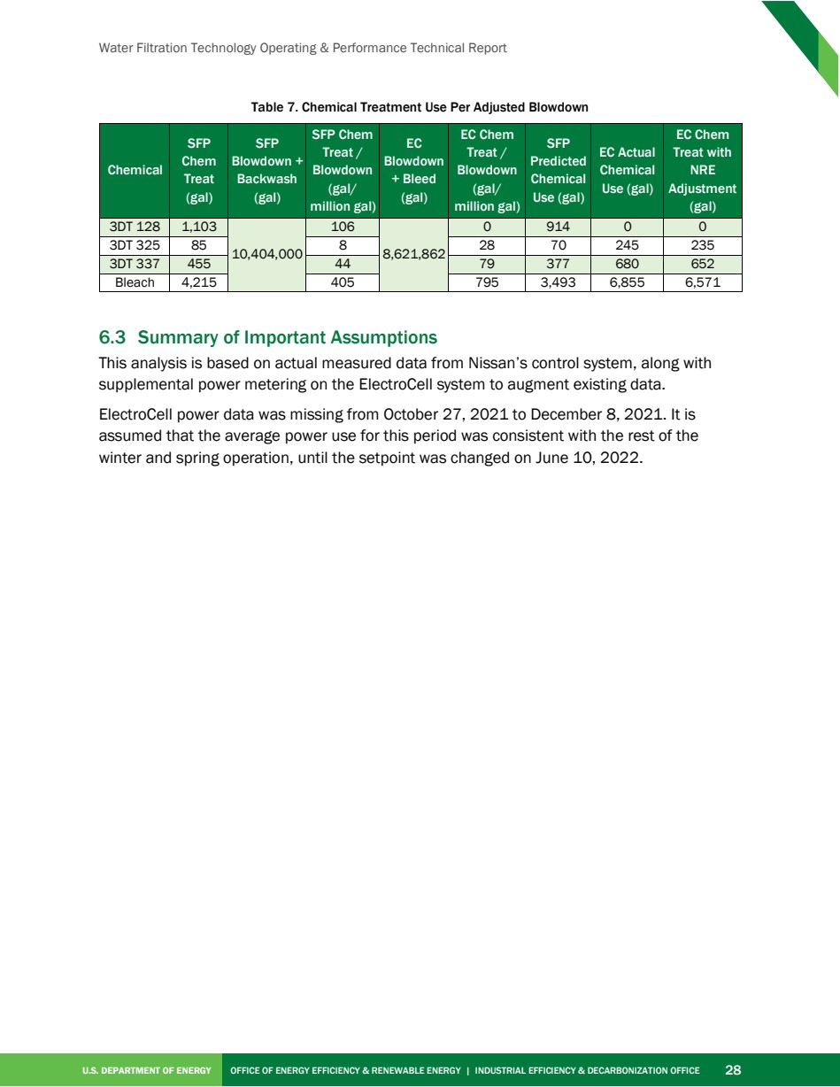

Source PDF page 43 | Nissan ElectroCell
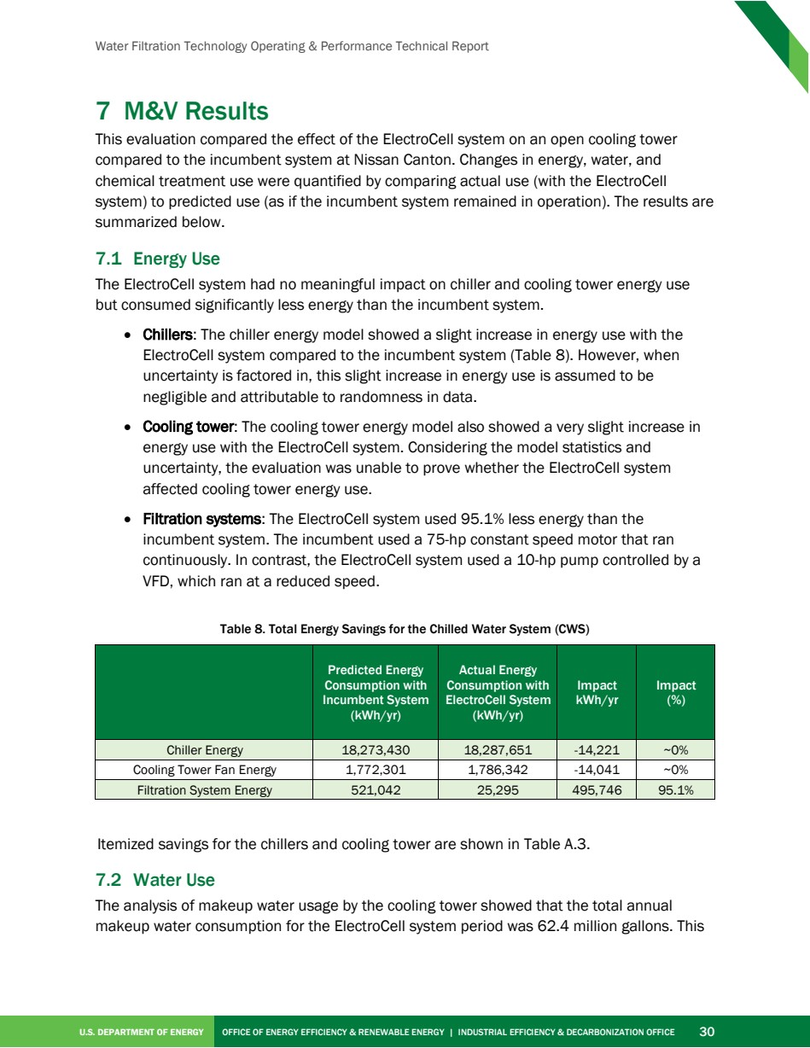

Source PDF page 44 | Nissan ElectroCell
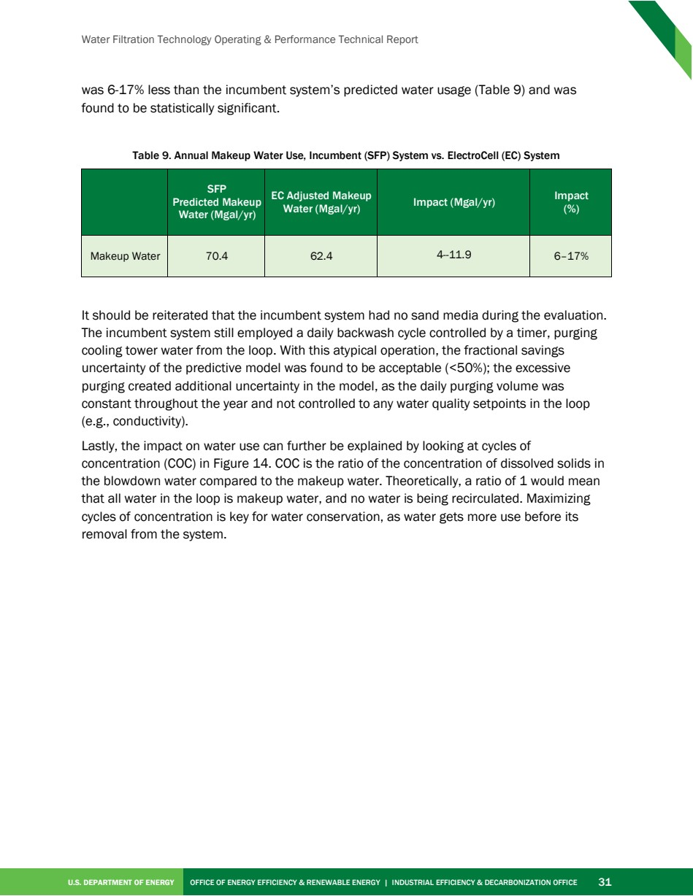

Source PDF page 45 | Nissan ElectroCell
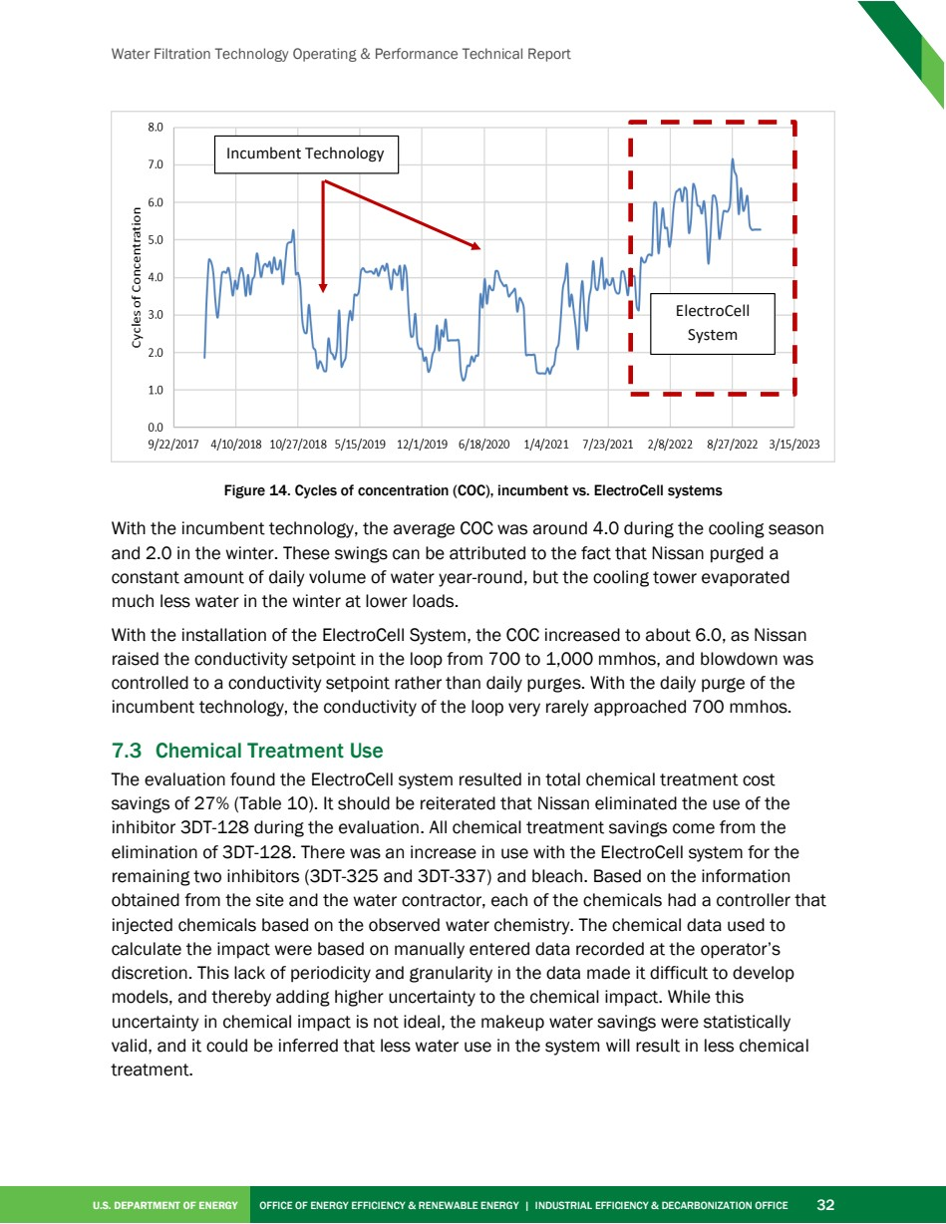

Source PDF page 46 | Nissan ElectroCell
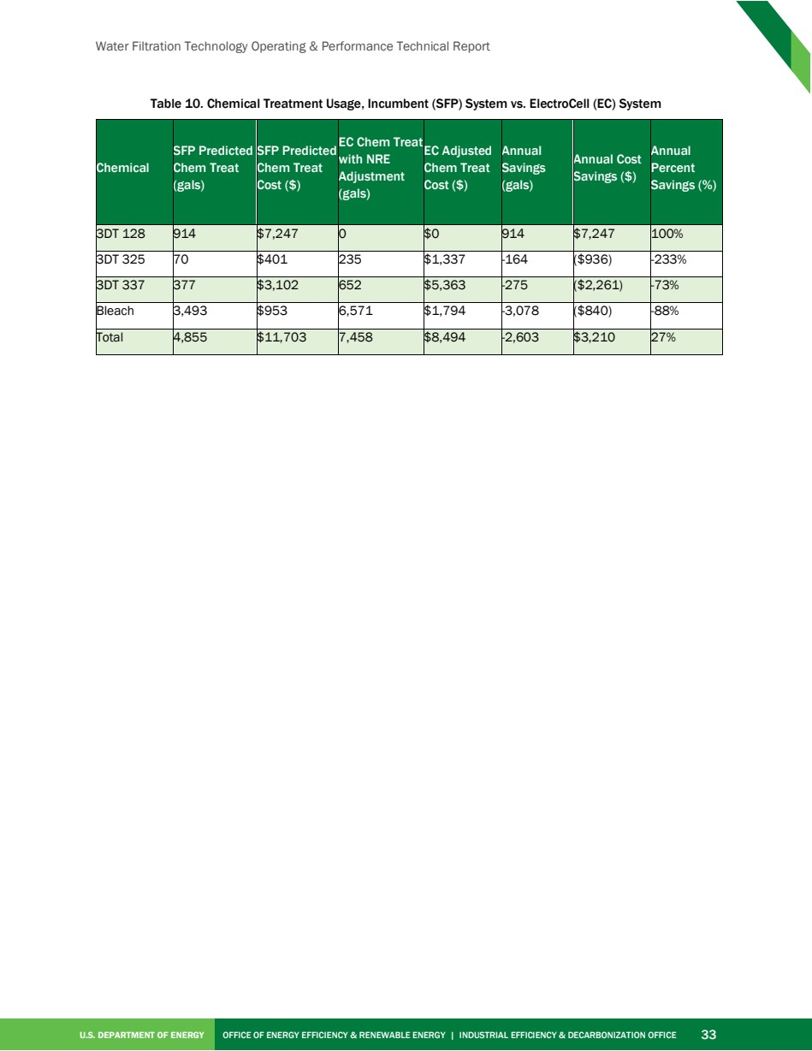

Source PDF page 48 | Nissan ElectroCell
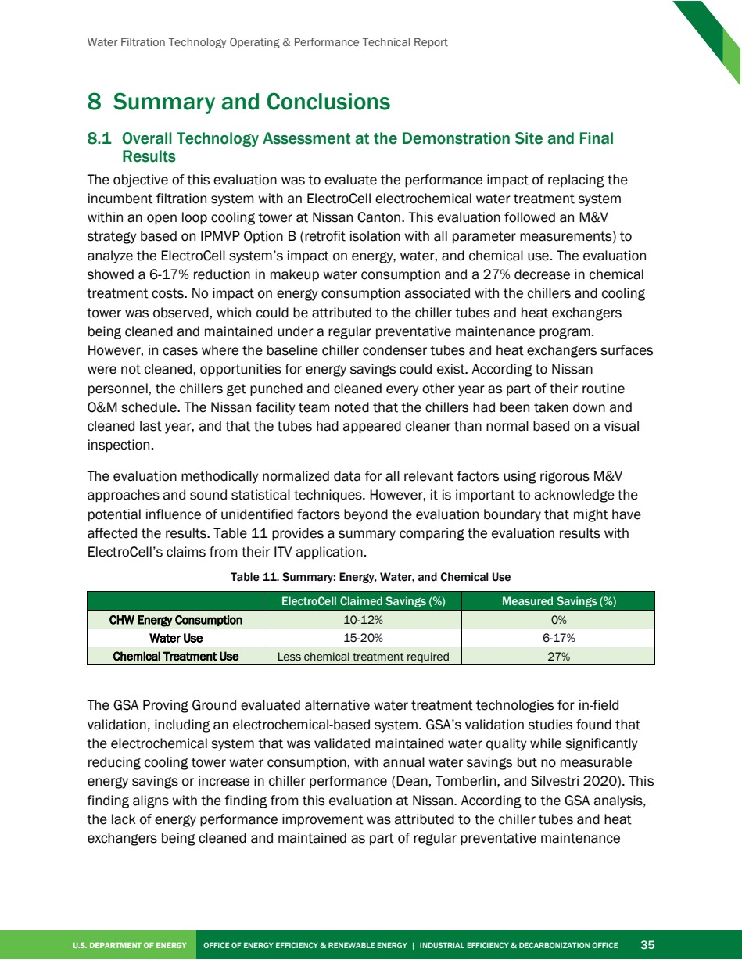

Source PDF page 52 | Nissan ElectroCell
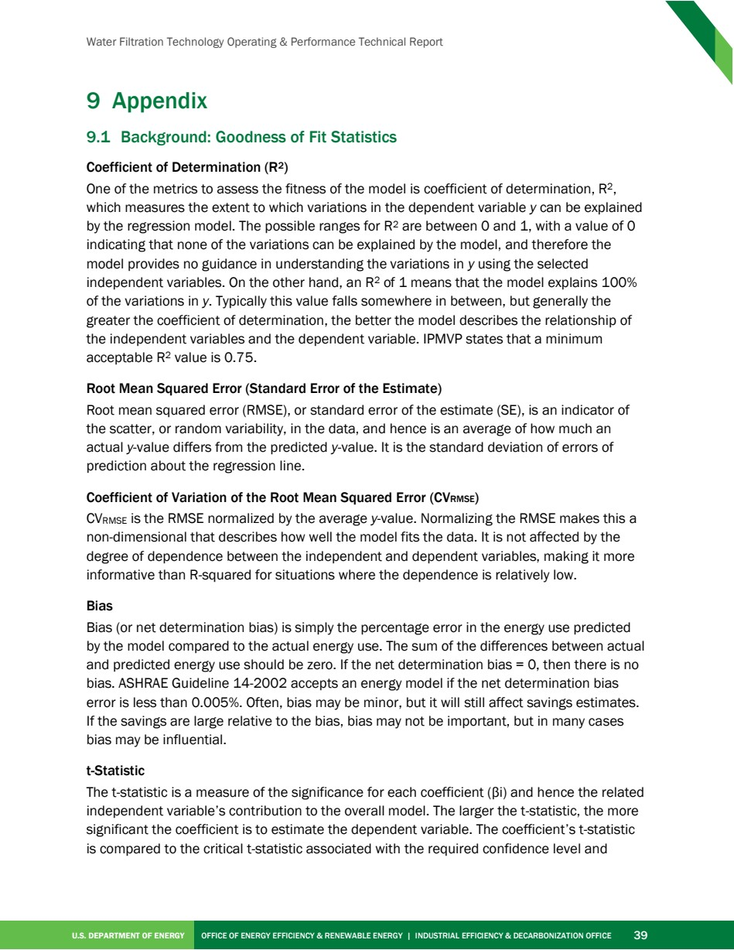

Source PDF page 53 | Nissan ElectroCell
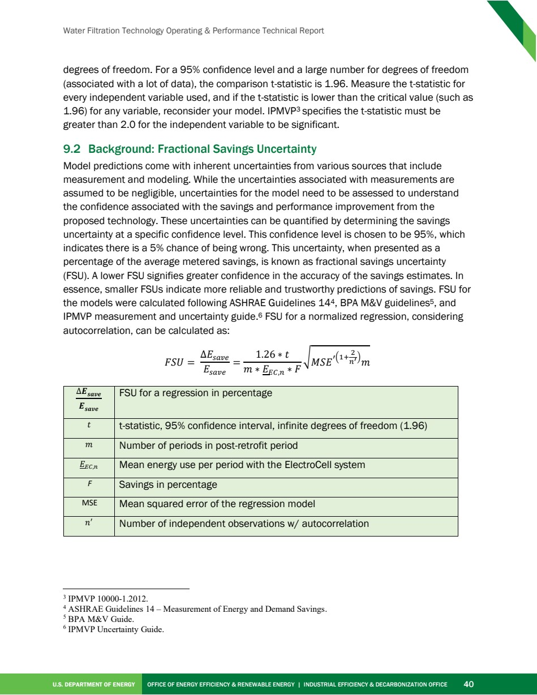

Source PDF page 54 | Nissan ElectroCell
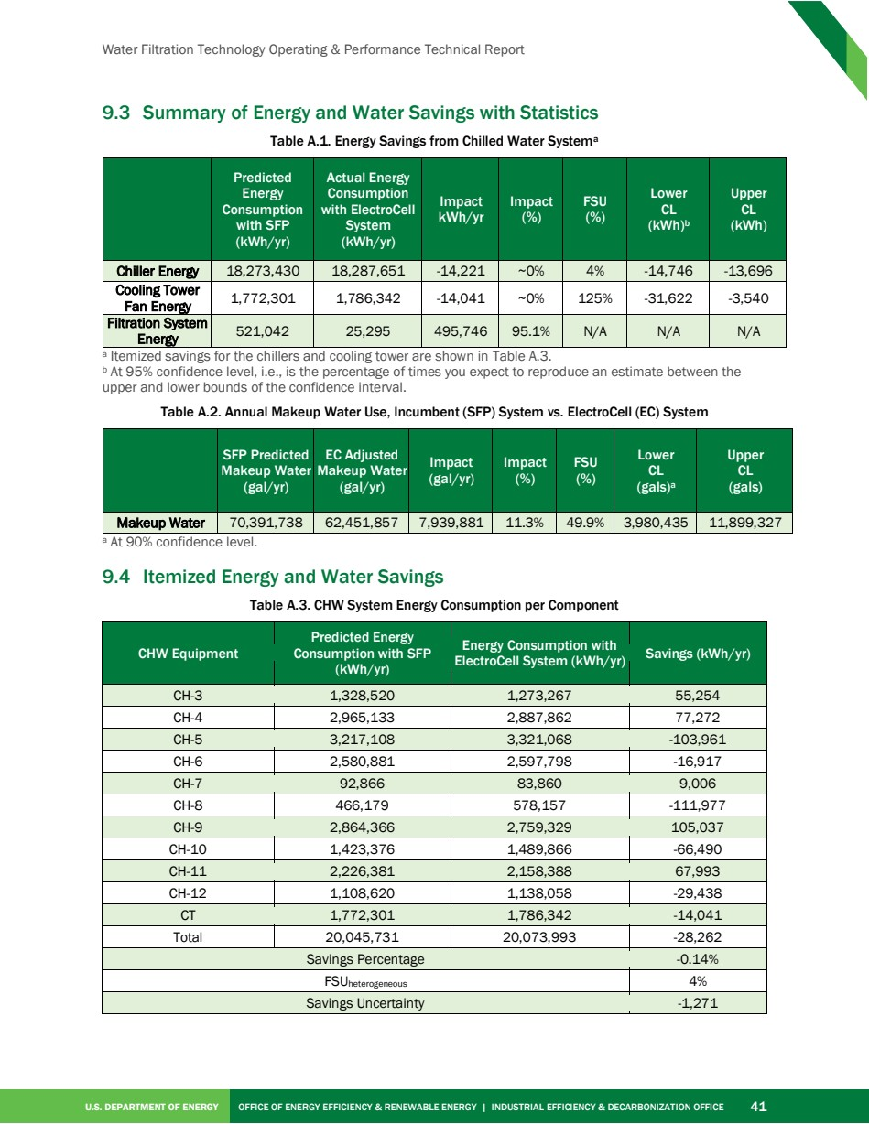

Source PDF page 55 | Nissan ElectroCell
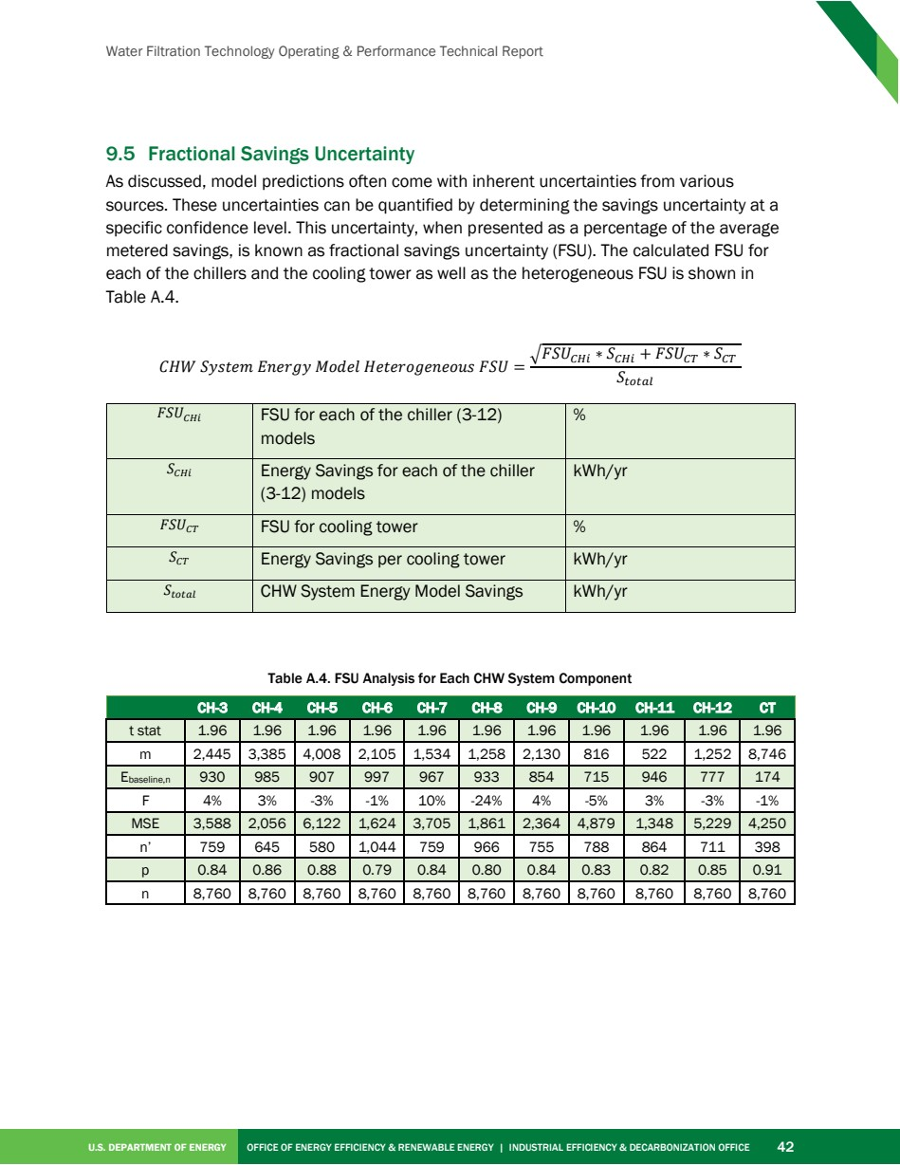

Source PDF page 56 | Nissan ElectroCell
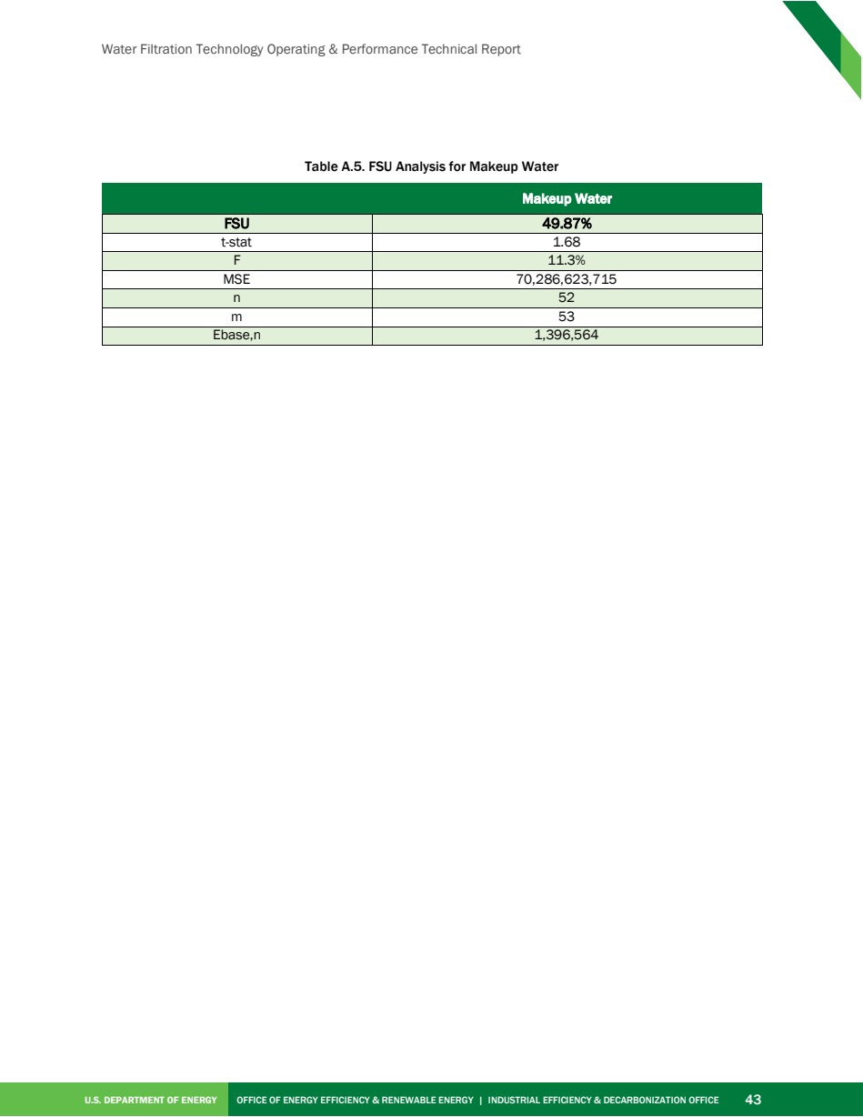

Source PDF page 57 | Nissan ElectroCell


