INDUSTRIAL TECHNOLOGY VALIDATION

Stryker HRSRM Supplemental Technical Annex
  - Supporting data and figures omitted from the restructured report
Field Validation of High Rotor Pole Switched Reluctance Motor
Stryker Plant | Mahwah, New Jersey
Companion to Stryker_MV_Report_Completed.docx
Source report: January 2026

Purpose and Use
This annex preserves technical supporting material from Stryker_MV Report_2026_01.docx that is not reproduced in full in Stryker_MV_Report_Completed.docx. It is intended for audit, replication, and detailed review. The completed report remains the primary reading document for conclusions and interpretation.
Included here are the source report’s original figures, detailed measurement coverage, regression coefficients and diagnostics, uncertainty inputs, and instrument signals. The figures are reproduced from the source document. Data tables are transcribed from its exhibits; see the source report for complete narrative context and any additional raw time series.
The source material reports estimates for one RTU at one site. It does not establish compressor savings, motor reliability, maintenance savings, or a project payback. The compressor result remains inconclusive in the completed report.

A. Detailed Measurement Inventory

A.1 Baseline and post-installation data
The source distinguishes baseline fan and compressor windows and reports discontinuous post-installation coverage. The detail below retains the measurement channels and exact periods shown in the original data tables.
Phase / system | Measured point | Unit | Source and interval | Coverage
Baseline fan | Supply-fan motor load | W | Turntide meter; 1 minute | Oct. 17–Dec. 11, 2023
Baseline fan | Supply-fan motor load | W | ITV Dent logger; 15 minutes | Oct. 17–Dec. 11, 2023
Baseline DX compressor | Phase 1–3 current | A | ITV Dent logger; 15 minutes | Jun. 6–Dec. 11, 2023
Baseline DX compressor | Phase 1–3 voltage | V | ITV Dent logger; 15 minutes | Jun. 6–Dec. 11, 2023
Baseline DX compressor | Phase 1–3 power factor | % | ITV Dent logger; 15 minutes | Jun. 6–Dec. 11, 2023
Post fan | Supply-fan motor load | W | Turntide meter; 1 minute | Dec. 12–27, 2023; Mar. 7–Apr. 9, 2024; Jul. 31–Oct. 24, 2024
Post fan | Supply-fan motor load | W | ITV Dent logger; 15 minutes | Dec. 12, 2023–Apr. 9, 2024; Jul. 31–Oct. 23, 2024
Post fan | Requested/current motor speed | rpm | Turntide dashboard; 1 minute | Dec. 12–27, 2023; Mar. 7–Apr. 9, 2024; Jul. 31–Oct. 24, 2024
Post compressor | Phase 1–3 current, voltage, power factor | A / V / % | ITV Dent logger; 15 minutes | Dec. 12, 2023–Oct. 24, 2024

A.2 Weather and building-automation inputs
Data group | Variables | Source / frequency | Coverage / use
Actual meteorological year (AMY) | Dry-bulb, wet-bulb, dewpoint, RH, HDD, CDD | NOAA Teterboro Airport (TEB); hourly and daily | Jan. 1, 2023–May 21, 2025; model development and observed context.
Typical meteorological year (TMY) | Dry-bulb, wet-bulb, dewpoint, RH | NOAA TEB; hourly and daily | Typical-year normalization for annual fan savings.
Room conditions | Room temperature and humidity | Stryker BAS; 15 minutes | Temperature: Feb. 19–May 30, 2023; Jun. 30–Aug. 30, 2023; Feb. 14–May 22, 2025. Humidity: Feb. 24–May 30, 2023; Feb. 12–May 22, 2025.
RTU stages and schedule | Cooling 1/2, Heating 1/2, Day/Night, Cooling/Heating modes | Stryker BAS; 15 minutes | Cooling stages: Jul. 1, 2024–May 22, 2025; heating stages: Dec. 22, 2024–May 22, 2025; Day/Night: Aug. 27, 2024–May 22, 2025; Cooling/Heating: Sep. 18, 2024–May 22, 2025.

The source notes intermittent BAS coverage. The data inventory did not include a separate sensor calibration log.

B. Full Regression Coefficients and Diagnostics

B.1 Model 1: daily average supply-fan airflow
The source model predicts daily average supply-fan airflow percentage from baseline/post status, Saturday status, and relative outside-air temperature (rOAT65 = outside-air temperature minus 65°F), with separate weekday and Saturday temperature terms.
Term | Coefficient | t-statistic | p-value
Intercept | 0.4488 | 270.3 | <0.0001
Baseline/Post (0/1) | −0.0634 | −3.72 | 0.0003
Saturday (0/1) | −0.1516 | −7.52 | <0.0001
Saturday × rOAT65 | 0.0120 | 18.84 | <0.0001
Weekday × rOAT65 | 0.0077 | 5.48 | <0.0001

Fit measure | Source criterion | Reported value | Reading
R² | ≥75% | 77% | Meets cited criterion.
CV-RMSE | ≤20% daily target | 28% | Above target; interpret daily airflow prediction cautiously.
Net determination bias | ≤0.005% | 0 | Meets cited criterion.
F-statistic p-value | <0.05 | <0.0001 | Model is statistically significant overall.

B.2 Models 2 and 3: fan energy versus airflow
Model / term | Coefficient | t-statistic | p-value
Model 2 baseline: intercept | 0.04006 | 0.28 | 0.783
Model 2: daily average airflow (%) | 48.4126 | 101.22 | <0.0001
Model 3 HRSRM: intercept | 0.30566 | 2.79 | 0.0061
Model 3: daily average airflow (%) | 43.8409 | 133.86 | <0.0001

Model | R² | CV-RMSE | Net determination bias | F-statistic p-value
Model 2 baseline fan energy | 99% | 1% | 0 | <0.0001
Model 3 HRSRM fan energy | 99% | 5% | 0 | <0.0001

The source expresses predicted daily energy as a function of daily average supply airflow. In the annual savings calculation, Model 1 generates typical-year airflow and Models 2 and 3 translate it to baseline and post-retrofit fan energy.

B.3 DX compressor energy model
Term | Coefficient | t-statistic | p-value
Intercept | −275.811 | −7.72 | <0.0001
Baseline/Post (0/1) | 7.8473 | 1.10 | 0.214
Relative humidity (%) | 1.3018 | 4.34 | <0.0001
Weekday CDD55 | 18.9611 | 14.6 | <0.0001
Weekday CDD75 | 7.4900 | 6.4 | <0.0001
Saturday CDD55 | 14.2454 | 10.1 | <0.0001
Saturday CDD75 | 7.0546 | 5.78 | <0.0001

Goodness-of-fit item | Reported value
R² | 79%
Baseline/post coefficient t-statistic | 1.10
Baseline/post coefficient p-value | 0.214
Data coverage for model | 212 days
Result | Retrofit indicator not statistically significant; no savings determination.

The source excludes compressor readings during the maintenance-related outage from April 9 through July 30, 2024. The missing interval overlaps the summer peak, so the model is not treated as a reliable compressor savings estimate.

C. Normalization Coverage and Uncertainty Inputs

C.1 Reported savings outputs
Output | Baseline normalized use | Post / modeled use | Impact / interval
RTU 3 supply fan | 4,262 kWh/year | 3,156 kWh/year | 1,106 kWh/year saved (26%); FSU 7%.
Fan post-use 95% interval | — | 1,033–1,179 kWh/year | 95% confidence interval reported by source.
DX compressor | Measured baseline period | Post-period data affected by maintenance | No savings estimate; retrofit coefficient t=1.10, p=0.214.

C.2 Weather coverage
Model | Training coverage | TMY coverage rule / range | Treatment
Supply-fan airflow | 140 days; AMY dry-bulb 32–85°F | ASHRAE-style rule applied by source: 90% of training minimum to 110% of maximum; valid range 29–93°F. | 30 TMY days below 29°F excluded; source reports negligible impact due to infrequent low-temperature fan operation.
DX compressor | 212 days; training dry-bulb 41–93°F; RH 45–100% | TMY dry-bulb 16–83°F; RH 51–97%. | Model imposed 45°F lower dry-bulb limit; RH range was within training coverage.

C.3 Fan savings FSU calculation terms
Term | Meaning | Source value
FSU | Fractional savings uncertainty at 95% confidence | 7%
t | 95% confidence; large degrees of freedom | 1.96
m | Post-retrofit periods | 56
n | Baseline periods | 118
g | Typical-year periods | 365
r / p | Post / baseline model parameter counts | 2 / 2
Mean interval energy | Post / baseline | 11.7 / 12.5
Mean normalized annual energy | Post / baseline | 8.7 / 11.6
MSE | Post / baseline | 0.66 / 0.65
Effective independent observations n′ | Post / baseline, autocorrelation-adjusted | 18.6 / 67.3
Autocorrelation coefficient | Post / baseline | 0.50 / 0.27

The source provides the full FSU equation and definitions in its appendix. The 7% result is carried into the completed report; this table preserves its input values for auditability.

D. Turntide Meter and Dashboard Signals
The source’s detailed point inventory is reproduced below. These one-minute signals supported post-retrofit operation checks and motor-power analysis.
Signal | Unit | Source / interval
Motor uptime | seconds | Power meter / 1 minute
Motor energy | Wh | Power meter / 1 minute
Total motor power; phase A/B/C power | W | Power meter / 1 minute
Phase A/B/C current | A | Power meter / 1 minute
Line-to-line voltage AB, BC, AC; average line-to-line voltage | V | Power meter / 1 minute
Motor frequency | Hz | Power meter / 1 minute
Phase A/B/C power factor and average power factor | % | Power meter / 1 minute
Motor on status | 0/1 | Turntide dashboard / 1 minute
Power in; power out | W | Turntide dashboard / 1 minute
Requested speed; current speed | rpm | Turntide dashboard / 1 minute
Phase A/B/C motor current | mA | Turntide dashboard / 1 minute
DC voltage | V | Turntide dashboard / 1 minute

D.1 Measured fan power by operating mode
RTU mode | Baseline speed | Baseline measured power | HRSRM speed | HRSRM measured power
Cooling Stage 1 | 100% | 1.9–2.48 kW | 75% | 1.34 kW
Cooling Stage 2 | 100% | 1.9–2.48 kW | 90% | 2.09 kW
Ventilation | 100% | 1.9–2.48 kW | 40% | 0.78 kW
Heating Stage 1 | 100% | 1.9–2.48 kW | 90% | 2.09 kW
Heating Stage 2 | 100% | 1.9–2.48 kW | 90% | 2.09 kW

The source notes that the constant-speed induction motor’s steady-state power varied between 1.9 and 2.48 kW, including possible damper-operation effects. HRSRM fan power varied with programmed speed, with lower values in Ventilation and Cooling Stage 1.

E. Original Figures from the Source Report
The following figures were embedded in Stryker_MV Report_2026_01.docx and were not carried into the restructured report. They are reproduced here as supporting visuals; numbering and captions follow the source report.
Figure 1. Illustration of typical RTU and its components
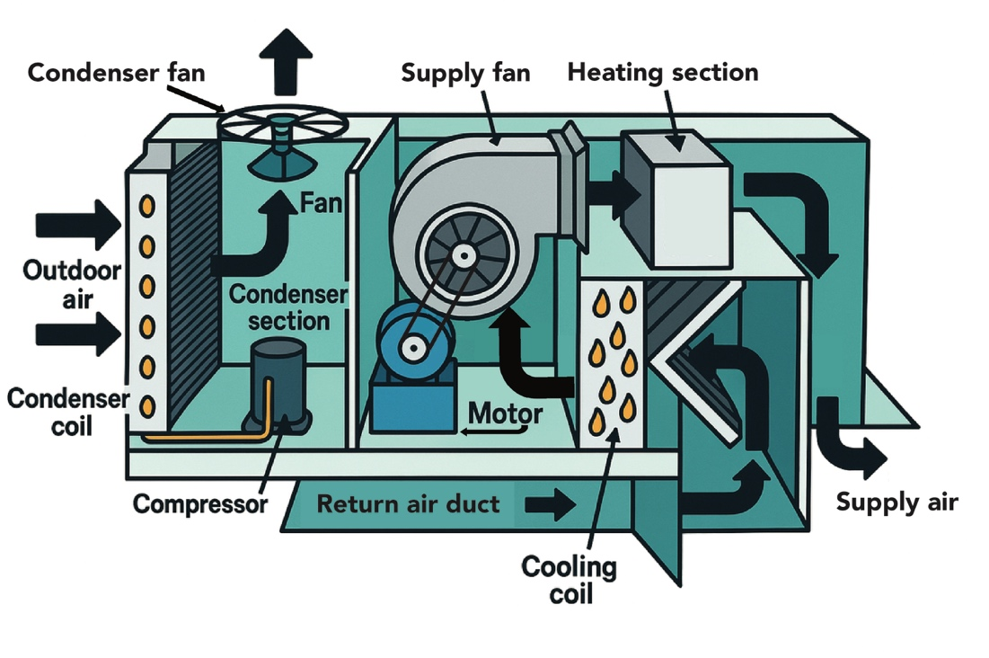

Figure 2. Weekly operating schedule of RTU 3
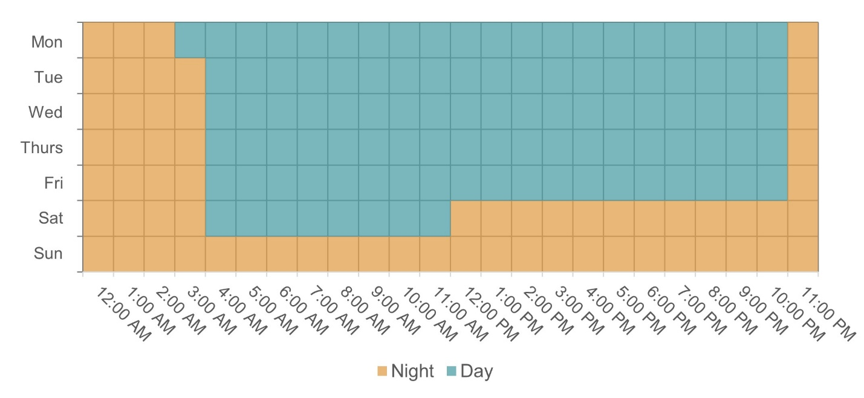

Figure 3. Illustration of induction motor and HRSRM components
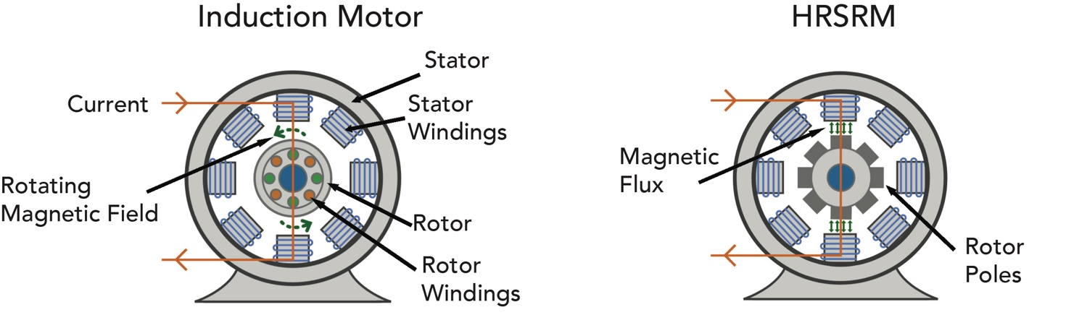

Figure 4. Software-controlled HRSRM components
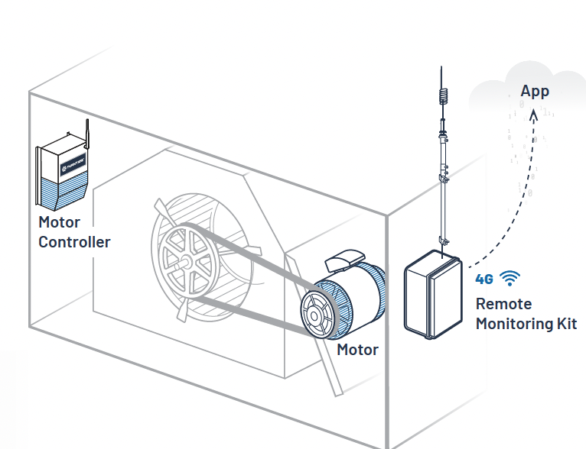

Figure 5. Flow chart: fan motor energy model development
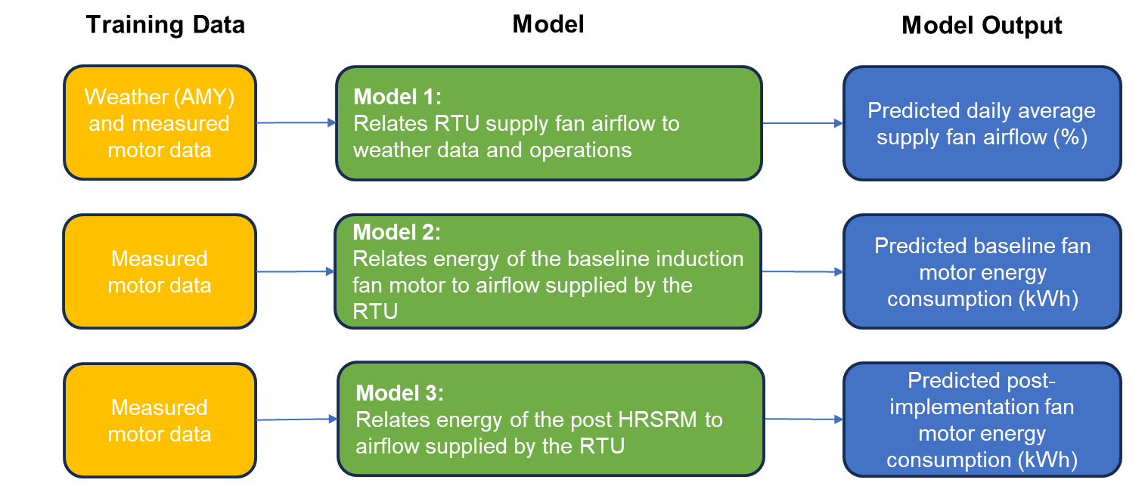

Figure 6. Flow chart: fan motor annual energy savings methodology
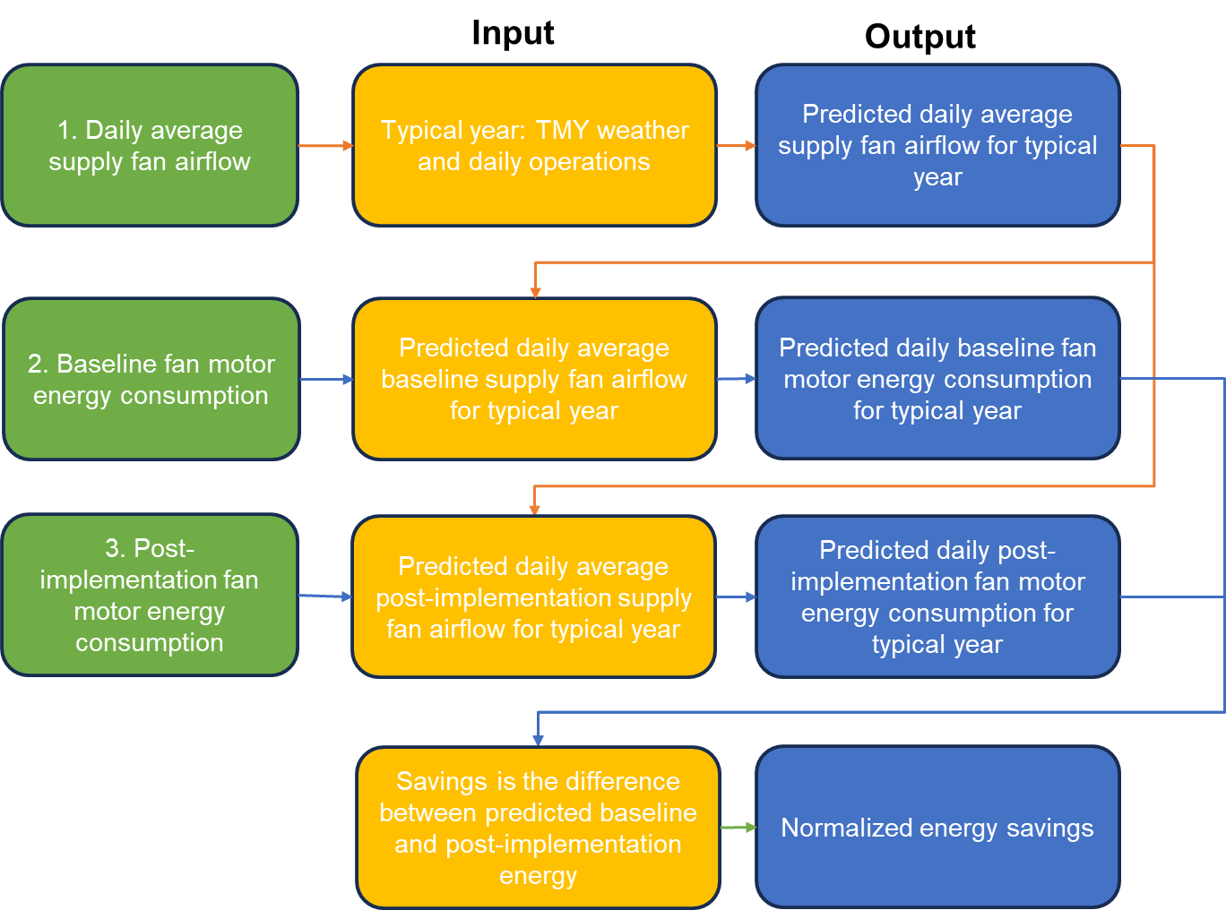

Figure 7. Predicted vs. actual – Model 1: daily average supply fan airflow
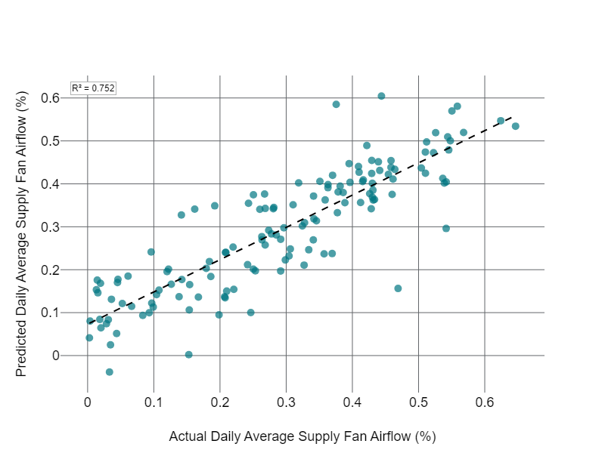

Figure 8. Baseline daily fan motor energy vs. daily supply fan airflow (%)
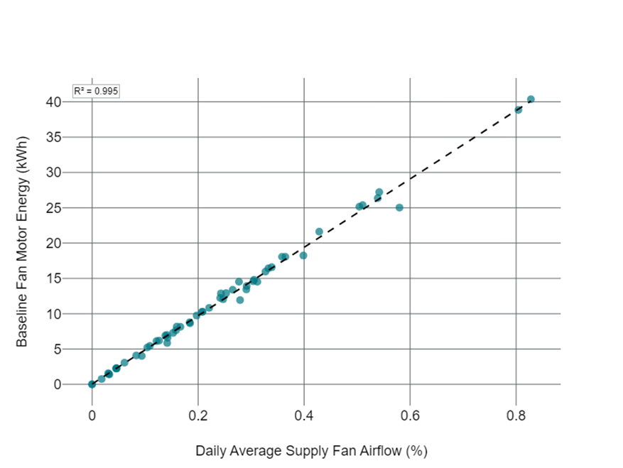

Figure 9. Predicted vs. actual – Model 2: baseline fan motor energy model
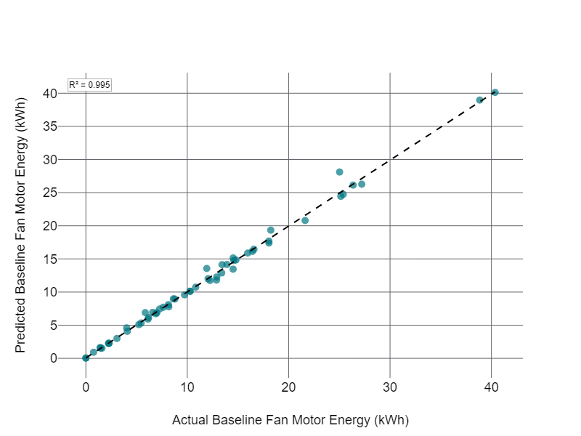

Figure 10. Post-implementation daily supply fan motor energy vs. daily average supply fan airflow
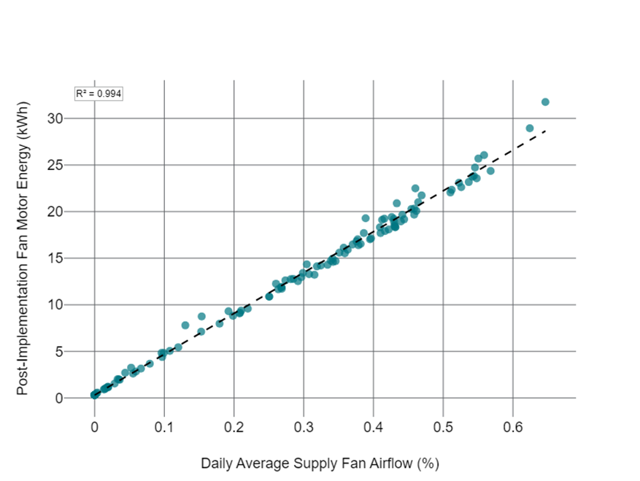

Figure 11. Predicted vs. actual – Model 3: post-implementation fan motor energy model
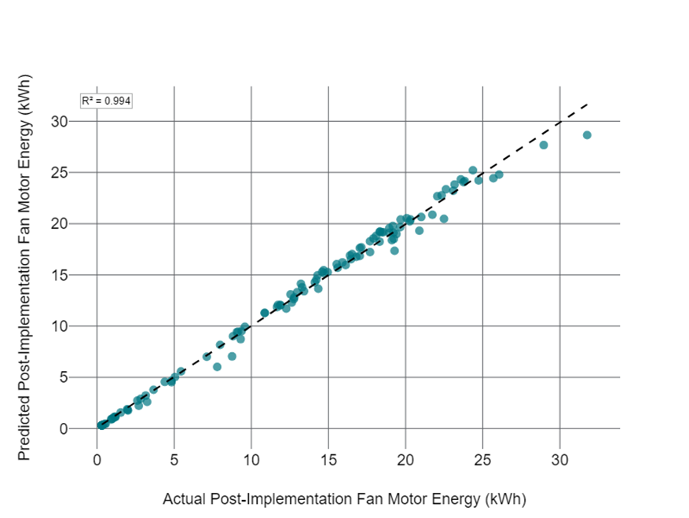

Figure 12. Daily DX compressor energy vs. outside air temperature
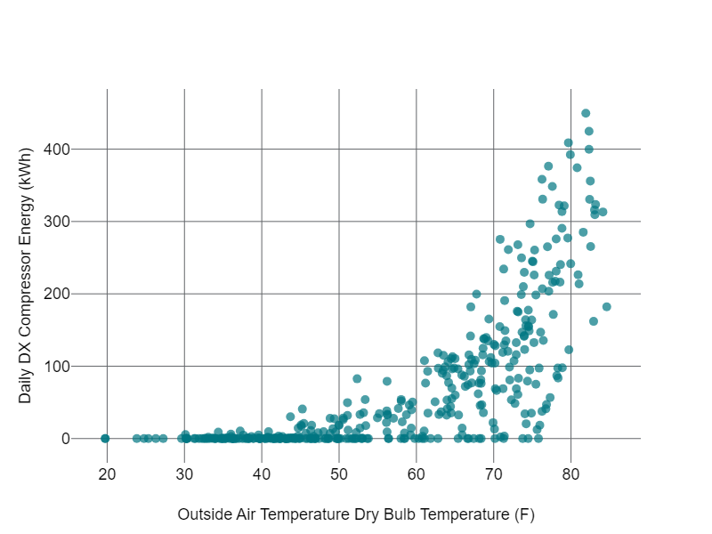

Figure 13. Daily DX compressor energy time series
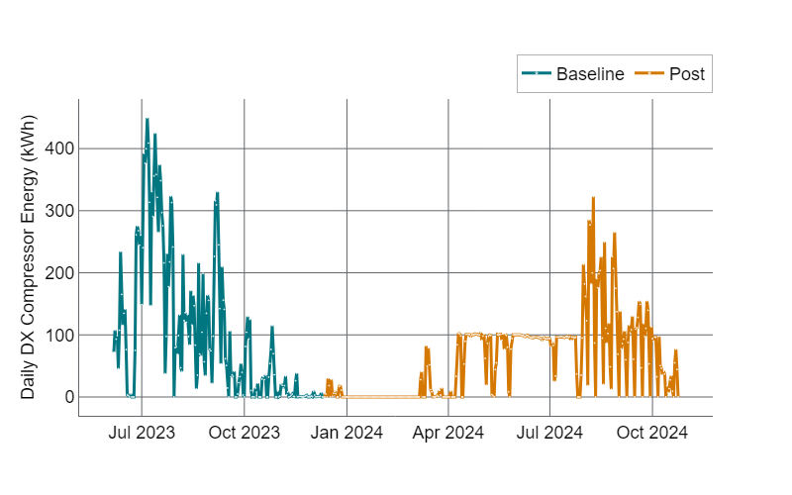

Figure 14. Daily compressor energy vs. average outside air temperature, with July 2023 usage highlighted
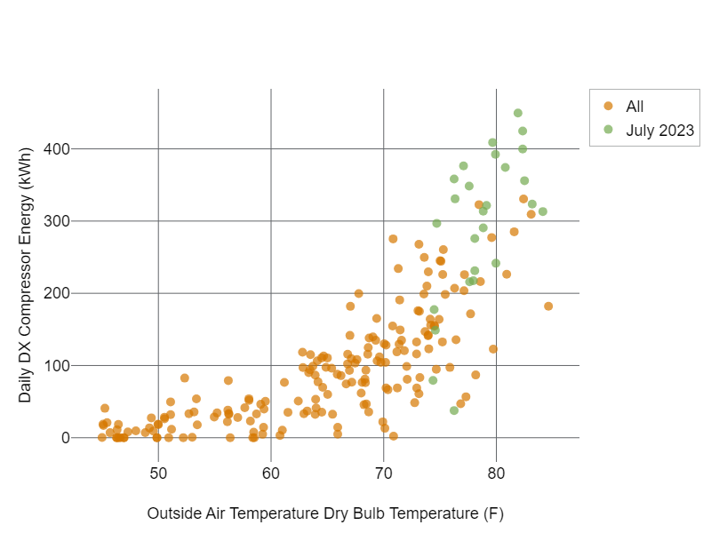

Figure 15. Post-implementation daily supply-fan motor energy vs. daily average supply-fan airflow
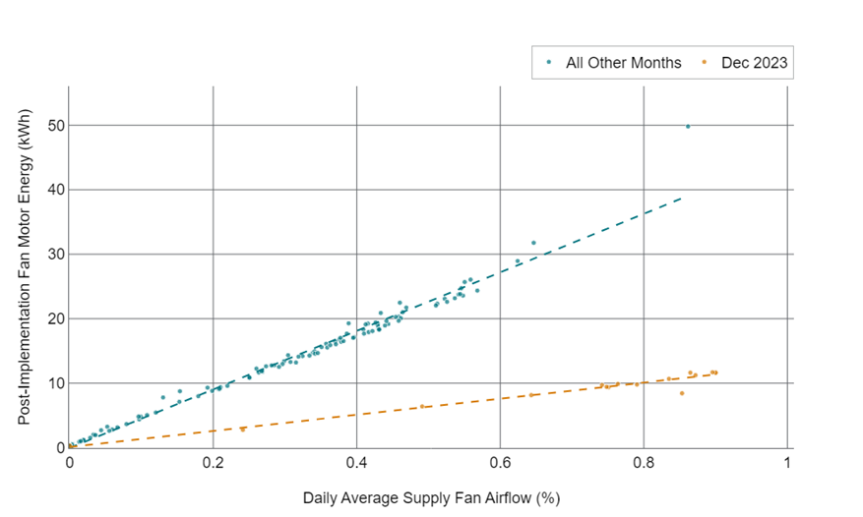

Figure 16. AMY and TMY dry-bulb data coverage for the fan savings calculation
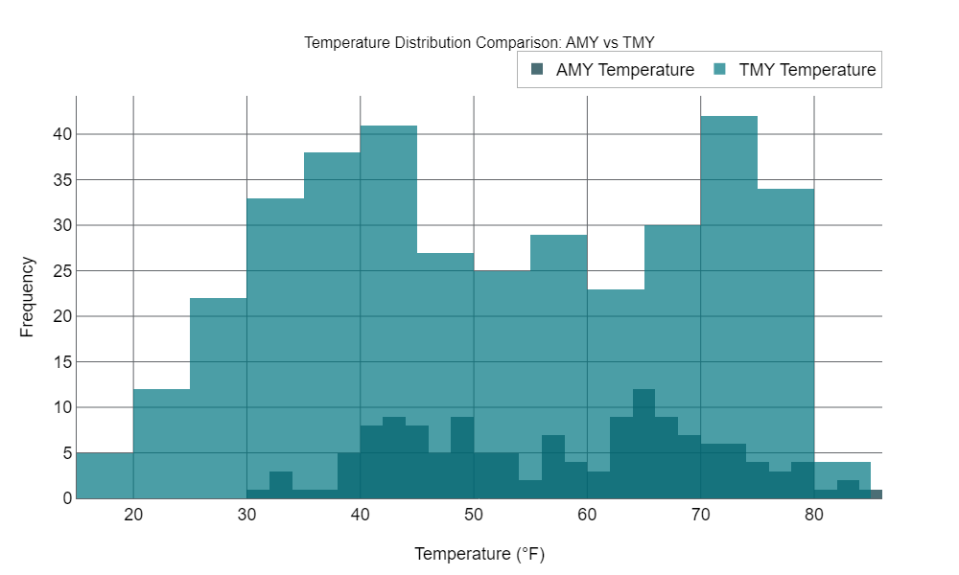

Figure 17. AMY and TMY dry-bulb data coverage for the compressor energy model


