INDUSTRIAL TECHNOLOGY VALIDATION

Toyota ElectroCell Supplemental Technical Annex
  - Supporting source exhibits omitted from the restructured technical report
Companion report: Toyota_ElectroCell_Technical_Report.docx
Primary source PDF: iedo-itv-toyota-electrocell.pdf
Project report title: Electrochemical Water Filtration at Toyota Mississippi

Purpose and Use
This annex preserves detailed evidence from the source PDF that is not reproduced in full in the restructured project report. It is intended as a companion for audit and technical review; the completed report remains the primary reading document for conclusions and interpretation.

Project Summary from the Completed Report
The evaluation compared ElectroCell Systems’ EC-6000 electrochemical side-stream treatment with Toyota Motor Manufacturing Mississippi’s (TMMMS) incumbent Lakos centrifugal filtration system. The strongest direct result is lower filtration-system electricity. Model-based chiller and compressor impacts were small relative to the system loads and are characterized by the source as statistically negligible; cooling-tower fan savings were not established. Makeup water and chemical costs were lower in the adjusted comparison, with water uncertainty reported explicitly.

Source Pages Included
The selected pages reproduce source technical material, including instrumentation/data coverage, operating conditions, equations and model diagnostics, uncertainty and detailed result exhibits, equipment information, figures, and scale-up or market analysis where present. Each page is reproduced directly from the original PDF. Original page headers, captions, tables, and printed page numbers remain visible; “PDF page” labels refer to the file page index.
Included source PDF pages: 17-18, 22-24, 26-29, 31-46, 48-50, 52-53, 56, 58-64.
These are facsimile reproductions, not a new analysis. Values, chart scales, and qualifications are as presented in the source. Refer to the completed report for the summarized findings and project-specific interpretation.

Source PDF page 17 | Toyota ElectroCell
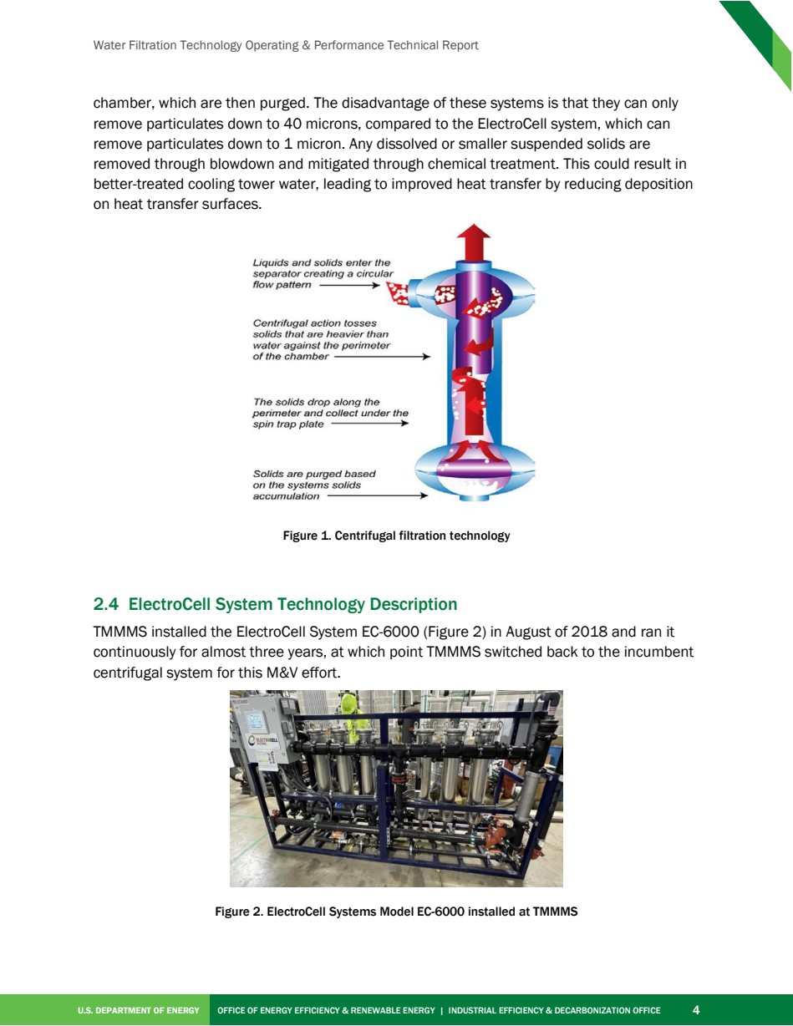

Source PDF page 18 | Toyota ElectroCell
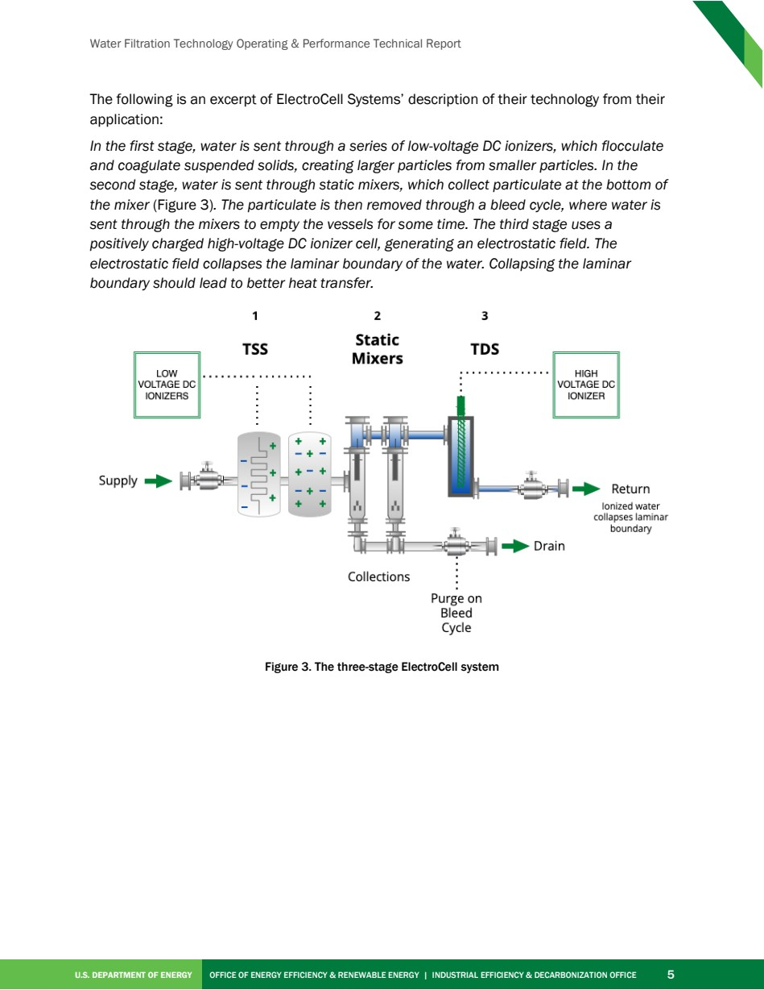

Source PDF page 22 | Toyota ElectroCell
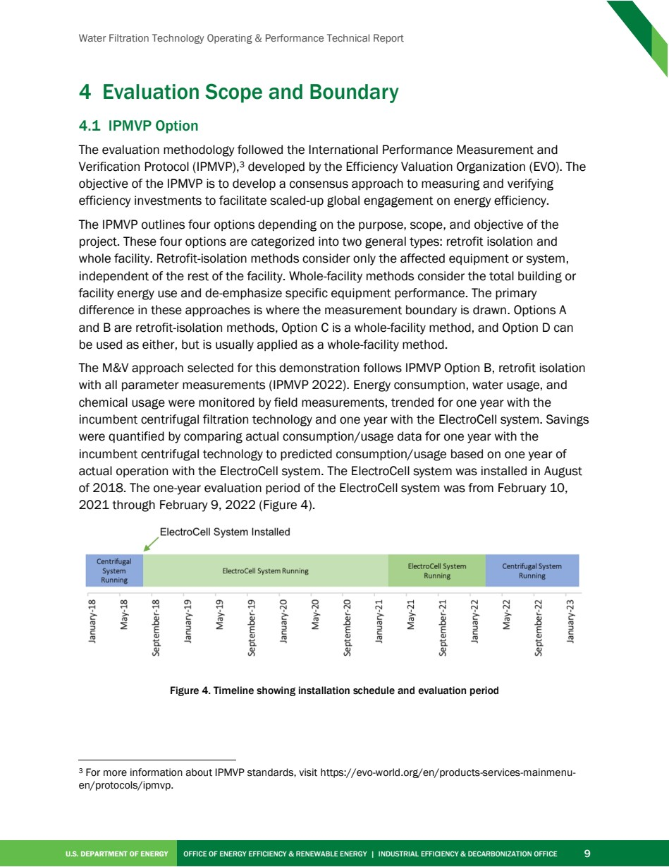

Source PDF page 23 | Toyota ElectroCell
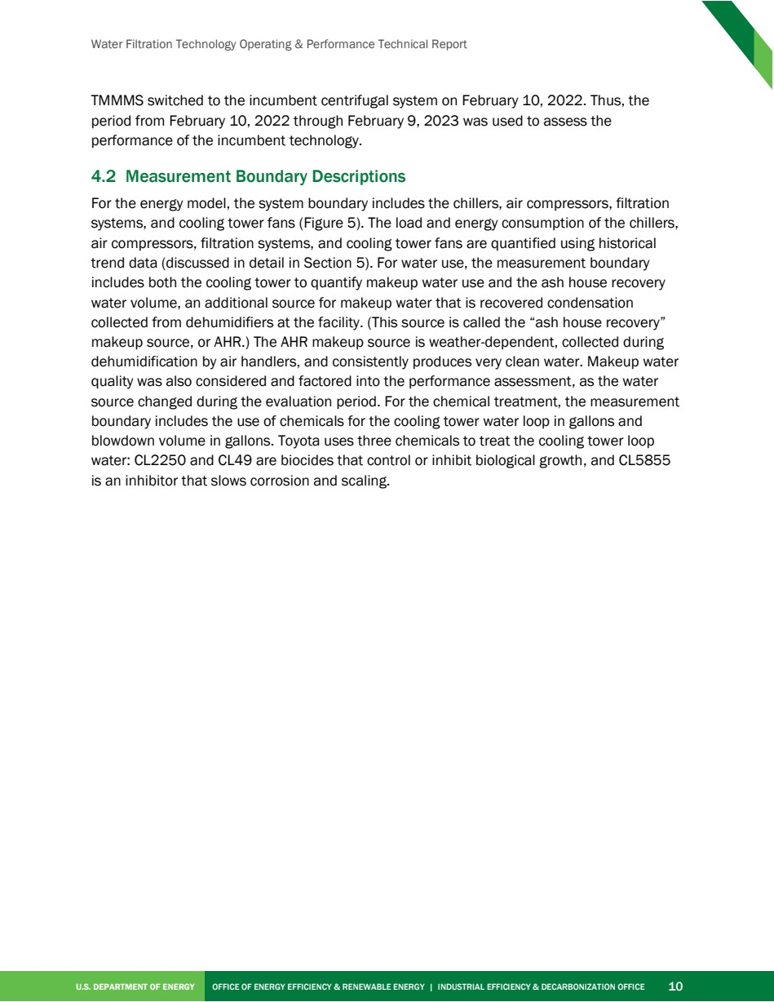

Source PDF page 24 | Toyota ElectroCell
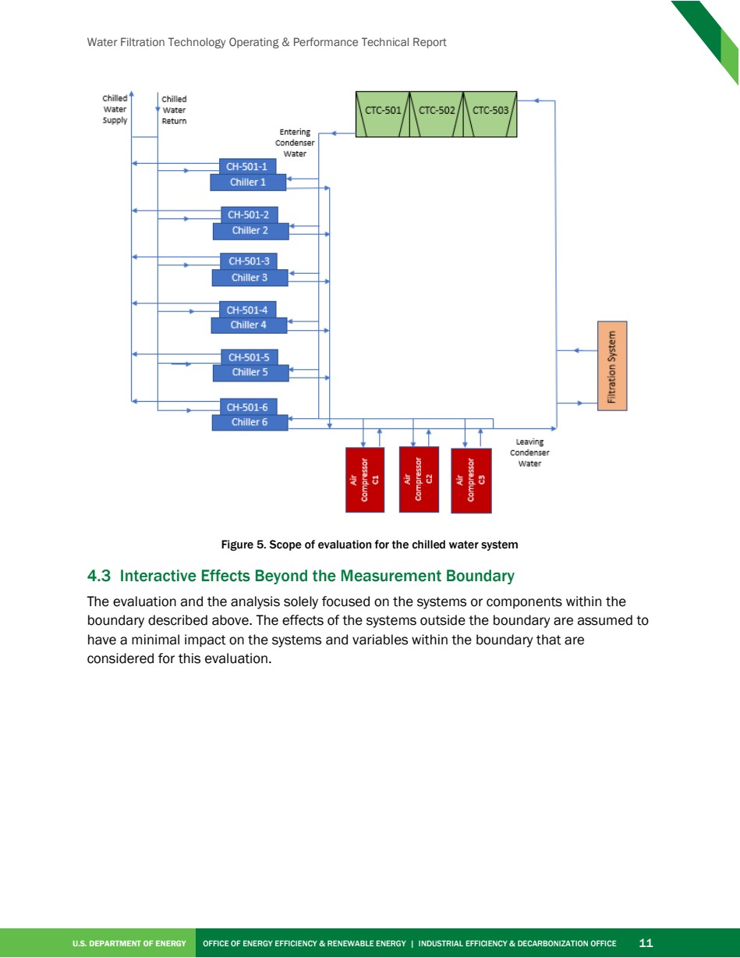

Source PDF page 26 | Toyota ElectroCell
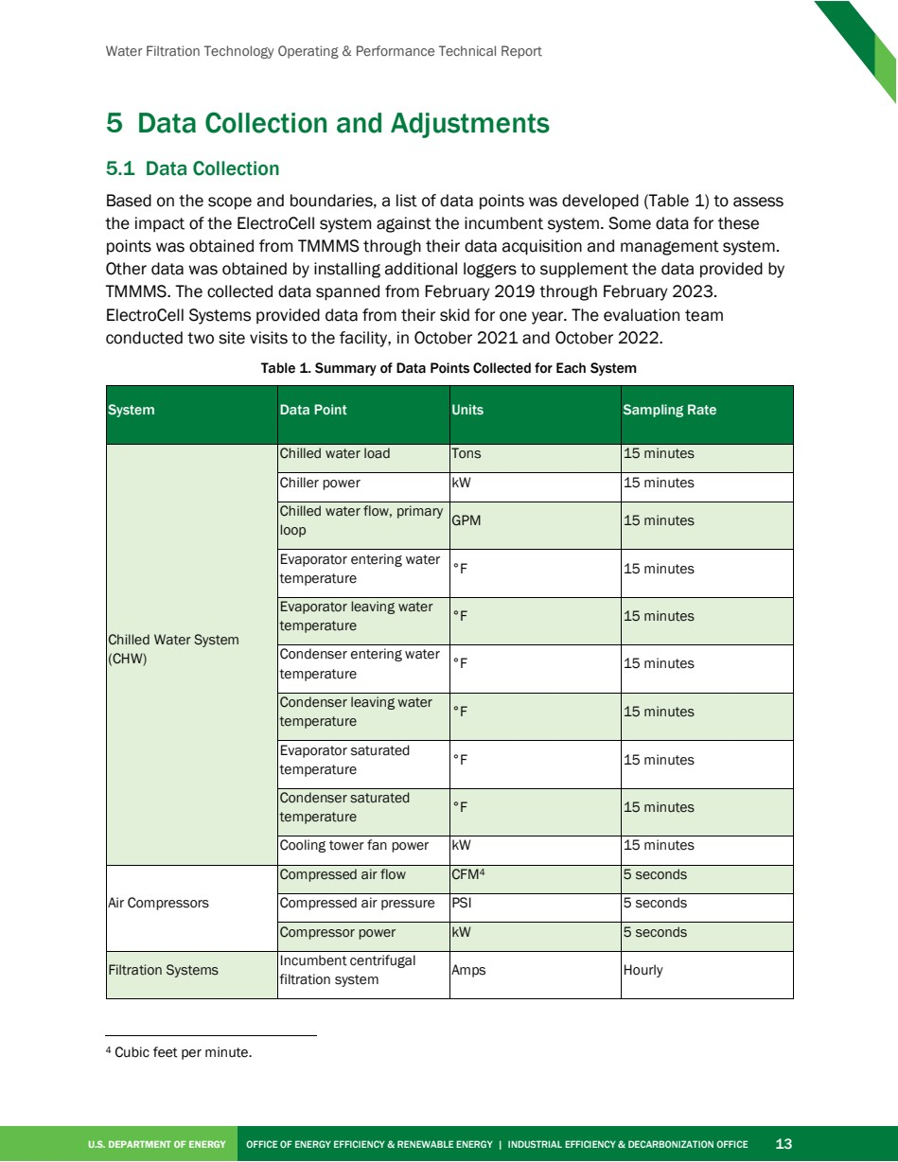

Source PDF page 27 | Toyota ElectroCell
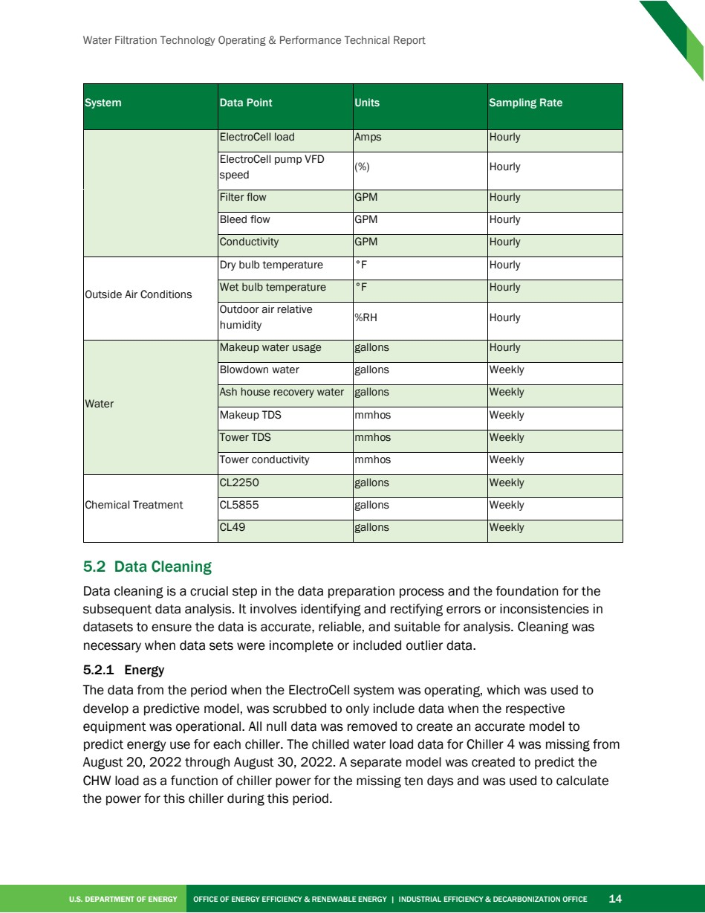

Source PDF page 28 | Toyota ElectroCell
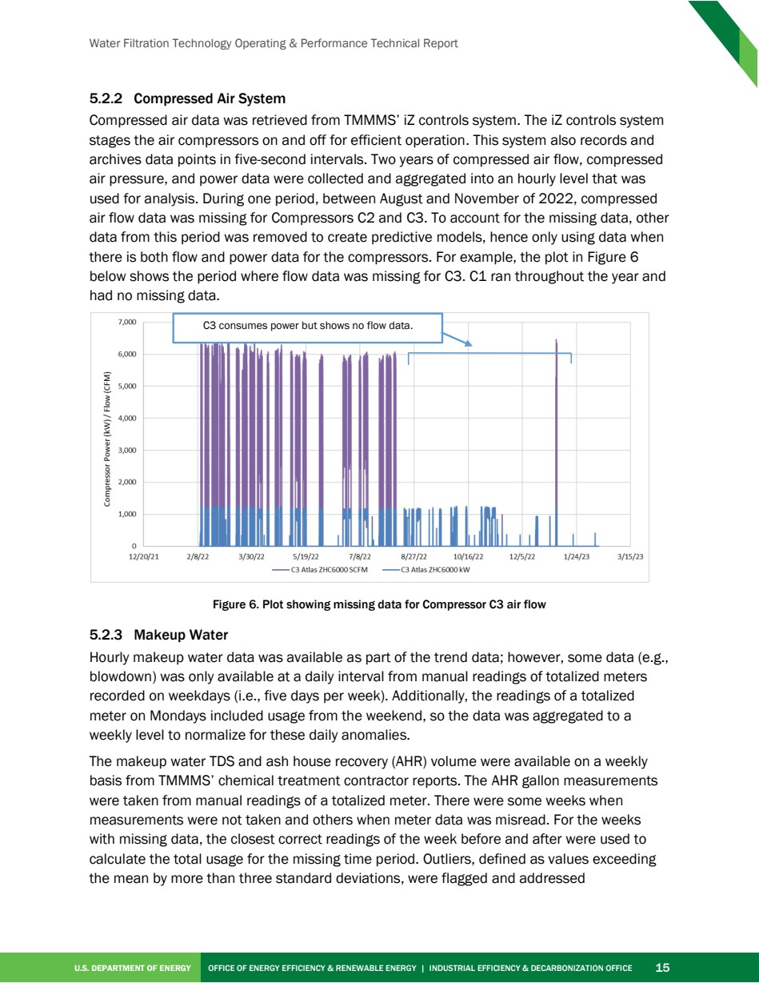

Source PDF page 29 | Toyota ElectroCell
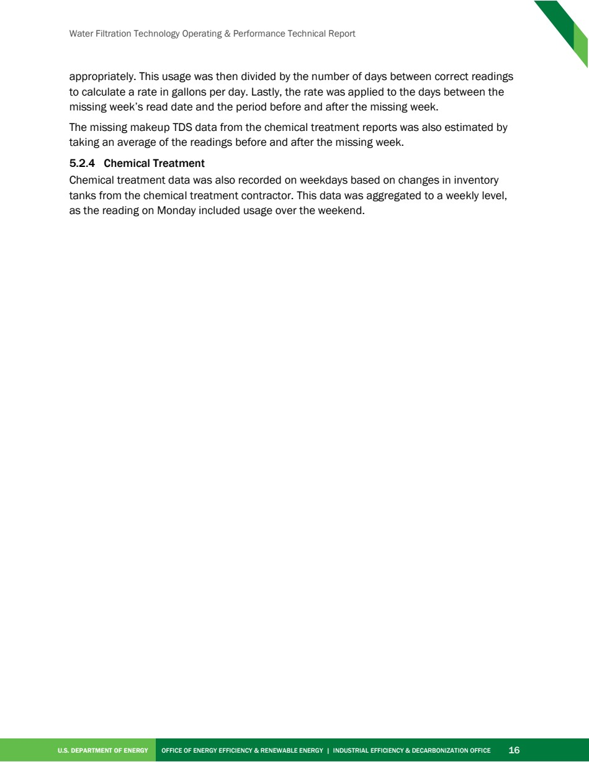

Source PDF page 31 | Toyota ElectroCell
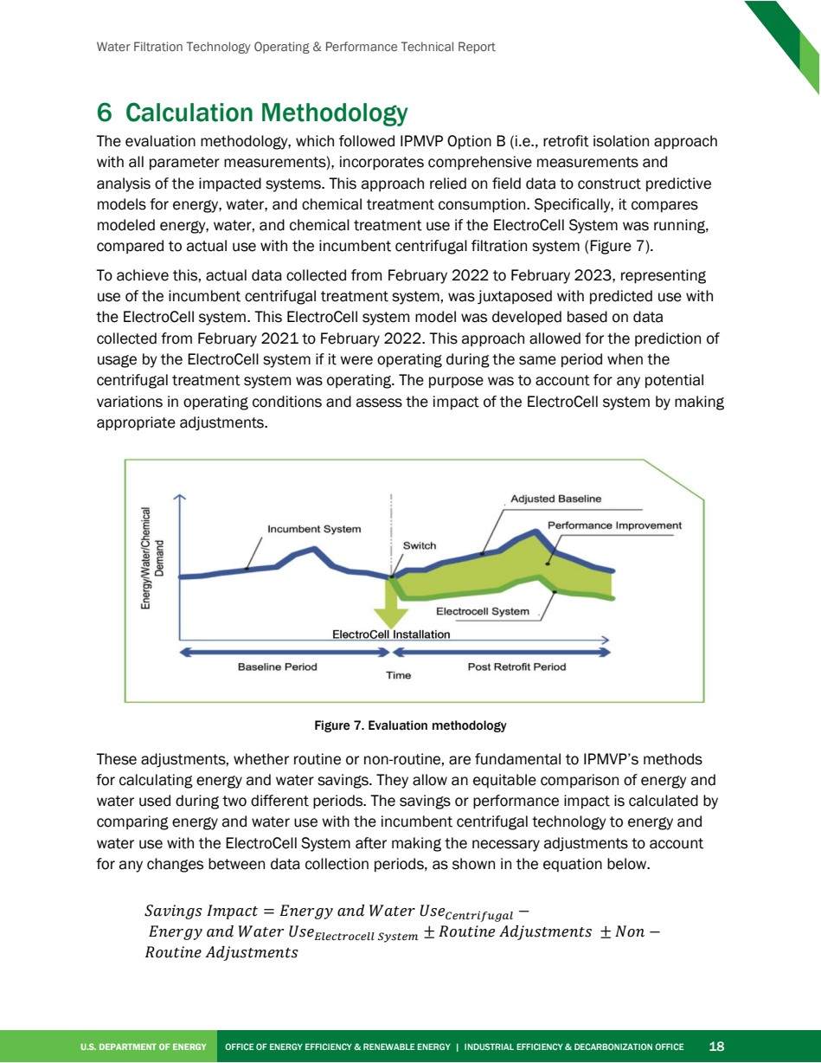

Source PDF page 32 | Toyota ElectroCell
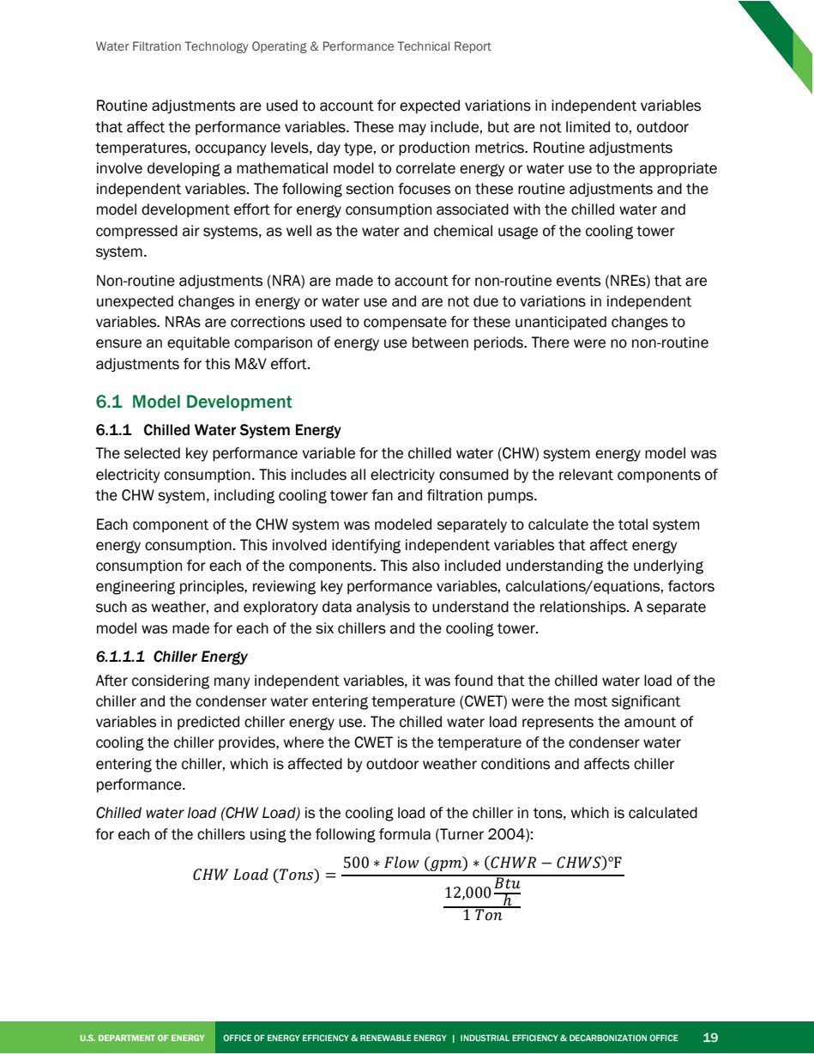

Source PDF page 33 | Toyota ElectroCell
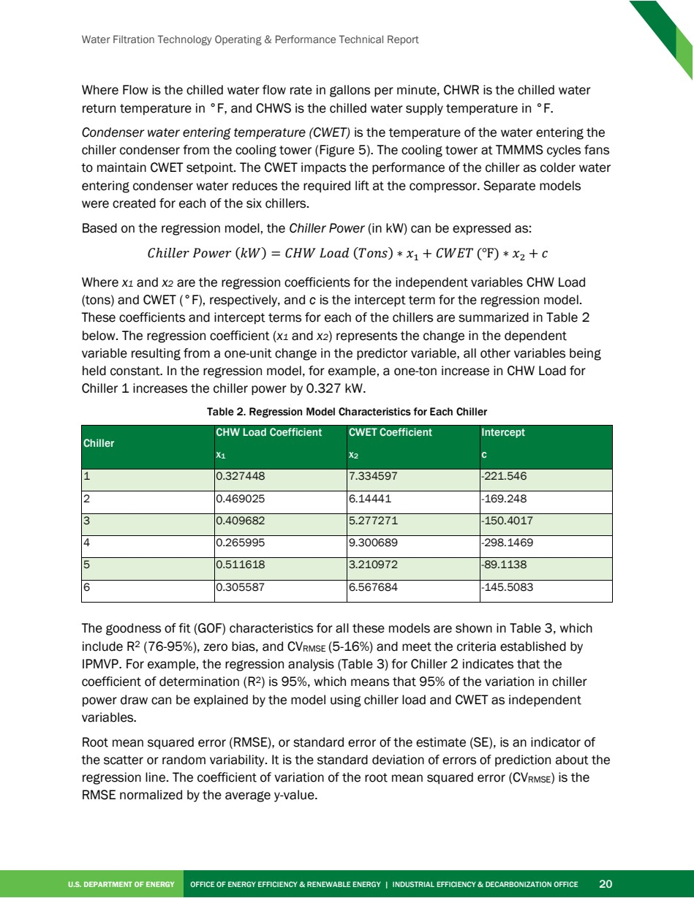

Source PDF page 34 | Toyota ElectroCell
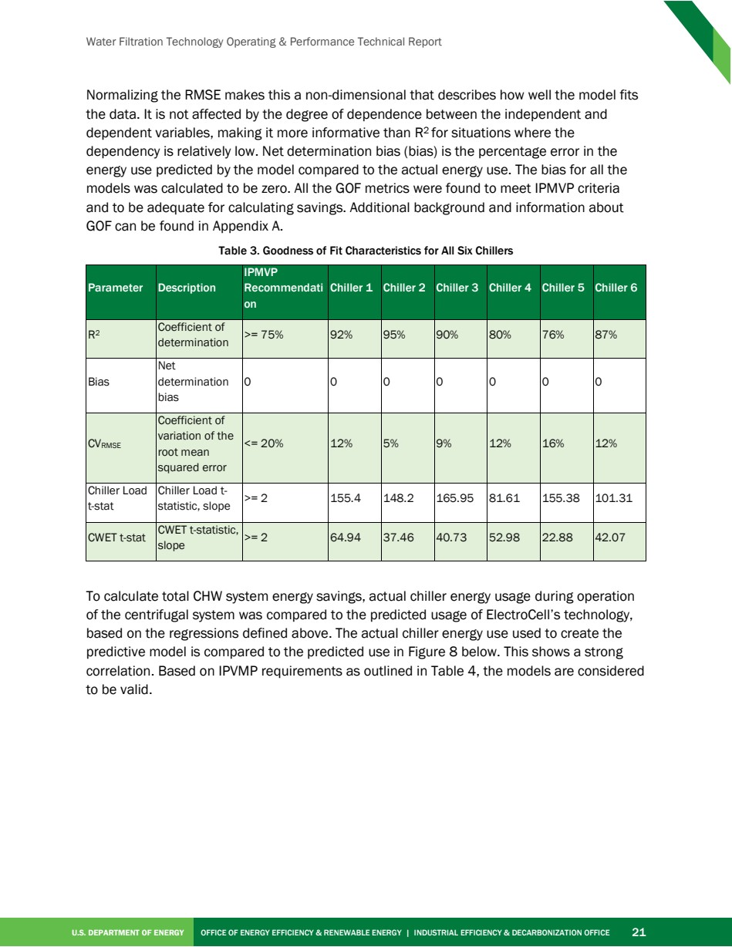

Source PDF page 35 | Toyota ElectroCell
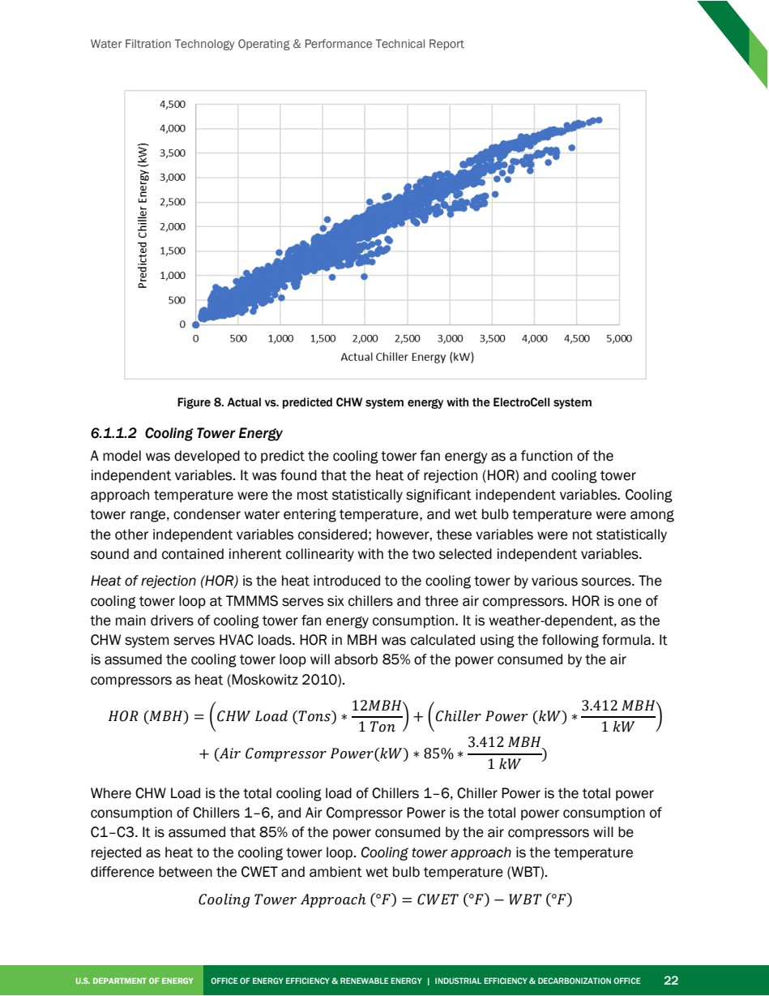

Source PDF page 36 | Toyota ElectroCell
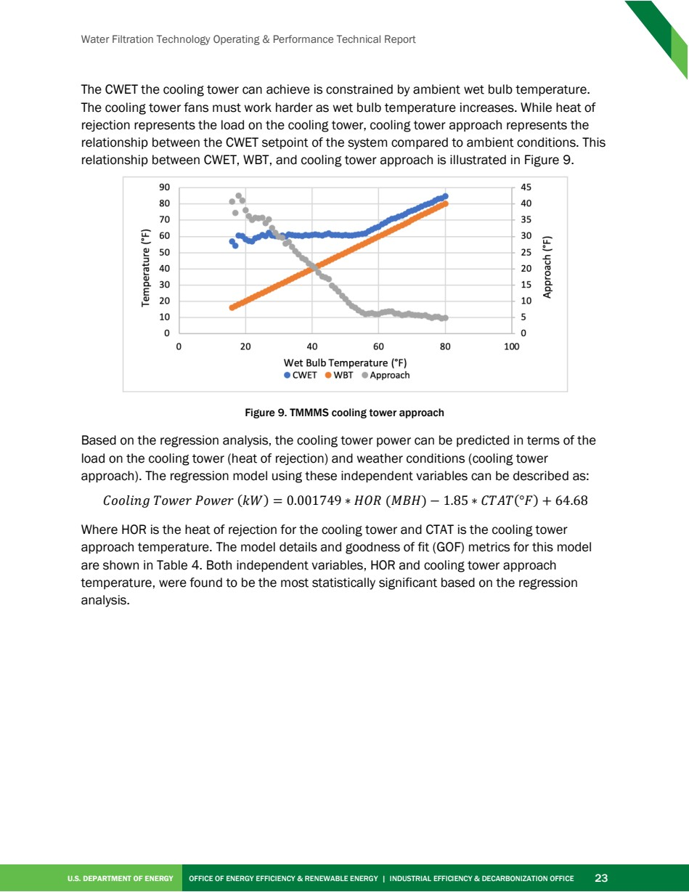

Source PDF page 37 | Toyota ElectroCell
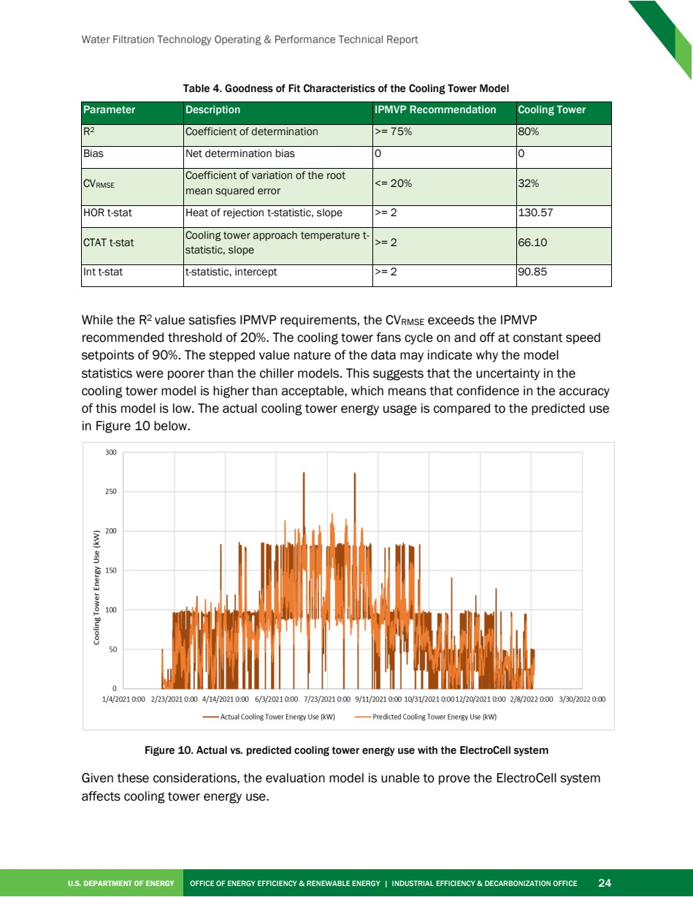

Source PDF page 38 | Toyota ElectroCell
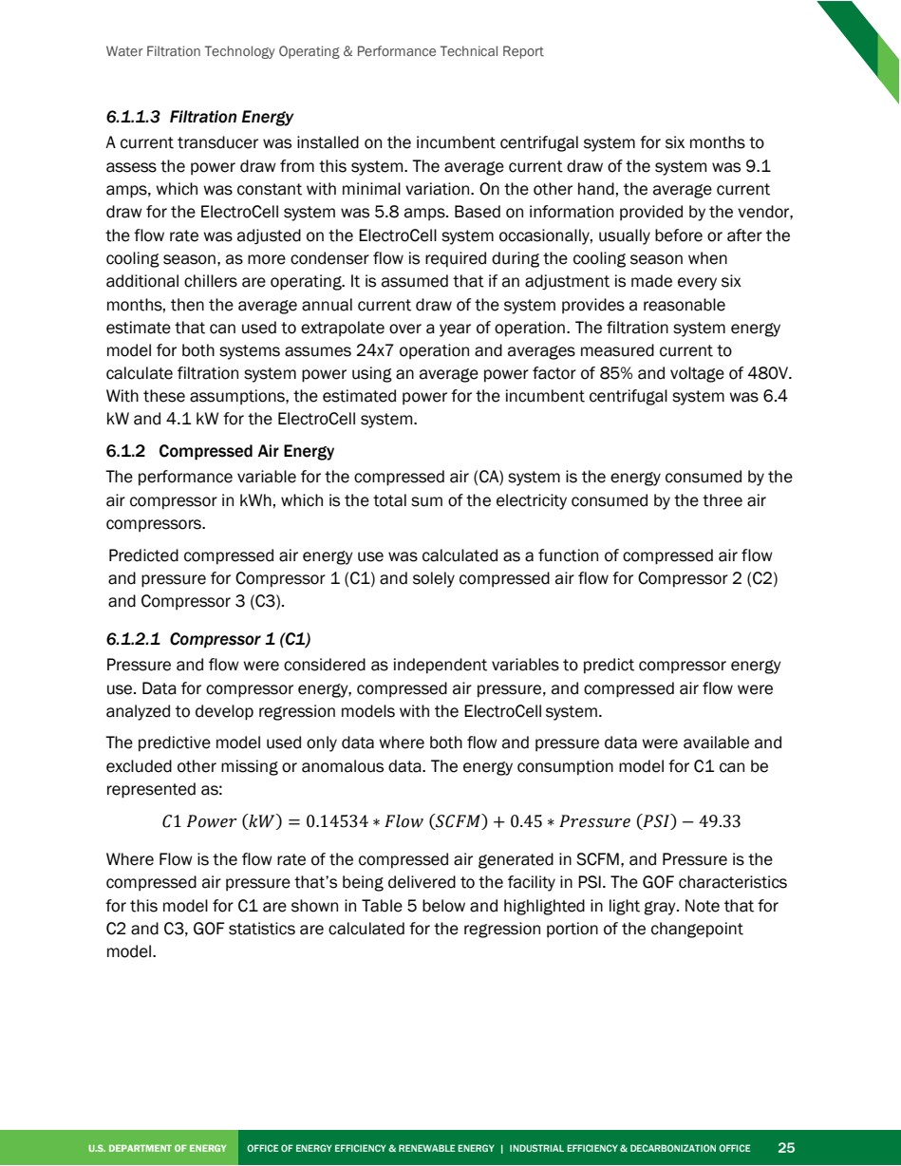

Source PDF page 39 | Toyota ElectroCell
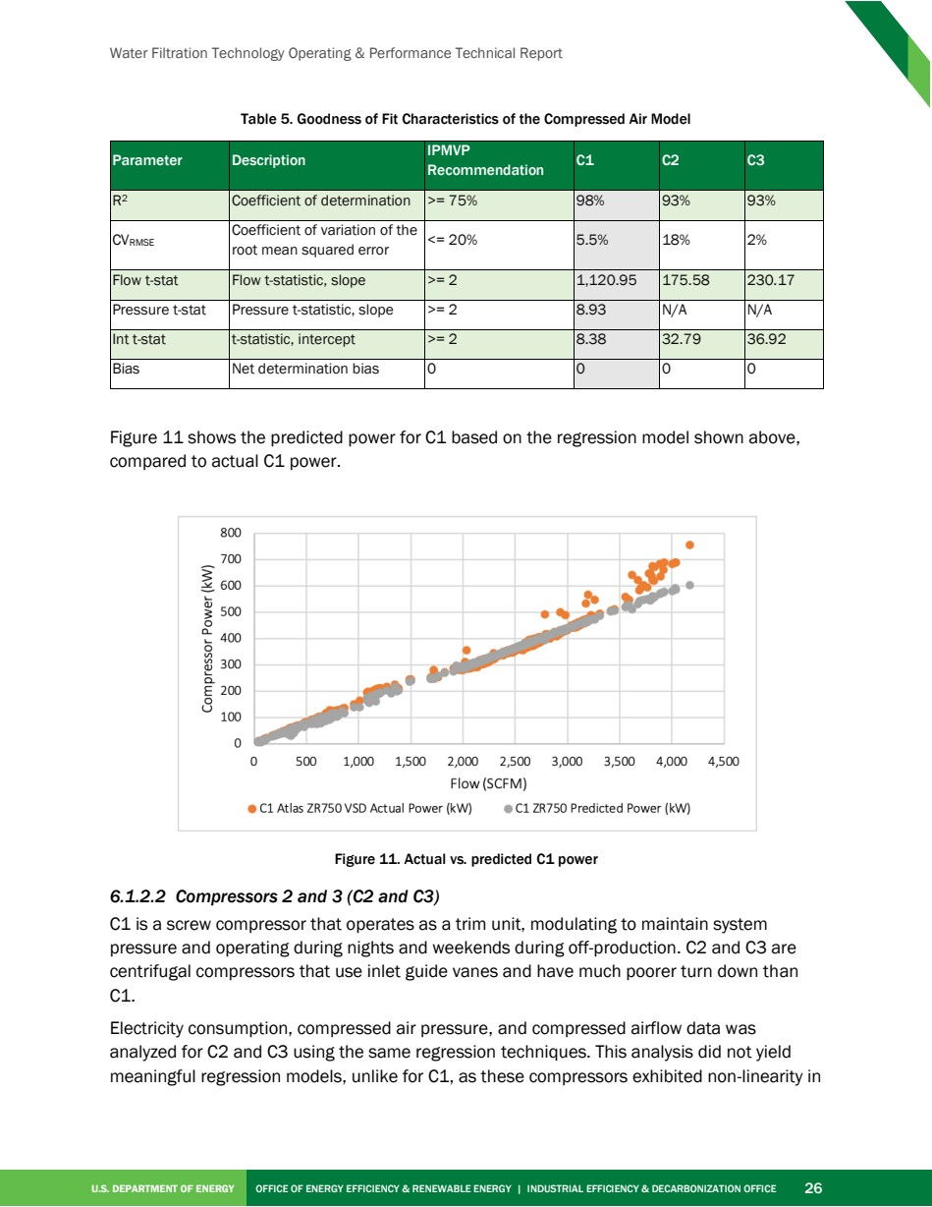

Source PDF page 40 | Toyota ElectroCell
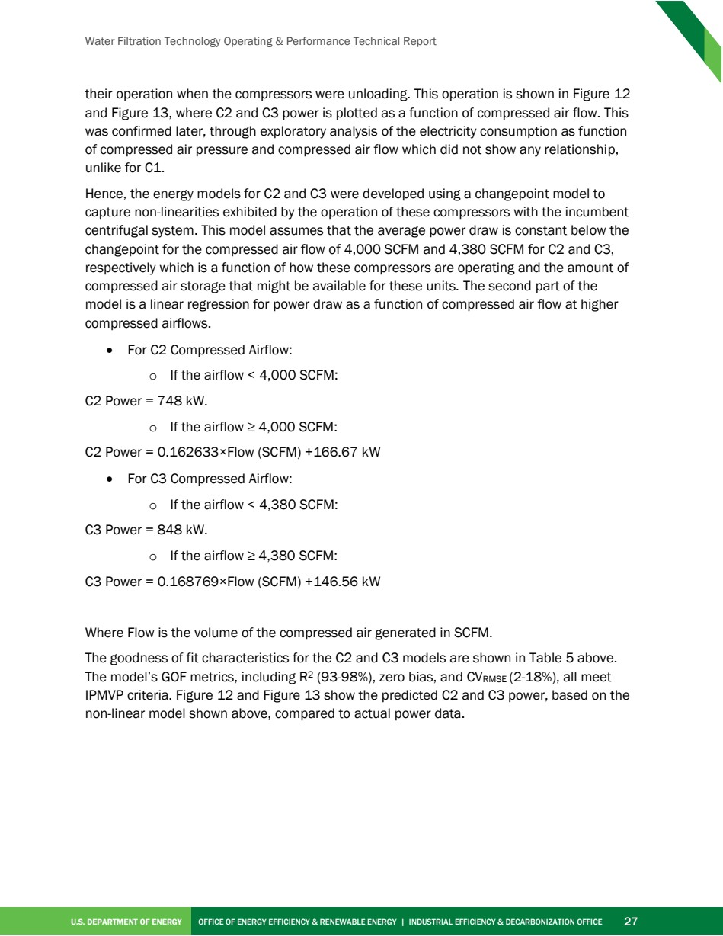

Source PDF page 41 | Toyota ElectroCell
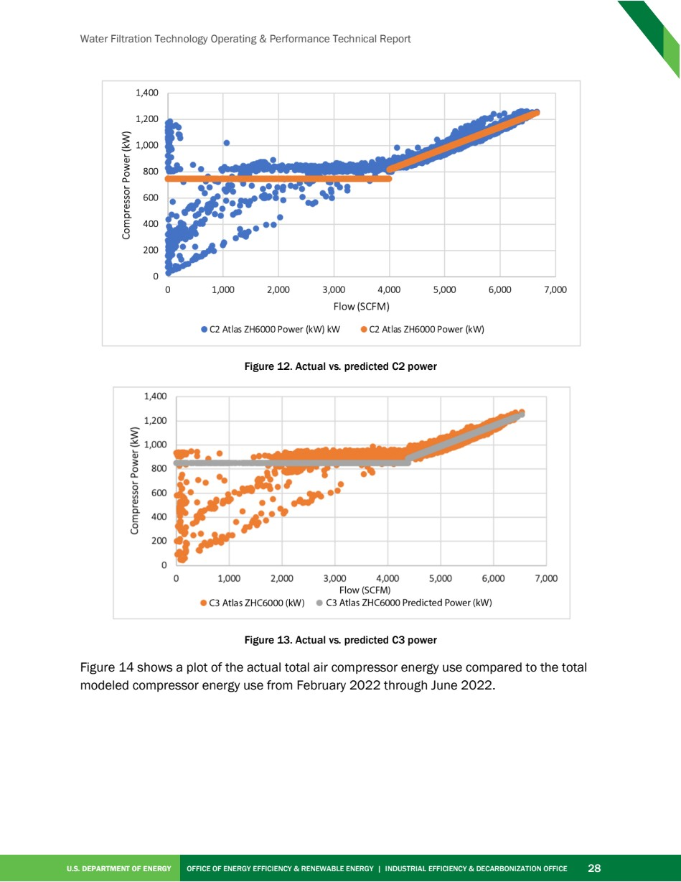

Source PDF page 42 | Toyota ElectroCell
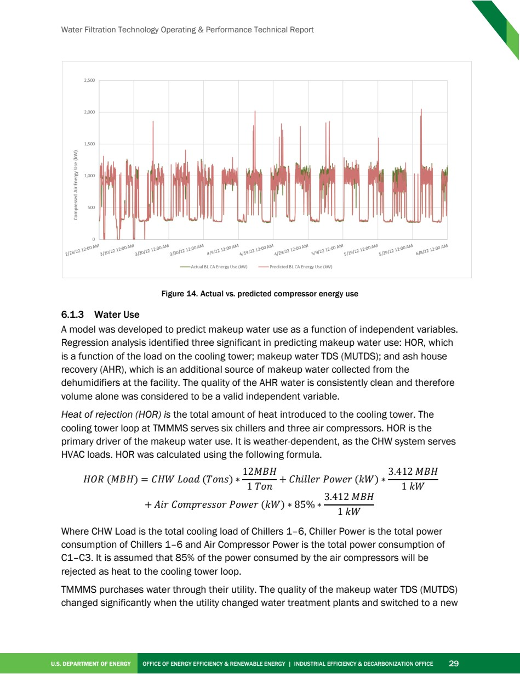

Source PDF page 43 | Toyota ElectroCell
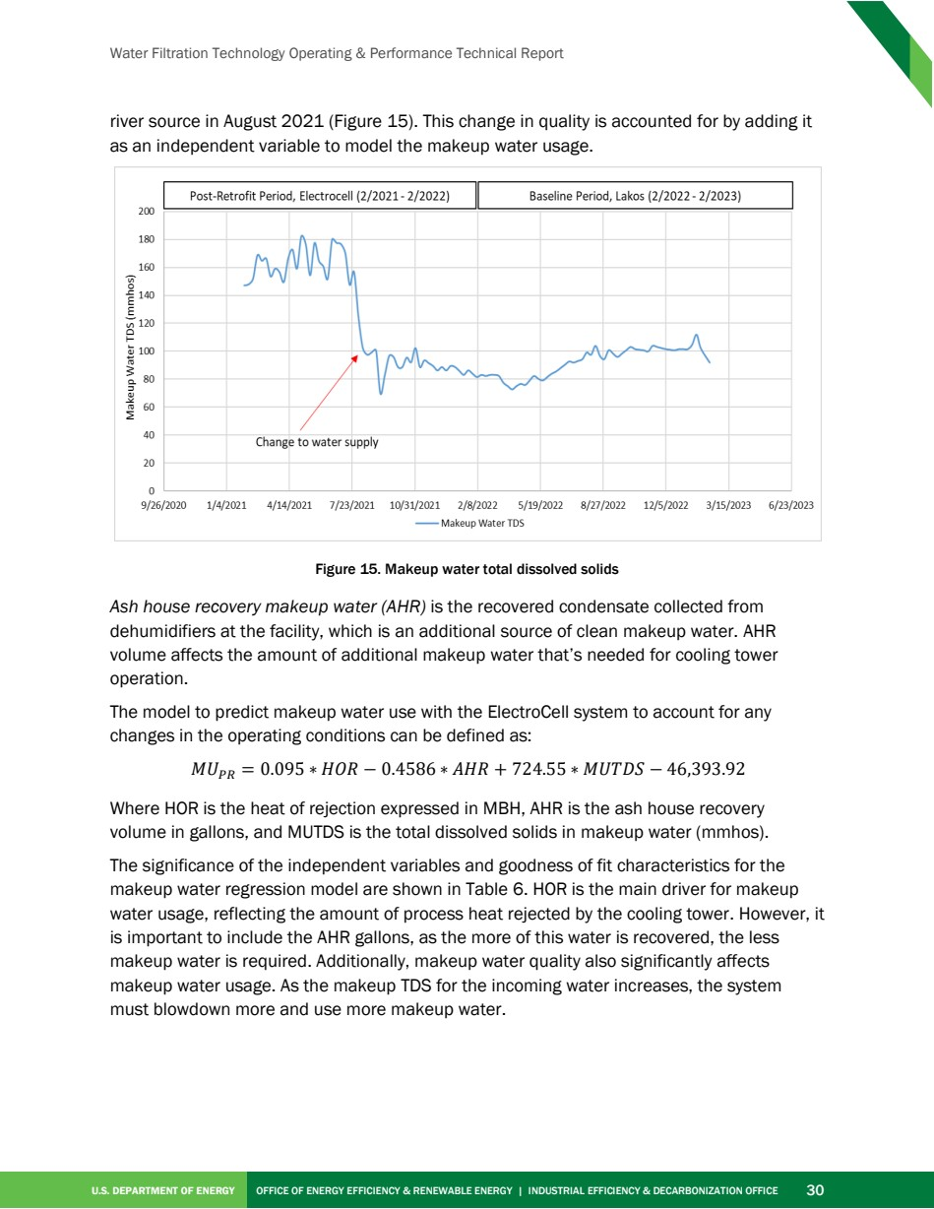

Source PDF page 44 | Toyota ElectroCell
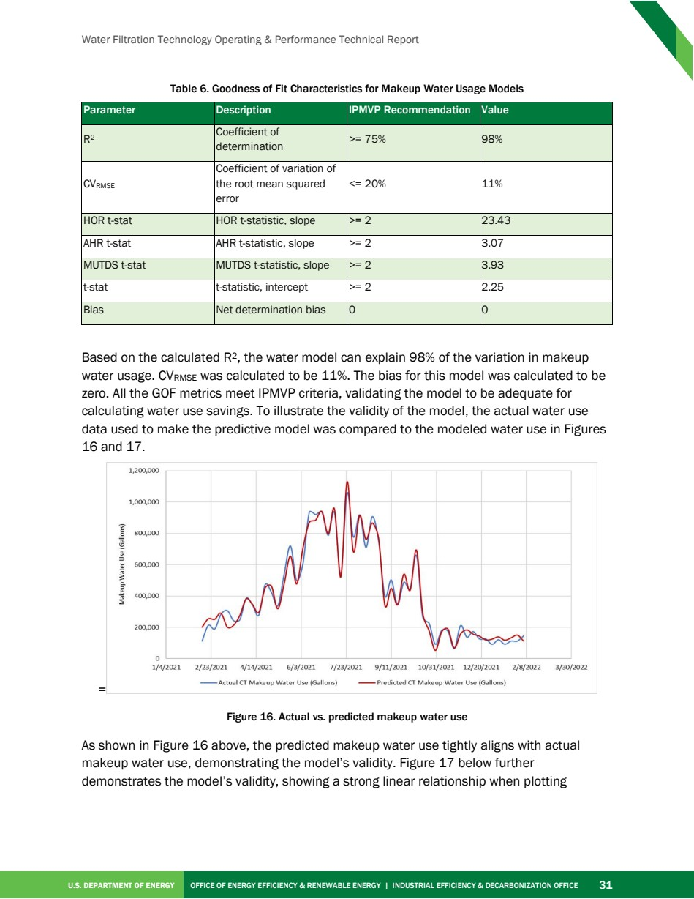

Source PDF page 45 | Toyota ElectroCell
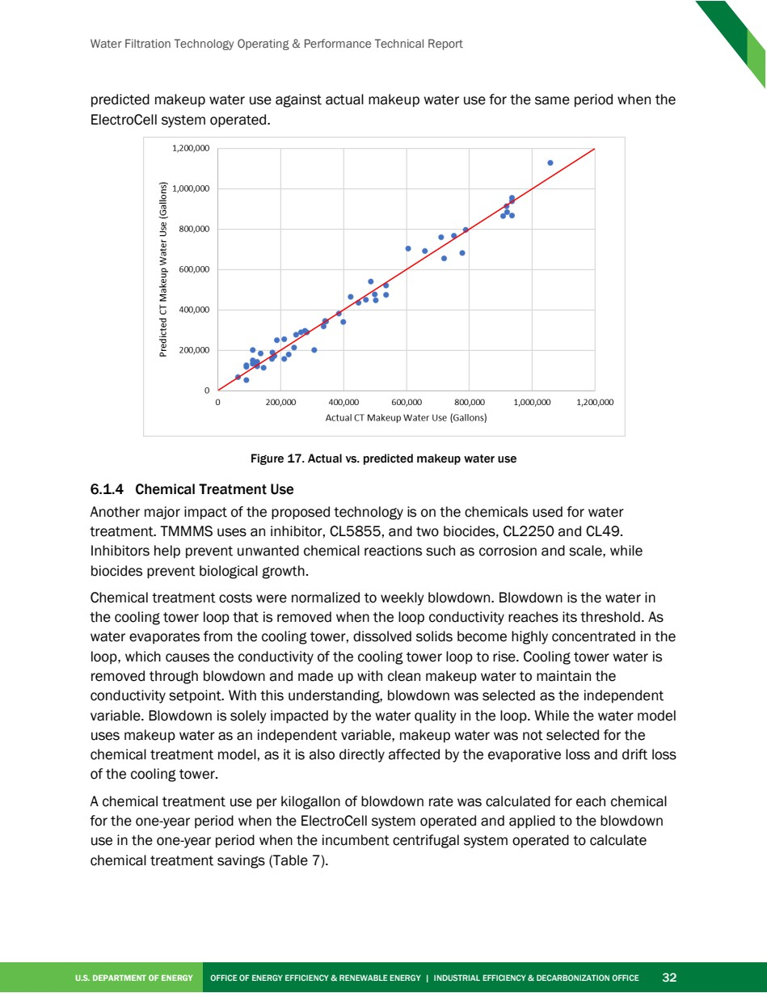

Source PDF page 46 | Toyota ElectroCell
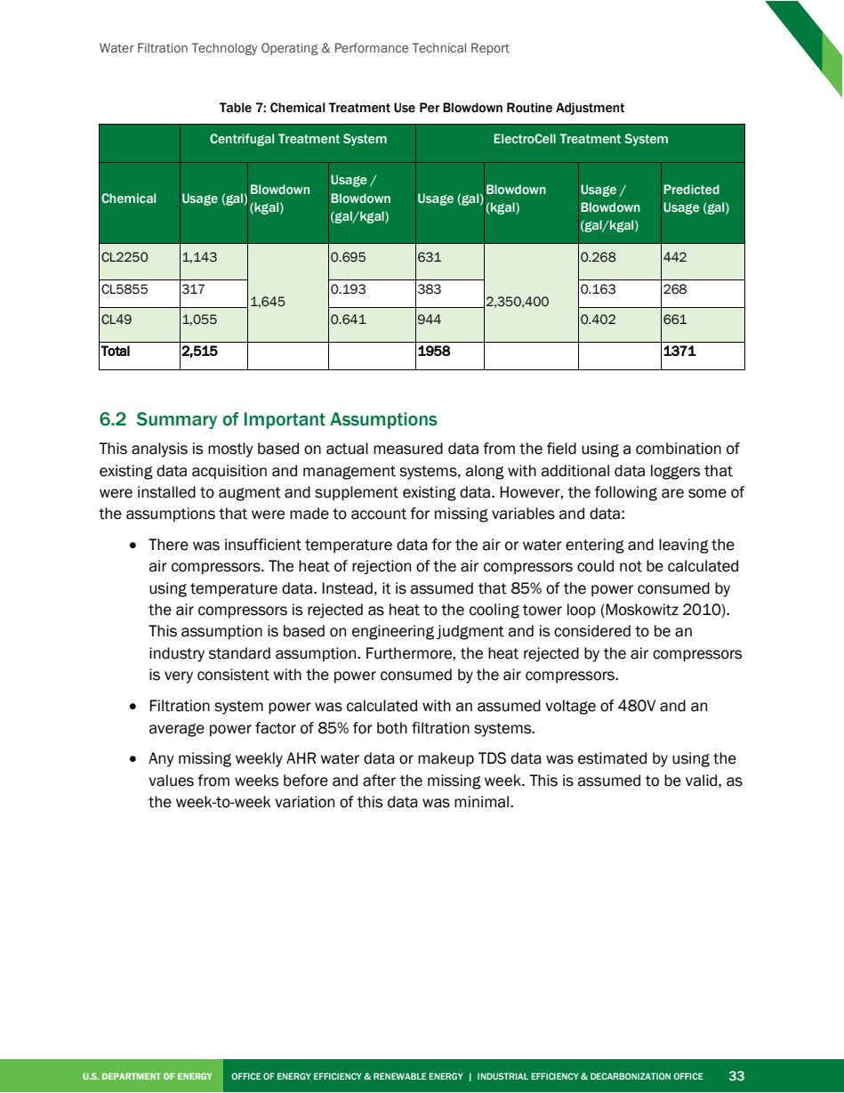

Source PDF page 48 | Toyota ElectroCell
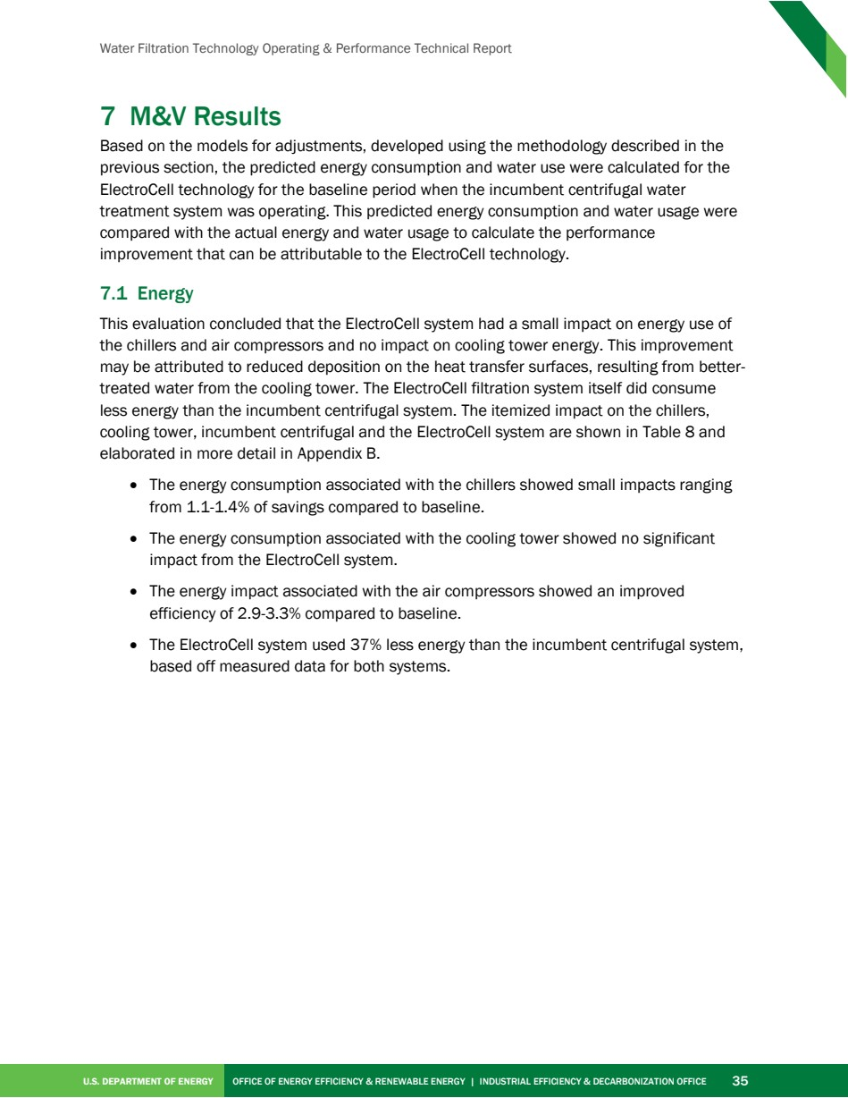

Source PDF page 49 | Toyota ElectroCell
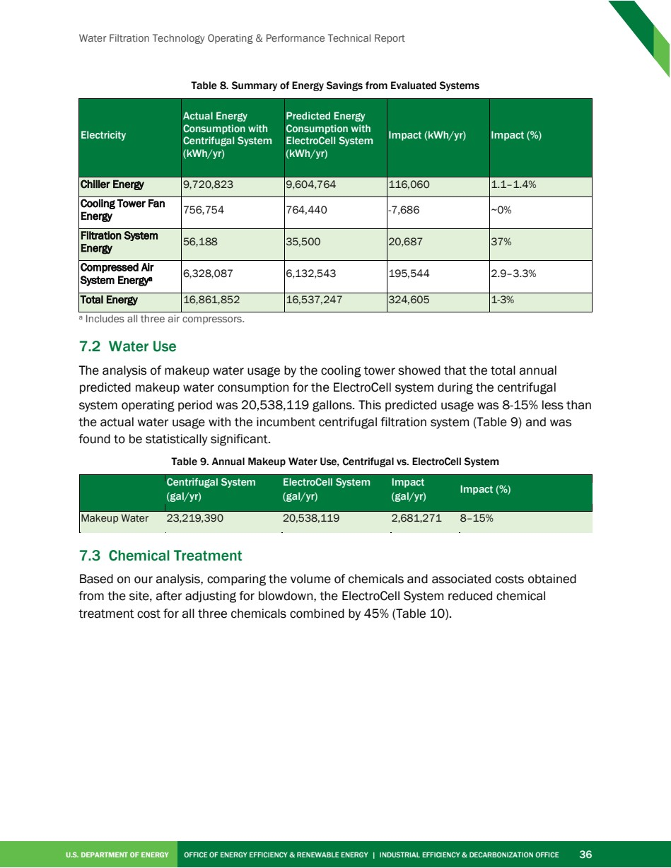

Source PDF page 50 | Toyota ElectroCell
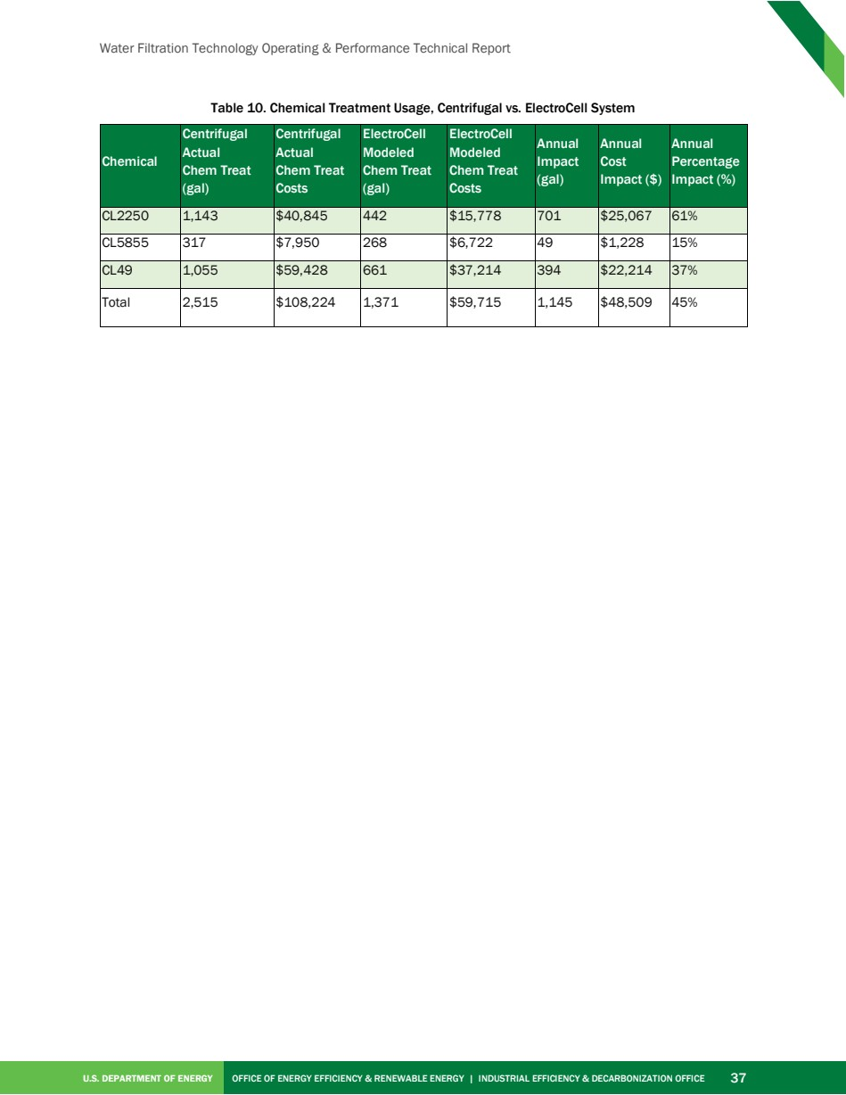

Source PDF page 52 | Toyota ElectroCell
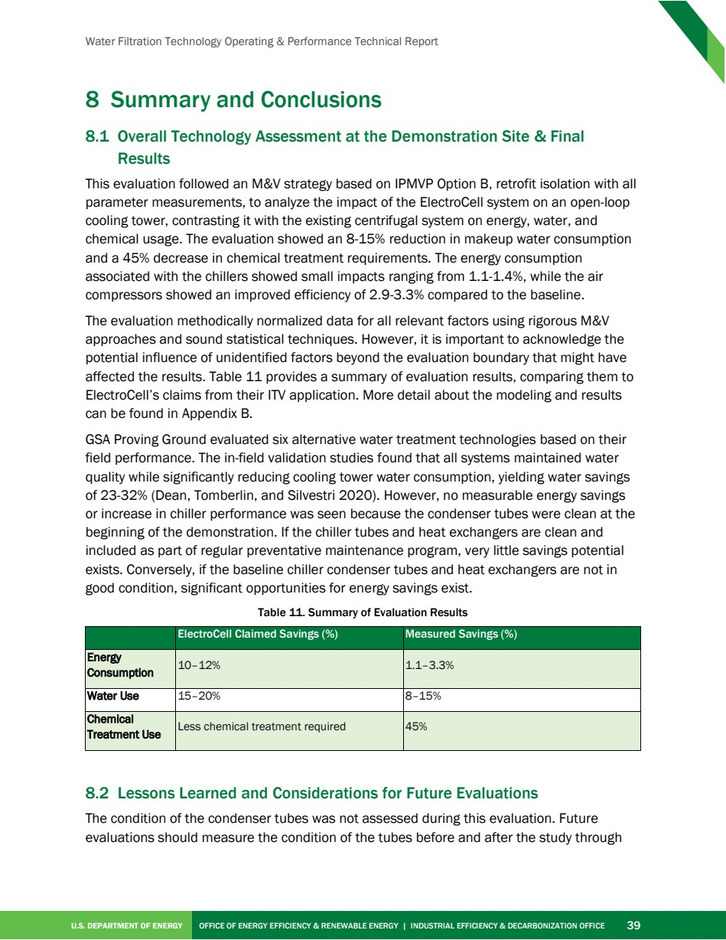

Source PDF page 53 | Toyota ElectroCell
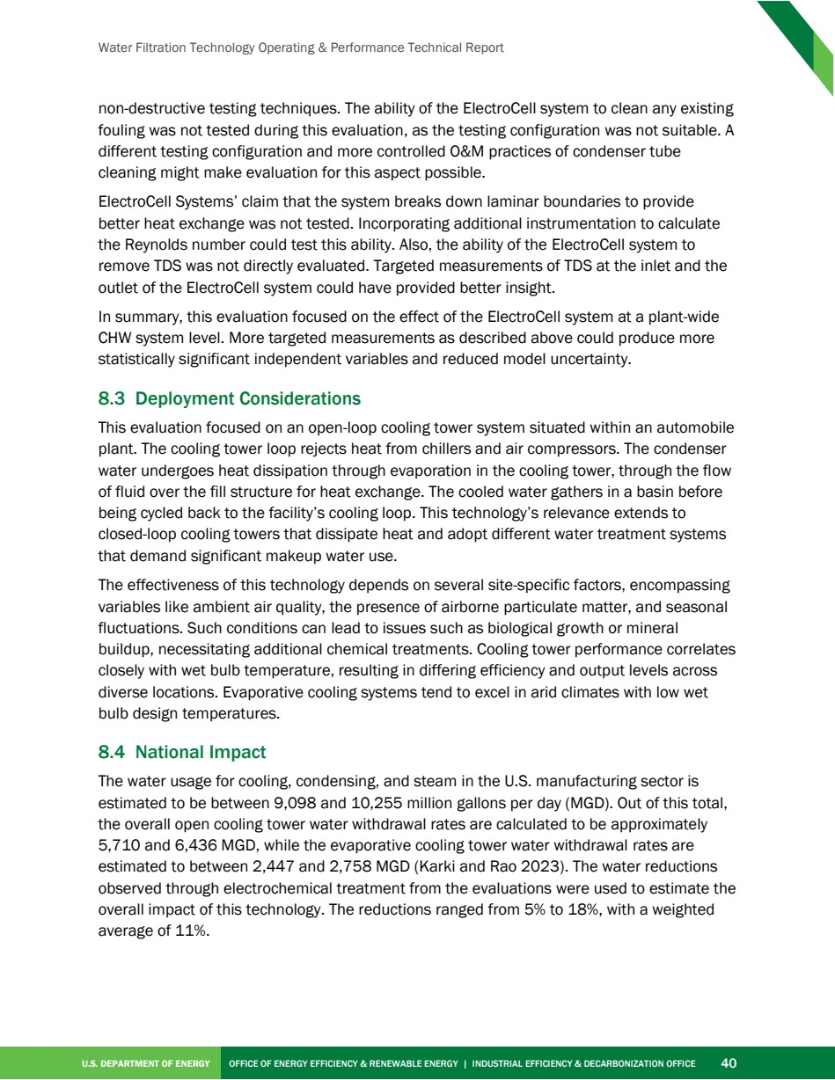

Source PDF page 56 | Toyota ElectroCell
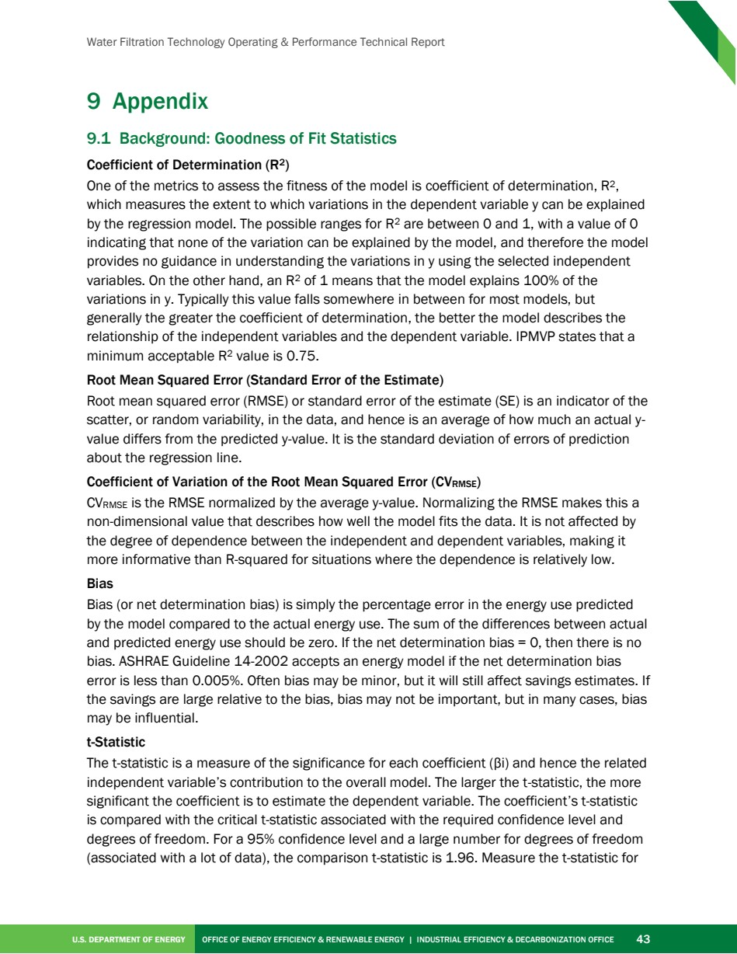

Source PDF page 58 | Toyota ElectroCell
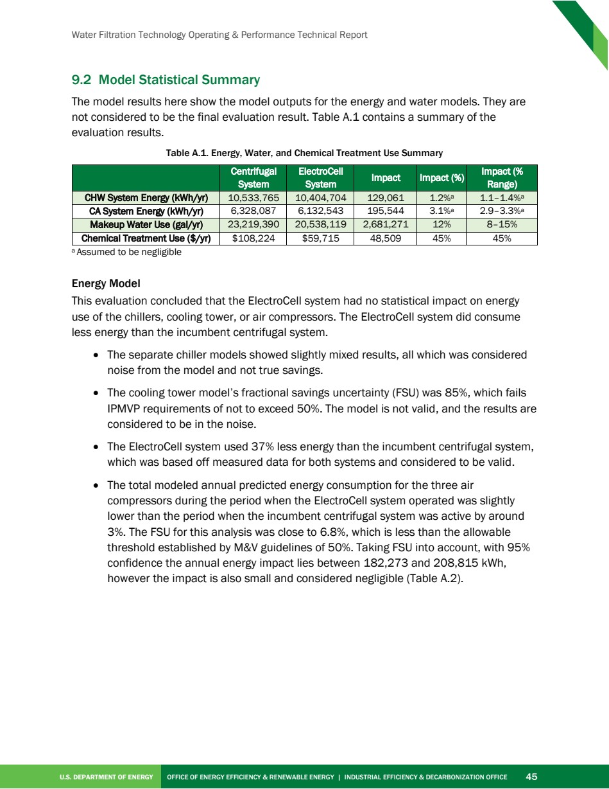

Source PDF page 59 | Toyota ElectroCell
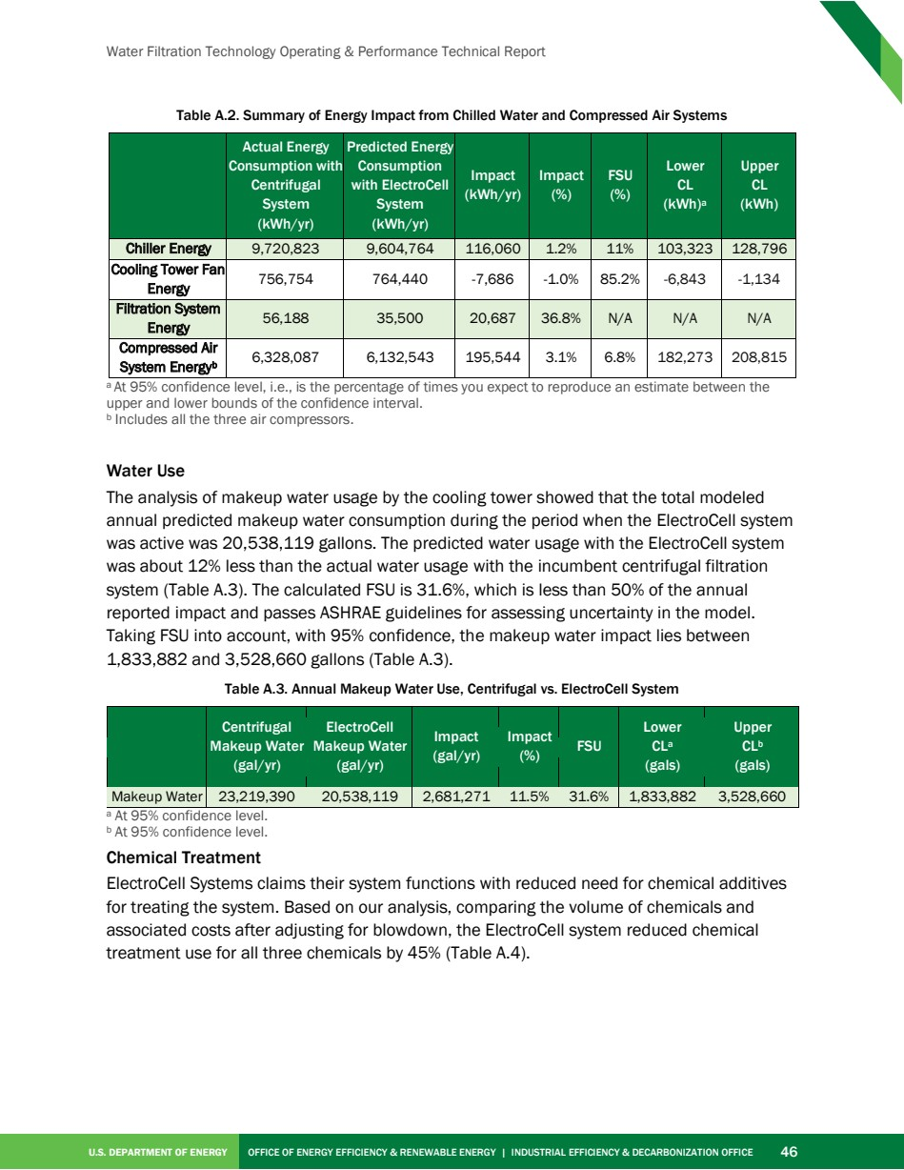

Source PDF page 60 | Toyota ElectroCell
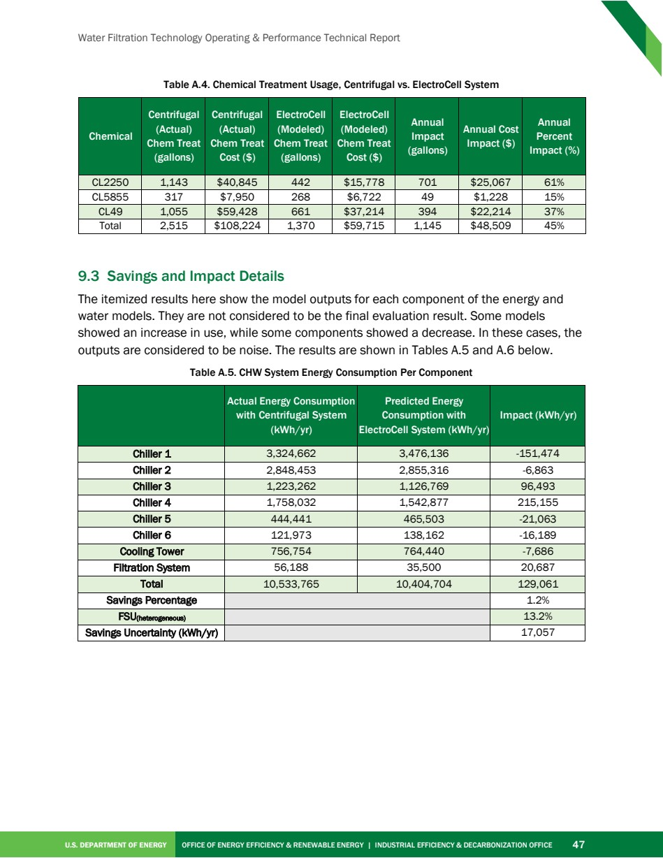

Source PDF page 61 | Toyota ElectroCell
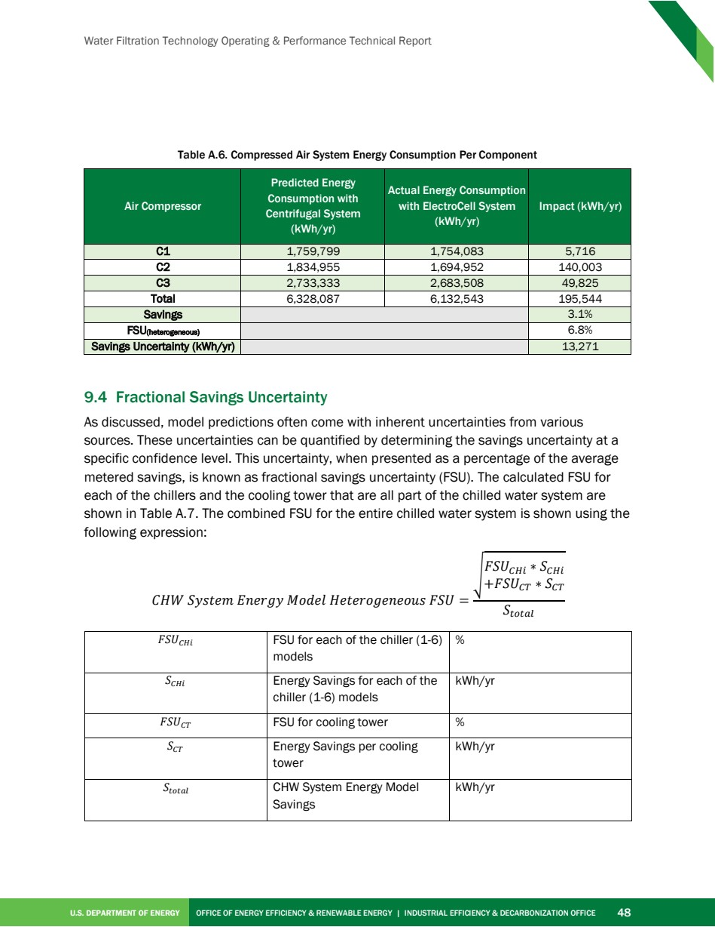

Source PDF page 62 | Toyota ElectroCell
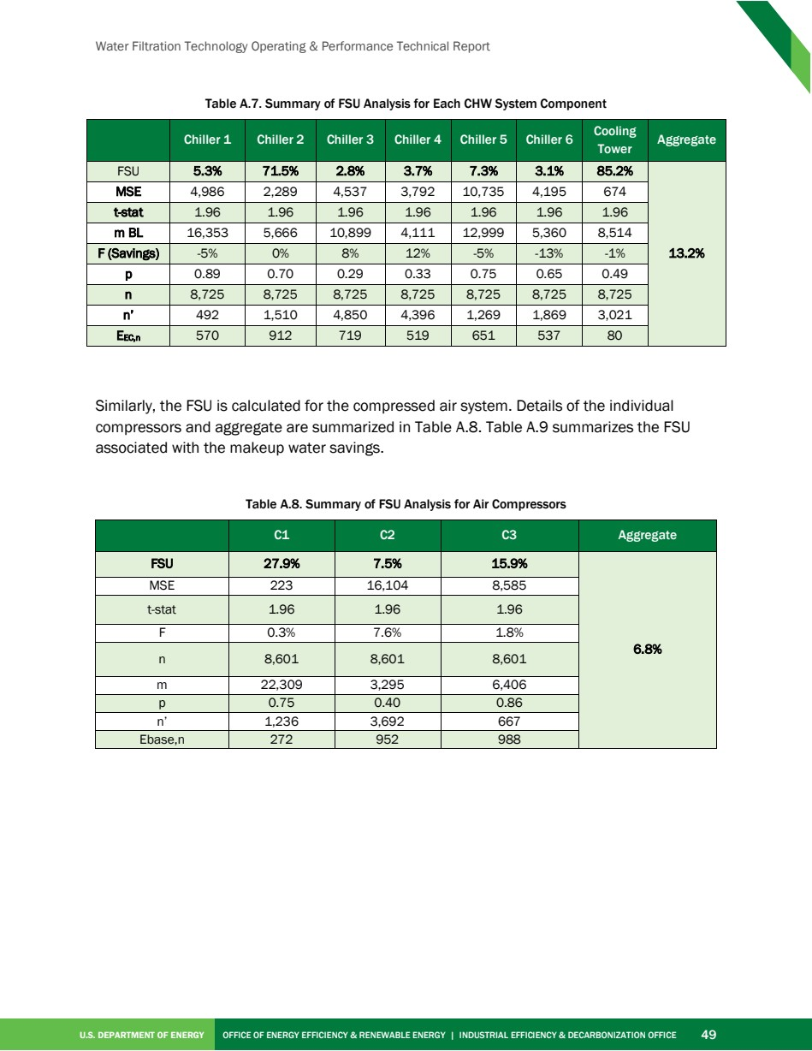

Source PDF page 63 | Toyota ElectroCell
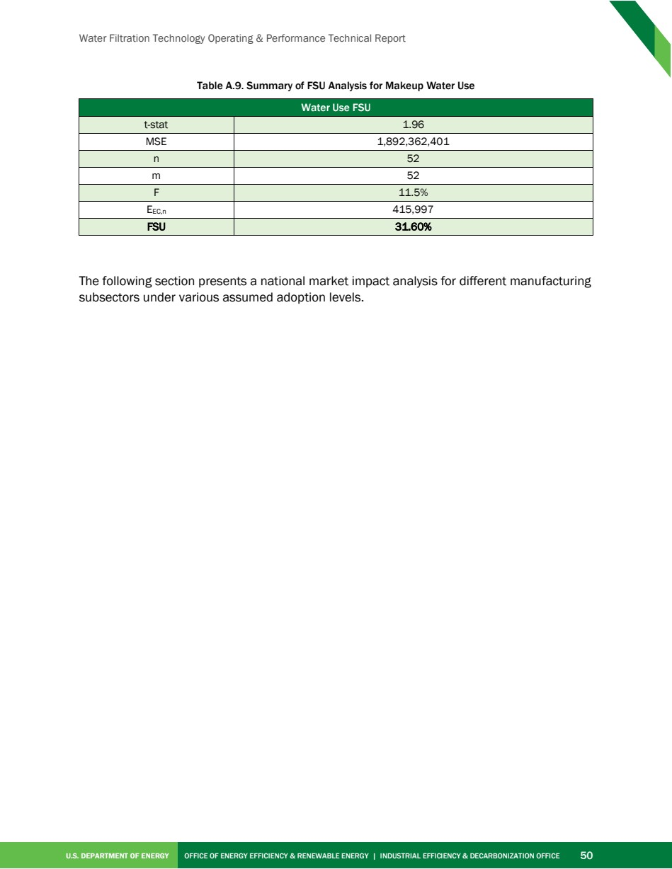

Source PDF page 64 | Toyota ElectroCell


