一、

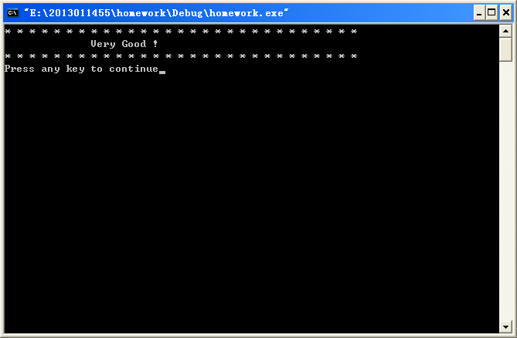#include<stdio.h>

void main()

{

printf("\* \* \* \* \* \* \* \* \* \* \* \* \* \* \* \* \* \* \* \* \* \* \* \* \* \* \* \* \*\n Very Good !\n\* \* \* \* \* \* \* \* \* \* \* \* \* \* \* \* \* \* \* \* \* \* \* \* \* \* \* \* \*\n");

}

二、

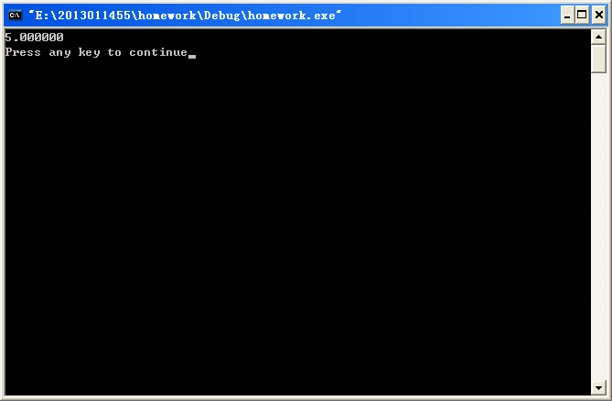

#include<stdio.h>

#include<math.h>

void main()

{

float a,b,y;

a=3;

b=4;

y=sqrt(a\*a+b\*b);

printf("%f\n",y);

}

三、

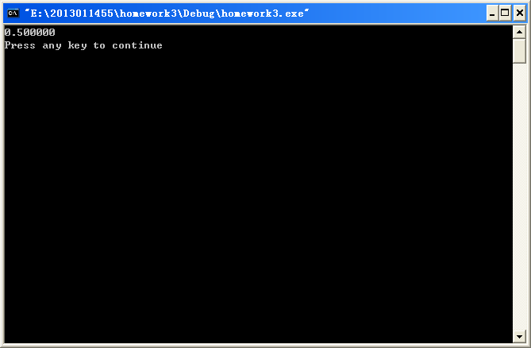

#include<stdio.h>

#include<math.h>

void main()

{

double y;

int a=60;

y=sqrt((1-cos(a\*3.1415926/180))/2);

printf("%f\n",y);

}

四、

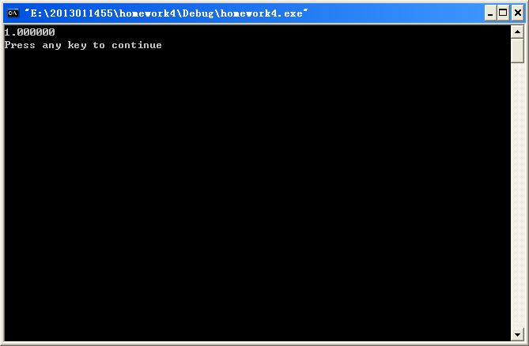

#include<stdio.h>

#include<math.h>

void main()

{

double a=2.0,b=1.0,c=-1.0,y,z;

int x=45;

z=x\*3.1415926/180;

y=a\*sin(z)\*sin(z)+b\*sin(z)\*cos(z)+c\*cos(z)\*cos(z);

printf("%f\n",y);

}

五、

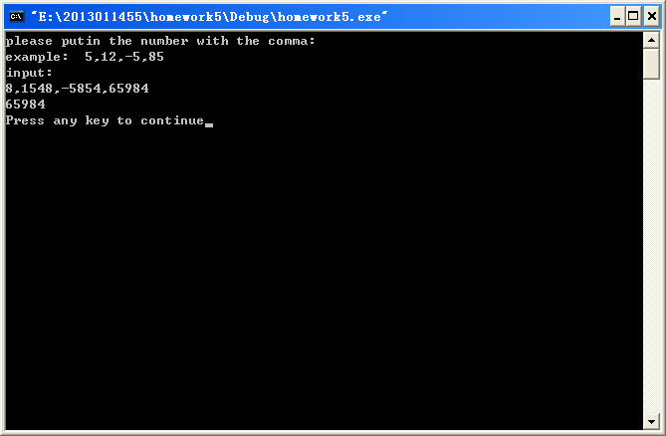

#include<stdio.h>

int max(int a,int b,int c,int d)

{

int x;

if(a>b)

x=a;

else

x=b;

if(c>x)

x=c;

if(d>x)

x=d;

return(x);

}

void main()

{

int a,b,c,d;

printf("please putin the number with the comma:\nexample: 5,12,-5,85\ninput:\n");

scanf("%d,%d,%d,%d",&a,&b,&c,&d);

printf("%d\n",max(a,b,c,d));

}

六、

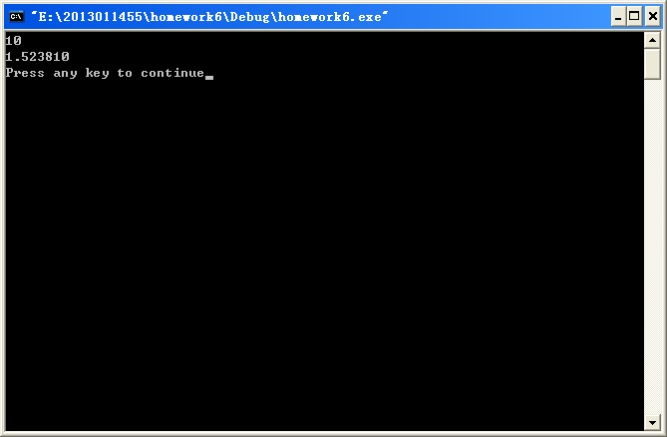

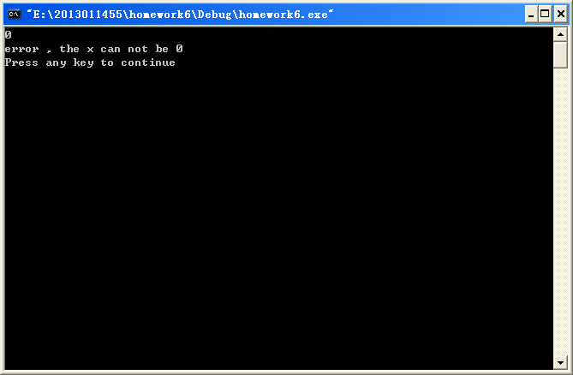

#include<stdio.h>

void main()

{

double x,y;

scanf("%lf",&x);

if(x==0)

printf("error , the x can not be 0\n"); //检验是否为0

else

{

y=1+1/(1+1/(1+1/x));

printf("%f\n",y);

}

}