一、

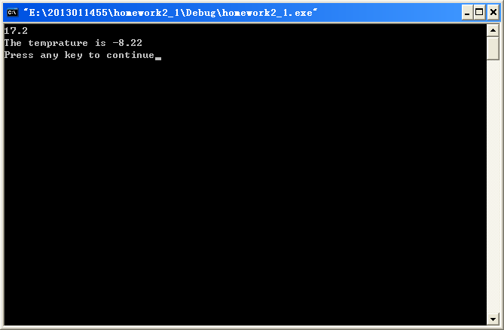

#include<stdio.h>

void main()

{

float f;

scanf("%f",&f);

printf("The temprature is %.2f\n",5*(f-32)/9);

}

二、

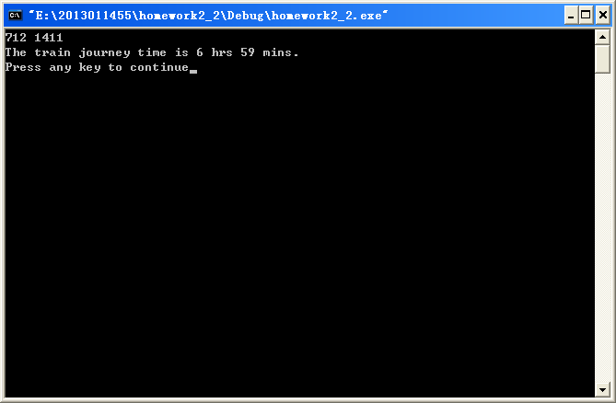

#include<stdio.h>

void main()

{

int start,end,h1,m1,h2,m2,time;

scanf("%d %d",&start,&end);

h1=(start-start%100)/100;

h2=(end-end%100)/100;

m1=start%100;

m2=end%100;

time=h2*60+m2-h1*60-m1;

printf("The train journey time is %d hrs %d mins.\n",(time-time%60)/60,time%60);

}

三、

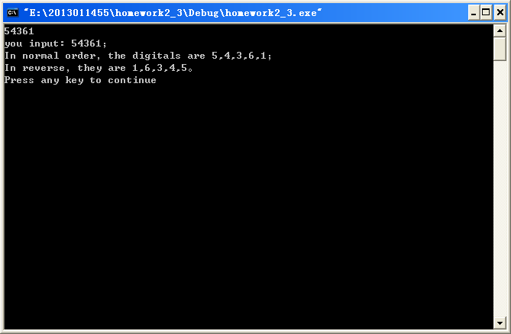

#include<stdio.h>

void main()

{

char a[5];

scanf("%s",a);

printf("you input: %s；\nIn normal order，the digitals are %c,%c,%c,%c,%c；\n",a,a[0],a[1],a[2],a[3],a[4]);

printf("In reverse，they are %c,%c,%c,%c,%c。\n",a[4],a[3],a[2],a[1],a[0]);

}

四、

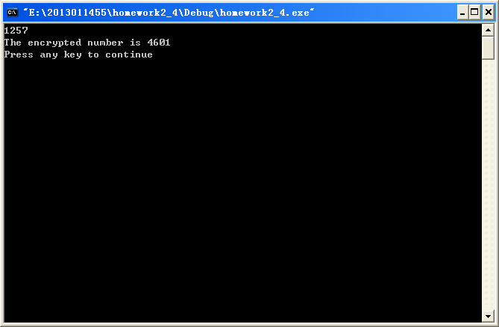

#include<stdio.h>

void main()

{

int a[4],i;

for(i=0;i<=3;i++)

{

scanf("%1d",&a[i]);

a[i]=(a[i]+9)%10;

}

printf("The encrypted number is %d%d%d%d\n",a[2],a[3],a[0],a[1]);

}

五、

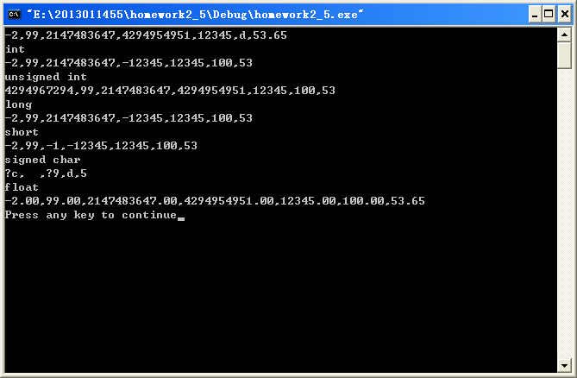#include<stdio.h>

void main()

{

inta,b,c;

unsignedintd,e;

char f;

float g;

scanf("%d,%d,%d,%u,%u,%c,%f",&a,&b,&c,&d,&e,&f,&g);

printf("int\n%d,%d,%d,%d,%d,%d,%d\n",(int)a,(int)b,(int)c,(int)d,(int)e,(int)f,(int)g);

printf("unsigned int\n%u,%u,%u,%u,%u,%u,%u\n",(unsigned int)a,(unsigned int)b,(unsigned int)c,(unsigned int)d,(unsigned int)e,(unsigned int)f,(unsigned int)g);

printf("long\n%ld,%ld,%ld,%ld,%ld,%ld,%ld\n",(long)a,(long)b,(long)c,(long)d,(long)e,(long)f,(long)g);

printf("short\n%d,%d,%d,%d,%d,%d,%d\n",(short)a,(short)b,(short)c,(short)d,(short)e,(short)f,(short)g);

printf("signed char\n%c,%c,%c,%c,%c,%c,%c\n",(signed char)a,(signed char)b,(signed char)c,(signed char)d,(signed char)e,(signed char)f,(signed char)g);

printf("float\n%.2f,%.2f,%.2f,%.2f,%.2f,%.2f,%.2f\n",(float)a,(float)b,(float)c,(float)d,(float)e,(float)f,(float)g);

}

六、

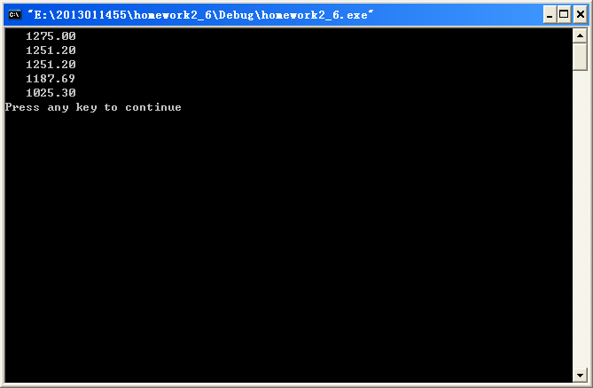

#include<stdio.h>

void main()

{

floata,b,c,d,e;

e=1000;

inti;

a=1000*(1+5*0.055);

b=(1000*(1+2*0.044))*(1+3*0.05);

c=(1000*(1+3*0.05))*(1+2*0.044);

d=1000*(1+0.035)*(1+0.035)*(1+0.035)*(1+0.035)*(1+0.035);

for(i=1;i<=20;i++)

e=e*(1+0.005/4);

printf("%10.2f\n%10.2f\n%10.2f\n%10.2f\n%10.2f\n",a,b,c,d,e);

}

七、1、

|  |  |  |  |
| --- | --- | --- | --- |
| 十进制 | 二进制 | 八进制 | 十六进制 |
| 10 | 1010 | 12 | A |
| 32 | 100000 | 40 | 20 |
| 75 | 1001011 | 113 | 4B |
| 2483 | 100110110011 | 4663 | 9B3 |
| 21003 | 101001000001011 | 51013 | 520B |

2、

|  |  |
| --- | --- |
| 十进制 | 补码 |
| -111 | 111111111111 1111 1111 1111 1001 0001 |
| -617 | 1111 1111 1111 1111 1111 1101 1001 0111 |
| -28654 | 1111 1111 1111 1111 1001 0000 0001 0010 |

八、

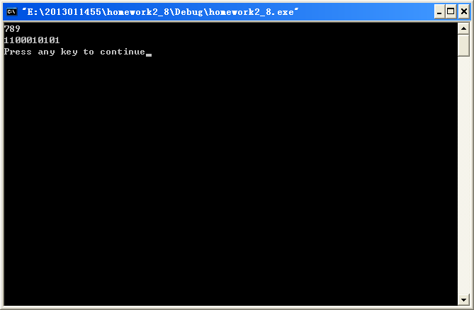

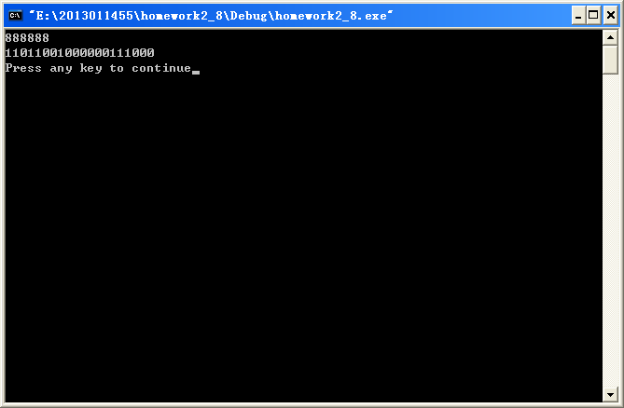

#include<stdio.h>

void main()

{

int a[1000],e,i,j;

i=0;

a[0]=0;

scanf("%d",&e);

while(e!=0)

{

a[i]=e%2;

i++;

e=e/2;

}

for(j=i-1;j>=0;j--)

printf("%d",a[j]);

printf("\n");

}

八（加强版）、不用数组的做法

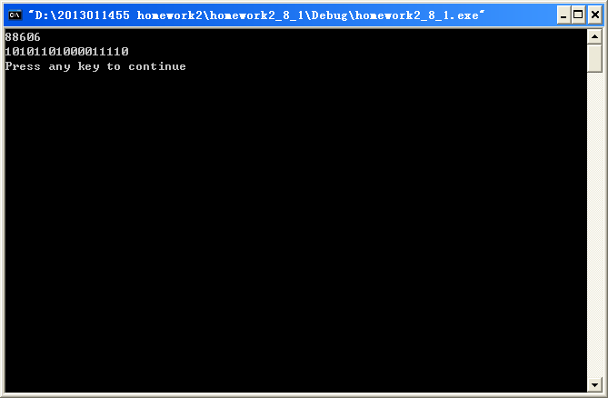

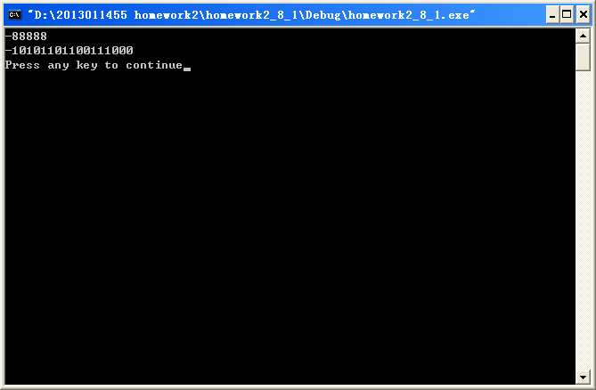

#include<stdio.h>

#include<math.h>

void main()

{

int M,line,i;

scanf("%d",&M);

i=M;

line=0;

while(i!=0)

{

i=i/2;

line++;

}

if(line==0)

printf("0\n");

else

{

if(M>0)

{

for(i=0;i<line-1;i++)

printf(" ");

for(i=line;i>=1;i--)

{

printf("%d\b\b",M%2);

M=M/2;

}

}

else

{

for(i=0;i<line;i++)

printf(" ");

for(i=line;i>=1;i--)

{

printf("%d\b\b",abs(M)%2);

M=M/2;

}

printf("-");

}

printf("\n");

}

}