1. Firefox only

2. Addon Greasemonkey: https://addons.mozilla.org/en-CA/firefox/addon/greasemonkey/

3. <https://github.com/sggongshow/Oscar>

4. Click this column, depending on which script you want

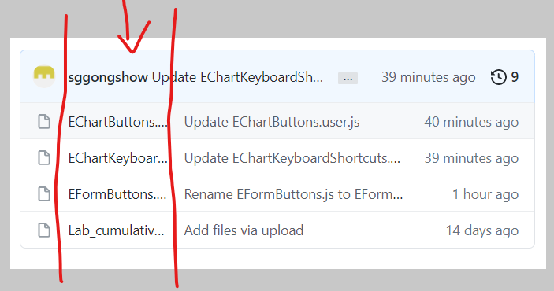

5. Click RAW to download, you will be prompted to install

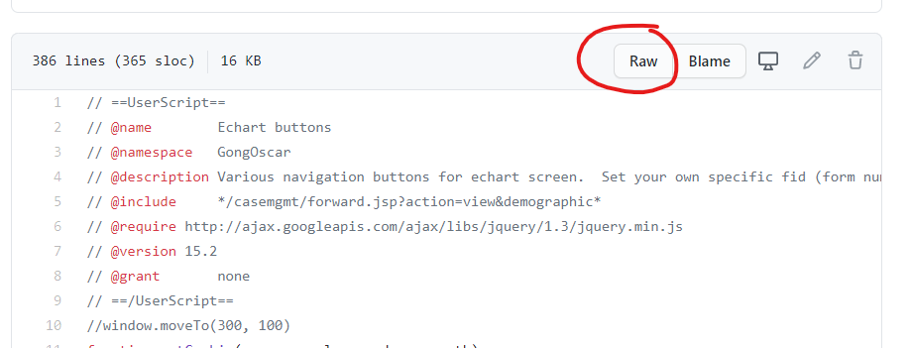

6. Click Greasemonkey extension and click the Script you want need to modify and EDIT it (it is written in Javascript with JQuery)

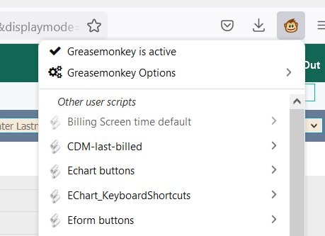

7. **YOU NEED TO SETUP YOUR OWN FORMS TO BE LINKED**. Every Oscar has different numbering for their forms

8. Find the FID for the form you want

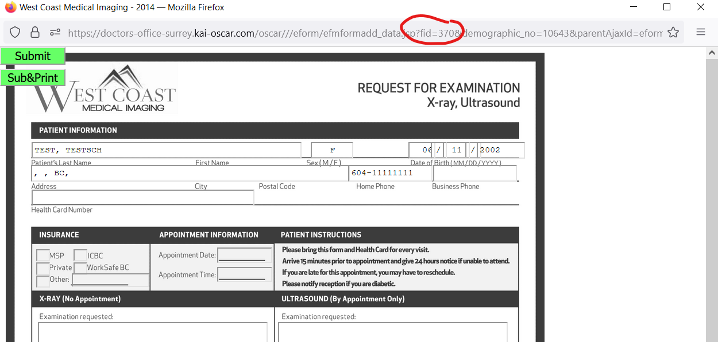

9. Put that FID into the code for each Button.

- Each button’s code is different depending on if it’s to link to something, to open an form, or to press another button on the page

10. Find the Button in the Code (Ex. EChart Buttons)

**EFORM BUTTONS** has the phrase “fid” in it

* A. Change the fid= to the correct fid for your Oscar
* B. Change the **inputX.Value** to whatever you want your button to be called

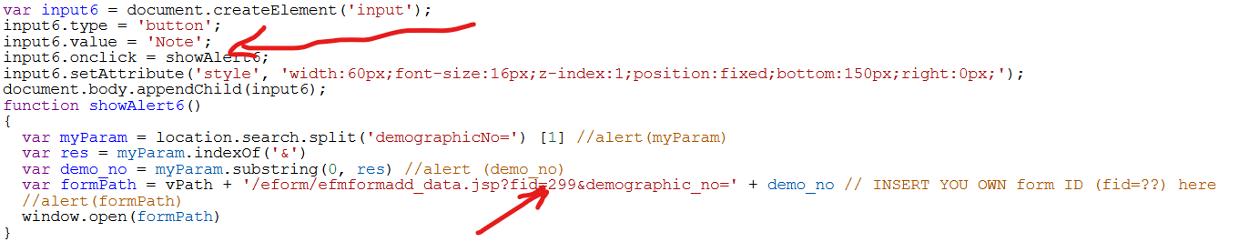

* C. Adjust the position with this line
* 
* By ‘bottom’ ‘top’, ‘right’ ‘left’ and the number of pixels to adjust it by

Note

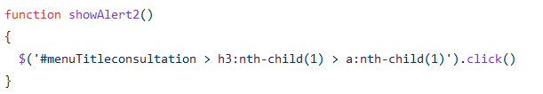

* Things that look like the above is trying to click a button on the screen. Gotta manually look into the webpage HTML to find the correct phrase to click the correct button

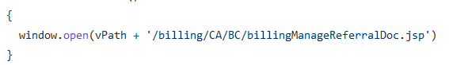

* Thins that look like this is opening another page. If you have a page you need to open you can use this.