福建师范大学数信学院2015级
软件工程专业
软件体系结构与设计模式实验报告

实验名称：中介模式\职责链模式的综合训练
姓 名： 黄劲
学 号： 123012015058

日期: 2018年5月 31 日

- 实验目的
加深对中介模式\职责链模式原理的理解
- 实验要求
- 实验原理
- 实验内容和分析

实验内容(一)：
采用中介模式来说明联合国的作用，联合国实际上是一个协调性组织，各个成员国之间有下属机构WTO、WFC、WHO，他们作为各个成员国家之间的事务协调者，采用中介模式来设计该模拟系统。
⑴实验过程：
①、构建实现场景，画出UML类图
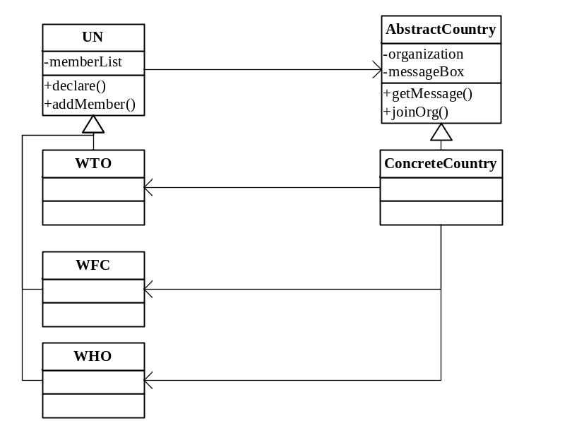
②、实现代码
import java.util.Enumeration;
import java.util.Vector;

public class Main {
public static void main(String args[]){
WTO wto = new WTO();
ConcreteCountry China = new ConcreteCountry();
ConcreteCountry USA = new ConcreteCountry();
China.joinOrg(wto);
USA.joinOrg(wto);
wto.declare("We are family:)");
China.getMessage();
USA.getMessage();
}
}

abstract class UN{
Vector<MemberCountry> memberList;
void declare(String msg){
Enumeration vEnum = memberList.elements();
while(vEnum.hasMoreElements()){
MemberCountry c = (MemberCountry) vEnum.nextElement();
c.messageBox = msg;
}
}
void addMember(MemberCountry c){
memberList.addElement(c);
}
UN(){
memberList = new Vector<MemberCountry>();
}
}

abstract class MemberCountry{
Vector<UN> orgnizations;
String messageBox;
MemberCountry(){
orgnizations = new Vector<UN>();
}
void getMessage(){
System.out.println(messageBox);
}
void joinOrg(UN org){
orgnizations.addElement(org);
org.addMember(this);
}
}

class ConcreteCountry extends MemberCountry{}

class WTO extends UN{}
class WFC extends UN{}
class WHO extends UN{}

实验内容(二)：
某物质管理系统中物质采购需要分批审批，主任可以审批一万元及以下的采购单，部门经理可以审批5万及以下的采购单，副总经理可以审批10万及以下的采购单，总经理可以审批20万元及以下的采购单，20万以上的需要会议审批，现采用职责链模式来设计该模拟系统。
⑴实验过程：
①、构建实现场景，画出UML类图
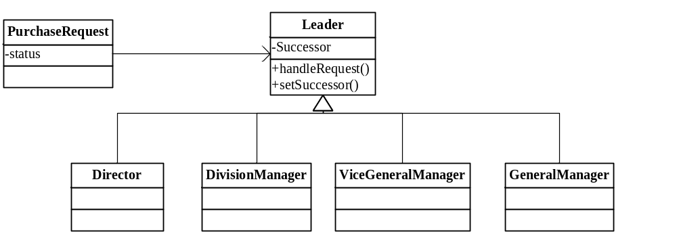
②、实现代码
public class Main {
public static void main(String args[]){
PurchaseRequest purchaseRequest = new PurchaseRequest();
purchaseRequest.setPrice(150000);
purchaseRequest.setThings("Television");
Direct direct = new Direct();
DivisionManager divisionManager = new DivisionManager();
ViceGeneralManager viceGeneralManager = new ViceGeneralManager();
GeneralManager generalManager = new GeneralManager();
direct.setSuccesssor(divisionManager);
divisionManager.setSuccesssor(viceGeneralManager);
viceGeneralManager.setSuccesssor(generalManager);
direct.handleRequest(purchaseRequest);
}
}

class PurchaseRequest{
int price;
String things;
boolean status;

public void setPrice(int price) {
this.price = price;
}

public void setThings(String things) {
this.things = things;
}

PurchaseRequest(){
status = false;
}
}

abstract class Leader{
Leader Successsor;

public void setSuccesssor(Leader successsor) {
Successsor = successsor;
}

abstract void handleRequest(PurchaseRequest purchaseRequest);
}

class Direct extends Leader{
void handleRequest(PurchaseRequest purchaseRequest){
if(purchaseRequest.price < 10000){
purchaseRequest.status = true;
System.out.println("Direct approval request:" + purchaseRequest.things + ". Price:" + purchaseRequest.price);
} else {
System.out.println("Request beyond authority, transfer to DivisionManager");
Successsor.handleRequest(purchaseRequest);
}
}
}

class DivisionManager extends Leader{
void handleRequest(PurchaseRequest purchaseRequest){
if(purchaseRequest.price < 50000){
purchaseRequest.status = true;
System.out.println("DivisionManager approval request:" + purchaseRequest.things + ". Price:" + purchaseRequest.price);
} else {
System.out.println("Request beyond authority, transfer to ViceGeneralManager");
Successsor.handleRequest(purchaseRequest);
}
}
}

class ViceGeneralManager extends Leader{
void handleRequest(PurchaseRequest purchaseRequest){
if(purchaseRequest.price < 100000){
purchaseRequest.status = true;
System.out.println("ViceGeneralManager approval request:" + purchaseRequest.things + ". Price:" + purchaseRequest.price);
} else {
System.out.println("Request beyond authority, transfer to GeneralManager");
Successsor.handleRequest(purchaseRequest);
}
}
}

class GeneralManager extends Leader{
void handleRequest(PurchaseRequest purchaseRequest){
if(purchaseRequest.price < 200000){
purchaseRequest.status = true;
System.out.println("GeneralManager approval request:" + purchaseRequest.things + ". Price:" + purchaseRequest.price);
} else {
System.out.println("Request beyond authority, transfer to CenterMeeting");
}
}
}
⑵实验讨论（效果分析）:
