福建师范大学软件学院2015级
软件工程专业
软件体系结构与设计模式实验报告

实验名称：工厂方法及抽象工厂设计的综合训练
姓 名： 黄劲
学 号： 123012015058

日期: 2018年4月 19 日

- 实验目的
加深对工厂方法设计模式及创建型设计模式原理的理解，进一步掌握配置文件的使用。
- 实验要求
- 实验原理
- 实验内容和分析

一、
某系统日志记录器要求支持多种日志记录方式，如文件日志记录和到数据库日志记录等，且用户在应用场景下可以根据要求动态选择日志记录方式，现使用工厂方法设计模式设计该系统。

实验过程：
- 构建实现场景，画出UML类图
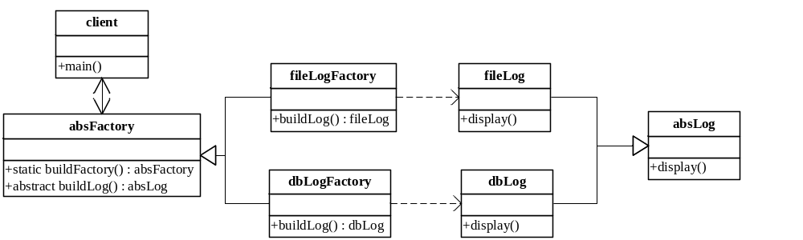
2、实现代码（要求利用反射机制及配置文件）

import java.util.ResourceBundle;
public class client {
public static void main(String args[])throws Exception{
ResourceBundle rb = ResourceBundle
.getBundle("logType");
String logType = rb.getString("TYPE");
absFactory logFactory = absFactory.buildFactory(logType);
absLog log = logFactory.buildLog();
log.display();
}
}

public abstract class absFactory {
static absFactory buildFactory(String type)throws Exception{
Class cls = Class.forName(type);
Object obj = cls.newInstance();
absFactory f = (absFactory) obj;
return f;
}
abstract absLog buildLog();
}

class fileLogFactory extends absFactory{
absLog buildLog(){
absLog log = new fileLog();
return log;
}
}

class dbLogFactory extends absFactory{
absLog buildLog(){
absLog log = new dbLog();
return log;
}
}

public abstract class absLog {
abstract void display();
}

class fileLog extends absLog{
void display(){
System.out.println("fileLog Recording...");
}
}

class dbLog extends absLog{
void display(){
System.out.println("dbLog Recording...");
}
}
3、如要在系统中增加一个日志记录方式：控制台日志记录（ConsoleLog），绘制类图并修改代码。
类图:
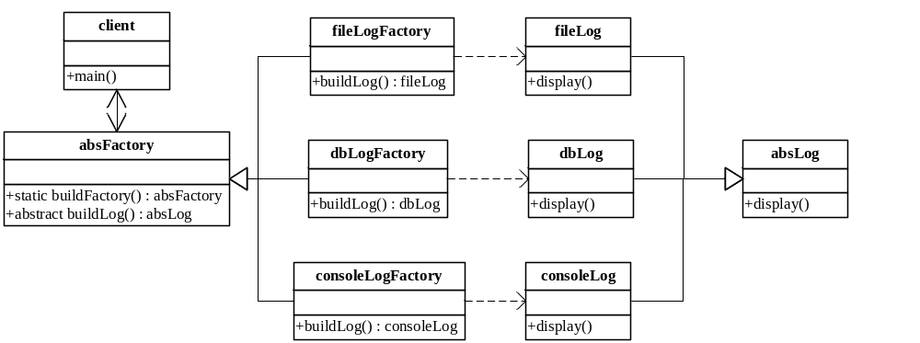
代码:
import java.util.ResourceBundle;
public class client {
public static void main(String args[])throws Exception{
ResourceBundle rb = ResourceBundle
.getBundle("logType");
String logType = rb.getString("TYPE");
absFactory logFactory = absFactory.buildFactory(logType);
absLog log = logFactory.buildLog();
log.display();
}
}

public abstract class absFactory {
static absFactory buildFactory(String type)throws Exception{
Class cls = Class.forName(type);
Object obj = cls.newInstance();
absFactory f = (absFactory) obj;
return f;
}
abstract absLog buildLog();
}

class fileLogFactory extends absFactory{
absLog buildLog(){
absLog log = new fileLog();
return log;
}
}

class dbLogFactory extends absFactory{
absLog buildLog(){
absLog log = new dbLog();
return log;
}
}

class consoleLogFactory extends absFactory{
absLog buildLog(){
absLog log = new consoleLog();
return log;
}
}
public abstract class absLog {
abstract void display();
}

class fileLog extends absLog{
void display(){
System.out.println("fileLog Recording...");
}
}

class dbLog extends absLog{
void display(){
System.out.println("dbLog Recording...");
}
}

class consoleLog extends absLog{
void display(){
System.out.println("consoleLog Recording...");
}
}

- 重构以下设计
某单据管理子系统中的单据管理设计
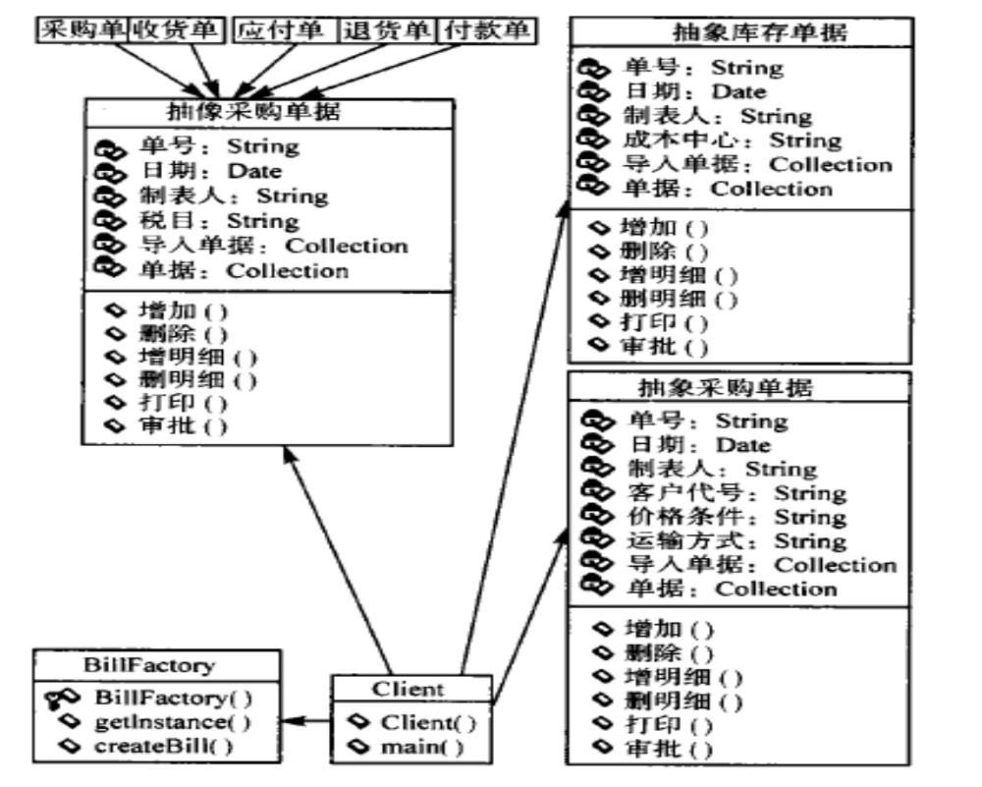

重构后的类图:
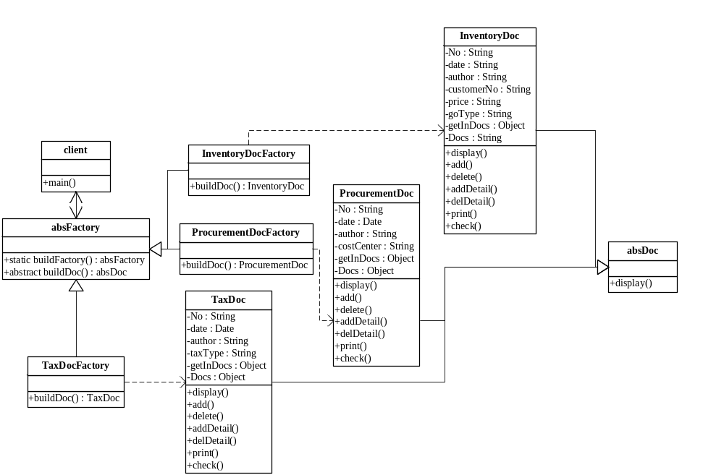
代码实现:
import java.util.ResourceBundle;
public class client {
public static void main(String args[])throws Exception{
ResourceBundle rb = ResourceBundle
.getBundle("docType");
String docType = rb.getString("TYPE");
absFactory docFactory = absFactory.buildFactory(docType);
absDoc doc = docFactory.buildDoc();
doc.display();
}
}
public abstract class absFactory {
static absFactory buildFactory(String type)throws Exception{
Class cls = Class.forName(type);
Object obj = cls.newInstance();
absFactory f = (absFactory) obj;
return f;
}
abstract absDoc buildDoc();
}

class InventoryDocFactory extends absFactory{
absDoc buildDoc(){
absDoc doc = new InventoryDoc();
return doc;
}
}

class ProcurementDocFactory extends absFactory{
absDoc buildDoc(){
absDoc doc = new ProcurementDoc();
return doc;
}
}

class TaxDocFactory extends absFactory{
absDoc buildDoc(){
absDoc doc = new TaxDoc();
return doc;
}
}
import java.util.Collection;
import java.util.Date;

public abstract class absDoc {
String No;
Date date;
String author;
String customerNo;
String price;
String goType;
Collection<absDoc> getInDocs;
Collection<absDoc> Docs;
void add(){}
void delete(){}
void addDetail(){}
void delDetail(){}
void print(){}
void check(){}
abstract void display();
}

class InventoryDoc extends absDoc{
String No;
Date date;
String author;
String costCenter;
Collection<absDoc> getInDocs;
Collection<absDoc> Docs;
void add(){}
void delete(){}
void addDetail(){}
void delDetail(){}
void print(){}
void check(){}
void display(){
System.out.println("fileLog Recording...");
}
}

class ProcurementDoc extends absDoc{
void display(){
System.out.println("dbLog Recording...");
}
}

class TaxDoc extends absDoc{
String No;
Date date;
String author;
String taxType;
Collection<absDoc> getInDocs;
Collection<absDoc> Docs;
void add(){}
void delete(){}
void addDetail(){}
void delDetail(){}
void print(){}
void check(){}
void display(){
System.out.println("consoleLog Recording...");
}
}

