Simple Incident management System

Incident management system is a role based ticketting system; this means that the fields and activities that are presented to the user depends on the profile the user has.

There are two main areas the main new ticket area, and the ticket management area.

The new ticket area has two windows one in html5 for external company users and the other internal for our staff.

the following is an example of a new ticket window:

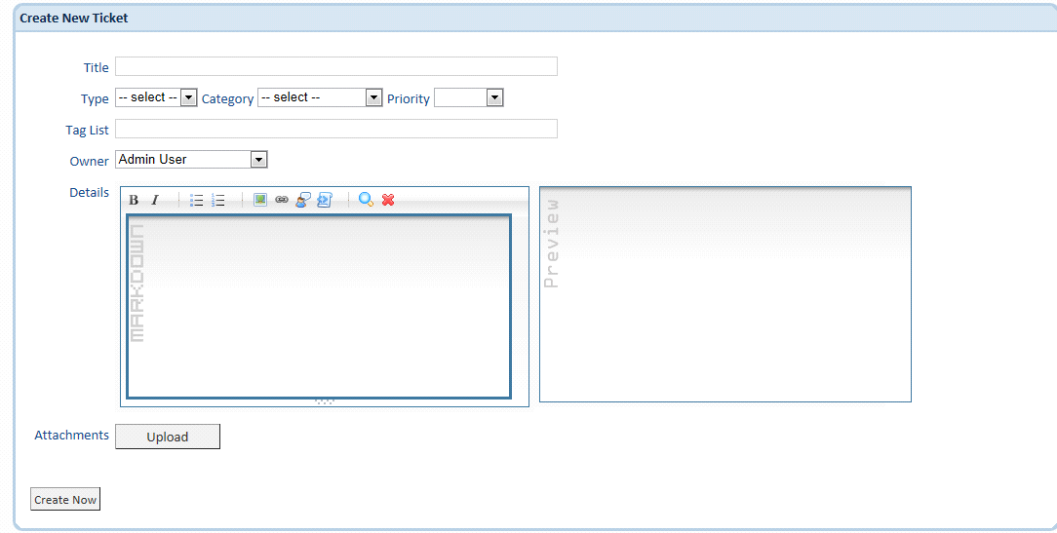

with this differences of internal or external use:

external (html5): hasn't type, category, priority, owner. Has contact email, name, surname, company, phone number.

internal: has area (business area of company), ¿is emergency?, contact information: Company, company contact.

The 2nd are is the ticket management that has a clasified view and then a modification/workin window.

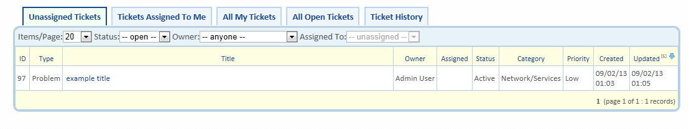

The when click on a ticket we can work on it:

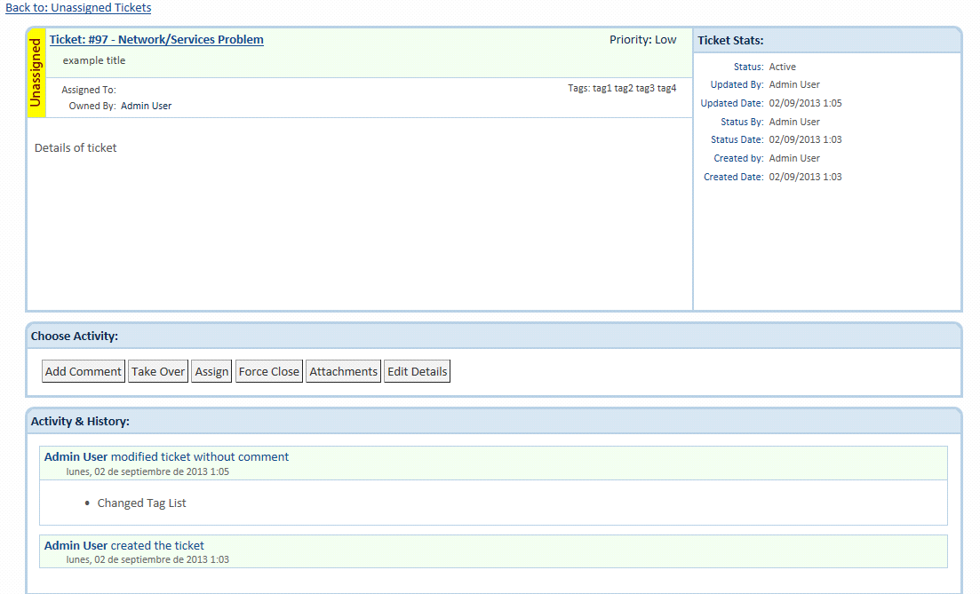

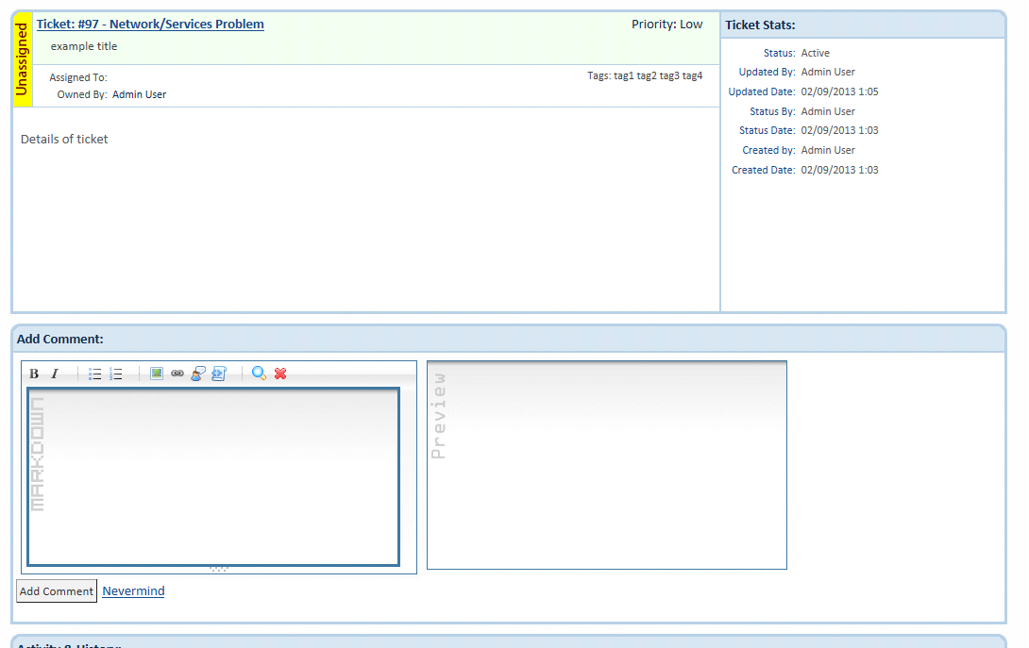

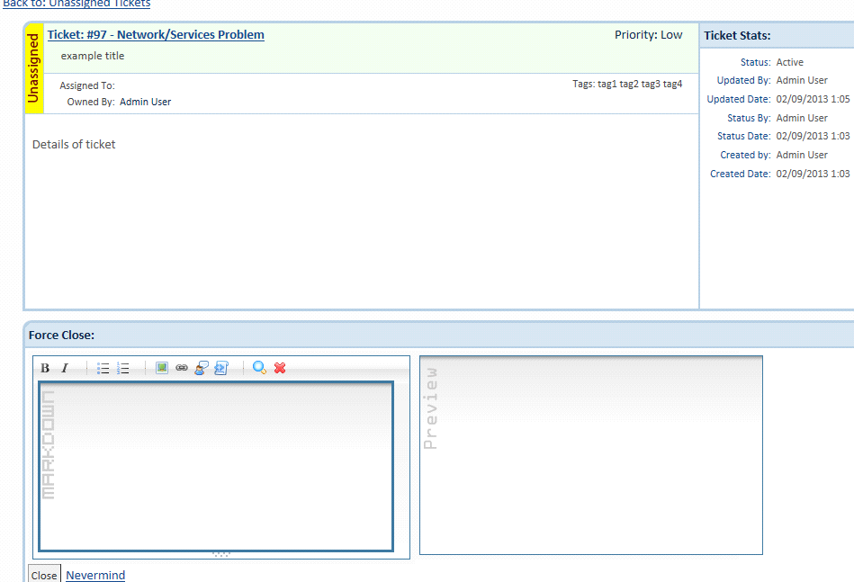

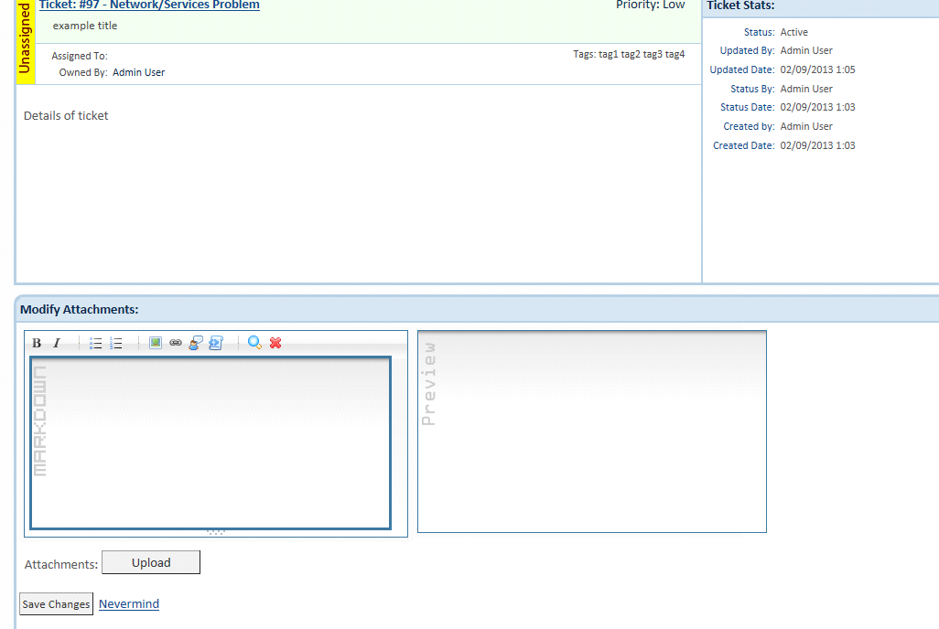

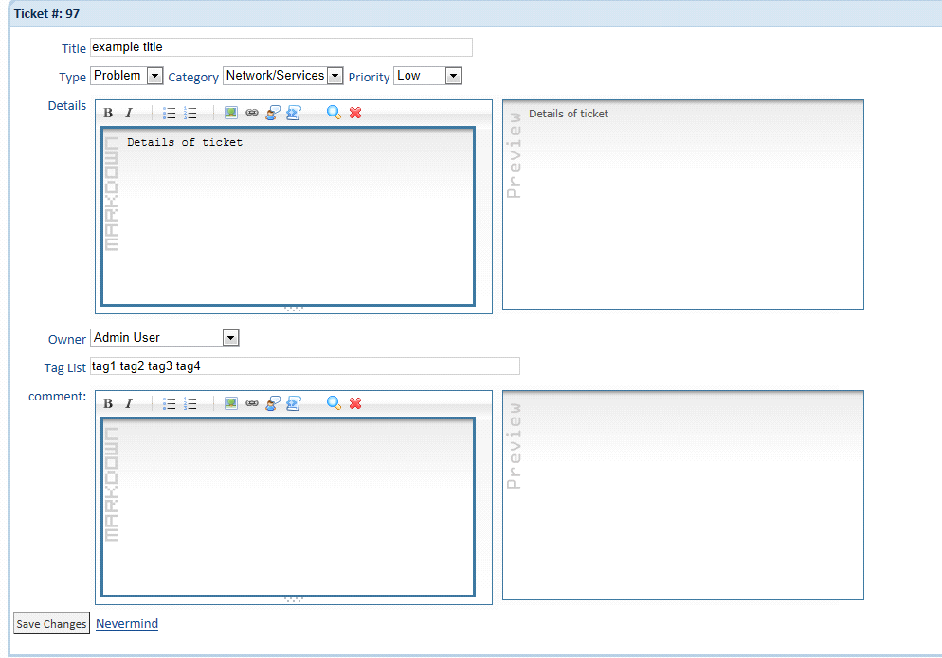

These are all samples of distribution of information. The designer/developer has freedom to use any telerik control to improve the organization of information.

PLease read the database model/workflow document to know how this module works.