# Summary

This document is a reference document for ResLog development. It is not intended for normal users and does not give general information on the user interface.

Table of Contents

Summary 1

Introduction 2

Tables 2

System tables 5

Order tables 5

Assembly tables 7

Queries 8

Forms 25

Order planning 26

Assembly 27

Slot Data 28

frmQC 29

Other forms 30

VB Code 31

# Introduction

# Tables

The database has four types of tables:

* System
* Order
* Assembly
* Temporary

| Name | Type | Description |
| --- | --- | --- |
| tblAllocated | O | Traceability reference to MfgPro ID for components allocated to a given work order. Reference to special parts like wrap wire, where more information like wire width and standard deviation is stored. |
| tblAngle | S | List of angles corresponding to given number of lines |
| tblAsBuiltBOM | A | Traceability per assembly and operation |
| tblAsBuiltOperation | A | Record of operations per assembly |
| tblAsBuiltTest | A | Record of tests or inspections per assembly and operation |
| tblAssembly | A | Main table per assembly including assembly serial number and link to work order (OrderLineID) |
| tblBug | S | Independent able for reporting of bugs. In some cases, error code generated by VB code is automatically entered into this table. |
| tblCsg | S | List of casing and tubing dimensions used as base pipe for the screen assembly |
| tblLocation | S | List of all Reslink manufacturing locations (where ResLog is being used) |
| tblMachine | S | List of all individual machines (machine serial number) |
| tblOperation | O | List of all operations required to produce a given assembly |
| tblOperationBOM | O | Links the various components in the bill of material to the relevant operations where they will be used |
| tblOperationTest | O | List of questions requiring OK reply or numerical value for each assembly operation |
| tblOperator | S | List of all operators including privileges. This defines which elements of ResLog they get access to and for which work station their initials will occur. |
| tblOrder | O | Top level table for customer order |
| tblOrderLine | O | One order line or work order is generated for each assembly part number. This table contains this part number and detailed information about the product required for ResLog |
| tblOrderLineBOM | O | Bill of material for the given assembly as it comes from GeMS or MfgPro |
| tblProductType | S | List of the various product types relevant to make. Some fields in tblOrderLine are populated based on selected product. |
| tblReport | O | Table used to define reports based on various manufacturing tests |
| tblScanLargeSlot | A | Summary per assembly of slot results covering the scan for large slots algorithm. This table is automatically populated when slot inspection is signed off. |
| tblScreenType | S | List of the various screen types meaning all combinations of axial wire and wrap wire. Some fields in tblOrderLine are populated based on selected screen type. |
| tblSearch | S | Not yet being used. The intention is to make a simplified system to predefine queries. |
| tblSlotData | A | This is a large table storing all slot data (typically 3000 records per assembly). Because of the size, this is stored in a separate Access database (ResLogBtbl02). |
| tblSlotFile | A | Table containing file name and path to slot data txt file as it comes out of ResGauge. |
| tblSlotImp | T | Temporary table used to store slot data in the text file as it comes from ResGauge. This tabel is stored in a separate Access database (ResLogBtbl03). After the slot data is appended to tblSlotData, all records in this table is deleted. |
| tblSlotReq | O | List of slot opening requirements that are applied to the product. It defines min or max percentage of slots within given ranges. It also includes the option of defining a maximum standard deviation.  The standard deviation requirement should be considered moved into tblOrderLine as this only can be applied once to the assembly. |
| tblSlotResult | A | Summary per assembly of slot results covering the slot range algorithm. This table is automatically populated when slot inspection is signed off. |
| tblSlotStatistics | A | Summary per assembly of slot results covering general slot statistics (min, max, average, standard deviation etc.). This table is automatically populated when slot inspection is signed off. |
| tblUnit | S | Units used in BOM |
| tblWireHardness | A | Wire hardness values recorded for a given wrapped section |
| tblWirePullTest | A | Wrap wire pull off strength recorded for a given wrapped section |
| tblWorkStation | S | List of work station types |
| tblWrap | A | Record for each wrapped section in an assembly containing machine settings and wrapping parameters. |
| tblWrapLength | O | Start position and length of each wrap section may be entered. If entered, these values will be used in the predefined records being generated in tblWrap |
| tblWrapType | S | Status table indicating if a given wrapped section is normal (OK), test wrapping or scrap. |

## System tables

System tables are tables used to contain general information related to product description operators and similar. The table for the operators has a form for entry of data while data for the others must be entered directly into the table. These last tables will not need to be updated with much new information.

## Order tables

Tables related to the order and work order (order line) contains the information that has to be entered for a given job. The table tblOrder contains only top level information as several products (screen types) may be produced as individual work orders under one customer order.

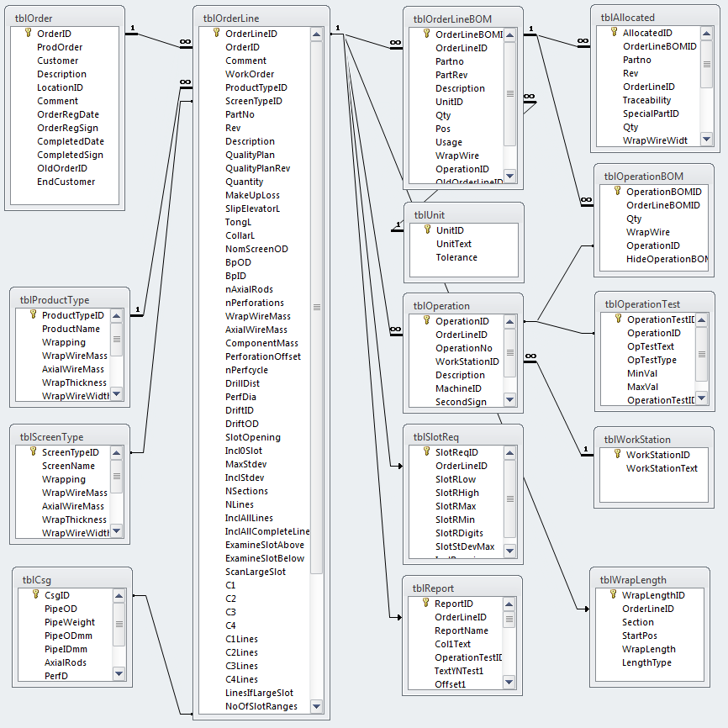

Figure 1 Relationships between tables related to the order. The tables marked transparent blue are system tables, while the rest must be populated as part of the order planning process.

## Assembly tables

The main table is tblAssembly. This table is populated with Serial number as part of the order planning process. Some of the other tables are also populated with relevant ID numbers to make them ready to receive operator input data.

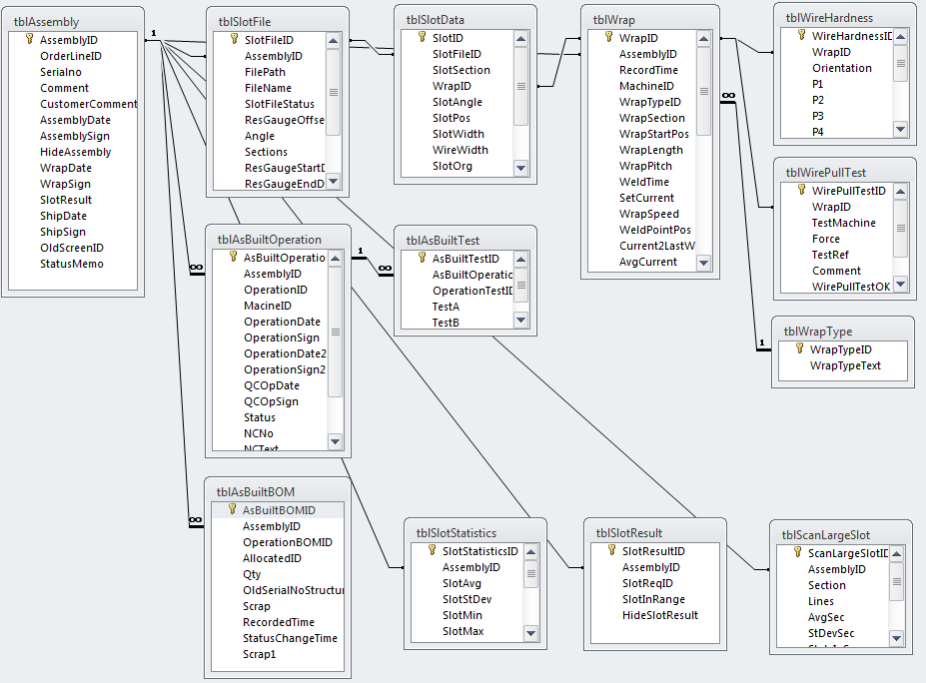

Figure 2 Relationships between tables related to the assembly. The table marked transparent blue is a system table, while the tables marked transparent green are populated automatically when signing off on the slot inspection form.

# Queries

Below is a complete list of queries including the referenced tables/queries. The list is generated using system tables (the query testSysQry). Some of the queries may not be in use. For some of the queries, a short description is given and where it is being used.

M3

| Query | Based on table/query | Description | Used |
| --- | --- | --- | --- |
| qryAllocated | tblAllocated, tblOrderLineBOM | Link to unit field | frmAllocated |
| qryAllocatedFree | tblAllocated, tblOrderLineBOM, qryAsBuiltBOMSum, tblUnit | List of not already allocated parts for a given part no | frmAssembly/ Operation |
| qryAllocatedStatus | tblUnit, tblOrderLine, tblOrderLineBOM, qryAllocatedTotal, qryAsBuiltUsed |  |  |
| qryAllocatedTotal | tblAllocated |  |  |
| qryappAsBuiltBOM | tblAssembly, tblOrderLine, tblOrderLineBOM, tblOperationBOM |  |  |
| qryappAsBuilt-OperationXXX | tblOrderLine, tblAssembly, tblOperation |  |  |
| qryappAsBuiltTestXXX | tblOrderLine, tblAsBuiltOperation, tblOperation, tblOperationTest |  |  |
| qryappSlotData3 | tblAssembly, qrySlotData111, qrySlotData121, qrySlotData21, tblOrderLine | Append to tblSlotResults | Run after signing off slot results |
| qryappSlotData31 | qrySlotData3 | Append to tblSlotStatisitics | Run after signing off slot results |
| qryappSlotExp1111 | qrySlotExp1111 | Append to tblScanLargeSlot | Run after signing off slot results |
| qryappSlotImpSlotData | tblSlotImp | Append to tblSlotData | Import of slot data |
| qryappSlotImpSlotFile | tblSlotImp | Append to tblSlotFile | Iport slot data file name and data related to slot file import |
| qryAsBuiltBOM | tblUnit, tblOrderLineBOM, tblAsBuiltBOM, tblAllocated, tblOperationBOM |  | frmAsBuiltBOM |
| qryAsBuiltBOMAll | tblUnit, tblOrderLineBOM, tblOperation, tblAsBuiltBOM, tblAllocated, tblOperationBOM |  | frmAsBuiltBOMAll |
| qryAsBuiltBOMList | tblAssembly, tblAsBuiltBOM |  |  |
| qryAsBuiltBOMSum | tblAsBuiltBOM |  |  |
| qryAsBuiltOperationList | tblAssembly, tblAsBuiltOperation |  |  |
| qryAsBuiltOperationSlot | tblAssembly, tblAsBuiltOperation, tblOperation |  | frmAsBuiltOperationSlot |
| qryAsBuiltOperation-StatusSlot | tblAssembly, tblAsBuiltOperation, tblOperation |  |  |
| qryAsBuiltOperation-Wrapping | tblAsBuiltOperation, tblOperation |  | frmAsBuiltOperationWrapping |
| qryAsBuiltTestA | tblOperationTest, tblAsBuiltTest |  | frmAsBuiltTestA |
| qryAsBuiltTestB | tblAsBuiltOperation, tblOperationTest, tblAsBuiltTest |  | frmAsBuiltTestB |
| qryAsBuiltTestList | tblAsBuiltTest, tblAsBuiltOperation, tblAssembly |  |  |
| qryAsBuiltTestVal | tblAsBuiltOperation, tblAsBuiltTest |  |  |
| qryAsBuiltUsed | tblAsBuiltBOM, tblOperationBOM |  |  |
| qryAsBuiltWrapWireUsed | tblAsBuiltBOM, tblOperationBOM |  |  |
| qryAssembly | tblOperator, tblAssembly, qryAssyOpStatusGB |  | frmAssemblyStatus |
| qryAssemblyAsBuilt-Operation | tblAssembly, tblAsBuiltOperation |  | frmlAsBuiltOperation |
| qryAssemblyDateGB | tblAssembly |  |  |
| qryAssemblyDateGBTo | qryAssemblyDateGB |  |  |
| qryAssemblyShip- DateGB | tblAssembly |  |  |
| qryAssemblyShip-DateGBTo | qryAssemblyShipDateGB |  |  |
| qryAssyOpStatus | tblAssembly, tblOperator, tblOperator, tblAsBuiltOperation, tblOperation |  | frmAssyOpStatus |
| qryAssyOpStatusGB | qryAssyOpStatus |  |  |
| qryAssyStatus0 | tblOperation, tblAssembly |  |  |
| qryAssyStatus11Sign | tblOperation, tblAsBuiltOperation |  |  |
| qryAssyStatus12Test | tblOperation, tblAsBuiltOperation, tblOperationTest, tblAsBuiltTest |  |  |
| qryAssyStatus13Wrap | tblOrderLine, tblOperation, tblAsBuiltOperation, tblWrap |  |  |
| qryAssyStatus22Test | qryAssyStatus12Test |  |  |
| qryAssyStatus23Wrap | qryAssyStatus13Wrap |  |  |
| qryAssyStatus4 | qryAssyStatus11Sign, qryAssyStatus22Test, qryAssyStatus13Wrap |  |  |
| qryAssyStepStatus11Test | tblAssembly, tblAsBuiltOperation, tblOperation, tblAsBuiltTest, tblOperationTest |  |  |
| qryAssyStepStatus12BOM | tblAssembly, tblOperation, tblAsBuiltBOM, tblOperationBOM |  |  |
| qryAssyStepStatus21Test | qryAssyStepStatus11Test |  |  |
| qryAssyStepStatus22BOM | qryAssyStepStatus12BOM |  |  |
| qryAssyStepStatus31Test | qryAssyStepStatus21Test |  |  |
| qryAssyStepStatus4 | qryAssyStepStatus22BOM, qryAssyStatus0, qryAssyStepStatus31Test, qryAssyStatus23Wrap |  |  |
| qrydelAsBuiltTest-Obsolete | tblAsBuiltTest, tblAsBuiltOperation, tblOperationTest, tblAssembly, tblOperation |  |  |
| qrydelSlotImp | tblSlotImp |  |  |
| qryListOperationStatus | tblAsBuiltOperation, tblOperation |  |  |
| qryMachine | tblMachine |  |  |
| qryMfgStepCode | tblOperationType |  | frmMfgStepCode |
| qryOldRLSlot- ReqtblOrderLine | tblOrderLine1, tblOrderLine |  |  |
| qryOldRLtblOrderLine | tblOrderLine1, tblOrder1, tblPipeReceive |  |  |
| qryOperation | qryMachine, tblOperation |  |  |
| qryOperationBOM | tblOrderLineBOM, tblUnit, tblOperationBOM |  |  |
| qryOperationSort | tblOperation |  | frmOperation |
| qryOperationStatus12 | tblOrderLineBOM, tblAsBuiltBOM, tblOperationBOM |  |  |
| qryOperationStatusx | tblAsBuiltOperation, tblAsBuiltTest, tblAsBuiltBOM, tblOrderLineBOM, tblOperationBOM, tblOperationTest |  |  |
| qryOperationTest | tblOperation, tblOperationTest |  |  |
| qryOpStat2Sign | tblAsBuiltOperation, tblOperation |  |  |
| qryOpStatBOM1 | tblUnit, tblOrderLineBOM, tblOperationBOM, tblAsBuiltBOM |  |  |
| qryOpStatBOM2 | qryOpStatBOM1 |  |  |
| qryOpStatTest | tblAsBuiltOperation, tblAsBuiltTest, tblOperationTest |  |  |
| qryOrderLineBOM | tblOrderLineBOM, tblUnit, qryAllocatedTotal |  |  |
| qryOrderLineBomSort | tblOrderLineBOM |  | frmOrderLineBOM |
| qryOrderLocation | tblLocation, tblOrder |  |  |
| qryPreviousOp-QCStatus | tblAsBuiltOperation, tblOperation |  |  |
| qryPreviousOp-QCStatusGB | qryPreviousOpQCStatus |  |  |
| qryPreviousOp-SlotStatus | tblAsBuiltOperation, tblOperation |  |  |
| qryPreviousOp-SlotStatusGB | qryPreviousOpSlotStatus |  |  |
| qryPreviousOp-Status | tblAsBuiltOperation, tblOperation |  |  |
| qryPreviousOp-StatusGB | qryPreviousOpStatus |  |  |
| qryProductNewWO | tblOrderLine, tblProductType, tblCsg |  |  |
| qryPullTest1 | tblAssembly, tblAllocated, tblAllocated, tblWrap |  |  |
| qryPullTest2 | qryPullTestAll, qryPullTest1, tblOrderLine |  |  |
| qryPullTestAll | tblAssembly, tblAllocated, tblAllocated, tblWrap, tblWirePullTest, tblMachine |  |  |
| qryPullTestAxial | tblWirePullTest, tblWrap, tblAllocated |  |  |
| qryPullTestWrap | tblWrap, tblWirePullTest, tblAllocated |  |  |
| qryQCWrap | tblAllocated, tblAllocated, tblWrap, tblMachine |  | frmQCWrap |
| qryRepAllocated | tblUnit, tblOrderLine, tblOrderLineBOM, qryAllocatedTotal, qryAsBuiltUsed |  |  |
| qryRepAsBuiltBOM | tblUnit, tblOrderLineBOM, tblAssembly, tblAsBuiltBOM, tblOperationBOM, tblAllocated |  |  |
| qryRepAssy | tblOrder, tblAssembly, tblOrderLine, tblOperation, tblAsBuiltOperation |  |  |
| qryRepAssyComplDate | tblOrder, tblAssembly, tblOrderLine, tblOperation, tblAsBuiltOperation |  |  |
| qryRepAssyShipDate | tblOrder, tblAssembly, tblOrderLine, tblOperation, tblAsBuiltOperation |  |  |
| qryRepOperations | tblOrder, tblAssembly, tblOrderLine, tblOperation |  |  |
| qryRepOperations- ComplDate | tblOrder, tblAssembly, tblOrderLine, tblOperation |  |  |
| qryRepOperations- ShipDate | tblOrder, tblAssembly, tblOrderLine, tblOperation |  |  |
| qryRepSlot | tblOrder, tblOrderLine, tblAssembly, qrySlotStatisticsOperator, qryAsBuiltOperationStatusSlot |  |  |
| qryRepSlotDetail | tblOrder, tblOrderLine, tblAssembly, qrySlotStatisticsOperator, qrySlotResult, qryAsBuiltOperationStatusSlot |  |  |
| qryRepSlotDetail- ComplDate | tblOrder, tblOrderLine, tblAssembly, qrySlotStatisticsOperator, qrySlotResult, qryAsBuiltOperationStatusSlot |  |  |
| qryRepSlotDetail- ShipDate | tblOrder, tblOrderLine, tblAssembly, qrySlotStatisticsOperator, qrySlotResult, qryAsBuiltOperationStatusSlot |  |  |
| qryRepTest | tblAssembly, tblAsBuiltOperation, tblAsBuiltTest, tblOperationTest |  |  |
| qryRepTestsC1 | tblAssembly, tblAsBuiltOperation, tblAsBuiltTest, tblReport, tblOperationTest, tblOrderLine, qryRepTestsC1Wrap, qryRepTestsC1AxialMass, qryRepTestsC1WrapMass |  |  |
| qryRepTestsC1- AxialMass | tblAsBuiltBOM, tblOperationBOM, tblOrderLineBOM |  |  |
| qryRepTestsC1- Wrap | tblWrap |  |  |
| qryRepTestsC1- WrapMass | tblAsBuiltBOM, tblOperationBOM, tblOrderLineBOM |  |  |
| qryRepTestsC2 | tblAssembly, tblAsBuiltOperation, tblAsBuiltTest, tblOperationTest, tblReport |  |  |
| qryRepTestsC3 | tblAssembly, tblAsBuiltOperation, tblAsBuiltTest, tblOperationTest, tblReport |  |  |
| qryRepTestsC4 | tblAssembly, tblAsBuiltOperation, tblAsBuiltTest, tblOperationTest, tblReport |  |  |
| qryRepTestsC5 | tblAssembly, tblAsBuiltOperation, tblAsBuiltTest, tblOperationTest, tblReport |  |  |
| qryRepTestsCAll | tblOrder, tblOperator, tblOrderLine, tblAssembly, qryRepTestsC1, qryRepTestsC2, qryRepTestsC3, qryRepTestsC4, qryRepTestsC5, tblReport, qryRepTestsCSign, tblOperation |  |  |
| qryRepTestsC- AllComplDate | tblOrder, tblOperator, tblOrderLine, tblAssembly, qryRepTestsC1, qryRepTestsC2, qryRepTestsC3, qryRepTestsC4, qryRepTestsC5, tblReport, qryRepTestsCSign, tblOperation |  |  |
| qryRepTestsC- AllShipDate | tblOrder, tblOperator, tblOrderLine, tblAssembly, qryRepTestsC1, qryRepTestsC2, qryRepTestsC3, qryRepTestsC4, qryRepTestsC5, tblReport, qryRepTestsCSign, tblOperation |  |  |
| qryRepTestsCSign | tblOperator, tblAsBuiltOperation, tblReport |  |  |
| qryScanLargeSlot | tblAssembly, tblScanLargeSlot |  |  |
| qrySearchProd | tblOrder, tblOrderLine, tblProductType, tblScreenType, tblCsg |  | frmSearchProd |
| qrySearchTrace | tblOrder, tblOrderLine, tblAssembly, tblAsBuiltBOM, tblAllocated, qryOperationBOM |  | frmSearchTrace |
| qrySlotData1 | tblAssembly, tblSlotFile, tblSlotData | Look up valid slot data for given screen joint(s) and line(s) |  |
| qrySlotData11 | qrySlotData1 | List slots =0 |  |
| qrySlotData111 | qrySlotData11 | Count slots =0 |  |
| qrySlotData12 | qrySlotData1 | List slots >0 |  |
| qrySlotData121 | qrySlotData12 | Statistics for slots >0 |  |
| qrySlotData21 | qrySlotData2Union |  |  |
| qrySlotData2Union | , |  |  |
| qrySlotData2Union-A | tblAssembly, qrySlotData1, tblOrderLine, tblSlotReq |  |  |
| qrySlotData2Union-B | tblOrderLine, tblSlotReq, qrySlotData121 |  |  |
| qrySlotData3 | tblOrderLine, tblAssembly, qrySlotData111, qrySlotData121, qrySlotData21 |  | frmSlotData3List |
| qrySlotData31 | qrySlotData3 |  | frmSlotData31 |
| qrySlotDataA1 | tblAssembly, tblSlotFile, tblSlotData, tblOrderLine |  |  |
| qrySlotDataA11 | qrySlotDataA1 |  |  |
| qrySlotDataA111 | qrySlotDataA11 |  |  |
| qrySlotDataA1111 | qrySlotDataA111 |  |  |
| qrySlotDataA12 | qrySlotDataA1 |  |  |
| qrySlotDataA121 | qrySlotDataA12 |  |  |
| qrySlotDataA1211 | qrySlotDataA121 |  |  |
| qrySlotDataA131 | qrySlotDataA12 |  |  |
| qrySlotDataA1311 | qrySlotDataA131 |  |  |
| qrySlotDataA141 | qrySlotDataA12 |  |  |
| qrySlotDataA1411 | qrySlotDataA141 |  |  |
| qrySlotDataA2 | qrySlotDataA1211, qrySlotDataA1111, qrySlotDataA1311, qrySlotDataA1411 |  | frmSlotDataA2 |
| qrySlotExp1 | tblAssembly, tblSlotFile, tblSlotData |  |  |
| qrySlotExp11 | qrySlotExp1, tblOrderLine |  |  |
| qrySlotExp111 | qrySlotExp11 |  |  |
| qrySlotExp1111 | qrySlotExp111 |  | frmSlotExp |
| qrySlotExp11111 | qrySlotExp1111 |  | frmSlotExp11111 |
| qrySlotFileData0 | tblSlotData |  |  |
| qrySlotFileData1 | tblSlotData |  |  |
| qrySlotFileData11 | qrySlotFileData1 |  |  |
| qrySlotFileData2 | qrySlotFileData11, qrySlotFileData0 |  |  |
| qrySlotFileDetail | tblAssembly, tblSlotFile |  | frmSlotFileDetail |
| qrySlotFileOperator | tblOperator, tblSlotFile |  | frmSlotFile |
| qrySlotFrequency | qrySlotStatNot0 |  |  |
| qrySlotFrequencyNorm | qrySlotFrequency, qrySlotStatNot0T |  |  |
| qrySlotImportAngle | tblAngle |  |  |
| qrySlotLarge | tblAssembly, tblOrderLine, tblSlotFile, tblSlotData |  | frmSlotLarge |
| qrySlotLarge1 | tblAssembly, tblOrderLine, tblSlotFile, tblSlotData |  |  |
| qrySlotLarge11 | qrySlotLarge1 |  | frmSlotLarge11 |
| qrySlotOutOfSpec | tblOrderLine, tblScreen, tblSlotFile, qrySlotDataCor |  | frmSlotOutOfSpec |
| qrySlotRange1 | tblAssembly, qrySlotData1, tblOrderLine, tblSlotReq |  |  |
| qrySlotRange11 | qrySlotRange1 |  |  |
| qrySlotRange2 | tblOrderLine, tblAssembly, tblSlotReq |  |  |
| qrySlotRange3 | qrySlotRange2, qrySlotRange11 |  |  |
| qrySlotResult | tblSlotResult, tblSlotReq |  |  |
| qrySlotStat | tblOrderLine, tblSlotReq, tblScreen, tblSlotFile, qrySlotDataCor |  |  |
| qrySlotStat0 | tblOrderLine, tblScreen, tblSlotFile, qrySlotDataCor |  |  |
| qrySlotStat0FileID | tblOrderLine, tblScreen, tblSlotFile, qrySlotDataCorAll |  |  |
| qrySlotStat0T | qrySlotStat0 |  |  |
| qrySlotStat0TFileID | qrySlotStat0FileID |  |  |
| qrySlotStatAll | tblOrderLine, qrySlotStatNot0T, qrySlotStat0T, qrySlotStatT, tblScreen |  | frmPivSlotStatAll  frmSlotStatAll  frmSlotStatAllList |
| qrySlotStatistics | tblAssembly, tblSlotStatistics, tblOperator, tblAsBuiltOperation, tblOperation |  | frmSlotStatistics |
| qrySlotStatisticsList | tblAssembly, qrySlotStatisticsOperator, qryAsBuiltOperationStatusSlot |  | frmSlotStatisticsList |
| qrySlotStatisticsOperator | tblSlotStatistics, tblOperator, tblAssembly |  |  |
| qrySlotStatNot0 | tblOrderLine, tblScreen, tblSlotFile, qrySlotDataCor |  |  |
| qrySlotStatNot0FileID | tblOrderLine, tblScreen, tblSlotFile, qrySlotDataCorAll |  |  |
| qrySlotStatNot0T | qrySlotStatNot0 |  |  |
| qrySlotStatNot0TFileID | qrySlotStatNot0FileID |  |  |
| qrySlotStatT | qrySlotStatUnion |  |  |
| qrySlotStatTest1 | tblOrderLine, tblSlotReq, tblScreen, qrySlotStatAll |  |  |
| qrySlotStatUnion | , |  |  |
| qryWireCombination | tblWrap, tblAllocated, tblOrderLineBOM, tblOperationBOM, tblAsBuiltBOM, tblAssembly, tblOrderLineBOM, tblAsBuiltBOM, tblOperationBOM, tblAllocated |  |  |
| qryWrap | tblWrapType, tblAssembly, tblOperator, tblWrap, tblOrderLine |  | frmWrapDetail |
| qryWrapLock | tblAsBuiltOperation, tblOperation |  |  |
| qupdAsBuilt-OperationLock | tblAsBuiltOperation, tblOperation |  |  |
| qupdAsBuiltSlot-OperationLock | tblAsBuiltOperation, tblOperation |  |  |
| qupdAsBuiltSlot-OperationUnLock | tblAsBuiltOperation, tblOperation |  |  |
| qupdScanLargeSlot | tblScanLargeSlot |  |  |
| qupdSlotResult | tblSlotResult |  |  |
| qupdSlotStatistics | tblSlotStatistics |  |  |
| qupdSlotStatistics-StatusTxt | tblSlotStatistics |  |  |
| testAllocateOldData | tblOrderLineStructure, tblScreen, tblSerialNoStructure, tblOrderLine |  |  |
| testappOld-OrderLine | tblOrder, tblOrderLine, tblOrderLine1 |  |  |
| testappRes-ShuntSlotFile | tblSlotFile1, tblAssembly, tblSlotFile |  |  |
| testappSec-WrapSection | tblScreen, tblOrder, tblOrderLine, tblAssembly |  |  |
| testMakeAs-BuiltBOM2 | tblAssembly, tblSerialNoStructure, testMakeAsBuiltBOM |  |  |
| testWrapLength | testShuntWrapL, tblAssembly, tblWrap |  |  |

# Forms

A form named Start is used for navigation within the database. This form does also contain some hidden text boxes holding data which is being used by queries and VB code. This is done to be able to use the same query from different forms.

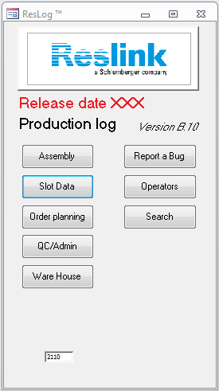

The buttons on the left side are for operational use. All buttons opens various forms which are described in more detail below. Details on how to enter information is given in the user guide.

## Order planning

This form is used by the planner prior to a job to enter general information. This information is used to populate tables and as input for queries and similar.

| Tab | Form/sub form | Description |
| --- | --- | --- |
| Main form | frmOrder | Select or create order and work order.  Selection can be made between active and all orders. An order is active until it is signed off as completed in the Order tab. |
| Order | FrmOrderDetail | Enter general order details |
| Product details | frmOrderLineDetails  frmWrapLength | Enter order line details and generate records. One record for each assembly is generated in tblAssembly, and one for each wrap section and joint in tblWrap |
| Operations | frmOperation | Define operations and select work station for each operation. One record is generated for each operation and assembly in tblAsBuiltOperation. |
| Mfg Tests | frmOperationTest | Define tests for selected operations. One record is generated for each test and assembly in tblAsBuiltTest |
| Work o. BOM | frmOrderLineBOM | Enter BOM as it comes from GeMS into tblOrderLineBOM.  A more automated method to copy data from GeMS should be considered. |
| Operation BOM | frmOperationBOM | Each item in the BOM is linked to the applicable operation. If part is needed in two different operations, the record is duplicated in tblOrderLineBOM. The link to the operation is done in tblOperationBOM. The records in tblOperationBOM is duplicated for each assembly into tblAsBuiltBOM. |
| Slot requirements | frmOrderLineSlot  frmSlotReq | Slot requirements being used by queries |
| Report setup | frmReportSetup | Reports with up to 5 data columns plus serial number, date and signature can be defined. Any already defined manufacturing test can be used. The definitions are stored in tblReport |

## Assembly

This form is used for general assembly and the screen wrapping process. Each predefined operation is selected in a combo box.

| Tab | Form/sub form | Description |
| --- | --- | --- |
| Main form | frmAssembly | Select order, work order ID, Serial no and Operation. |
| Operation | frmAsBuiltOperation  frmAsBuiltTestB  frmAsBuiltTestA  frmAsBuiltBOM | Form for general operation. The operator enters data and signs off. VB code (GotFocus) is used to verify that required information has been entered. After signing off, the previous operation is being locked (VB AfterUpdate).  We could also consider locking the current record. |
| Wrapping | frmAsBuiltOperationWrapping  frmWrapDetail  frmWirePullTest | Record data from wrapping process for each wrapped section (in most cases only one section).  Wire traceability is selected and remaining wire on spool is calculated.  When all wrapped sections are signed off as completed, the last date and signature is to denote that the operation is completed. |
| BOM | frmAsBuiltBOMAll | Non editable list of the complete as built BOM |
| Status | frmAssyOpStatus | Non editable list of status for all operaitons |

## Slot Data

This form is used to record and view slot measurement data

| Tab | Form/sub form | Description |
| --- | --- | --- |
| Main form | frmSlotResult | Select serial no |
| Slot Import | frmSlotFile | Import and lists already imported slot data files.  At file import after a data file has been selected, the slot data are analysed by VB code. |
| Results | 1. frmSlotData31 2. frmSlotExp 3. frmSlotLarge11 4. frmSlotData3List 5. frmAsBuiltOperationSlot 6. frmSlotExp11111 | The results are presented in up to four categories. Statistics (1), largest expected slots (2), number of and max large slot (3) and percentage of slots within ranges (4)  When signing off, the record is being locked and key statistical data are copied into tblSlotStatistics, tblSlotResults and tblScanLargeSlot. If the record is being unlocked, old data are marked as not valid, but still stored in the table. |
| Large slots | frmSlotLarge | All slots outside of eventually pre-set values in the slot specifications are listed. The table also includes the slot on each side (SlotBefore and SlotAfter). The form allows for editing on slot data. If slots are manipulated, the neighbour slots will also appear as individual records to allow for this slot width value also to be updated. |
| Section and angle details | frmSlotDataA2 | Non editable list of slot data per section and line measured. |
| ID summary | frmSlotStatisticsList | Non editable list of slot data summary |

## frmQC

|  |  |  |
| --- | --- | --- |
| Tab | forms |  |
|  | frmQC |  |
| ID Status | frmAssemblyStatus | Non editable form listing progress and non-conformity status for each assembly |
| EditID | frmAssemblyEdit | The serial number for each assembly can be edited if the automatically applied serial number is not used. Assemblies can also be hidden, meaning that they will not show up in Assembly or Slot Data form and reports. This feature may be used if a joint is being scrapped and rewrapped. |
| SN Status | frmAssyOpStatus | Status per serial number listing all operations. This is used to change status and record any non-conformances information. Operations can also be unlocked. |
| Pull off | frmQCWrap  frmQCWirePullTest | Form to record wrap wire to axial rod pull off test values. |
| Hardness | frmWireHardness | Form to record hardness values |
| Reports |  | Various reports can be selected based on various selections of assemblies. |
| Slot summary | Slot summary tab | Non editable list of slot data summary |
| Ship | frmSlotStatisticsList | If a work order is shipped in several batches, the shipping date can be recorded to make it possible to generate reports for the correct selection of assemblies. |
| Parts allocated | frmAllocatedUB  frmAllocated | Non editable list of parts allocated |

## Other forms

| Name | Form/sub form | Description |
| --- | --- | --- |
| Ware House | FormWareHouse  frmAllocatedUB  frmAllocated | The BOM is displayed based on selected work order ID. For each part, relevant traceability information is recorded. For serialised items, VB code is used to update multiple records through the form frmPopulateAllocated |
| Report a Bug | frmBug | Form to report any database issues. Information is stored in a separate table independent of other tables. Some VB code is automatically reporting to this table if an error occurs. |
| Operators | frmOperator  frmOperatorSub | Look up or add operators. New operators are added through the form frmNewOperator. Privileges are set to display the operator for the given operation where qualified. |
| Search | frmSearch | A query is generated based on the various selections and the results are displayed through the forms frmSearchProd or frmSearchTrace. |

# VB Code