ResLog user guide

Reslink screen manufacturing database

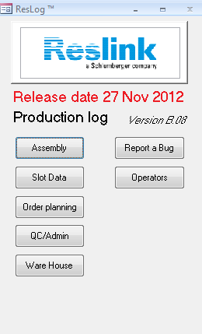

Part 1 – Administrator part

Table of Contents

Introduction 3

Revision history 3

Order and Work order registration 3

Order 4

Work order 4

Product details 4

Operations 5

Mfg Tests 7

Work o. BOM 8

Operation BOM 9

Slot requirements 10

Allocation of parts 13

Reports 13

Ware House 14

QC/Admin 15

ID status 15

Status 16

Pull off 17

Assembly 20

# Introduction

ResLog is a database developed to track details of the Reslink screen production. It is recording details of each screen joint as it passes through one or more manufacturing steps or operations. The information that can be recorded is:

* Wrapping process details
* Slot opening measurements and verification of slot requirements
* Process inspections and measurements
* Traceability of components

The system is intended to work together with MfgPro, but no automated link is made.

To use ResLog, the following sequences must be completed:

* Planner must enter work order details
* If component traceability is included, ware house operator must allocate parts and enter traceability information
* Operator must record production data

# Revision history

|  |  |  |  |
| --- | --- | --- | --- |
| Version | Created | Released | Updates |
| B05 |  | 08 June 2012 |  |
| B06 | 11 June 2012 | 25 June 2012 | Bug fix on slot import function |
| B07 | 06 July 2012 |  |  |
| B08 |  | 27 Nov 2012 | Possible to select slot data only, new reports |

# Order and Work order registration

A planner must do initial registration of order and work order. This is required to be able to populate the database with required records.

When entering data, click in the text box to see a descriptive text in the lower left corner.

The following information must be entered to use ResLog:

|  |  |  |
| --- | --- | --- |
|  | Description | Comment |
| Order | Top level order to one customer that may include several line items | To make new, click New Order |
| Product details | Record for one specific product with given part no and revision under the given order | To make new, click New WO  To populate database, click Generate records |
| Operations | Record at least one operation. The operation has to be linked to a work station. Wrapping and ResGauge are operations treated specially, but must also be defined as operations. | To populate database, click Generate records |
| Mfg Tests | Tests or questions that will require feedback from the operator | Optional |
| Work o. BOM | Bill of material as defined in GeMS or MfgPro | Optional, but required if traceability is to be recorded |
| Operation BOM | Components are linked to the given operations | Optional, but required if traceability is to be recorded |
| Slot requirements | Defines requirements to be used when importing data from ResGauge | Required if ResGauge work station is selected under operations |
| Report setup | Definition of reports based on manufacturing tests. Multiple reports can be defined. Each report can include up to 5 columns based on the defined tests. First column may also include weight increase of the given joint. | Optionalter |

## Order

General information about the order is recorded (Figure 1). The purpose is to record sales order number and record information to make it easy to look up the order later.

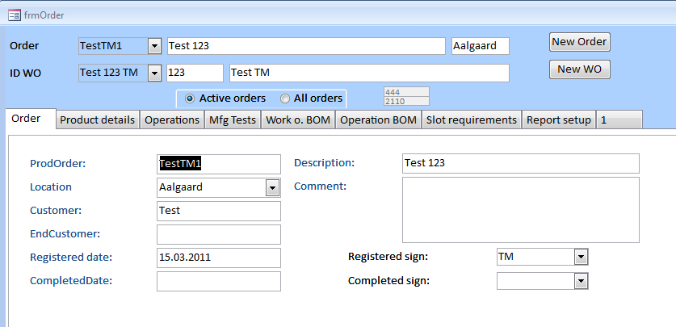

Figure Order registration form

The order number is the order number as generated from MfgPro. To generate a new order, click on the New Order button. A new form is opened and the Order number can be entered. By closing the form, the record is stored and the order becomes selectable in order drop down list box.

Location must be selected to link the order and underlying work order(s) to a given production centre. Signature fields used on various forms are also linked to the selected location. By signing off for completed order, the status is changed to not active. This will hide the order unless the All orders button is selected.

## Work order

The ID number for the work order as generated in MfgPro is used as the reference for the work order. This is generated the same way as for the Order but by clicking New WO. All required information about the product and the process must be recorded. This is organised under the different tabs in the Order form.

In the case of single piece flow and individual work orders for each screen joint, the ResLog database is designed to hold a group of individual MfgPro work orders within one ResLog work order. The individual MfgPro work order IDs can later on be assigned to the individual serial numbers in ResLog.

### Product details

Enter information (Figure 2) and click button Generate records. Required information in red boxes is being verified and records generated based on quantity and number of wrap sections.

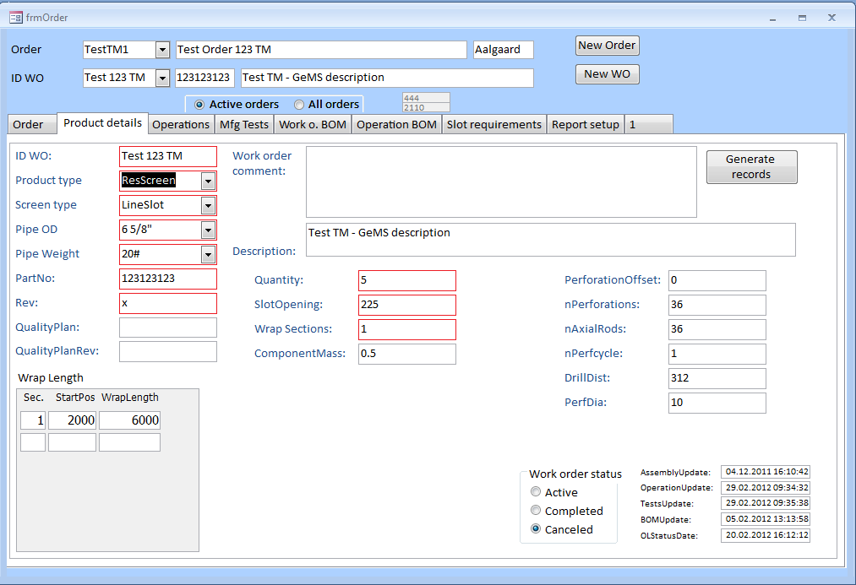

Figure Product details form

Wrap sections is the number of individual screen sections in the given product. Default is 1, while products like ResShunt may have 6 sections. Start position and wrap length may be entered. If entered, these values are used as default values in the wrapping process. If ResLog is being used to capture ResGauge data only, this information must be entered.

Number of joints in a work order may be increased. In this case, “Generate records” must be run on this and subsequent forms.

Number of axial rods is also used to calculate axial wire consumption. This means actual number of rods must be use without including shunt tubes for ResShunt.

### Operations

The different operations are defined and associated work stations are selected (Figure 3). Click “Generate records” to generate required records. New operations may be added later. In this case, “Generate records” must be run on this and subsequent forms.

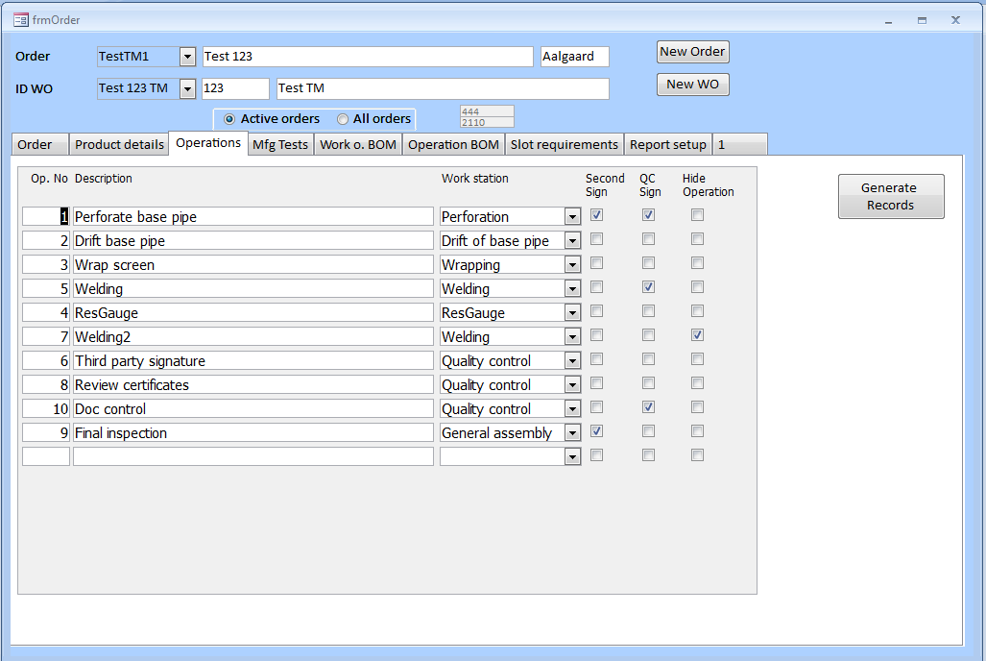

Figure Operations form

The operation number (Op. No.) defines the sequential order of the operations. This is used both for sorting and to verify that previous operations have been completed.

Second sign is ticked off when an operation needs to be witnessed by a second operator.

Hide operation, removes the given operation from the manufacturing process. This may be used if too many operations have been entered. If records has been generated, operations must not be renamed or linked to new work stations as this may cause problems with links related to manufacturing tests and operation BOM.

Description and work station may be edited at any stage. This will be reflected immediately in the manufacturing process.

### Mfg Tests

For each operation, operation tests may be defined (Figure 4). This can either be a Yes/No type test or a numerical test. The Yes/No type test may also include a comment, like initials of a TPI or similar.

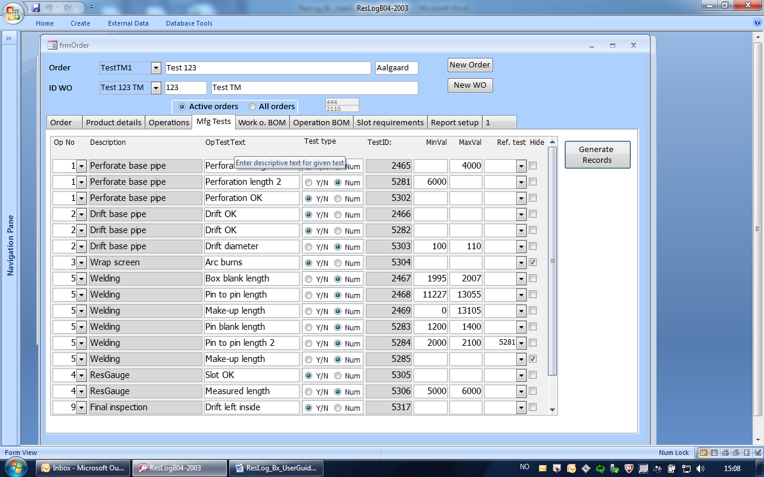

Figure Manufacturing test form

Select an operation from the drop down list and type in a descriptive operation test text and choos test type. If MinVal and MaxVal are entered, the input value is validated against the given value. The operator will not be able to type in a value falling outside of the defined range. The values may be edited without generating records.

A third option is to reference a previously entered value (by operator) and define an offset values. In this case, the reference TestID must also be selected.

|  |
| --- |
| Example:  Base pipe length shall be between 9000 and 12000 mm and is actually measured to be 10400. Perforation length shall be 3000 mm shorter than actual pipe length with a tolerance of +/- 100 mm. In this case, reference is made to the base pipe length test using MinVal = -3100 and MaxVal = -2900. This will accept input values in the range from 7300 (10400 – 3100) to 7500. |

Click “Generate records” to generate required records. New operations may be added later. In this case, “Generate records” must be run on this and subsequent forms. Operation test text, MinVal and MaxVal can be edited without updating records. Hide test, removes the given test from the manufacturing process.

### Work o. BOM

Type in bill of material as it is listed in GeMS/MfgPro (Figure 5).

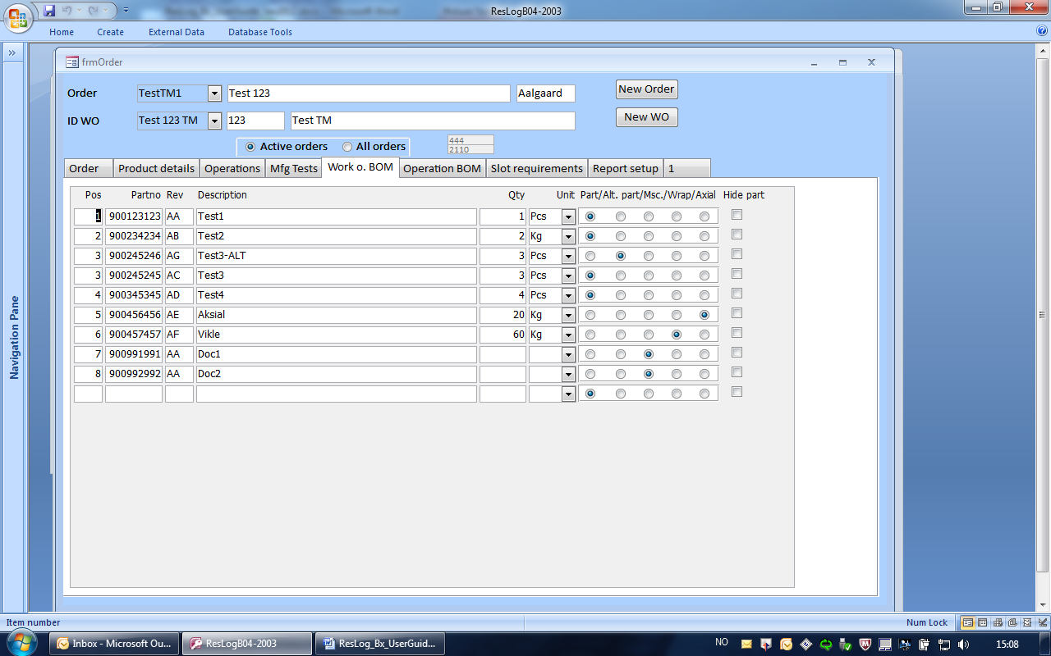

Figure Work order BOM

Additionally, select part type:

* Part – standard part (default)
* Alt. part – alternative part that may replace part. In this case, use same pos as the main part. This option should be used for end rings when different variants are given different part numbers.
* Msc – Parts, jigs, documents or similar which are not consumables. This will be listed in the as built BOM, for reference only.
* Wrap – defines the wrapping wire and is required to link the part to the wrapping process
* Axial – defines the axial wire and is required to link the part to the wrapping process. Only standard wrapping wire shall be recorded and not components like shunt tubes or similar.

Hide part, removes the given part from the manufacturing process.

### Operation BOM

Link part to given operation (Figure 6). Select the operation in which the part is going to be used. If a part is used in several operations, click “Part in new Op.” to duplicate the record. Update Qty to reflect consumption in each operation. Qty with gray background is reference to initial BOM and is not editable in this form.

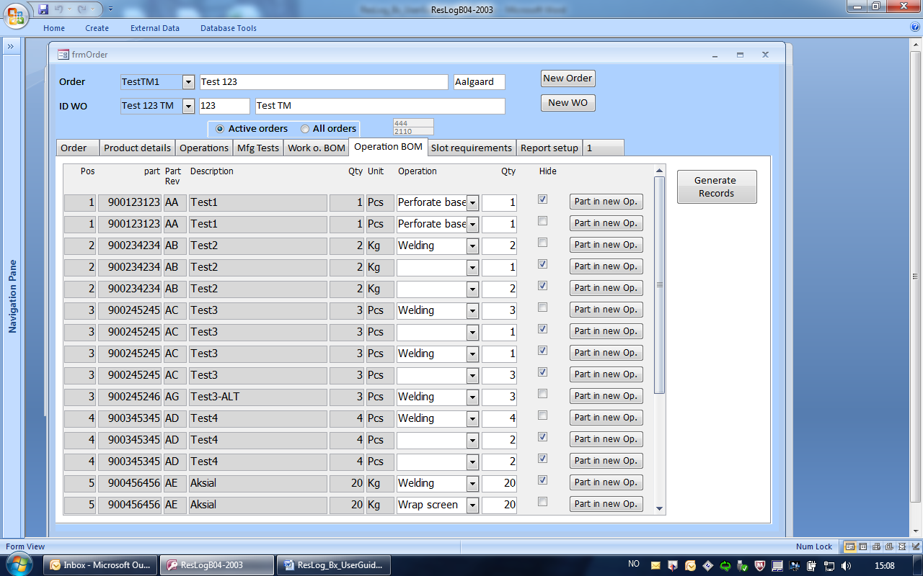

Figure Operation BOM

Click “Generate records” to generate required records. New links to operations may be added later. In this case, “Generate records” must be run again.

Hide, removes the given part from the given operation.

### Slot requirements

Slot requirements (Figure 7) are looked up each time slot import and slot interpretation is run. Consequently, changes to some of the settings can lead to variation in interpretation of slot data.

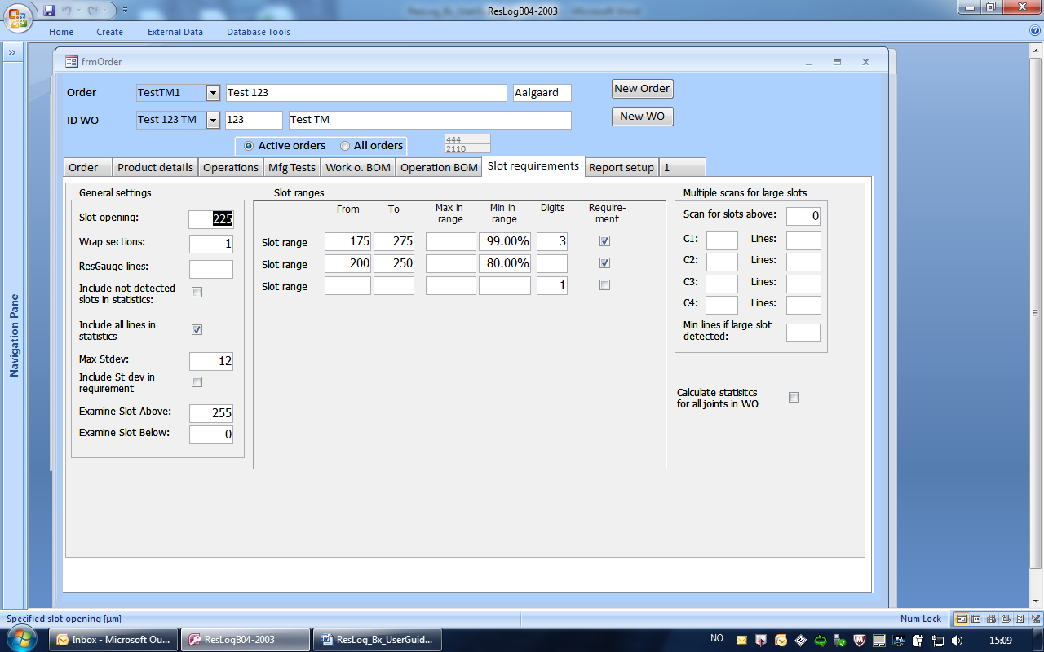

Figure Slot requirement form

#### General settings

Enter information as listed and in accordance with the quality plan.

|  |  |
| --- | --- |
| Slot opening: | The same value as set in the “Product details” tab. The value can be set under both tabs. |
| Wrap sections: | Number of screen sections on the joint. This value is required for ResLog to be able to identify individual sections wrapped on a joint. |
| ReaGauge lines: | Maximum number of lines relevant to measure. ResGauge angle drop down list is calculated based on this value. If value is set to 1 or left blank, angel drop down list will not appear and angle is set to 0. In this case multiple lines cannot be analysed. |
| Include not detected slots in statistics | Slots not detected by ResGauge (=0) will also be included in the statistics of slots being within ranges. This means the percentage of slots within +/- 50 micron will be reduced accordingly. Default is not to include not detected slots as these slots are considered to follow the same distribution as the detected slots. |
| Include all lines in statistics | All measured and valid lines will be used to calculate percentage of slots within ranges. This should not be used for products like ResShunt with multiple sections and more lines may be measured in the less good sections. In that case more weight will be given to the less good section. |
| Max Stdev  Include Stdev in requirement | Max Stdev is combined with Include Stdev in requirement. If this is ticked off, the entered maximum standard deviation is part of the slot requirement. If not ticked off, the max xtdev may be left blank. |
| Examine slots above | All slots larger than (but not including) the given value are reported and an error message is generated. |
| Examine slots below | All slots smaller than (but not including) the given value are reported and an error message is generated. |

#### Slot ranges

Define slot range(s) and minimum or maximum percent of slots that must be in range. The range is defined as from and including and to and including. Either the field Max in range or Min in range shall be used. The other one shall be left blank.

The check box Requirement means that the value in the given slot range is part of the client requirement. This allows for simulations of percentages within different slot ranges.

#### Multiple scans for large slots

These are settings for use when multiple scans are used to identify large slots (Figure 8). The largest expected slot is calculated based on average slot opening and standard deviation times the constant CX. This is being calculated for a line and a section at a time.

The value Scan for slots above is the critical slot opening. The scanning procedure is aiming at identifying any slot being larger than this slot.

If a large slot is identified even if the standard deviation is low, this is probably caused by sudden change in friction in the wrapping machine. This slot may go around the whole screen and can easily be identified visually. To verify this, some more line may be run. Min lines if large slot detected denotes this number.

Values used for ResShunt production and 215 µm slot opening are:

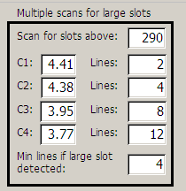

Figure Details on multiple scans

### Allocation of parts

The BOM is displayed on top as a list box. This shows total requirement based on Work o. BOM and quantity in Product details. Alloc is quantity currently allocated for this work order and Used shows how much has been used in the assemblies up to now.

To record traceability, select a part. Part and part information with table for recording of information is displayed below. Record traceability information as displayed on the parts and quantity in the batch. If the part is a wrapping wire, record wire width [mm] and standard deviation of the wire width [µm]

## Reports

Based on various tests defined under the manufacturing tests tab, reports can be set up to list results from these individual tests (Figure 9).

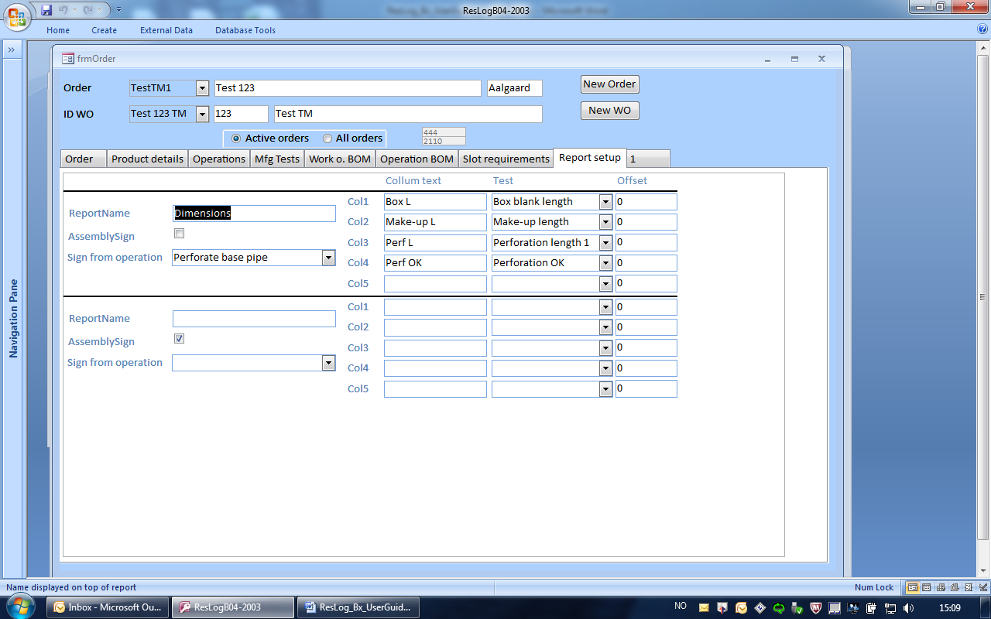

Figure Report setup form

Each report may include up to 5 columns of data selectable form the various tests recorded. Report name is the name that appears on the top of the report

# Ware House

Allocation of parts most be performed before they are selectable by the operators (Figure 10).

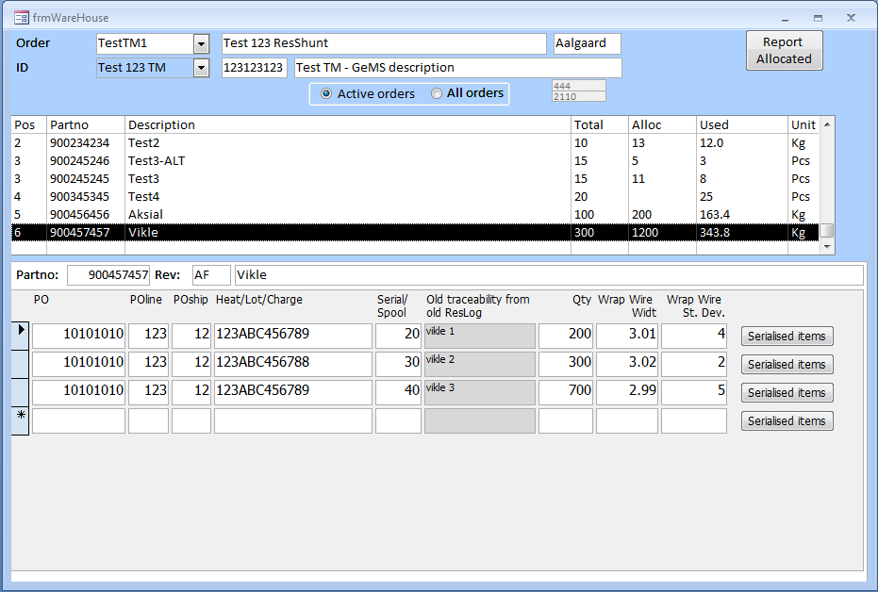

Figure Ware house form for allocation of parts

Select the part from the bill of material and record traceability information and quantity. For wrapping wire (based on type of component in the Work o. BOM) wire width and standard deviation should also be recorded.

# QC/Admin

This is a set forms to be used by QC and planners during the execution of an order. Progress of the order can be reviewed and information like hardness and pull off values can b recorded.

## ID status

Status for the given work () order summarised number of closed and open non conformances along with the relative progress of the given joint based on total number of operations.

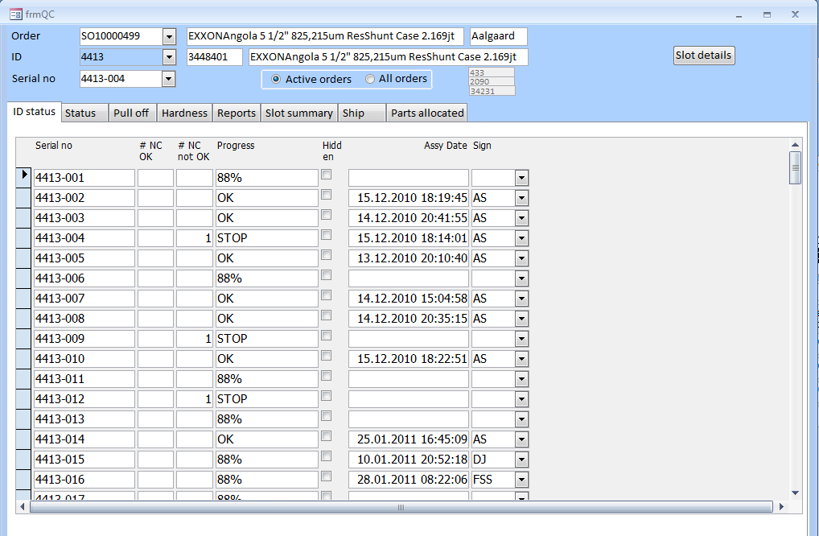

Figure Ware house form for allocation of parts

The hidden check box is not currently available but is intended to indicate that a complete joint is scraped or in other ways removed from the work order.

## Status

QC status for the selected assembly can be reviewed ().

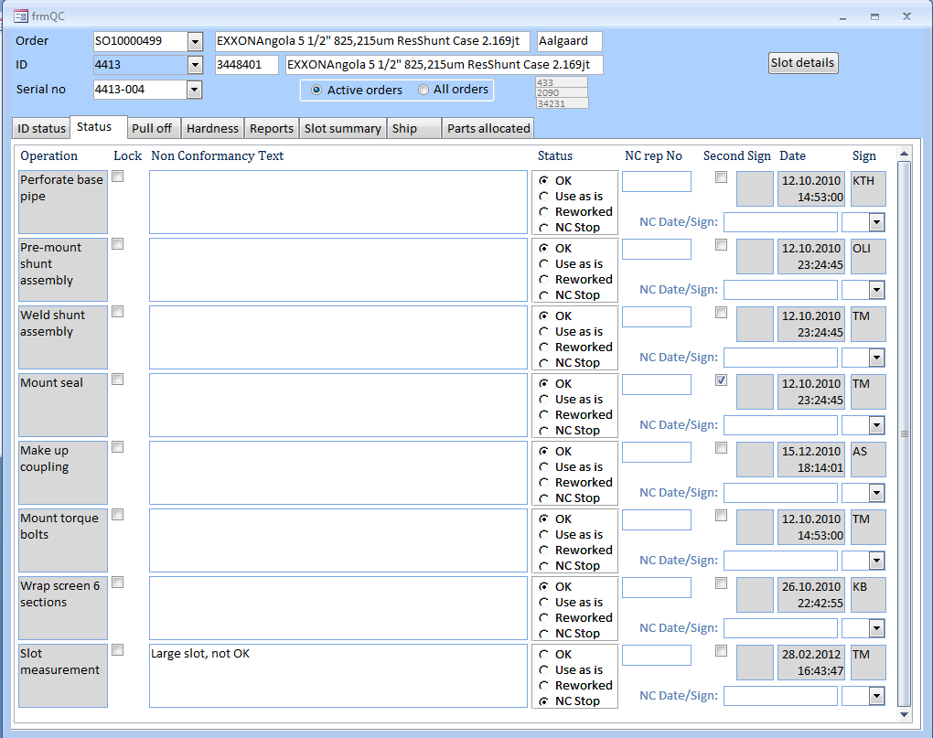

Figure QC status for selected joint

The Lock check box for each operation indicates that the given operation is locked and cannot be edited by the operator (Assembly form). QC has access to unlock a given operation to allow the operator to modify already entered information.

The status can be changed if the status has been set to NC Stop by the operator. In this case status can be set to Use as is or Reworked. If status is changed, QC must sign off and eventually record reference to any non conformance report.

## Pull off

Pull off values () and hardness values (next tab) can be recorded in these forms.

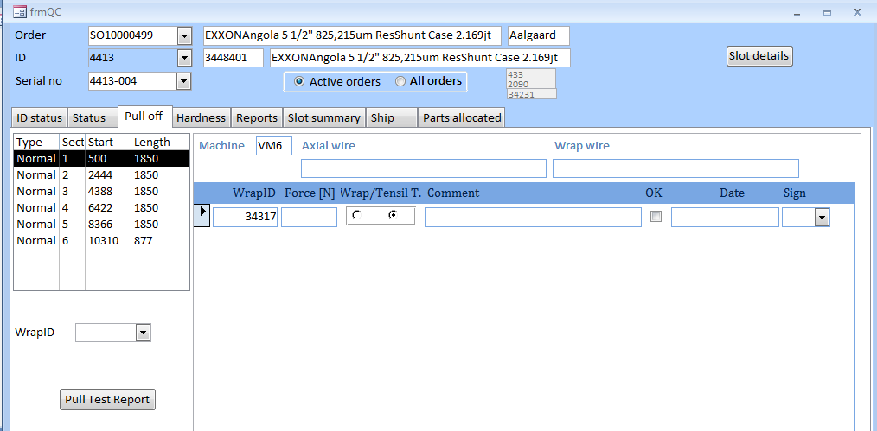

Figure Ware house form for allocation of parts

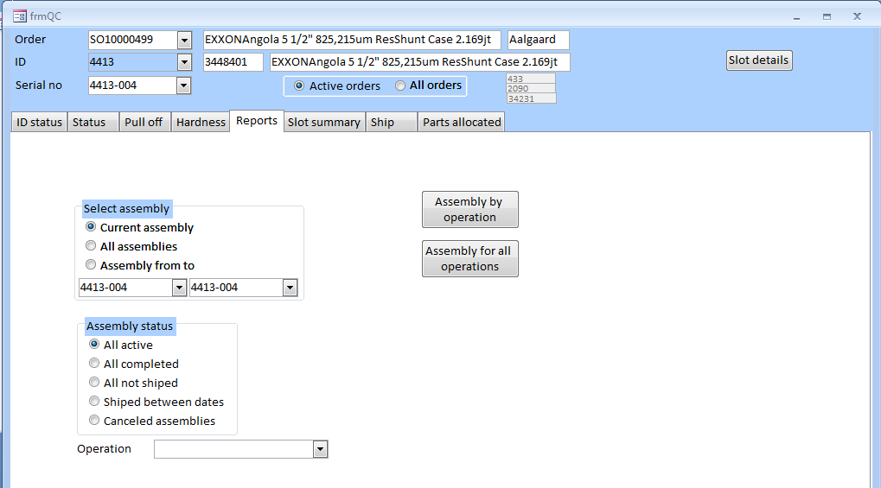

Figure Ware house form for allocation of parts

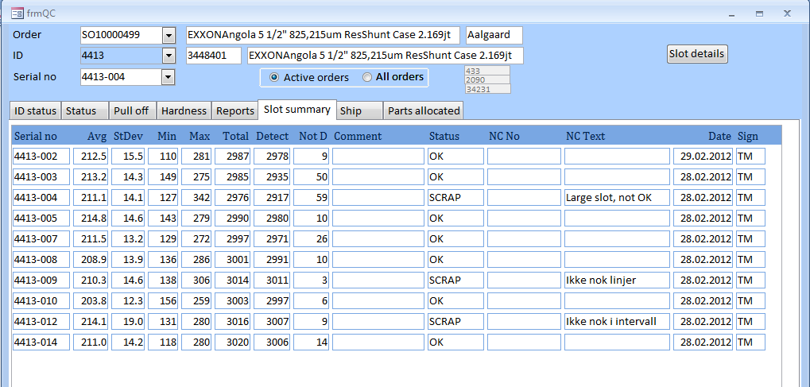

Figure Ware house form for allocation of parts

# Assembly

See user guide part 2

To start assembly process