# Summary

ResLog is a database developed to track details of the Reslink screen production. It can record details of each screen joint as it passes through the different manufacturing steps or operations or any subset of the defined operations. The information that may be recorded is:

* Wrapping process details
* Slot opening measurements and verification of slot requirements
* Process inspections and measurements
* Traceability of components

The system is intended to work together with MfgPro, but no automated link is made.

# Introduction

This user guide is covering the assembly process as it is supposed to be recorded in ResLog. This information should be recorded by the individual operator as soon as the given operation is completed.

# Assembly

The assembly process consists of a set of assembly steps which are predefined by the planner. Some of these steps may typically be:

* Perforation of base pipe
* Inspection and drifting
* Tack weld axial wires
* Wrapping of screen
* Slot measurement
* Welding of end rings
* Packing

The number and type of steps will vary with the type of product. Compared to the old ResLog, definition of assembly steps is dynamic. Consequently, more steps may be added to standard screen products or steps may be removed if recorded otherwise. The key difference is that the operator should be able to complete the given operation leaving the assembly in operation mode for a short time period as possible.

The forms have a verification of the recorded data. This means that requested information has to be recorded and in some cases, values have to be within given limits. If information is missing, the operator will not be able to sign off.

If a non conformance should occur, the status should be changed to NC and STOP and an explanation should be written in the Non Conformance text box. In this case, the operation can be signed off even without being completed.

## Assembly form

Open assembly form by clicking on Assembly. The relevant work order ID can be selected either by first selecting the relevant Order, or if the Order field is blank, all active work order ID’s will be displayed. Next, select Serial no and Operation to display operation tab (Figure 1). These two fields can be selected in any order.

### Operation Tab

The operation tab covers general assembly steps.

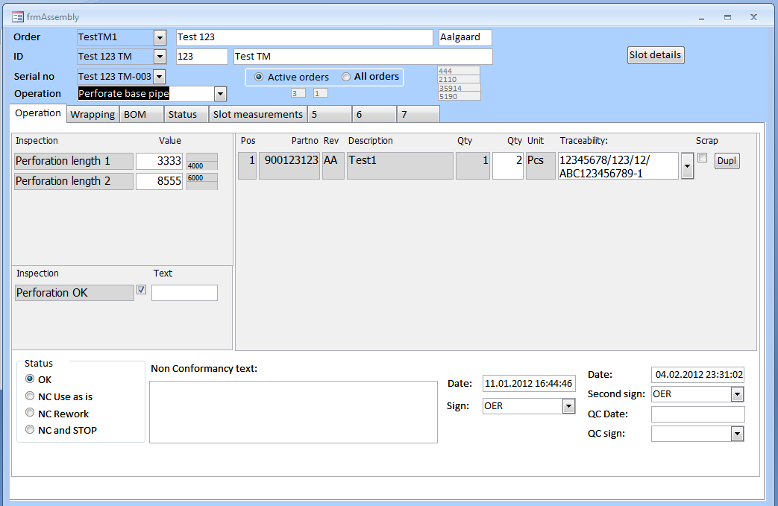

5

4

3

2

1

Figure Assembly form displaying tab for general operations.

The text boxex with gray background are fixed and cannot be edited. The form has an input section for numerical inspection values (1) and Yes/No type questions (2). A text may also be entered when relevant based on the type of inspection.

The traceability is selected (3) from the drop down list. The quantity in gray is the intended quantity according to the BOM, while the actually used quantity of the component with the selected traceability should be entered in the white box. If alternative parts (different end rings, nozzle rings or similar) can be used. The actual selected part number can be chosen from the drop down list for the relevant part number.

If a part is scraped during the assembly process, tick of the scrap check box. This should be done to indicate that the part has been used but is not a part of the given assembly. To be able to select a new part, click the Dupl button do generate duplicate record to record traceability information. Make sure the quantity is entered correctly.

If a non conformance should occur, change status to NC and STOP and write a short explanation in the text box (4).

When the operation is completed, select your initials in the drop down list. If an operation needs to be witnessed by another operator, this second operator must be entered first. If a second signature is not required, the field is not visible. If the status is changed to NC and STOP, the signature can be entered even without all information entered into the various fields. If signature is missing, you have not been given the right to do this operation. In this case, contact your supervisor.

### Wrapping tab

The wrapping tab is tailor made for the wrapping process (Figure 2). Several screen sections may be covered on joint. The status of these sections may be Normal, Test of Scrap. Test and scrap are options for screen sections that will not be part of the finished product. Test is typically used for machine setup or if an extra section is wrapped to collect samples for testing. Scrap should be used if a screen section needs to be rewrapped. Old wrap date should not be overwritten with new data. To be able to add new sections, click Add new wrap sections.

Select the relevant section in the list box (1) and fill in information in part (2) of the form. When traceability information for the wires is selected, reference to eventually wire pull test will be displayed and the estimated quantity remaining on to spool will be displayed.

If wire pull test is done in the wrapping machine, the recorded force should be entered (3). This field is not intended for the pull test done by QC in the Instron machine.

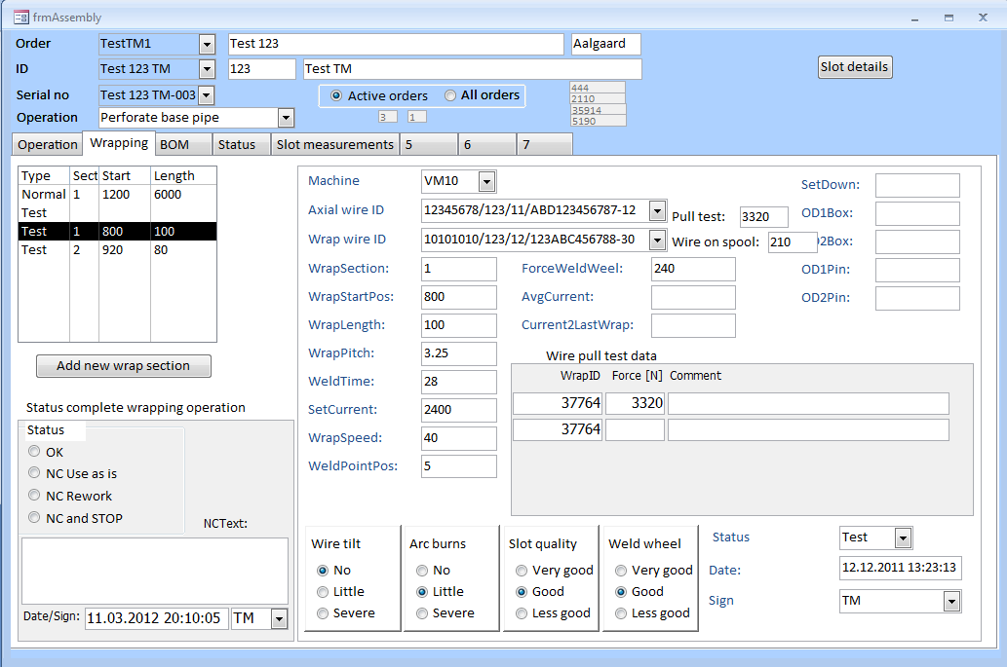

6

2

5

3

4

1

Figure Assembly form displaying tab for wrapping operations.

When the given screen section is wrapped, sign off (5). Status of the given screen section is set above the date field (5).

If a non conformance should occur, this must be recorded the same way as for general operation (4).

When wrapping of the whole screen joint is completed, sign off in bottom left corner (6). If the screen joint is rewrapped after this signature has been entered, the signature must be reentered.

### BOM tab

This tab covers the complete bill of material for the assembly. This form is intended for information only and should preferably not be used to enter information.

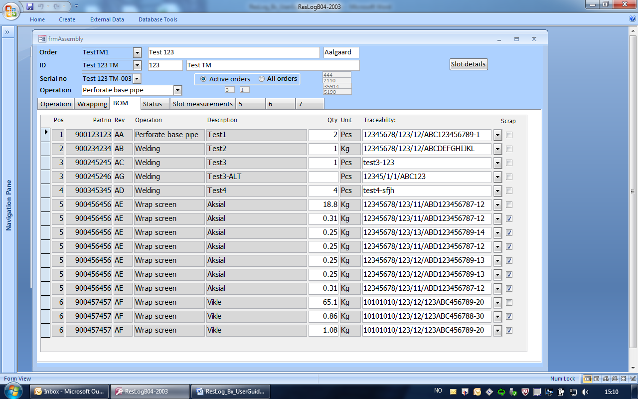

Figure As built BOM for all operations

### Status tab

This form is for information only. It is showing details of the routing and eventually QC issues.

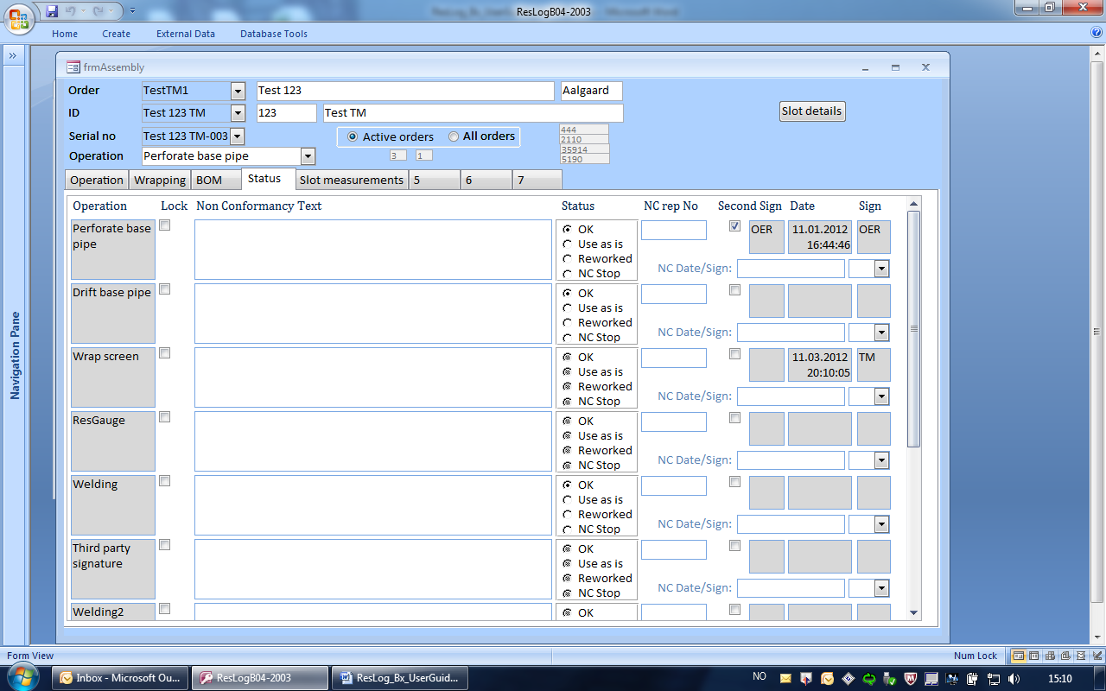

Figure Operation status for a given screen joint

This formed is to be filled in by the operators. Order or work order can be used to start selection. If Order is left blank, all work orders will be listed.

Serial no shall list all assemblies in sequential order. Operation lists all operations that shall be completed as part of the manufacturing process. All operations apart from screen wrapping and slot inspection are covered under the tab Operation.

Each operation shall be completed in sequential order. The next operation cannot be signed off before the previous has been completed.

Boxes intended for data entry are white, while fixed information are in grey boxes.

## Slot measurements

To be able to correlate slot data with wrapping machine settings and wire traceability, wrap data must be recorded before slot measurements can be recorded. Start position, wrap length, traceability and other relevant information must be recorded. Position and length is particularly important for screen joints with multiple wrapped sections.

By clicking Slot details in the upper right corner, a new form is opened. In this form different screen joints under the given work order ID can be selected. The form consists of three tabs. The first one covering slot data import (Figure 5), the second a summary of the results (Figure 6) and the last one a list of large slots when applicable (Figure 7).

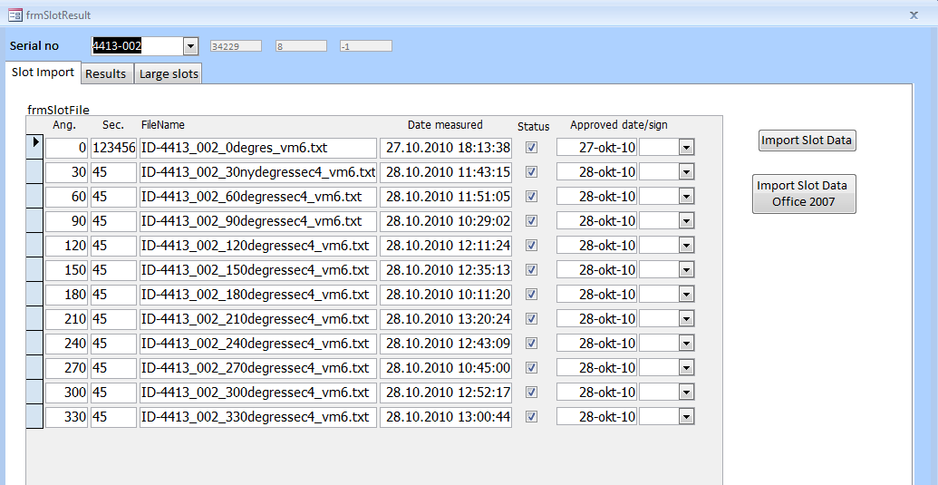

Figure List of imported slot data files

To select slot data file, click on Import Slot Data or if Office 2007 or Windows 7 is installed, click Import Slot Data Office 2007. The file dialogue box is opened, and relevant data file can be selected. The slot data are than analysed to link the data to relevant slot sections and angle. The slot data file can cover multiple sections, but only one angle (this version of ResLog).

Valid slot data files shall have Status ticked off. If a slot data contains inaccurate data or too many non detected slots, the tick mark in the Status field can be removed and data from this log file will no longer be part of the slot results.

The Results tab shows summary of the slot data for the given screen joint based on the slot requirement settings.

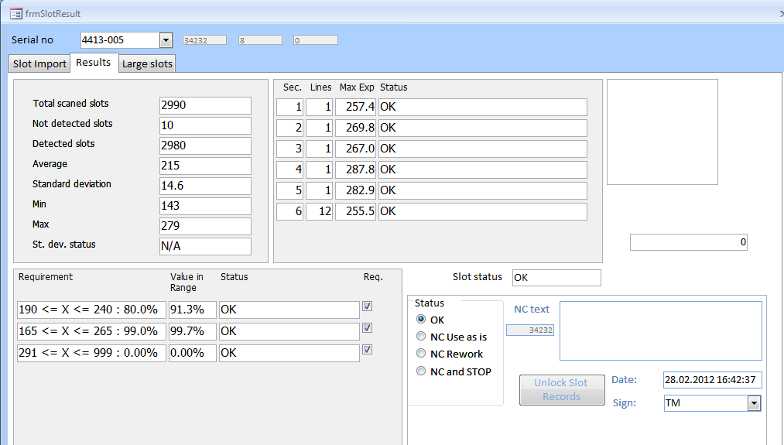

6

5

4

3

2

1

Figure Summary page showing slot data summary

A summary (1) shows key statistical data for relevant lines that shall be included in the statistics. For ResShunt and current quality plan, only the first line is used for statistical analyses, while eventually further lines measured are used to identify eventual large slots. Percentage of slots falling within required ranges are displayed in (2). In the case of running multiple scans to identify large slots, the result is displayed in (3). Summary of eventually slots exceeding a given value will be displayed in (4). Details of large slots (or eventually small slots) are also displayed under the tab Large Slots.

When slot data meets requirements, Slot Status (5) will display OK. Status shall be set to OK and signature shall be entered (6). If screen joint do not meet requirement, Status shall be set to NC and STOP, a non conformance text shall be written and signature shall be signed off.

In the case slots above a given value (or below a given value) shall be examined, slots faling within this range will be displayed under the tab Large slots (Figure 7).

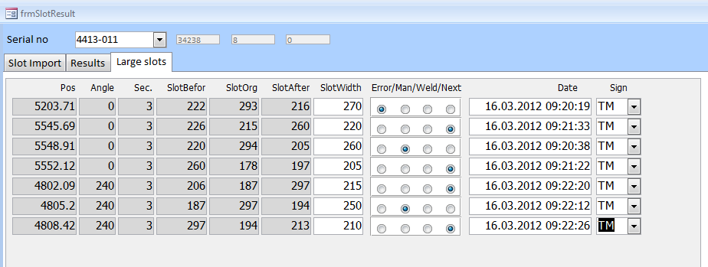

Figure Summary of large and eventually small slots

Position, angle, section and original slot opening is displayed along with the slot width of the neighbour slot before and after. The actual slot can be corrected based on manual measurement or eventually slot manipulation. The following selections are available:

|  |  |
| --- | --- |
| Error | ResGauge has given wrong slot width. In this case, a correct slot value shall be entered. Statistical analyses will be updated based on the new recorded slot value. |
| Man | Slot opening is manipulated and the slot opening after the manipulation shall be entered. In this case the two slots next to the manipulated slot shall also be updated. |
| Weld | Slot opening is closed by welding and the slot opening shall be set to 0. In this case the two slots next to the welded slot shall also be updated. |
| Next | This is set automatically for the slot on each side of a slot being manipulated or welded. The new values in the two neighbour slots next to the relevant slot will be used when calculating slot statistics. |