This document of Cybage Software Pvt. Ltd. is for restricted circulation. No part of this publication may be reproduced, stored in a retrieval system or transmitted in any form or by any means – recording, photocopying, electronic and mechanical, without prior written permission of Cybage Software Pvt. Ltd.
Help & Manual for MaaS UI Automation

Document name | Help & Manual for MaaS UI Automation  MaaS Phunware | System Recruitment Specification
Version no. | 1.0 | 1.2
Release date | 04-03-2014 | 1st Oct ‘09
Classification | Confidential



Document History

Ver. No | Release Date | Created By / Modified By and Date | Reviewed By and Date | Approved By and Date | Remarks and Changes Made
1.0 | 04.03.2014 | Ganesh G | Bhargava S | Nikhil Khankhoje

Distribution List
Sr. No. | Name | Role | Organization Name
1. | Paresh Suthar | Product Owner | Phunware Inc.
2. | Farrell S | QA Engineer | Phunware Inc.
3. | Ranjeet | Delivery Manager | Cybage Software Pvt. Ltd.
4. | Nikhil Khankhoje | Sr. Project Manager | Cybage Software Pvt. Ltd.
5. | Bhargava S | QA Engineer | Cybage Software Pvt. Ltd.
6 | Pramod | QA Engineer | Cybage Software Pvt. Ltd.

Table of Contents
1. Introduction 3
2. Work Product/Application Detail 3
3. Test Environment 3
4. Manual 3
5. Contact Points 8

Introduction
This document explains detail steps to run MaaS UI automation scripts on Windows and Mac Machine. The code is downloaded on the local machine using SVN link and it can be updated using the same link.
This document also has screen shot at required steps to run the script. The browser modification for compatibility testing is also mentioned in the help manual.

Work Product/Application Detail
Name of the Product/Application | MaaS By Phunware
Name of the Sub product/Component (if applicable) | MaaS UI Automation
Submitted By | Ganesh G QA Engineer
Reviewed By | Bhargava S QA Engineer
Approved By | Nikhil Khankhoje Project Manager

Test Environment
1. O.S: Windows.
Browsers: Google Chrome, Mozilla Firefox, IE
2. O.S: Mac
Browsers: Google Chrome, Mozilla Firefox, Safari

Manual
        - To copy code to your local machine from SVN
            - Create a folder at the desired location to extract the Automation code via SVN
            - Right click on the folder and select “Open in Smart SVN”
            - Go to the “Project” tab and click on “CheckOut”

Insert the below path for the repository: https://svn.handson.com/us/cybage

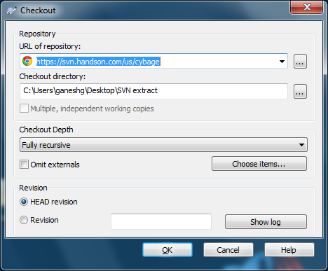

Extraction of the required folder will be done as below:

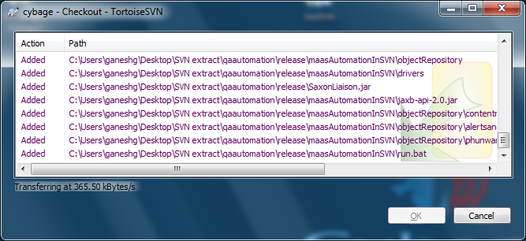

            - The folder will be up to date after download completion.

        - Execution of the script on Windows machine
            - After complete download of the code, double click the “maasautomation” in the folder to run the script.

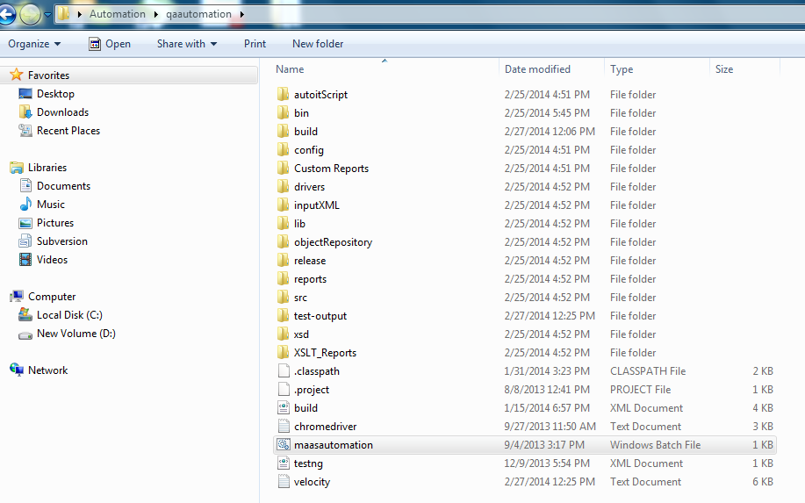

            - The automation script will start executing on the double click and below “cmd” prompt window will be seen for the execution.

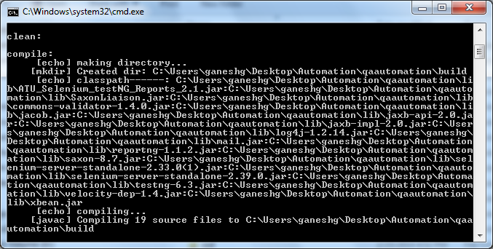

            - The script will execute automatically on the selected browser in the config file of the script and logs will be displayed in the cmd prompt.

        - Execution of the script on the MAC machine

            - Complete the download of the automation code on the local folder of the Mac Machine as stated in the “To copy code to your local machine from SVN” above.
            - Open the “Terminal” and insert the path for the script execution.
Example:
Last login: Wed Feb 26 11:09:55 on ttys000
Administrators-Mac-mini-2:~ dev5$ cd ~/Desktop/maas-auto
Administrators-Mac-mini-2:maas-auto dev5$

“cd ~/Desktop/maas-auto” is the path for the selected folder in the above example.

            - Insert below command to execute the script on Mac machine:
“ant run”
Example: Administrators-Mac-mini-2:maas-auto dev5$ ant run

d. The automation script will start executing.

        - Changing the browsers in the script

The “config” file in the code need to be changed to execute the script on different browsers.
The available browsers to run the scripts are IE, SAFARI, CHROME and FIREFOX.
Below are the steps to change the browser in the config file:

- Go to the “config” folder of the downloaded automation folder.

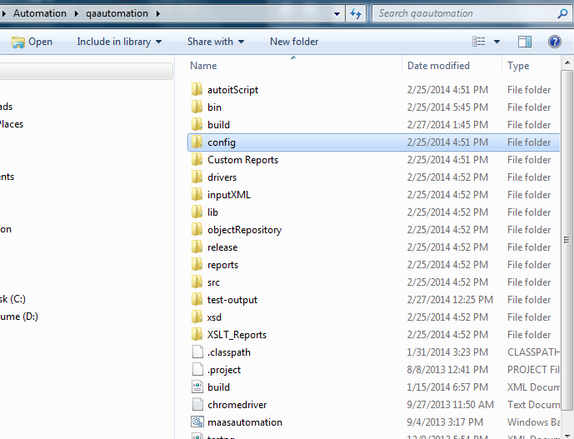

- Edit the file using notepad and modify the config file for selecting the desired browser, environment and URL.

For example:
<?xml version="1.0" encoding="UTF-8"?>
<!-- browser IE/CHROME/FIREFOX/SAFARI -->
<config>
<environment name="mass-stage" runmode="Y">
<browser>SAFARI</browser>
<url>https://maas-stage.phunware.com/login</url>
</environment>
<environment name="mass-dev" runmode="N">
<browser>FIREFOX</browser>
<url></url>
</environment>
<environment name="mass-production" runmode="N">
<browser>FIREFOX</browser>
<url></url>
</environment>
</config>
- The runmode can be multiple for different environment. “Y stands for yes” and “N stands for No”.

        - Steps to check the Custom reports
After successful execution of the script the Custom report is generated in the below path of the automation script folder.
Below are the steps to view the custom reports:
- Go to the below path to check the Custom reports.
Automation folder (xx) →quautomation → Custom Reports → index (double click)

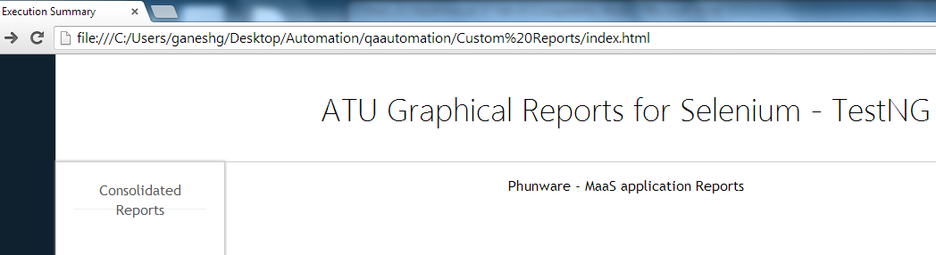

- On the custom report, click on the Consolidate reports tab to view all the Test Runs of the automation scripts.
- Greater the run number, latest is the run. For the below chart, Run 11 is the latest run along with the Line and Bar chart.

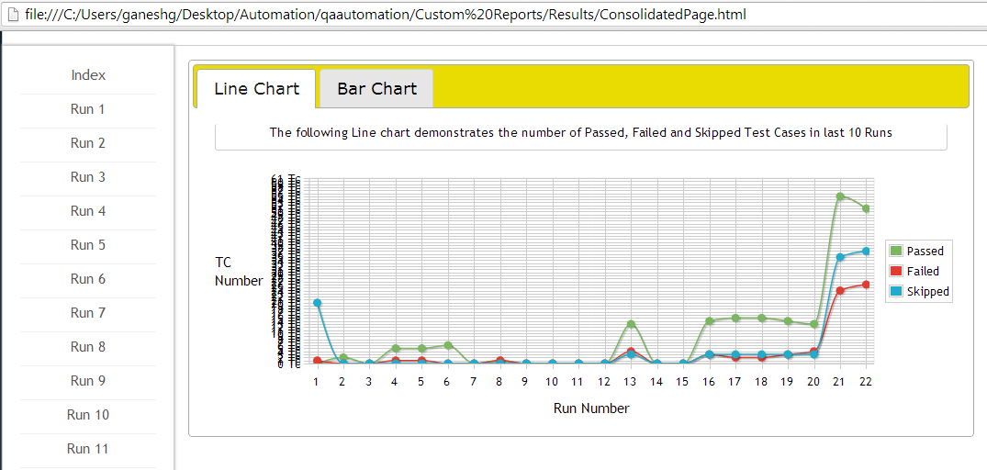

- Click on the Run, to view the detail about the execution along with the Pie chart.

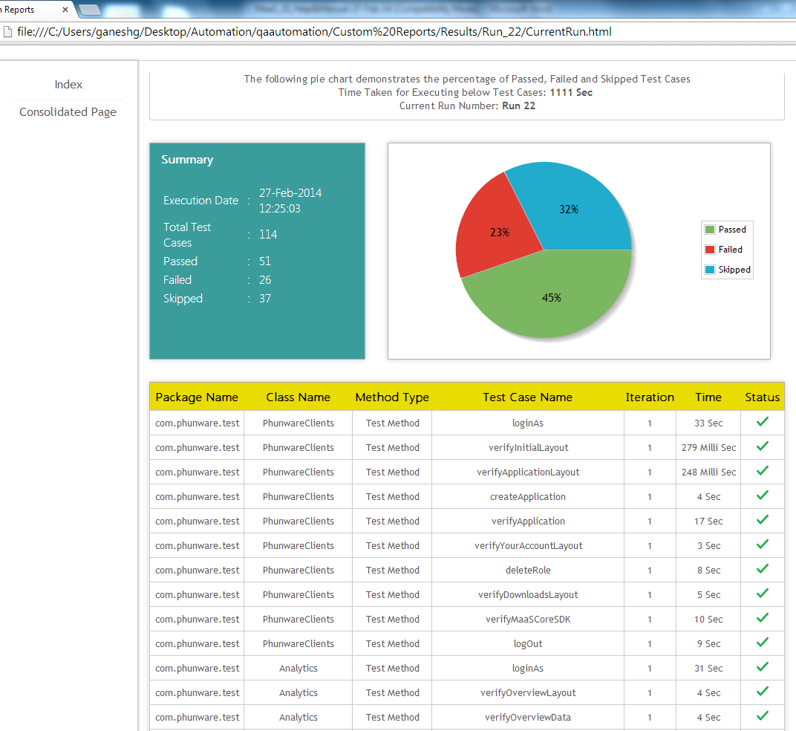
- The summary report has detail explanation of the execution date, total Test cases, Passed, Failed and Skipped test cases along with screen shots for the failed scenarios attached.

Contact Points
Sr. No | Name | Role | E-mail | Phone No. & Extension | Mobile
 | Nikhil Khankhoje | Project Manager | NKhankhoje@cybage.com | 91-20-66041700, Ext:6235 | 91-9561099180
 | Ganesh Ghubade | QA Engineer | ganeshg@cybage.com | 91-20-66041700, Ext: 6235 | 91-940464966
 | Bhargava S | QA Engineer | bhargavas@cybage.com | 91-20-66041700, Ext:6235 | 91-9049120756

