How to build&run

1. Extract the source code
2. $ cmake CMakeLists.txt
3. $ make
4. You can see two binaries, server_main client_main

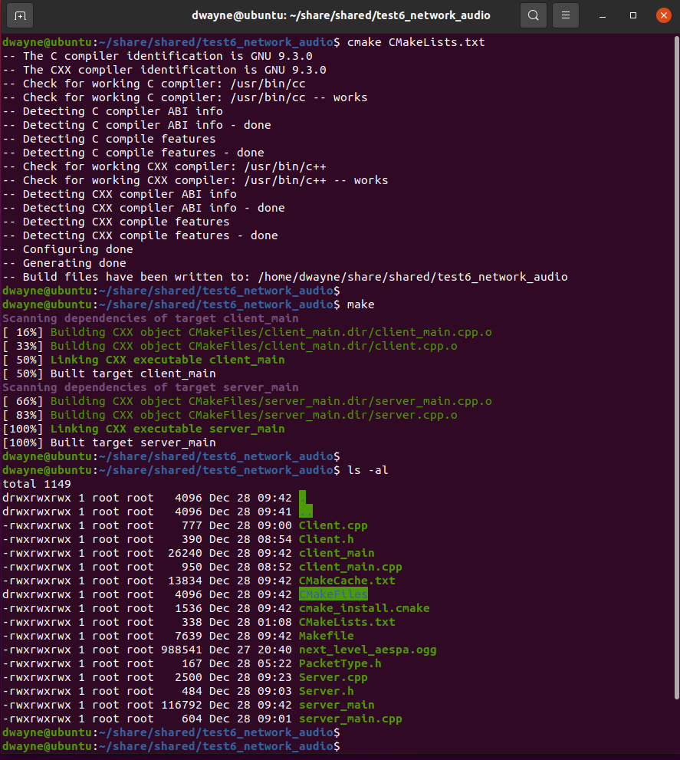

1. Run 2 binaries in each terminal
2. Server_main

* Input port number

1. Client_main

* Input name
* Input port number
* Input “local” or real IP
* When you command “p”, “s” or “q”, then you can listen to the music.

