**(SCREENSHOTS)**

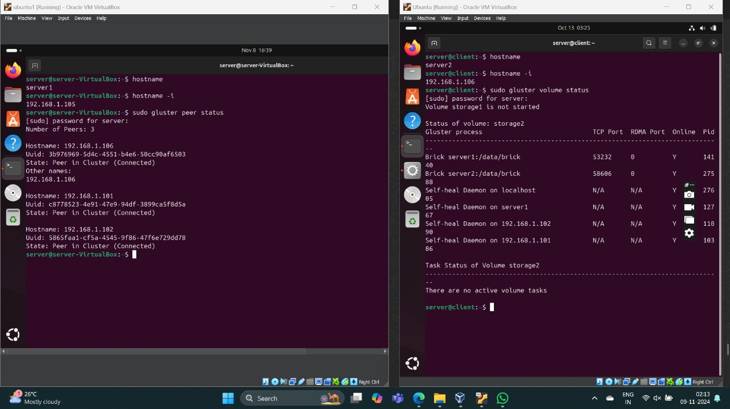

**Server: Peer probing nodes and Volume creation**

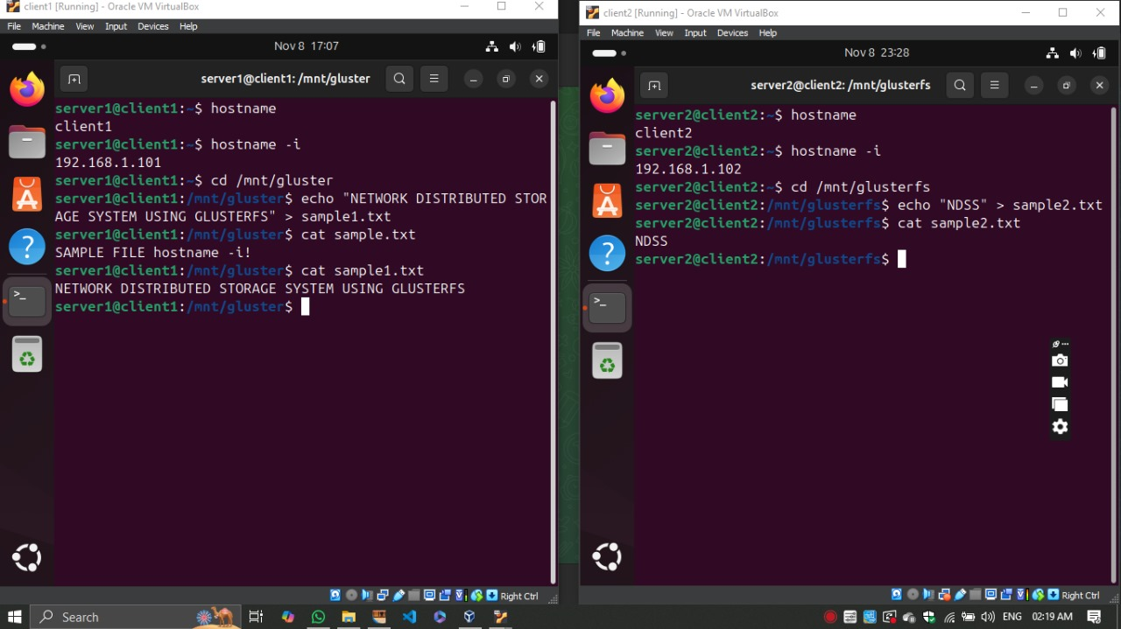

**Client: Adding files to the server**

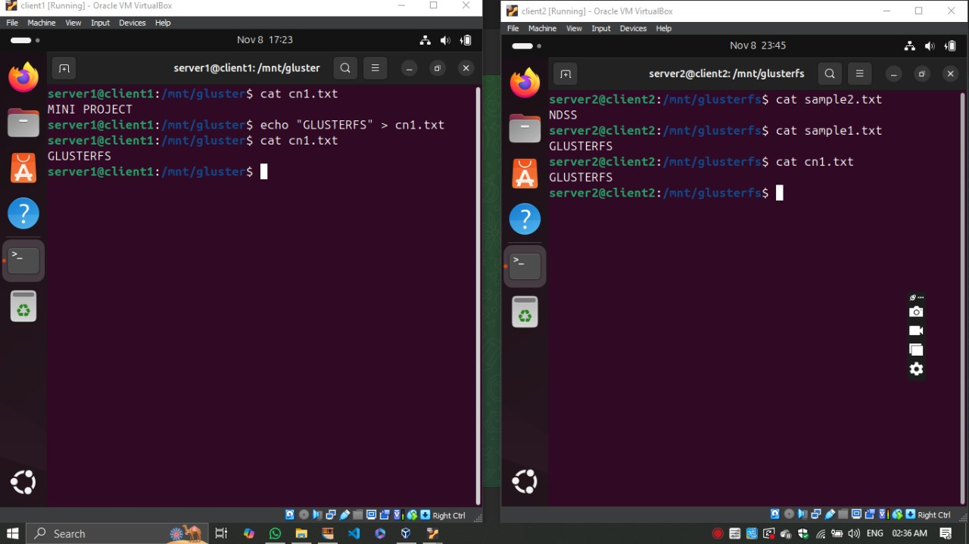

**Data consistency**

**Data replication**

**Shutting down of a server**

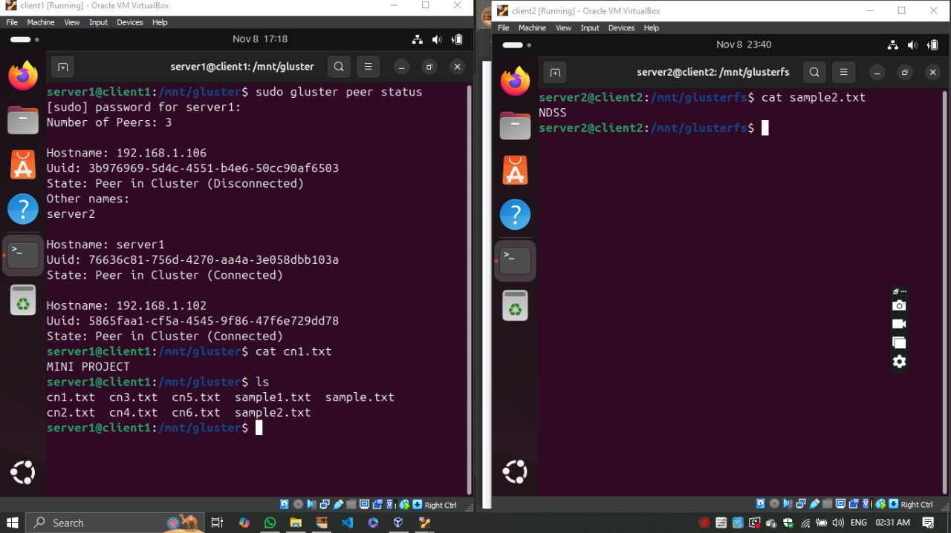

**Fault Tolerance**