

**SCD Assignment 1: Module Features Submission**

**APP Name: Snack Bar Café App**

**Menu Management Module**

**https://github.com/fast-isb/assignment-1-sghazaan**

**Department:** SOFTWARE ENGINEERING

**Section:** Q

**Group Members**

Maaidah Arif 20i – 0997

Umer Asif 20i - 1863

Umar Waheed 20i - 0926

Shah Rukh Abdullah 20i – 0995

Aleena Fatima Khalid 20k-1688

**Project: Cafe Application**

Module:

|  |  |
| --- | --- |
| **a.** | **Menu Management – Admin PANEL** |
| **1.** | Add customer in app |
| **2.** | Remove customer from app |
| **3.** | Update customer from app |
| **4.** | View customer from app |
| **5.** | Search customer |
|  | **ASSIGNED TO : Shah Rukh Abdullah** |

1. **Starting Project**

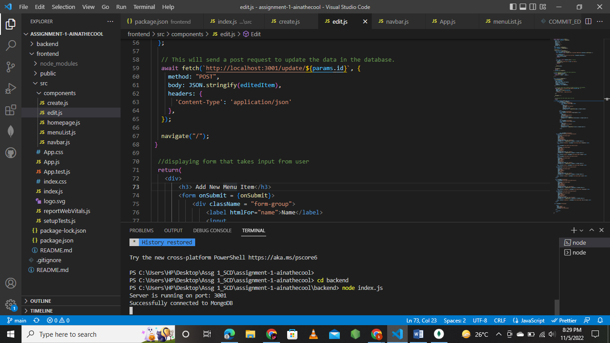

1. **MongoDB Database**

Database name: CafeAppDB

Menu Management Collection: CafeMenu

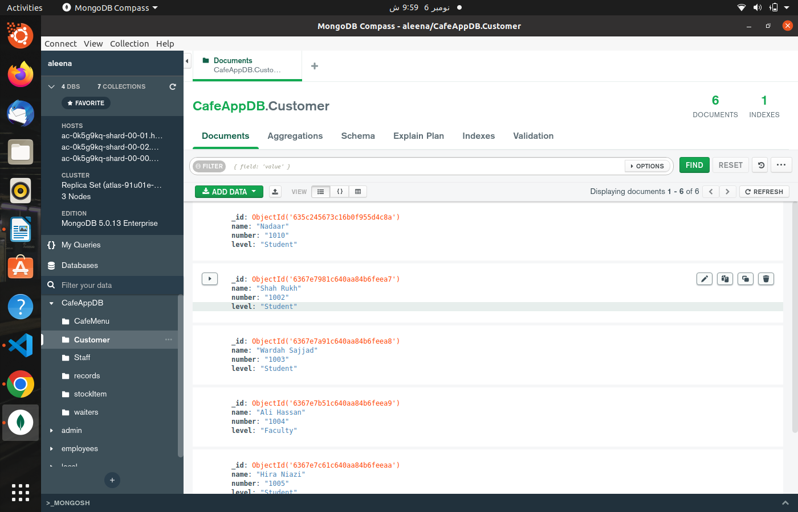

1. **Compilation Successful**

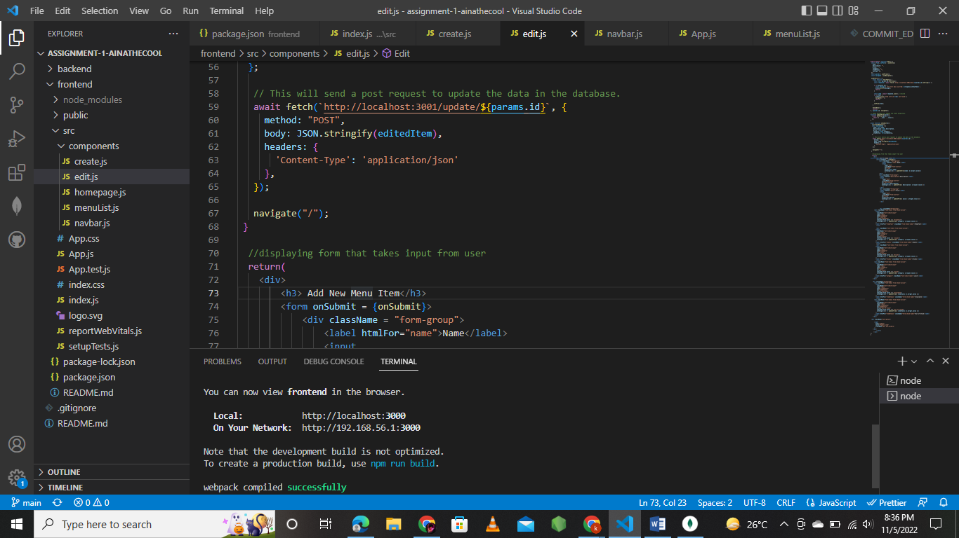

1. **Home Page**

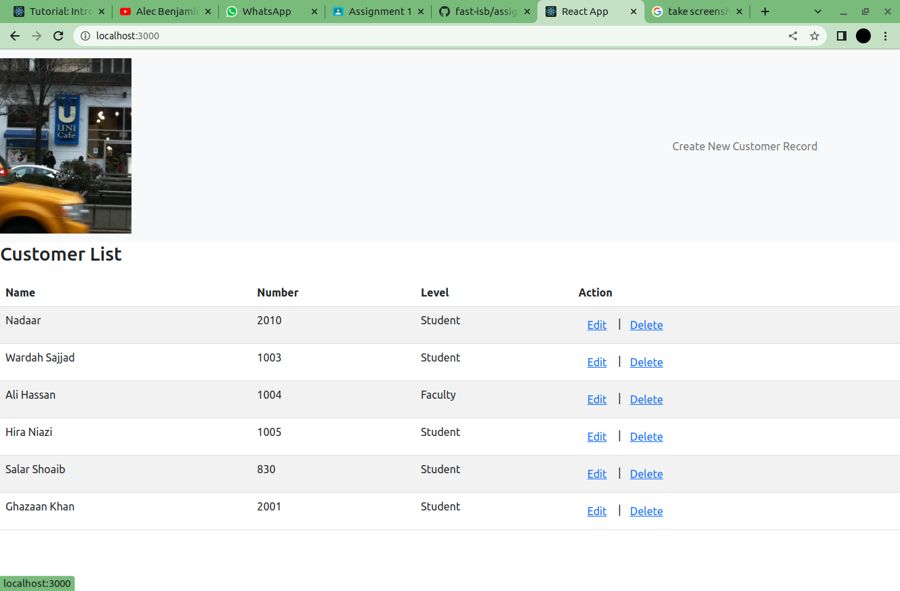

1. **Add Customer**

This feature enables the admin to add a new customer by filling out all of its required details. The item is then added into the database collection CafeMenu, and displayed in the Menu List as well.

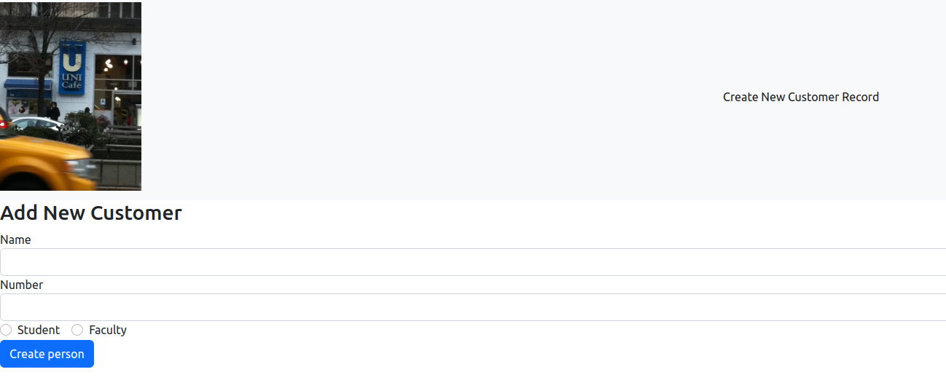

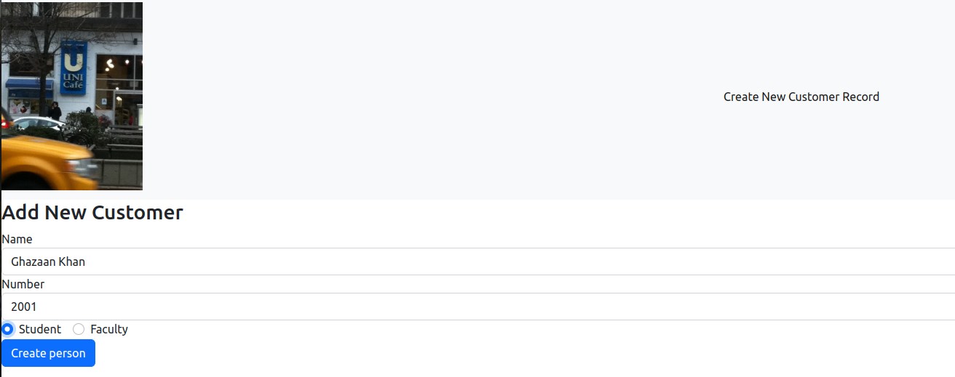

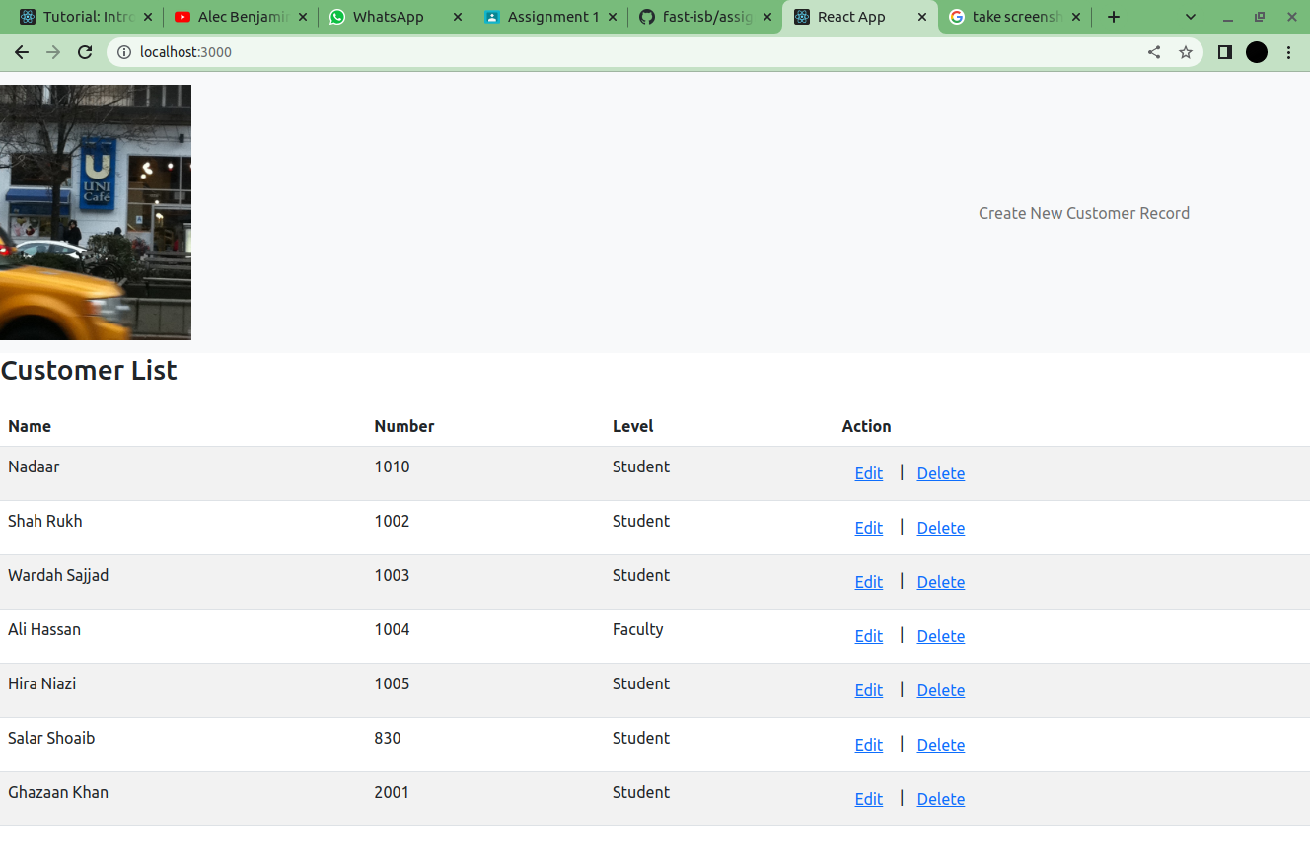

New Customer has been added to CafeAppDB’s collection Customer

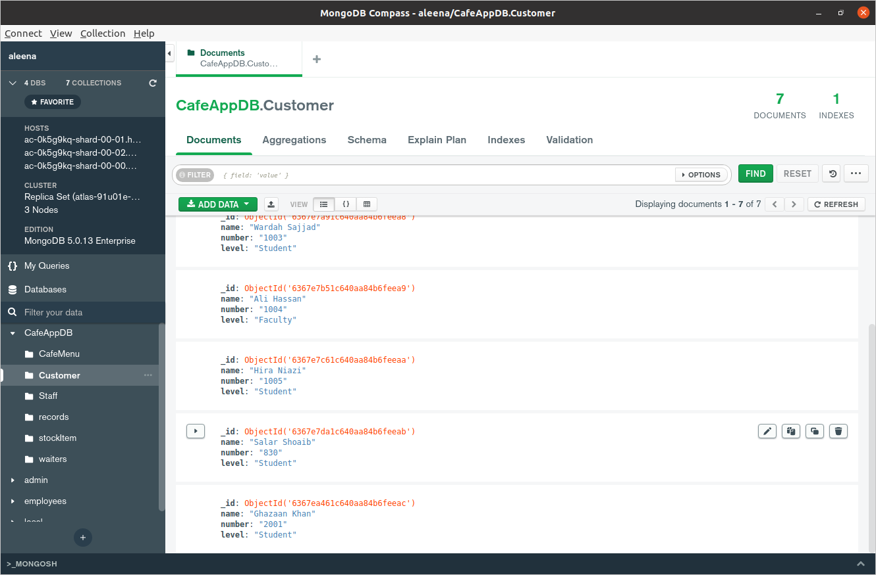

New customer listed in the displayed Customer list.

1. **View Customers**

This feature enables the admin to view all of the customers present in the database collection Customers. It also provides the admin with the options of Edit/Update Customer and Delete Customer..



Customer list displayed, fetching customers from the CafeAppDB collection Customer.

1. **Edit/Update Customer**

This feature enables the admin to edit the selected customer, and updates it properties in the database as well, updating the customer list too.

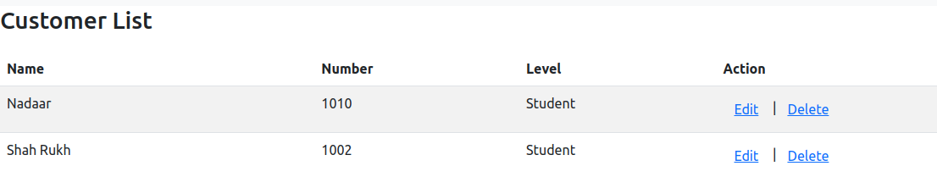

Select the Edit option for the desired customer.

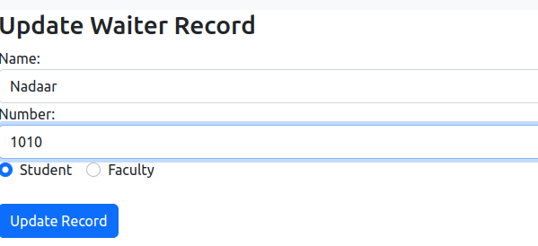

Edit number of the customer

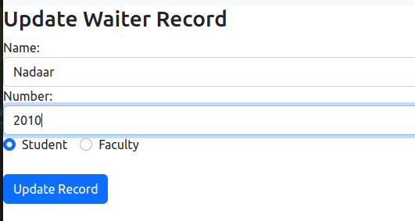

Number of customer has been edited

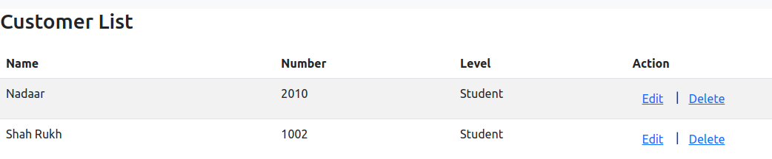

Updated customer list fetched from the database and displayed.

1. **Delete Customer**

This feature enables the admin to delete the desired customer. The customer is removed from the CafeAppDB collection Customer and is then also not displayed within the customer list.



List of customers in database. Deleting the desired customer from the list. For eg: Customer: “Shah Rukh”

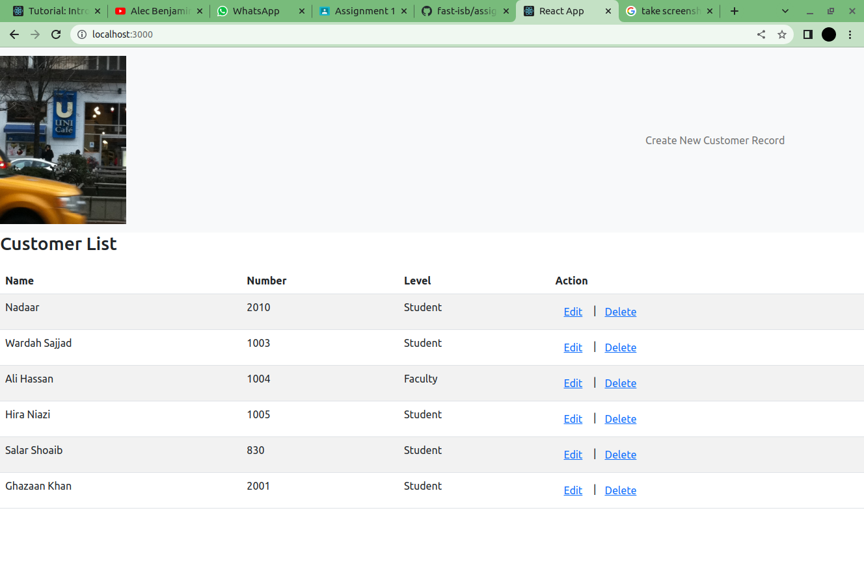

customer (Shah Rukh) deleted from the list.

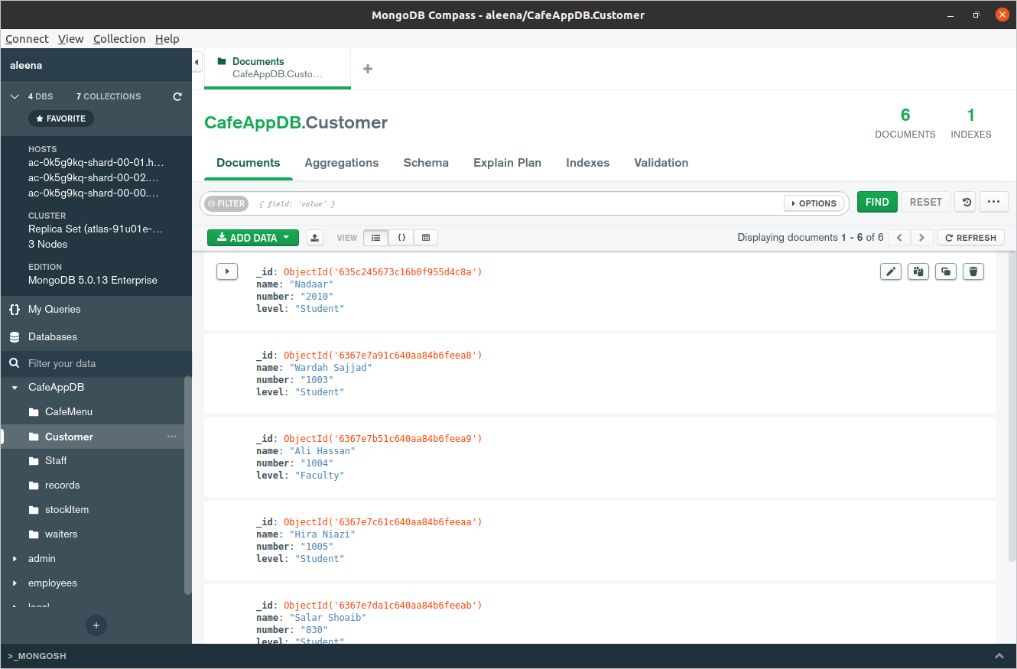

Customer (Shah Rukh) has been deleted from the database as well.