Manual Test Plan

Start the app.js and go to the localhost:3000 and verify you see this screen:

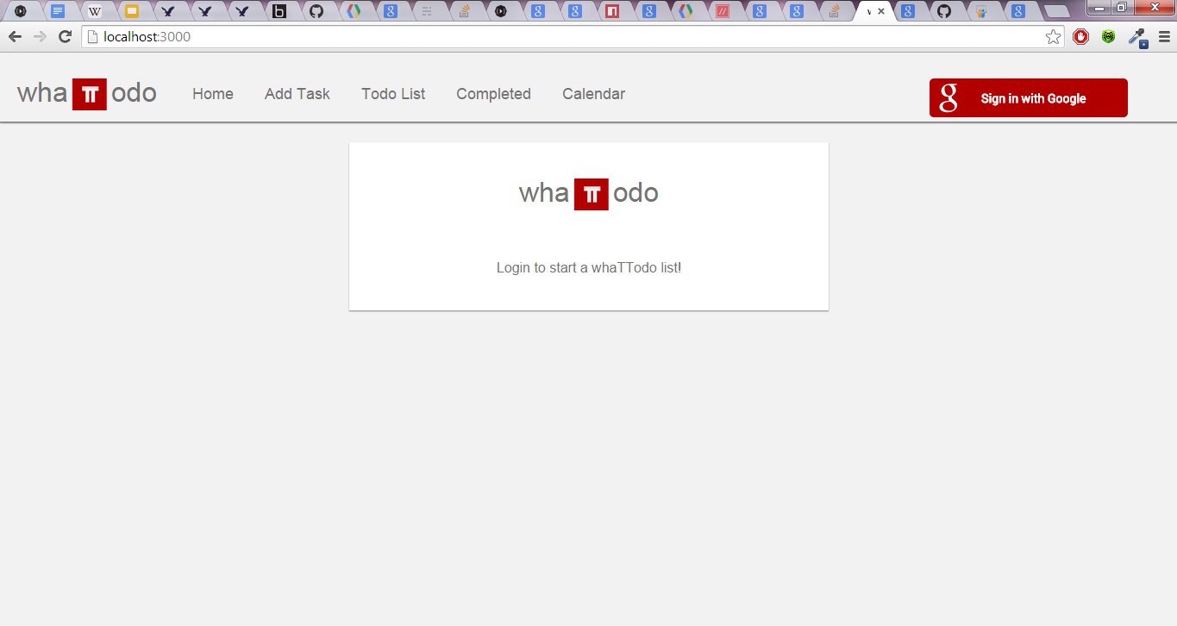

Press the ‘Sign in with Google’ logo:



Verify you get sent to the google sign in page:

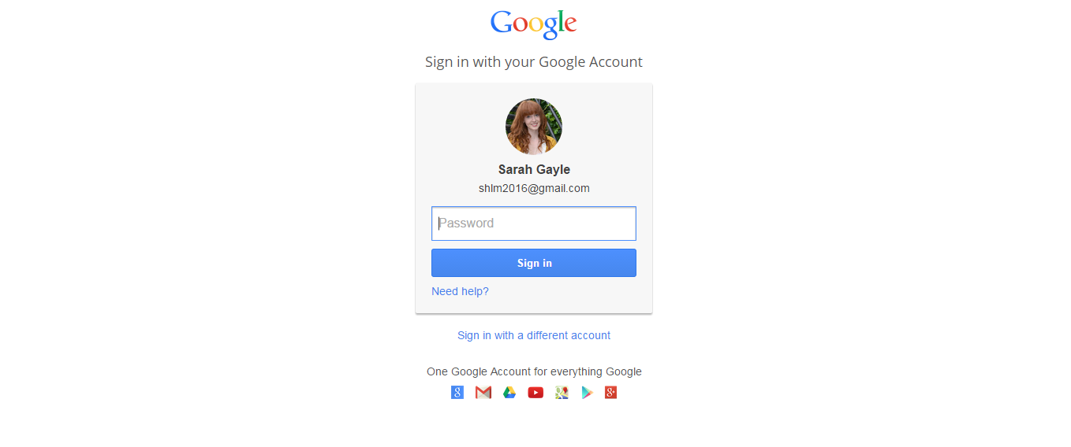

Accept the permissions and verify the user’s name and image is shown in the right corner:

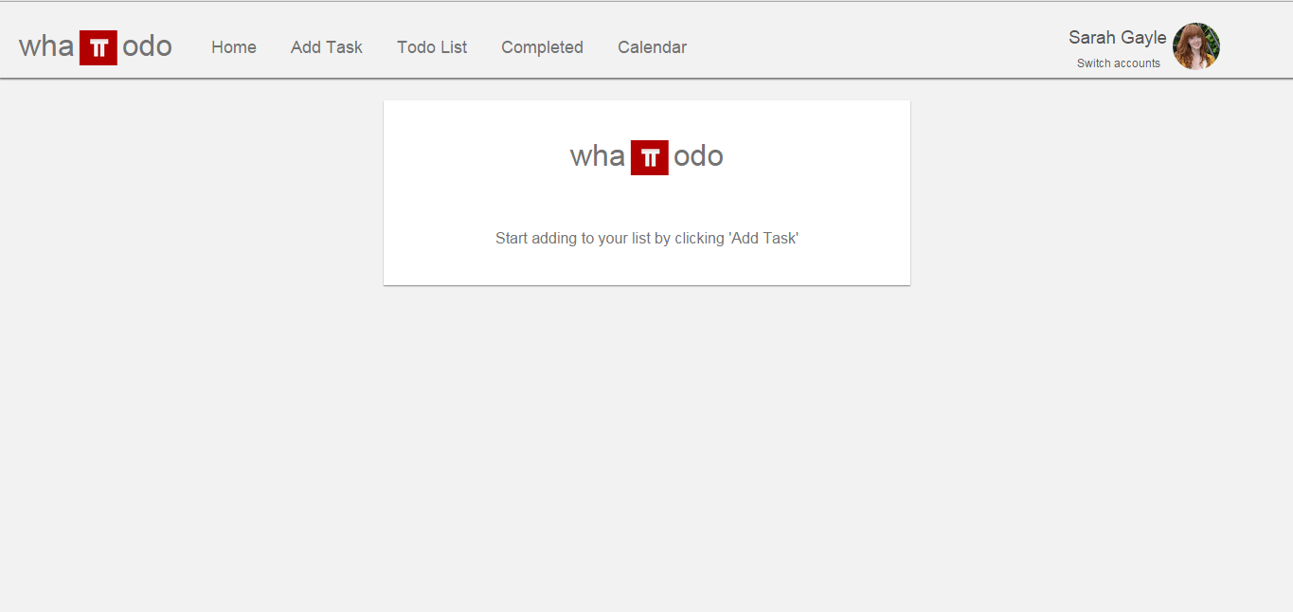

Hover over the ‘Add Task’ link and notice it have a red border

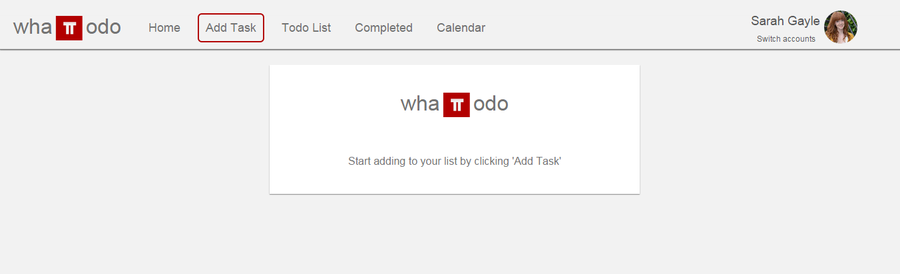

Type ‘New Task’ in the Task input

Type ‘1’ in the Priority input

Choose a due date

Press the ‘add’ button

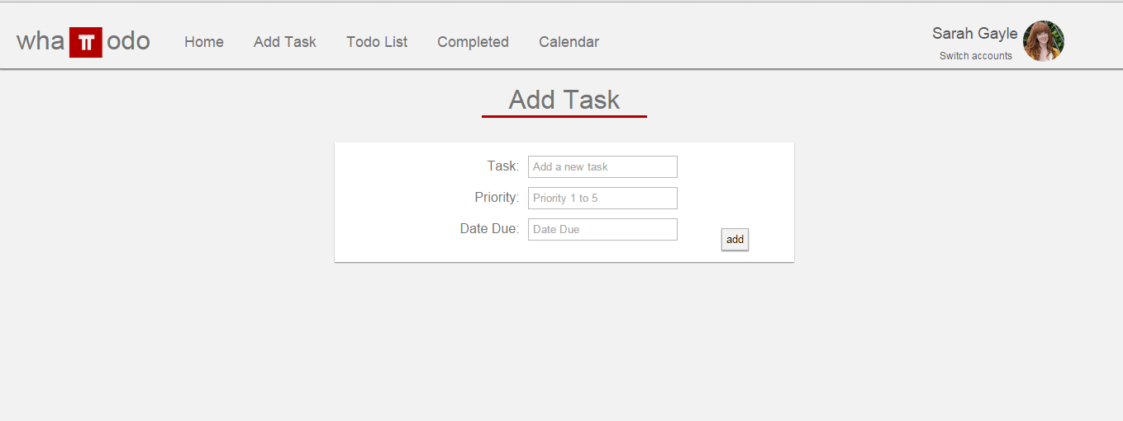

Click on the ‘Todo List’ link and verify on hover the border appears

Verify your previous task was added to the list:

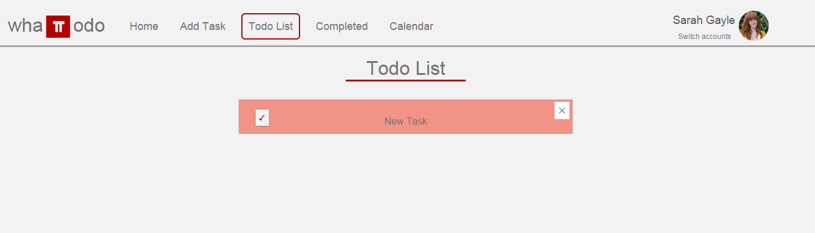

Press the ‘x’ and verify the task is removed from the list

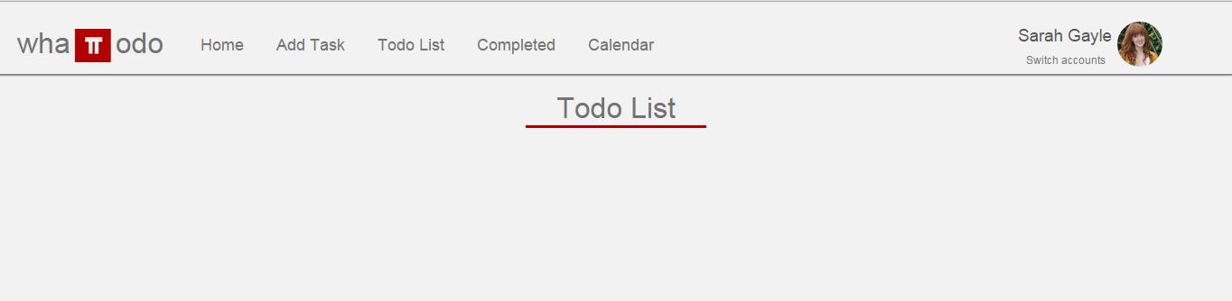

Add a repeated task:

Click on TodoList and verify the added task shows up:

Press the check box and verify the date of the new task changes to a week later and the ordering of the tasks changes based on the priority/due date

Press the check box until it is the last task in the series:

Verify it is removed from the todo list

Click on completed:

Verify that the task completed is visible:

Click on the check box:

Verify the task is now gone from the completed list:

Click todo list:

Verify the task is added back to the todo list at the right location: