Results of HUEM_ABC on the CEC2022 benchmark
F | NABC | ASABC | ABC-ANT | HUEM-ABC
F1 | (0.00±0.00)×10⁰ | (0.00±0.00)×10⁰ | (3.81±12.86)×10⁻¹ | (1.29±0.47)×10³
F2 | (7.18±12.10)×10⁰ | (5.24±2.50)×10⁰ | (2.92±3.47)×10¹ | (3.82±1.75)×10⁰
F3 | (0.00±0.00)×10⁰ | (0.00±0.00)×10⁰ | (5.16±14.64)×10⁻¹¹ | (0.00±0.00)×10⁰
F4 | (3.15±1.23)×10¹ | (1.45±0.53)×10¹ | (5.51±2.58)×10¹ | (9.66±2.13)×10⁰
F5 | (3.98±4.13)×10⁻¹ | (0.00±0.00)×10⁰ | (1.05±0.98)×10⁰ | (8.71±3.24)×10⁰
F6 | (1.31±1.72)×10⁴ | (1.17±1.86)×10³ | (4.83±5.04)×10³ | (2.66±1.62)×10³
F7 | (2.60±0.94)×10¹ | (1.14±1.00)×10¹ | (2.80±1.69)×10¹ | (6.20±9.78)×10⁻¹
F8 | (5.05±10.15)×10¹ | (8.40±10.01)×10⁰ | (2.20±0.62)×10¹ | (1.55±0.56)×10¹
F9 | (3.47±0.65)×10² | (2.99±1.36)×10² | (3.17±1.40)×10² | (2.30±0.02)×10²
F10 | (1.30±1.25)×10² | (2.44±13.34)×10⁰ | (2.35±1.20)×10² | (3.37±18.00)×10⁰
F11 | (1.44±3.23)×10² | (1.14±2.97)×10² | (2.18±3.80)×10² | (0.00±0.00)×10⁰
F12 | (1.63±0.09)×10² | (1.16±0.55)×10² | (1.84±0.24)×10² | (1.64±0.02)×10²
w/t/l (HUEM-ABC) | 8/1/3 | 5/1/6 | 10/0/2 | --
Wilcoxon p | 0.102 (≈) | 0.700 (≈) | 0.052 (≈) | --
Friedman rank | 2.88 | 1.54 | 3.58 | 2.00
Friedman test: χ² = 18.65, p < 0.001
Table 1. Mean ± std error of the compared algorithms on CEC2022 benchmark functions (D=10). Bold = best per function. Wilcoxon signed-rank test (α=0.05) compares HUEM-ABC with each competitor ('+' HUEM-ABC significantly better, '−' significantly worse, '≈' no significant difference). Friedman rank: lower is better.

F | NABC | ASABC | ABC-ANT | HUEM-ABC
F1 | (0.00±0.00)×10⁰ | (1.52±2.56)×10⁻¹⁴ | (2.76±12.43)×10⁰ | (5.67±1.10)×10³
F2 | (3.86±1.89)×10¹ | (4.60±0.93)×10¹ | (8.15±3.81)×10¹ | (2.78±1.82)×10¹
F3 | (0.00±0.00)×10⁰ | (3.41±5.30)×10⁻¹⁴ | (1.37±5.84)×10⁻³ | (0.00±0.00)×10⁰
F4 | (1.00±0.39)×10² | (7.62±1.94)×10¹ | (1.72±0.68)×10² | (3.47±0.47)×10¹
F5 | (2.92±1.64)×10⁰ | (3.63±16.63)×10⁻² | (5.17±2.90)×10⁰ | (2.36±0.56)×10²
F6 | (3.47±2.01)×10⁴ | (3.39±1.45)×10⁴ | (2.32±1.35)×10⁴ | (1.76±0.52)×10⁴
F7 | (3.30±7.71)×10¹ | (2.97±7.72)×10⁰ | (5.44±4.45)×10¹ | (2.70±0.86)×10¹
F8 | (4.31±13.11)×10¹ | (8.00±10.71)×10⁰ | (8.92±9.72)×10² | (2.27±0.04)×10¹
F9 | (3.36±0.00)×10² | (3.36±0.00)×10² | (3.66±0.16)×10² | (1.81±0.00)×10²
F10 | (1.10±1.66)×10² | (0.00±0.00)×10⁰ | (6.27±15.08)×10¹ | (2.45±13.06)×10⁰
F11 | (1.28±2.83)×10² | (4.55±0.00)×10⁻¹³ | (2.26±4.78)×10² | (3.60±0.80)×10²
F12 | (2.58±0.27)×10² | (2.17±0.08)×10² | (3.44±1.11)×10² | (2.37±0.04)×10²
w/t/l (HUEM-ABC) | 8/1/3 | 5/0/7 | 9/0/3 | --
Wilcoxon p | 0.638 (≈) | 0.622 (≈) | 0.380 (≈) | --
Friedman rank | 2.54 | 1.83 | 3.50 | 2.12
Friedman test: χ² = 11.52, p = 0.009
Table 2. Mean ± std error of the compared algorithms on CEC2022 benchmark functions (D=20). Bold = best per function. Wilcoxon signed-rank test (α=0.05) compares HUEM-ABC with each competitor ('+' HUEM-ABC significantly better, '−' significantly worse, '≈' no significant difference). Friedman rank: lower is better.

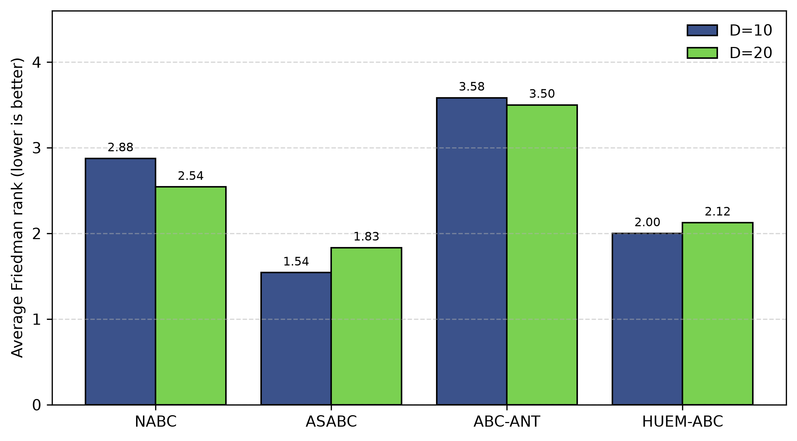
Figure 2. Average Friedman rank of NABC, ASABC, ABC-ANT, HUEM-ABC on the CEC2022 benchmark (D=10 and D=20). Lower is better.

Friedman test results on the cec2022 benchmark

D | NABC | ASABC | ABC-ANT | HUEM-ABC | χ² | p
10 | 2.88 | 1.54 | 3.58 | 2.00 | 18.65 | <0.001
20 | 2.54 | 1.83 | 3.50 | 2.12 | 11.52 | 0.009
Mean | 2.71 | 1.69 | 3.54 | 2.06 | -- | --
Table 3. Average Friedman ranks of the compared algorithms for each dimension on the CEC2022 benchmark (lower is better, best in bold).

Figure 2. Average Friedman rank of NABC, ASABC, ABC-ANT, HUEM-ABC on the cec2022 benchmark (D=10 and D=20). Lower is better.

