Results of HUEM_ABC on the cec2013 benchmark
F | ABC | ABC-Scout | ABC-HUFS | HUEM-ABC
F1 | (3.28±1.13)×10⁻⁷ | (8.34±11.14)×10⁻¹⁴ | (1.52±5.77)×10⁻¹⁴ | (7.58±40.81)×10⁻¹⁵
F2 | (2.29±0.17)×10⁷ | (9.05±2.73)×10⁶ | (1.93±0.57)×10⁷ | (7.17±1.81)×10⁶
F3 | (1.59±0.68)×10⁶ | (2.16±1.49)×10⁴ | (3.49±2.04)×10⁵ | (5.37±3.87)×10⁴
F4 | (1.10±0.04)×10⁵ | (5.47±0.79)×10⁴ | (7.06±0.61)×10⁴ | (1.86±0.48)×10⁴
F5 | (0.00±0.00)×10⁰ | (1.14±0.00)×10⁻¹³ | (9.85±3.93)×10⁻¹⁴ | (9.85±3.86)×10⁻¹⁴
F6 | (1.85±0.09)×10¹ | (1.55±0.35)×10¹ | (2.23±0.52)×10¹ | (1.87±0.47)×10¹
F7 | (2.05±0.19)×10² | (1.08±0.14)×10⁵ | (1.07±0.11)×10⁵ | (7.02±0.75)×10⁴
F8 | (2.11±0.00)×10¹ | (2.09±0.01)×10¹ | (2.09±0.00)×10¹ | (2.10±0.01)×10¹
F9 | (2.12±0.05)×10¹ | (2.77±0.16)×10¹ | (2.68±0.14)×10¹ | (2.42±0.23)×10¹
F10 | (1.66±0.12)×10⁰ | (2.03±0.44)×10⁰ | (7.74±2.49)×10⁰ | (5.26±1.11)×10⁰
F11 | (1.99±1.99)×10⁻¹ | (4.93±1.97)×10⁻¹⁴ | (0.00±0.00)×10⁰ | (0.00±0.00)×10⁰
F12 | (3.69±0.30)×10² | (1.64±0.26)×10² | (1.66±0.23)×10² | (1.26±0.15)×10²
F13 | (3.54±0.19)×10² | (1.90±0.22)×10² | (2.06±0.23)×10² | (1.40±0.15)×10²
F14 | (1.18±0.18)×10¹ | (0.00±0.00)×10⁰ | (0.00±0.00)×10⁰ | (2.05±3.28)×10⁻¹
F15 | (5.30±0.14)×10³ | (0.00±0.00)×10⁰ | (1.61±2.42)×10² | (4.47±0.38)×10³
F16 | (2.77±0.11)×10⁰ | (1.08±0.19)×10⁰ | (2.07±0.26)×10⁰ | (1.28±0.26)×10⁰
F17 | (3.05±0.00)×10¹ | (3.00±0.00)×10¹ | (3.00±0.00)×10¹ | (3.00±0.00)×10¹
F18 | (4.36±0.23)×10² | (0.00±0.00)×10⁰ | (0.00±0.00)×10⁰ | (0.00±0.00)×10⁰
F19 | (3.10±0.35)×10¹ | (1.40±0.20)×10¹ | (1.55±0.12)×10¹ | (1.71±0.16)×10¹
F20 | (1.49±0.01)×10¹ | (1.36±0.04)×10¹ | (1.29±0.06)×10¹ | (1.25±0.03)×10¹
F21 | (3.00±0.00)×10² | (3.32±0.53)×10² | (3.59±0.55)×10² | (3.30±0.46)×10²
F22 | (1.41±0.31)×10² | (0.00±0.00)×10⁰ | (0.00±0.00)×10⁰ | (3.78±4.81)×10¹
F23 | (6.20±0.08)×10³ | (7.05±23.23)×10¹ | (9.72±5.45)×10² | (4.61±0.49)×10³
F24 | (2.35±0.01)×10² | (2.30±0.76)×10² | (2.69±0.05)×10² | (2.62±0.05)×10²
F25 | (2.59±0.01)×10² | (3.00±0.07)×10² | (2.89±0.05)×10² | (2.77±0.06)×10²
F26 | (2.02±0.00)×10² | (1.06±0.90)×10² | (2.01±0.00)×10² | (2.01±0.00)×10²
F27 | (4.00±0.00)×10² | (4.00±0.00)×10² | (4.08±0.18)×10² | (5.47±2.39)×10²
F28 | (1.04±0.04)×10³ | (8.92±2.36)×10² | (7.07±0.44)×10² | (5.07±0.20)×10²
w/t/l (HUEM-ABC) | 19/0/9 | 14/1/13 | 18/3/7 | --
Wilcoxon p | 0.045 (+) | 0.981 (≈) | 0.048 (+) | --
Friedman rank | 3.11 | 2.18 | 2.61 | 2.11
Friedman test: χ² = 11.03, p = 0.012
Table 4. Mean ± std error of the compared algorithms on cec2013 benchmark functions (D=30). Bold = best per function. Wilcoxon signed-rank test (α=0.05) compares HUEM-ABC with each competitor ('+' HUEM-ABC significantly better, '−' significantly worse, '≈' no significant difference). Friedman rank: lower is better.

F | ABC | ABC-Scout | ABC-HUFS | HUEM-ABC
F1 | (2.55±0.84)×10⁻⁷ | (2.27±0.00)×10⁻¹³ | (2.27±0.00)×10⁻¹³ | (2.27±0.00)×10⁻¹³
F2 | (3.55±0.27)×10⁷ | (1.54±0.38)×10⁷ | (4.16±0.84)×10⁷ | (1.77±0.45)×10⁷
F3 | (2.44±1.31)×10⁷ | (5.07±2.68)×10⁵ | (5.64±3.24)×10⁶ | (1.75±1.29)×10⁶
F4 | (1.81±0.10)×10⁵ | (8.72±0.65)×10⁴ | (1.30±0.10)×10⁵ | (4.26±1.00)×10⁴
F5 | (0.00±0.00)×10⁰ | (2.12±0.39)×10⁻¹³ | (1.14±0.00)×10⁻¹³ | (1.14±0.00)×10⁻¹³
F6 | (4.46±0.10)×10¹ | (4.21±0.47)×10¹ | (4.43±0.07)×10¹ | (4.41±0.05)×10¹
F7 | (3.50±0.23)×10² | (3.73±0.33)×10⁵ | (4.53±0.29)×10⁵ | (2.99±0.15)×10⁵
F8 | (2.13±0.00)×10¹ | (2.11±0.00)×10¹ | (2.11±0.00)×10¹ | (2.12±0.00)×10¹
F9 | (4.22±0.11)×10¹ | (5.56±0.34)×10¹ | (5.35±0.23)×10¹ | (5.10±0.34)×10¹
F10 | (1.93±0.13)×10⁰ | (3.05±0.61)×10⁰ | (2.24±0.67)×10¹ | (2.24±0.48)×10¹
F11 | (1.24±1.16)×10⁻⁷ | (6.44±1.97)×10⁻¹⁴ | (5.68±0.00)×10⁻¹⁴ | (5.68±0.00)×10⁻¹⁴
F12 | (9.28±0.40)×10² | (3.21±0.52)×10² | (5.12±0.45)×10² | (2.56±0.23)×10²
F13 | (9.29±0.25)×10² | (4.17±0.51)×10² | (5.67±0.32)×10² | (3.21±0.22)×10²
F14 | (2.10±0.88)×10² | (0.00±0.00)×10⁰ | (0.00±0.00)×10⁰ | (8.65±26.37)×10⁻¹
F15 | (1.02±0.03)×10⁴ | (4.19±5.89)×10² | (4.93±0.72)×10³ | (8.90±0.59)×10³
F16 | (3.20±0.16)×10⁰ | (1.46±0.20)×10⁰ | (2.88±0.22)×10⁰ | (1.78±0.22)×10⁰
F17 | (5.10±0.00)×10¹ | (5.02±0.00)×10¹ | (5.02±0.00)×10¹ | (5.02±0.00)×10¹
F18 | (1.01±0.03)×10³ | (4.93±6.11)×10⁻¹⁴ | (0.00±0.00)×10⁰ | (0.00±0.00)×10⁰
F19 | (7.00±0.31)×10¹ | (3.32±0.54)×10¹ | (3.83±0.31)×10¹ | (3.99±0.27)×10¹
F20 | (2.50±0.00)×10¹ | (2.41±0.05)×10¹ | (2.28±0.04)×10¹ | (2.22±0.05)×10¹
F21 | (4.02±0.00)×10² | (4.00±0.00)×10² | (4.00±0.00)×10² | (4.00±0.00)×10²
F22 | (2.65±0.70)×10² | (0.00±0.00)×10⁰ | (0.00±0.00)×10⁰ | (1.21±1.72)×10¹
F23 | (1.22±0.02)×10⁴ | (1.10±1.31)×10³ | (6.25±0.82)×10³ | (9.16±0.62)×10³
F24 | (2.95±0.03)×10² | (3.52±0.08)×10² | (3.45±0.07)×10² | (3.31±0.06)×10²
F25 | (3.39±0.02)×10² | (4.01±0.09)×10² | (3.72±0.06)×10² | (3.51±0.07)×10²
F26 | (2.05±0.01)×10² | (1.92±0.39)×10² | (2.03±0.01)×10² | (2.03±0.00)×10²
F27 | (5.41±1.31)×10² | (4.47±2.44)×10² | (4.71±1.24)×10² | (7.72±5.68)×10²
F28 | (2.01±0.50)×10³ | (1.94±0.15)×10³ | (1.61±0.07)×10³ | (1.24±0.02)×10³
w/t/l (HUEM-ABC) | 21/0/7 | 13/1/14 | 15/3/10 | --
Wilcoxon p | 0.013 (+) | 0.701 (≈) | 0.128 (≈) | --
Friedman rank | 3.29 | 2.14 | 2.39 | 2.18
Friedman test: χ² = 14.87, p = 0.002
Table 5. Mean ± std error of the compared algorithms on cec2013 benchmark functions (D=50). Bold = best per function. Wilcoxon signed-rank test (α=0.05) compares HUEM-ABC with each competitor ('+' HUEM-ABC significantly better, '−' significantly worse, '≈' no significant difference). Friedman rank: lower is better.

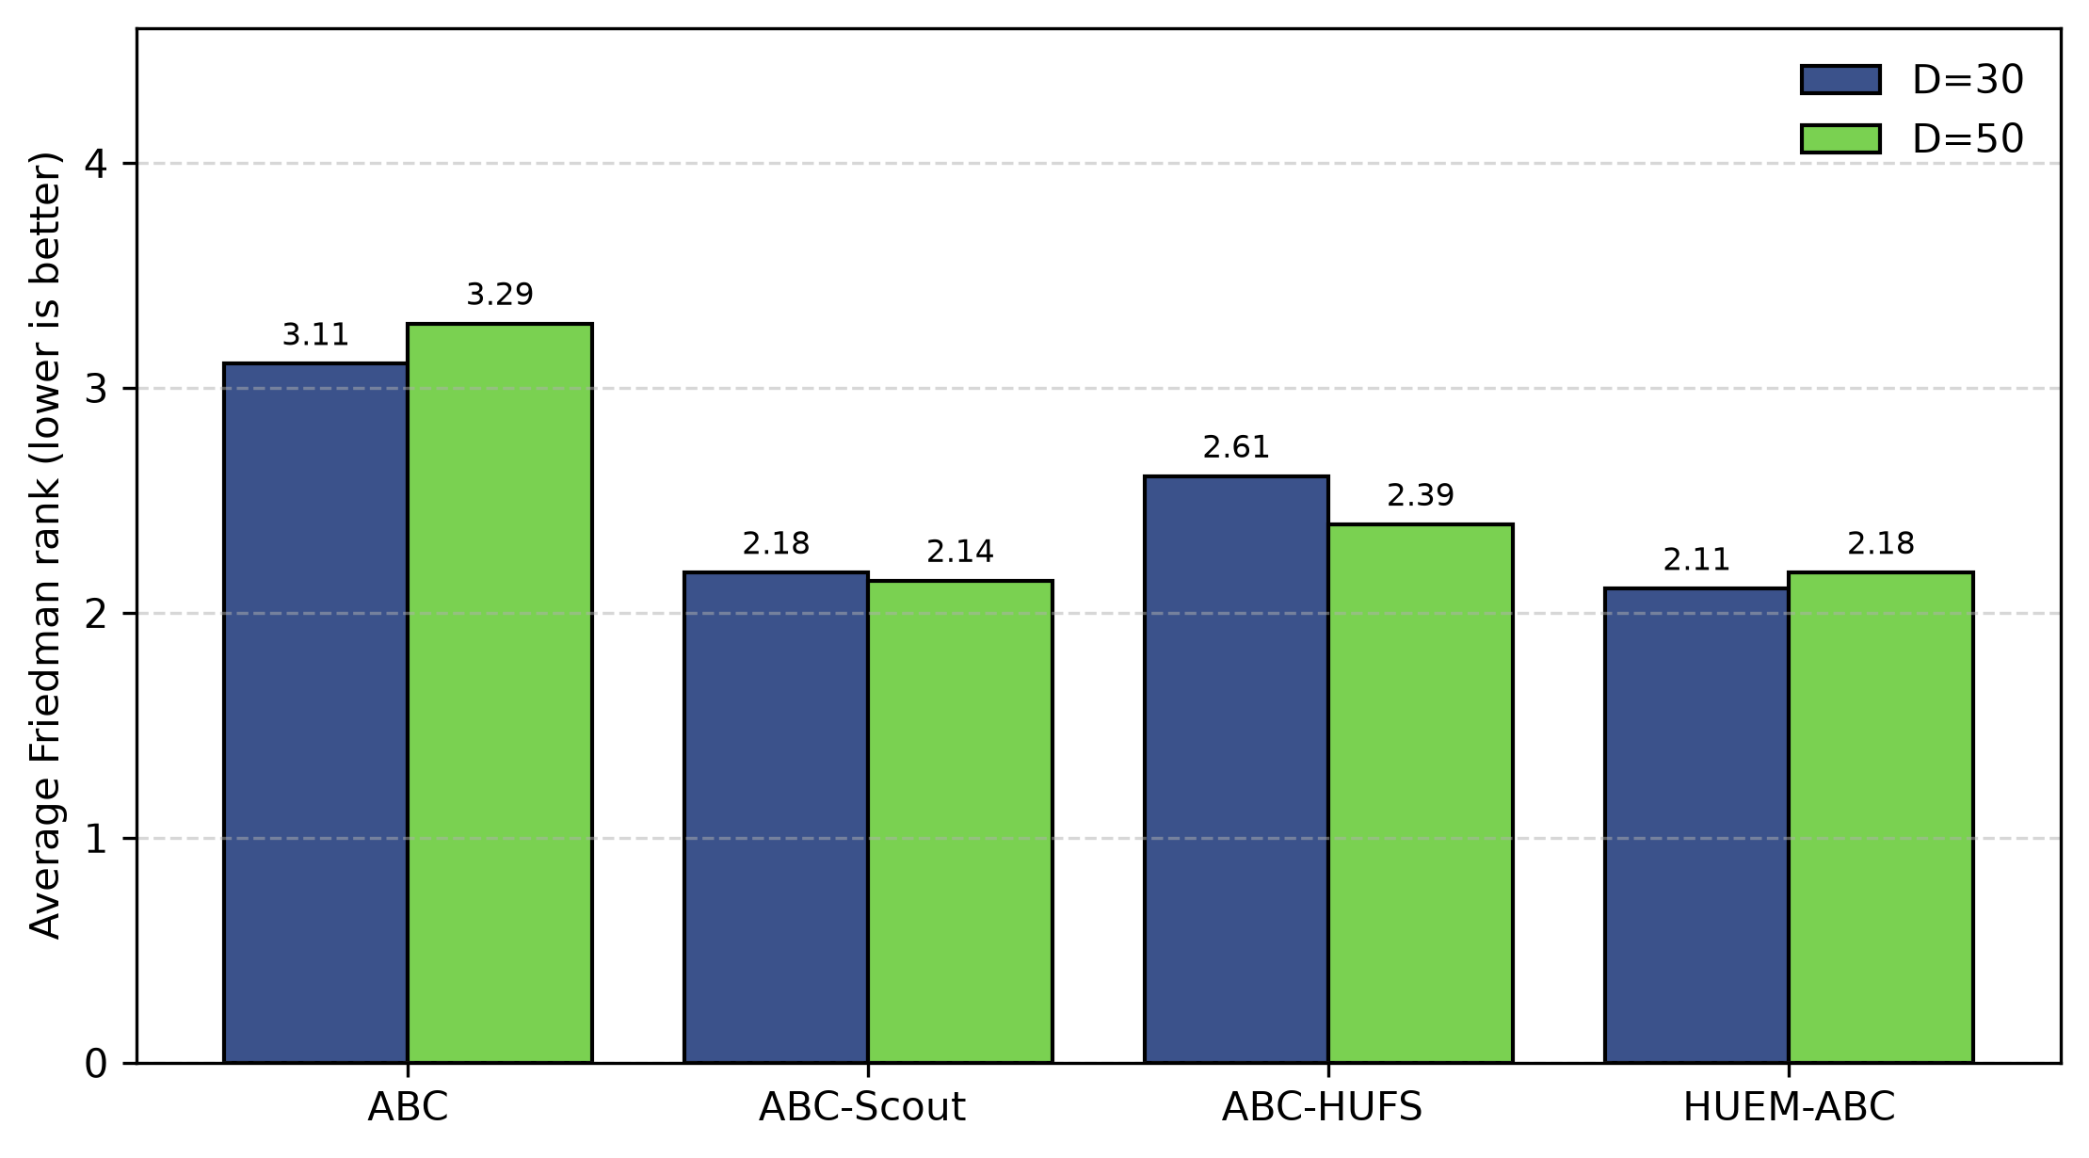
Figure 3. Average Friedman rank of ABC, ABC-Scout , ABC-HUFS , HUEM-ABC on the cec2013 benchmark (D=30 and D=50). Lower is better.
D | ABC | ABC-Scout | ABC-HUFS | HUEM-ABC | χ² | p
30 | 3.11 | 2.18 | 2.61 | 2.11 | 11.03 | 0.012
50 | 3.29 | 2.14 | 2.39 | 2.18 | 14.87 | 0.002
Mean | 3.20 | 2.16 | 2.50 | 2.14 | -- | --
Table 6. Average Friedman ranks of the compared algorithms for each dimension on the cec2013 benchmark (lower is better, best in bold).

