Results of HUEM_ABC on the cec2013 benchmark
F | NABC | ASABC | ABC-ANT | HUEM-ABC
F1 | (3.02±5.14)×10⁻⁴ | (1.97±0.79)×10⁻¹³ | (1.36±1.13)×10⁻¹³ | (7.58±40.81)×10⁻¹⁵
F2 | (9.31±1.26)×10⁶ | (1.08±0.37)×10⁷ | (8.19±2.44)×10⁶ | (7.17±1.81)×10⁶
F3 | (9.08±14.72)×10³ | (1.16±2.11)×10⁴ | (2.76±5.16)×10² | (5.37±3.87)×10⁴
F4 | (6.37±0.14)×10⁴ | (4.35±1.09)×10⁴ | (2.46±0.55)×10⁴ | (1.86±0.48)×10⁴
F5 | (7.79±18.92)×10⁻⁴ | (1.14±0.00)×10⁻¹³ | (1.14±0.00)×10⁻¹³ | (9.85±3.86)×10⁻¹⁴
F6 | (3.60±1.05)×10¹ | (1.61±0.18)×10¹ | (1.82±0.67)×10¹ | (1.87±0.47)×10¹
F7 | (9.65±0.78)×10⁴ | (9.33±1.49)×10⁴ | (6.33±0.76)×10⁴ | (7.02±0.75)×10⁴
F8 | (2.11±0.01)×10¹ | (2.10±0.01)×10¹ | (2.10±0.00)×10¹ | (2.10±0.01)×10¹
F9 | (2.86±0.34)×10¹ | (2.89±0.24)×10¹ | (2.28±0.36)×10¹ | (2.42±0.23)×10¹
F10 | (1.21±0.30)×10⁰ | (1.41±0.21)×10⁰ | (1.12±0.13)×10⁰ | (5.26±1.11)×10⁰
F11 | (1.05±5.51)×10⁻¹ | (5.68±0.00)×10⁻¹⁴ | (3.32±18.17)×10⁻² | (0.00±0.00)×10⁰
F12 | (3.38±0.19)×10² | (2.56±0.42)×10² | (5.48±1.14)×10¹ | (1.26±0.15)×10²
F13 | (3.20±0.27)×10² | (2.14±0.17)×10² | (9.98±1.59)×10¹ | (1.40±0.15)×10²
F14 | (0.00±0.00)×10⁰ | (0.00±0.00)×10⁰ | (3.81±2.42)×10⁰ | (2.05±3.28)×10⁻¹
F15 | (7.16±4.73)×10² | (2.90±10.80)×10¹ | (1.73±0.70)×10³ | (4.47±0.38)×10³
F16 | (1.08±0.35)×10⁰ | (1.09±0.21)×10⁰ | (1.29±0.19)×10⁰ | (1.28±0.26)×10⁰
F17 | (3.00±0.02)×10¹ | (3.00±0.00)×10¹ | (3.00±0.00)×10¹ | (3.00±0.00)×10¹
F18 | (9.92±52.32)×10⁻⁷ | (1.71±2.65)×10⁻¹⁴ | (1.66±3.77)×10⁻¹ | (0.00±0.00)×10⁰
F19 | (1.92±0.26)×10¹ | (5.49±1.15)×10⁰ | (4.60±0.77)×10⁰ | (1.71±0.16)×10¹
F20 | (1.49±0.02)×10¹ | (1.43±0.03)×10¹ | (1.35±0.16)×10¹ | (1.25±0.03)×10¹
F21 | (5.36±3.08)×10² | (4.67±2.45)×10² | (5.14±3.55)×10² | (3.30±0.46)×10²
F22 | (0.00±0.00)×10⁰ | (0.00±0.00)×10⁰ | (9.66±4.02)×10⁰ | (3.78±4.81)×10¹
F23 | (2.81±0.63)×10³ | (9.36±26.79)×10¹ | (1.17±0.97)×10³ | (4.61±0.49)×10³
F24 | (2.53±0.07)×10² | (2.79±0.06)×10² | (2.30±0.07)×10² | (2.62±0.05)×10²
F25 | (2.69±0.18)×10² | (2.97±0.05)×10² | (2.66±0.11)×10² | (2.77±0.06)×10²
F26 | (2.00±0.00)×10² | (1.76±0.63)×10² | (2.00±0.00)×10² | (2.01±0.00)×10²
F27 | (5.66±2.12)×10² | (5.35±2.76)×10² | (4.79±1.18)×10² | (5.47±2.39)×10²
F28 | (1.78±0.26)×10³ | (4.53±0.38)×10² | (6.44±3.40)×10² | (5.07±0.20)×10²
w/t/l (HUEM-ABC) | 18/0/10 | 15/0/13 | 13/0/15 | --
Wilcoxon p | 0.295 (≈) | 0.902 (≈) | 0.202 (≈) | --
Friedman rank | 3.18 | 2.38 | 2.09 | 2.36
Table 1. Mean ± std error of the compared algorithms on cec2013 benchmark functions (D=30). Bold = best per function. Wilcoxon signed-rank test (α=0.05) compares HUEM-ABC with each competitor ('+' HUEM-ABC significantly better, '−' significantly worse, '≈' no significant difference). Friedman rank: lower is better.

F | NABC | ASABC | ABC-ANT | HUEM-ABC
F1 | (1.22±2.66)×10⁻⁶ | (2.50±0.69)×10⁻¹³ | (2.35±0.42)×10⁻¹³ | (2.27±0.00)×10⁻¹³
F2 | (1.98±0.54)×10⁷ | (2.46±0.68)×10⁷ | (4.32±1.38)×10⁶ | (1.77±0.45)×10⁷
F3 | (3.46±5.35)×10⁶ | (4.63±12.93)×10⁴ | (7.77±17.55)×10³ | (1.75±1.29)×10⁶
F4 | (7.49±0.33)×10⁴ | (7.75±2.80)×10⁴ | (3.97±0.62)×10⁴ | (4.26±1.00)×10⁴
F5 | (2.97±4.70)×10⁻¹⁰ | (2.31±0.21)×10⁻¹³ | (3.26±0.65)×10⁻¹³ | (1.14±0.00)×10⁻¹³
F6 | (4.65±0.08)×10¹ | (4.35±0.10)×10¹ | (4.40±0.10)×10¹ | (4.41±0.05)×10¹
F7 | (2.76±0.26)×10⁵ | (3.91±0.37)×10⁵ | (2.27±0.19)×10⁵ | (2.99±0.15)×10⁵
F8 | (2.13±0.00)×10¹ | (2.12±0.00)×10¹ | (2.11±0.00)×10¹ | (2.12±0.00)×10¹
F9 | (5.70±0.35)×10¹ | (5.77±0.30)×10¹ | (2.92±0.40)×10¹ | (5.10±0.34)×10¹
F10 | (4.93±1.21)×10⁰ | (1.73±0.24)×10⁰ | (2.30±1.05)×10⁻¹ | (2.24±0.48)×10¹
F11 | (2.33±6.52)×10⁻¹¹ | (1.04±0.22)×10⁻¹³ | (3.32±18.17)×10⁻² | (5.68±0.00)×10⁻¹⁴
F12 | (3.65±0.29)×10² | (3.56±0.34)×10² | (1.06±0.14)×10² | (2.56±0.23)×10²
F13 | (4.10±0.44)×10² | (3.94±0.49)×10² | (1.95±0.26)×10² | (3.21±0.22)×10²
F14 | (0.00±0.00)×10⁰ | (0.00±0.00)×10⁰ | (2.13±2.78)×10⁰ | (8.65±26.37)×10⁻¹
F15 | (4.20±0.99)×10³ | (1.55±0.91)×10³ | (7.35±86.15)×10¹ | (8.90±0.59)×10³
F16 | (1.86±0.32)×10⁰ | (1.51±0.28)×10⁰ | (1.20±0.18)×10⁰ | (1.78±0.22)×10⁰
F17 | (5.02±0.00)×10¹ | (5.02±0.00)×10¹ | (5.02±0.02)×10¹ | (5.02±0.00)×10¹
F18 | (7.50±27.28)×10⁻⁷ | (1.57±0.41)×10⁻¹³ | (9.95±30.36)×10⁻² | (0.00±0.00)×10⁰
F19 | (3.36±0.51)×10¹ | (1.78±0.28)×10¹ | (7.62±1.17)×10⁰ | (3.99±0.27)×10¹
F20 | (2.35±0.07)×10¹ | (2.45±0.01)×10¹ | (2.11±0.09)×10¹ | (2.22±0.05)×10¹
F21 | (4.00±0.00)×10² | (4.00±0.00)×10² | (4.00±0.00)×10² | (4.00±0.00)×10²
F22 | (0.00±0.00)×10⁰ | (0.00±0.00)×10⁰ | (4.65±3.88)×10⁰ | (1.21±1.72)×10¹
F23 | (6.67±1.24)×10³ | (1.91±1.47)×10³ | (1.44±2.04)×10³ | (9.16±0.62)×10³
F24 | (3.18±0.09)×10² | (3.60±0.11)×10² | (2.60±0.08)×10² | (3.31±0.06)×10²
F25 | (3.81±0.12)×10² | (3.98±0.11)×10² | (3.10±0.08)×10² | (3.51±0.07)×10²
F26 | (2.09±0.40)×10² | (2.02±0.01)×10² | (2.06±0.29)×10² | (2.03±0.00)×10²
F27 | (8.59±5.76)×10² | (1.74±0.46)×10³ | (8.02±2.94)×10² | (7.72±5.68)×10²
F28 | (3.15±0.28)×10³ | (1.20±0.04)×10³ | (1.33±0.51)×10³ | (1.24±0.02)×10³
w/t/l (HUEM-ABC) | 19/0/9 | 17/0/11 | 10/0/18 | --
Wilcoxon p | 0.186 (≈) | 0.537 (≈) | 0.005 (−) | --
Friedman rank | 3.11 | 2.64 | 1.89 | 2.36
Table 2. Mean ± std error of the compared algorithms on cec2013 benchmark functions (D=50). Bold = best per function. Wilcoxon signed-rank test (α=0.05) compares HUEM-ABC with each competitor ('+' HUEM-ABC significantly better, '−' significantly worse, '≈' no significant difference). Friedman rank: lower is better.

Friedman test results on the cec2013 benchmark

D | NABC | ASABC | ABC-ANT | HUEM-ABC | χ² | p
30 | 3.18 | 2.38 | 2.09 | 2.36 | 11.30 | 0.010
50 | 3.11 | 2.64 | 1.89 | 2.36 | 13.17 | 0.004
Mean | 3.14 | 2.51 | 1.99 | 2.36 | -- | --
Table 3. Average Friedman ranks of the compared algorithms for each dimension on the cec2013 benchmark (lower is better, best in bold).

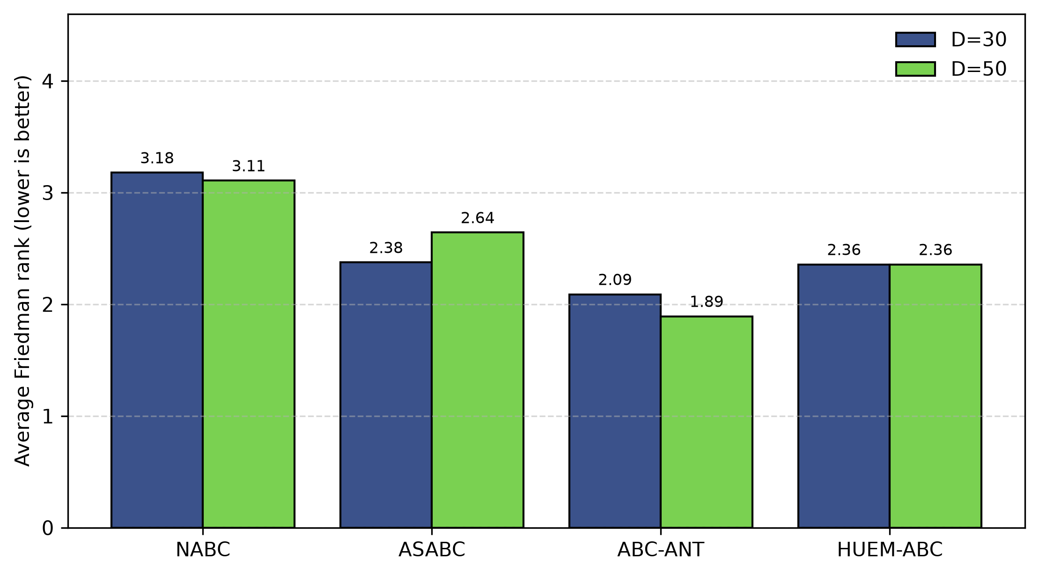
Figure 2. Average Friedman rank of NABC, ASABC, ABC-ANT, HUEM-ABC on the cec2013 benchmark (D=30 and D=50). Lower is better.

