Webserver Python Lab
Suresh Ghimire
University of the Cumberlands
Advanced Computer Networks (MSCS-631-B01)
Professor: Dax Bradely
March 8, 2026
GitHub Repository : https://github.com/sghimire2025/-MSCS-631-Webserver-Python

Web Server Python Lab
Paragraph explaining my experience working on this lab. What did I learn about socket programming, HTTP protocols, and client-server communication? How did implementing the web server help you understand how web servers work at a fundamental level?
Working on this web server lab provided valuable hands-on experience with socket programming and HTTP protocol implementation. I learned how TCP sockets establish connections through the bind, listen, and accept sequence, and how HTTP requests are parsed to extract filenames. Understanding the structure of HTTP responses, including status codes and headers, gave me insight into how web browsers and servers communicate. The most enlightening aspect was seeing how a simple Python script can act as a functional web server, handling client requests and serving files over a network connection.
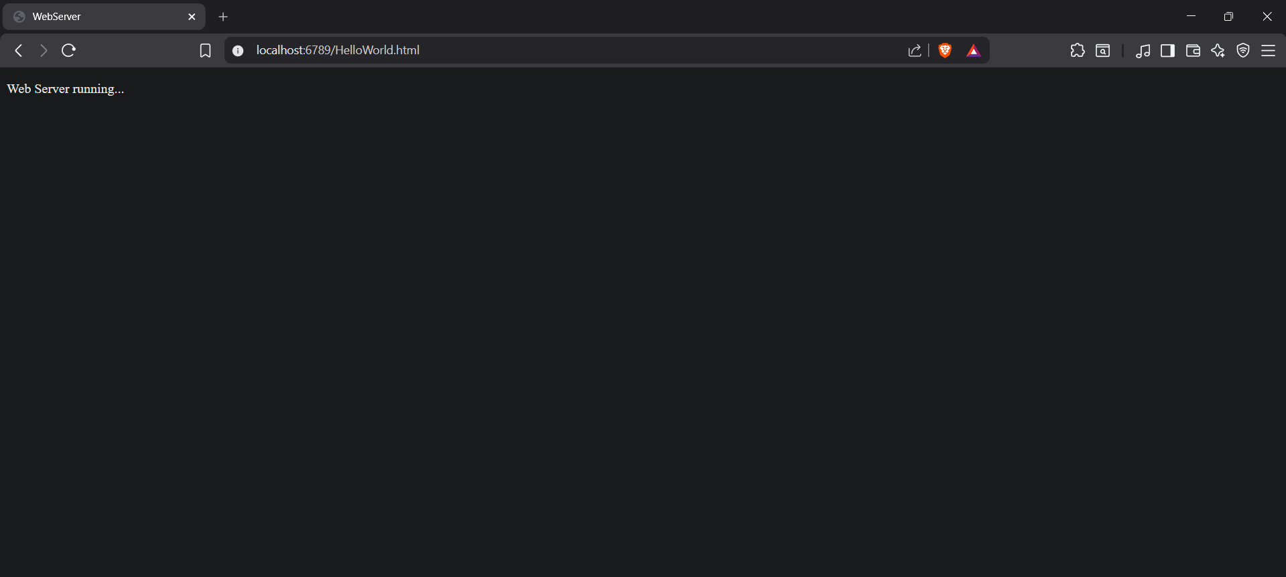
Challenges I encountered and how I solved them. Did I face issues with port binding, file paths, encoding, error handling, or testing? What debugging strategies did you use?
The main challenge I encountered was handling edge cases in HTTP request parsing. Initially, my server crashed when receiving malformed or empty requests from the browser's automatic connection probes. I resolved this by adding validation to check if the request message had the proper format before attempting to parse it. Another challenge was understanding file path handling - the URL includes a leading slash that needs to be removed when opening local files. Testing the 404 error response also required ensuring the server properly caught IOError exceptions and sent appropriate error messages. Through careful debugging and testing with various URLs, I was able to create a robust implementation that handles both successful requests and error conditions gracefully.
