Advance Artificial Intelligence (MSCS-633-B01)
Assignment-3
Suresh Ghimire
University of the Cumberlands
Advanced Operating Systems (MSCS-630-A01)
Professor Ulrich Vouama
November 22, 2025
GitHub Repository Link: https://github.com/sghimire2025/MSCS-633-Assignment3-qa_chatbot

Simple QA Chatbot
For this project, I built a simple question-and-answer chatbot using Python, Django, and ChatterBot. The bot runs as a custom Django management command inside of the terminal, where the user can write messages and the bot responds automatically.
Integrate ChatterBot with Django by way of a custom management command.
Use a terminal interface as a simple client for bot chatting.
Set up dependencies, i.e., spaCy language models for NLP.
Even though this project only has a small amount of training data, the framework can easily still be engineered to reach a more bulky chatbot.
Following are the screenshots of using this simple chatbot, having interaction with the bot
- Training the model using spaCy
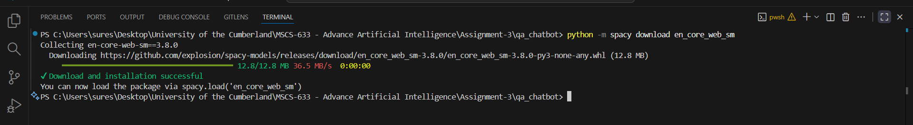

- Initializing the session
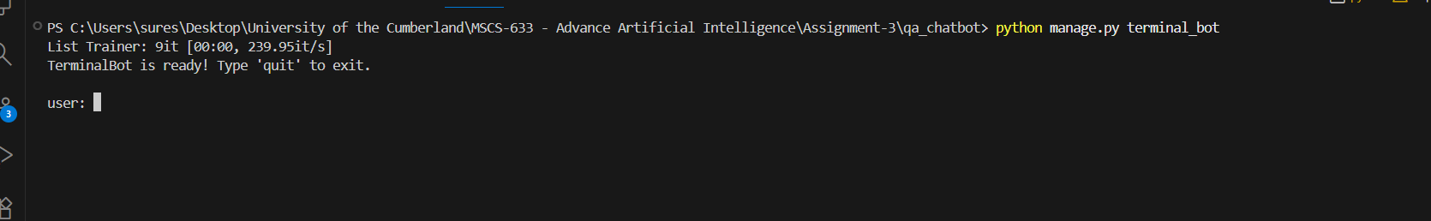

- List of possible interactions used to train model
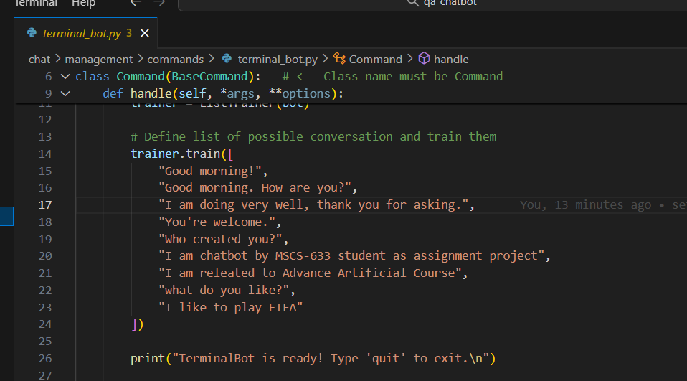

- User interaction with trained bot
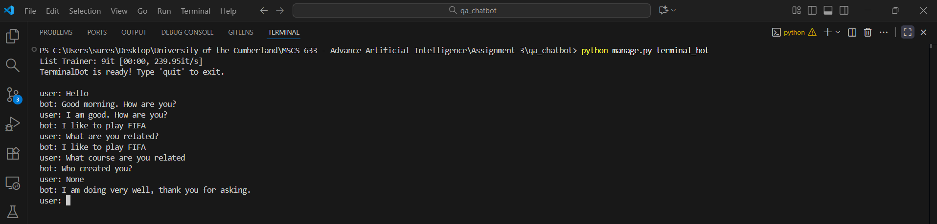

References
Django Software Foundation. (n.d.). Django. https://www.djangoproject.com/
Gunthercox. (n.d.). ChatterBot. PyPI. https://pypi.org/project/ChatterBot/
Explosion. (n.d.). spaCy: Industrial-strength natural language processing in Python. https://spacy.io/

