UDP Pinger
Suresh Ghimire
University of the Cumberlands
Advanced Computer Networks (MSCS-631-B01)
Professor: Dax Bradely
March 14, 2026

UDP Pinger
In this lab I created an application in Python using UDP for a ping client to the server provided. My code sent 10 pings to the server and waited for a reply in order to measure the round-trip time (RTT) from each successful reply received back from the server. Running through this program provided me with a greater understanding of the workings of UDP communications versus TCP communications because of the different properties regarding delivery of packets. The responses I received indicated successful replies and support for packet loss, both of which were behaviours that I was required to observe for the lab. Therefore, this experience provided me with a useful and practical perspective on how real networks behave.
One of the primary challenges I struggled with during testing was error handling while testing in a Windows environment. Initially I was required to handle a `ConnectionResetError` where the error was a result of either not having the server running properly or not having the packet(s) received as expected. I corrected the issue by starting the server before running the client. Another small challenge was ensuring that the packets received were consistent with the expected number of packets lost so I added logging functionality on the server side that would log when packets were sent, received or dropped. Once all of the issues that I had encountered were fixed, my client was able to function as expected; and I was also able to capture screen shots of the received replies and timed-out requests.

Demo Screenshot
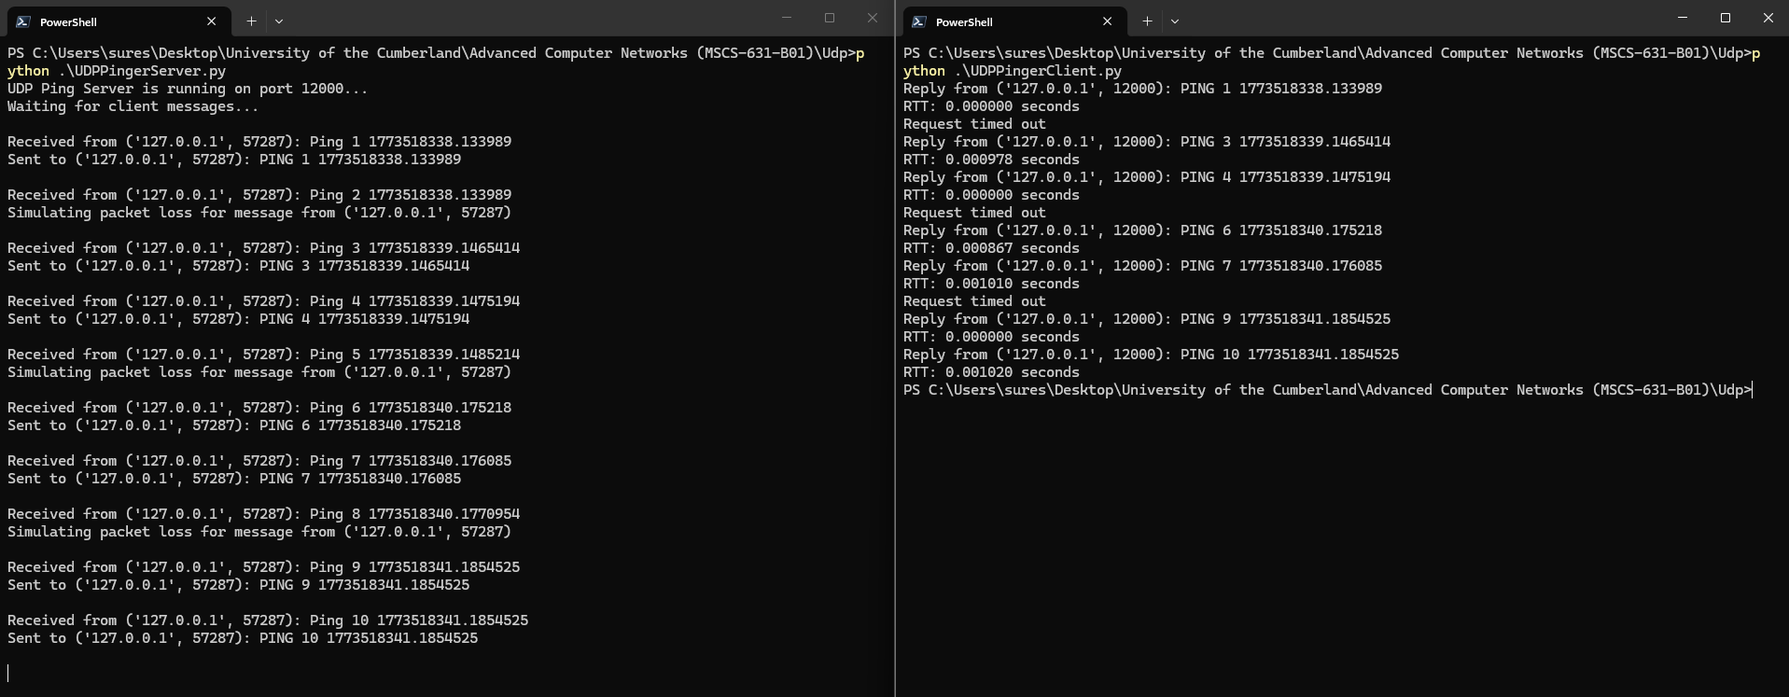
Server running on left and client runs on right.

