**Title: Add title**

# Authors: Shyamolina Ghosh1 and James D. Bever2

# Authors Affiliations:

1Department of Ecology and Evolutionary Biology and Kansas Biological Survey, The University of Kansas, 1200 Sunnyside Avenue, Lawrence, KS, 66045, USA

2Department of Ecology and Evolutionary Biology, The University of Kansas, 1200 Sunnyside Avenue, Lawrence, KS, 66045, USA

**Corresponding Author:** James D. Bever; Department of Ecology and Evolutionary Biology, The University of Kansas, 1200 Sunnyside Avenue, Lawrence, KS, 66045, USA; [jbever@ku.edu](mailto:jbever@ku.edu)

**Notes communicate concise points, using either data or theory. However, like Articles, they present insights of broad general significance and interest. Notes are no more than 3000 words of text (not including the literature cited) and have no more than three figures and/or tables in print.**

**Abstract**

**Keywords**: preferential allocation, resource competition, species coexistence.

**Introduction**

Mutualisms are a remarkably common interaction, particularly between plants and symbionts. However, simple arguments suggest that the persistence and stability of mutualisms in the face of demonstrable costs is problematic. If plants reward symbionts indiscriminately and there is a cost to the symbiont for being mutualistic, then non mutualist fitness will be greater than mutualist fitness and mutualism should decline. Recent demonstration of host preferential allocation to, and sanctions of, symbionts (Bever et al. 2009; Jandér & Herre 2010; Kiers et al. 2011; Ji and Bever 2016) have offered a resolution to this problem as preferential allocation can prevent the spread of cheating symbionts. With preferential allocation, the benefit available to the non-mutualist is reduced by fidelity of investment and mutualist fitness can exceed non-mutualist fitness when the fidelity times benefit is greater than the cost. This simple model of preferential allocation, however, identifies a second apparent paradox, as preferential allocation results in either all mutualists or all cheaters, but never local coexistence. Therefore, the forces that stabilize horizontally-acquired mutualisms over evolutionary timescales should eliminate variability in symbiont quality (Heath & Stinchcombe 2014). Why then, do mutualists of varying quality commonly coexist?

Currently, there are several solutions to this apparent paradox. Environmental variability may slow the rate exclusion and maintain variation in mutualist quality (Moeller and Neubert 2015). A cost to the host of preferential allocation may generate negative community feedback, thereby leading to coexistence of beneficial and non-beneficial symbionts (Steidinger and Bever 2014). These two mechanisms will generate spatial heterogeneity in symbiont quality, thereby leading to coexistence. Several mechanisms have been proposed to explain the persistence of variation in mutualist quality within host in a static environment. Joint dynamics of host recognition and host sanctions against ineffective partners maintains can allow the persistence of variation in symbiont quality (Yoder and Tiffin 2017). Mixed colonization of modules (e.g., rhizobia nodules or figs) permits coexistence of beneficial and non-beneficial symbionts in face of host discrimination (Steidinger and Bever 2016) and this framework has been shown to predict patterns of fig wasp dynamics (Steidinger.. ).

For promiscuous nutritional mutualisms, which include the most common and consequential of plant-symbiont interactions such as mycorrhizae and N-fixation, variation in symbiont quality can persist within host roots of a single host (e.g. Bever et al. 2013, Hart et al. ). Negative physiological feedback in the host for allocation to nutritional symbionts, as has been demonstrated for plant interactions with mycorrhizal fungi (Zhang et al 2015, Ji and Bever 2015), can allow beneficial and non-beneficial symbionts to coexist and this mechanism predicts patterns of efficiency of mutualism across environmental gradients (Bever 2015). This mechanism allows that the host associates promiscuously with symbionts of varying quality and subsequently allocates preferentially to the most effective symbiont. This sequence allows for a second mechanisms of coexistence via resource partitioning, as non-beneficial symbionts could specialize on the plants initial investment in the association and beneficial symbionts capitalizes on plants preferential allocation to the most effective mutualist as illustrated by Christian and Bever (2018). While the long-term dynamics of the symbiosis will then depend upon the joint operation of negative physiological feedback and symbiont resource competition, this dynamic has not been explored.

We present and analyze a general model that incorporates host preferential allocation toward the mutualist in proportion to its resource need (generating negative physiological feedback) and symbiont resource competition. We show that coexistence of beneficial and non-beneficial symbionts will be commonplace given expected costs. We then use this modeling framework to predict environmental patterns of the efficiency of nutritional mutualisms. While the model is general, we develop it in the context of arbuscular mycorrhizae, the most common plant nutritional mutualism. Construction of models governing efficiency of the mycorrhizal mutualism is of particular interest as this mutualism can have large impacts on terrestrial ecosystem function and sustainable agriculture through the modulation plant phosphorus uptake and mediation of carbon sink in soil.

**The Model**

In comparison to previous work (Bever 2015, Christian and Bever 2018), we present a more complete representation of plant-mycorrhizal community dynamics resulting from the interdependence of four state variables, namely, plant’s preferentially allocated carbon *(Ca)* to the mutualist, plant’s construction carbon *(Cc)* and the densities of two symbionts (mutualist *(M)* and non-mutualist *(N)*). Plants initially invest carbon *(Cc)* for the construction of symbiosis structure to the two types of symbionts promiscuously, as it is cannot recognize the beneficial symbionts until trading commences. Plants then preferentially allocate their resources *(Ca)* to the mutualistic symbiont in exchange for phosphorus. As in Bever (2015), the accuracy of preferential carbon-allocation is represented by the fidelity *(f)* of preferential allocation, which will depend on the spatial structure of the symbionts in the roots, the morphology and modularity of association, and the physiological potential of plants to allocate resources preferentially to mutualists even in absence of spatial structures. It is considered that fidelity has a range in between 0 to 1, whereas *f = 0* means plant does not allocate preferentially to any specific symbiont at all and *f = 1* means plant selectively allocate carbon to mutualist only. Both symbionts compete with each other to exploit the resources and mutualists have to pay a cost *(s)* due to mutualism which can reduce its maximum growth rate.

From our model as represented by Equations (1 - 4), we have derived the condition for co-existence of both symbionts and got the parameter range for fidelity *(f)* for a given cost *(s)*. The model is represented as follows;

|  | (1) |
| --- | --- |

|  | (2) |
| --- | --- |

|  | (3) |
| --- | --- |

|  | (4) |
| --- | --- |

All the terms and parameters are described in Table 1. Equation (1) represents the rate of change of allocated carbon which decreases with increasing phosphorous availability *(Ps)* in the soil. As colonization of plant roots by mutualists increases, plants receive more P per allocated carbon and this increase in efficiency results in plants needing to allocate less carbon to mycorrhizae (i.e. negative physiological feedback). We assume that the efficiency of P return, *F(M,N)* in Equation (1), is a saturating function of the density and proportion of mutualists, as shown in Figure 1 *(A)*. While the per capita growth rate of mutualist and non-mutualist decreases with same death rate (d), their growth rate is affected differently by costs and preferential allocation as represented in Equation (2) and Equation (3). Though fidelity *(f)* gives the advantage to the mutualist, it has to pay an energetic cost *(s)*. Equation (4) demonstrates a constant supply rate *(Cc0)* for construction carbon, consistent with continual growth of a root system. The available construction carbon *(Cc)* is depleted as the roots are colonized by symbionts, as represented by a linear function of the product of total symbiont-density and the density of construction carbon itself.

By setting equation (1) and (4) equal to zero, we can get equilibrium values for allocated carbon () and construction carbon () as follows;

|  | (5) |
| --- | --- |
|  | (6) |

For finite equilibrium values of mutualist and non-mutualist (i.e., when), we set both equation (2) and (3) equal to zero and get the following two equations for mutualist and non-mutualist, respectively;

|  | (7) |
| --- | --- |

|  | (8) |
| --- | --- |

Equation (7) indicates zero net growth isocline (ZNGI) for mutualist (so are subscripted with *M*) as a straight line with slope of -1 (see solid line in Figure 1 *(B)*) and equal intercepts on allocated carbon and construction carbon axes as *CaM*=CcM* =*  . Equation (8) represents the ZNGI (see dashed line in Figure 1 *(B)*) for non-mutualist (so are subscripted with *N*) with a much steeper slope of *-1/(1-f)* as *0 <f <1*. The ZNGI for non-mutualist has unequal intercepts on their respective axes as *CaN\**= *CcN*/(1-f)=*  . Christian and Bever (2018) identified that coexistence of mutualist and non-mutualist is possible if these two isoclines intersect for a set of positive finite values *(Ca*, *Cc)* depending on rates of supply of carbon resources*.* Here, we find that with negative physiological feedback adjusting the supply of allocated carbon, the mutualist and non-mutualist always co-exist for positive intersection of the carbon resource isoclines. We represent the condition for co-existence of both symbionts as follows;

|  | (9) |
| --- | --- |

We can express the permissible range of fidelity *(f)* for co-existence of both symbionts as *fmin < f < fmax*, where *fmin* has the generalized form as follows;

|  | (10) |
| --- | --- |

If mutualist and non-mutualist had equal half-saturation constant *(KM = KN)* then minimum fidelity required to initiate co-existence of both symbionts would be . To get the higher limit of fidelity *fmax*, we have to ensure that equilibrium values for both symbionts should have positive finite values. The condition satisfies this scenario (for details see appendix A1) where is the equilibrium solution for mutualist.

We illustrate and confirm the potential dynamics using three different cases for different possible combination of fidelity *(f)* and *Cc0.* We solved numerically Equations (1) to (4) by classical 4th order Runge-Kutta method with time increment Δ*t = 0.01* and initial values for *(Ca , Cc , M, N)t=0* *= (0.5, 0.5, 1.0,1.0).* We set parameters *Ps = 0.3, u = 0.4, bmax = 0.8, d = 0.5, s = 0.1, g = 0.2, Kc = 5* throughout our study. To understand how the equilibrium values for all four variables vary with fidelity *(f)* and phosphorous availability in soil (*Ps*), please see appendix A1.

**Results**

For different combinations of fidelity of plant investment *(f)* and construction carbon supply rates *(Cc0)*, we demonstrated symbionts could show different dynamics. For *f = 0.2* and *Cc0 = 5*, mutualist and non-mutualist ZNGI did not intersect (see Figure A1 *(A)*) violating the condition for coexistence (Equation 9), therefore destabilizing the system indicated by the numerical divergence in Figure A1 *(B)* and *(C).* Even if for very high supply of *Cc0*, stable coexistence is not possible for *f = 0.2*.

For relatively higher fidelity (*f* *= 0.3)*, two ZNGI for mutualist and non-mutualist intersect at positive phase-space of allocated and construction carbon (Figure 2A*)*) indicating that both symbionts can co-exist. We found that the allocated and construction carbon concentrations reached the equilibrium state (*Cc0 =0.5* and *Cc0 =5*) determined by the crossing of the isoclines regardless of the construction carbon supply rates *Cc0* (Figure 2B and 2D). For lower supply rates of construction carbon, *Cc0,* mutualist dominated over co-existing non-mutualist (Figure 2C),but with increasing *Cc0* non-mutualist attained greater proportion than mutualist (Figure 2E). This phenomenon could be explained from the fact that with larger input of *Cc0*, non-mutualists grew faster as they had an energetic-cost advantage over mutualists. Figure 2F shows the variation of ratios of equilibrium values of construction carbon over allocated carbon () and non-mutualist over mutualist () as we varied *Cc0.* Regardless of *Cc0*, the equilibrium resource carbon-ratio was constant and symbionts coexisted. Symbiont dominance, however, switched when *Cc0* crossed approximately *1.1,* with mutualists dominating at lower values of *Cc0.* Our numerical finding was consistent with the analytic-condition for co-existence (Equations (9)) as for *f = 0.3*, *1 < CaN* / CaM* (=1.047) < 1/ (1-f) (=1.428)* with *fmin ~ 0.26.* Though at equilibrium resource-carbon levels remain independent with soil-phosphorous availability *(Ps)* for a given fidelity *f=0.3* (Figure 2 *(G)*), symbionts showed opposite behavior (mutualist decreased and non-mutualist increased with growing *Ps*) resulting in gradual decrease in proportion of mutualist at equilibrium () (Figure 2 *(H)*). With *Ps = 0.3*, both symbionts showed co-existence at equilibrium for a limited range of fidelity *(f)*. Co-existence started at *f ~ 0.27* but as *f > fmax (~0.84)* non-mutualist became extinct from the system and mutualist won (Figure 2 *(I)*) and reached to *1*. Figure 2 is shown with *KM = KN = 10*, but we also carried out our analysis with KM ≠ KN and got similar conclusion (see Figure A2).

**Discussion**

**Tables**

Table 1: Description of model terms.

|  |  |
| --- | --- |
| Model Term | Definition |
| *Ca* | Density of allocated carbon that is discriminately and preferentially allocated to mutualists |
| *Cc* | Density of construction carbon that is allocated indiscriminately to symbionts to construct the site of symbiosis |
| *M* | Density of mutualist symbiont |
| *N* | Density of non-mutualist symbiont |
| *F(M,N)* | Function representing phosphorous uptake by both symbionts |
| *Ps* | Phosphorus availability in the soil |
| *u* | Phosphorous uptake per unit of preferentially allocated carbon received by mutualists |
| *f* | Fidelity of plant allocation to mutualist symbionts which has a range *(fmin , fmax)* |
| *s* | Cost of mutualism *(s >0)* |
| *bmax* | Maximum growth rate of symbionts |
| *d* | Constant death rate *(d < bmax)* |
| *Kc* | Half-saturation constant for allocated carbon |
| *KM* | Half-saturation constant for mutualist symbiont |
| *KN* | Half-saturation constant for non-mutualist symbiont |
| *g* | Rate at which construction carbon is allocated to both symbionts |
| *Cc0* | Source density of construction carbon stored in the plant |

**Figures**

(A)  
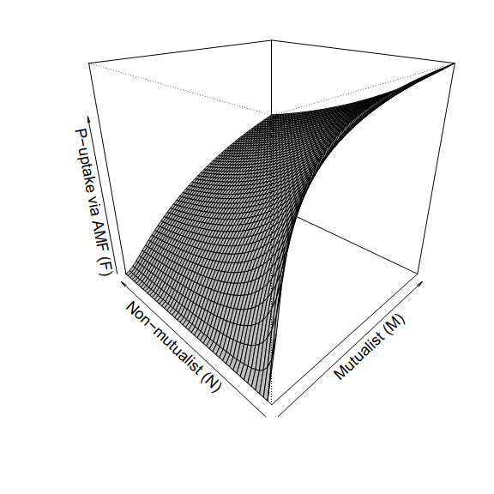

(B)  
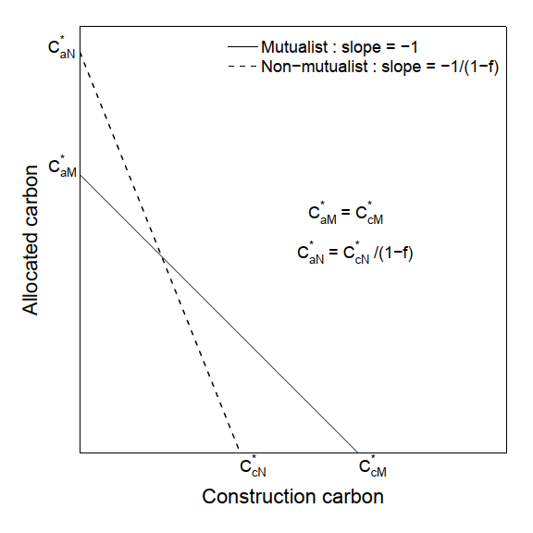

Figure 1: *(A)* P-uptake via mycorrhizal fungi *F(M,N)* as a function of densities of mutualists (M) and non-mutualist (N). M and N vary over range (0,100), parameters used: *f=0.3*, *u=0.4*, *Kc=5*. *(B)* Schematic diagram depicting the condition for stable co-existence of both symbionts. Figure 2: For equal growth rate of both symbionts with *KM = KN = 10,* fidelity *f = 0.3*: *(A)* Zero net growth isoclines (ZNGI) for both symbionts intersect at a common point which indicates stable co-existence of mutualist and non-mutualist. Other parameters include *Ps = 0.3, u = 0.4, bmax = 0.8, d = 0.5, s = 0.1, g = 0.2, Kc = 5*. Two trajectories in the resource carbons’ phase space initiated at (0.5, 0.5) reached to that common point for *Cc0* *= 0.5* and *5*. *(B)* Numerical solutions of Equation (1) and (4): dynamics of allocated carbon (*Ca*) and construction carbon (*Cc*) respectively against time for *Cc0* *= 0.5*. *(C)* Numerical solutions of Equation (2) and (3): dynamics of mutualist (*M*) and non-mutualist (*N*) against time for *Cc0* *= 0.5*. *(D - E)* same as described for (*B - C*) but with *Cc0 = 5. (F)* Variation of equilibrium values of () and () against *Cc0* : construction carbon remained always lower than allocated carbon (green solid line below black dotted line at 1) as it is consumed by both symbionts, similarly with increasing greater storage of source construction carbon-density (*Cc0*) in the plant, non-mutualist dominated over mutualist in co-existing population. With *Cc0 = 5* and keeping other parameters fixed as mentioned earlier *(G)* analytical solution for equilibrium values (see Appendix A1) of allocated and construction carbon (,) remains at a fixed level when we vary phosphorous availability in soil (*Ps*). *(H)* Equilibrium value for mutualist () decreases as plant can avail phosphorous directly from soil and so does not depend upon the symbionts much, whereas equilibrium value for non-mutualist () increases with soil-phosphorous as it gets same level of resources as that of mutualist without paying any cost of mutualism (*s*). As a result proportion of mutualism at equilibrium () decreases with soil-phosphorous level. *(I)* With *Ps = 0.3*, *Cc0 = 5* and other parameters as mentioned earlier equilibrium value for mutualist () initially decreases but then increases as fidelity *(f)* approaches its maximum value *fmax*, so reaches to *1* as beyond *f > fmax(~0.84)* non-mutualist become extinct from the system.

(I)  
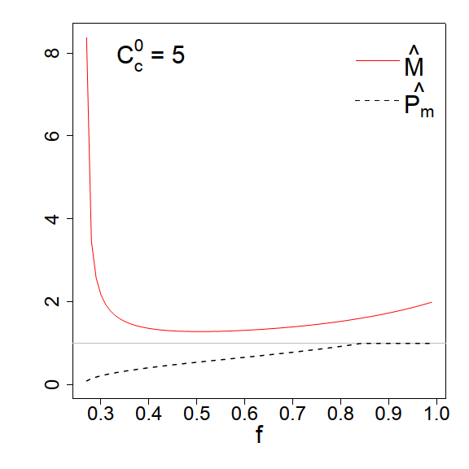

(H)  
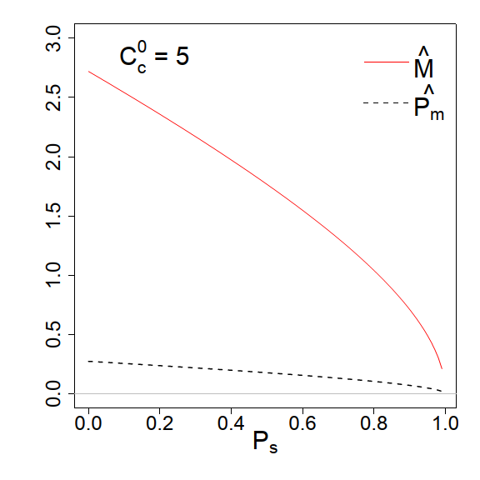

(G)  
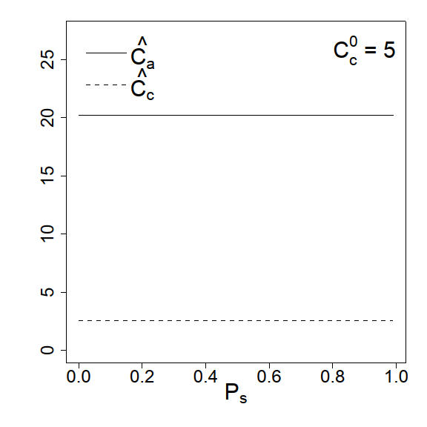

(B)  
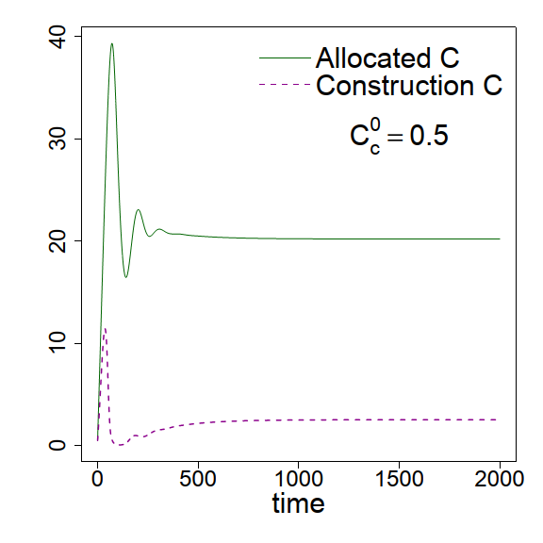

(C)  
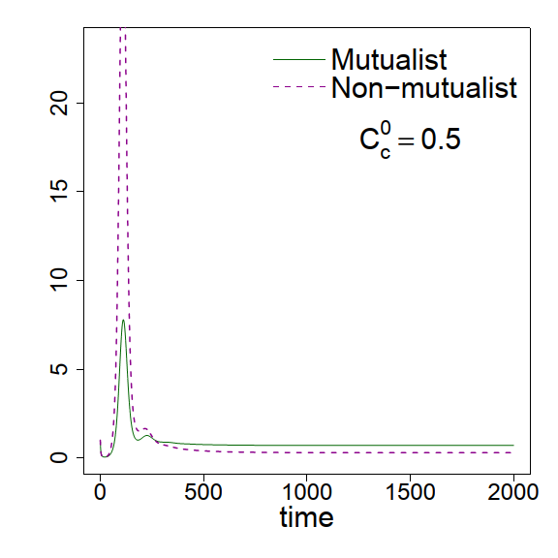

(D)  
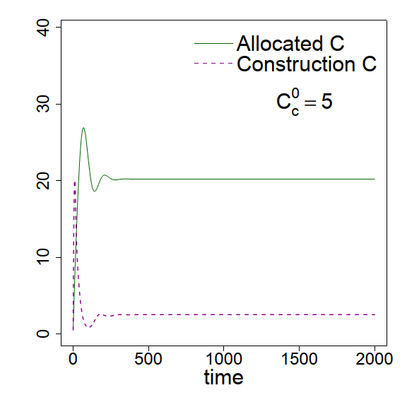

(E)  
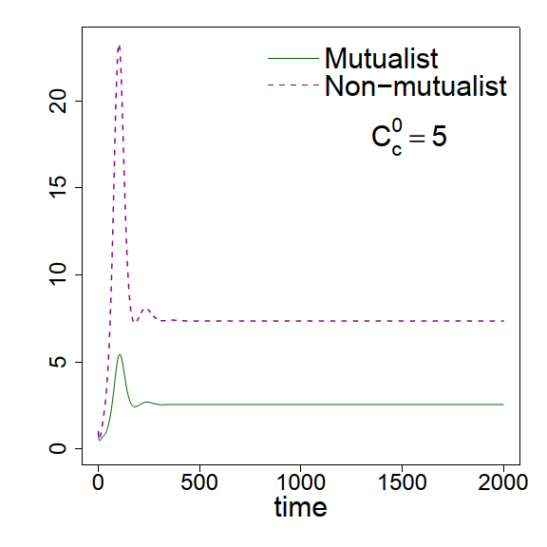

(F)  
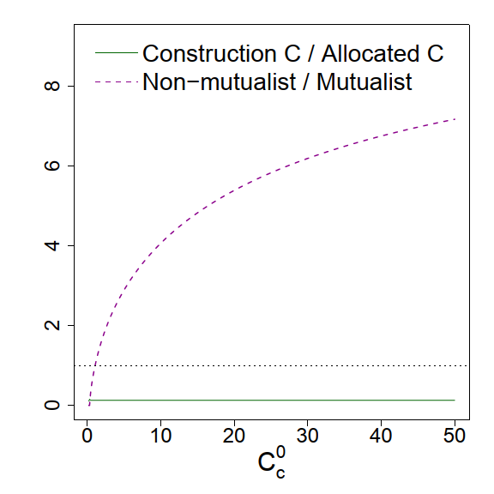

(A)  
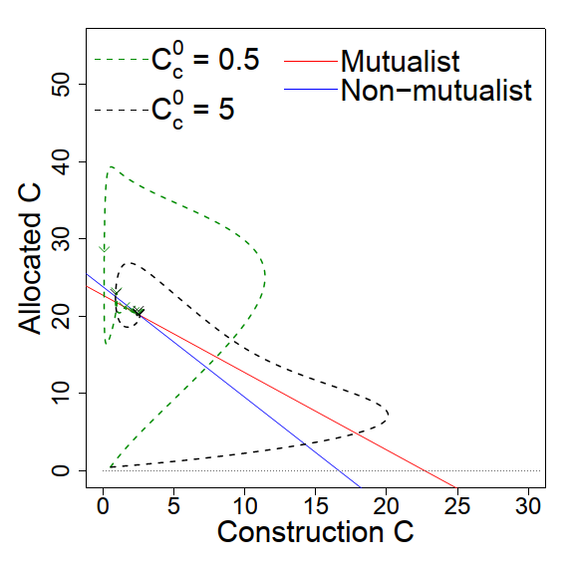

**Acknowledgements**

**Literature Cited**

**Appendix:**

**A1: Equilibrium solution for allocated carbon, construction carbon and both symbionts**

Solving Equations (5) to (8), we get equilibrium solutions for allocated carbon (), construction carbon (), mutualist () and non-mutualist () (given a finite phosphorous uptake per unit of preferentially allocated carbon received by mutualists (u)) as follows;

| Where, |  |
| --- | --- |
|  |  |

This equilibrium solution is valid when both and has some positive finite values, i.e., when they co-exist. Analytically this is guaranteed with. For practical purpose and numeric use we generally considered mutualist and non-mutualist should not differ by a magnitude of ~103 at their co-existing states.

Figure A1: *(A)* For fidelity *f = 0.2*: Zero net growth isoclines (ZNGI) for both symbionts do not intersect no coexistence of both symbionts is possible (Equation 9 is not satisfied, *CaN* / CaM\** < *1*). Trajectories in the resource carbons’ phase space initiated at (0.5, 0.5) diverged for *Cc0* *= 5.* *(B)* Numerical solution of Equation (1) and (4): dynamics of allocated carbon (*Ca*) and construction carbon (*Cc*) against time for *Cc0* *= 5*. *(C)* Numerical solution of Equation (2) and (3): dynamics of mutualist (*M*) and non-mutualist (*N*) against time for *Cc0* *= 5*. The system showed unrealistic numerical solution as construction carbon (*Cc*) become negative after a short time. Fidelity was also not sufficient to compensate mutualist’s need for energetic cost (*s = 0.1*), so mutualist became rare in that system whereas non-mutualist grew abundantly. Non-mutualist only uptake resources from the plant without adding any benefit, so the system collapsed. Other parameters used as *KM = KN =10.0, Ps = 0.3, u = 0.4, bmax = 0.8, d = 0.5, s = 0.1, g = 0.2, Kc = 5.*

(A)  
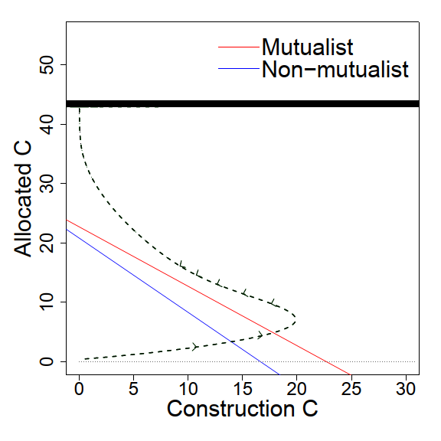

(B)  
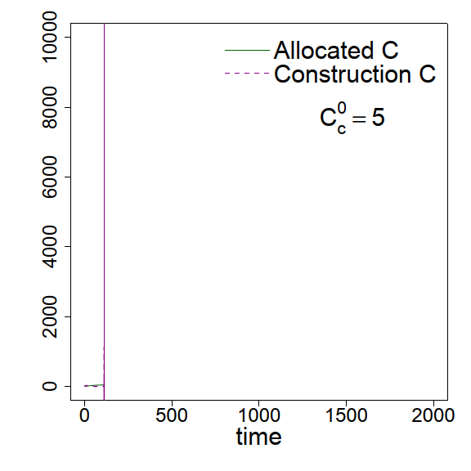

(C)  
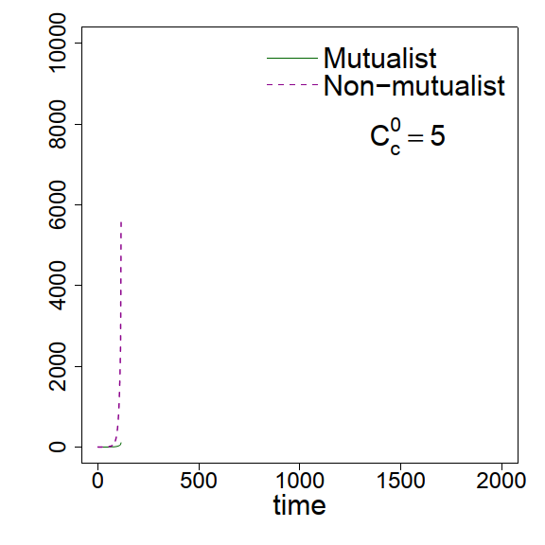

(F)  
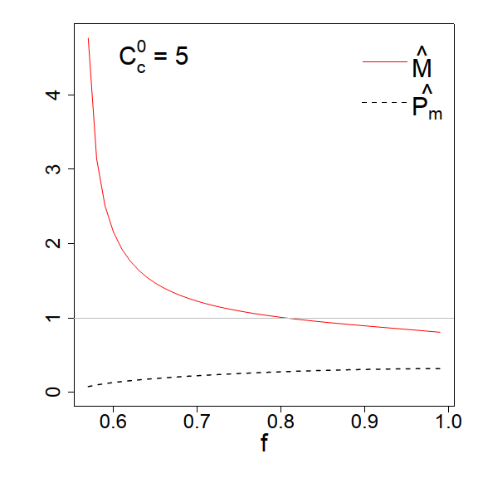

(E)  
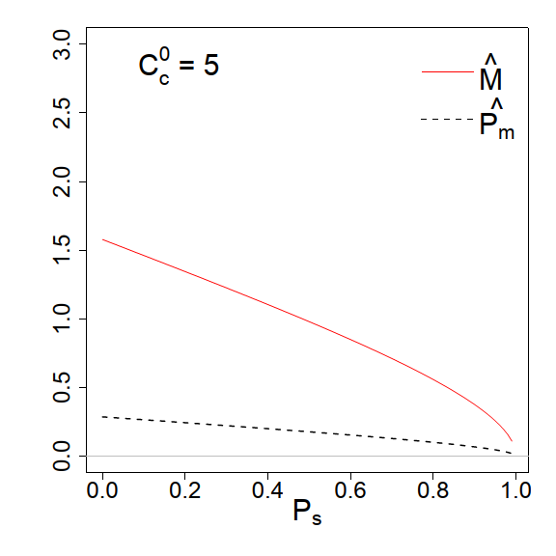

(D)  
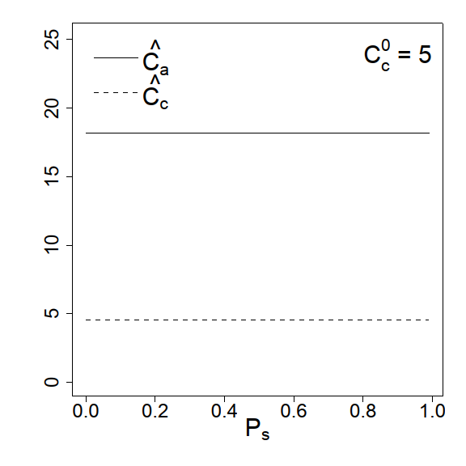

(C)  
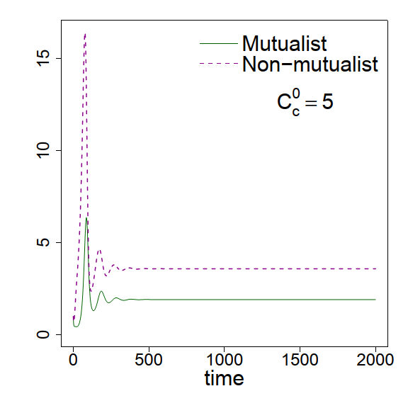

(B)  
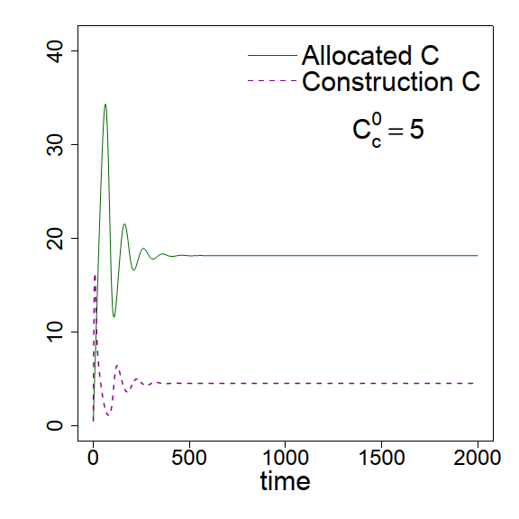

(A)  
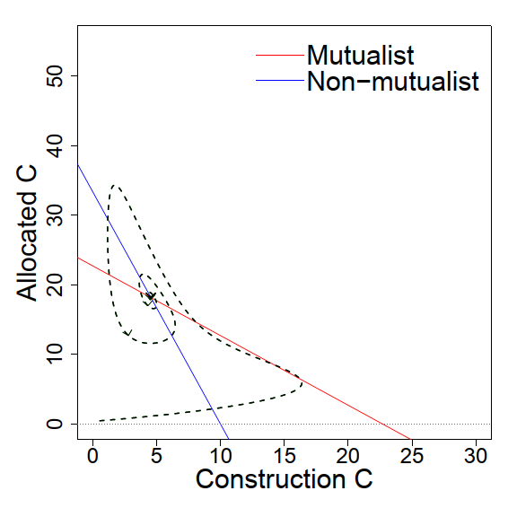

Figure A2: *(A)* For different growth rates of symbionts with parameters *KM =10.0, KN = 6.0, f = 0.7, Ps = 0.3, u = 0.4, bmax = 0.8, d = 0.5, s = 0.1, g = 0.2, Kc = 5*: Zero net growth isoclines (ZNGI) for both symbionts intersect at positive resource carbon’s phase space. Though non-mutualist has higher growth rate (as *KN < KM*), increased fidelity with minimum fidelity *fmin* *= 0.56* (compare with the *fmin* *= 0.26* of Fig. 2) added an advantage to the mutualist-abundance enabling it to co-exist with non-mutualist. Trajectory in the resource carbons’ phase space initiated at (0.5, 0.5) reached to two different equilibrium values for *Cc0* *= 5*. *(B)* Solution of Equation (1) and (4): dynamics of allocated carbon (*Ca*) and construction carbon (*Cc*) against time for *Cc0* *= 5*. *(C)* Solution of Equation (2) and (3): dynamics of mutualist (*M*) and non-mutualist (*N*) against time for *Cc0* *= 5*. *(D - F)* similar as described for (*G - I*) but with default values *Cc0* *= 5, f = 0.7, Ps = 0.3.*