Coding Mutants

SIET on Android

**Software Requirements Specification**

Version 1.0

**Team Guide:** Mr. Pankaj Tiwari

**Members:** Zeeshan Khan and Swati Kesarwani

**College Name:** Shambhunath Institute of Engineering and technology (SIET)

**Department:** Computer Science

**State:** work in progress

**Revision History**

|  |  |  |  |
| --- | --- | --- | --- |
| **Date** | **Version** | **Description** | **Author** |
| 28-Sep-2014 | 1.0 | SRS | Coding Mutants |

**Table of Contents**

**Description** **Page**

1. **Introduction 4**
   1. Purpose 4
   2. Scope 4
   3. Definition Acronyms, and Abbreviations 4
   4. References 4
   5. Technologies to be used 4
   6. Overview 5
2. **Overall Description 5**
   1. Software Perspective 5
   2. Software Interface 6
   3. Hardware Interface 6
   4. Product Function 5
   5. User Characteristics 5
   6. Constraints 5
   7. Architecture Design 5
   8. Use Case Model Description 5
   9. Class Diagram 5
   10. Sequence Diagram 5
       1. Database Diagram 5
       2. ER Diagram 5
   11. Assumptions and Dependencies 5
3. **Specific Requirements** 5
   1. Use Case Reports 0
   2. Supplementary Requirements 0

**Software Requirements Specification**

1. **Introduction**

Team (Coding Mutants) is aimed to develop an android application for students as well as faculty members of Shambhunath Institution of Engineering and Technology (SIET) which provide a platform to interact with each other.

* 1. **Purpose**

The purpose of this document is to make reader aware from the features and usefulness of the product.

* 1. **Scope**

The product consist of an android application and supporting web service, application will be available to users via Play Store and the web service will be hosted on the college server providing supporting functions to the application.

By using the application the user is able to text any other user using the app and the faculty users can fire a notification to the desired selected students and/or faculties.

* 1. **Definition Acronyms, and Abbreviations**

**SIET:** Shambhunath Institute of Information and Technology

**SGI:** Shambhunath Group of Institutions

**APK:** Android Package

**SDK:** Standard Development Kit

**ADT:** Android Development Tool

**JSON:** JavaScript Object Notation

**API:** Application Programming Interface

**XML:** Extensible Markup Language

**HTTP:** Hyper Text Transfer Protocol

**HTML:** Hyper Text Markup Language

**IDE:** Integrated Development Environment

**REST:** Representational State Transfer

**URI:** Uniform Resource Identifier

* 1. **References**

**Android API Guide:** [*https://developer.android.com/guide/index.html*](https://developer.android.com/guide/index.html)

**Android References:** [*https://developer.android.com/reference/packages.html*](https://developer.android.com/reference/packages.html)

**RESTful Web Service:** [*http://docs.oracle.com/javaee/6/tutorial/doc/gijqy.html*](http://docs.oracle.com/javaee/6/tutorial/doc/gijqy.html)

* 1. **Technologies to be used**

1. **Java:** RESTful web service is written in java version
2. **XML:** For layouts in Android
3. **MySQL:** Server side database is in MySQL version 5.5.29
4. **SQLite:** Relational Database management System
5. **Apache Tomcat Server:** Apache Tomcat Server version 6.0 is used to host the web service
6. **Eclipse**: Eclipse Juno with ADT plugin for android application and Eclipse Kelper(Java EE) for RESTful web service  
   1. **Overview**
      1. **Overall description**

The user is allowed to log in using the login id and password provided by the college and the actions he can perform will be decided by whether he is a faculty member or a student.

To interact with database and other secure tasks we will be developing a web service which will be running on the SIET College server.

* + 1. **Specific requirements**

1. User must have an android device running Android version 2.3 (Gingerbread) or up to install and use the application.
2. User should also have SIET college login credentials provided by the college itself
3. **Overall Description**

Project has two main modules

1. Android Application on user device consisting of
   1. Activities and fragments
   2. Background Service
2. Web service running on college server  
   1. **Software Perspective**

Software product is self-contained and is cable of running on any android device running on android version 2.3(Gingerbread) and up, but to avail its functionalities a web server is required to be up and running on the SIET College server.

The android application activities is handling all the GUI and interaction to user and the background service will communicate with the web service running on college server, In order to secure the communication to the database and authentication mechanism on web service a new layer is introduces between android application and the database on college server, which is in the form of a web service running on the same server where the database lies.

This web service will accept HTTP requests from running application and will output the result in JPG, Text, PDF and JSON format which will be captured and processed again by application running on user device.

Web Service

App Database

College Database

User Application

College server

Server

* 1. **Software Interface**
     1. **Front End Client**

Front end will be an android application running on a compatible device consisting of number of activities, fragments, and one background service, Activities and fragments will be moving back and forth on user interaction whereas background service is used to interact with the web service running on remote server.

Some data are fetched from server database (MySQL) and store in local database running SQLite (version is depends on client device) for reducing server overhead and fast user experience.

* + 1. **Webserver and Back End**

Webserver will be Apache Tomcat version 6.0 on which our RESTful web service will run and provide core functionalities to the user application.

The resources (classes and functions) of web service are written in Java and are accessible using URIs. Client application interact through hyperlinks and response is sent in Text, PDF, JPEG, HTML, XML and JSON formats depending upon the request from client.

* + 1. **Database Server**The database server is running centOS and database on server side is MySQL v5.5.29  
       whereas the database on user device is SQLite
  1. **Hardware Interface**
     1. **Client Side**
     2. **Server Side**
  2. **Product Function**
  3. **User Characteristics**
  4. **Constraints**
  5. **Architecture Design**
  6. **Use Case Model Description**
  7. **Class Diagram  
     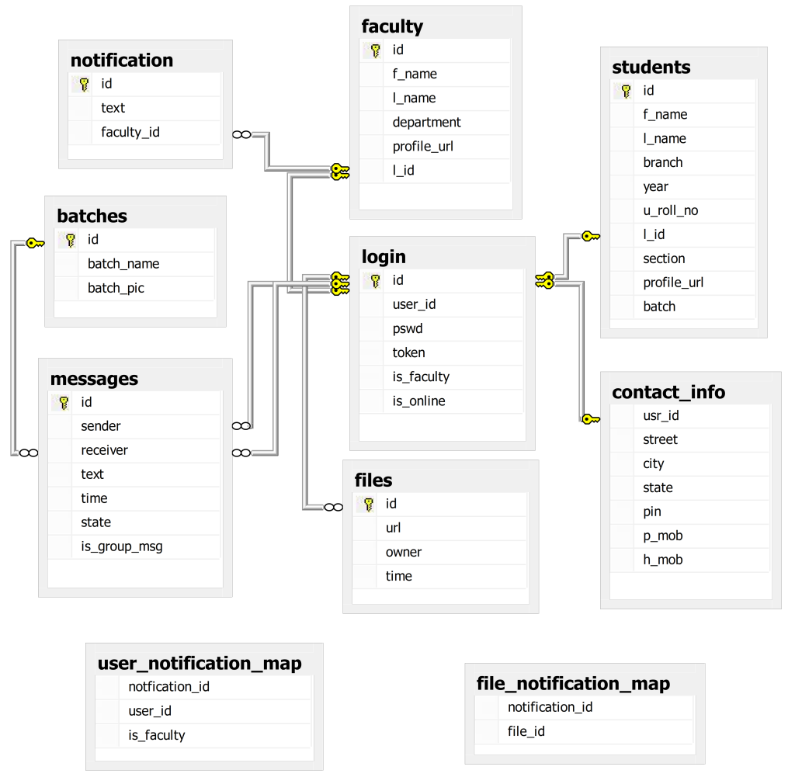**
  8. **Sequence Diagram**
     1. **Database Diagram**
     2. **ER Diagram**
  9. **Assumptions and Dependencies**

1. **Specific Requirements**
   1. **Use Case Reports**
   2. **Supplementary Requirements**