CodeCoins
Technical Overview · Gamified Coin-Tracking Platform for Coding Schools

What It Does
CodeCoins is a web application that lets coding-school instructors (“Senseis”) award or redeem reward points (“Code Coins”) for students (“Ninjas”) as they complete activities. A public leaderboard displays live coin balances, and an admin console manages the underlying reference data — all running on a lightweight, fully serverless stack.

Core Functionality
- Public Leaderboard — ranks active students by coin balance in real time, with search and medal badges for the top three
- Staff Coin Entry — password-protected screen for instructors to log coins earned or redeemed per activity, with searchable transaction history
- Admin Console — password-protected management of Ninjas, Senseis, and Activities, including add, edit, delete, and active/inactive status toggling
- All three pages share the same backend API and update from a single, always-current data source

Architecture at a Glance
Three static front-end pages call a small set of serverless API functions, which read and write a shared MongoDB database through a single pooled connection.
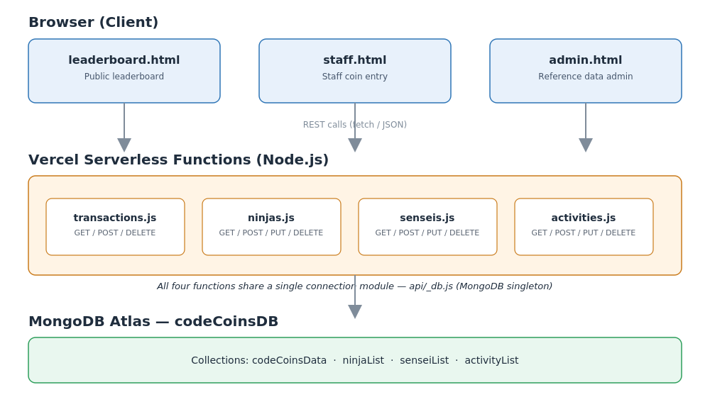

Key Components
Layer | Technology | Role
Frontend | Static HTML + JavaScript | Three pages: leaderboard, staff entry, admin
API Layer | Vercel Serverless Functions (Node.js) | Four endpoints handling transactions, ninjas, senseis, activities
Database | MongoDB Atlas | Stores transactions and reference data in four collections
Hosting | Vercel | Serves static pages and runs serverless functions

How Data Flows
- A transaction is logged by staff → sent to the API → written to the database
- The leaderboard pulls all transactions and active students in parallel, then calculates each balance as coins earned minus coins redeemed
- Admin changes to students, instructors, or activities update the same reference data instantly used across all three pages

Why It's Built This Way
- Serverless functions mean no servers to maintain or scale manually
- A single shared database connection keeps the app fast and cost-efficient under Vercel's serverless model
- Plain HTML/JS keeps the front end simple, fast-loading, and easy to maintain

