IFT780 – TP3 – Question 2

Endroits où du code a été ajouté

texte en vert: ajout
texte en rouge: retrait

- Fichier ‘src/train.py’:

[…]

if data_augment:
print('Data augmentation activated!')
+ data_augment_transforms = [
+ transforms.RandomRotation(15),
+ transforms.ColorJitter(contrast=0.5,
+ hue=0.5),
+ transforms.RandomHorizontalFlip(p=0.5),
+ transforms.RandomResizedCrop(32, scale=(0.5, 1.0), ratio=(1.0, 1.0))
+ ]
else:
print('Data augmentation NOT activated!')
+ data_augment_transforms = []

[…]

+ train_transform = transforms.Compose([
+ base_transform,
+ *data_augment_transforms
+ ])
+
if args.dataset == 'cifar10':
# Download the train and test set and apply transform on it
- train_set = datasets.CIFAR10(root='../data', train=True, download=True, transform=base_transform)
+ train_set = datasets.CIFAR10(root='../data', train=True, download=True, transform=train_transform)
test_set = datasets.CIFAR10(root='../data', train=False, download=True, transform=base_transform)

elif args.dataset == 'svhn':
# Download the train and test set and apply transform on it
- train_set = datasets.SVHN(root='../data', split='train', download=True, transform=base_transform)
+ train_set = datasets.SVHN(root='../data', split='train', download=True, transform=train_transform)
test_set = datasets.SVHN(root='../data', split='test', download=True, transform=base_transform)

+ if val_set:
+ len_val_set = int(len(train_set) * val_set)
+ train_set, val_set = torch.utils.data.random_split(train_set, [len(train_set) - len_val_set, len_val_set])
+ val_set.dataset.transform = base_transform
+

[…]
Courbes d’entraînement et de validation

1. --model=CnnVanilla --dataset=svhn --num-epochs=20

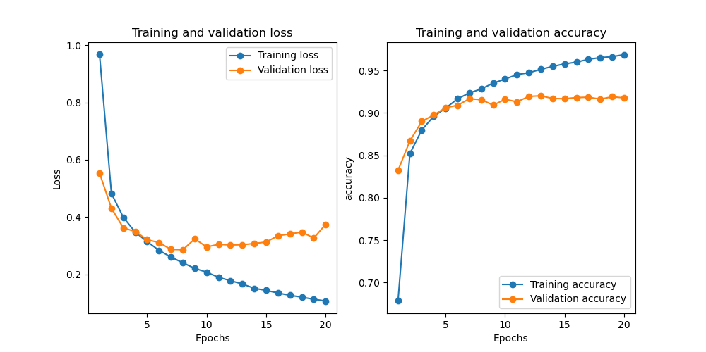

(ift725) simon@alien:~/tp3/src$ python train.py --model=CnnVanilla --dataset=svhn --num-epochs=20
Data augmentation NOT activated!
Using downloaded and verified file: ../data/train_32x32.mat
Using downloaded and verified file: ../data/test_32x32.mat
Training CnnVanilla on svhn for 20 epochs
Epoch: 1 of 20
100%|█| 3297/3297 [00:25<00:00, 131.73it/s, loss=0.967]
Validation loss 0.553
Epoch: 2 of 20
100%|█| 3297/3297 [00:25<00:00, 129.30it/s, loss=0.482]
Validation loss 0.431
Epoch: 3 of 20
100%|█| 3297/3297 [00:25<00:00, 131.38it/s, loss=0.399]
Validation loss 0.362
Epoch: 4 of 20
100%|█| 3297/3297 [00:25<00:00, 127.37it/s, loss=0.347]
Validation loss 0.349
Epoch: 5 of 20
100%|█| 3297/3297 [00:26<00:00, 123.69it/s, loss=0.314]
Validation loss 0.321
Epoch: 6 of 20
100%|█| 3297/3297 [00:26<00:00, 123.84it/s, loss=0.284]
Validation loss 0.311
Epoch: 7 of 20
100%|█| 3297/3297 [00:26<00:00, 123.19it/s, loss=0.260]
Validation loss 0.287
Epoch: 8 of 20
100%|█| 3297/3297 [00:26<00:00, 124.06it/s, loss=0.240]
Validation loss 0.286
Epoch: 9 of 20
100%|█| 3297/3297 [00:26<00:00, 125.08it/s, loss=0.221]
Validation loss 0.324
Epoch: 10 of 20
100%|█| 3297/3297 [00:26<00:00, 125.00it/s, loss=0.207]
Validation loss 0.296
Epoch: 11 of 20
100%|█| 3297/3297 [00:27<00:00, 122.07it/s, loss=0.189]
Validation loss 0.305
Epoch: 12 of 20
100%|█| 3297/3297 [00:26<00:00, 123.60it/s, loss=0.178]
Validation loss 0.302
Epoch: 13 of 20
100%|█| 3297/3297 [00:26<00:00, 123.46it/s, loss=0.166]
Validation loss 0.303
Epoch: 14 of 20
100%|█| 3297/3297 [00:27<00:00, 121.45it/s, loss=0.151]
Validation loss 0.308
Epoch: 15 of 20
100%|█| 3297/3297 [00:26<00:00, 122.60it/s, loss=0.144]
Validation loss 0.313
Epoch: 16 of 20
100%|█| 3297/3297 [00:26<00:00, 124.30it/s, loss=0.135]
Validation loss 0.335
Epoch: 17 of 20
100%|█| 3297/3297 [00:26<00:00, 122.35it/s, loss=0.127]
Validation loss 0.341
Epoch: 18 of 20
100%|█| 3297/3297 [00:26<00:00, 123.13it/s, loss=0.120]
Validation loss 0.348
Epoch: 19 of 20
100%|█| 3297/3297 [00:26<00:00, 125.41it/s, loss=0.113]
Validation loss 0.327
Epoch: 20 of 20
100%|█| 3297/3297 [00:26<00:00, 124.37it/s, loss=0.107]
Validation loss 0.374
Finished training.
Accuracy (or Dice for UNet) on the test set: 90.658 %
2. --model=CnnVanilla --dataset=svhn --num-epochs=20 --data_aug

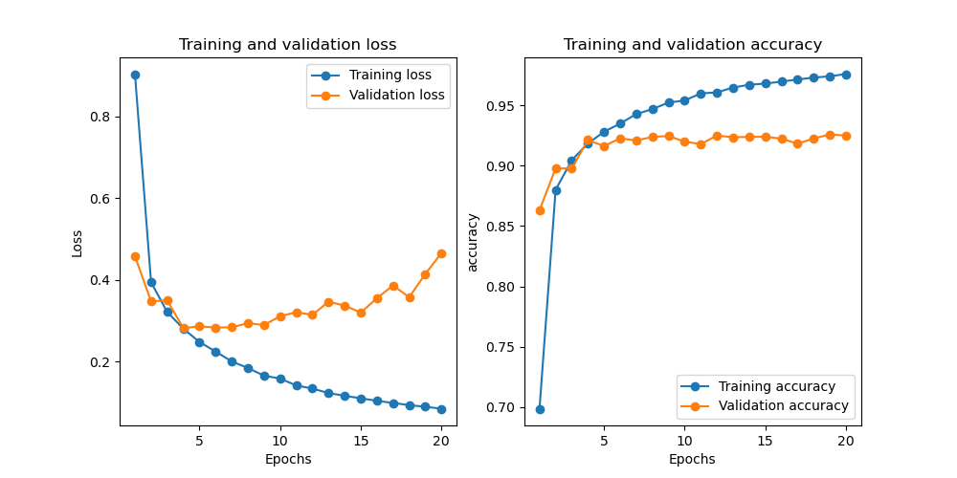

(ift725) simon@alien:~/tp3/src$ python train.py --model=CnnVanilla --dataset=svhn --num-epochs=20 --data_aug
Data augmentation activated!
Using downloaded and verified file: ../data/train_32x32.mat
Using downloaded and verified file: ../data/test_32x32.mat
Training CnnVanilla on svhn for 20 epochs
Epoch: 1 of 20
100%|█| 3297/3297 [00:25<00:00, 129.00it/s, loss=0.904]
Validation loss 0.458
Epoch: 2 of 20
100%|█| 3297/3297 [00:25<00:00, 128.27it/s, loss=0.394]
Validation loss 0.348
Epoch: 3 of 20
100%|█| 3297/3297 [00:25<00:00, 128.42it/s, loss=0.322]
Validation loss 0.350
Epoch: 4 of 20
100%|█| 3297/3297 [00:26<00:00, 126.68it/s, loss=0.281]
Validation loss 0.282
Epoch: 5 of 20
100%|█| 3297/3297 [00:26<00:00, 124.68it/s, loss=0.248]
Validation loss 0.286
Epoch: 6 of 20
100%|█| 3297/3297 [00:26<00:00, 124.37it/s, loss=0.225]
Validation loss 0.284
Epoch: 7 of 20
100%|█| 3297/3297 [00:26<00:00, 124.63it/s, loss=0.201]
Validation loss 0.284
Epoch: 8 of 20
100%|█| 3297/3297 [00:26<00:00, 125.55it/s, loss=0.185]
Validation loss 0.294
Epoch: 9 of 20
100%|█| 3297/3297 [00:26<00:00, 125.55it/s, loss=0.166]
Validation loss 0.290
Epoch: 10 of 20
100%|█| 3297/3297 [00:26<00:00, 125.00it/s, loss=0.159]
Validation loss 0.311
Epoch: 11 of 20
100%|█| 3297/3297 [00:26<00:00, 124.77it/s, loss=0.142]
Validation loss 0.321
Epoch: 12 of 20
100%|█| 3297/3297 [00:26<00:00, 123.86it/s, loss=0.134]
Validation loss 0.315
Epoch: 13 of 20
100%|█| 3297/3297 [00:26<00:00, 123.82it/s, loss=0.123]
Validation loss 0.347
Epoch: 14 of 20
100%|█| 3297/3297 [00:26<00:00, 123.92it/s, loss=0.117]
Validation loss 0.337
Epoch: 15 of 20
100%|█| 3297/3297 [00:26<00:00, 124.40it/s, loss=0.111]
Validation loss 0.320
Epoch: 16 of 20
100%|█| 3297/3297 [00:26<00:00, 125.93it/s, loss=0.104]
Validation loss 0.355
Epoch: 17 of 20
100%|█| 3297/3297 [00:26<00:00, 125.32it/s, loss=0.099]
Validation loss 0.387
Epoch: 18 of 20
100%|█| 3297/3297 [00:26<00:00, 124.28it/s, loss=0.094]
Validation loss 0.358
Epoch: 19 of 20
100%|█| 3297/3297 [00:26<00:00, 123.70it/s, loss=0.090]
Validation loss 0.415
Epoch: 20 of 20
100%|█| 3297/3297 [00:26<00:00, 124.18it/s, loss=0.085]
Validation loss 0.466
Finished training.
Accuracy (or Dice for UNet) on the test set: 92.651 %
3. --model=CnnVanilla --dataset=cifar10 --num-epochs=20

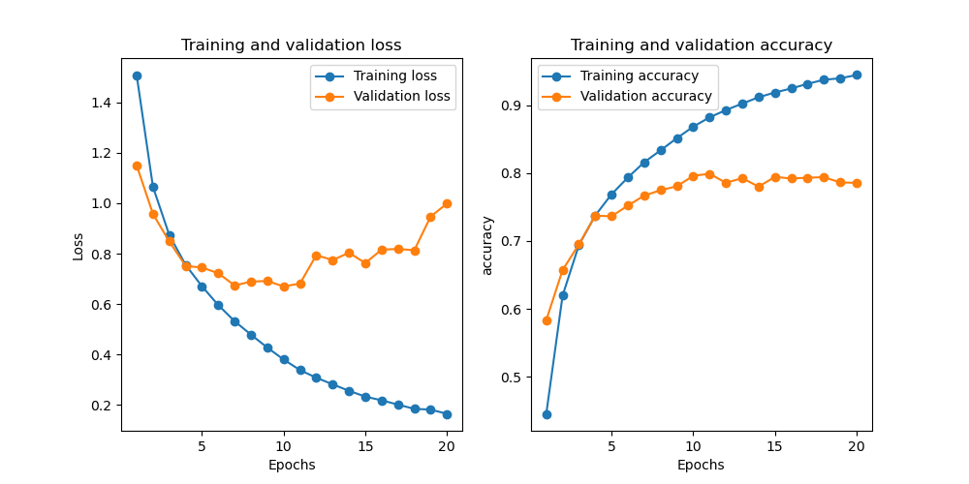

(ift725) simon@alien:~/tp3/src$ python train.py --model=CnnVanilla --dataset=cifar10 --num-epochs=20
Data augmentation NOT activated!
Downloading https://www.cs.toronto.edu/~kriz/cifar-10-python.tar.gz to ../data/cifar-10-python.tar.gz
170499072it [00:14, 11708473.40it/s]
Extracting ../data/cifar-10-python.tar.gz to ../data
Files already downloaded and verified
Training CnnVanilla on cifar10 for 20 epochs
Epoch: 1 of 20
100%|█| 2250/2250 [00:18<00:00, 123.99it/s, loss=1.508]
Validation loss 1.150
Epoch: 2 of 20
100%|█| 2250/2250 [00:17<00:00, 128.08it/s, loss=1.065]
Validation loss 0.957
Epoch: 3 of 20
100%|█| 2250/2250 [00:17<00:00, 129.52it/s, loss=0.874]
Validation loss 0.848
Epoch: 4 of 20
100%|█| 2250/2250 [00:17<00:00, 127.47it/s, loss=0.756]
Validation loss 0.751
Epoch: 5 of 20
100%|█| 2250/2250 [00:17<00:00, 127.32it/s, loss=0.671]
Validation loss 0.745
Epoch: 6 of 20
100%|█| 2250/2250 [00:18<00:00, 124.68it/s, loss=0.596]
Validation loss 0.723
Epoch: 7 of 20
100%|█| 2250/2250 [00:17<00:00, 126.29it/s, loss=0.532]
Validation loss 0.674
Epoch: 8 of 20
100%|█| 2250/2250 [00:18<00:00, 122.22it/s, loss=0.479]
Validation loss 0.689
Epoch: 9 of 20
100%|█| 2250/2250 [00:18<00:00, 122.14it/s, loss=0.428]
Validation loss 0.692
Epoch: 10 of 20
100%|█| 2250/2250 [00:18<00:00, 123.06it/s, loss=0.380]
Validation loss 0.670
Epoch: 11 of 20
100%|█| 2250/2250 [00:18<00:00, 124.72it/s, loss=0.338]
Validation loss 0.681
Epoch: 12 of 20
100%|█| 2250/2250 [00:18<00:00, 121.76it/s, loss=0.308]
Validation loss 0.794
Epoch: 13 of 20
100%|█| 2250/2250 [00:18<00:00, 123.49it/s, loss=0.282]
Validation loss 0.775
Epoch: 14 of 20
100%|█| 2250/2250 [00:17<00:00, 126.45it/s, loss=0.256]
Validation loss 0.804
Epoch: 15 of 20
100%|█| 2250/2250 [00:18<00:00, 124.97it/s, loss=0.233]
Validation loss 0.763
Epoch: 16 of 20
100%|█| 2250/2250 [00:18<00:00, 124.47it/s, loss=0.219]
Validation loss 0.816
Epoch: 17 of 20
100%|█| 2250/2250 [00:18<00:00, 122.48it/s, loss=0.202]
Validation loss 0.819
Epoch: 18 of 20
100%|█| 2250/2250 [00:18<00:00, 121.76it/s, loss=0.185]
Validation loss 0.814
Epoch: 19 of 20
100%|█| 2250/2250 [00:18<00:00, 122.54it/s, loss=0.182]
Validation loss 0.947
Epoch: 20 of 20
100%|█| 2250/2250 [00:18<00:00, 124.21it/s, loss=0.165]
Validation loss 0.999
Finished training.
Accuracy (or Dice for UNet) on the test set: 78.310 %
4. --model=CnnVanilla --dataset=cifar10 --num-epochs=20 --data_aug

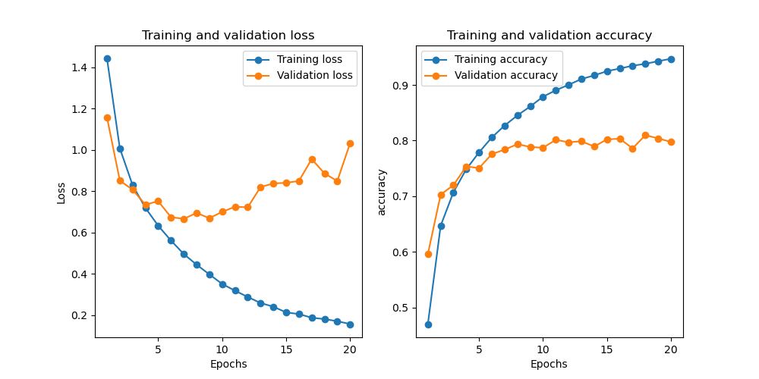

(ift725) simon@alien:~/tp3/src$ python train.py --model=CnnVanilla --dataset=cifar10 --num-epochs=20 --data_aug
Data augmentation activated!
Files already downloaded and verified
Files already downloaded and verified
Training CnnVanilla on cifar10 for 20 epochs
Epoch: 1 of 20
100%|█| 2250/2250 [00:17<00:00, 128.69it/s, loss=1.442]
Validation loss 1.157
Epoch: 2 of 20
100%|█| 2250/2250 [00:17<00:00, 131.66it/s, loss=1.008]
Validation loss 0.852
Epoch: 3 of 20
100%|█| 2250/2250 [00:16<00:00, 132.43it/s, loss=0.829]
Validation loss 0.807
Epoch: 4 of 20
100%|█| 2250/2250 [00:17<00:00, 129.35it/s, loss=0.719]
Validation loss 0.735
Epoch: 5 of 20
100%|█| 2250/2250 [00:17<00:00, 128.82it/s, loss=0.633]
Validation loss 0.752
Epoch: 6 of 20
100%|█| 2250/2250 [00:17<00:00, 127.49it/s, loss=0.561]
Validation loss 0.674
Epoch: 7 of 20
100%|█| 2250/2250 [00:17<00:00, 127.25it/s, loss=0.496]
Validation loss 0.666
Epoch: 8 of 20
100%|█| 2250/2250 [00:17<00:00, 127.37it/s, loss=0.444]
Validation loss 0.695
Epoch: 9 of 20
100%|█| 2250/2250 [00:17<00:00, 125.20it/s, loss=0.397]
Validation loss 0.670
Epoch: 10 of 20
100%|█| 2250/2250 [00:18<00:00, 124.02it/s, loss=0.351]
Validation loss 0.701
Epoch: 11 of 20
100%|█| 2250/2250 [00:17<00:00, 126.54it/s, loss=0.318]
Validation loss 0.725
Epoch: 12 of 20
100%|█| 2250/2250 [00:17<00:00, 125.39it/s, loss=0.288]
Validation loss 0.723
Epoch: 13 of 20
100%|█| 2250/2250 [00:17<00:00, 125.08it/s, loss=0.259]
Validation loss 0.820
Epoch: 14 of 20
100%|█| 2250/2250 [00:17<00:00, 127.24it/s, loss=0.241]
Validation loss 0.838
Epoch: 15 of 20
100%|█| 2250/2250 [00:17<00:00, 126.97it/s, loss=0.213]
Validation loss 0.841
Epoch: 16 of 20
100%|█| 2250/2250 [00:17<00:00, 127.19it/s, loss=0.205]
Validation loss 0.850
Epoch: 17 of 20
100%|█| 2250/2250 [00:17<00:00, 125.45it/s, loss=0.187]
Validation loss 0.956
Epoch: 18 of 20
100%|█| 2250/2250 [00:17<00:00, 126.31it/s, loss=0.181]
Validation loss 0.886
Epoch: 19 of 20
100%|█| 2250/2250 [00:18<00:00, 124.91it/s, loss=0.170]
Validation loss 0.850
Epoch: 20 of 20
100%|█| 2250/2250 [00:17<00:00, 125.50it/s, loss=0.157]
Validation loss 1.033
Finished training.
Accuracy (or Dice for UNet) on the test set: 78.650 %

