Stephanie Gillihan
CSPB 4502 Data Mining
Project Part 4: Final Report

Chess Insights: Result Predictors and Play Sequences by Player Ranking

Abstract
(insert abstract here)

Introduction
This project investigates which features of online chess games are strongly associated with wins, losses, and draws, and whether those relationships change across player rating levels. The project builds on my initial proposal and project progress update, which identified Lichess.org game data as a strong source for studying game characteristics, opening choices, move sequences, player ratings, and outcomes at large scale. In the initial work, I confirmed that the February 2026 Lichess standard rated games dataset contains the attributes needed to answer these questions, including game metadata, player ratings, results, and move sequences.

The main knowledge I hope to gain is whether common chess advice and assumptions about openings, rating differences, and move patterns are visible in a very large real-world dataset. For example, a move sequence may appear strong overall but may only be successful at certain rating levels, or a predictor such as rating difference may dominate outcome prediction so strongly that opening choice has limited predictive value. This project will also help me apply data mining methods to a dataset that is large, semi-structured, and computationally challenging. The final result will be a reproducible analysis pipeline and a written report that explains which predictors are most associated with game outcomes, which opening or early-move patterns appear most common, and how these findings vary by player ranking.

Related Work
Previous chess data studies show that online chess platforms can support large-scale analysis of player behavior, game outcomes, and opening choices. De Marzo and Servedio used Lichess data to study chess openings as a relatedness network, measuring similarity between openings and using online community data to understand the structure and complexity of opening theory. Their work is relevant because it treats openings not only as isolated labels, but as patterns that can be compared and grouped based on how they are played.

Chowdhary et al. used large-scale Lichess data to quantify human performance in chess. Their study notes that the Lichess dataset includes detailed information about played games, including moves, openings, win/loss outcomes, and player skill level. This supports the feasibility of my project because the same general data source contains the features needed to connect player rating, move behavior, and game result.
Recent machine learning work has also explored prediction of chess game outcomes. Samara developed and compared machine learning models for classifying chess game results as White win, Black win, or draw using Lichess data, player rating information, and game metadata. This is closely related to my predictive modeling goal, but my project will place more emphasis on interpretable aggregate comparisons, opening and move-sequence patterns, and differences across rating bins rather than only model performance.
My work differs from previous studies in its scope and emphasis. Rather than focusing only on opening similarity, only human performance, or only predictive accuracy, this project combines interpretable descriptive analysis, frequent sequence analysis, and classification. It will also explicitly compare results across player rating bins, which should help determine whether predictors of success differ between lower-rated, intermediate, and higher-rated players.

Dataset
The dataset is the Lichess dataset from February 2026. The file was 27.8GB compressed, and 184.12GB decompressed. It contains information for 84,600,043 chess games. The dataset citation is provided in the works cited section. This dataset contains the key fields needed for the project: game results, player ratings, game metadata, and full move sequences. Its large size also makes it appropriate for a data mining project because it supports analysis across rating groups and less common opening patterns while requiring careful preprocessing and computational planning.

Techniques Applied
Part A: Languages and Libraries
Python is the primary programming language used for Chess Insights because it supports the full workflow from parsing to modeling and visualization. Several Python libraries are used to support various processing and analysis work. Zstandard, python-chess, pandas, NumPy, and PyArrow are used for parsing, extraction, cleaning, transformation, sampling, aggregation, and storage.

For modeling and evaluation, scikit-learn supports train/test splits, classification models, confusion matrices, and performance metrics. For visualization, matplotlib and seaborn are used to create charts and tables that support the final report.

The tools above worked very well on an initial 50k game sample dataset, but did not automatically or easily scale to the full 85 million game dataset. It was necessary to add explicit deletion and garbage collection, as well as chunked processing and sampling for memory management. Despite the efforts to make the data analysis pipeline as computationally efficient as possible, I still could not process 85 million games on my PC, instead maxing out at 5 million games. This experience working with Python on a massive dataset demonstrated that while it excels at tabular manipulation on fairly large datasets, there is a ceiling on what standard libraries can handle when performing parsing and modeling.

Part B: Descriptive Statistics and Categorical Comparisons
Descriptive statistics such as counts, percentages, means, medians, standard deviations, quartiles, and interquartile ranges are reported for player ratings, rating differences, game length, outcome frequencies, and opening frequencies. See the preliminary results section for summaries.
Support, confidence, and lift are used to describe association rules and frequent patterns. Support measures how common a move sequence or opening pattern is. Confidence measures how often a result occurs given a particular pattern. Lift helps determine whether a pattern is more strongly associated with an outcome than would be expected from the baseline outcome rate.
For categorical comparisons, I used chi-squared tests on contingency tables, such as opening category by result or rating bin by result. A chi-squared test checks whether two categorical variables are associated by comparing observed counts with the counts expected if the variables were independent. A small p-value suggests the observed relationship is unlikely to be due to random chance.

Part C: Classification and Model Training
For classification, I use train/test splits and evaluate models with accuracy, precision, recall, F1 score, specificity where appropriate, and confusion matrices. Since chess outcome prediction may involve imbalanced classes, especially if draws are less common than wins/losses in some subsets, I will not rely on accuracy alone. I will compare model performance against simple baselines, such as always predicting the most common class or predicting the higher-rated player to win. I need to refine the target that I want to train prior to final analysis.

I will focus modeling on random forest modeling to predict game outcomes based on features known before a match begins. I will also report ROC/AUC for binary classification tasks, such as predicting whether White wins or whether the higher-rated player wins. I will use ROC/AUC because it evaluates how well a model separates positive and negative cases across thresholds, which is useful when class probabilities are more informative than hard class labels.

Key Results
Part A: Part A: Languages and Libraries
I developed a complete data pipeline with assistance from Claude Code to perform the following steps.

Data Ingestion and PGN parsing- parsed the original source file into a data frame and parquet. Chunking and sample mode were built into the pipeline, allowing the pipeline to process 50,000 games at a rate of ~424 games per second.
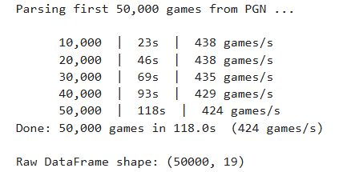
Figure 1: Data ingestion and parsing

Data Cleaning and standardization- the data was already relatively clean, and only 164 out of 50,000 games were removed for missing values. Please see summaries below of before cleaning and after cleaning numbers for key columns.

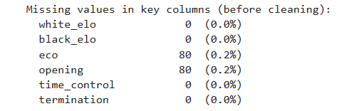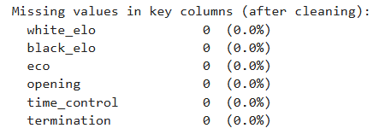
Figure 2: Before and after data cleaning

Feature Engineering- The following features were added to support analysis: result_label, rating_diff, avg_rating, rating_bin, num_moves, tc_cat, eco_family, opening_family, white_wins, higher_rated_wins

The most challenging aspect of engineering this data pipeline was overcoming memory issues and computational limitations. (expand this section)

Part B: Descriptive Statistics and Categorical Comparisons
The descriptive analyses establish the dataset’s baseline characteristics and identify candidate relationships for later association-rule mining and predictive modeling. Please see the graphs and charts below for illustration of descriptive analysis results.

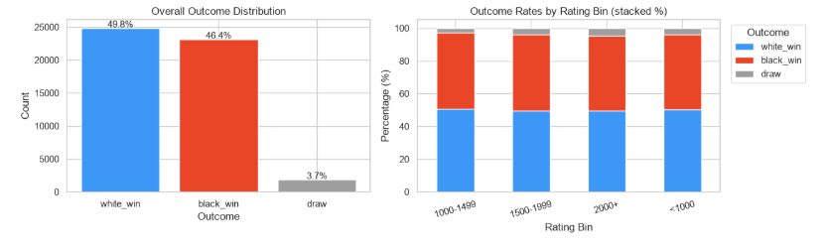
Figure 3: Outcome Distribution

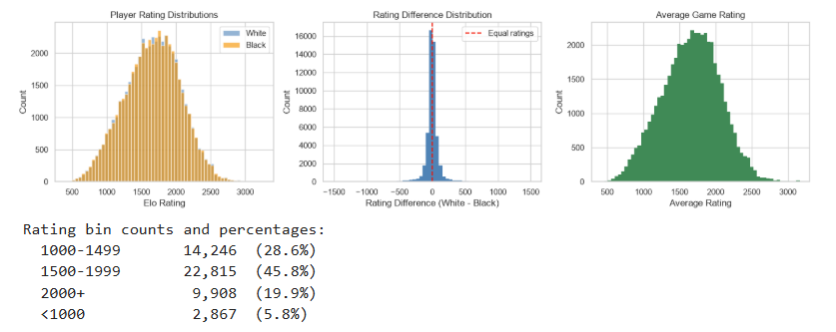
Figure 4: Player Rating Analysis and Rating Difference Analysis

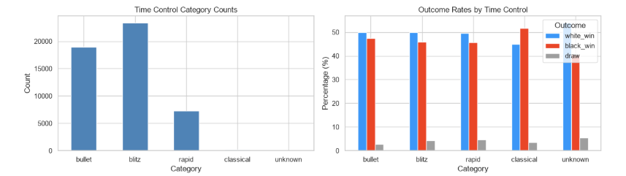
Figure 5: Game Length and Time Control Analysis

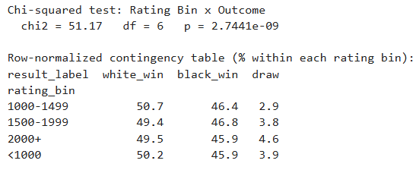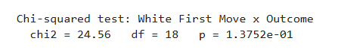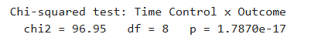
Figure 6: Chi-squared tests

The graphs above indicate that …(insert some discussion of the descriptive statistics here)

Part C: Frequent Patterns and Model Training

Applications

Conclusions and Limitations
The Chess Insights project highlights several key findings. First, chess is a game in which skill level matters significantly. All results pointed to player ranking being the primary game outcome predictor. Second, chess is a complex strategy game in which it is difficult to pre-determine a winning combination of moves that will ensure a win.
A glaring limitation of this project was computational time and space. Despite efforts to optimize the data pipeline, I was unable to run the pipeline on the entire dataset. However, I was able to randomize the game selection and increase the games sampled from 50,000 to 5,000,000, an increase of 100x.

References

Chowdhary, Sandeep, Iacopo Iacopini, and Federico Battiston. “Quantifying Human Performance in Chess.” Scientific Reports, vol. 13, 2023, article no. 2113, https://doi.org/10.1038/s41598-023-29369-7.
De Marzo, Giordano, and Vito D. P. Servedio. “Quantifying the Complexity and Similarity of Chess Openings Using Online Chess Community Data.” Scientific Reports, vol. 13, 2023, article no. 5327, https://doi.org/10.1038/s41598-023-31658-w.
Lichess. “Lichess Database: Standard Rated Games, February 2026.” Lichess, 2026, https://database.lichess.org/.
Samara, Khalid. “Machine Learning Approaches for Classifying Chess Game Outcomes: A Comparative Analysis of Player Ratings and Game Dynamics.” Electronics, vol. 15, no. 1, 2026, article no. 1, https://doi.org/10.3390/electronics15010001.

