Stephanie Gillihan
CSPB 4502 Data Mining
Project Part 3: Progress Report

Chess Insights: Result Predictors and Play Sequences by Player Ranking

Updated Proposal

Motivation
This project will investigate which features of online chess games are strongly associated with wins, losses, and draws, and whether those relationships change across player rating levels. The project builds on my initial proposal, which identified Lichess.org game data as a strong source for studying game characteristics, opening choices, move sequences, player ratings, and outcomes at large scale. In the initial work, I confirmed that the February 2026 Lichess standard rated games dataset contains the attributes needed to answer these questions, including game metadata, player ratings, results, and move sequences.
The main knowledge I hope to gain is whether common chess advice and assumptions about openings, rating differences, and move patterns are visible in a very large real-world dataset. For example, a move sequence may appear strong overall but may only be successful at certain rating levels, or a predictor such as rating difference may dominate outcome prediction so strongly that opening choice has limited predictive value. This project will also help me apply data mining methods to a dataset that is large, semi-structured, and computationally challenging. The final result will be a reproducible analysis pipeline and a written report that explains which predictors are most associated with game outcomes, which opening or early-move patterns appear most common, and how these findings vary by player ranking.
Proposed Work
The project will proceed in several stages: data collection, parsing, cleaning, feature engineering, descriptive analysis, move-sequence analysis, predictive modeling, and evaluation.
First, I will use the February 2026 Lichess standard rated games dataset. The raw file is provided in PGN format compressed as a .pgn.zst file. PGN is a plain-text chess game notation format, so the first major preprocessing step will be parsing the text into a structured format suitable for analysis. I plan to create one main game-level table and, if feasible, a second move-sequence table. The game-level table will contain one row per game, including attributes such as result, White rating, Black rating, rating difference, time control, opening information when available, number of moves, termination type, and selected early moves. The move-sequence table will support analysis of common k-move patterns, such as the first 2, 4, or 6 plies of each game.
Cleaning includes removing or flagging games that are empty, incomplete, improperly parsed, missing required metadata, or have invalid results or ratings. Outcomes are standardized into White win, Black win, and draw labels. Binary perspective-based outcome variables are also useful, such as whether the higher-rated player won. This makes it possible to examine both direct result prediction and rating-adjusted result patterns. After preliminary analysis, I found that the dataset is already fairly clean and a very small number of games will need to be excluded from the dataset.
Feature engineering includes derived variables such as rating difference, average player rating, rating bin, game length in moves, opening family or first move, first k-move sequence, time-control category, and binary result from White’s perspective. Rating bins are defined using the following ranges: under 1000, 1000-1499, 1500-1999, and 2000+. A test dataset of 50,000 records was created to test feature engineering, analysis, and modeling code.
The analysis includes three main components. First, descriptive analysis summarizes the dataset and compares outcome rates by rating bin, rating difference, opening move, time control, and game length. Second, frequent-pattern and association-rule methods will be used to identify common move sequences and evaluate whether they are associated with particular outcomes. For preliminary analysis, only the first k-moves were considered for pattern analysis, but the final report will incorporate move sequence analysis anywhere in the game. Third, supervised classification models test whether game metadata and engineered features can predict outcome categories. During preliminary analysis, I ran logistic regression, decision trees, and random forest models on the test data. The random forest model performed considerably better than the others, so my final analysis will focus on the random forest model.
My work differs from previous studies in its scope and emphasis. Rather than focusing only on opening similarity, only human performance, or only predictive accuracy, this project combines interpretable descriptive analysis, frequent sequence analysis, and classification. It will also explicitly compare results across player rating bins, which should help determine whether predictors of success differ between lower-rated, intermediate, and higher-rated players.
Tools
Python is the primary programming language because it supports the full workflow from parsing to modeling and visualization. Several Python libraries are used to support various processing and analysis work. Zstandard, python-chess, pandas, NumPy, and PyArrow are used for parsing, extraction, cleaning, transformation, sampling, aggregation, and storage.
For modeling and evaluation, scikit-learn supports train/test splits, classification models, confusion matrices, and performance metrics. For visualization, matplotlib and seaborn are used to create charts and tables that support the final report.
Evaluation Plan
Descriptive statistics such as counts, percentages, means, medians, standard deviations, quartiles, and interquartile ranges are reported for player ratings, rating differences, game length, outcome frequencies, and opening frequencies. See the preliminary results section for summaries.
Support, confidence, and lift are used to describe association rules and frequent patterns. Support measures how common a move sequence or opening pattern is. Confidence measures how often a result occurs given a particular pattern. Lift helps determine whether a pattern is more strongly associated with an outcome than would be expected from the baseline outcome rate.
For categorical comparisons, I used chi-squared tests on contingency tables, such as opening category by result or rating bin by result. A chi-squared test checks whether two categorical variables are associated by comparing observed counts with the counts expected if the variables were independent. A small p-value suggests the observed relationship is unlikely to be due to random chance.
For classification, I use train/test splits and evaluate models with accuracy, precision, recall, F1 score, specificity where appropriate, and confusion matrices. Since chess outcome prediction may involve imbalanced classes, especially if draws are less common than wins/losses in some subsets, I will not rely on accuracy alone. I will compare model performance against simple baselines, such as always predicting the most common class or predicting the higher-rated player to win. I need to refine the target that I want to train prior to final analysis.
I will focus modeling on random forest modeling to predict game outcomes based on features known before a match begins. I will also report ROC/AUC for binary classification tasks, such as predicting whether White wins or whether the higher-rated player wins. I will use ROC/AUC because it evaluates how well a model separates positive and negative cases across thresholds, which is useful when class probabilities are more informative than hard class labels.
Milestones
Please refer to Milestones Completed and Milestones Remaining Sections to avoid redundancy.
Summary of Changes from Project Part 2
There are several changes or refinements I plan to make for the final analysis and final report. First, I realized that the features must be considered in the context of whether they are known before the start of game play, or whether they are only known in a retrospective analysis. This requires two different approaches to predictive modeling. I will build one model that predicts game outcome based on features known prior to start of game, and I will build another predictive model that attempts to predict the outcome of the game at k-move intervals based on whether or not any frequent patterns have been detected in those k-moves. Second, the frequent pattern analysis has been tricky to frame correctly. I am still working on refining the code to perform as I would like. I will also need to build out the frequent pattern analysis over different player ranking bins, separately from the overall pattern analysis. Generally, I have a decent working pipeline, but refinement and a narrowing in focus is needed for the final analysis.

Milestones Completed

I developed a complete data pipeline with assistance from Claude Code to perform the following steps.

Data Ingestion and PGN parsing- parsed the original source file into a data frame and parquet. Chunking and sample mode were built into the pipeline, allowing the pipeline to process 50,000 games at a rate of ~424 games per second.
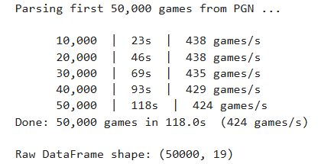
Figure 1: Data ingestion and parsing

Data Cleaning and standardization- the data was already relatively clean, and only 164 out of 50,000 games were removed for missing values. Please see summaries below of before cleaning and after cleaning numbers for key columns.

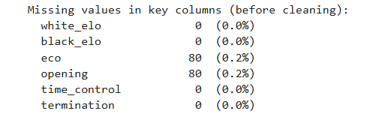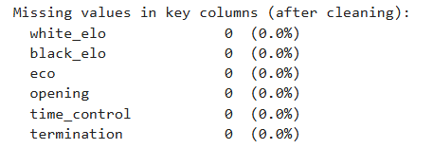
Figure 2: Before and after data cleaning

Feature Engineering- The following features were added to support analysis: result_label, rating_diff, avg_rating, rating_bin, num_moves, tc_cat, eco_family, opening_family, white_wins, higher_rated_wins

Descriptive Analysis- These descriptive analyses establish the dataset’s baseline characteristics and identify candidate relationships for later association-rule mining and predictive modeling. Please see the graphs and charts below for illustration of descriptive analysis preliminary results.

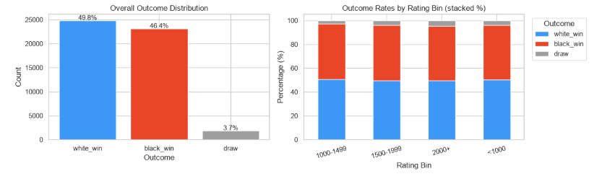
Figure 3: Outcome Distribution

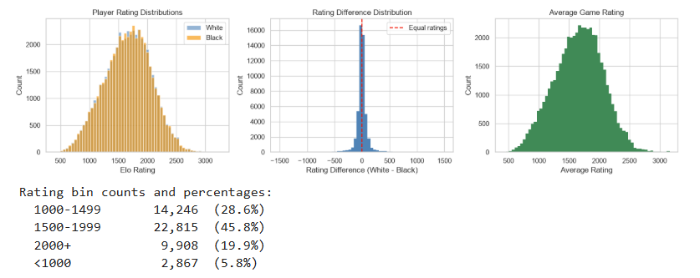
Figure 4: Player Rating Analysis and Rating Difference Analysis

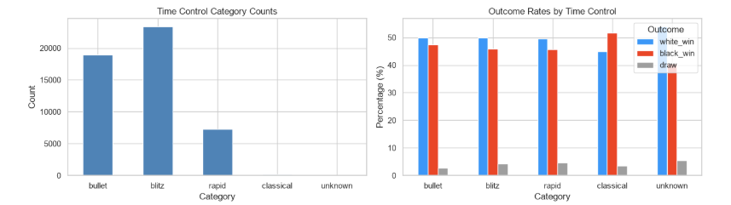
Figure 5: Game Length and Time Control Analysis

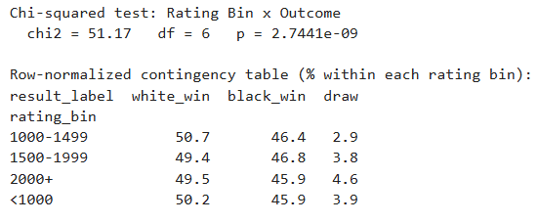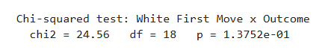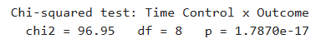
Figure 6: Chi-squared tests
Frequent Patterns and Association Rules- This section proved most challenging due to differences in my concept and execution. I am currently working on refining how I want to analyze the data to answer the questions posed in my proposal. I implemented an initial association-rule analysis using the first four plies, equivalent to White’s first two moves and Black’s first two responses. The current rules are preliminary because some consequents mix moves and outcomes, reducing interpretability.

Supervised Classification- I trained and evaluated logistic regression, decision tree, and Random Forest classifiers using a train/test split. Random Forest produced the strongest preliminary binary results, with 62.95% accuracy, an F1 score of 0.6293, and ROC-AUC of 0.6698. These models serve as proof of concept and establish baseline performance for the refined modeling tasks.

Preliminary Results

The complete pipeline described above was run on the sample dataset of 50000 records. After cleaning, the development subset contained 49,836 games. White won 49.8% of games, Black won 46.4%, and 3.7% ended in draws. The low draw rate also creates a class-imbalance concern for three-class modeling. Please see below for a summary of preliminary findings and supporting figures. I expect that final results will be more interesting once all of the outlined objectives are completed.

Rating bin and outcome were statistically associated: $χ^{2}=51.17$, $p<0.001$, although the percentage differences between rating groups were fairly small.
Time control and outcome were also statistically associated: $χ^{2}=96.95$, $p<0.001$.
White’s first move was not statistically associated with outcome in the current sample: $χ^{2}=24.56$, $p=0.138$.
The early-move association rules generally showed weak direct relationships with winning once they were interpreted correctly. I hope to identify stronger associations by refining the pattern analysis code.

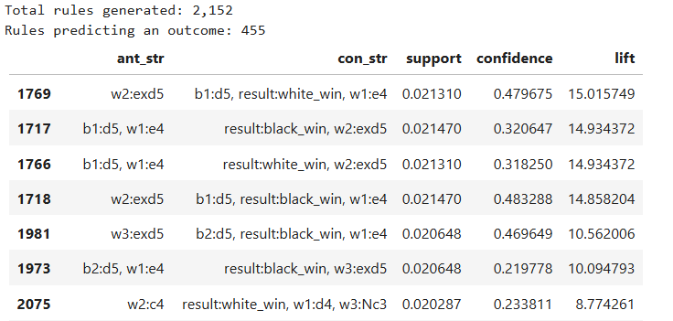
Figure 7: Early Move Associations
Random Forest was the strongest binary prediction model, with 62.95% accuracy, 0.6293 F1, and 0.6698 ROC-AUC. The strongest three-class model achieved approximately 55.9% accuracy, but draw prediction is likely difficult because draws constitute only 3.7% of the sample.

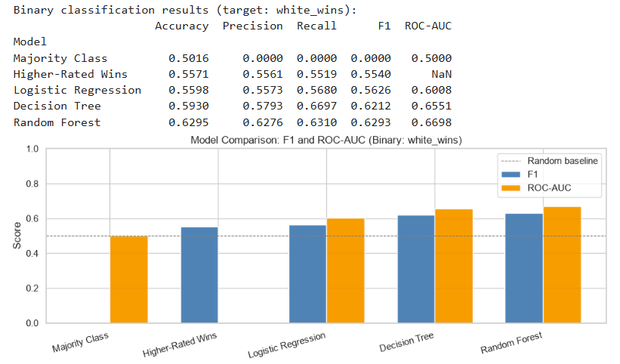
Figure 8: Preliminary model performance comparison

Milestones Remaining

July 19-July 26: Refine the analysis scope and pipeline. Separate move sequence analysis by color to analyze move sequence for wins overall. Analyze the complete white/black move sequence for frequent patterns leading to white_win/black_win. Repeat the sequence analysis within rating groups. Strengthen the association analysis by building one vs rest analyses for white_win vs others, black_win vs others, draw vs others and compare findings across outcomes. Split the modeling analysis into one model for predicting outcomes with only information available prior to match start (player ranking, white/black) and a different model that predicts outcomes based on whether or not the first k moves contain certain sequences that were identified in the earlier analysis.
July 26-August 2: Continue the above as needed. Refine and add any clarifying analyses. Expand the analysis to the full dataset for steps up until modeling. This will support model building. Make any necessary adjustments to the code to process the data in chunks if needed due to size.
August 2-August 9: Expand the modeling analysis to the full dataset. Make any necessary adjustments to the code to process the data in chunks if needed due to size. Evaluate the results of the analysis and modeling and begin to identify the strongest findings.
August 9-August 14: Refine visualizations, interpret results, and document limitations. Finalize Final Report, which is due August 14.
Blockers/Risks

The main risk remaining in the project is that the code fails to run on the whole data set due to memory allocation issues. If that is the case, I will have to revisit the current chunking strategy or research additional libraries that might help. If full-dataset modeling is not computationally feasible, I will use a substantially larger, clearly documented and randomized subset and prioritize reproducibility and methodological validity over processing all 84.6 million games.

Additional References

Follow or explore this project in its current form:
https://sgillihan.github.io/projects/data_mining-chess/

