**Supplementary Figure 1.** Fluctuating asymmetry patterns in the grasshopper head.

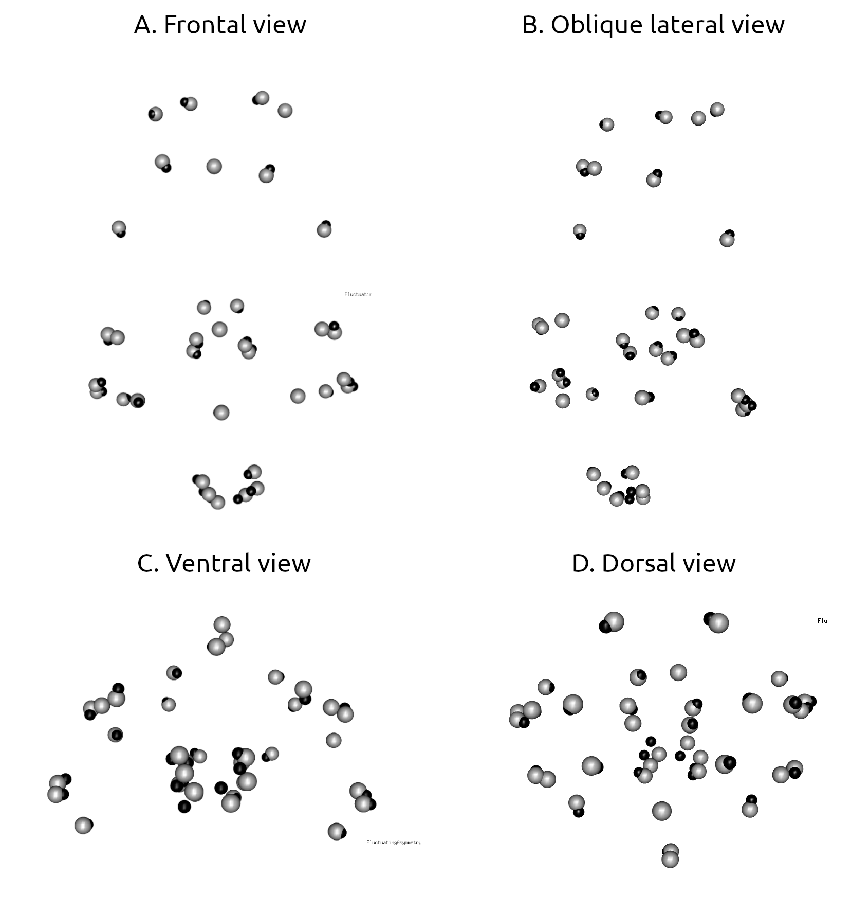

Supplementary Figure 2. Biplot comparing r-PLS values obtained for the same partitions, using either global Procrustes superimposition (x axis), or module by module Procrustes superimposition (y axis). Each dot represents a module to module pairwise r-PLS correlation (some are overlapping). The black line represents the significant linear regression between global superimposition values and module by module superimposition, with its associated 95% confidence interval shown as the gray area. The grey dashed line represents the equality function.

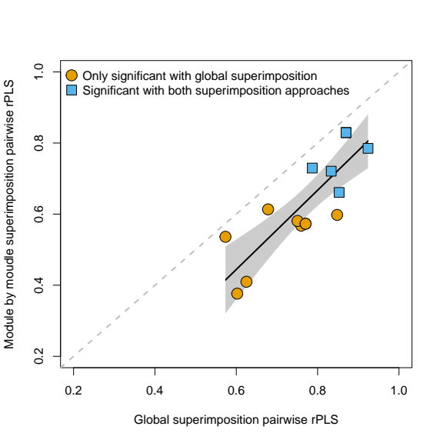

**Supplementary Table 1.** Results from EMMLi, rounded to the second decimal place. Highlighted in bold are the most likely modularity partitions. Note the high K value for these partitions, suggesting these results might be spurious.

|  |  |  |  |  |  |  |  |
| --- | --- | --- | --- | --- | --- | --- | --- |
|  | MaxL | K | n | AICc | dAICc | Model_L | Post_Pob |
| No.modules.default | 635.78 | 2 | 595 | -1267.54 | 272.83 | 0 | 0 |
| head_mand.same.Mod + same.between | 661.79 | 3 | 595 | -1317.54 | 222.83 | 0 | 0 |
| head_mand_sens.same.Mod + same.between | 693.65 | 3 | 595 | -1381.25 | 159.12 | 0 | 0 |
| head_mand.sep.Mod + same.between | 727.39 | 4 | 595 | -1446.7 | 93.67 | 0 | 0 |
| head_mand_sens.sep.Mod + same.between | 728.57 | 5 | 595 | -1447.03 | 93.34 | 0 | 0 |
| head_mand_sens.same.Mod + sep.between | 697.59 | 5 | 595 | -1385.09 | 155.28 | 0 | 0 |
| head_mand_sens.sep.Mod + sep.between | 732.51 | 7 | 595 | -1450.83 | 89.54 | 0 | 0 |
| head_mand_sens.same.Mod + same.between | 693.65 | 3 | 595 | -1381.25 | 159.12 | 0 | 0 |
| head_mand_sens.sep.Mod + same.between | 728.57 | 5 | 595 | -1447.03 | 93.34 | 0 | 0 |
| head_mand_sens.same.Mod + sep.between | 697.59 | 5 | 595 | -1385.09 | 155.28 | 0 | 0 |
| head_mand_sens.sep.Mod + sep.between | 732.51 | 7 | 595 | -1450.83 | 89.54 | 0 | 0 |
| head_mand_asym.same.Mod + same.between | 647.81 | 3 | 595 | -1289.57 | 250.8 | 0 | 0 |
| head_mand_asym_sens.same.Mod + same.between | 679.1 | 3 | 595 | -1352.17 | 188.2 | 0 | 0 |
| head_mand_asym.sep.Mod + same.between | 757.43 | 5 | 595 | -1504.76 | 35.61 | 0 | 0 |
| head_mand_asym.same.Mod + sep.between | 665.01 | 5 | 595 | -1319.93 | 220.44 | 0 | 0 |
| head_mand_asym_sens.sep.Mod + same.between | 755.91 | 6 | 595 | -1499.68 | 40.69 | 0 | 0 |
| **head_mand_asym.sep.Mod + sep.between** | **774.64** | **7** | **595** | **-1535.09** | **5.28** | **0.07** | **0.07** |
| head_mand_asym_sens.same.Mod + sep.between | 704.6 | 8 | 595 | -1392.96 | 147.41 | 0 | 0 |
| **head_mand_asym_sens.sep.Mod + sep.between** | **781.41** | **11** | **595** | **-1540.37** | **0** | **1** | **0.93** |
| head_mand_asym_sens.same.Mod + same.between | 679.1 | 3 | 595 | -1352.17 | 188.2 | 0 | 0 |
| head_mand_asym_sens.sep.Mod + same.between | 755.91 | 6 | 595 | -1499.68 | 40.69 | 0 | 0 |
| head_mand_asym_sens.same.Mod + sep.between | 704.6 | 8 | 595 | -1392.96 | 147.41 | 0 | 0 |
| **head_mand_asym_sens.sep.Mod + sep.between** | **781.41** | **11** | **595** | **-1540.37** | **0** | **1** | **0.93** |