AttackAware PolyIoM v1.1.4
Figure package
Every figure prepared for the paper, with what each one claims, how to read it, and the decision behind its chart form. Numbers in this document are transcribed from the sealed run outputs and were checked against them.

How to use this document
Five figures are ready to place. Three are new and carry the paper's central argument; two are existing method diagrams. Two further figures from the original study are recommended for the appendix, and one is recommended for removal — the reasoning is in the last section, because it is a judgement about the argument rather than about the picture.
A convention runs through all of them: the three compared systems always take the same colour and the same marker shape, in the same order. A reader learns the encoding once. Marker shape doubles the colour so the figures still work when printed in greyscale, and the colour set was checked with a colour-vision simulator rather than by eye.
System | Colour | Marker | What it is
PolyIoM (ours) | blue | circle | keyed polynomial, then IoM hashing
IoM only | orange | square | IoM hashing on the raw embedding
Random proj. + IoM | aqua | triangle | random linear map, then IoM hashing

Figure 6 — What the hardening stage costs
The claim. Removing the keyed polynomial improves recognition, and does not make unlinkability worse. The accuracy the polynomial costs is not buying anything on the measure it was expected to buy.
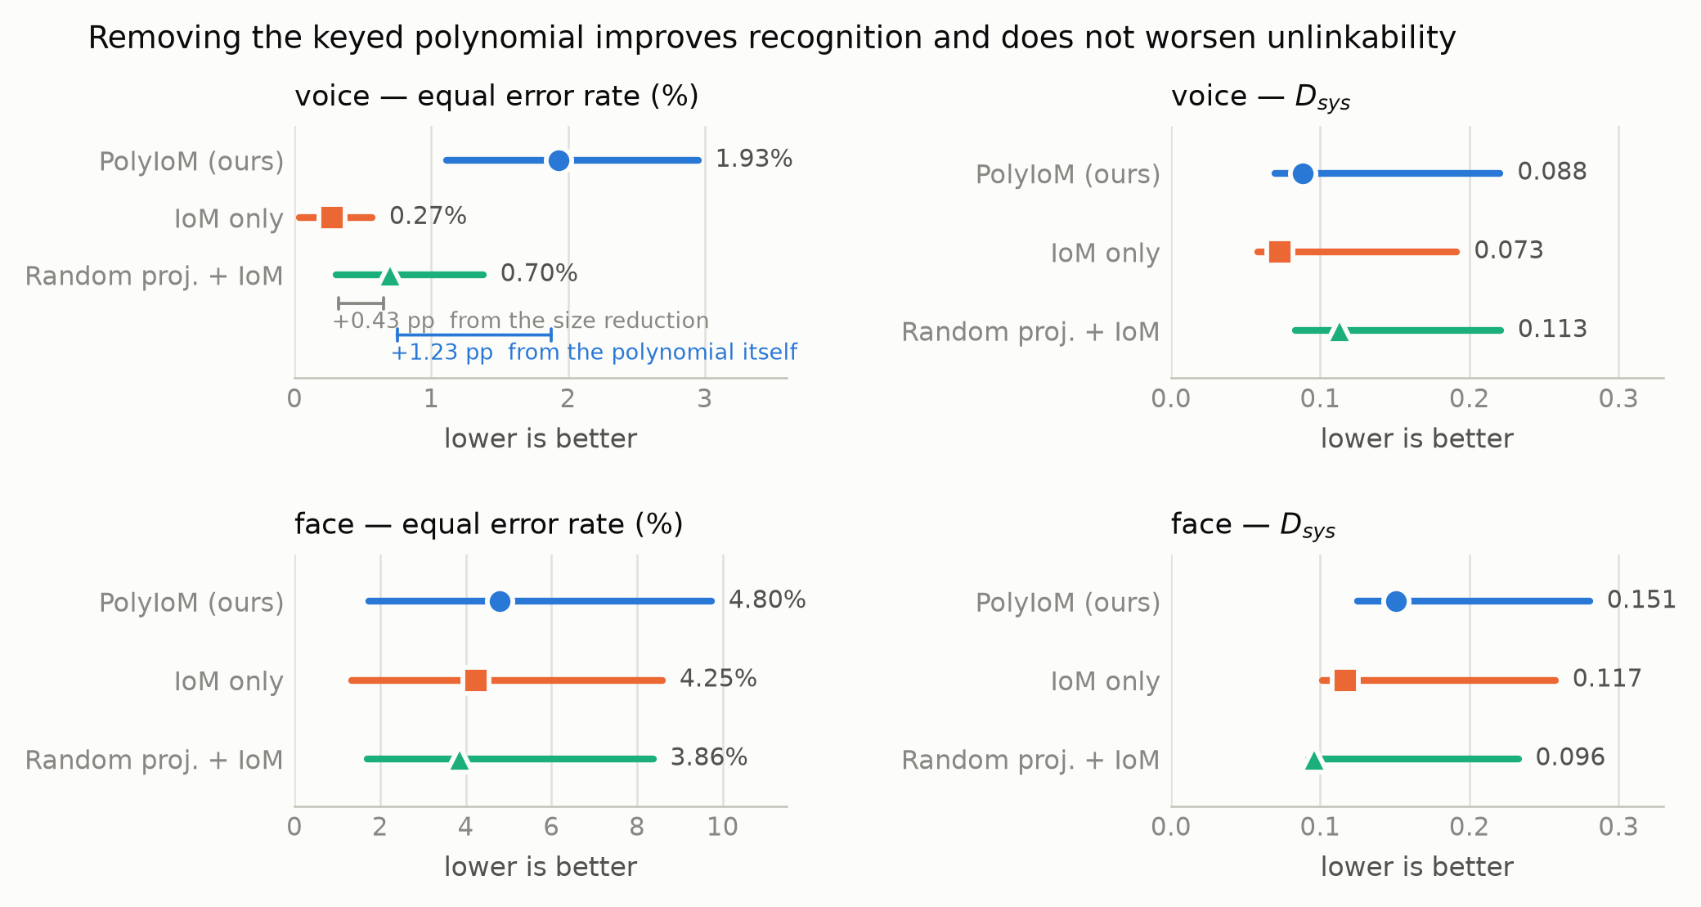
Figure 6. What the hardening stage costs. Equal error rate and unlinkability for the three systems on the 58 held-out identities, at the sealed operating point. Dots are point estimates; lines are 95% confidence intervals from a paired identity-cluster bootstrap. Lower is better on both measures. On voice, both comparisons against PolyIoM are firm and both favour the baseline: −1.655 pp for IoM only and −1.228 pp for random projection. No unlinkability comparison is distinguishable. The two rungs below the voice panel separate the two things the polynomial does at once: shortening the vector accounts for +0.43 pp of error, and the polynomial itself for a further +1.23 pp. No face comparison is distinguishable, which is consistent with 259 genuine trials.

How to read it
- The dot is the estimate; the line is the range the data supports. Where two lines overlap heavily, the data cannot separate those systems.
- The face intervals are much wider than the voice intervals. That is the power limitation, visible rather than stated.
- The two rungs are the sentence most likely to be quoted: the polynomial costs about 2.9 times more accuracy than the size reduction it performs.

Why this chart form
Dots with intervals, not bars with error bars. A bar asserts that zero is a meaningful baseline, which is true for error rate and not for unlinkability, and a bar spends a great deal of ink to place a single number. The dot-and-interval form also lets a reader compare interval widths directly, which is the whole point of the face row.

Figure 7 — Revocation, key by key
The claim. Without keyed compression, revocation does not work at all. With it, it usually works — but the polynomial fails completely for a minority of new keys, and the random linear map never does.
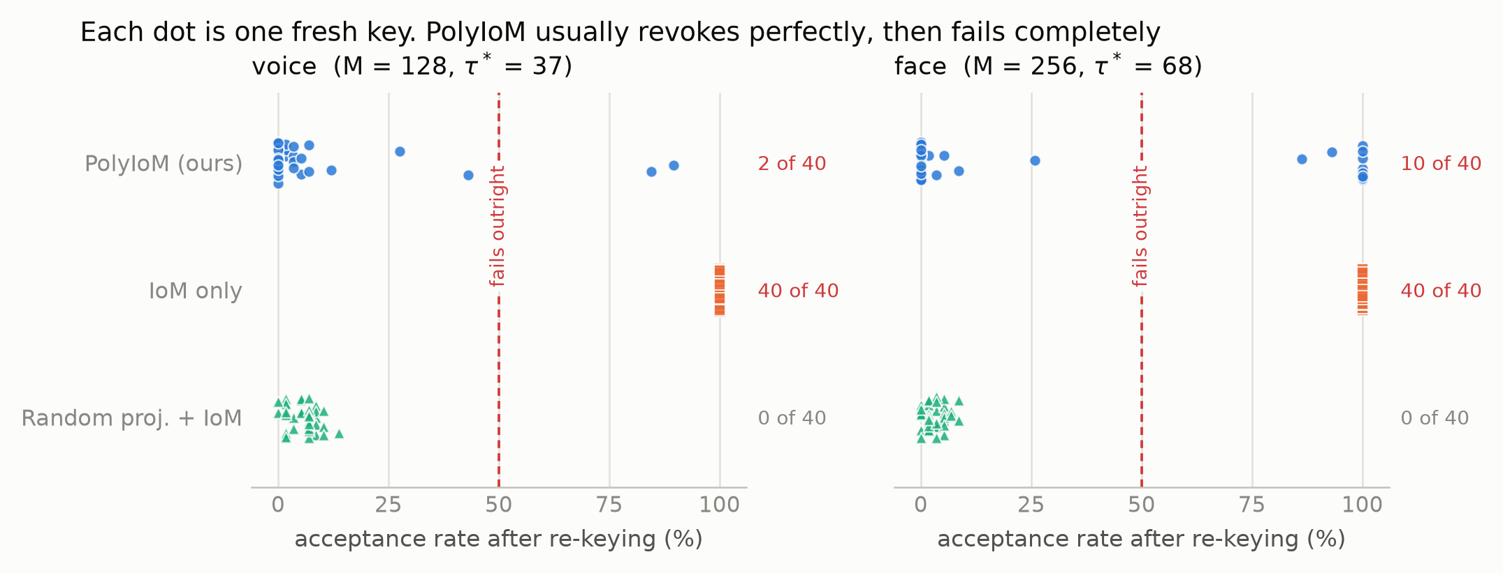
Figure 7. Revocation, key by key. Each dot is one of 40 freshly issued key sets. The horizontal position is the fraction of the 58 subjects whose old template's reconstruction is still accepted after they re-enrol under that new key. Revocation works only when the dots sit at the left edge. IoM hashing on the raw embedding sits at 100% for all 40 keys on both modalities: a stolen template stays a valid credential permanently. PolyIoM usually revokes perfectly — its median is 0.00% — but fails outright for 2 of 40 voice keys and 10 of 40 face keys. The random projection never fails outright, with a worst case of 13.79%. Counts on the right give the number of keys past the 50% line.

How to read it
- Left edge is good. A dot at 100% means the attacker's reconstruction was accepted for every subject, so re-keying achieved nothing.
- The orange row is the finding that is beyond doubt: 80 out of 80 keys, both modalities, complete failure.
- The blue row is the finding that is not: two clusters, one at zero and one at the far right, with nothing in between. That gap is the shape of the problem.

Why this chart form
A strip plot with every key visible, and deliberately not a box plot. PolyIoM's median is 0.00% and its maximum is 100%. A box plot would draw a flat box at zero with one long whisker, and a reader would conclude “fine, with an outlier.” The truth is that ten of forty keys fail completely. Concealing that split is exactly what a box plot does to this data, and it is the reason this figure exists.
Vertical scatter within each row carries no meaning; it only stops dots at the same value hiding one another.

Figure 8 — Inversion under a full-knowledge attacker
The claim. The attack succeeds completely against every system. The polynomial nevertheless hides the underlying biometric. Both statements are true, and the figure has to let them sit together.
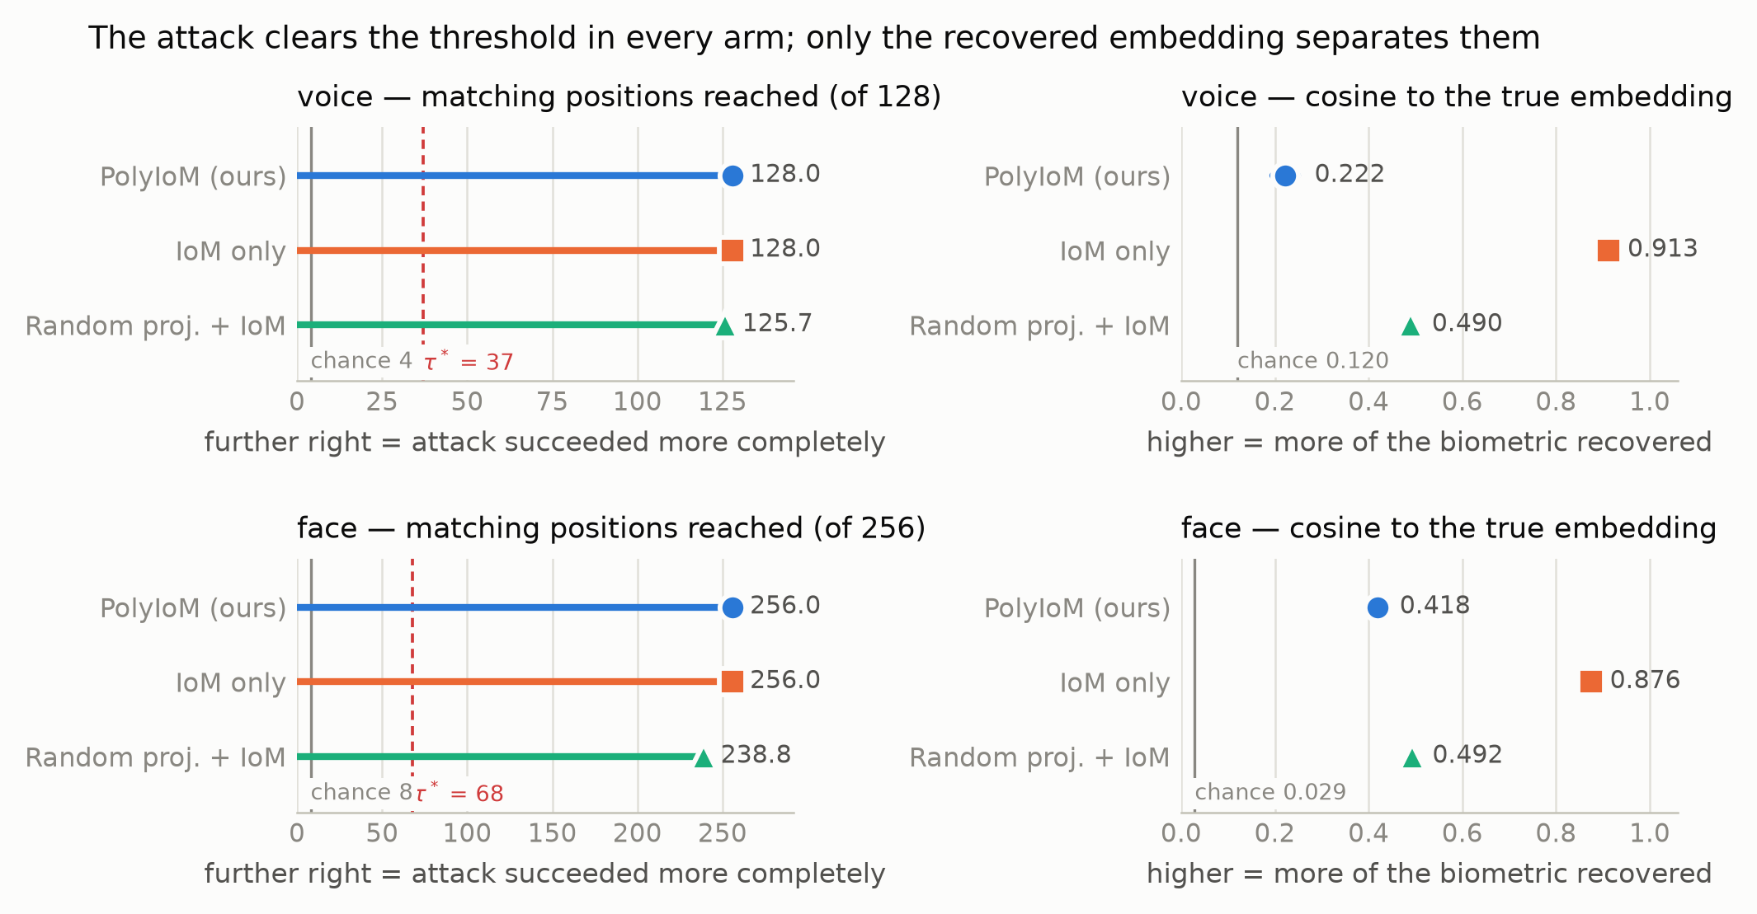
Figure 8. Inversion under a full-knowledge attacker. The attacker holds the key, the projections, the algorithm and the stored template. Left: how many template positions the reconstruction matches, against the sealed decision threshold and against the level a random input reaches. Every system is driven far past its threshold, which is why the success attack rate is 100% everywhere and cannot distinguish them. Right: how much of the true embedding the reconstruction recovers, as cosine similarity, against the level for two different people. Here the systems separate firmly: IoM hashing on the raw embedding leaks it almost completely at 0.913, while PolyIoM leaks far less at 0.222. Confidence intervals are present but narrower than the markers.

How to read it
- Left panels: the dashed red line is the threshold for acceptance. Everything to its right is an accepted forgery. All three systems are hundreds of positions past it.
- Right panels: the grey line is what a stranger's embedding scores. Distance above it is how much of the person was recovered.
The two panels together are the paper's central observation: the system compares hardened vectors, not embeddings. The attack recovers the hardened vector exactly while recovering little of the embedding, so hiding the biometric does not prevent acceptance. An evaluation that measured only the right-hand panel would report strong protection and would be wrong.

Why this chart form
Two panels, one measure each. Matching positions and cosine similarity are on completely different scales, and putting them on one pair of axes would be a two-scale chart — the most common way a chart misleads. The success attack rate itself is not plotted: three identical bars at 100% is a sentence, not a chart, and the left-hand panel carries the same information while remaining informative.

Figures 1 and 2 — Method diagrams
These two were drawn earlier and need no change. They are included so the package is complete.
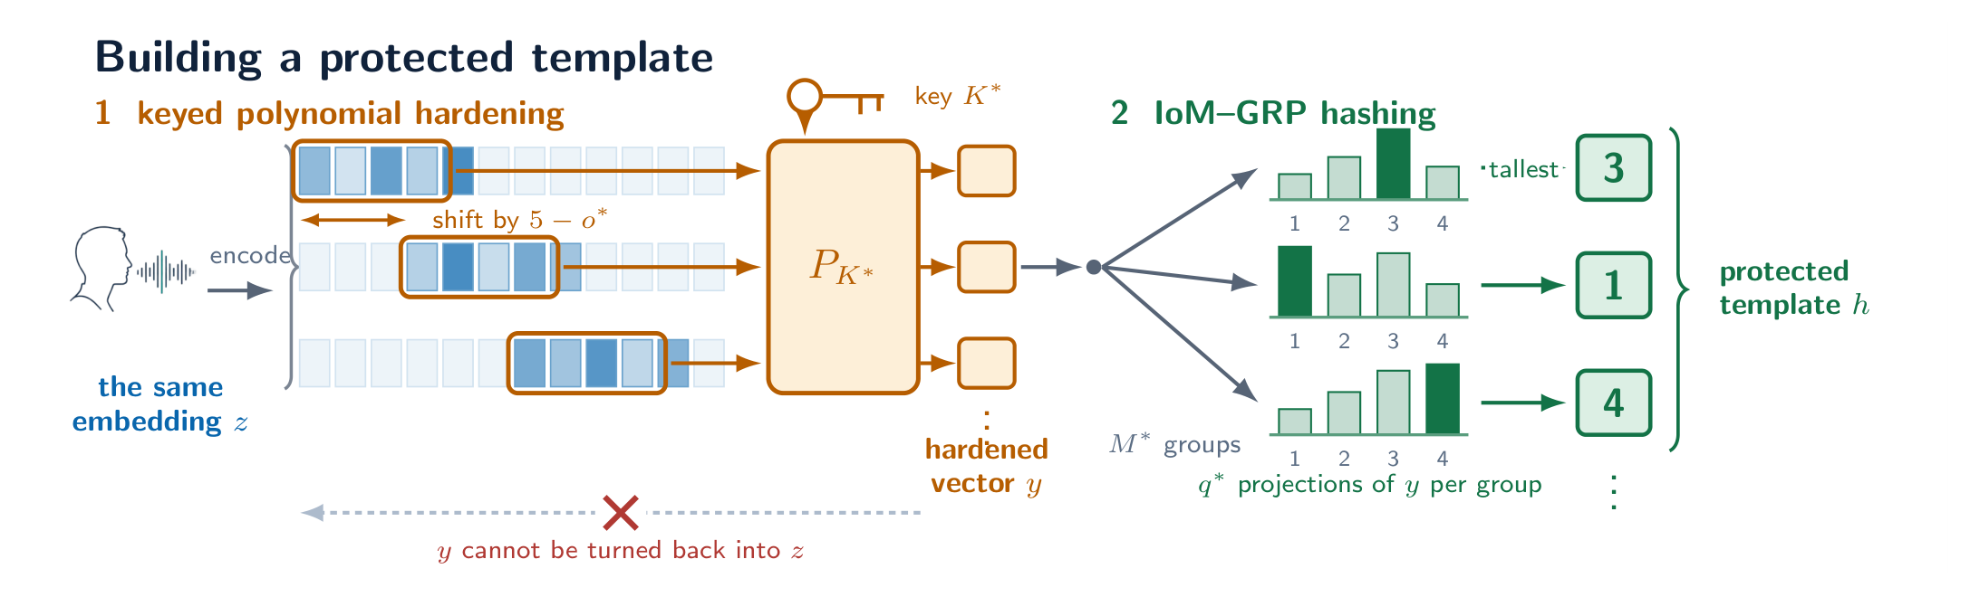
Figure 1. Building a protected template. A frozen encoder turns the sample into an embedding. The keyed polynomial is applied to overlapping windows of five values, shifted by 5 − o* so neighbouring windows share values; each window contributes one value to the hardened vector. Cells outside the current window are greyed. The step is one-way: the hardened vector cannot be turned back into the embedding. IoM hashing then keeps only the index of the largest of q* projections in each of M* groups, discarding the magnitudes. That list of indices is the stored template.
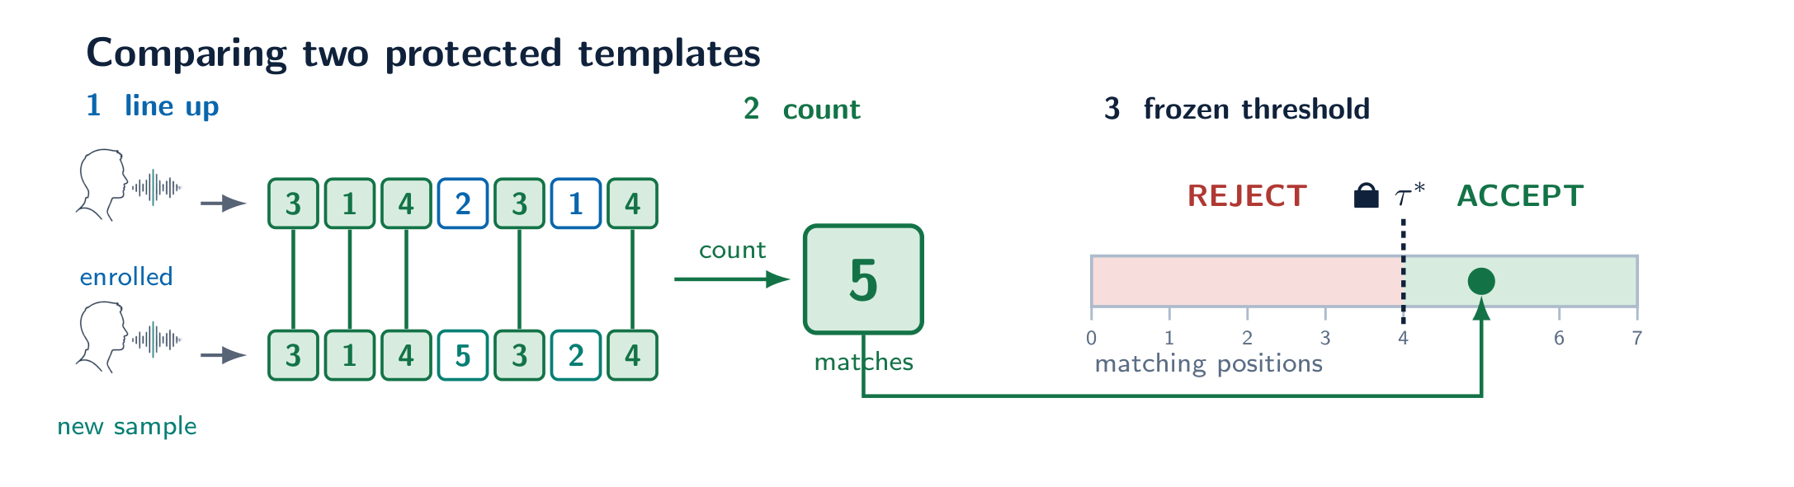
Figure 2. Comparing two protected templates. Comparison uses the index lists alone; neither the original sample nor the embedding is used again after enrolment. The two templates are aligned position by position and the agreeing positions are counted. That count is compared with the frozen threshold τ*, drawn as a position on the score scale so that accept and reject are regions rather than words. The padlock marks τ* as fixed on development identities before any evaluation identity was read.

Existing figures: what to keep, move, and cut
The paper's argument changed. These figures were made when the claim was that the scheme works. The claim is now that the hardening stage does not earn its place, and that keyed compression is what matters. A figure that served the first argument does not automatically serve the second.
Figure | Recommendation | Reason
Operating-point selection | Keep | Still carries the recognition floor and the selection rule.
Generalisation | Keep, re-lay out | Split into a voice block and a face block so the missing external face estimate shows as an absence rather than being hidden by row order.
Design-space heat maps | Appendix | Documents the 80-configuration sweep honestly, but the sweep is no longer the contribution.
Trade-off frontier | Cut, or appendix with a caveat | See below — it now raises a question the study cannot answer.

Why the frontier figure has become a liability
That figure argued that a good point was chosen on the recognition–unlinkability frontier. The paper now argues that the frontier is beside the point, because a simpler system dominates the whole family. Any reader who sees the plot will ask why the random projection is not on it, and the honest answer is that it was never swept — which is a stated limitation. It is better to declare that limitation in prose than to invite the question with a picture that cannot answer it. If the figure stays, it belongs in the appendix with that caveat in its caption.

Provenance and checks
- Every number in Figures 6 to 8 is transcribed from the sealed run outputs, and the transcription was verified by recomputing the summary statistics from the per-key values and matching them against the run log.
- The colour set was checked with a colour-vision validator, not by eye. It passes the lightness band, the chroma floor, colour-blind separation and the normal-vision floor. One colour sits below the contrast guideline against the page, which is why every system is labelled directly and every figure has a table beside it.
- Marker shape duplicates colour throughout, so the figures survive greyscale printing and do not rely on colour alone to convey identity.
- Figures are 6.9 inches wide and were drawn at final size, so type prints at the size shown. PDF versions with embedded editable text are in figures/paper/ alongside the PNGs used here.
- Confidence intervals resample identities, never individual comparisons. Figure 7 resamples keys as well, because its variation is across keys and an identity-only interval on that data was confidently wrong in an earlier version of the analysis.

