CHRIST (Deemed to be University), Bangalore
Department of Computer Science and Data Science

Course: CSC102-2 Data Structures (C Programming)

Comprehensive Assessment Mini Project
Dairy Farm Management System (MILK IT)

Submitted by:

Regalagadda Uday Kumar Yadav Roll No: 2540165
Karthik M Kargi Roll No: 2540160

Date of Evaluation: 03-March-2026

Contents
- Problem Statement 2
- Selected Domain Description 2
- Data Structures Used 2
- Algorithm Explanation 3
  - Binary Search Tree (BST) Insertion and Search 3
  - Graph Traversal: Breadth-First Search (BFS) 3
  - Priority Queue Insertion 3
- Sample Output 3
- Conclusion 5

Problem Statement
Managing a dairy farm involves handling multiple interconnected operations: track- ing the health and yield of cattle, managing daily milk production, fulfilling cus- tomer orders based on priority, scheduling rotational delivery routes, and tracking revenue. Traditional manual logging is prone to errors and inefficiencies. The objective of this project is to build a unified, terminal-based ”Dairy Farm Man- agement System” in C that optimally manages these resources using appropriate data structures to ensure fast lookups, organized processing, and persistent data storage.

Selected Domain Description
The chosen domain is Agriculture and Dairy Farm Management. This do- main provides an excellent canvas to implement a wide variety of data structures. For example, livestock (cows) represent distinct entities that need to be dynam- ically added, searched, and sorted. Customer orders require queue management based on subscription tiers (premium vs. regular). The distribution of milk re- quires geographical routing, representing a classic graph traversal problem. By applying data structures to this domain, we bridge theoretical computer science with practical agricultural management.

Data Structures Used
The system successfully integrates the following mandatory data structures to solve specific domain problems:
- Doubly Linked List: Used to maintain the primary registry of cows, al- lowing easy bidirectional traversal of livestock records.
- Binary Search Tree (BST): Built alongside the Linked List to index Cow IDs, bringing lookup and deletion time complexity down to O(log n).
- Stack (Singly Linked List): Tracks daily milk collection entries using a Last-In-First-Out (LIFO) approach.
- Array & Bubble Sort: Used dynamically to extract cow records and rank them in descending order based on their average milk yield.
- Hash Table: Manages customer profiles using separate chaining to handle collisions, allowing O(1) average time complexity for profile retrieval.
- Priority Queue: Processes milk orders. ”Premium” customers are given higher priority and are served before ”Regular” customers.
- Circular Linked List: Manages a continuous, rotating delivery zone sched- ule where the last delivery point connects back to the starting point.
- Graph (Adjacency Matrix): Represents delivery locations and the routes connecting them.

- Singly Linked List: Maintains chronological records of daily sales and revenue for monthly reporting.

Algorithm Explanation

Binary Search Tree (BST) Insertion and Search
When a new cow is added, its ID is inserted into the BST. If the tree is empty, it becomes the root. Otherwise, the algorithm recursively compares the ID: if smaller, it traverses left; if larger, it traverses right, inserting it as a leaf node. Searching follows the same O(log n) traversal logic.

Graph Traversal: Breadth-First Search (BFS)
To explore delivery locations, the system uses a BFS algorithm. It starts at a user- selected node, marks it as visited, and enqueues it. It then dequeues the node, prints it, and explores all its unvisited adjacent nodes (checked via the adjacency matrix), enqueuing them until all connected delivery points are mapped out.

Priority Queue Insertion
When a new order is placed, the system checks the customer’s priority via the Hash Table. The order is inserted into the Linked List such that elements with Priority 1 (Premium) are always placed before elements with Priority 2 (Regular). It traverses the queue and inserts the new order just after the last node of the same priority.

Sample Output
Note: Below are textual representations of the terminal output. Replace this sec- tion with actual screenshots using \includegraphics before final submission.

- Admin Login and Adding a Cow
===== ADMIN LOGIN =====
Username: admin Password: ****
Login Successful!
-- Add Cow --
Cow ID : 101
Breed : Holstein
Age (years) : 4 Avg Milk (L/day) : 25.5
Cow #101 added successfully!

Figure 1: Adding a Cow to the Doubly Linked List and BST
- Adding a Customer Profile (Hash Table)
-- Add Customer Profile (Hash Table) -- Customer ID : 501
Name : JohnDoe
Type (1=Premium / 2=Regular): 1
Customer ’JohnDoe’ (#501) registered as Premium.

Figure 2: Registering a new Premium Customer

- Placing an Order (Priority Queue)
-- Place Order (Priority Queue) -- Customer ID: 501
Customer ’JohnDoe’ (Premium) - Priority 1 assigned. Milk quantity (L): 10
Order placed! Bill: 525.00 [PREMIUM]

Figure 3: Priority Queue prioritizing a Premium customer’s order

- Sorting Cows by Milk Yield (Array & Bubble Sort)

-- Sort |  | Cows | by Average | Milk | Yield | (Descending) --
Rank |  | ID | Breed |  |  | Age AvgMilk(L/day)
1 |  | 101 | Holstein |  |  | 4 25.50
2 |  | 105 | Jersey |  |  | 3 18.20

Figure 4: Displaying the sorted Array of Cows

- System Dashboard
+====================================+
| DAIRY FARM DASHBOARD |
+====================================+
| | Total Cows : | 2 | |
| | Total Milk Today : | 45.00 | |
| | Pending Orders : | 1 | |
| | Delivery Zones : | 0 | |
| | Delivery Locations : | 0 | |
+====================================+

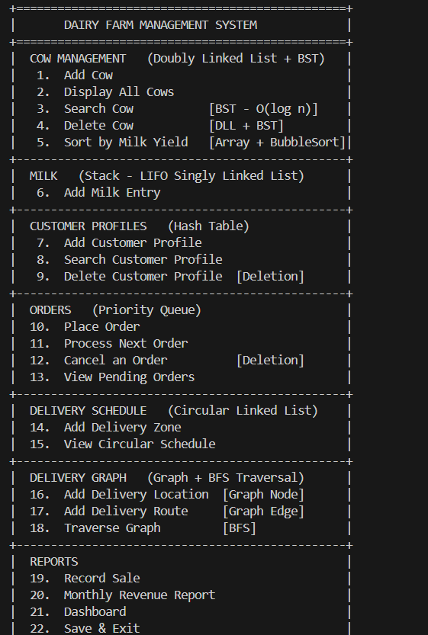
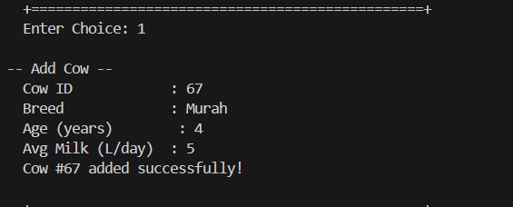

Conclusion
This mini-project successfully demonstrates the practical application of diverse data structures within a single, cohesive domain. By utilizing advanced struc- tures like Hash Tables for customer lookups and Binary Search Trees for inven- tory indexing, the system optimizes time and space complexities far beyond what standard arrays could achieve. The integration of File Handling ensures data per- sistence, making this a viable prototype for real-world dairy farm administration. The project solidified our understanding of dynamic memory allocation, pointer manipulation, and the structural design of complex C programs.

