Observations

1. 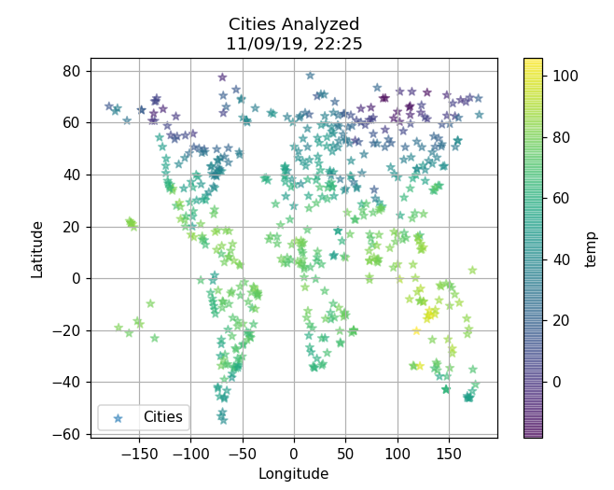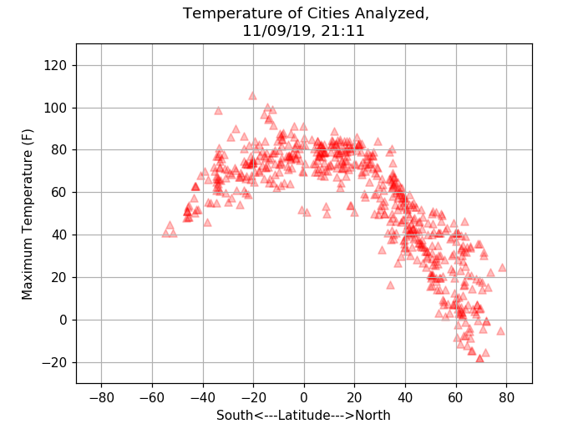The global city temperature graph of 9th November 2019 suggests that the northern hemisphere started experiencing winter, whereas the southern hemisphere is getting warmer towards summer.
2. 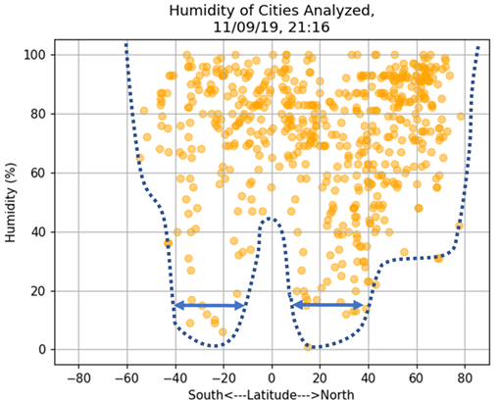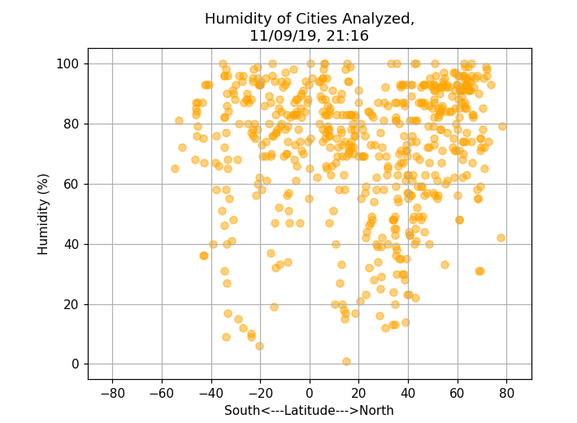The humidity plot indicates that -40 to -15 and 15 to 40 latitudes have broader range of humidity from 0-100%, whereas rest of the latitude has narrower range of humidity, mostly between 35-100%.

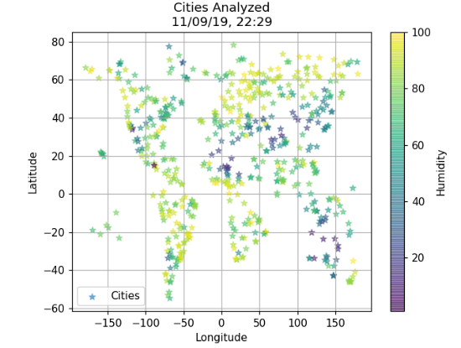

Geographic plot shows the lowest humidity are mostly in Asia and Australia.

1. 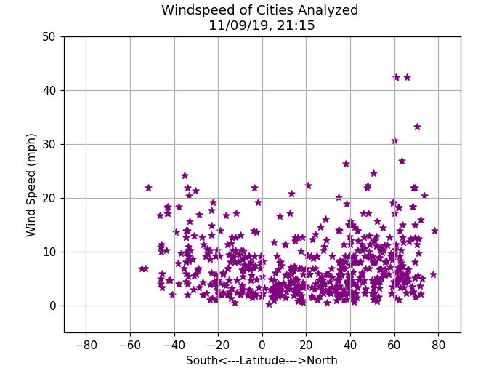Most of the cities across the globe have mild wind speed ranging up to 25mph. However, couple of cities in the northern hemisphere (around 60 -70 latitude) got strong winds above 40mph.

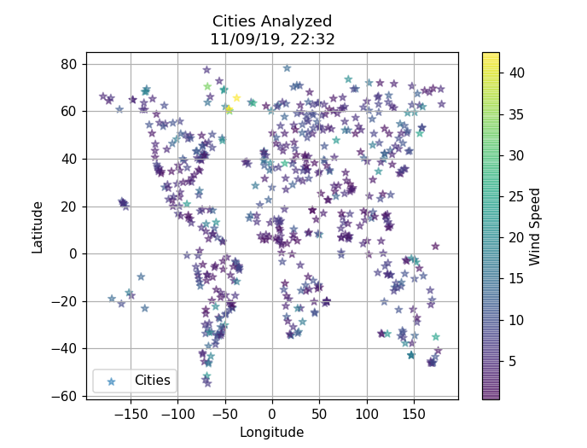

Geographic plot shows the heavy winds are in Greenland.