Numerical modeling of SP observed at a low-temperature geothermal site, Korea

Sung Keun Lim⁽¹⁾, Yoonho Song⁽¹⁾, Tae Jong Lee⁽¹⁾, Kasumi Yasukawa⁽²⁾, and Young Soo Song⁽³⁾

⁽¹⁾Korea Institute of Geoscience & Mineral Resources (song@kigam.re.kr), ⁽²⁾Geological Survey of Japan, AIST, ⁽³⁾Chonbuk National University, Dept. of Mineral Resources and Energy Engineering, Korea.

ABSTRACT

Continuous self-potential (SP) measurements on the surface can be used to investigate flow path of ground water and detect fluctuation patterns in geothermal reservoirs. SP survey to figure out overall potential distribution was carried out in the Pohang geothermal site, Korea. According to the results of long-term SP monitoring performed during the pumping test, we can identify some parts responding to pumping, which possibly indicate hydraulic connection through the zones. These zones matched the low-resistivity zone at depth range of 600 m ~ 1,000 m from a three-dimensional (3-D) inversion result of magnetotelluric (MT) data.
We compose a 3-D SP simulation algorithm and then apply it to the Pohang geothermal site for the interpretation of the geological structure and the fluid flow patterns. For the steady state of the Pohang geothermal model, we have performed numerical SP simulation based on the 3-D MT data analysis, drilling results, and other geological information until a good match between the field data and calculated data on surface SP is achieved. Again, the final 3-D model by the simulation results shows an anomalous zone with low-resistivity and high-permeability in the depth of 300 ~ 1,000 m at the very parts that shown clear SP variations with the pumping in the field SP monitoring. Therefore, it seems that close hydraulic connections exist between the zone characterized by low-resistivity and high permeability and the pumping well.

KEY WORDS: self-potential (SP), geothermal, long-term monitoring, reservoir, simulation, electrokinetic potential

INTRODUCTION

A deep seated geothermal development project has been launched in 2003 at Pohang, located in the south-eastern part of the Korean peninsular, by Korea Institute of Geoscience and Mineral Resources (KIGAM). Various geological/ geophysical investigations for the sites have been carried out including 3-D MT survey, lineaments analysis with satellite images, gravity and magnetic surveys, regional geological survey, and pilot drillings. The SP surveys in 2004 and 2005 were carried out before the drilling and SP monitoring during the pumping test from a pilot borehole of 1.5 km depth. The primary purpose of the SP monitoring is to figure out the reservoir variation and direction of fluid flow.
Pumping rate, water temperature, water table, and rain falls are also monitored during the pumping and SP monitoring period so that we can separate SP signals, SP perturbations by the pumping from the pumping well, from various noises contained in the SP monitoring data. And the groundwater levels from several boreholes with shallow depth were also monitored because variations of the shallow groundwater can affect the SP fluctuations on the surface during the monitoring period.
Since no ideal reference point exists in real field situations, a concept of “relative SP” suggested by Yasukawa et al. (2005) was used to interpret the SP monitoring data. We tried to separate the zones showing clear SP responses caused by deep fluid flow due to the pumping, and to integrate the interpretations with the geological and geophysical information.
In this study, a 3-D SP simulation algorithm (3-D SP simulator) was composed by combining a 3-D resistivity modeling algorithm developed by Park (1994) and a mass/heat program by Bodvarsson (1982) for a more quantitative study of SP in terms of fluid and heat flow. Finally we have applied the simulator to SP survey data from the Pohang geothermal site to get a simplified model based on the 3-D MT results and other geological information.

PUMPING TEST AND SP MONITORING

Pumping tests were carried out twice: step pumping test from January 21 to 27, 2005 to decide suitable pumping rate and constant pumping test from February 16 to 22, 2005 to get transmissivity and storage coefficient. SP monitoring was performed from February to March including the two pumping test periods. Total of 63 non-polarizing electrodes were installed around the pumping well (BH-2) with 1.5 km deep (Figure 1) and SP monitoring was made using a 128 channel automatic recording system. Separation between the electrodes was about 100 ~ 150 m. A reference point for the SP monitoring is denoted ‘R’ at south part of map (Figure 1).
Since a Tertiary sediment layer of about 360 m thick right beneath the surface works as conductive cap rocks in the area, SP variations induced by reservoir perturbation during the pumping in 1.5 km deep borehole will have long period in SP time series data.
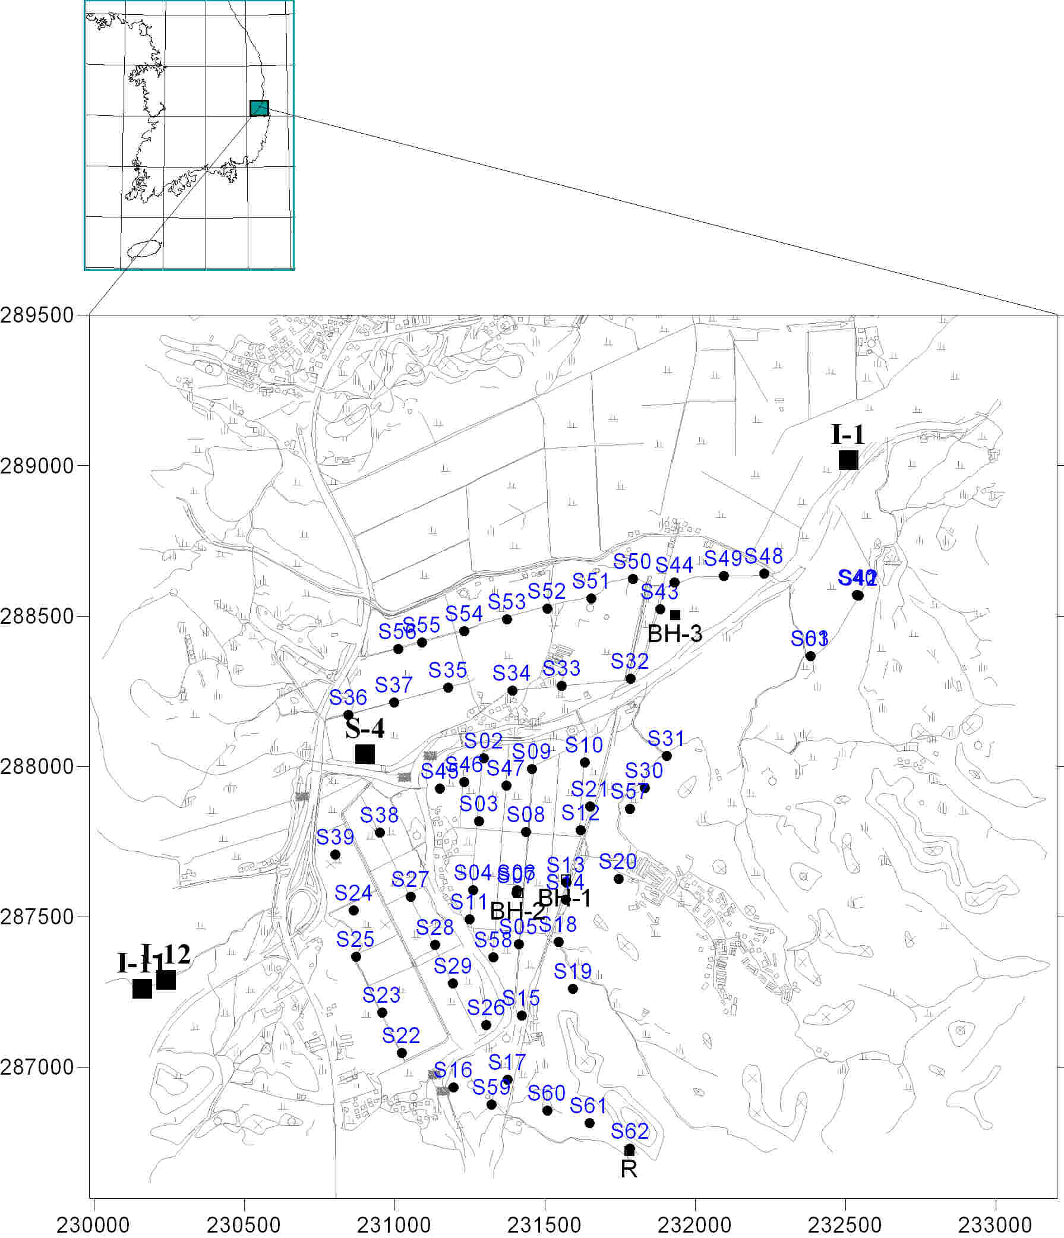

Figure 1. The location map of the Pohang site showing the second SP monitoring points (black circle dots). A reference point is located in the southern margin of the survey area and depicted as ‘R’. Boreholes for monitoring the shallow ground water level are denoted as black square dots.

Figure 2 shows some sample data from SP monitoring (c), depth to water and water temperature (a), which are interpreted to be associated with reservoir perturbations during well operation. Rainfall near the target area is shown in Figure 2(b). The period of first and second pumping test is marked by dotted rectangle. Figure 2(c) shows SP time series from 6 SP stations with typical SP trends during the pumping test. Though all of the time series show daily variations and external noises with high frequencies, the long period of SP variation can clearly be seen. As marked by arrows on Figure 2(c), all curves slowly decrease according to well operation and increase after pumping off, while no such variations can be found at station S53. The same SP trends can be found from most of SP measurement points at near the pumping well, the south-west part and some part of north. But most SP points at northern and eastern parts from the pumping well do not show such variations according to the pumping. SP data from the points in these areas showed only a short period (high frequency) variations due to rainfall effects.

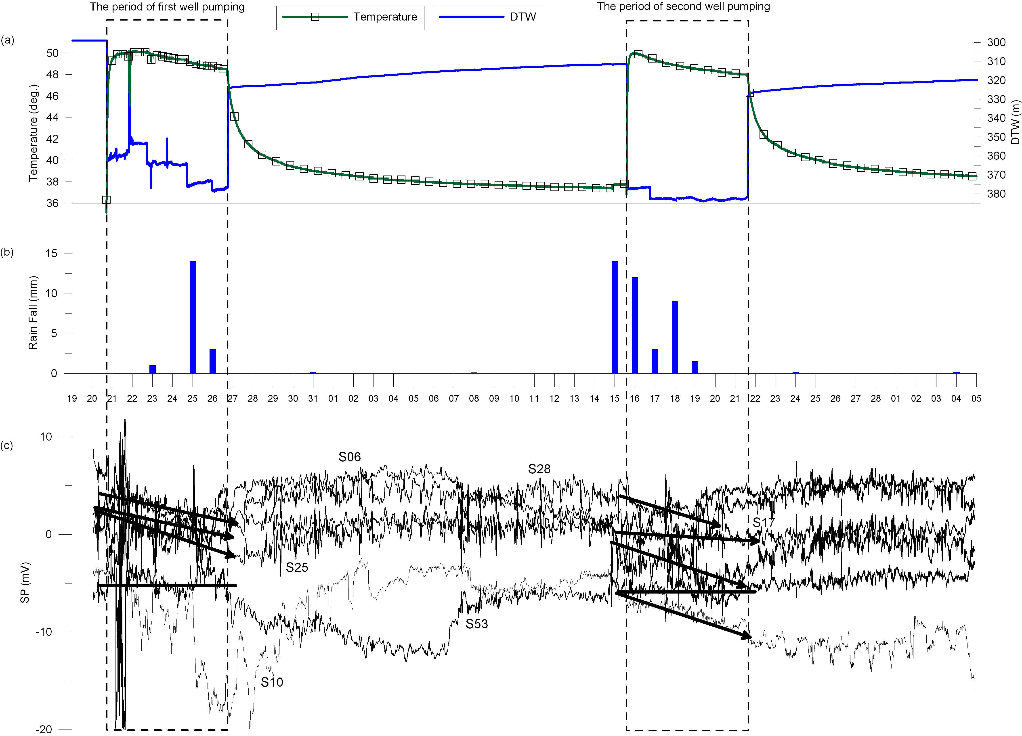

Figure 2. Fluctuation patterns of (a) depth to water and water temperature, (b) rain fall, and (c) measured SP. The period of pumping test is marked by dotted rectangle.

Based on the interpretations described above, spatial distribution of such SP points that are showing clear change due to the pumping can be earned as shown in Figure 3. As mentioned earlier, SP variations in these points are possibly related with water flow in deeper part due to electrokinetic effects caused by reservoir perturbations due to the well operation. 3-D inversion results of MT data tell that there exists the low-resistivity zone in depth range of 600 m ~ 1,000 m at the southwestern part from the borehole and two fractures shown in Figure 3 (Uchida et al., 2004). Note that most of the areas that show clear SP changes responding to well operation are concentrated around the borehole, following the fracture with the NNE direction, and southwestern part from the pumping well. Fluid flow in this area seems to follow not only through the fractures but also through the earth layering. Especially, SP at the southwestern part and near the borehole (BH-3) at north showed clear variation during pumping test. Therefore, the fluid flow leading SP variation is related to this low resistivity formation and a fracture in the NNE-SSW direction.

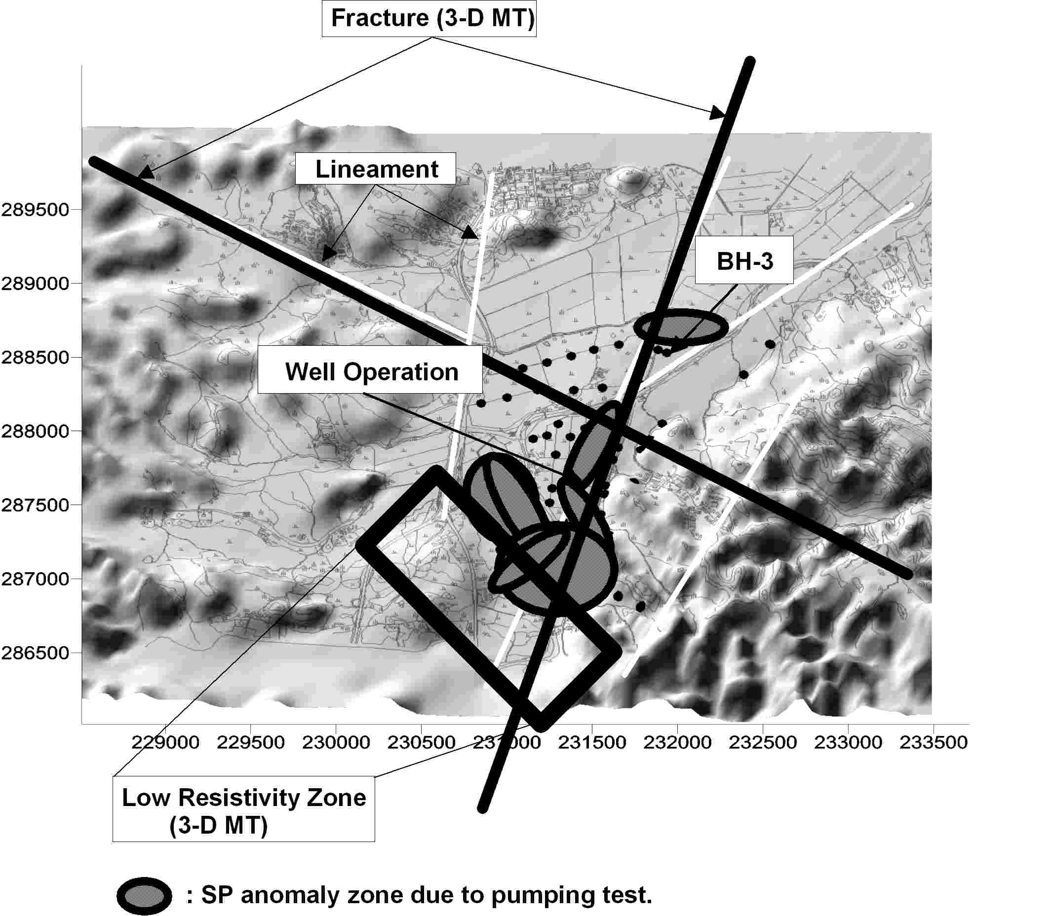

Figure 3. A relation of lineaments (white lines), the results of 3-D MT analysis with area showing clear SP changes during the whole pumping test. SP stations are indicated by black dots. It is obtained by relative SP (Yasukawa et al., 2005).

NUMERICAL MODEL IN POHANG SITE

To get more quantitative interpretation, a 3-D SP simulation algorithm has been composed by combining the geothermal system simulator PT module and the 3-D resistivity modeling algorithm. The composed SP algorithm is successfully verified by comparison with an analytic solution for a injection model in a homogeneous half space. The Pohang model in natural state, which is based on the 3-D MT survey results, geology, core and well log analysis was simulated using the 3-D SP simulator.
Figure 4 shows background SP data measured before the drilling. Positive SP anomalies in the south of BH-2 may indicate natural thermally driven up-flows in geothermal areas (Ishido, 1981). Northern part, however, shows low negative SP. The 3–D SP simulator is applied to the data to get a natural state of the Pohang geothermal model. An initial geothermal model is constructed by using a resistivity structure from 3-D MT inversion as well as rock types, general layering of the site and temperature distribution in depth from the drilling results. Final Pohang model was obtained by trial and error from a best fit between the modeled and observed SP.

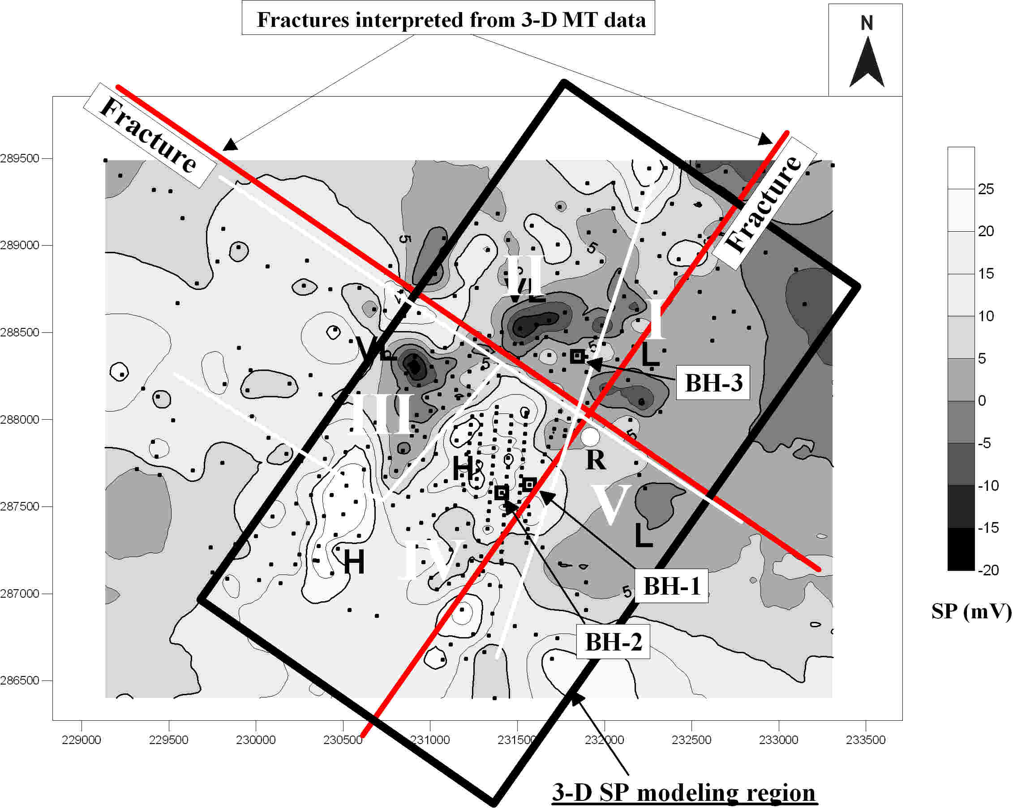

Figure 4. A contour map of background SP measured before drilling, which is used for 3–D SP modeling (black rectangle). The positions of SP stations (black dot), the reference point (white dot with ‘R’), and drilling sites (black square) are also shown.

Figure 5 shows the resultant 3-D permeability structure in different depths. The 3-D model shows a high-permeability zone at the depth of 300 ~ 1,000 m in southwestern parts, which are the very parts with clear SP variations in SP monitoring during the pumping test. It seems that there exist close hydraulic connections between the zone with high permeability and the pumping well.
Figure 6 shows the calculated SP distribution on the surface and at a depth of 300 m. We could obtain negative SP in region II by imposing the NW-SE fracture interpreted from 3-D MT results.

DISCUSSION

Geologically, our model corresponds to a fracture zone along which there exists a vertical component of fluid flow, of heat flow, or both of them. The zone separates regions of differing coupling coefficients (Corwin et al., 1978). Therefore, SP in region II may be caused by circulation of deep fluid and heat flow along the NW-SE fracture. Regarding region IV, the positive SP anomaly is well reproduced by 3-D modeling, which shows that there may exist up-flow from a depth in this region. However, regions III and V could not be reproduced properly in our modeling. More works are necessary to incorporate the variations in regions III and V.
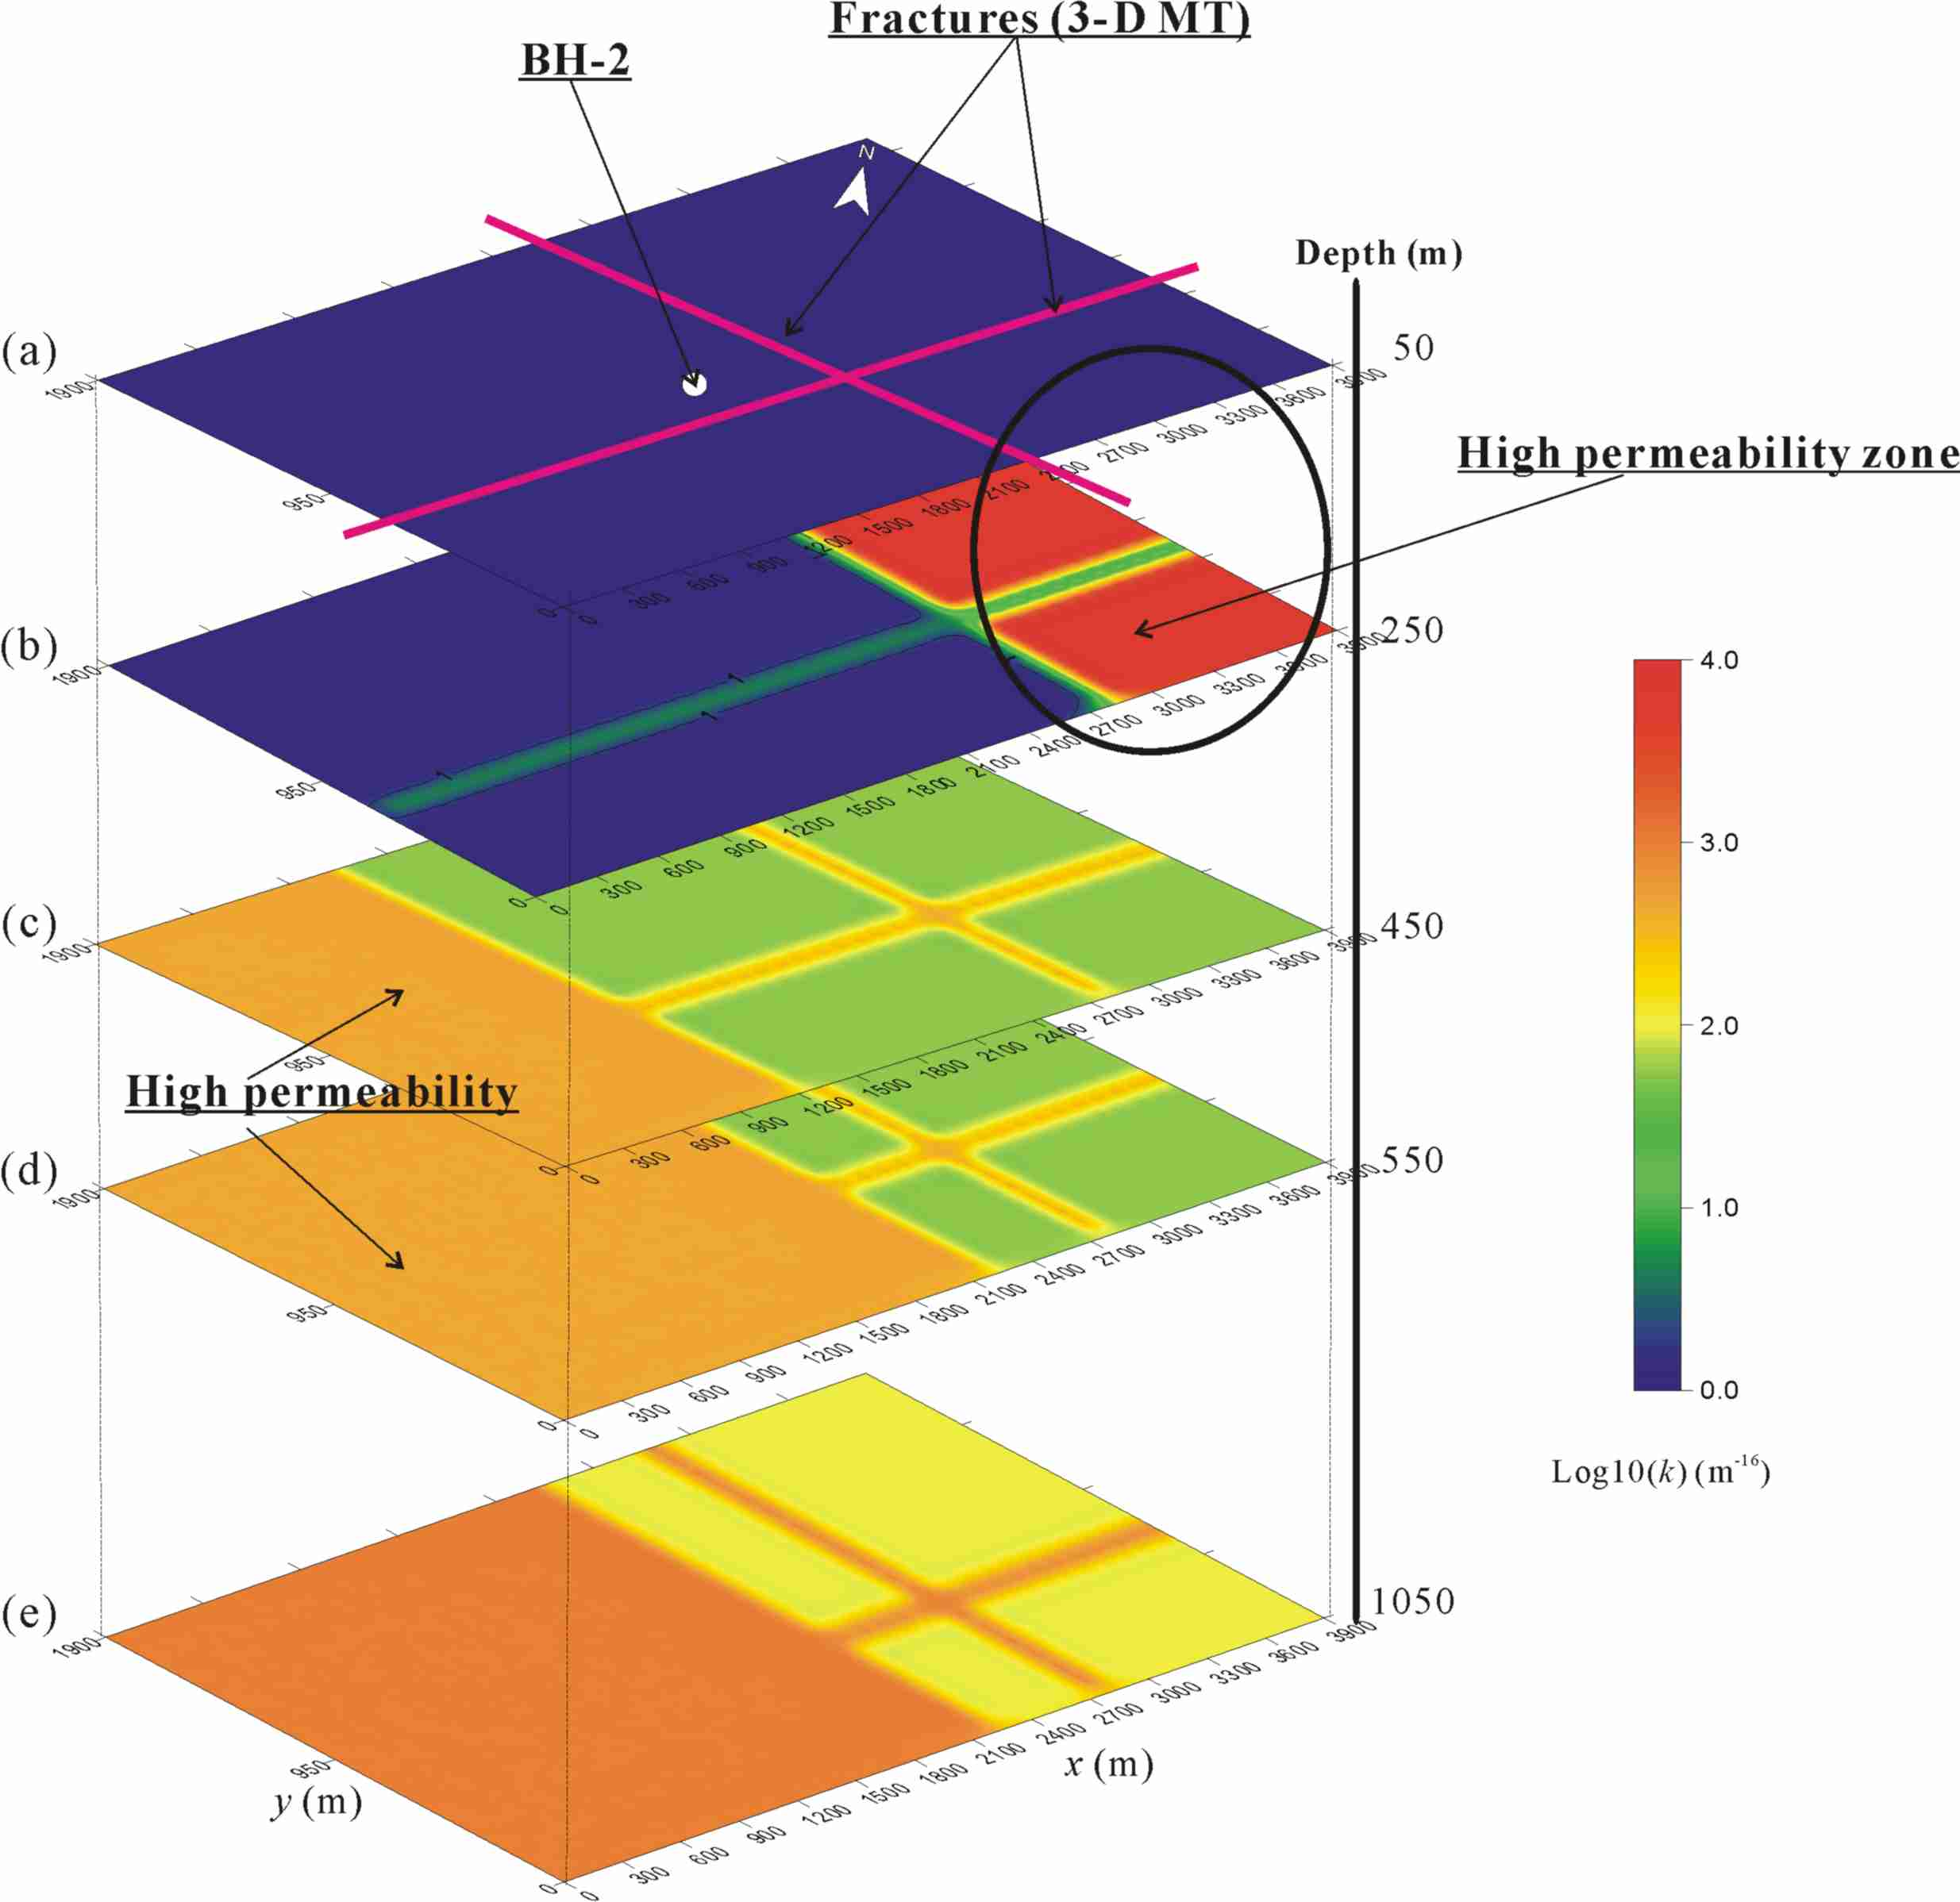

Figure 5. Final permeability distribution of the field model: (a) depth of 50 m, (b) depth of 250 m, (c) depth of 450 m, (e) depth of 550 m, and (e) depth of 1050 m.

CONCLUSION

The comparison of SP monitoring results with pumping data suggests that the SP variation on the surface by the pumping tests show at the southwestern part of the pumping well, but not clearly at the north in the Pohang geothermal site.
The final 3-D model derived from the simulation results also shows an anomalous zone with low-resistivity and high-permeability at the regions that showed clear SP variations with the pumping in SP monitoring.

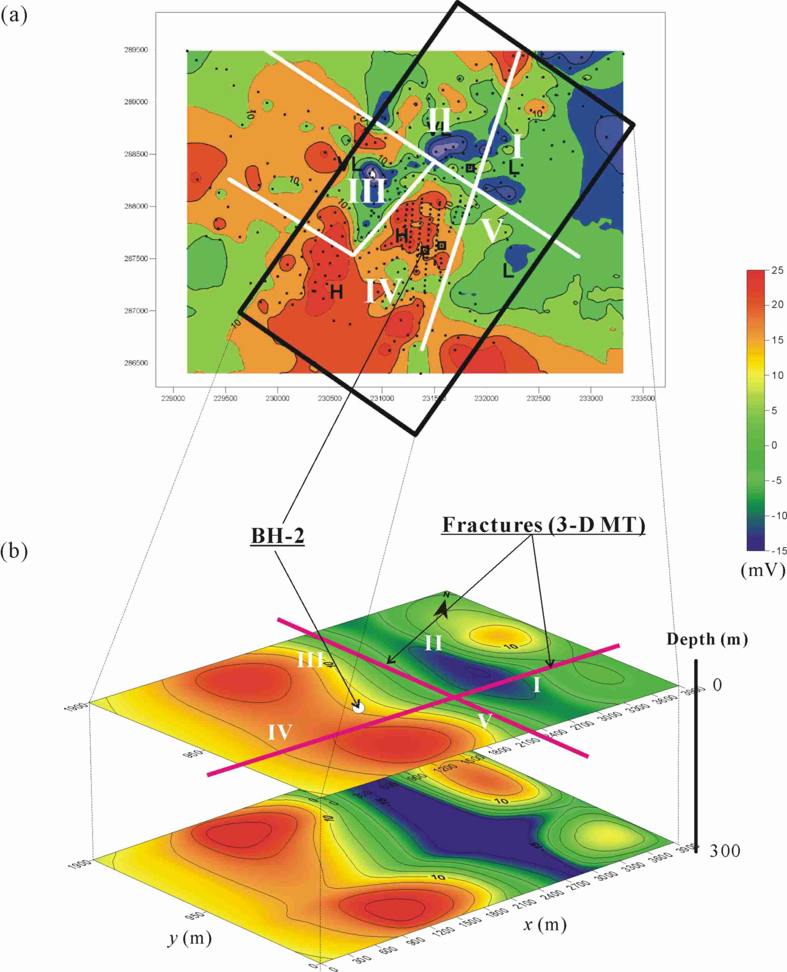

Figure 6. Comparison of observed SP and calculated SP at Pohang geothermal site. (a) Observed SP on surface and (b) Calculated SP on surface and depth of 300 m using the SP simulator algorithm.

Therefore, these results of 3-D SP simulation support the possibility that there exist close hydraulic connections between the zone characterized by this southwestern part and the pumping well. The simulation results also confirmed that the NW-SE fracture interpreted from 3-D MT survey, and that the negative SP anomaly near the fracture can be caused by the down-flow due to circulation of fluid flow, heat flow, or both of them through this fracture zone.

ACKNOWLEDGEMENTS

This work was supported by Basic Research Project of Korea Institute of Geoscience and Mineral Resources (KIGAM) funded by the Ministry of Science and Technology of Korea. We deeply thank for Dr. Byong Wook Cho of KIGAM for the data of pumping test.

REFERENCES

Bodvarsson, G. S., 1982, Mathematical Modeling of the Behavior of Geothermal Systems under Exploitaion, Ph. D. Thesis, U. C. Berkeley.

Corwin, R. F., Morrison, F., and Rodriguez, B., 1978, Self-potential studies at the Cerro Prieto geothermal field, First symposium on the Cerro Prieto Geothermal Field, Baja California, Mexico, 204-210.

Ishido, T., 1981, Streaming potential associated with hydrothermal convection in the crust: a possible mechanism of self-potential anomalies in geothermal areas (in Jap., with Engl. Abstr.), J. Geotherm. Res. Soc. Jpn., 3, 87-100.

Park, K. G, 1994, A study on 3-dimensional resistivity modeling by FEM and topography correction, Master Thesis, Seoul National University.

Uchida, T., Song, Y., Lee, T. J., Mitsuhata, Y., Lim, S.-K., and Lee, S. K., 2004, 3-D magnetotelluric interpretation for low-enthalpy geothermal resources in the Pohang area, Korea, Proceedings of 7th SEGJ International Symposium, Sendai, Japan, 55-60.

Yasukawa, K., Ishido, T., and Suzuki, I., 2005, Geothermal reservoir monitoring by continuous self-potential measurements, Mori Geothermal field, Japan, Geothermics, 34, 551-567.

