3D TEM-IP inversion workflow for galvanic source TEM data

Seogi Kang Douglas W. Oldenburg
University of British Columbia University of British Columbia
6339 Stores Rd., Vancouver, Canada 6339 Stores Rd., Vancouver, Canada
skang@eos.ubc.ca doug@eos.ubc.ca

SUMMARY

Electrical induced polarization (EIP) survey has been used to detect chargeable materials in the earth. For interpretation of the time domain EIP data, DC-IP inversion method, which first invert DC data (on-time) to recover conductivity, then invert IP data (off-time) to recover chargeability, has been successfully used especially for mining applications finding porphyry deposits. No EM-coupling is assumed for this approach, which has been a main concern for the EIP technique. A number of EM-decoupling techniques, which removes EM induction in the observation, have been developed, and effectively been used. However, these mostly assumed simple conductivity models such as half-space and layered-earth due to the lack of capability to compute TEM response from complex conductivity structures. However, recently 3D TEM forward modelling and inversion techniques have been developed, and hence we revisit this fundamental issue on EIP using modern technology. For this, in this study, we apply 3D TEM-IP inversion workflow to a galvanic source example. This includes three steps: a) invert DC and TEM data to recover 3D conductivity, b) using recovered conductivity compute TEM response and subtract this from the observation resulting in IP response, and c) invert obtained IP response to recover 3D chargeability. While applying above workflow, EM induction effects in the observation can be effectively removed, which reduces potential risk to misinterpret EM induction effects as IP signals. This enabled us to obtain better chargeability and conductivity models compared to conventional approaches.

Key words: Induced polarization, EM-decoupling, galvanic source, time domain EM, 3D inversion
INTRODUCTION

The electrical conductivity of earth materials can be frequency dependent with the effective conductivity decreasing with decreasing frequency due to the buildup of electric charges that occur under the applied electric field. Effectively, the rock is electrically chargeable. Controlled-source electromagnetic (EM) methods excite the earth using either galvanic or inductive source. Since either galvanic (a generator attached to two grounded electrodes) or inductive source (arising from currents flowing in a wire loop) will generate electric field in the earth, hence if the earth includes chargeable medium then measured data from any types of EM data will be affected by IP effects. Therefore, observation can include both EM and IP effects and depending on relative strength of each effect the observation can be dominated by either one of them. Most research and application has been focused upon using grounded electrodes and measuring electric fields or voltages as shown in Figure 1(a), and this is called an EIP survey (Seigel, 1959). To interpret observed IP data, two stage IP inversion is developed (Oldenurg and Li, 1994), and well-used in the industry for decades. Currently 3D IP inversion is common at least in mining industry. Figure 1(b) shows typical overvoltage effects measured due to a chargeable target with half-duty cycle waveform. First step is inverting late on-time data (V₀) using DC inversion. Second step is inverting late off-time data (V_{s}) using IP inversion, hence it is often called DC-IP inversion.

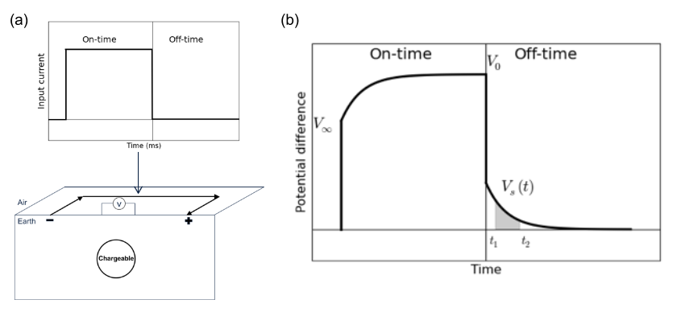
Figure 1. (a) A galvanic source TEM set-up with current waveform. (b) Observed voltage without EM induction effects.

Although application of this method has been successful, a main concern on the second step is EM coupling possibly remained even in the late off-time. Especially when the background is conductive significant EM induction effects could be remained in the observation even at the late off-time window that we often think pure IP data. There have been a number of researches about EM-decoupling, mostly assuming simple earth structures: half-space and layered earth (Wynn and Zonge, 1975). However, now we have capability to handle 3D forward modelling and inversion hence, it is timeless to revisit this issue with the current technology.

Recently, attention has turned towards the use of inductive sources. Inductive source IP (ISIP), can have transmitter loops in the air or on the ground. From airborne time domain EM (ATEM) surveys, negative transient has been observed indicating chargeable medium in the earth (Weidelt, 1982). The effects of chargeable objects using inductive source TEM system has been analyzed (Smith et al., 1988; Flis et al., 1989; Marchant et al., 2014). 3D TEM-IP inversion workflow has been developed to recover distributed IP information (Kang et. al, 2016) by taking analogy from DC-IP inversion. This includes three main steps: a) TEM inversion to recover 3D conductivity, b) EM-decoupling (forward model EM response then subtract from the observation), and c) IP inversion to recover pseudo-chargeability distribution at each time channel.

Same workflow can be applied to galvanic source case such as EIP data in time domain, and possibly handle EM-decoupling issue in conventional DC-IP inversion. A major difference between conventional and our approach is consideration on early time channels of EIP data. In conventional approach these have been considered as “noise” hence been thrown away. However, we consider these as “signal” to recover conductivity. In this study, we apply 3D TEM-IP inversion workflow to the synthetic galvanic source example (gradient array). This will include three steps. First, we invert DC and early time channels of TEM data to recover 3D conductivity. Second, using the recovered conductivity model we perform EM-decoupling and obtain IP data. Lastly, we apply conventional 3D IP inversion to the obtained IP data, and recover pseudo-chargeability model.

SEPARATION OF EM AND IP RESPONSE

Assuming the earth include a chargeable medium, observed responses from any TEM survey could have both EM and IP responses. We first define complex conductivity in frequency domain as

(1)

where is conductivity at infinite frequency, and ω is angular frequency (rad/s). For Cole-Cole model from Pelton et al. (1978),

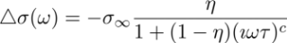, (2)

where η is intrinsic chargeability, τ is time constant, and c is frequency dependency. Following Smith et al. (1988), the observed datum including both EM and IP can be defined as

, (3)

where d^{F} and d^{IP} is fundamental and IP responses. Here the fundamental response can be considered as d^{F} = F[], where F[⋅] is a Maxwell’s operator which takes conductivity and computes EM fields hence, this indicates pure EM responses without IP effects. Note that when η=0. A main goal of our 3D TEM-IP inversion workflow is decomposing d^{F} and d^{IP} tangled in the observation. To identify features of both d^{F} and d^{IP}, we perform a simple TEM forward modelling using a galvanic source as shown in Figure 2(a). We inject half-duty cycle rectangular currents through grounded wire. A chargeable body is embedded in the earth, which may generate typical over-voltage effects. Figure 2 (b) shows measured voltage at a pair of potential electrode on the surface, and it is different from conventional over-voltage diagram shown in Figure 1(b). At early on- and off-time, we observe significant EM induction effects. In contrast, at late off-time, we identify typical over-voltage effects which are effectively IP responses. This suggests a possible separation of EM and IP responses in time.

For clear demonstration of this, we only take off-time data, and plot in the log-log plot as shown in Figure 3. Black, blue, and red lines correspondingly indicate observed, fundamental, and IP responses; solid and dotted lines distinguish negative and positive datum. At early time, fundamental is much greater than IP (EM-dominant; negative datum), whereas at late time, IP is greater than fundamental (IP-dominant; positive datum), and there is intermediate time when both of them are considerable. Following inversion workflow is based upon this natural separation of EM and IP in time.

3D TEM-IP INVERSION WORKFLOW

Our inversion workflow is based upon Kang and Oldenburg (2016) built upon for an inductive source case, but we apply this to a galvanic source example and deal with possible differences. Figure 4 shows the 3D TEM-IP inversion workflow to be applied. First step is inverting TEM data to recover 3D model. We ignore IP-contaminated data as much as we can. For instance, we can use some early time channels to invert TEM data based upon natural separation of EM and IP in time. Again, these early TEM data have been considered as “noise” in conventional approach hence they have been thrown away. However, here we consider these as “signal” to recover better conductivity model. Because we have both DC and TEM data for galvanic source case, we use both DC and early time channels of TEM data to recover conductivity.
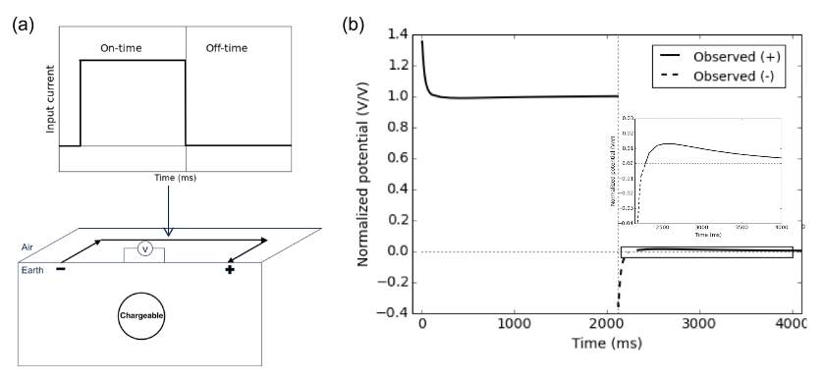
Figure 2. (a) A galvanic source TEM set-up with current waveform. (b) Observed voltage with EM induction effects.

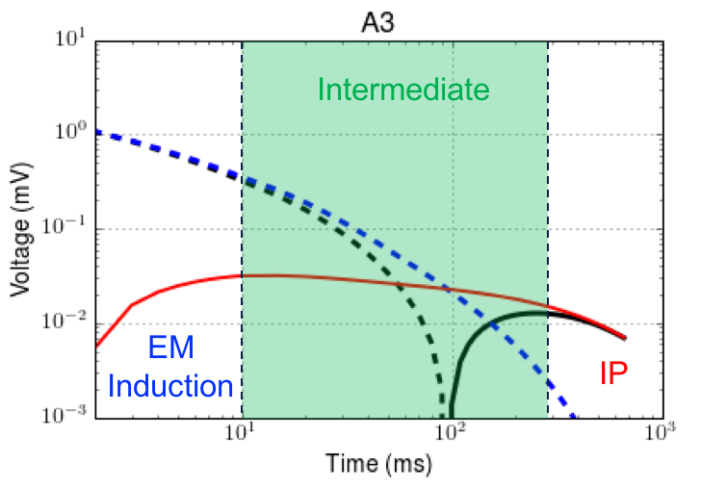
Figure 3. Transients of observed (black), fundamental (blue) and IP (red) at the off-time in the log-log plot. Solid and dotted lines distinguish positive and negative datum.

Estimated conductivity model, σ_{est}, will be used in the second step to decouple EM from the observation. This EM-decoupling process resulting in raw IP data can be expressed as

(4)

where d^{obs} is the observed data, and F[σ_{est}] is predicted data. Here, we identify predicted response might be different from true fundamental response, because σ_{est} is not same as true . Potential errors in raw IP data will be significant especially at early times, but will decrease as time increases. Effective region of EM-decoupling will be in the intermediate time when both EM and IP are considerable (Figure 3). Note that at late time (IP-dominant) EM-decoupling may not be required.

Using conventional IP inversion approach (Oldenburg and Li, 1994), which uses linear form of IP responses, we invert obtained IP data. Linear form of IP responses can be written as

, (5)

where G is the sensitivity function and is the pseudo-chargeability. When forming the sensitivity matrix, conductivity model is required. We invert each time channel of IP data separately, and recover pseudo-chargeability at multiple times. Interpreting this recovered pseudo-chargeability to extract intrinsic IP information such as η, τ, and c is possible, but we do not treat this in this study.

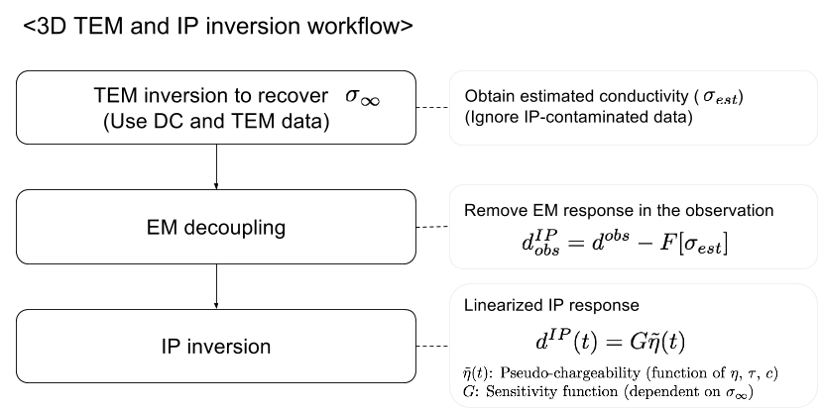

Figure 4. A 3D TEM-IP inversion workflow for galvanic source TEM data.

GALVANIC SOURCE EXAMPLE

Synthetic TEM data

For a synthetic example, we use a galvanic source and multiple receivers which measures voltage as shown in Figure 2(b). Four blocks (A1-A4) have different and η values; τ and c are fixed to 0.5 and 1 (Debye model) as shown in Table 1. Only A2 and A3 blocks are chargeable. Length of the transmitter wire is 4.5 km and potential difference between two electrodes along easting lines are measured (625 points per time channel). Measured time range is 1-600 ms (60 channels). Computed resposnes at 5, 80, and 350 ms are shown in Figure 5. At 5 ms, EM induction effect is dominant, and all data have negative sign. At 80 ms, both EM and IP effects are considerable, and still all data have negative sign. Note that A2 and A3 are chargeable, but A1 is not. Therefore, just looking at observed data at 80 ms, it is hard to differentiate chargeability and conductivity anomalies (A1 is conductive). At 350 ms, EM induction effects are significantly decayed, hence IP is dominant. Only A2 and A3 show positive anomaly originated from chargeability at this time. Depending on measured time window, and IP parameters of chargeable bodies we could have data in IP-dominant time or not. Hence, whenever our measured time window is not late enough to be considered as IP-dominant time, EM-decoupling is crucial step. Note that A1 anomaly 80 ms could be misinterpreted as chargeable response, if this is the latest time channel.

3D IP inversion
To recover , we use first six channels of TEM data (1-6 ms), which have minor contamination from IP. In addition, we have DC data (not available for the inductive source), which will contain IP effects, but minor EM induction effects. Hence we first invert DC data, and recover 3D conductivity. Then by using the recovered DC conductivity as reference model, we invert TEM data and recover conductivity. Recovered conductivity models from 3D DC and TEM inversions are shown in Figure 5.

Table 1. Conductivity at infinite frequency and intrinsic chargeability values for five units: A1-A4 and half-space.

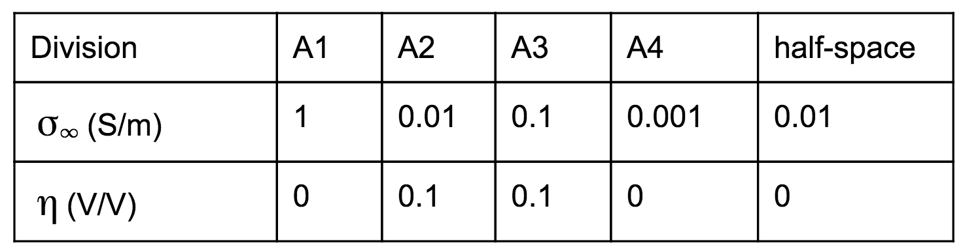

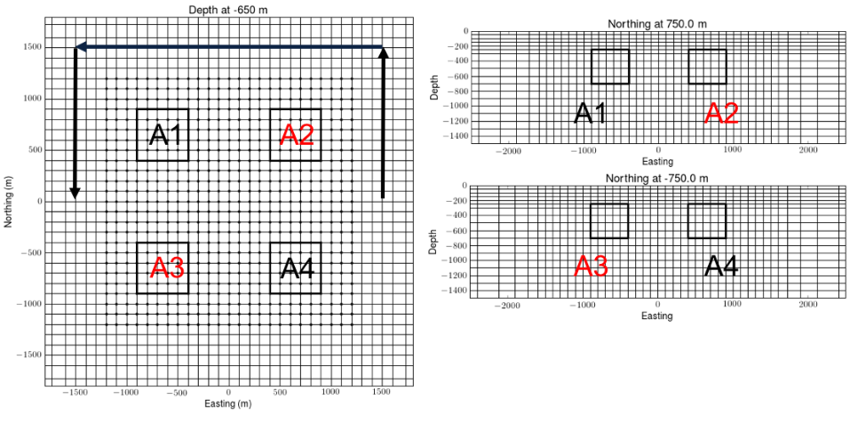
Figure 4. Plan and section views of 3D mesh. Black solid lines shows boundary of four blocks (A1-A4). Only A2 and A3 are chargeable. Arrows indicate an wire path for the galvanic source.
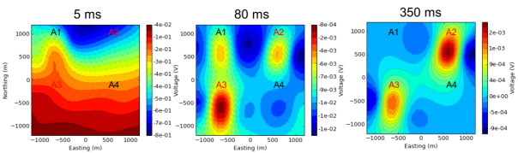
Figure 5. Plan maps of the observed TEM data at 5 (left panel), 80 (middle panel), 350 (right panel) ms. Dashed and solid contour differentiate negative and postive datum.

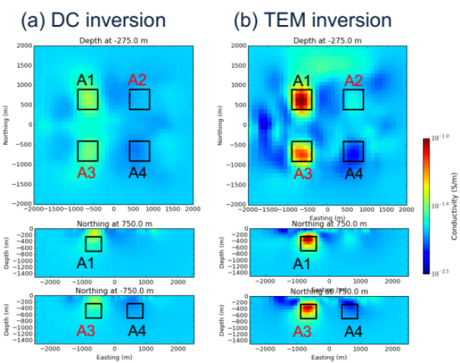
Figure 6. Recovered conductivity models from (a) DC and (b) TEM inversions.

EM-decoupling

Next step is EM-decoupling. The most important item here is 3D conductivity. Here we consider three conductivity: a) true , b) half-space conductivity (σ_{half-space}), and c) estimated conductivity from TEM inversion (σ_{est}). Using EM-decoupling shown in Eq. (4) with above three conductivity models, we compute raw IP data for each conductivity. Suggested procedure correspond to c), which uses σ_{est} from previous TEM inversion hence, we first present observed, predicted and raw IP data for this case at 80 ms in Figure 6. At this time, both EM and IP effects are considerable. Our EM-decoupling procedure effectively remove EM effects due to conductivity especially for regions close to A1 (not chargeable) and A3 (chargeable). Removing conductive anomaly at A1 is crucial, because this could be misinterpreted as chargeable anomaly.

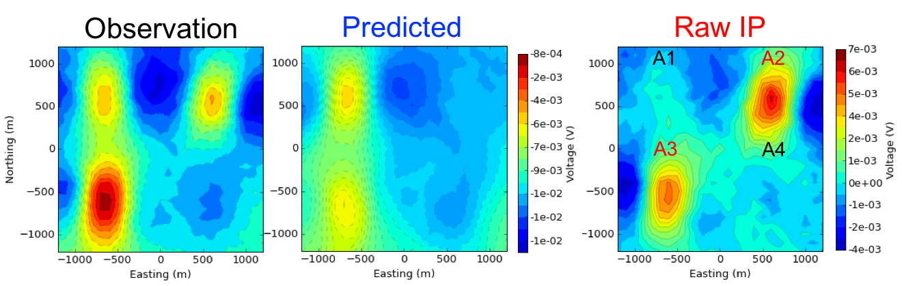
Figure 7. Plan maps of observed (left panel), fundamental (middle panel) and IP (right panel) at the 80 ms.

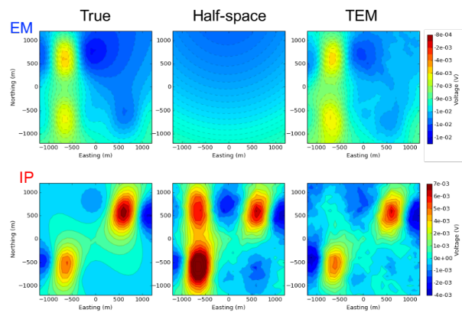
Figure 8. Comparison of EM (top panel) and IP (bottom panel) responses obtained from three different conductivity models. (a) true , b) half-space conductivity, and c) estimated conductivity from TEM inversion.

We compare performance of EM-decoupling for three different conductivity models. Figure 8 shows predicted and IP data generated using three different conductivity models. EM response computed using clearly shows two conductive anomalies. Using estimated conductivity from TEM inversion, we could reasonably predict EM induction effects, whereas half-space conductivity is not enough to predict EM effects. This clearly makes an impact to computed IP data. Raw IP data obtained from half-pace conductivity, d^{IP}_{raw} [σ_{half-space}], is significantly different from true IP data. Especially at A1 and A3 where we have conductive blocks, IP data is overestimated. However, using the estimated conductivity from TEM inversion, we obtained much closer IP data (d^{IP}_{raw} [σ_{est}]) to the true one. A1 and A3 conductive anomaly is effectively removed resulting stronger A1 anomaly than A3. As shown in the left panel Figure 7, A3 was stronger in the observation.

3D IP inversion

To recover 3D pseudo-chargeability, we invert raw IP data sets at 80 ms obtained using σ_{half-space} and σ_{est} from TEM inversion in the previous section. Recovered 3D pseudo chargeability models are shown in Figure 7. Recovered pseudo-chargeability from d^{IP}_{raw} [σ_{half-space}] imaged three chargeable bodies. A2 and A3 were chargeable, but A1 is not chargeable, which shows a possible misinterpretation of chargeable body due to EM induction effects. However, with the EM-decoupling procedure based upon σ_{est} from TEM inversion, we effectively remove false chargeable body in the recovered pseudo-chargeability.

Conclusions

In this study, we have applied the 3D TEM-IP inversion workflow to a galvanic source TEM example. First, we inverted DC data and recovered 3D conductivity. Then by using that as a reference model we inverted six earliest time channels of TEM data, which have minor IP-contamination and recovered 3D conductivity. These early TEM data often have been thrown away because they considered as “noise”. However, by considering them as “signal” and inverting them, we recovered better conductivity model. Based upon the recovered conductivity, second, we applied EM-decoupling resulting in raw IP data, and effectively removed EM induction responses in the observation, especially for regions close A1 and A3, which has significant conductivity response. For comparison, we also applied EM-decoupling with half-space conductivity model to compute raw IP data. Third, we inverted each raw IP data set generated from the TEM and half-space conductivity model using conventional 3D IP inversion. Recovered pseudo-chargeability models from these inversions demonstrated potential risk of EM induction effects to be misinterpreted as chargeable bodies. However, by using 3D conductivity model from TEM inversion for EM-decoupling, we effectively removed EM induction effects resulting in removal of the false chargeable body in the recovered pseudo-chargeability. This high performance of EM-decoupling basically originated from better conductivity obtained from TEM inversion of early TEM data, which often have been considered as noise. Therefore, the 3D TEM-IP inversion workflow developed for the inductive source can be still effective for the galvanic source as well, and it can provide both better conductivity and pseudo-chargeability models than conventional approach.

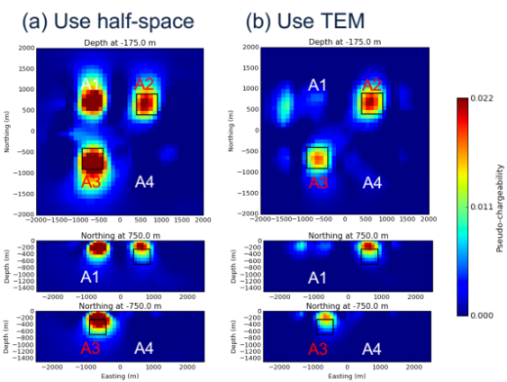
Figure 9. Recovered pseudo-chargeability model from raw IP datum generated by half-space (left panel) and TEM conductivity (right panel) models.

REFERENCES

Flis, M. F., G. A. Newman, and G. W. Hohmann, 1989, In- ducedpolarization effects in timedomain electromagnetic measurements: Geophysics, 54, 514–523.

Kang, S., and D. W. Oldenburg, 2016, On recovering dis- tributed IP information from inductive source time domain electromagnetic data (in revision): Geophysical Journal In- ternational.

Marchant, D., E. Haber, and D. Oldenburg, 2014, Three- dimensional modeling of IP effects in time-domain elec- tromagnetic data: Geophysics, 79, E303–E314.

Oldenburg, D., and Y. Li, 1994, Inversion of induced polariza- tion data: Geophysics, 59, 1327–1341.

Pelton, W., S. Ward, P. Hallof, W. Sill, and P. Nelson, 1978, Mineral discrimination and removal of inductive coupling with multifrequency IP: Geophysics, 43, 588–609.

Seigel, H., 1959, Matehmatical formulation and type curves for induced polarization: Geophysics, 24, 547–565.

Smith, R. S., P. Walker, B. Polzer, and G. F. West, 1988, The time-domain electromagnetic response of polarizable bod- ies: an approximate convolution algorithm: Geophysical Prospecting, 36, 772–785.

Weidelt, P., 1982, Response characteristics of coincident loop transient electromagnetic systems: 47, 1325–1330.

Wynn, J. C., and K. L. Zonge, 1975, EM coupling, its intrinsic value, its removal and the cultural coupling problem: Geo- physics, 40, 831–850

