3D TEM-IP inversion workflow for galvanic source TEM data

Seogi Kang Douglas W. Oldenburg
University of British Columbia University of British Columbia
6339 Stores Rd., Vancouver, Canada 6339 Stores Rd., Vancouver, Canada
skang@eos.ubc.ca doug@eos.ubc.ca

SUMMARY

Electrical induced polarization (EIP) surveys have been used to detect chargeable materials in the earth. For interpretation of the time domain EIP data, the DC-IP inversion method, which first invert DC data (on-time) to recover conductivity, then inverts IP data (off-time) to recover chargeability, has been successfully used especially for mining applications finding porphyry deposits. It is assumed that the off-time data are free of EM induction effects. When this is not the case, an EM-decoupling techniques, which removes EM induction in the observation, needs to be implemented. Usually responses from a half-space or a layered earth are subtracted. Recent capability in 3D TEM forward modelling and inversion allows us to revisit this procedure. Here we apply a 3D TEM-IP inversion workflow to the galvanic source example. This includes three steps: a) invert DC and early time channel TEM data to recover the 3D conductivity, b) use that conductivity to compute the TEM response at later time channels. Subtract this fundamental response from the observations to generate the IP response, and c) invert the IP responses to recover a 3D chargeability. This workflow effectively removes EM induction effects in the observations and produces better chargeability and conductivity models compared to conventional approaches.

Key words: Induced polarization, EM-decoupling, galvanic source, time domain EM, 3D inversion
INTRODUCTION

The electrical conductivity of earth materials can be frequency dependent with the effective conductivity decreasing with decreasing frequency due to the buildup of electric charges that occur under the applied electric field. Effectively, the rock is electrically chargeable.

Maybe a figure..

Controlled-source electromagnetic (EM) methods excite the earth using either galvanic (a generator attached to two grounded electrodes) or inductive source (arising from currents flowing in a wire loop). A typical ground-based galvanic source is shown in Fig 1.

…… fix up following paragraph with figure and text

Measured voltages as shown in Figure 1(a), and this is called an EIP survey (Seigel, 1959). To interpret observed IP data, a two-stage IP inversion is developed (Oldenburg and Li, 1994). Currently 3D IP inversion is Figure 1(b) shows typical overvoltage effects measured due to a chargeable target with half-duty cycle waveform. First step is inverting late on-time data (V₀) using DC inversion. Second step is inverting late off-time data (V_{s}) using IP inversion, hence it is often called DC-IP inversion.

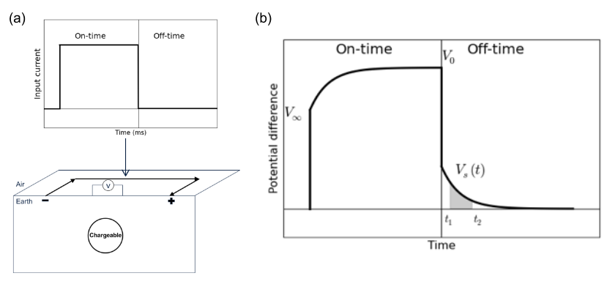
Figure 1. (a) A galvanic source TEM set-up with current waveform. (b) Observed voltage without EM induction effects.

Although application of this method has been successful, a main concern is the second step. The time decaying fields are assumed to be purely the result of IP phenomena and any EM induction effects that might be in the data are ignored. This assumption can be violated when the earth has a significant conductivity. This EM coupling can remain even in the late off-time. Removing the effects of EM induction from the measured data is referred to as EM-decoupling and it has been a focus of attention for many years. Most analyses have used simple earth structures: half-space and layered earth to ameliorate its effects. (Wynn and Zonge, 1975). However, with our current capability to handle 3D forward modelling and inversion it is timely to revisit this issue.

In a recent work (Kang and Oldenburg) we developed a workflow for inverting airborne IP data using inductive sources. This involved three main steps: a) inverting early time TEM data to recover a 3D conductivity, b) EM-decoupling (forward modeling the EM response and then subtracting it from the observations), and c) IP inversion to recover pseudo-chargeability distribution at each time channel.
The current problem of inverting IP data using grounded sources follows the same workflow but some aspects are greatly simplified because EIP measures data when electric fields, and charge accumulations, have reached a steady state. This provides another data set from which information about the electrical conductivity can be extracted.

A major difference between conventional EIP inversion and our approach is the useage make of early time channels in the EIP data. In conventional work these have been considered as “noise” and hence been thrown away. However, we consider these as “signal” to recover conductivity. In this study, we apply 3D TEM-IP inversion workflow to the synthetic galvanic source example (gradient array). This will include three steps listed above but the main alteration is that we invert both the DC data and early time channels of TEM data to recover 3D conductivity.

SEPARATION OF EM AND IP RESPONSE

Assuming the earth has chargeable material, the observed responses from any TEM survey has both EM and IP responses. To be more specific, we first define the complex conductivity in the frequency domain as

(1)

where is the conductivity at infinite frequency, and ω is angular frequency (rad/s). For the Cole-Cole model from Pelton et al. (1978),

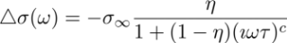, (2)

where η is intrinsic chargeability, τ is time constant, and c is frequency dependency. Following Smith et al. (1988), the observed datum including both EM and IP effects can be defined as

, (3)

where d^{F} and d^{IP} are respectively the fundamental and IP responses. Here the fundamental response is d^{F} = F[], where F[⋅] is a Maxwell’s operator; this takes the conductivity and computes EM responses without IP effects. Note that when η=0. A main goal of our 3D TEM-IP inversion workflow is to evaluate the d^{F} and d^{IP} components. To illustrate the challenge we perform a simple TEM forward modelling using a galvanic source as shown in Figure 2(a). We inject a half-duty cycle rectangular current through a grounded wire. A chargeable body is embedded in the earth. Figure 2 (b) shows the measured voltage at a pair of potential electrodes on the surface. It is different from the conventional over-voltage diagram shown in Figure 1(b). At early on- and off-time, we observe significant EM induction effects. It is only at late off-times that we can identify typical over-voltage effects which are characteristic of the IP responses. The fact that EM dominates the data at early times and IP effects dominate the late-time data suggests it may be possible to separate the EM and IP responses in time.

For a clearer demonstration of this, we view only the off-time data, and plot them on a log-log plot as shown in Figure 3. Black, blue, and red lines correspondingly indicate observed, fundamental, and IP responses; solid and dotted lines distinguish negative and positive data. At early times, the fundamental response is much greater than the IP data; this is the region of EM dominance. At later times, the IP signal is much greater than the fundamental; this is the region of IP-dominance. Importantly, there is an intermediate time region when both EM and IP are considerable. Our following inversion workflow is based upon this natural separation of EM and IP in time.

3D TEM-IP INVERSION WORKFLOW

Our inversion workflow is based upon Kang and Oldenburg (2016) which was built for an inductive source case, but is applicable here. Figure 4 shows the 3D TEM-IP inversion workflow to be applied. The first step is to invert the TEM data to recover the 3D model. As in our inductive source work, we use only early time data that we feel are not IP-contaminated. We note that these early time TEM data have previously been considered as “noise” in conventional analyses and hence have been thrown away. However, here we consider these as “signal” and use them to recover a better conductivity model. Another possibility for obtaining a background conductivity is to use the steady state fields just prior to switching the current off. These are the potentials that are traditionally used in DC-IP inversion. Inversion of these data yields a conductivity that is sigma_inf (1-eta) but if eta is small enough then this will be a reasonable approximation to sigma_inf. The inversion of DC data is analogous to inverting frequency data at one frequency and thus it might be expected that inverting data at multi-times (equivalent to multi-frequencies) might produce a better result. Our experiences verifies this. Nevertheless, the DC fields are valuable and we wish to use them. The options are to invert both the DC and the TEM data at once or to treat them as two separate data sets. For the present we have chosen the latter since we then don’t have to contend with the issue that the DC fields are really sigma_inf(1-eta). Thus the approach implemented here is to invert the DC data and use the resulting model as a starting and reference model for the TEM inversion
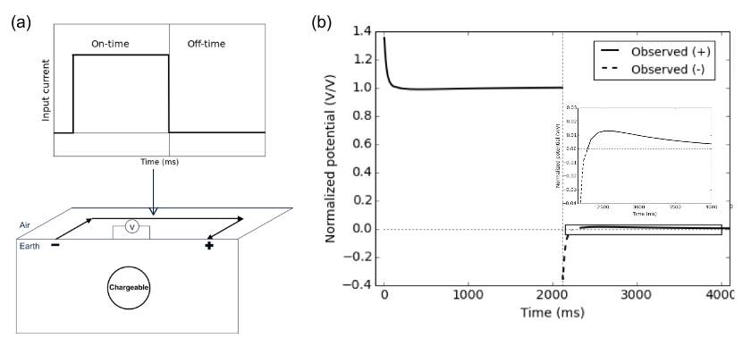
Figure 2. (a) A galvanic source TEM set-up with a half-duty cycle current waveform. (b) Observed voltage with EM induction effects. EM effects dominate the early off-time data.

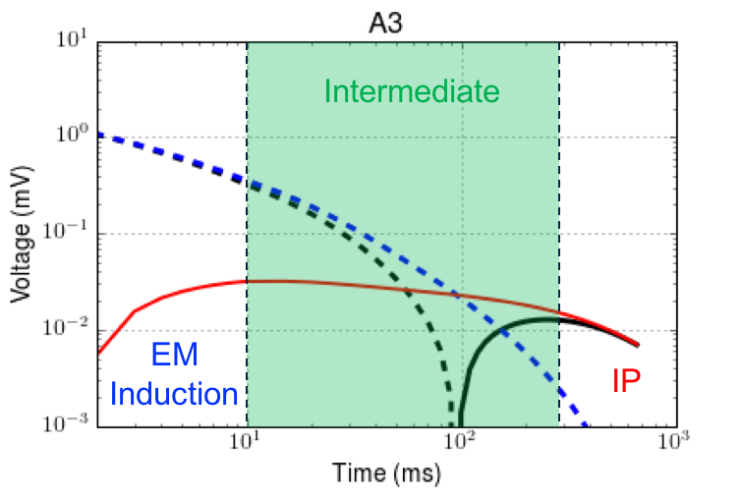
Figure 3. Transients of observed (black), fundamental (blue) and IP (red) at the off-time in the log-log plot. Solid and dotted lines distinguish positive and negative datum.

The second step of the workflow is involves EM decoupling. The estimated conductivity model, σ_{est}, from Step 1 is used to generate raw IP data according to

(4)

where d^{obs} is the observed data, and F[σ_{est}] is predicted data. Here, we identify that the predicted response might be different from true fundamental response, because σ_{est} is not the same as . Potential errors in raw IP data will be significant especially at early times, but they will decrease as time increases. The effective region for EM-decoupling will be in the intermediate time when both EM and IP are considerable (Figure 3). Note that at late time (IP-dominant) EM-decoupling may not be required.

The final step in the process is to carry out the IP inversion. We adopt the conventional IP inversion approach (e.g. Oldenburg and Li, 1994), which uses a linear form of IP responses written as

, (5)

where G is the sensitivity function and is the pseudo-chargeability. The conductivity model sigma_est is required to generate the sensitivity matrix. We invert each time channel of IP data separately, and recover pseudo-chargeability at multiple times. Interpreting this recovered pseudo-chargeability to extract intrinsic IP information such as η, τ, and c is possible, but we do not treat that in this study.

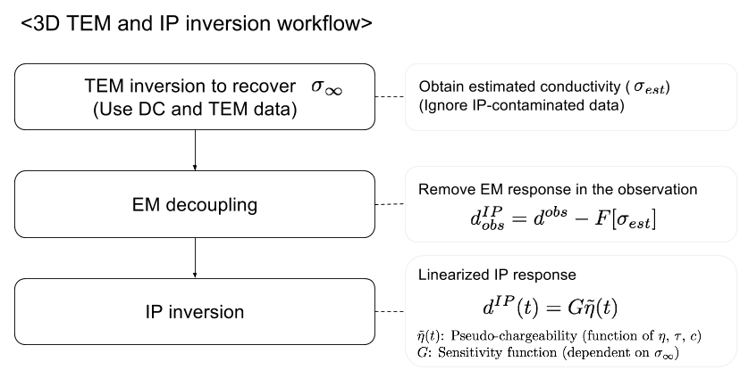

Figure 4. A 3D TEM-IP inversion workflow for galvanic source TEM data.

GALVANIC SOURCE EXAMPLE

Synthetic TEM data

As an example, we use a galvanic source and multiple receivers which measures voltages as shown in Figure 2(b). Four blocks (A1-A4) have different and η values (shown in Table 1); all blocks have τ =0.5 sec and c=1 (Debye model). Only A2 and A3 blocks are chargeable. The length of the transmitter wire is 4.5 km and potential differences between two electrodes along easting lines are measured at 625 locations. The measured time range is 1-600 ms (60 channels). Computed responses at 5, 80, and 350 ms are shown in Figure 5. At 5 ms, EM induction effects are dominant, and all data are negative. At 80 ms, both EM and IP effects are considerable, but still all data are negative. Note that A2 and A3 are chargeable, but A1 (which is conductive) is not. Therefore, it is difficult to differentiate chargeability and conductivity anomalies just by looking at observed data at 80 ms.. At 350 ms, EM induction effects are significantly decayed, hence IP is dominant. Only A2 and A3 show positive anomalies that originate from chargeability. Depending on the measured time window, and IP parameters of chargeable bodies, we could have data in IP-dominant time or not. Hence, whenever our measured time window is not late enough to be considered as IP-dominant time, EM-decoupling is crucial step. Note that the A1 anomaly at 80 ms could be misinterpreted as a chargeable response, if this is the latest time channel.

3D IP inversion
To recover , we use the first six channels of the TEM data (1-6 ms), which have minor contamination from IP. In addition, we have DC data which contain IP effects, but have minor EM induction effects. We first invert the DC data, and recover 3D conductivity. Then by using the recovered DC conductivity as a reference model, we invert the TEM data. The recovered conductivity models from the 3D DC and TEM inversions are shown in Figure 5. The conductive blocks A1 and A3 are much better imaged with the TEM inversion.

Table 1. Conductivity at infinite frequency and intrinsic chargeability values for five units: A1-A4 and half-space.

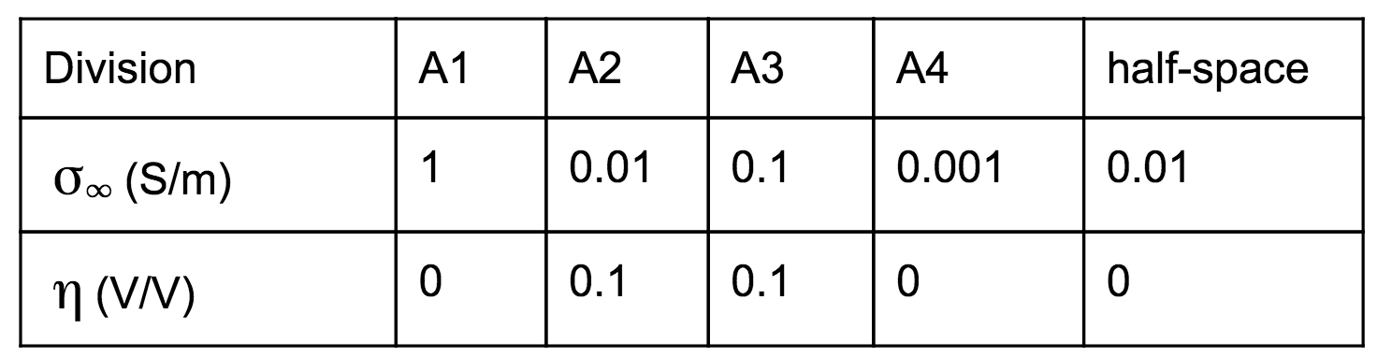

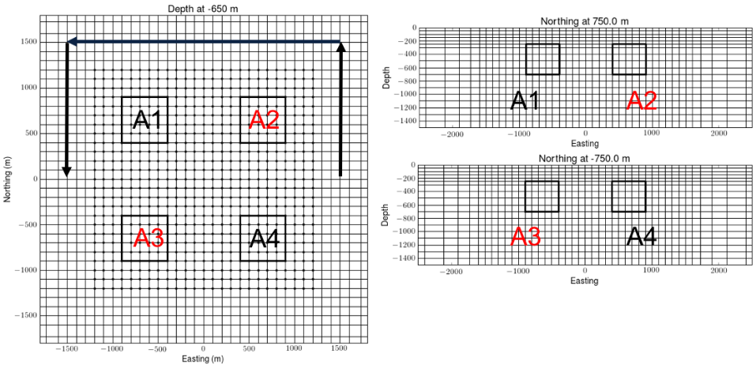
Figure 4. Plan and section views of the 3D mesh. Black solid lines shows boundary of four blocks (A1-A4). Only A2 and A3 are chargeable. Arrows indicate a wire path for the galvanic source.
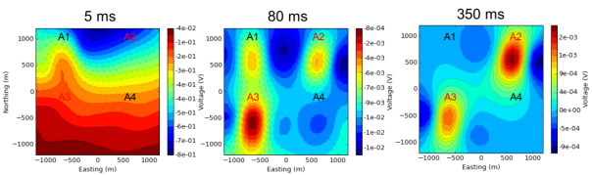
Figure 5. Plan maps of the observed TEM data at 5 ms (left panel), 80 ms (middle panel), 350 ms (right panel). Dashed and solid contours differentiate negative and positive data.

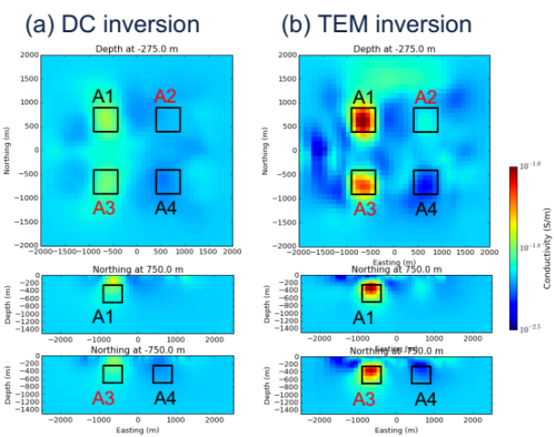
Figure 6. Recovered conductivity models from (a) DC and (b) TEM inversions.

EM-decoupling

The next step is EM-decoupling. We use the EM-decoupling shown in Eq. (4) with σ_{est} from the TEM inversion (Figure 6). In Figure 7 we present observed, predicted and raw IP data for 80 ms. At this time, both EM and IP effects are considerable. Our EM-decoupling procedure effectively removes EM effects due to conductivity especially for regions close to A1 (not chargeable) and A3 (chargeable). Removing the conductive anomaly at A1 is crucial, because this could be misinterpreted as chargeable anomaly.

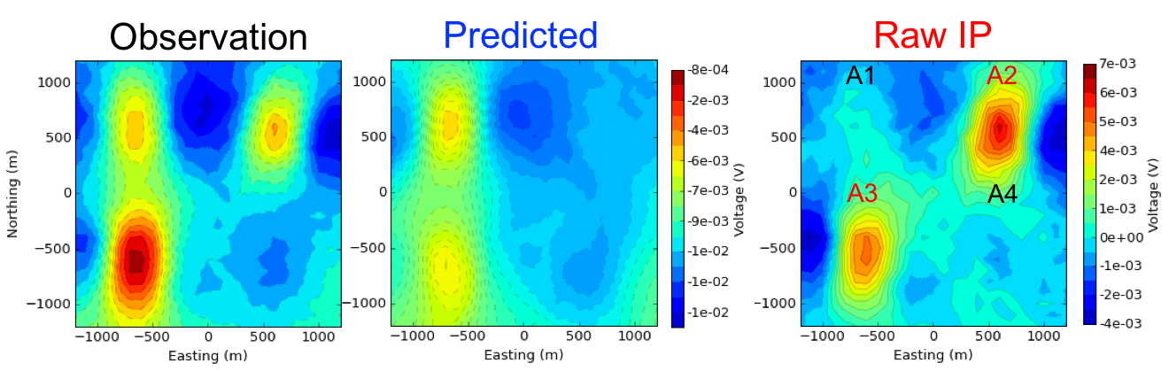
Figure 7. Plan maps of observed (left panel), fundamental (middle panel) and IP (right panel) at the 80 ms.

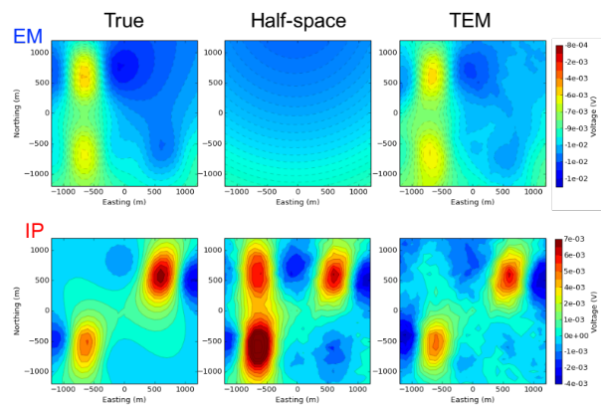
Figure 8. Comparison of EM (top panel) and IP (bottom panel) responses obtained from three different conductivity models. (a) true , b) half-space conductivity, and c) estimated conductivity from TEM inversion.

The crucial aspect of our EM-decoupling procedure is the effect of the background conductivity. To show this we consider two other candidates, namely a) true , b) half-space conductivity (σ_{half-space}),.
We compare performance of EM-decoupling for all three different conductivity models. Figure 8 shows predicted and IP data generated using three different conductivity models. EM response computed using clearly shows two conductive anomalies. Using the estimated conductivity from the TEM inversion, we could reasonably predict EM induction effects, whereas half-space conductivity is not enough to predict EM effects. This clearly makes an impact on the computed IP data. Raw IP data obtained from half-space conductivity, d^{IP}_{raw} [σ_{half-space}], is significantly different from true IP data. Especially at A1 and A3 where we have conductive blocks, IP data is overestimated. However, using the estimated conductivity from TEM inversion, we obtained much closer IP data (d^{IP}_{raw} [σ_{est}]) to the true one. A1 and A3 conductive anomaly is effectively removed resulting stronger A1 anomaly than A3. As shown in the left panel Figure 7, A3 was stronger in the observation.

3D IP inversion

Present the inversion first with sigma_est. Talk about it. Mention positivity, depth weighting ??? Also, ?? omit the analysis with halfspace. There are artefacts in the data so certainly there will be artifacts in the recovered model. We can just mention that. No one has done this before so let’s concentrate on the best result. To recover 3D pseudo-chargeability, we invert raw IP data sets at 80 ms obtained using σ_{half-space} and σ_{est} from TEM inversion in the previous section. Recovered 3D pseudo chargeability models are shown in Figure 9. Recovered pseudo-chargeability from d^{IP}_{raw} [σ_{half-space}] imaged three chargeable bodies. A2 and A3 were chargeable, but A1 is not chargeable, which shows a possible misinterpretation of chargeable body due to EM induction effects. However, with the EM-decoupling procedure based upon σ_{est} from TEM inversion, we effectively remove false chargeable body in the recovered pseudo-chargeability.

Conclusions

In this study, we have applied the 3D TEM-IP inversion workflow to a galvanic source TEM example. First, we inverted DC data and recovered 3D conductivity. Then by using that as a reference model we inverted six earliest time channels of TEM data, which have minor IP-contamination and recovered 3D conductivity. These early TEM data often have been thrown away because they considered as “noise”. However, by considering them as “signal” and inverting them, we recovered better conductivity model. Based upon the recovered conductivity, second, we applied EM-decoupling resulting in raw IP data, and effectively removed EM induction responses in the observation, especially for regions close A1 and A3, which has significant conductivity response. For comparison, we also applied EM-decoupling with half-space conductivity model to compute raw IP data. Third, we inverted each raw IP data set generated from the TEM and half-space conductivity model using conventional 3D IP inversion. Recovered pseudo-chargeability models from these inversions demonstrated potential risk of EM induction effects to be misinterpreted as chargeable bodies. However, by using 3D conductivity model from TEM inversion for EM-decoupling, we effectively removed EM induction effects resulting in removal of the false chargeable body in the recovered pseudo-chargeability. This high performance of EM-decoupling basically originated from better conductivity obtained from TEM inversion of early TEM data, which often have been considered as noise. Therefore, the 3D TEM-IP inversion workflow developed for the inductive source can be still effective for the galvanic source as well, and it can provide both better conductivity and pseudo-chargeability models than conventional approach.

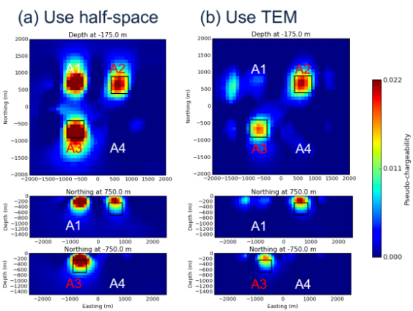
Figure 9. Recovered pseudo-chargeability model from raw IP datum generated by half-space (left panel) and TEM conductivity (right panel) models.

REFERENCES

Flis, M. F., G. A. Newman, and G. W. Hohmann, 1989, In- ducedpolarization effects in timedomain electromagnetic measurements: Geophysics, 54, 514–523.

Kang, S., and D. W. Oldenburg, 2016, On recovering dis- tributed IP information from inductive source time domain electromagnetic data (in revision): Geophysical Journal In- ternational.

Marchant, D., E. Haber, and D. Oldenburg, 2014, Three- dimensional modeling of IP effects in time-domain elec- tromagnetic data: Geophysics, 79, E303–E314.

Oldenburg, D., and Y. Li, 1994, Inversion of induced polariza- tion data: Geophysics, 59, 1327–1341.

Pelton, W., S. Ward, P. Hallof, W. Sill, and P. Nelson, 1978, Mineral discrimination and removal of inductive coupling with multifrequency IP: Geophysics, 43, 588–609.

Seigel, H., 1959, Matehmatical formulation and type curves for induced polarization: Geophysics, 24, 547–565.

Smith, R. S., P. Walker, B. Polzer, and G. F. West, 1988, The time-domain electromagnetic response of polarizable bod- ies: an approximate convolution algorithm: Geophysical Prospecting, 36, 772–785.

Weidelt, P., 1982, Response characteristics of coincident loop transient electromagnetic systems: 47, 1325–1330.

Wynn, J. C., and K. L. Zonge, 1975, EM coupling, its intrinsic value, its removal and the cultural coupling problem: Geo- physics, 40, 831–850

