Airborne IP for Kimberlite Exploration

Douglas W. Oldenburg Seogi Kang
University of British Columbia University of British Columbia
6339 Stores Rd., Vancouver, Canada 6339 Stores Rd., Vancouver, Canada
doug@eos.ubc.ca skang@eos.ubc.ca

SUMMARY

Negative transients of airborne time domain electro-magnetic (ATEM) data have been observed from a number of kimberlite deposits indicating chargeable materials. This often has been recognized as a problem, because it distorts EM signals from the conductive kimberlites. However, chargeability could be reflective of the kimberlite, hence induced polarization (IP) effects can be “signal”. ATEM surveys at Tli Kwi Cho (TKC) kimberlite complex showed negative transients. Complex impedance of TKC core samples are measured, and the results showed kimberlites can be charageable, and different kimberlite units has different IP characters. This raises two questions: a) can we invert ATEM data to recover chargeability?, and b) how meaningful it is for kimberlite exploration? A major challenge to answer these is depth resolution of the airborne IP (AIP). In this study, therefore, we systematically tested depth resolution of the AIP technique by generating synthetic AIP data from a chargeable target at different depths, and applying 3D IP inversion to them. Based upon these analyses, we apply 3D ATEM-IP inversion workflow to TKC field example, and recovered 3D conductivity and pseudo-chargeability at multiple time channels. Recovered pseudo-chargeability at different times provided possible distinction of different kimberlite units, which could be meaningful information for kimberlite exploration.
Key words: airborne EM, Induced polarization, Kimberlite, and 3D inversion
INTRODUCTION

Kimberlite exploration has focused on looking for high magnetic susceptibility, low density and high conductivity (Cites). Figure 1(a) shows a typical geologic model and the cross-section of the kimberlite composed of three different parts: crater, diatreme, and hypabyssal facies. Physical properties of those three facies are shown in Figure 1(b). Conductivity of the kimberlites is usually found using airborne EM (AEM) surveys, and in particular for the airborne time domain EM (ATEM) systems, negative transients often observed (Jansen and Witherly, 2004) indicating there is chargeable material (Weidelt, 1982). Ice and near surface clays are known to be chargeable (Smith and Klein, 1996), and these materials distort the AEM signals and impedes ability to extract good information about conductivity. As such, the existence of chargeable materials has been recognized as a problem (IP contamination). The possibility exists however, that the chargeability is reflective of the kimberlite and is therefore “signal” that we want to interpret.

The Tli Kwi Cho (TKC) kimberlite complex is located approximately 360 km northeast of Yellowknife, NWT, Canada within the Archean Slave craton. The complex is part of the larger Lac de Gras kimberlite field, which hosts numerous diamondiferous kimberlites that make it of economic interest to the mining industry. The TKC kimberlites are composed of two main pipes called DO-18 and -27, and they are respectively located at northern and southern part of TKC region as shown in Figure 2(a). There are four different kimberlites named XVK (Xenolithic kimberlite), VK (volcaniclastic kimberlite), HK (hypabyssal kimberlite) and PK (pyroclastic kimberlite). DO-18 pipe is mostly XVK and DO-27 is a combination of PK and HK. An easting geological section at the DO-27 pipe generated from drilling results (Harder et al., 2006) are shown in Figure 2(a). Petrophysical data including density, susceptibility, Koenigsberger, complex conductivity have been measured from core samples at DO-18 and -27. Figure 3 shows the measured complex impedance from TKC core samples corresponding to PK (green), HK (red), and XVK (purple) units. These kimberlites are chargeable, and estimated time constant values are different: PK has slower decay compared to HK and XVK.

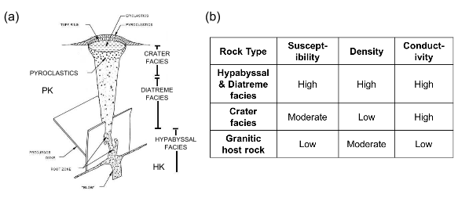
Figure 1. (a) General structure of kimberlite pipe. (b) Physical properties of geological units in the kimberlite pipe.

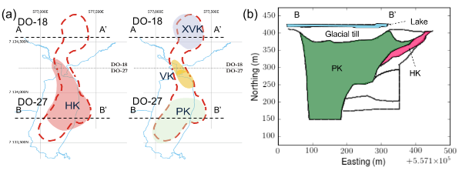
Figure 2. Geological backgrounds of Tli Kwi Cho (TKC) Kimberlites. (a) Plan map of TKC with four kimberlite units: PK, HK, VK, and XVK. (b) Geological section of DO-27 pipe.

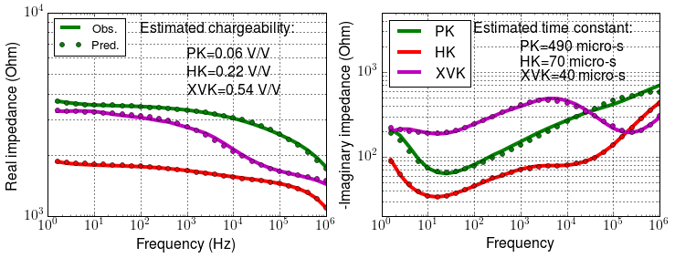
Figure 3. Complex impedance measured from core samples from PK (green), HK (red), and XVK (purple) units. Left and right panel shows real and imaginary parts of the impedance. Solid line and circle differentiate observed and predicted impedances.

Based upon the lab measurements results, TKC kimberlites are chargeable; the most diamondiferous part of the deposit is PK, and it has different IP parameters from different units. This raises two important questions: a) Can we invert ATEM data for chargeability? and b) Can this provide some meaningful information about the kimberlite?

A major challenge is on the great sensitivity of airborne IP (AIP) signals on near surface due to the 1/r³ decay of the IP signals from chargeable targets. In addition, most of observations on the AIP data are from top few tens meters such as permafrost and clay located in the very near surface (Macnae, 2015), so AIP often called ‘clay mapper’. Accordingly, investigation of the depth resolution on AIP is crucial part for this technique to be used to detect chargeable units at depths. By using the TKC field example, we address above essential questions upon the AIP technique for kimberlite exploration.

In this study, in order to investigate depth resolution of the AIP we generate synthetic AIP data sets with a chargeable target at different depths and apply 3D IP inversion to them. Based upon this, we apply 3D ATEM inversions and IP inversions to TKC ATEM data, and restore 3D conductivity and chargeability.

COMPLEX CONDUCTIVITY

Complex conductivity provides mathematical form of IP effects, and in frequency domain this can be expressed as

(1)

where is conductivity at infinite frequency, and ω is angular frequency (rad/s). There are a number of models, and depending on them will be different, but following choice from Smith et al. (1988), we use Cole-Cole model from Pelton et al. (1978):

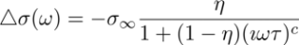, (2)

where η is intrinsic chargeability, τ is time constant, and c is frequency dependency.

LINEAR FORM OF IP RESPONSE

Observation, d^{obs}, can include both EM and IP effects hence this could be expressed as

, (3)

where F[] is fundamental response, which does not include any IP effects ,and d^{IP} is the IP response. Here F[⋅] indicates Maxwell’s operator which takes conductivity and compute TEM response. Accordingly, the IP datum could be expressed as

, (4)

This procedure can be considered as EM-decoupling because we are removing pure EM induction effects from the observations. IP responses could have linear form:

, (5)

where G is the sensitivity function and is the pseudo-chargeability. Note that this pseudo-chargeability is time-dependent, but the intrinsic chargeability is not. This linear form will be the forward function that we use to invert IP data. For detailed information on the linearization and the inversion of the AIP data, see Kang et al. (2016).

DEPTH INFORMATION IN AIP

Depth resolution of the AIP is limited in certain depth due to the significant geometric decay of IP signal from a chargeable target. The resolution possibly on top few tens meters for the compact target and about 90 m for the layers (Macnae, 2015). We systematically treat this issue in the context of the kimberlite exploration. We consider a circular-shaped chargeable target, which is moderately conductive and embedded in a resistive background. This could correspond to PK or crater facies (Figure 1a), which is conductive and chargeable.

Depth resolution of the AIP data includes two important items: detection and delineation. For the first item, using an ATEM survey geometry shown in Figure 1(a), we perform forward modelling and compute dbz/dt (Figure 1b) using EMTDIP code (Marchant et al., 2015). The half-space earth (10⁻⁴ S/m) includes a conductive and chargeable cylinder and Cole-Cole parameters of the chargeable unit are =10-1 S/m, η=0.1, c=0.5 and τ=10³ micro-s. With fixed thickness (75 m) and radius (100 m) of the cylinder, we alter the depth from the surface as 0, 75, and 150 m. Although the amplitude of the observation is decreasing with increasing depth, the first time when the negative value appear is almost constant (~700 micro-s) for all three depths. Assuming all negative shown in Figure 1(b) are above the system noise level, these results show two important aspects: a) we can detect chargeable response at depth, but b) with a single sounding data it might be challenging to differentiate depth information. However, in practice we obtain ATEM data from a number of sounding locations providing possibility to resolve depth information of chargeable targets.

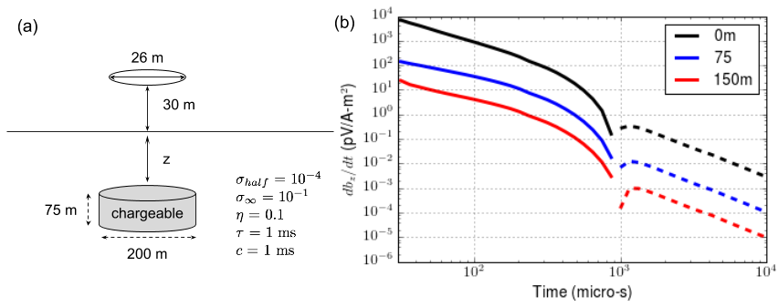
Figure 4. (a) Geometry of an ATEM system, and a chargeable cylinder embedded in the half-space earth. (b) Observed vertical magnetic fields (dbz/dt) with varying values for the chargeable unit. Solid and dotted lines indicate positive and negative data, respectively.

We perform two forward modellings: F[σ(t)] (observation) and F[] (fundamental) with 210 sounding locations. Then using Eq. (4) we evaluate IP data at 1300 micro-s as shown in Figure 5. As the depth increases, IP responses gets broader and smoother due to the geometric effects. Although not shown here, spatial variation of the IP data hardly changes in time, hence, this is similar to potential field data such as magnetic and gravity. Extracting depth information from these potential field data was challenging due to the greater sensitivity in the near surface, and the depth weight (1/r³) is used to compensate this. Similarly, our IP inversion may have similar challenge, and we investigate this by applying 3D IP inversion with and without the depth weight to the IP data sets from three different models having different depths (z=0, 75, and 150 m). Forming sensitivity function requires 3D conductivity model, and we used the true conductivity model for each case. Figure 6 shows recovered pseudo-chargeability models. Based upon these results, resolving depth information looks possible and the depth weighting seems to be advantageous, but not crucial.

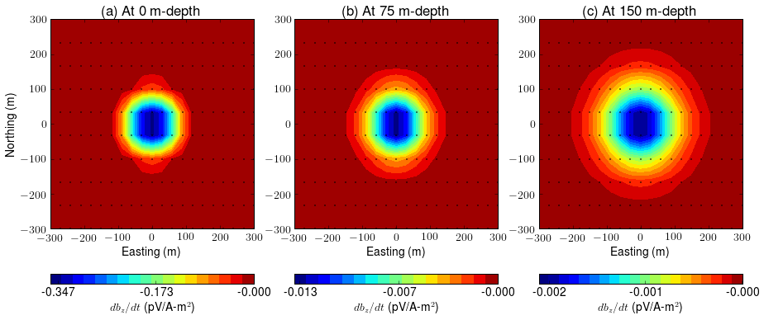

Figure 5. True IP responses computed by subtraction shown in Eq. (4). Depth of the chargeable cylinder varies: a) 0m, b) 75 m, and c) 150-m depth. Dots indicate horizontal locations of soundings.
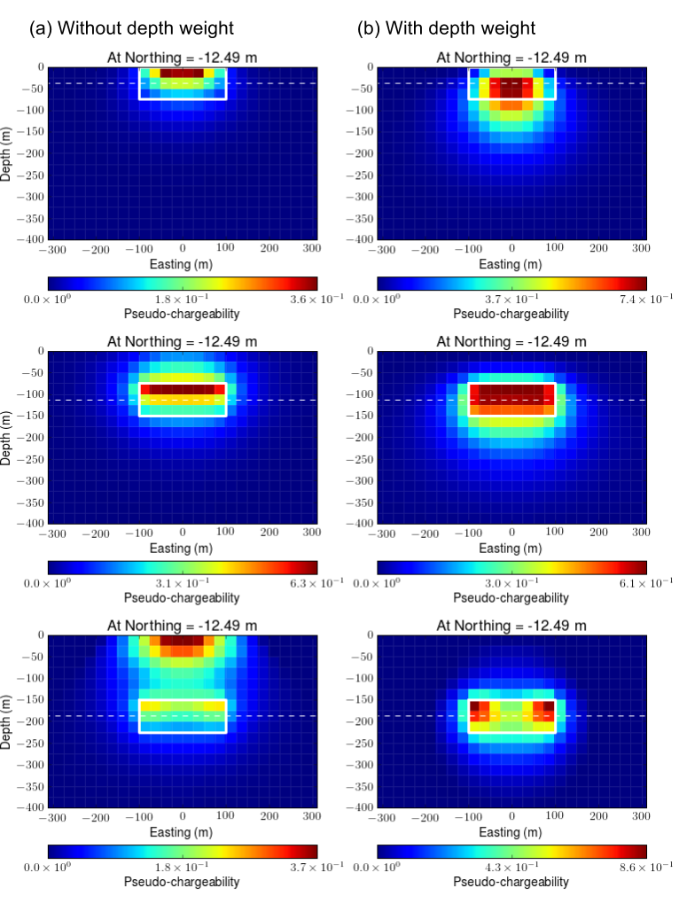
Figure 6. Sections of recovered pseudo-chargeability at different depths. (a) Without depth weight and (b) with depth weight. Top, middle, and bottom panel correspondingly indicate chargeable target at 0, 75, and 150 m-depth.

FIELD EXAMPLE: TKC

TKC ATEM data

Three airborne EM surveys have flown at TKC region by DIGHEM, AeroTEM, and VTEM systems. Although other AEM data sets suggest important information about TKC region, we focus on the VTEM data set because this clearly illustrates possible challenges we can encounter when handling AIP data. As shown in Figure 6(a), even at the earliest time (90 micro-s), VTEM data includes negative values (dotted contours) near DO-18 and between DO-18 and -27 , whereas DO-27 has positive high anomaly (solid contour) at this time, but changes to negative at 680 micro-s as shown in Figure 3b. Easting profile lines over DO-18 and -27 clearly show these trend, which are respectively shown in Figure 3(c) and (d).

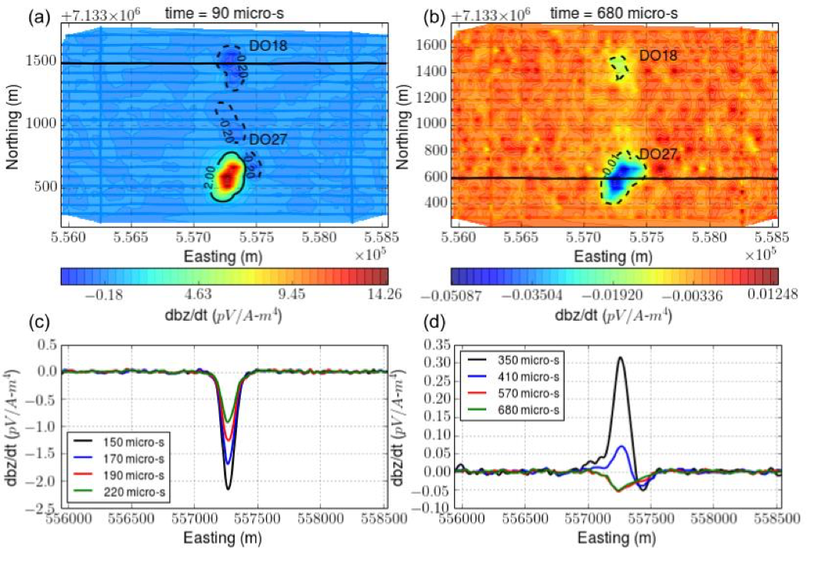
Figure 7. TKC VTEM data. Maps of VTEM responses at (a) 90 micro-s and (b) 680 micro-s. Easting profile line data near (c) DO-18 and (d) DO-27.

3D ATEM and IP inversions

Our approach to handle AIP data based upon Kang et al. (2016). First step is inverting ATEM data. At this step, to exclude possible IP effects in the observation, we only use first 6 time channels of the VTEM data (90-190 micro-s) near DO-27. For the VTEM data near DO-18, even the earliest channel is negative thus, we do not have positive data to invert. Fortunately, we have DIGHEM data covers DO-18, and they did not show distinctive IP signature in the observation although they might be affected by chargeable materials at TKC region. We cooperatively invert VTEM and DIGHEM data. Recovered 3D conductivity model is shown in Figure 8. At B-B’ section, we provided boundaries of different kimberlite units based upon drilling results (Figure 2b). Two conductive pipes near DO-18 and -27 are imaged at depth. Conductive pipe at DO-27 show deeper depth than one at DO-18. Location of recovered conductive pipe at DO-27 matches well with the PK unit.

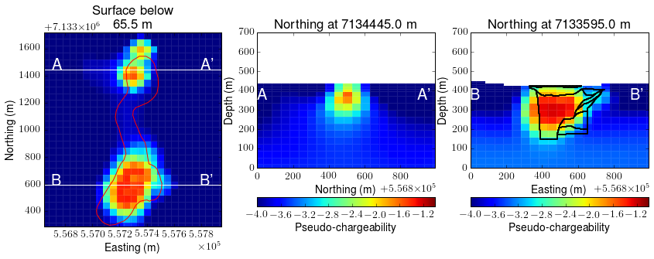
Figure 8. Recovered 3D conductivity model. Left panel shows plan view at 65.5 mbsf. Middle and right panels show section views at Northing 713445m and 7133595m.

Based upon the recovered conductivity, σ_{est}, we proceed EM-decoupling:

(6)

where d^{obs} is the observed data, and F[σ_{est}] is predicted data. Figure 9. shows the observed, predicted and raw IP data at 410 micro-s where both EM and IP effects are considerable in the observation. Our EM-decoupling effectively removes EM induction effects due to conductive pipe at DO-27.

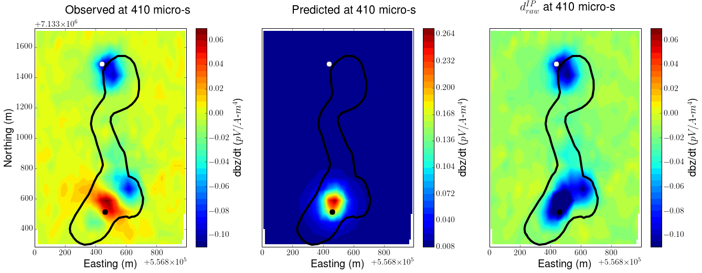

Figure 9. Plan maps of observed (left panel), predicted (middle panel) and raw IP (right panel) data at 410 (bottom panel) micro-s.

We separately invert each time channel of raw IP data and recover 3D pseudo-chargeability at multiple times. Figure 10. shows recovered pseudo-chargeability at 130 and 410 micro-s. Four chargeable anomalies are imaged at depths (A1-A4). A1, A2, A3, and A4 might be correspondingly connected to XVK, VK, HK, and PK. A1-A3 are imaged at 130 micro-s, whereas A4 is imaged not at this time but at 410 micro-s. This reflects different time decaying feature of the AIP signals, and is aligned well with the complex impedance measurements shown in Figure 3 (PK (A4) has smaller time constant than HK (A3) and XVK (A1)). Recalling the PK is the most diamondiferous unit, recovered pseudo-chargeability at these two different times provide distinction of PK from three other units: XVK, VK, and HK in 3D space. In particular, at B-B’ section (DO-27) comparisons of the pseudo-chargeability at 130 and 410 micro-s provide delineation of PK from HK, and this matches well with geological boundaries as shown in the right panel of Figure 10.

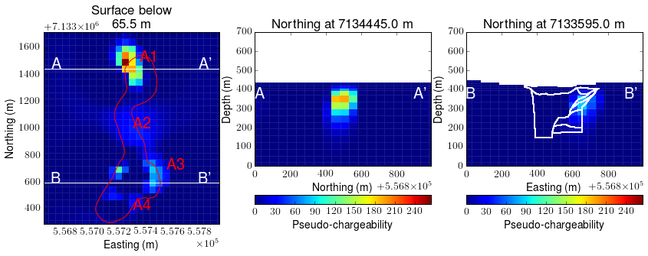
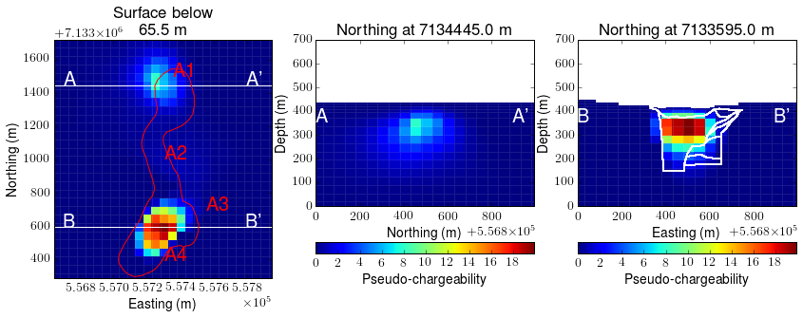
Figure 10. Recovered 3D pseudo-chargeability model at 130 (top row) and 410 (bottom row) micro-s. Left panel shows plan view at 65.5 mbsf. Middle and right panels show section views at Northing 713445m and 7133595m.

CONCLUSIONS

In this paper, we investigated the feasibility of AIP technique for kimberlite exploration with the TKC kimberlite example. Promising lab measurement results showed TKC kimberlites are chargeable, and they have different IP parameters. These raised two important questions: a) Can we invert ATEM data for chargeability? and b) Can this provide some meaningful information about the kimberlite? Analyzing depth resolution of the AIP was crucial to answer above questions. For this, we generated synthetic ATEM data with a chargeable target at different depths, and observed negative transients. This showed that we could detect IP signals from a chargeable target at depth when the host rock is resistive with moderately conductive chargeable chargeable target. In addition, by applying 3D IP inversion to these synthetic IP signals from a chargeable target at different depths, we showed that we could obtain reasonable depth information from recovered pseudo-chargeability. Impact of depth weight was tested, and the result showed that it helps, but not crucial.

Based upon above analyses, we applied 3D ATEM-IP inversion workflow to TKC VTEM data. To recover conductivity, we inverted several early time channels of VTEM data (minor IP-contamination), and successfully recovered 3D conductivity model. Recovered conductivity includes two moderately conductive pipes near DO-18 and -27 at depths. We applied EM-decoupling using the recovered conductivity, and effectively removed EM induction effects in the observation resulting in multiple time channels of the raw IP data. 3D IP inversions are separately applied to each time channel of the raw IP data, and restored pseudo-chargeability at multiple times. Four chargeable anomalies are imaged at depths (~70 m): A1-A4 which may correspond to four different kimberiltes: XVK, VK, HK and PK. Recovered pseudo-chargeability at different times suggested possible distinction of four kimberlites based on spatial distribution and time decaying feature. PK showed slower decay compared to three other units, and this is aligned with complex impedance measurements from TKC core samples. Therefore, a) we can invert ATEM data to recover pseudo-chargeability, and b) recovered pseudo-chargeability at multiple times can provide meaningful information for kimberlite exploration. This study addresses two essential questions in the AIP technique, and raise more thorough discussions on this to be established as a verified geophysical method.

ACKNOWLEDGEMENTS
XXX
REFERENCES

Jansen, J., and K. Witherly, 2004, The Tli Kwi Cho kimber- lite complex, Northwest Territories, Canada: A geophysical case study: SEG Technical Program Expanded Abstracts, 1147–1150.

Macnae, J., 2015, Quantifying Airborne Induced Polarization effects in helicopter time domain electromagnetics: Journal of Applied Geophysics.

Marchant, D., E. Haber, and D. Oldenburg, 2014, Three- dimensional modeling of IP effects in time-domain elec- tromagnetic data: Geophysics, 79, E303–E314.

Smith, R. S., and J. Klein, 1996, A special circumstance of air- borne inducedpolarization measurements: Geophysics, 61, 66–73.

Smith, R. S., P. Walker, B. Polzer, and G. F. West, 1988, The time-domain electromagnetic response of polarizable bod- ies: an approximate convolution algorithm: Geophysical Prospecting, 36, 772–785.

Weidelt, P., 1982, Response characteristics of coincident loop transient electromagnetic systems: 47, 1325–1330.

