Choose Directory and Output file (*.csv).

Input File type: Solartron *.z, Fuchs *.res, LabView *.lvm

Read in directory of all data files.

Data File handler, to allow selection random, next or previous file, and display of file name.

Read in data file. Create float array: Freq, Magn, Angle, Real, Imag

Calculate Cole-plot scales such that all data fits on y=x spacing.

Display and choose maximum and minimum frequencies to use from the data file.

PLOTS: Plot data and fit. Also plot the component interpreted to originate from the rock alone rather than the apparatus. Plot the frequencies corresponding to the Zarc fits.

Cole-Cole Plot: [Real, -Imag]

Bode Plots: [Log(Freq), Log(Magnitude)] and [Log(Freq), Log(Abs(Phase))]

[Log(Freq), dLog(Magnitude)/dLog(Freq)]. This plot has features similar to the Bode Phase plot.

[Log(Freq), Log(Real)] and [Log(Freq), Log(Abs(Imag))]

Plot linear frequency (f = ω/2π) and phase in degrees, for easier intuitive understanding. Since the Cole-Cole plot has high frequency on the left (i.e., low real impedance) and low frequency on the right (high real impedance), reverse the frequency scale to follow the same pattern.

Time Domain: [time, voltage(step up) and voltage(step down)] Shade in Newmont integral, 430 to 1100 ms.

SPECTRAL IMPEDANCE FITTING

Parameters are selected using the series equivalent circuit model, but the calculations are made with either the series or parallel model, set by a switch.

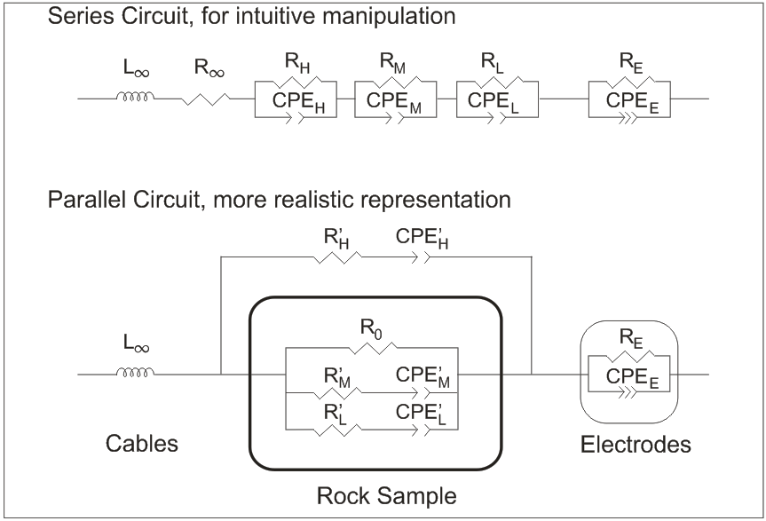

Fit Parameters.

|  |  |  |  |  |
| --- | --- | --- | --- | --- |
| Control Variable | Explanation | Initial Fit Value | Initial Fit Parameter Value | Initial free / constrained |
| Rinf | Log(infinite frequency resistance) | 4 | 1E4 | free |
| Rh | Log(high frequency Zarc resistance), | 5 | 1E5 | free |
| Fh | Log(high frequency Zarc resonant frequency) | 5 | 1E5 | free |
| Ph | 10*(high frequency Zarc exponent) | 8 | 0.8 | free |
| Rm | Log(medium frequency Zarc resistance) | 0 | 1 | constrained |
| Fm | Log(medium frequency Zarc resonant frequency) | -1 | 0.1 | constrained |
| Pm | 10*( medium frequency Zarc exponent) | 5 | 0.5 | constrained |
| Rl | Log(low frequency Zarc resistance) | 4 | 1E4 | free |
| Fl | Log(low frequency Zarc resonant frequency) | 1 | 10 | free |
| Pl | 10*(low frequency Zarc exponent) | 5 | 0.5 | free |
| Re | Log(high frequency Zarc resistance) | 10 | 1E10 | constrained |
| Qe | Log(high frequency Zarc resonant frequency) | -4 | 1E-4 | free |
| Pe-f | 10*(high frequency Zarc exponent for frequency) | 5 | 0.5 | free |
| Pe-i | 10*(high frequency Zarc exponent for phase) | 5 | 0.05 | free |
| Linf | Log(high frequency inductance) | -4 | 1E-4 | free |

For scaling, use the Log10 of exponentially varying parameters, and 10* the variable for parameters that must lie between 0 and 1. Flag “constrained” variables by multiplying value by 1E6. A separate constraint variable vector holds values 1 for “free” and 1E6 for “constrained”.

A “real offset” variable is set, usually at zero, for cases when the high frequency impedance has unanalysable negative resistances.

Derived variables (' for the parallel equivalent circuit):

R'0 = R∞+RH +RM +RL

ωH=2πFH

QH=1/(RH ωHPh);

CH=1/(RH ωH);

R'H = R∞( R∞+ RH ) / RH

Q'H = QH ( RH / (R∞+ RH ) )2

C'H = CH ( RH / (R∞+ RH ) )2

ωM=2πFM

QM=1/(RM ωMPm);

CM=1/(RM ωM);

R'M = ( R∞+ RH ) ( R∞+ RH + RM) / RM

Q'M = QM ( RM / (R∞+ RH + RM) )2

C'M = CM ( RM / (R∞+ RH + RM) )2

ωL=2πFL

QL=1/(RL ωLPl);

CL=1/(RL ωL);

R'L = (R∞+RH+RM)(R∞+RH+RM +RL) / RL

Q'L = QM ( RL / (R∞+ RH + RM+ RL) )2

C'L = CM ( RL / (R∞+ RH + RM+ RL) )2

These are saved in a vector: [Rinf, Ro, Rh, Qh, Ch, Ph, Fh, pRh, pQh, pCh, Rm, Qm, Cm, Pm, Fm, pRm, pQm, pCm, Rl, Ql, Cl, Pl, Fl, pRl, pQl, pCl, Re, Qe, Pe-f, Pe-i, Linf]

In summary, we have model control variables attached to sliders (Linf, Rinf, Rh, Fh, Ph, Rm, Fm, Pm, Rl, Fl, Pl, Re, Qe, Pef, Pei) which related to the model parameters (Series and Parallel models) through a set of simple transformations (log10, or ×10 depending on the expected range of values). The flag indicating if a control variable is “constrained”, that is, fixed in value during model fitting, is saved in a “Constraint Array” (1 for “free”, 1E6 for “fixed”), and the control parameter is multiplied by that same number (1 for “free”, 1E6 for “fixed”).

The predicted model is calculated using the arrays of control variables and constraints, and the array of frequencies as inputs into the subVI “3ZarcE.vi”. The subVI gets to know whether to use the series or parallel model through the global variable “sZarc/pZarc” in “ConstraintsModel ImpedanceSpectrum.vi”.

**Model fitting:**

Regardless of whether the model is built of serial or parallel Zarcs, optimization is accomplished by varying the 15 serial-Zarc model control variables. For each iteration, these control variables are transformed to the relevant model parameters, the misfit between the predicted and observed data is tallied, and a new set of control variables is chosen.

The operator is responsible to

1. **choose the high and low frequency limits.** If there are outlier observations between those limits, the observation points must be edited out in the file. This is a rare occurrence.
   1. Low frequency observations are often noisy. Often they are interpreted to represent the interaction between the sample holder and the sample, and thus they do not help interpretation of the rock impedance mechanisms. Often, there seems to be two different low frequency behaviours, and the model can only account for one. So the lowest frequencies are eliminated from the analysis.
   2. Very high frequency observations (> 1Mhz) are interpreted to be affected by standing waves in the apparatus wires, and must be eliminated. The high frequency Zarc is interpreted to be caused by the resistance of the ionic flow through the permeability coupled with the capacitance of the sample holder, amplified by the dielectric polarization of the sample. While the Zarc model usually fits this component surprisingly accurately, there is no fundamental reason to assume a perfect fit over several orders of magnitude of frequency. Thus it is considered sufficient to have enough points to precisely determine the resonant frequency of this high frequency Zarc, and the higher frequency points will only end in affecting the fit of the more important lower frequency impedance mechanisms.
2. **Choose the parameters to fix.** Usually there is only evidence for two only Zarcs, and interpretation would only be confused by allowing a third Zarc. In these cases, the resistance of the middle frequency Zarc is set to some insignificant value, say 0.1 ohm and fixed. When the Rm is so small, the frequency Fm is irrelevant, and it is set to some very low value (say 0.1 Hz) just to get the symbols for that point out of the way. With Rm, Fm and Pm fixed, it essentially makes a two-Zarc model.
   1. There are times that one fits different parts of the spectrum separately. For example the low frequencies are hidden, and the high frequency Zarc is fit. Then the parameters for the hig frequency Zarc are fixed and the low frequency observations are fit.
3. **Choose the initial model.** The optimization method typically minimizes the objective functions within one energy well. So the initial model must lie within that well, using the physics understanding of the operator.

Optimization is done using the downhill simplex method.

**Downhill Simplex nD ValueImpedanceSpectrum(BodeMisfit).vi**

The objective function is the sum of absolute (L1) or square (L2) deviations between the observed impedance and the model impedance at each of the observed frequencies (after the high and low frequency limits were set). There are three distinct but not independent deviations:

1. **Cartesian deviations:** The magnitude of the complex difference on the Cole-Cole plot, |Zmodel-Zobs|.
2. **Log(magnitude) deviations**: the difference between the logs of the magnitudes, equal to the logarithm of the quotient of the magnitudes. |Log(|Zmodel|)-Log(|Zobs|)|
3. **Log(phase) deviations**: the difference between the logs of the phases, equal to the logarithm of the quotient of the phases. This deviation is the best at fitting important features in low phase parts of the spectrum, especially the chargeability at low frequencies. |Log(angle(Zmodel))-Log(angle(Zobs))|

Deviations 2 and 3 are combined into a single **polar deviation**. They seem to work best with equal weighting. It is possible that there could be other weighting combinations.

In practise the best fits are done by alternating between fits based on Cartesian and polar deviations, ending with the polar deviation fit to ensure that low-phase features are well-fit.

**Tuning the Objective Function.**

1. Hard constraint to limit P exponents to <=1. If any of Ph, Pm, Pl, or Pef is >1, then the misfit function is multiplied by 1000, certainly forcing rejection of any step that attempts to contradict this hard constraint. Note that the Pei, defining the angle of the sample holder impedance, can have any angle.
2. Soft constraint to encourage P exponents to >0.2 . When P exponents are below 0.2, the Zarc frequencies are spread out and the Zarc is poorly defined. For each P, the misfit function is multiplied by 3exp(-15P)+1.

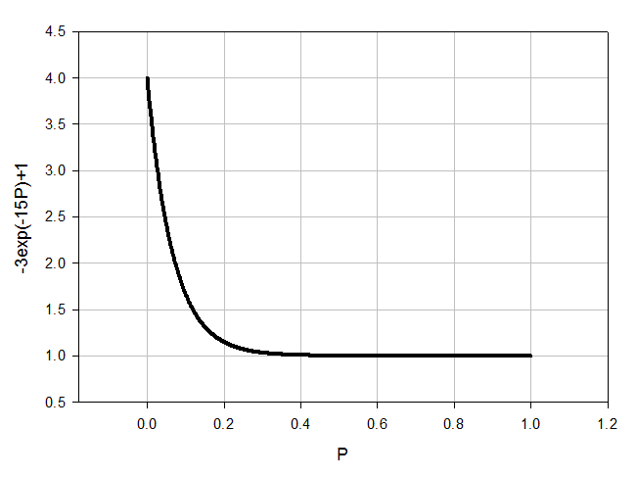

1. Soft constraint on step size. There is no penalty when the model step is small, but there is when the step is large. The deviations in the 15 model control variables divided by the constraint width, squared and summed, and added to one. This penalty multiplies the data misfit.