GTU

**DEPARTMENT OF COMPUTER ENGINEERING**

**CSE 312 – Spring 2023**

**HOMEWORK 2  
REPORT**

SÜLEYMAN GÖLBOL 1801042656

# REQUIREMENTS

***NONFUNCTIONAL REQUIREMENTS***

1. Portability → The application should be portable. All computers that have Linux Ubuntu 14.04 Virtual Machine with GCC compiler can run the program.

2. Maintainability → In case of an interrupt occurrence, the system in order handles interrupt to give feedback on terminal or to use system calls.

3. Performance → The system’s performance should be fast enough to show user the feedback.

***FUNCTIONAL REQUIREMENTS***

These are the requirements that I install in order to run the program.

# sudo apt-get update

# sudo apt-get install build-essential

After installing those, I installed Oracle VirtualBox on my computer and inside the VirtaulBox, I used the VirtualBox machine which is provided by lecturer.

These are the commands that I use to create the binary file.

**make clean  
make run**

1. **PROBLEM SOLUTION APPROACH AND REQUIREMENT ACHIEVEMENT**

Binary and Linear Search -> One thread for binary, one thread for linear search.

**3 ) FUNCTIONS**

Since collatz will give different sequence results for odd and even numbers, these are the method that I used.

metin içeren bir resim

Açıklama otomatik olarak oluşturuldu

Linear Search

metin, ekran, ekran görüntüsü içeren bir resim

Açıklama otomatik olarak oluşturuldu

Binary Search

metin içeren bir resim

Açıklama otomatik olarak oluşturuldu

Round Robin Scheduling

metin içeren bir resim

Açıklama otomatik olarak oluşturuldu

Process Creation

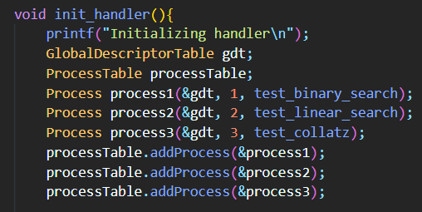

Here 1,2,3 are the process ids.

Forking

metin içeren bir resim

Açıklama otomatik olarak oluşturuldu

Here interrupt $0x80 calls system calls dointerrupt method and with this way using a and b, I sent information.

Pt_regs is similar to cpustate, I learned the content of the pt_regs from here.

<https://faculty.nps.edu/cseagle/assembly/sys_call.html>  
metin içeren bir resim

Açıklama otomatik olarak oluşturuldu

**4 ) TEST CASES AND RESULTS**

# 3.a) LINEAR SEARCH

# metin içeren bir resim Açıklama otomatik olarak oluşturuldu

# 3.b) BINARY SEARCH

# metin içeren bir resim Açıklama otomatik olarak oluşturuldu

# 3.c) COLLATZ (I DON’T HAVE PRINTF THAT WRITES DECIMAL SO THESE ARE HEXADECIMAL RESULTS)

# metin içeren bir resim Açıklama otomatik olarak oluşturuldu

# All 3 microkernels run until infinity. So you need the exit the virtual machine.

# Unfortunately, I couldn’t exactly implement fork(), waitpid() and execve(). I made the connections between the function that fork is called and system call file that has handleInterrupt function.