GTU

**DEPARTMENT OF COMPUTER ENGINEERING**

**CSE 463 – Spring 2022**

**HOMEWORK 1  
REPORT**

SÜLEYMAN GÖLBOL 1801042656

1. **PROBLEM SOLUTION APPROACH AND ALGORITHMS**

My first problem that I have encountered in application was OpenCV’s window problems. For example, OpenCV doesn’t close the window when user clicks into X button. To solve this problem I named window and used the function below.



To get the 4 points from user I used if event == cv.EVENT_LBUTTONDOWN: to get the mouse left clicks from user and in every click, I saved the position into a list and after 4 points, I sent these points to my Homography module.

To select button option between webcam or folder; I used tkinter module.



If user opens webcam to save image from it, in the left top of the screen, a text appears for the exit and capture keyboard shortcuts.

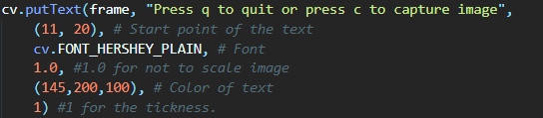

After user selects the image and save the 4 points of input image, the Homography class is being called.

**I** **INTERSECTION OF PARALLEL LINES**

To find the intersection of parallel lines in the soccer model field,

In the formula above, O shows a matrix full of One’s. And the size of it is 10x10 (because of coordinates) to multiply.  
After we get the deviation score; if we multiply transpose of the matrix with this matrix, we get a new matrix that is n (size, in our case 10) times bigger than covariance matrix.

**INTEGER/DOUBLE - STRING CONVERSION**

And if the divide this value to n (10), we get the covariance matrix.  
  
 Covariance matrix: a‘ * a / n

**Example** from my input file:

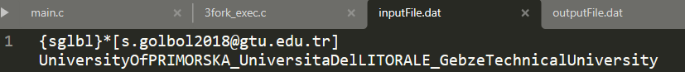

My input file starts with this line and when my program reads first 10 coordinates (30 bytes);  
It gives this output to stdout:

To calculate covariance matrix, first I needed to get the deviation score matrix.

O * A

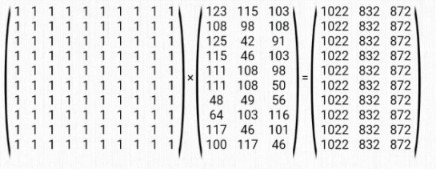

O * A * ( 1 / n )

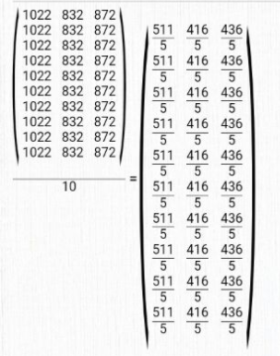

a = A – O * A * ( 1 / n )

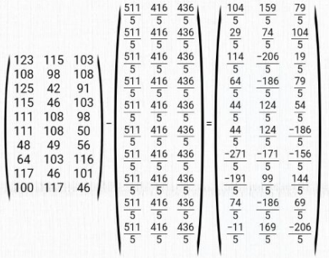

Now if we multiply its transpose matrix with itself and then if we divide to the size we will get covariance matrix.

Covariance matrix: a‘ * a / n

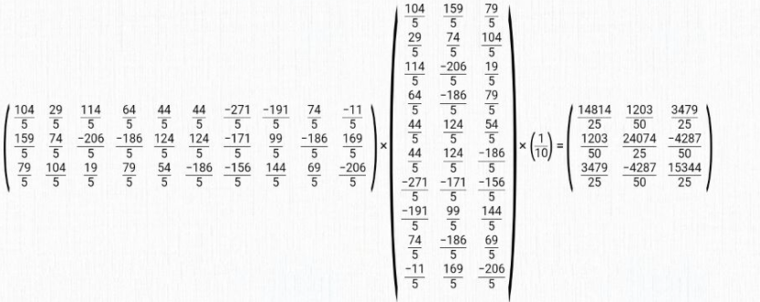

This value is my covariance matrix of first child.

After this, for the frobenius norm, it wasn’t difficult. I just summed the squares of output values and then get the square root of it.

**INTEGER/DOUBLE - STRING CONVERSION**

Another big problem that I was into was printing integer or double values using write(STDOUT_FILENO, …) system call.

write() doesn’t have formatter like printf does. So it needs char* as argument and itoa is not C standard function for every environment so I tried to create a int variable and send it’s address to function but it didn’t work while printing so I tried to cast to void* and dereferenced it , also it didn’t work. So I wrote my own itoa function that works for nonnegative ascii integers.

Also I wrote my own double to string function for double value printing. I thought 2 parts of double(before dot, after dot) as different values then I converted them to string with putting “.” between these two.

**3 ) TESTS AND RESULTS**

# TEST SS VE JUPYTERR

# 

# GUI

# 

# 

# 

# 

# 