CS153 Final Project: Pirate Compiler

The Tokenizers



Members:
Marie "Wycee" de Vera
Stefan Gloutnikov
Chris Shoban

Table of Contents
Table of Contents 2
Compiler Design 3
High-Level Description 3
UML Diagrams 4
Source Language Grammar, BNF for Pirate.jj 5
TOKENS 5
NON-TERMINALS 6
Jasmin Code Diagrams 9
Procedure and Function 9
While Loop 10
If-Else 11
For Loop 12
To Run the Pirate Program 14

Compiler Design

High-Level Description
The Pirate programming language has a JavaCC grammar consisting of pirate terms that correspond to common language constructs, such as ‘if’, ‘while’, and so on. JavaCC is used to generate a scanner and parser for the language, which results in a parse tree consisting of the nonterminals of the grammar. JJTree is used to preprocess the JavaCC grammar to construct an Abstract Syntax Tree (AST) when the parser is generated and executed with a .arr program file. The grammar for the Pirate source language is defined in Pirate.jjt using methods to represent each EBNF statement of the grammar.
The corresponding Pirate Compiler is a four-pass compiler: the first pass builds an AST, the second pass decorates the AST with type information, the third pass generates Jasmin assembly code, and the fourth pass assembles the object (.j) file to get a Java .class file that can be run with the Java Virtual Machine (JVM). The type setting of variables in the AST and the Jasmin code generation is made possible through use of the Visitor pattern, which does a post-order traversal of the tree. JJTree generates AST nodes that represent each nonterminal of the grammar, and the Visitor pattern is used to visit each node. The Pirate Compiler generates corresponding Jasmin instructions based on the type of a node.
The compiler utilizes the symbol table and intermediate code node design as described in Ronald Mak’s “Writing Compilers and Interpreters: A Software Engineering Approach”. The symbol table stack keeps track of all of the identifiers and their corresponding type and attributes (based on the definition of the identifier). The intermediate code node is integrated with the AST by extending the Node interface generated by JJTree to the ICodeNode. This allows the compiler to reuse classes such as the Cross Reference and Parse Tree printer that was already created
The compiler outputs a Jasmin .j object file when it parses a source file written in the Pirate language. This .j file can be assembled using the Jasmin assembler (http://jasmin.sourceforge.net/), which generates a .class file. Jasmin is an assembler for the JVM, the target machine. Any computer that supports Java can run the .class file.

UML Diagrams

The following UML diagram shows the relationships between major classes.

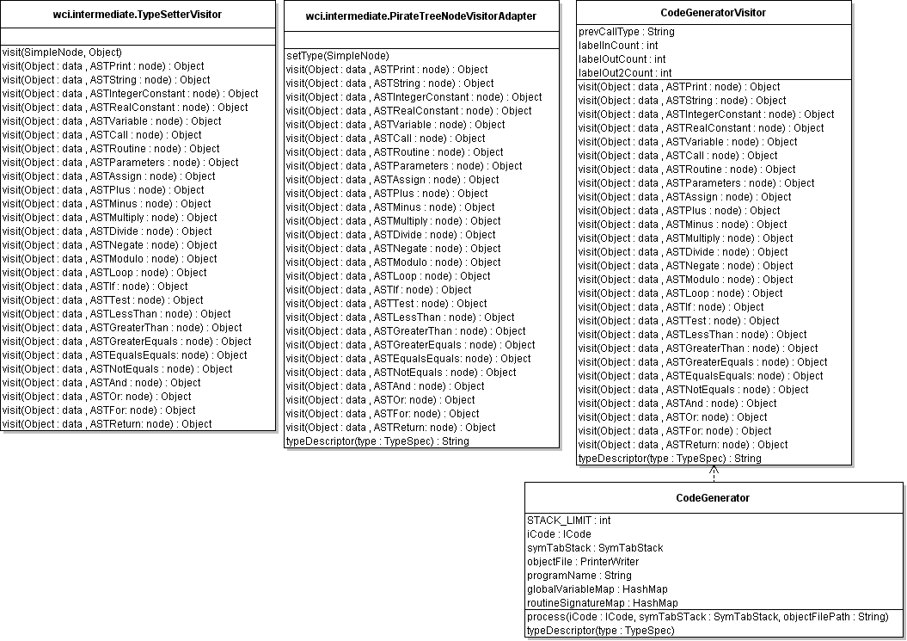
UML of CodeGenerator which applies Visitor Pattern in CodeGeneratorVistitor.java

Source Language Grammar, BNF for Pirate.jj

TOKENS
<DEFAULT> SKIP : {
" "
| "\r"
| "\t"
| "\n"
| <"//" (~["\n","\r"])* ("\n" | "\r")>
| "/*" : SLASH_STAR
}

<SLASH_STAR> SKIP : {
"*/" : DEFAULT
| <~[]>
}

<DEFAULT> TOKEN : {
<CHARACTER: (["\'"]){1} ((["\\"]){1} ("n" | "t" | "\'" | "\\") | (~["\'"]){1}) (["\'"]){1}>
}

<DEFAULT> TOKEN : {
<STRING: (["\""]){1} ((["\\"]){1} ("n" | "t" | "\"" | "\\") | ~["\"","\\","\n"])* (["\""]){1}>
}

<DEFAULT> TOKEN : {
<BUCCANEERS: "Buccaneers">
| <THARSHEBLOWS: "TharSheBlows">
| <FORE: "Fore">
| <RUM: "RUM">
| <ARRR: "Arrr">
| <MAKESAIL: "MakeSail">
| <GUNNER: "Gunner">
| <OVERBOARD: "Overboard">
| <PILLAGE: "Pillage">
| <WEIGHANCHOR: "WeighAnchor">
| <YOHOHO: "YoHoHo">
| <HARHARHAR: "HarHarHar">
}

<DEFAULT> TOKEN : {
<LESS_EQUALS: "<=">
| <GREATER_EQUALS: ">=">
| <EQUAL_EQUALS: "==">
| <OR: "||">
| <AND: "&&">
| <NOT_EQUALS: "!=">
| <SLASH_SLASH: "//">
| <STAR_SLASH: "*/">
| <BANG: "!">
| <PERCENT: "%">
| <STAR: "*">
| <MINUS: "-">
| <PLUS: "+">
| <EQUALS: "=">
| <SLASH: "/">
| <LESS_THAN: "<">
| <GREATER_THAN: ">">
| <COMMA: ",">
| <QUOTE: "\'">
| <DOUBLE_QUOTE: "\"">
| <LEFT_PAREN: "(">
| <RIGHT_PAREN: ")">
| <LEFT_BRACKET: "[">
| <RIGHT_BRACKET: "]">
| <LEFT_BRACE: "{">
| <RIGHT_BRACE: "}">
| <BOOTY: "$">
}

<DEFAULT> TOKEN : {
<IDENTIFIER: <LETTER> (<LETTER> | <DIGIT>)*>
| <INTEGER: <UNSIGNED_NUMBER>>
| <REAL: <WHOLE> <FRACTION> <EXPONENT> | <WHOLE> <FRACTION> | <WHOLE> <EXPONENT>>
| <#LETTER: ["a"-"z","A"-"Z"]>
| <#DIGIT: ["0"-"9"]>
| <#SIGN: ["+","-"]>
| <#UNSIGNED_NUMBER: (<DIGIT>)+>
| <#WHOLE: <UNSIGNED_NUMBER>>
| <#FRACTION: "." <UNSIGNED_NUMBER>>
| <#EXPONENT: "E" (<SIGN>)? <UNSIGNED_NUMBER>>
}

<DEFAULT> TOKEN : {
<ERROR: ~["\r","\n"]>
}

NON-TERMINALS
PirateProgram | ::= | ProgramHeader block <EOF>
ProgramHeader | ::= | <YOHOHO> <IDENTIFIER> <BOOTY>
block | ::= | Declarations MainProcedure <LEFT_BRACE> ( ( VariableDeclaration ) )* FunctionCompoundStatement <RIGHT_BRACE>
MainProcedure | ::= | <PILLAGE> <WEIGHANCHOR> formalParameterList
Declarations | ::= | ( ( <BUCCANEERS> ) ( VariableDeclaration )+ )? ( ( functionDeclaration | procedureDeclaration ) )*
VariableDeclaration | ::= | <IDENTIFIER> <IDENTIFIER> ( <EQUALS> Expression )? <BOOTY>
ParameterVariableDeclaration | ::= | <IDENTIFIER> <IDENTIFIER>
Statement | ::= | ( CompoundStatement | ( ( AssignmentStatement | procedureCall ) | ifStatement | whileStatement | ForStatement | returnStatement | printStatement ) <BOOTY> )
ProcedureBody | ::= | ( AssignmentStatement | CompoundStatement | ifStatement | whileStatement | ForStatement )
LessThan | ::= | <LESS_THAN> SimpleExpression
GreaterThan | ::= | <GREATER_THAN> SimpleExpression
LessEquals | ::= | <LESS_EQUALS> SimpleExpression
GreaterEquals | ::= | <GREATER_EQUALS> SimpleExpression
NotEquals | ::= | <NOT_EQUALS> SimpleExpression
EqualEquals | ::= | <EQUAL_EQUALS> SimpleExpression
Expression | ::= | SimpleExpression ( LessThan | GreaterThan | LessEquals | GreaterEquals | NotEquals | EqualEquals )?
SimpleExpression | ::= | ( "+" Term | Negate | Term ) ( Plus | Minus | Or )*
Negate | ::= | "-" Term
Plus | ::= | "+" Term
Minus | ::= | "-" Term
Or | ::= | "||" Term
Term | ::= | Factor ( ( Multiply | Divide | Modulo | And ) )*
Multiply | ::= | "*" Factor
Divide | ::= | "/" Factor
Modulo | ::= | "%" Factor
And | ::= | "&&" Factor
IntegerConstant | ::= | <INTEGER>
RealConstant | ::= | <REAL>
Error | ::= | <ERROR>
Factor | ::= | ( FunctionCall | Variable )
 | | | IntegerConstant
 | | | RealConstant
 | | | String
 | | | Character
 | | | Not
 | | | ( ( <LEFT_PAREN> ) Expression ( <RIGHT_PAREN> ) )
String | ::= | <STRING>
Character | ::= | <CHARACTER>
Not | ::= | <BANG> Factor
AssignmentStatement | ::= | Variable ( "=" Expression )+
ifStatement | ::= | <ARRR> <LEFT_PAREN> Expression <RIGHT_PAREN> Statement ( <THARSHEBLOWS> Statement )?
whileStatement | ::= | <MAKESAIL> Condition Statement
returnStatement | ::= | <OVERBOARD> ( String | IntegerConstant | RealConstant | Variable )
printStatement | ::= | <HARHARHAR> <LEFT_PAREN> ( String | IntegerConstant | RealConstant | Variable ) <RIGHT_PAREN>
ForStatement | ::= | <FORE> ForInitializeStatement ( "{" ) statementList ( "}" )
ForInitializeStatement | ::= | RumVariable <EQUALS> IntegerConstant
RumVariable | ::= | <RUM>
MethodName | ::= | <IDENTIFIER>
functionDeclaration | ::= | <GUNNER> <IDENTIFIER> <IDENTIFIER> formalParameterList <LEFT_BRACE> ( ( VariableDeclaration ) )* FunctionCompoundStatement <RIGHT_BRACE>
procedureDeclaration | ::= | <PILLAGE> <IDENTIFIER> formalParameterList <LEFT_BRACE> ( ( VariableDeclaration ) )* FunctionCompoundStatement <RIGHT_BRACE>
formalParameterList | ::= | <LEFT_PAREN> ( ParameterVariableDeclaration ( ( <COMMA> ParameterVariableDeclaration )* ) )* <RIGHT_PAREN>
actualParameterList | ::= | ( ( <LEFT_PAREN> <RIGHT_PAREN> ) | ( <LEFT_PAREN> Expression ( ( <COMMA> Expression )* ) <RIGHT_PAREN> ) )
FunctionCall | ::= | MethodName actualParameterList
procedureCall | ::= | MethodName actualParameterList
Condition | ::= | <LEFT_PAREN> Expression <RIGHT_PAREN>
CompoundStatement | ::= | <LEFT_BRACE> statementList <RIGHT_BRACE>
FunctionCompoundStatement | ::= | statementList
statementList | ::= | ( Statement )*
Variable | ::= | <IDENTIFIER>
processVariableDecl | ::= | java code
processParameterVariableDecl | ::= | java code
handleError | ::= | java code

Jasmin Code Diagrams

Procedure and Function

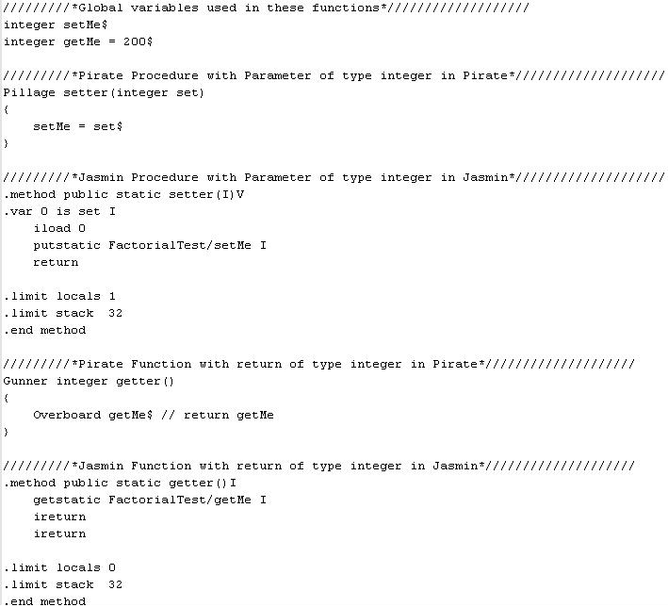

Code Diagram for a Function and Procedure In Pirate Language Converted to Jasmin Using Visitor Pattern

While Loop

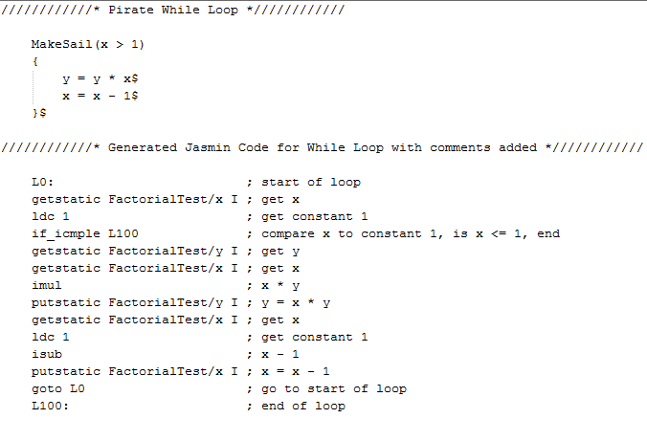

Code Diagram for While Loop In Pirate Language Converted to Jasmin Using Visitor Pattern

If-Else

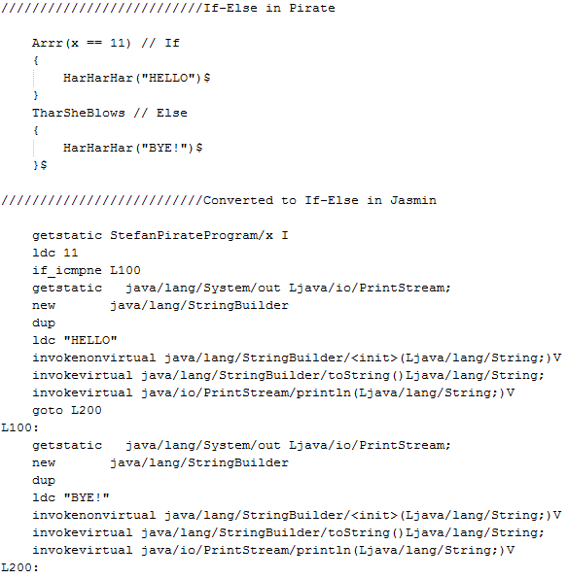

Code Diagram for If-Else In Pirate Language Converted to Jasmin Using Visitor Pattern

For Loop

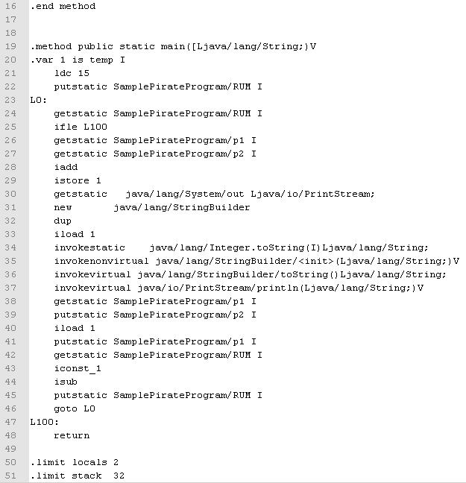

Code Diagram for For Loop In Pirate Language Converted to Jasmin Using Visitor Pattern

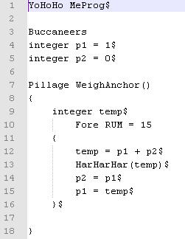

Pirate Language For Loop

To Run the Pirate Program
The Pirate Program Files available to test include all files ending in “.arr”
To run the Pirate Program:
- Compile with JavaCC the Pirate.jjt file in Eclipse
- Run Pirate.java as a program with the argument of “PirateProgramFileName.arr”
- The file named “PirateProgramFileName.j” will now be generated in Eclipse
- From the directory of the generated “PirateProgramFileName.j”
- To assemble the .j Jasmin file in a class file, the user will need to type
“java -jar jasmin.jar PirateProgramFileName.j”
- Final you can run the class program by typing
“ java PirateProgramFileName”

