**SGN-41007 Assignment Task 1**

Group 15: Pasi Virta, Kalle Aaltonen, Samuli Ainola-Pukkila, Aleksi Timonen

Our group followed the instructions given for the assignment as closely as possible.

**At step four** we implemented all the mandatory vectorization approaches. In the optional part we also implemented choosing sensors, transforming quaternions into orientation angles and accelerations and velocities into absolute values.

After preprocessingour LDA gave results as seen below.

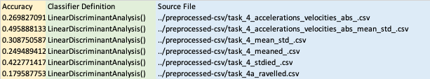

The best results came from changing accelerations and velocities to absolute values and taking mean and standard deviation from the result, which gave 49,5% accuracy with Linear Discriminant Analysis.

**At step five** we had results seen below

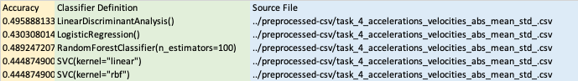

Best result was the LDA at accuracy of 49,5%. Random Forest coming close by at 49%.

**Step seven**

In Kaggle the score for LDA was 55%.