The 3-dimensional tensor *x* of shape  represents the input 𝑥 that is fed into the RNN.

The shape of the 2D slice for each time step is .

The prediction  is a 3D tensor of shape .

For a single time step 𝑡, a 2D slice  has shape .

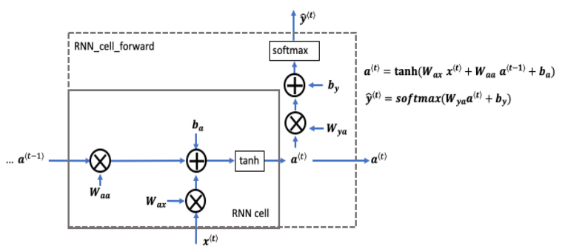

Basic Recurrent Neural Network (RNN) cell.

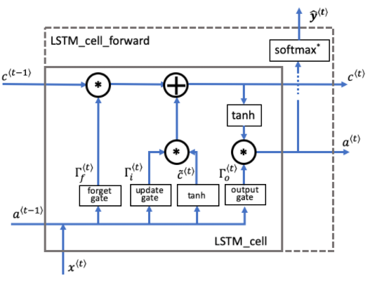

Long Short-Term Memory (LSTM) cell.