Q1.SQL LOADER

Using Concurrent program upload the data present in file “customer.dat” to the table “XXCUSTLAB01USERXX” with the following validation (:instead of xx put your user name so that your table name will not get conflicted with any other user table name”)

1.Make sure no extra spaces shou;d be present in columns

2.gender should have only m and F;reject the data if other characters are there

STEP1:CREATION OF TABLE

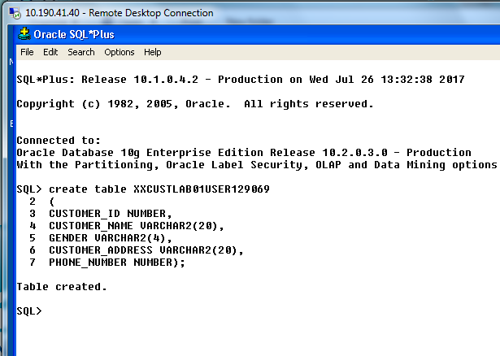

STEP2: CONTROL FILE COPIED TO THE SERVER

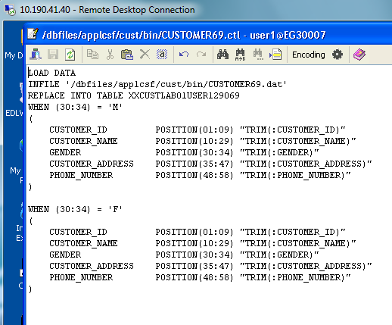

STEP3: DATA FILE COPIED TO THE SERVER

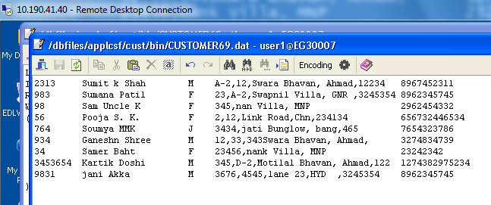

STEP4: APPLICATION DEVELOPER🡪 PROFILE🡪CONCURRENT🡪EXECUTABLES

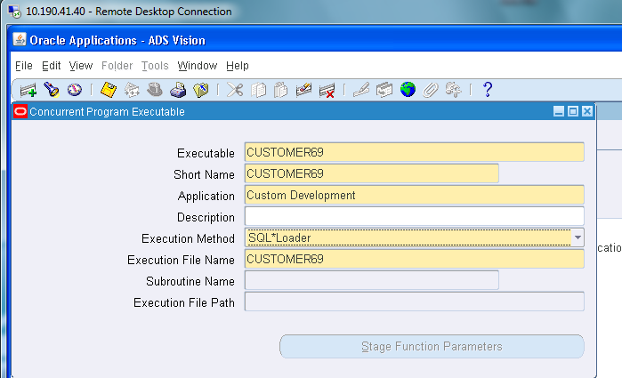

STEP5: APPLICATION DEVELOPER🡪 PROFILE🡪CONCURRENT🡪PROGRAM

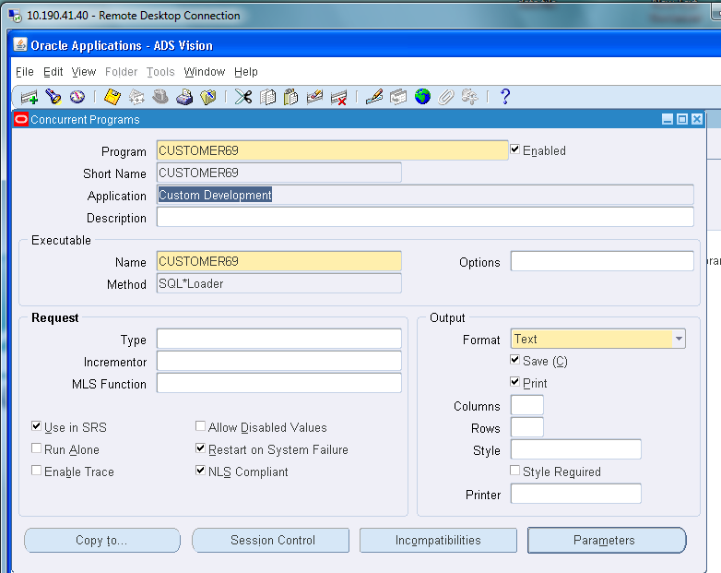

STEP6:REQUESTING GROUP

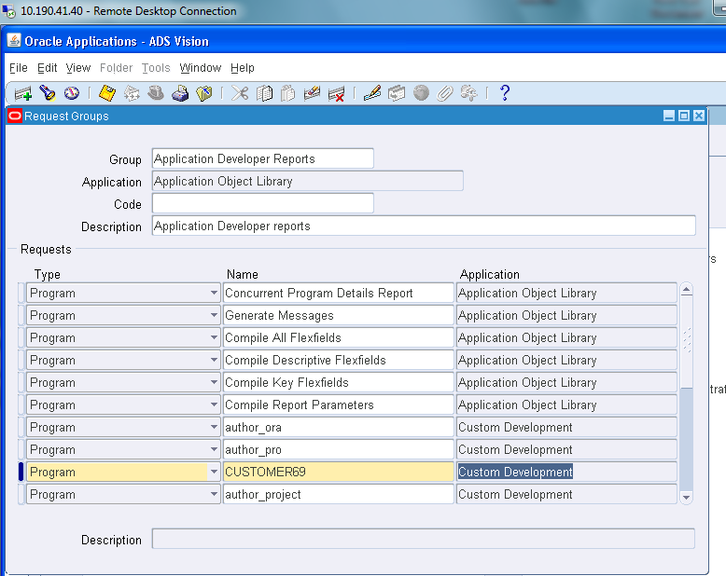

STEP7: SWITH RESPONSIBILITY🡪SYSTEM ADMINISTRATOR🡪SECURITY🡪RESPONSIBILITY🡪REQUEST

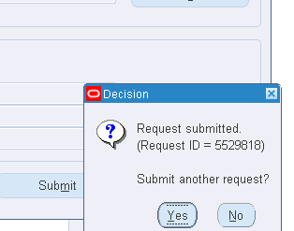

STEP8: REQUESTS, got warning because one record is violating the validations

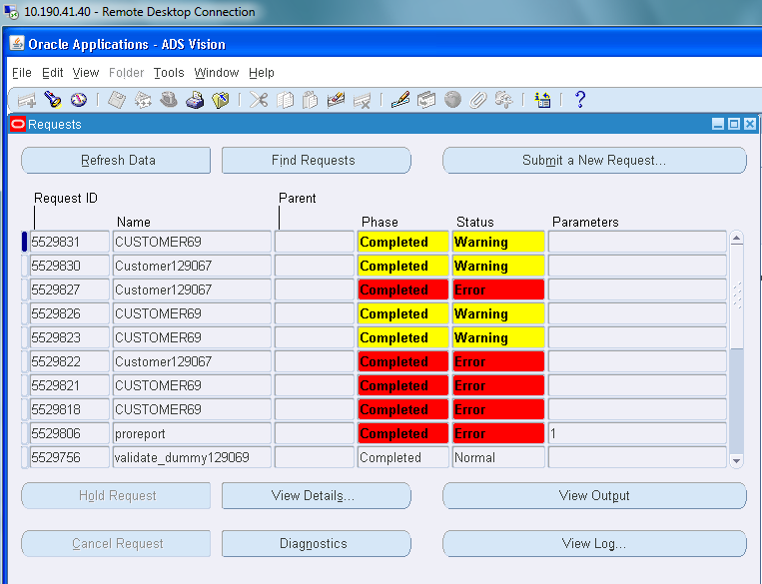

STEP9: OUTPUT

Only 8 rows selected because of validations

