Q2.CONCURRENT PROGRAM

USING CONCURRENT PROGRAM TRANSFER THE DATA FROM XXCUSTLAB01USER129069 to TABLE XXCUSTSTLAB01USER129069 WITH THE FOLLOWING VALIDATIONS

1.REJECT THE DATA IF MOBILE NUMBER>10 digits

2.TRANSFER M to male and F to female while the data in another table

STEP1:PACKAGE

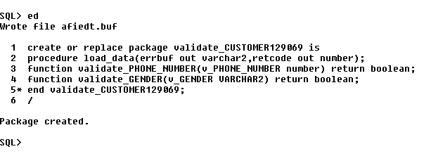

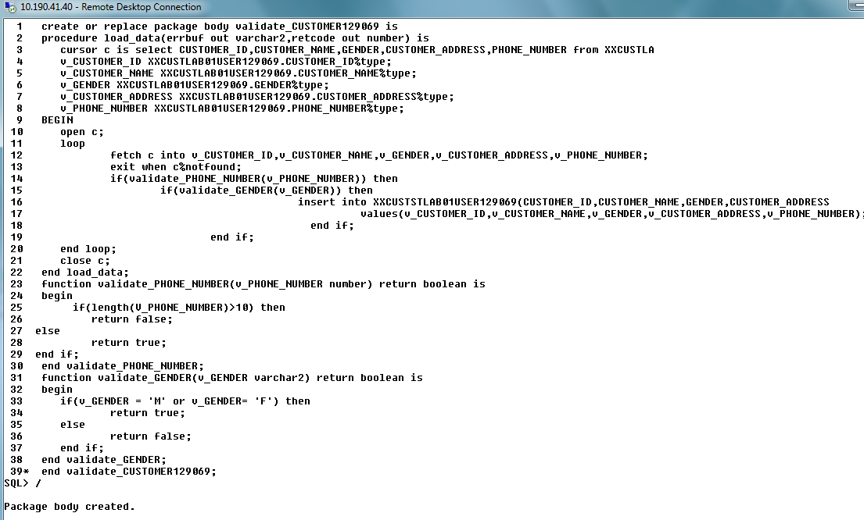

STEP2: EXECUTABLES

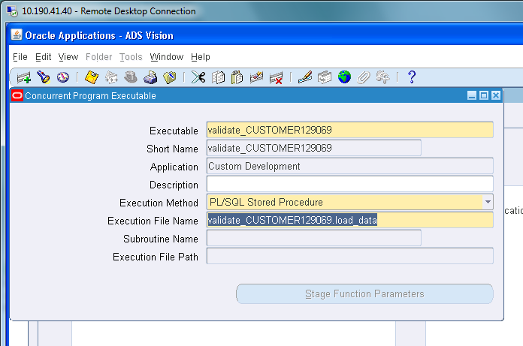

STEP3:PROGRAM

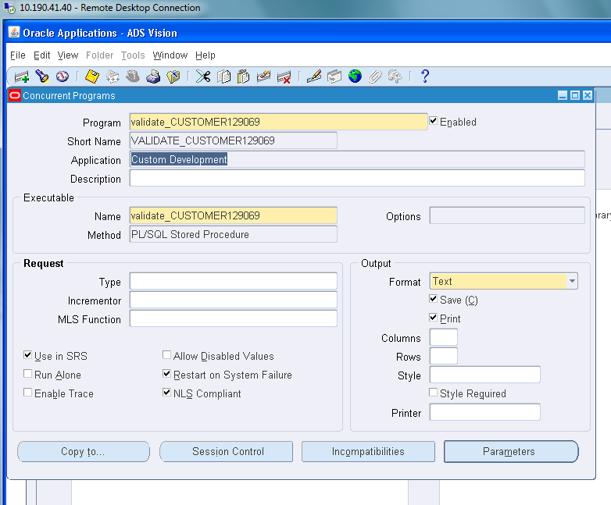

STEP4:REQUEST GROUP

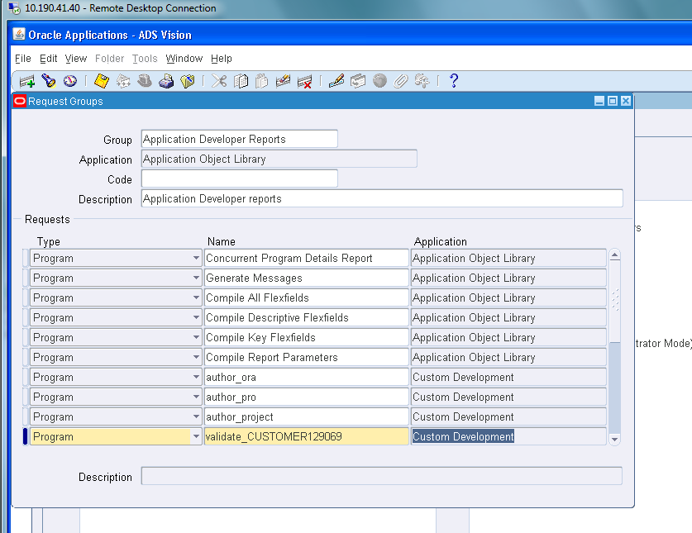

STEP5:

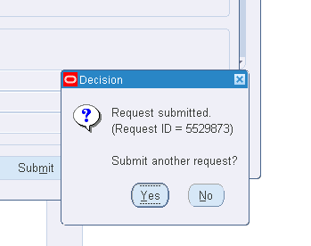

STEP6:

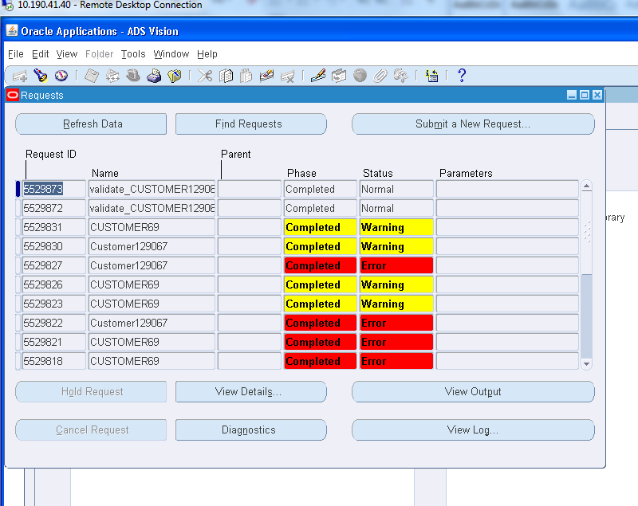

STEP7:OUTPUT

