Q3:FORM PERSONALISATION

ADD THE RESPONSIBILITY “RECEIVABLES SUPER VISION CORPORATION JAPAN” TO YOUR LOGIN.GO to THE FORM AND PERFORM THE FOLLOWING

1.MAKE DOCUMENT NUM FIELD COMPULSORY

2.DISABLE THE BUTTON “DISTRIBUTIONS”

STEP1:ADDING RESONSIBILITY

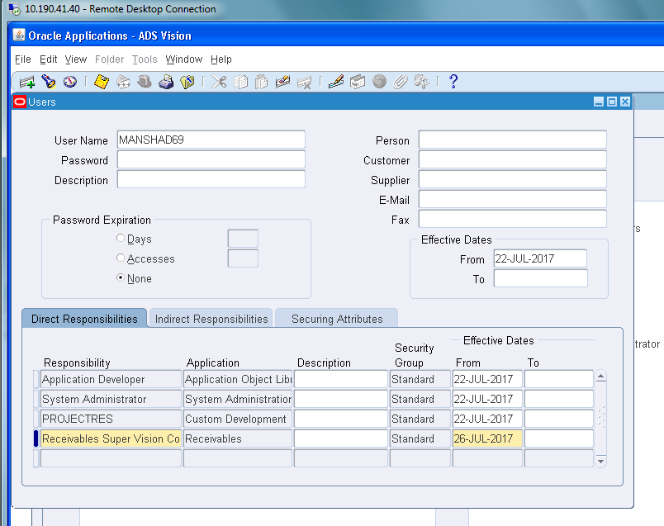

STEP2:UTILITIES DUAGNOSTICS AND HIDE DIAGNOSTICS MENU ENTRY

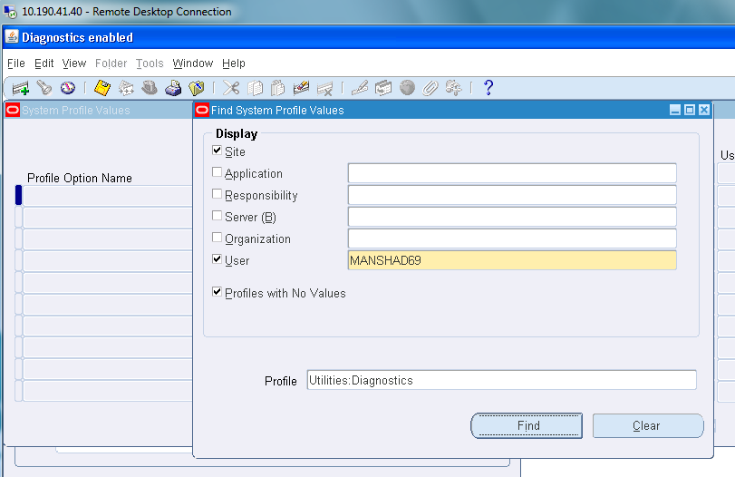

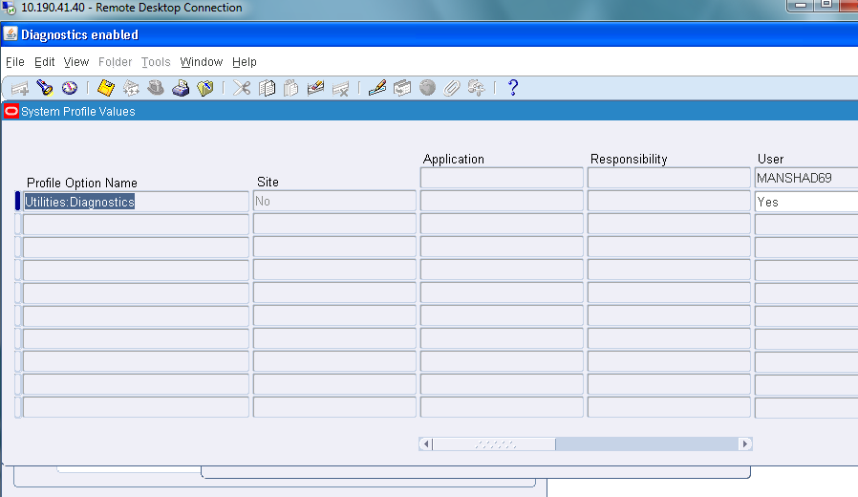

STEP3:HIDE DIAGNOSTICS MENU ENTRY

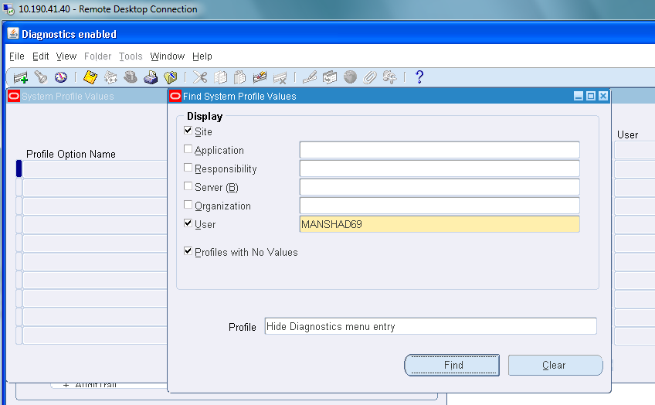

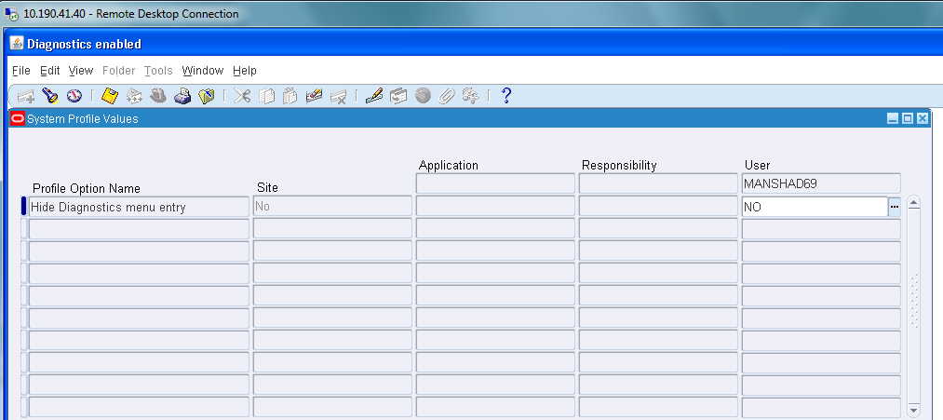

STEP5:

TRANSACTION🡪TRANSACTION

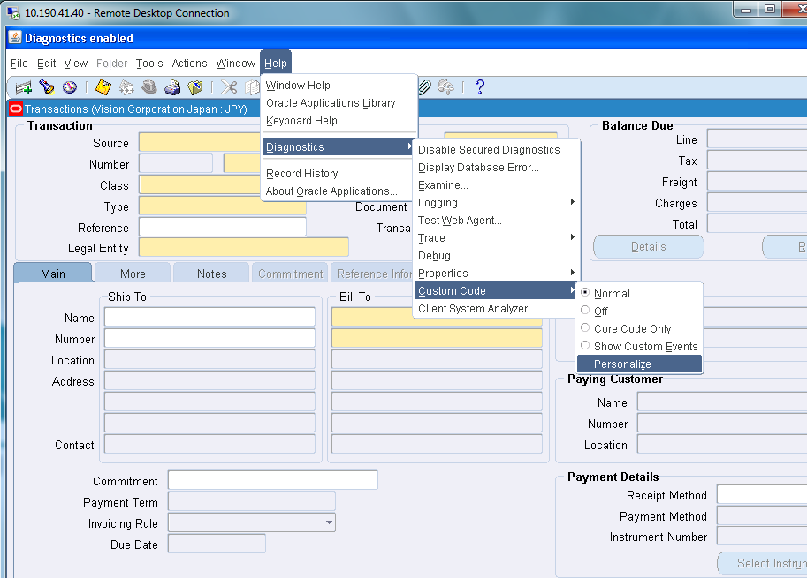

STEP6: 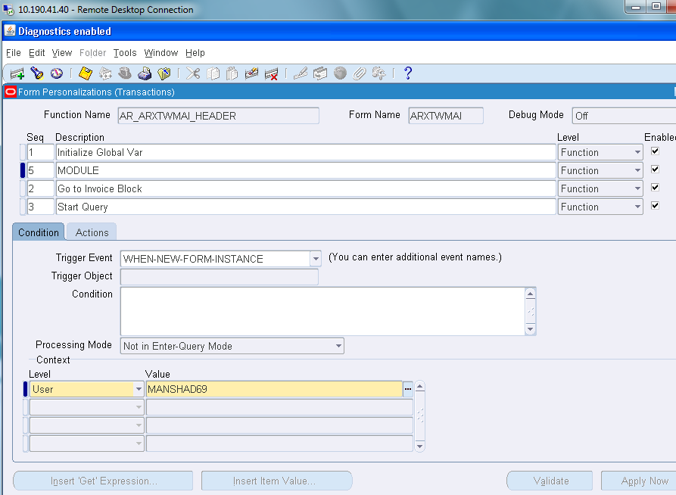

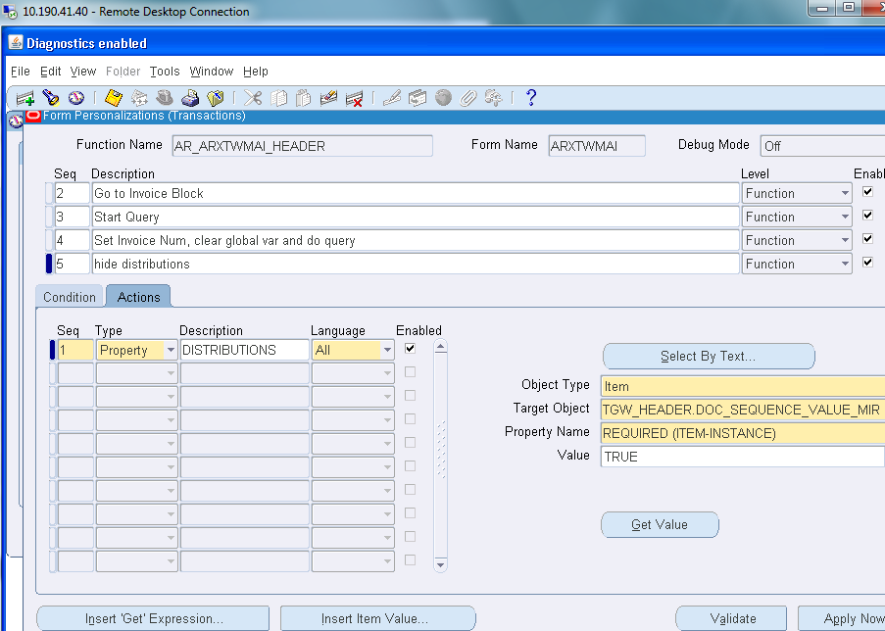

STEP7: NOW WE CAN SEE THE DOCUMENT NUM FIELD IN YELLOW COLOUR i.e COMPULSORY

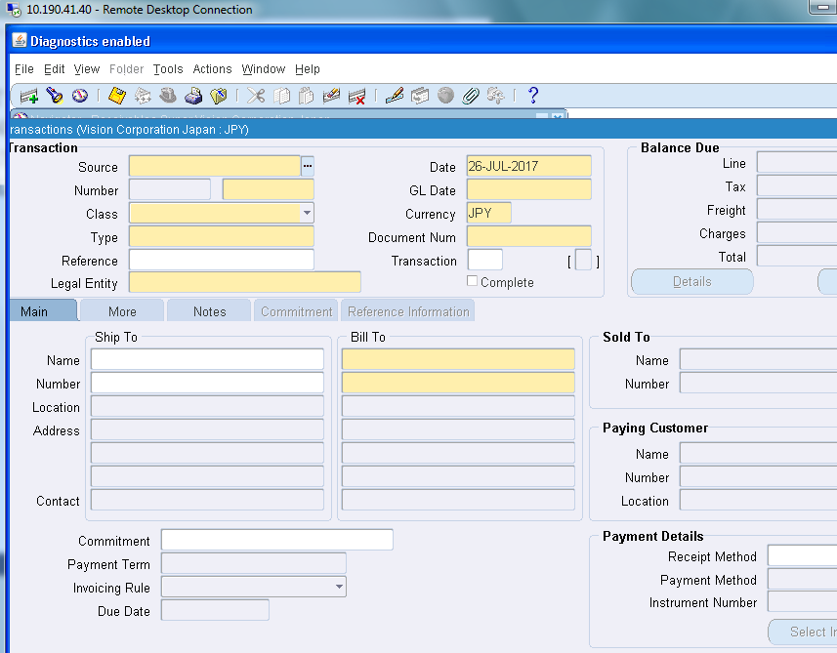

STEP8:

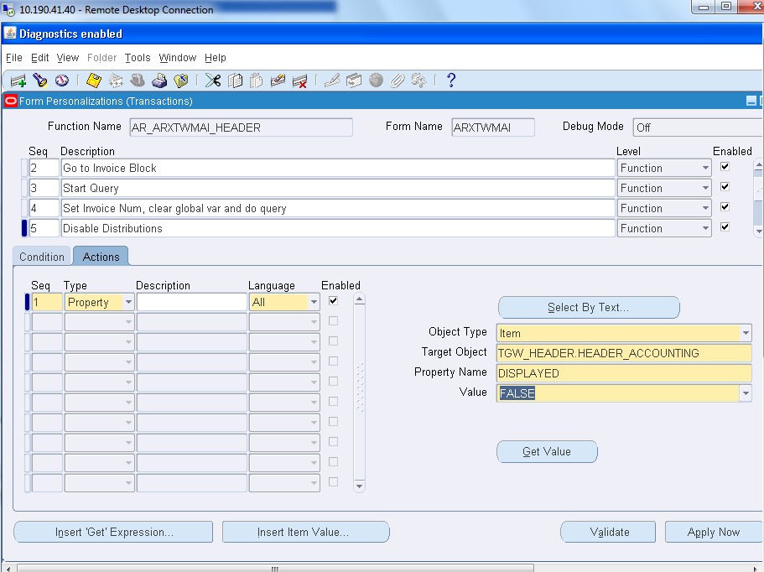

STEP9: NOW WE CAN SEE THE DISTRIBUTION FIELD IS DISABLED 