Q1.PERFORM THE FOLLOWING

1.Design a user friendly form for employee table

2.validate contents as appropriate from the Employee table,

OUTPUT:

**OBJECT NAVIGATOR**

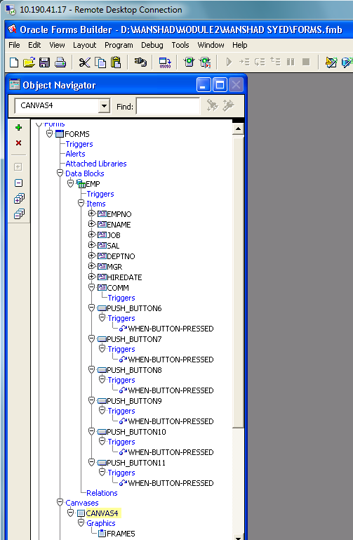

**CANVAS**

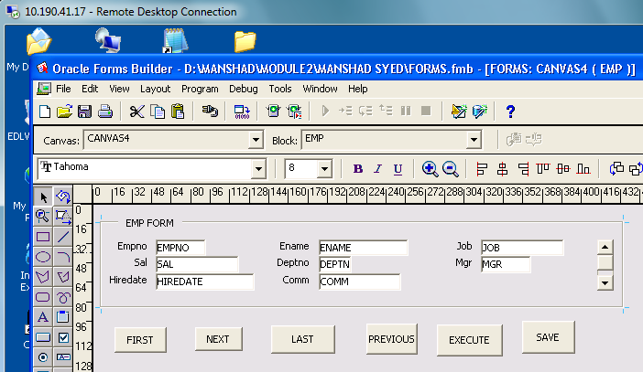

**FIRST BUTTON QUERY**

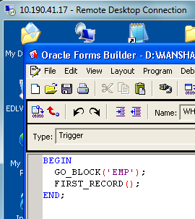

**NEXT BUTTON QUERY**

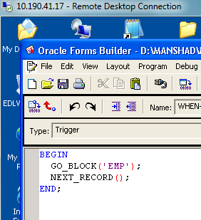

**LAST BUTTON QUERY**

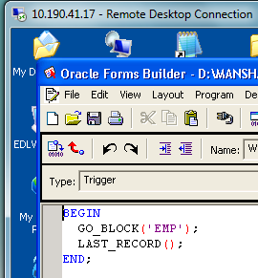

**PREVIOUS BUTTON QUERY**

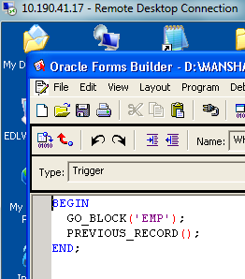

**EXECUTE QUERY**

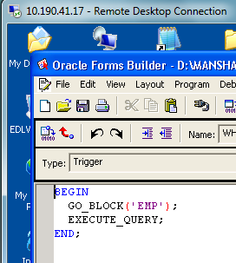

**SAVE BUTTON(INSERTING A NEW RECORD)**

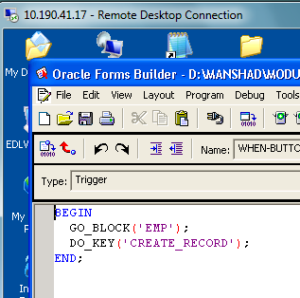

**FORM OUTPUT:**

