Q2.Perform the following

a.create a base class manager which has method calcmgrsalary() that returns calculated salary of manager

b.Create a derived class employee which has method calcEmpSalary() that returns calculated salary of the employee.

c.From derived class method call the base class method and display it in derived class method.

**OUTPUT :**

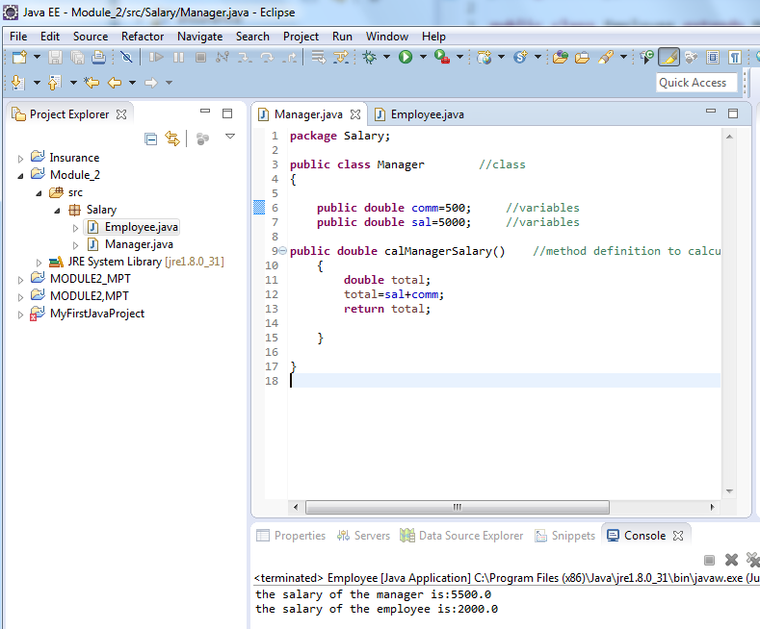

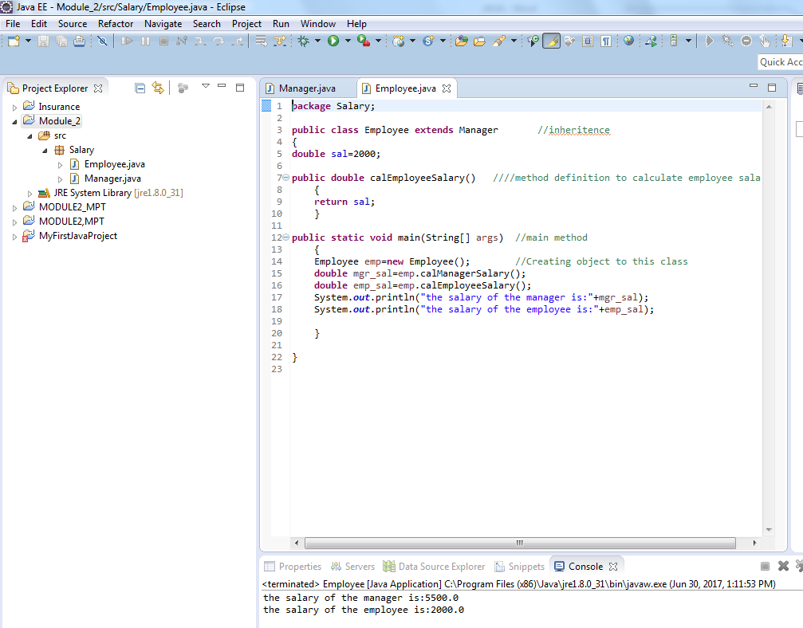

**CODE:**

**EMPLOYEE.JAVA**

package Salary;

public class Employee extends Manager //inheritence

{

double sal=2000;

public double calEmployeeSalary() ////method definition to calculate employee salary

{

return sal;

}

public static void main(String[] args) //main method

{

Employee emp=new Employee(); //Creating object to this class

double mgr_sal=emp.calManagerSalary();

double emp_sal=emp.calEmployeeSalary();

System.out.println("the salary of the manager is:"+mgr_sal);

System.out.println("the salary of the employee is:"+emp_sal);

}

}

MANAGER.JAVA

package Salary;

public class Manager //class

{

public double comm=500; //variables

public double sal=5000; //variables

public double calManagerSalary() //method definition to calculate manager salary

{

double total;

total=sal+comm;

return total;

}

}