3. Design the following reports

1. Create a parameterized report that displays master and detail information bound to a particual department. The department id should be passed as parameter.

2. Display department wise subtotal and grand total of salary for employees

OUTPUT:

**OBJECT NAVIGATOR**

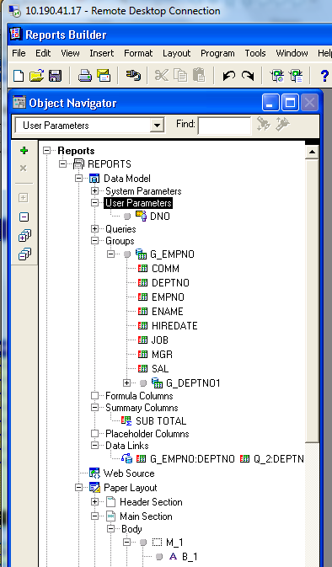

**DATA MODEL**

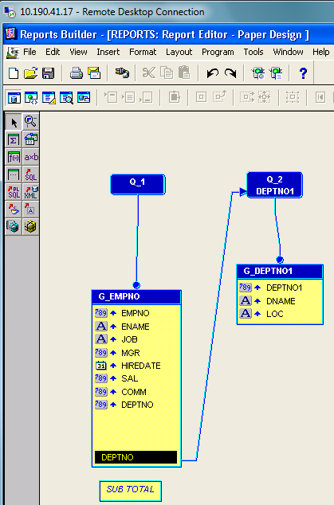

**PAPER LAYOUT**

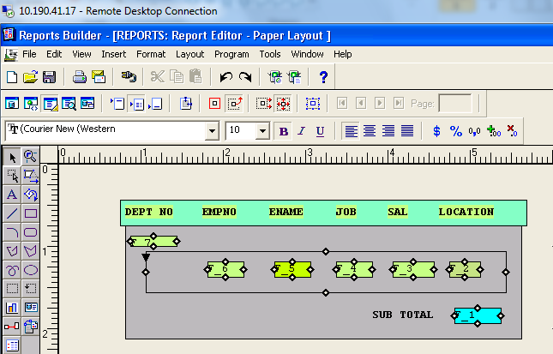

**RUNTIME PARAMETER FORM**

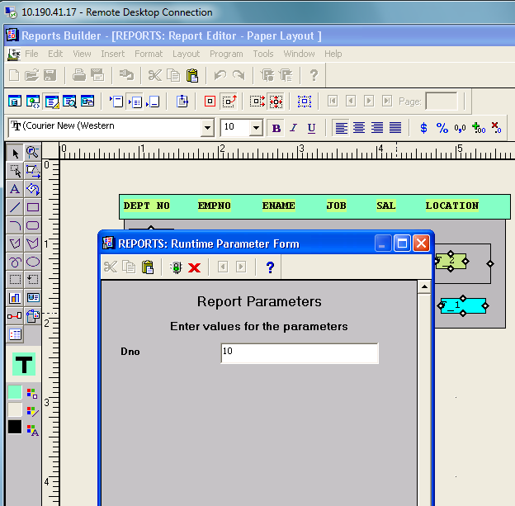

**OUTPUT**

